**Synthesis And Development of Anticancer Drug Capmatinib**

Prof. Tandale L.D, Ms. Dolas sakshi S.

Department of pharmaceutical chemistry

Shri Swami Samarth Institute of pharmacy Malwadi,( Bota)

India- 422602

Email id: sakshidolas159@gmail.com

**Abstract**

Capmatinib (Tabrecta) is a novel, selective MET kinase inhibitor approved for the treatment of MET exon 14 skipping-mutated non-small cell lung cancer. This review paper provides an overview of the synthesis, pharmacology, and clinical development of capmatinib. We discuss the medicinal chemistry strategies employed to optimize the lead compound, highlighting key structural modifications that improved potency and selectivity. The synthesis routes, including the original patent-pending process and subsequent improvements, are critically evaluated. Additionally, we summarize the preclinical and clinical data supporting capmatinib’s efficacy and safety profile. The review also explores the future directions for capmatinib development, including combination therapies and potential applications in other MET-driven cancers.

**Keywords**: capmatinib, Tabrecta, MET kinase inhibitor, non-small cell lung cancer, synthesis, clinical development.

* **Introduction**

In 2018, lung cancer was the most frequently diagnosed cancer and the primary cause of cancer-related deaths for both genders. Globally, there were over 2 million new cases and more than 1.7 million deaths attributed to lung cancer that year. Non-small-cell lung cancer (NSCLC) makes up about 85% of all lung cancer cases.Capmatinib is a powerful oral MET inhibitor that competes with ATP and falls under the type 1b category. This report presents the phase 1 results of dose escalation for Capmatinib in patients with advanced MET-positive solid tumors, along with dose expansion findings for advanced non-lung tumors. Overall, Capmatinib was well tolerated, exhibiting a manageable safety profile at all doses tested. Capmatinib is an oral small molecule mesenchymal-epithelial transition (MET) inhibitor developed by Novartis Oncology, with a license from Incyte Corporation, aimed at treating lung cancer. This drug specifically targets and binds to MET, including the mutant variant caused by exon 14 skipping, and slows the growth of cancer cells driven by this mutation. In May 2020, capmatinib received its initial global approval in the U.S. for treating adults with metastatic non-small cell lung cancer (NSCLC) whose tumors exhibit a mutation that results in MET exon 14 skipping, as identified by an FDA-approved diagnostic teoral Capmatinib is a small molecule tyrosine kinase inhibitor (TKI) that is orally available, highly selective, and effective. It specifically targets mesenchymal-epithelial transition (MET), including mutant variants created by exon 14 skipping and MET amplification. As a type 1b MET inhibitor, Capmatinib functions by obstructing ATP binding, which inhibits the phosphorylation and activation of crucial downstream effectors in MET-dependent tumor cell lines, showcasing increased specificity for MET.

* **Structure**

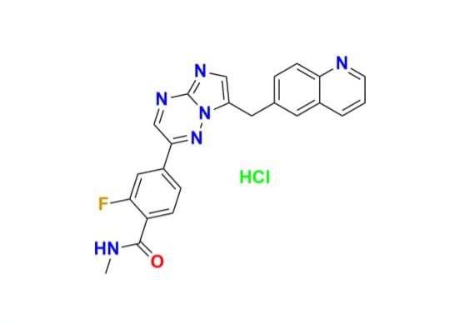Capmatinib hydrochloride is a small molecule kinase inhibitor with the following chemical structure:

* IUPAC Name -: 2-fluoro-N-methyl-4-(7-(quinolin-6-ylmethyl)imidazo[1, 2-b][1, 2, 4]triazin-2-yl)benzamide hydhydrochloride
* Molecular Formula -: C23H17FN6O : HCl
* Molecular weight-: 412.4 : 36.46 g/mol
* synonyms -: Tabrecta
* **Physical properties -:**

1. Appearance – white to off – white crystalline powder
2. Solubility – soluble in water , dimethyl Sulfoxide and ethanol.
3. Melting point – 235 – 240°C

* **Method of preparation**

CAPMA-001 reacts with oxalyl chloride to form CAPMA-002, which is then reacted with N-methoxymethylamine hydrochloride to produce CAPMA-003. Next, CAPMA-003 is treated with methylmagnesium chloride in THF to obtain CAPMA-004. Following this, CAPMA-004 is reacted with hydrogen bromide in DMSO and subsequently with triethyl orthoformate in the presence of Toluenesulfonamide (PTSA) to yield CAPMA-007.

A condensation reaction between CAPMA-007 and aminoguanidine bicarbonate results in CAPMA-008, which is transformed into CAPMA-009 through treatment with CAPMA-010. CAPMA-011 is created when CAPMA-009 undergoes a cyanidation reaction under palladium-catalyzed conditions, leading to the formation of CAPMA-012. CAPMA-012 is then hydrolyzed in acidic conditions to yield benzoic acid, designated as CAPMA-013. Finally, CAPMA-013 undergoes amidation with methylamine to produce capmatinib.

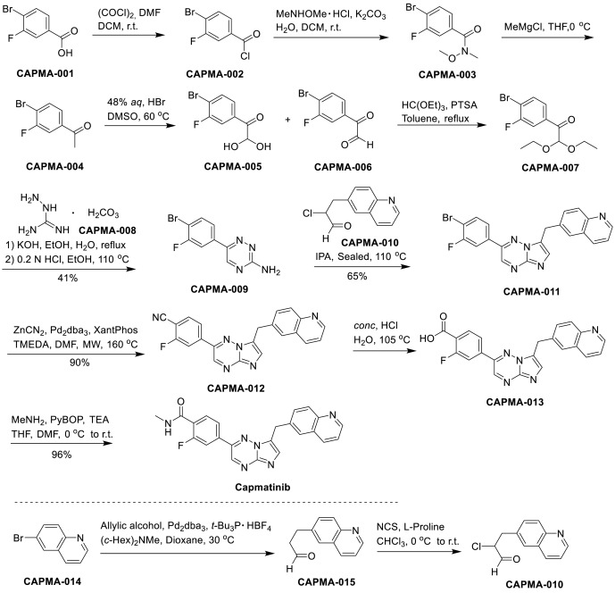

* **Synthesis**

An efficient synthetic route starting from 4-bromo-3-fluorobenzoic acid 218 is outlined in Scheme 35 [141]. The chlorination of 4-bromo-3-fluorobenzoic acid 218 with oxalyl chloride produced the acyl chloride 219. In the presence of TEA, a substitution reaction between 219 and N,O-dimethylhydroxylamine 214 yielded compound 220 with a 96% yield over two steps. The methylation of compound 221 using the Grignard reagent MeMgCl led to the corresponding acetophenone with a 98% yield. Oxidation of the acetophenone to form 2-oxo-2-phenylacetaldehyde, followed by an acetalization reaction with triethoxy methane, resulted in the formation of acetal 223 with a 92% yield. Subsequently, a [4 + 2] cycloaddition of 223 with hydrazinecarboximidamide 224 occurred in a basic environment, yielding 1,2,4-triazin-3-amine 225. This compound then underwent a [3 + 2] cycloaddition with fragment 226 in 1-butanol, producing the crucial scaffold 227 with an overall yield of 27%. Treatment of compound 227 with Zn(CN)2 and Pd(dppf)Cl2 resulted in a cyano-substituted product 228 with a yield of 73%. Finally, the hydrolysis of the cyano group, followed by condensation with methylamine, led to the synthesis of campatinib with a yield of 79%.

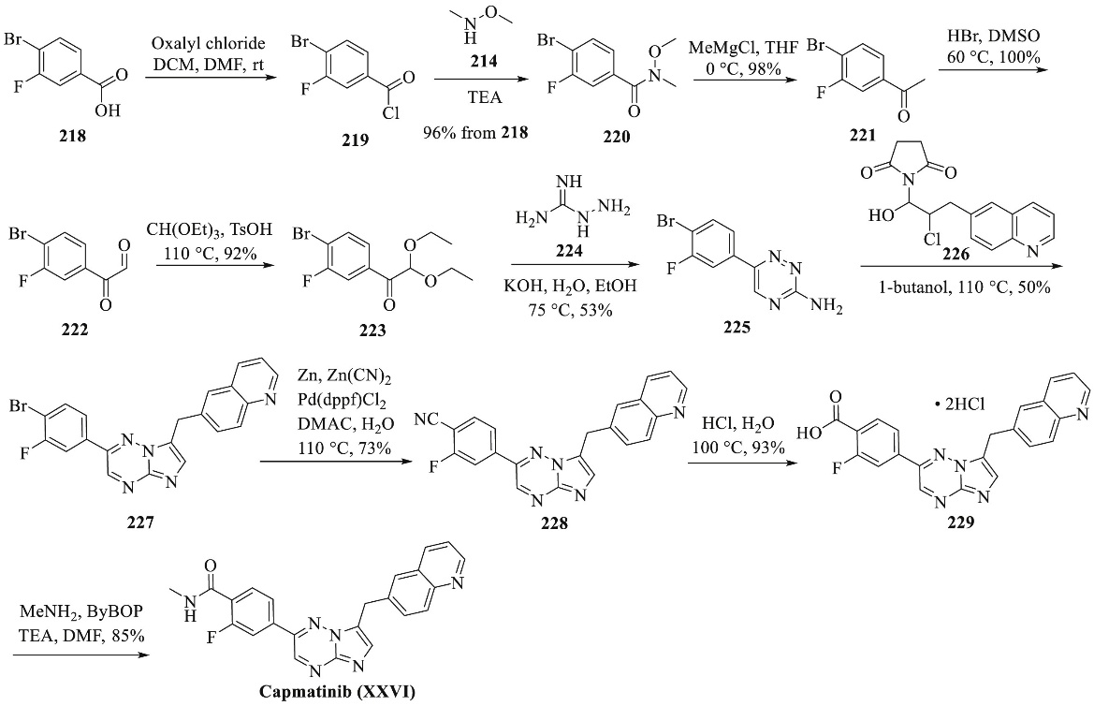

The synthesis of subunit 226 is depicted in Scheme 36. In a basic environment, 6-bromoquinoline 230 reacted with 3,3-diethoxyprop-1-yne 231 in N, N-dimethylformamide (DMF), yielding coupling product 232 with a 99% yield. The compound 232 was then reduced using PME in a hydrogen atmosphere to form product 233, which was subsequently treated with hydrochloric acid to produce the corresponding aldehyde 234 with a yield of 98%. Finally, the treatment of aldehyde 234 with proline and N-chlorosuccinimide resulted in the desired fragment 226, obtained in a yield of 54%.

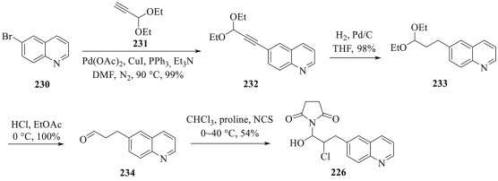

* **Mechanism of Action**

Capmatinib targets the MET protein, including the mutant variant caused by exon 14 skipping, and effectively suppresses the growth of cancer cells associated with this mutation at clinically relevant concentrations. The absence of exon 14 in MET results in the loss of a regulatory domain, which weakens its negative regulation and leads to increased downstream MET signaling. The anti-tumor effects of Capmatinib have been demonstrated In mouse tumor xenograft models derived from human lung cancers with MET amplification

or mutations causing exon 14 skipping. Capmatinib exerts its preventive effect by inhibiting the phosphorylation of both mutant and wild-type MET, which can be activated by MET amplification or hepatocyte growth factor.

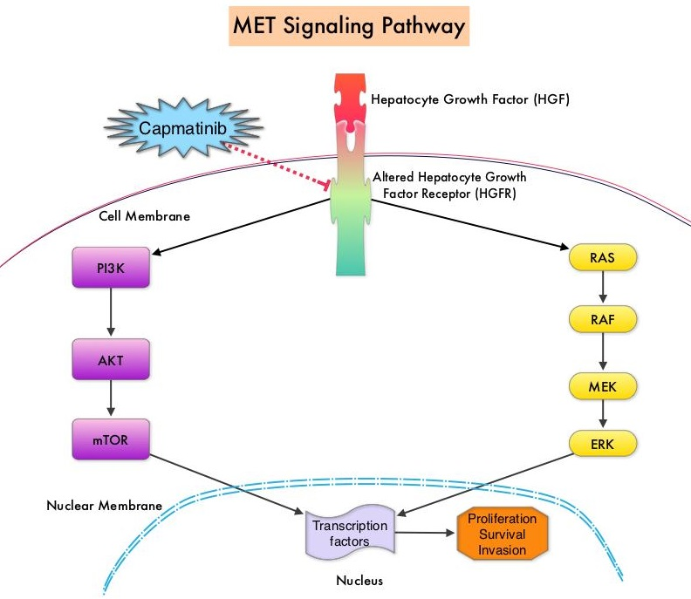

* **Pharmacokinetic Property**

MET inhibition was observed two hours after the final dose, with residual phospho-MET levels returning in two out of three models twelve hours later. In human trials, capmatinib shows linear pharmacokinetics, with both peak plasma concentration (Cmax) and area under the concentration-time curve increasing proportionally with doses ranging from 200 to 400 mg daily. It is quickly absorbed, reaching Cmax within one to two hours post-administration. The bioavailability surpasses 70%, consistent whether taken with or without

food. With a twice-daily regimen, steady-state levels are achieved by the third day. The elimination half-life of capmatinib is 6.5 hours, and it Is metabolized by cytochrome P450 A34 (CYP3A4) and aldehyde oxidase.

* **Pharmacodymic property**

The suggested dosage of capmatinib is 400 mg, taken orally twice daily, regardless of food intake. The details regarding exposure-response and the dynamics over time remain largely unclear.

* **Development**

1)Preclinical development

Capmatinib is an selective type Ib inhibitor of the MET receptor tyrosine kinase . In in vitro assays, capmatinib was shown to be more potent than other MET

inhibitors (half maximal inhibitory concentration of 0.6 nmol/L Moreover, capmatinib is highly selective for MET compared with other

Kinases, as demonstrated by testing over large panels of kinases in biochemical and binding assays . Using a selectivity screening platform of 442 kinases and disease-associated variants, capmatinib bound to only nine kinases (including wild-type MET and two MET variants: MET M1250T and Y1235D). Additionally, binding affinities of capmatinib for both wild-type and the two variants of MET . Capmatinib effectively inhibits MET downstream signaling and consequently hinders tumor growth and progression . Cancer cell growth in MET-dependent cancer cell lines was blocked by capmatinib treatment, and hepatocyte growth factor-stimulated cell migration was decreased by capmatinib in a concentration-dependent manner . MET signaling is known to mediate cell resistance to apoptosis . Treatment with capmatinib induced apoptosis in MET-dependent cell lines, as shown by increased levels of fragmented DNA and by poly (ADP-ribose) polymerase activation . In MET-dependent tumor cell lines, capmatinib inhibited the phosphorylation of downstream effectors of the MET pathway, such as ERK1/2, AKT, FAK, GAB1, and STAT3/5, and inhibited tumor cell proliferation and migration .

Capmatinib has also demonstrated in vivo activity against METdriven tumors in preclinical models . MET inhibition by capmatinib was dose dependent and this was sustained over time Furthermore, capmatinib treatment demonstrated anti-tumor activity in xenograft models, with tumor regression shown in some of these models , including in tumors. This included the regression of tumors in a patient-derived xenograft model with METex14

2)Clinical studies

The study focused on tumors, including non-small cell lung cancer (NSCLC), with MET alterations (excluding METex14) to determine the recommended dosing regimen for phase 2 and to assess the preliminary safety and effectiveness of capmatinib as a standalone treatment. Initially, a capsule form of capmatinib was used during the dose-escalation phase, which was later switched to a tablet form. The recommended phase 2 dose was established at 400 mg of capmatinib taken twice daily in tablet form, found to be equivalent to the 600 mg dosage of capsules. The results indicated that capmatinib was quickly absorbed following oral intake, with peak plasma concentrations reached within 1 to 4 hours for the capsules, and drug exposure increased with doses up to the 600 mg level.

The expansion phase Involved 55 patients with NSCLC, divided into two groups: the original cohort, which included those who completed the dose escalation, and an additional cohort with slightly different molecular diagnostic inclusion criteria. In the original cohort, MET alterations were defined by specific scoring criteria. Meanwhile, the additional cohort required patients to be EGFR wild-type and to have centrally tested MET with a high immunohistochemistry score. The study completed enrollment in February 2016, and the primary analysis results, with a data cutoff on July 17, 2017, indicated that all patients had stopped treatment. The median age of participants was 60 years, with a performance status of ≤ 2 for all, and about 90% had non-squamous histology, with 95% having received prior treatment.

* phase 2 trial

GEOMETRY mono-1 (NCT02441439) study is an ongoing multicenter, open-label, multicohort phase 2 trial evaluating the effectiveness of capmatinib at a prescribed dose of 400 mg BID in patients with advanced or metastatic non-small cell lung cancer (NSCLC) classified as stage IIIB or IV. Eligible patients were required to be EGFR wild-type, ALK fusion-negative, and possess either METex14 mutations or MET amplification. Testing for METex14 was carried out in a central lab using reverse transcriptase polymerase chain reaction (RT-PCR), while MET amplification was assessed through fluorescence in situ hybridization (FISH) on tissue samples. Participants were divided into various cohorts to determine which subgroup would benefit most from capmatinib, such as those with METex14 mutations or varying degrees of MET genomic copy number (GCN) gain, and they were analyzed individually. In Cohorts 1 to 5, patients received capmatinib while fasting, whereas in expansion Cohorts 6 and 7, food restrictions were lifted based on safety and pharmacokinetic findings from a prior study. The primary endpoint was the overall response rate (ORR), defined as the proportion of patients achieving a best overall response of partial response (PR) or complete response (CR), evaluated by an independent review committee (BIRC). Key secondary endpoints included duration of response (DOR), disease control rate, time to response, progression-free survival (PFS) per investigator and BIRC assessments, overall survival, pharmacokinetics, and safety

As of January 6, 2020, 364 patients had been recruited for the study. Efficacy data were provided for 128 individuals with METex14 advanced NSCLC across various cohorts, including 69 from Cohort 4 (1 or 2 prior treatments), 28 from Cohort 5b (treatment-naïve), and 31 from Cohort 6 (1 prior treatment). The BIRC-assessed ORR was 68% (95% CI: 48–84) for treatment-naïve patients in Cohort 5b, while for pre-treated patients, it was 41% (95% CI: 29–53) in Cohort 4 and 48% (95% CI: 30–67) in Cohort 6. For treatment-naïve patients, the median DOR was 12.6 months (95% CI: 5.6–NE) and median PFS was 12.4 months (95% CI: 8.2–NE). For pre-treated patients in Cohort 4, the median DOR was 9.7 months (95% CI: 5.6–13.0) and median PFS was 5.4 months (95% CI: 4.2–7.0). In the expansion cohort with 2L treatment, the median DOR was 6.9 months (95% CI: 4.2–NE) and median PFS was 8.1 months (95% CI: 4.2–9.9) in patients with METex14; these results are not yet fully mature. The observed differences in response rates between treatment-naïve and pre-treated patients underscore the importance of early diagnosis in patients with METex14 .

* **Uses**

The Food and Drug Administration (FDA) has authorized the use of prescription medications, including capmatinib for the treatment of specific conditions.

1. Capmatinib for Non-Small Cell Lung Cancer

Capmatinib is FDA-approved for treating a particular form of non-small cell lung cancer (NSCLC) in adults, specifically for metastatic cases where the cancer has spread beyond the lungs.

For capmatinib to be applicable, the NSCLC must exhibit irregular changes in the mesenchymal-epithelial transition (MET) receptor gene, particularly the absence of a section known as METex14. This deletion can lead to an overactive MET gene, which facilitates the rapid proliferation of lung cancer cells in the body.

Tabrecta received accelerated approval from the FDA for this use. For further details, refer to the “FDA approval” section in “What is Tabrecta?” above.

1. Testing for Genetic Alterations

Prior to starting treatment with Tabrecta, your physician will conduct a blood test or a biopsy (a procedure where a small tumor sample is removed for analysis). These tests are used to assess the genetic characteristics of your NSCLC. If a change is detected in the METex14 gene, your doctor might suggest Tabrecta as a treatment option.

Tabrecta is designed to target lung cancer cells with these MET gene alterations, inhibiting the growth of the cancer cells.

1. Symptoms of Non-Small Cell Lung Cancer

In the early stages, NSCLC might not present any symptoms. However, when symptoms do appear, they may include:

- Persistent cough

- Fatigue

- Breathing difficulties

- Chest pain

* **Side effects**

Capmatinib may lead to either mild or severe side effects. The lists below highlight some of the important side effects that can arise during treatment with Tabrecta, although they do not encompass every potential side effect.

Severe side effects and their associated symptoms may consist of:

Unusual liver function test results, indicating potential liver issues. Symptoms of liver problems may include:

- Nausea and vomiting

- Pale-colored stool

- Dark urine

* **ADR**

Common Adverse Reactions (ADRs) associated with capmatinib include:

- Swelling in the limbs

- Nausea

- Vomiting

- Diarrhea

- Headache

* **Toxicity**

About the toxicity and overdose potential of capmatinib is sparse. Animal studies have shown embryo-fetal toxicity, so both male and female patients taking capmatinib are advised to use reliable contraception during treatment and for one week after stopping the medication.

* **Conclusion**

The synthesis and development of Tabrecta (capmatinib) represent a significant achievement in the field of targeted cancer therapies. Through a multidisciplinary approach, combining medicinal chemistry, pharmacology, and clinical expertise, capmatinib has demonstrated potent and selective inhibition of MET kinase, leading to impressive efficacy and safety profiles in MET-driven non-small cell lung cancer. This targeted therapy has the potential to improve patient outcomes and quality of life, addressing an unmet medical need.

* **References**

1. Wu, Y. L., Smit, E. F., & Bauer, T. M. (2021). Capmatinib for patients with non-small cell lung cancer with MET exon 14 skipping mutations: A review of preclinical and clinical studies. Cancer Treatment Reviews, 95, 102173.
2. Bang, Y. J., Su, W. C., Schuler, M., Nam, D. H., Lim, W. T., Bauer, T. M., & Ma, B. (2020). Phase 1 study of capmatinib in MET‐positive solid tumor patients: Dose escalation and expansion of selected cohorts. Cancer science, 111(2), 536-54
3. Dhillon, S. (2020). Capmatinib: first approval. Drugs, 80(11), 1125-1131

1. Hossain, M., Habib, I., Singha, K., & Kumar, A. (2024). FDA-approved heterocyclic molecules for cancer treatment: Synthesis, dosage, mechanism of action and their adverse effect. Heliyon.
2. Niu, Z. X., Wang, Y. T., Lu, N., Sun, J. F., Nie, P., & Herdewijn, P. (2023). Advances of clinically approved small-molecule drugs for the treatment of non-small cell lung cancer. European Journal of Medicinal Chemistry, 115868.
3. Yuan, S., Luo, Y. Q., Zuo, J. H., Liu, H., Li, F., & Yu, B. (2021). New drug approvals for 2020: Synthesis and clinical applications. European Journal of Medicinal Chemistry, 215, 113284.
4. Astor, L. (2022). Tepotinib Demonstrates Durable Benefit With High-Level MET Amplification
5. Wu, Y. L., Smit, E. F., & Bauer, T. M. (2021). Capmatinib for patients with non-small cell lung cancer with MET exon 14 skipping mutations: A review of preclinical and clinical studies. Cancer Treatment Reviews, 95, 102173
6. <https://www.medicalnewstoday.com/articles/drugs-tabrecta#about>
7. https://go.drugbank.com/drugs/DB117911.