**An overview and Therapeutic Applications of pomegranate**

Ph. prof.Sangle.S.S, Ms. Deshmukh Rajeshwari R.

Department of Pharmacognosy

Shri Swami Samarth Institute of pharmacy Malwadi,( Bota)

India- 422602

Email id : mdbdeshmukh@gmail.com

**Abstract**

**Pomegranate, or Anar, comes from the organic source Punica granatum and has many medicinal properties. Although it can be produced in many countries, India is the main producer. The fruit consists of several components, including the skin, juice and seeds. It contains various chemical compounds such as gallic acid, ellagic acid and rutin. The methodologies used to study the grenades include, among others, collection and analysis. In general, pomegranate provides significant health benefits and is used in the treatment of various diseases. A fruit originating from Central Asia that is found in countries located in the East.**

* **Keywords – pomegranate, chemical constituents, uses,**

Introduction

The pomegranate (Punica granatum L.), belonging to the Lythraceae family, is a historical fruit native to Central Asia and found in countries like the East. Medium. East, Iran and Turkmenistan to the north of India. P. Granatum is a fruit shrub or small tree that grows at 501 507 m and has many different varieties. Pomegranate and its components have been shown to have powerful antioxidant, anti-inflammatory, antifungal, antibacterial and antimicrobial effects

The pomegranate trees can reach up to 9 meters in height. Leaves

Are opposite, narrow, elongated, long from 3 to 7 cm and

2 cm wide. Its flowers are bright red, orange or pink,

3 cm in diameter and have four to five petals.

The edible fruits have a rounded hexagonal shape, from 5 to 12 cm in diameter and weigh 200 g.

The seeds can be used in salads, appetizers, soups and desserts.

This fruit can be grown as an ornamental tree in parks and gardens. They are drought resistant and can survive in dry areas. They are the perfect winter food, rich in fiber and ranked among the healthiest fruits. Pomegranate is known to improve heart health, protect against prostate cancer, help prevent diabetes and is rich in antioxidants that help fight cancer and the formation of free radicals Serum. Pomegranate juice and seeds contain three times more vitamins, potassium and antioxidants. More than green tea. The seeds are mainly used as a spice in Pakistani cuisine as Anar dana. These seeds are dried and used in the preparation of curry. Supplements are available in dry form, but by drinking concentrated juices that contain polyphenolic antioxidants, you can survive high blood pressure and high cholesterol levels in the body Heftmann.

The edible part of the fruit consists of 20% seeds and 80% juice. In sugar, fructose and glucose are present in equal amounts. The polyphenolic part consists of catechins, tannins, ellagic acid and anthocyanins. Its seeds are rich in pectin, sugars and fibers that are

* **Biological source**

Botanical Name: Punica granatum

Family Name: Puniacaceae

Common Name: Pomegranate, Anar

Part Used: Seeds, flower

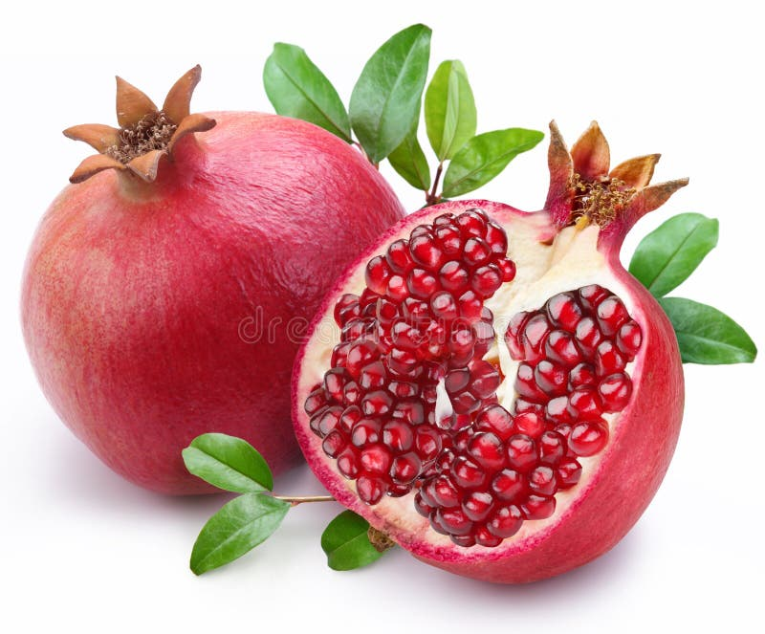

**Cultivation**

India mainly produces grenades. Maharashtra is the largest producer while Punjab contribute to its production in isolated areas. 40,000 tons are produced on 9,000 hectares. This fruit grows in tropical and subtropical regions and can be propagated sexually or asexually. Pakistan has exceptional climatic conditions for the production of pomegranate, but due to the lack of knowledge of the farmers, the poor management of the orchard and the lack of basic modern techniques. Limited his production of success AR Awan.

**Pomegranate parts**

In general, the pomegranate fruit consists of pericarp, mesocarp and seeds arranged in eight carpels superimposed on two vertices and protected by carpel membranes. According to the literature review, when studying the bioactive compounds and nutritional value of pomegranate fruits, the pericarp or peel is commonly called peel (PP). The PP can represent a maximum of 50% of the total weight of the fruit and is an important source of bioactive compounds). In Spanish pomegranate varieties, determined that pomegranate seeds constituted approximately 60-70% of the total weight, while PP remained in the range of 25-40%

1)Pomegranate peel

Thus, in terms of bioactivity, PP was the most studied part of the fruit. Based on the analysis of the literature, it was observed that the antioxidant activity of PP was the most studied for all varieties of pomegranate. This was followed by antimicrobial, anti-inflammatory and antifungal activity, among others.

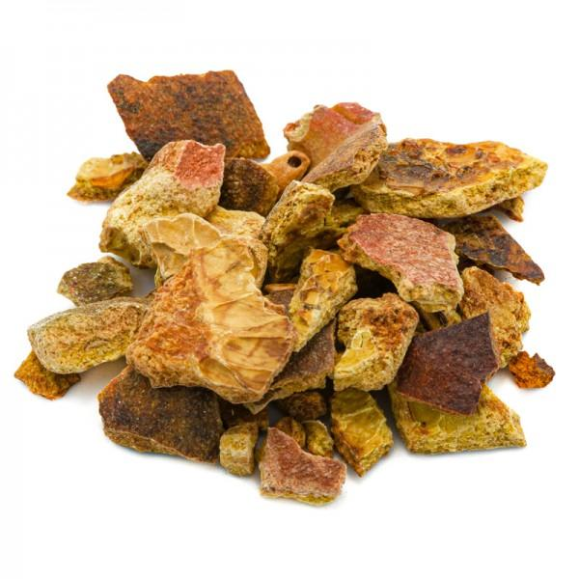

The antioxidant capacity offers, in addition to medical and health applications, and especially due to its influence on the inhibitory mechanism of tyrosinase, characteristics suitable for use in other sectors, such as the preservation of food, the development of functional foods for health and the improvement of agriculture.

2) pomegranate juice

PJ is the second most sought after part of the grenade. PJ has also been associated with microbial inhibitory properties with interesting medical and industrial applications. Some work has shown that soaking chicken in PJ reduced microbial growth at refrigeration temperatures. In the same line, other research studies have shown that the growth of certain Gram-positive bacteria such as Escherichia coli, Listeria monocytogenes, Staphylococcus aureus, Bacillus cereus and Clostridium perfringens and Gram-negative bacteria such as Helicobacter pylori and Vibrio parahaemolyticus, were infected by pomegranate juice.

The inhibition of Helicobacter pylori may indicate that pomegranate juice and may be useful as a supplement for the treatment of gastric ulcers, which are caused by this organism. However, another study showed that Escherichia coli bacteria, inhibited by Pomegranate peel extract, were not affected by pomegranate juice However, in another experiment, Pomegranate Juice seemed to inhibit the growth of Escherichia coli.

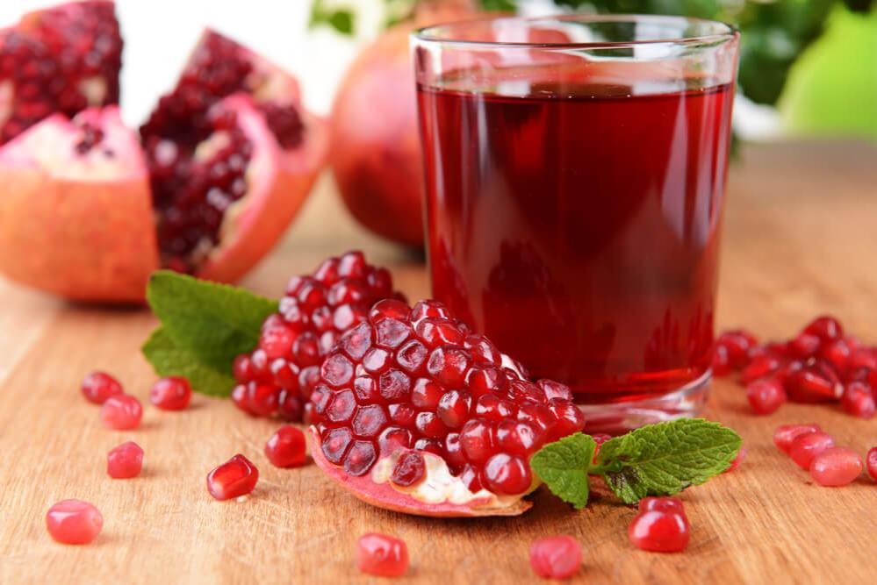

3) pomegranate seed

In pomegranate, PS are important sources of fiber , although its importance is mainly found in its oil. It has been reported that SP oil has great potential to fight cancer in male and female reproductive systems.

It has also been reported to inhibit aromatase, the enzyme that produces estrogen from testosterone 17-β-hydroxysteroid dehydrogenase type 1, which is responsible for the conversion of estrone into estradiol.

This enzyme block helps to increase the ability of pomegranate to prevent the growth of estrogen-dependent breast cancer cells in culture and also minimize the invasiveness of cancer cells. PS oil also inhibits the proliferation of some human prostate cancer lines by altering the cell growth cycle and inducing apoptosis.

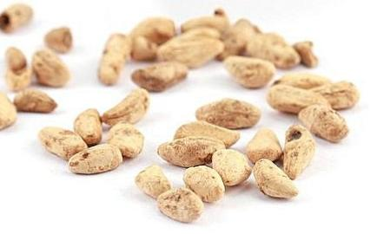

**Chemical constituent** The chemical composition depends on the region where the fruit is grown, the composition of the soil, the type of crop and other conditions. Significant changes in chemical constituents have been reported over the decade of research. However, most of the medicinal properties of the fruit are attributed to specific secondary metabolites such as ellagitannins, ellagic acid, punicic acid, anthocyanins such as delphinidin, cyanidin and pelargonidin, anthocyanidin, flavonoids and flavones, and condensed tannins. Pomegranate skin is a good source of minerals, polysaccharides, flavonoids, ellagitannins and phenolic compounds. The edible part of the grain contains mainly water, seeds, phenolic compounds, anthocyanins, pectin’s, malate, ascorbates, citrates and sugars, mainly glucose and fructose. The oil extracted from the seeds is fatty It also contain palmitate, stearic acid, oleic acid, punicic acid vitamins, proteins, sugars, fibers ,polyphenols , and minerals

**Material and Methods**

**1.Sample collection**

Fresh pomegranate (Punica granatum L.) fruits of Taifi cultivars were selected from the Agricultural Research and Experimentation Station of the College of Agriculture, KSU, Riyadh, Saudi Arabia. The fruits were harvested manually at different stages after fruiting. The fruits were classified into three different maturities, based on the subjective evaluation of the structure of the fruit and the colour of the skin.

1. Green: firm texture and green colour 2. Semi-ripe: firm structure and light green colour. 3. Ripe: soft texture and red colour.

2. Physical characteristics

Twenty fruits of each stage were analysed individually for their physical characteristics. Mohese’s (1970) procedure was adapted for physical measurements. The fruits were weighed in the air on a balance with an accuracy of 0.001 g. Fruit weight density was obtained from the weight/volume ratio. The length and diameter of the fruit were measured with a calliper and the volume by the liquid displacement method. The length measurement was taken at the polar axis of the fruit, i.e. between the tip and the stem. English The maximum width of the fruit, measured in the direction perpendicular to the polar axis, is defined as 2.3 times the diameter.

3.Proximal Analysis

The moisture content, protein percentage, fat and ash at each stage of fruit ripening were determined according to AOAC (1990) and the colour was measured using a Lovibond Tintometer (model E, England). Soluble solids were determined using a refractometer (Erma, Tokyo). The results were reported in degrees Brix at 21. For titratable acidity, the samples were homogenized and 10 g of each sample was accurately weighed into a beaker; 40 ml of distilled water was added and the pH of the sample was recorded. The resulting mixture was titrated with 0.1 N NaOH to pH 8.1, monitored using a pH meter (Corning Ltd., England). The acidity is expressed in meq/100 g of sample. French minerals were measured with an anatomical absorption spectrometer (Perkin-Elmer, USA). All results were expressed on a fresh weight basis.

**4.Ascorbic acid**

Ascorbic acid was measured using the method described by Ruck (1963). Thirty-gram portions of the homogeniz Statistical analysis Data were analysed statistically (ANOVA) using analysis of variance (Steel and Torrie, 1980) and differences between means were determined for significance in P and lt; 0.05 using Duncan’s multiple tests and the SAS system program (1982). Results and discussion Physical properties of grained sample were mixed with 100 ml of 0.4% oxalic acid for 2 minutes in a Waring blender. The mixture was made up to 500 ml with 0.4% oxalic acid and filtered. The filtrate (20 ml) was titrated with the standard 2,6-dichlorophenol indophenol. The results were expressed in mg per 100 g on a wet weight basis.

5.Sugars

Glucose, fructose and sucrose were determined by HPLC (Model Schimadzu, LC-10 AD, Japan), using a refractive index detector (RTP-6A), on a 30 cm Shim-pack LC-NH2 column. French sample preparation and chromatographic procedure was done as described in AOAC (1995) and the total sugar was calculated from the sum of individual sugars.

6.Fatty acid Analysis

Fatty acid methyl esters (FAME) were prepared following the procedure described by Metcalf, Schmitz, and Pelka (1966). Aliquots of the lipid extract (20 mg) were saponified with 1.5 ml of methanolic KOH solution (0.5 N) under reflux for 10 min at 85 ° C. After adding 4 ml of BF3-ether, the sample was boiled for 5 min. FAMEs were extracted from a salt mixture saturated with petroleum ether (40–60°C). Esters were separated by GC (Scimadzu 17 A, Japan) equipped with a capillary column (Suplecowax 10, 30 m, 0.32 id. Film thickness 0.5 mm). Helium was used as the carrier gas at an inlet pressure of 1.2 kg/cm2. All FAMEs were run in duplicate and compared to standard samples

7.Statistical analysis

Data were analysed statistically (ANOVA) using analysis of variance (Steel and Torrie, 1980) and differences between means were determined for significance in P and lt; 0.05 using Duncan’s multiple tests and the SAS system program.

**Therapeutic Application**

1. **Heart problem**

Pomegranate juice can maintain good blood circulation in the body. Along with this, it reduces the risk of heart attack and stroke,

**2 . Gastric disorders**

Peel, bark and pomegranate leaves are used to calm the stomach or diarrhea caused by any kind of digestive problem. The tea made from the leaves of this fruit helps to cure digestive problems. Pomegranate juice is also used to treat dysentery and cholera problems.

**3 . Dental care**

The best benefit of the pomegranate is that its juice, with its antibacterial properties and antiviral, helps to reduce the effects of dental plague.

**4 . Cancer**

Pomegranate contains an advanced level of antioxidants called flavonoids. These flavonoids are believed to be effective in the fight against various radial cancers. People who are at high risk of prostate and breast cancer should start drinking the juice of this fruit, because it will help reduce the risk of developing cancer. Regular consumption of pomegranate can reduce the level of PSA in the body and help fight cancer cells existing in the body.

**5 . Osteoarthritis**

Pomegranate minimizes diseases caused in different forms, such as atherosclerosis and osteoarthritis. The loss caused by the thickening and hardening of the arterial walls and cartilage and joints can be cured by consuming this fruit. In addition, pomegranate is able to prevent the creation of minerals responsible for the breakdown of connective tissue.

**6. Diabetes**

The consumption of pomegranate sugar by a diabetic patient can prevent coronary heart disease. Along with this, there is a slowdown in the hardening of blood circulation, which can promote Lack of occurrence of various heart diseases

**7 .Anemia**

Healthy blood circulation can be maintained in the body by consuming this fruit in any form. Pomegranate extract provides iron in the blood and thus helps to reduce anemic symptoms including fatigue, dizziness, weakness and hearing loss.

Reference

1)Mohammadi, M., Boghrati, Z., Emami, S. A., & Akaberi, M. (2023).

Pomegranate A review of the heavenly healer’s past, present, and future. Iranian Journal of Basic Medical Science

2)Zarfeshany, A., Asgary, S., & Javanmard, S. H. (2014). Potent health effects of pomegranate. Advanced biomedical research, 3(1), 100.

3)Shamsia, S. M. (2009). Nutritional and therapeutic properties of camel and human milks. International journal of genetics and molecular biology, 1(2), 52-58.

Bhowmik, D., Gopinath, H., Kumar, B. P., & Kumar, K. S. (2013). Medicinal uses of Punica granatum and its health benefits. Journal of Pharmacognosy and Phytochemistry, 1(5), 28-35.

5)Melgarejo-Sánchez, P., Nunez-Gómez, D., Martínez-Nicolás, J. J., Hernández, F., Legua, P., & Melgarejo, P. (2021). Pomegranate variety and pomegranate plant part, relevance from bioactive point of view: A review. Bioresources and Bioprocessing, 8, 1-29.

6)Puneeth, H. R., & Chandra, S. S. P. (2020). A review on potential therapeutic properties of Pomegranate (Punica granatum L.). Plant Science Today, 7(1), 9-16.