**Comprehensive Analysis of Claim Management in Indian Infrastructure Projects: Challenges and Strategic Insights**

**Abstract**  
Effective claim management is pivotal in ensuring the smooth execution of infrastructure projects. This research analyses critical factors influencing claim management in the Indian construction sector, focusing on dispute causes, financial impacts, and resolution mechanisms. By examining case studies, literature, and data-driven insights, the study highlights key challenges such as payment delays, ambiguous contracts, and design variations. It also proposes strategies, including negotiation, proactive risk management, and the integration of digital tools, to mitigate disputes and improve project outcomes. These findings aim to contribute to the global discourse on effective claim management in the construction industry.

1. **Introduction**

Infrastructure projects in India are critical for national development but are frequently marred by disputes and claims. These disputes often arise from the sector’s complex nature, involving multiple stakeholders, significant capital investment, and stringent timelines. Effective claim management, encompassing prevention, identification, quantification, and resolution of claims, is crucial to maintaining project viability and stakeholder trust. This research investigates claim management practices in Indian infrastructure projects, offering insights into prevalent challenges, their impacts, and strategies for resolution. The study’s findings aim to provide actionable recommendations for enhancing the efficiency of claim management processes.

1. **Literature Review**

The literature underscores the importance of proactive claim management to minimize disputes in construction projects. Disputes often stem from ambiguities in contracts, payment delays, scope changes, and design errors. Studies highlight that efficient communication and comprehensive documentation are essential for early claim detection and resolution. However, existing research reveals gaps in understanding the nuanced impacts of claims on project timelines and budgets, particularly in India’s infrastructure sector. This study addresses these gaps by analyzing real-world cases and presenting a data-driven approach to claim management.

1. **Methodology**

The methodology adopted in this research is designed to address the identified research gaps by conducting an in-depth analysis of case studies from infrastructure projects in India. The primary objective is to investigate the root causes, dynamics, and outcomes of claims and disputes within these projects. Through this approach, the research aims to uncover actionable insights and develop strategies to enhance claim management practices, mitigate disputes, and improve project performance within the construction industry.

This structured methodology focuses on identifying recurring patterns, challenges, and unique issues encountered by contractors, clients, and stakeholders. The insights derived will form the basis for proposing practical frameworks and effective solutions tailored to the Indian construction context.

**Detailed Methodology Process**

1. **Selection of Case Studies**:
   * Identify infrastructure projects across diverse sectors such as roads, bridges, railways, and urban development.
   * Focus on projects that experienced significant claims and disputes during their lifecycle.
   * Ensure diversity in project size, geographical location, and contractual conditions to capture a wide range of challenges.
2. **Data Collection**:
   * Gather detailed project documentation, including contracts, claim reports, dispute resolution records, and project progress reports.
   * Conduct interviews and surveys with key stakeholders such as contractors, consultants, and project owners to capture their perspectives.
   * Utilize publicly available information, arbitration reports, and industry publications for additional context.
3. **Categorization and Analysis**:
   * Classify claims and disputes based on factors such as their origin (e.g., delays, payment issues, design errors), stakeholder responsibilities, and impacts on time, cost, and quality.
   * Apply qualitative and quantitative analysis techniques to identify trends, recurring patterns, and root causes.
4. **Development of Risk and Claim Management Frameworks**:
   * Based on findings, formulate best practices and proactive measures for contractors to effectively prevent and manage claims.
   * Propose strategies to improve contractual terms, communication processes, and stakeholder coordination to minimize disputes.
5. **Validation Through Expert Feedback**:
   * Share the proposed frameworks and strategies with industry experts for review.
   * Incorporate expert feedback to refine recommendations, ensuring their practicality and relevance.

**Contribution to Effective Claim Management**

This methodology facilitates a comprehensive understanding of claims and disputes in infrastructure projects by exploring real-world complexities beyond theoretical analysis. The key contributions of this research include:

* **Improved Risk Identification and Allocation**: Highlight common risk factors and suggest mechanisms for their effective allocation in contracts to reduce disputes.
* **Enhanced Early Detection of Claims**: Provide tools for contractors to identify potential claims early in the project lifecycle, enabling timely mitigation.
* **Strengthened Negotiation and Resolution Strategies**: Offer tailored techniques for resolving disputes efficiently through negotiation or other methods before escalation.
* **Support for Stakeholder Collaboration**: Emphasize the importance of clear communication and collaboration among stakeholders to avoid misunderstandings and conflicts.
* **Tailored Solutions for Indian Infrastructure Projects**: Address unique challenges such as delays due to land acquisition and complex regulatory frameworks specific to the Indian construction industry.

By following this structured approach, the research delivers actionable recommendations to contractors and stakeholders. It aims to reduce the frequency and impact of claims and disputes in Indian infrastructure projects. By learning from past experiences, the findings provide targeted solutions to manage claims more effectively, foster better collaboration between parties, and anticipate potential risks from the outset of a project. This methodology serves as a practical guide for improving claim management practices and enhancing the overall success of infrastructure projects.

|  |  |  |  |  |  |  |  |
| --- | --- | --- | --- | --- | --- | --- | --- |
| **Sr. No.** | **Project Name** | **Claim Overview** | **Claim Cost (INR)** | **Claim Awarded (INR)** | **Cause of Dispute** | **Effect on Project** | **Lessons Learned/Conclusion** |
| 1 | Mumbai Coastal Road Project | Unforeseen geological conditions (high water tables, unstable soil) | 150 Cr | 110 Cr | Poor site conditions | Project delayed, cost overruns | Importance of thorough site investigations before construction begins. |
| 2 | Kolkata East-West Metro Corridor | Delays in obtaining environmental clearances | 100 Cr | 70 Cr | Delayed government clearances | Delayed construction and increased public frustration | Need for faster environmental clearance processes. |
| 3 | Mumbai Metro Line 5 | Lack of coordination in land acquisition and utility diversion | 200 Cr | 150 Cr | Delays in land acquisition and utility shifting | Delays in progress and increased costs | Need for better coordination among project stakeholders. |
| 4 | Amritsar-Kolkata Industrial Corridor | Force majeure events (severe floods and cyclones) affecting construction | 130 Cr | 90 Cr | Weather-related delays | Significant delays and disruptions | Inclusion of force majeure clauses in contracts. |
| 5 | Hyderabad Pharma City | Delays in shifting utilities (water, power, sewage lines) | 90 Cr | 60 Cr | Delay in utility shifting | Project halted, cost overruns, and timeline extension | Coordination with utility providers must be improved. |
| 6 | Purvanchal Expressway | Changes in scope (addition of flyovers and bridges) | 120 Cr | 100 Cr | Unanticipated changes in scope | Delays and cost overruns | Delays and cost overruns |
| 7 | Surat Metro Rail | Dispute over material quality and replacement of defective materials | 60 Cr | 45 Cr | Defective material supply | Rework and delays | Stringent material quality control during procurement. |
| 8 | Bangalore Suburban Railway Project | Claims due to unclear specifications leading to redesigns and rework | 85 Cr | 65 Cr | Ambiguity in design specifications | Delays and additional costs | Need for clear and detailed design specifications. |
| 9 | National Waterway Project | Claims due to slow approval processes from government agencies | 50 Cr | 40 Cr | Delayed government approvals | Project delays, labor and material procurement issues | Fast-tracking approvals to avoid project delays. |
| 10 | Surat Metro Phase 2 | Claims due to unbalanced bidding (contracts submitted at a loss) | 70 Cr | 50 Cr | Financial strain due to low bids | Delays and cost disputes | Better evaluation of bids with realistic pricing during tendering. |
| 11 | Patna Bypass | Delays caused by slow land acquisition processes | 90 Cr | 60 Cr | Delayed land acquisition | Delayed start and prolonged project timeline | Importance of timely land acquisition for smooth project initiation. |
| 12 | Purvanchal Expressway | Claims for redesign due to errors in original design | 50 Cr | 35 Cr | Design error requiring redesign | Delays due to rework and redesign | Thorough review of designs to avoid errors during the planning phase. |
| 13 | Delhi-Meerut Expressway | Inadequate information in tender documents (incorrect work volume estimation) | 110 Cr | 85 Cr | Incorrect work volume estimates in tender documents | Cost overruns, delays, and work revision | Accurate and detailed tender documents are crucial for project success. |
| 14 | Delhi-Meerut Expressway | Claims due to delayed utility shifting and re-routing | 80 Cr | 60 Cr | Delayed utility shifting work | Stopped work and prolonged project timeline | Improved coordination for utility shifting should be emphasized. |
| 15 | Amritsar-Kolkata Industrial Corridor | Claims for additional labor and machinery costs due to disrupted transportation | 120 Cr | 90 Cr | Delayed transportation logistics | Disruptions in the supply chain | Need for proactive logistics planning to prevent delays. |
| 16 | Mumbai Coastal Road Project | Additional excavation due to unstable soil | 140 Cr | 100 Cr | Soil instability | Work stoppage and delays | Comprehensive geological surveys can help mitigate unforeseen costs. |
| 17 | Kolkata Metro Corridor | Claims for compensations due to delayed approvals for construction activities | 100 Cr | 75 Cr | Delayed approvals from the government | Delays in project commencement | Expedited approval processes should be a priority |
| 18 | Patna Bypass | Delay in land acquisition and its impact on timeline | 80 Cr | 60 Cr | Delay in land clearance | Delay in project work and resource wastage | Need for advanced land acquisition planning and coordination. |
| 19 | Surat Metro Line 5 | Claims for compensating delays caused by unclear utility diversion agreements | 100 Cr | 80 Cr | Ambiguous utility shifting agreements | Project delay, additional work costs | Clearer agreements and contracts to avoid utility-related delays. |

1. **Case Study Analysis**

The case studies reveal diverse dispute causes and their implications:

This section provides a brief overview of various claims arising from Indian infrastructure projects, focusing on the key issues, resolutions, and lessons learned. These case studies highlight the importance of effective claims management strategies and the need for better project planning, risk assessment, and communication.

1. Mumbai Coastal Road Project

Claim arose from unforeseen geological conditions, causing rework and delays. The final settlement awarded INR 110 crore out of INR 150 crore claimed, emphasizing the need for thorough site investigations.

2. Kolkata East-West Metro Corridor

Delayed environmental approvals caused idle resources and project setbacks. The claim of INR 100 crore was resolved with INR 70 crore awarded, underlining the importance of timely clearances.

3. Patna Bypass Project

Slow land acquisition delayed project commencement, resulting in a claim for INR 90 crore, with INR 60 crore awarded. This case stresses the importance of timely land acquisition.

4. Delhi-Meerut Expressway

Incorrect tender information led to additional work claims. INR 110 crore was claimed, and INR 85 crore awarded, highlighting the need for accurate tender documentation.

5. Surat Metro Phase 2

Unbalanced bidding forced contractors to submit underpriced bids, leading to a claim for INR 70 crore, with INR 50 crore awarded. This case emphasizes the need for realistic bidding.

6. National Waterway Project

Delays in approvals from government agencies caused project disruptions, leading to a claim for INR 50 crore, with INR 40 crore awarded. It demonstrates the need for fast-tracking approvals.

7. Amritsar-Kolkata Industrial Corridor

Unforeseen weather disruptions led to claims for INR 120 crore, with INR 90 crore awarded, stressing the importance of force majeure clauses in contracts.

8. Bangalore Suburban Railway Project

Unclear design specifications led to claims for INR 85 crore, with INR 65 crore awarded. The case underlines the necessity of clear and detailed project specifications.

These cases underscore the critical role of clear contracts, timely payments, and proactive dispute resolution mechanisms.

1. **Results and Discussion**

The analysis identifies payment delays (35%), ambiguous contracts (25%), and design variations (20%) as leading dispute causes. Other factors include scope changes (10%) and unforeseen external events (10%). The financial impact of claims ranged from ₹5 crores to ₹50 crores, with resolution times varying significantly based on the method employed. Negotiation emerged as the most effective resolution mechanism, accounting for 40% of resolved disputes, followed by mediation (25%) and arbitration (20%).

**Graphical Insights**

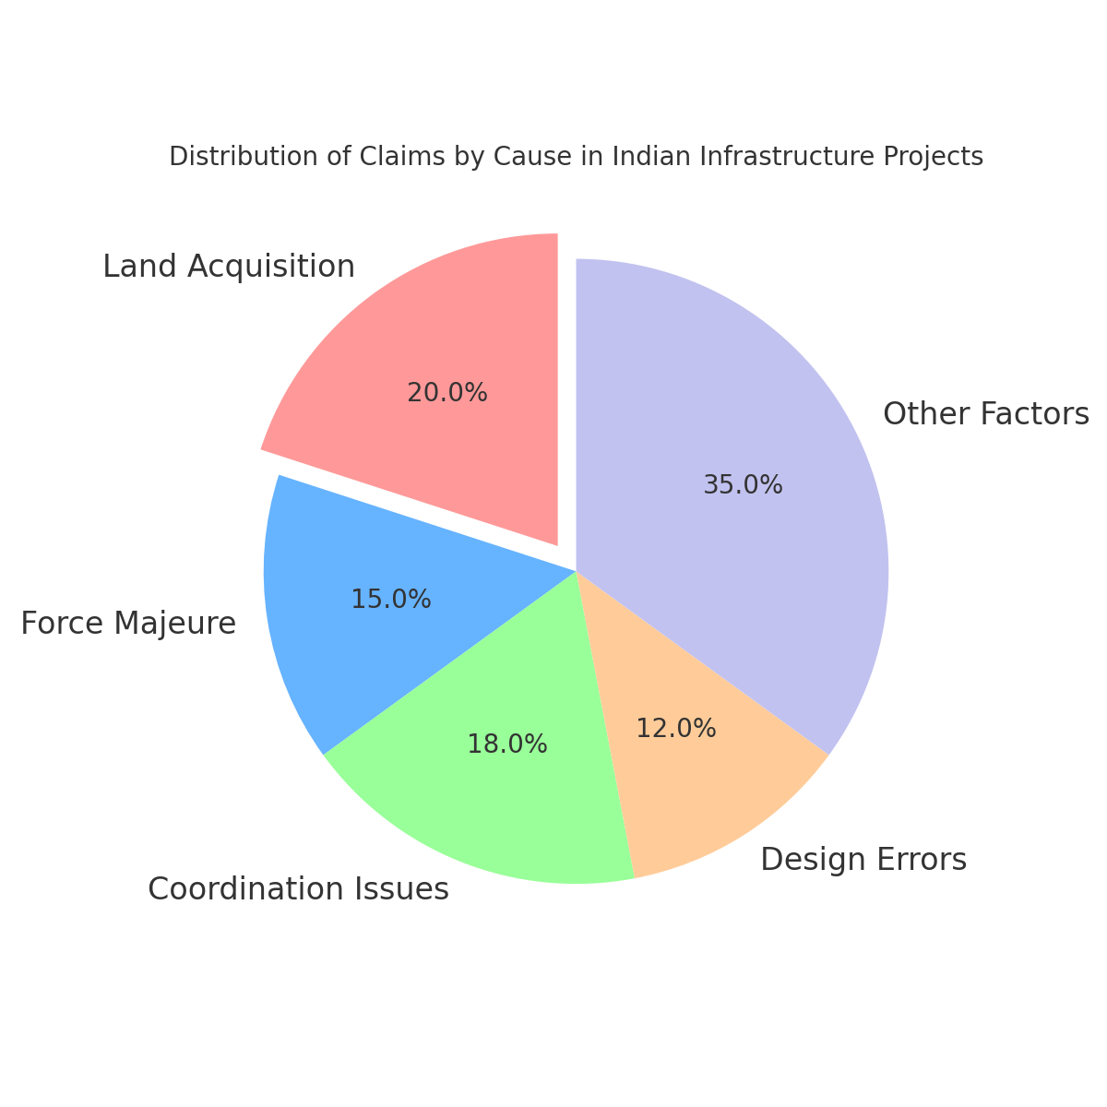

**6. Conclusion**

This study provides a comprehensive analysis of claim management in Indian infrastructure projects, offering insights into dispute causes, impacts, and resolution strategies. Payment delays and ambiguous contracts are identified as the most significant contributors to claims. The research highlights negotiation as the most effective resolution method, emphasizing the need for proactive risk management, robust documentation, and stakeholder collaboration. These findings aim to guide policymakers, contractors, and clients in adopting best practices for claim management, ensuring smoother project execution and improved outcomes.

**7. Recommendations**

1. **Enhance Contract Clarity:** Draft precise and comprehensive contracts to minimize ambiguities.
2. **Implement Timely Payment Protocols:** Establish mechanisms to ensure prompt payments, avoiding cash flow disruptions.
3. **Adopt Digital Tools:** Leverage technology for real-time monitoring and documentation.
4. **Invest in Training:** Conduct regular training sessions on contract and claim management.
5. **Promote Alternative Dispute Resolution (ADR):** Encourage negotiation and mediation over litigation and arbitration.

**References**  
**Journal papers: -**

1. Amit Moza and Virendra Kumar Paul (2018), “Analysis of Claims in Public Works Construction Contracts in India”, Journal of Construction in Developing Countries, 23(2), pg. 7–26.
2. Dikeledi Anna Matseke and Nthatisi Khatlel (2021), “Proceedings of International Structural Engineering and Construction 8(1) pg. CON-27-1- CON 27-6
3. D. Mohamed Abdel-Hamid, Abdel-Rahman Alaa El-Din Mostafa (2023), “The Effect of FIDIC red book 2017 to avoid disputes in Egyptian construction field”, Ain Shams Engineering Journal Volume 14, Issue 5, May 2023, 101963, pg. 1-7.
4. Dimitrios Robert I Stamatiou, Konstantinos A Kirytopoulos, Stavros T Ponis, Sotiris Gayialis & Ilias Tatsiopoulos (2018), “A process reference model for claims management in construction supply chains: the contractors’ perspective”, International Journal of Construction Management, pg. 1-19.
5. H H Shaikh (2020), “Claims in Construction Projects: A Comprehensive Literature Review,” The Fifth International Conference on Civil and Environmental Engineering for Sustainability, Johor, Malaysia, pg. 19-20.
6. Hesham A. Abdel-Khalek, Remon Fayek Aziz, Israa A. Abdellatif (2019), “Prepare and analysis for claims in construction projects using Primavera Contract Management (PCM)”, Alexandria Engineering Journal Volume 58, pg. 487-497.
7. JeeHee Lee,June-Seong Yi and Jeong Wook Son (2019), “Development of Automatic-Extraction Model of Poisonous Clauses in International Construction Contracts Using Rule-Based NLP”, Journal of Computing in Civil Engineering, Volume 33, Issue 3),
8. Kemala Hayati, Yusuf Latief, Achmad Jaka (2019) “Risk-base Contract Management on the Design and Build Construction to Minimize Disputes in Infrastructure Projects”, IOP Conference Series: Materials Science and Engineering, pg. 1-8.
9. Kalidoss Rajakani (2022), “BIM-based claims management system: A centralized information repository for extension of time claims”, Automation in Construction, pg. 1-16.
10. Kalidoss Rajakani (2022), “Construction Project Claim Management under the Background of Wireless Communication and Artificial Intelligence”, Wireless Communications and Mobile Computing Volume 2022, Article ID 6074104, pg. 1-6.
11. Mohammed Taha Al-Qershi, and Ravande Kishore (2017), “Claims causes and types in Indian Construction Industry – Contractor Perspective”, American Journal of Civil Engineering and Architecture Vol 5, pg.196-203.
12. Mohammed Taha Al-Qershi, and Ravande Kishore (2018), “Leading factors contributing to the generation of claims in Indian Construction Industry – Consultants Perception”, American Journal of Civil Engineering and Architecture Vol 5.
13. Olalekan Olaolu Titu, Hamizah Liyana binti Tajul Ariffin, Kherun Nita Ali (2023), “Construction dispute and contract incompleteness in Nigeria Construction Industry”, Ain Shams Engineering Journal, pg. 1-15.
14. Ssegawa, J.K and Keakile, S (2023), “Analysing the Nature of Contractor Claims and Strategies for their Effective Management: A case of Build Serve in Botswana”, IOP Conf. Series: Earth and Environmental Science 498 (2020) 012095, pg. 1-8.
15. Upadhay Parth Dipakkumar (2021), “An Analytical Study of Dispute Resolution in Construction Project in Gujrat”, Journal of Emerging Technologies and Innovative Research (JETIR), pg. b536-b542.