.**The synthesis of zynlonta for targeted cancer therapy**

Prof.Tandale L.D,Ms.Dherange Sakshi. S .

Department of Pharmaceutical Chemistry

Shri Swami Samarth Institute of Pharmacy Malwadi ( Bota) .

India -422602

Email id: sanjaydherange9922@gmail.com

**Abstract**:

Antibody-Drug Conjugates (ADCs) represent a promising new class of anticancer therapeutics, showing significant potential for targeted cancer treatment. The rapid advancements in ADC development over the past two decades have been largely enabled by innovative technologies and methodologies. Among these, Click Chemistry has emerged as a valuable tool, facilitating efficient bioconjugation, material science applications, and drug discovery. This review explores the impact of Click Chemistry on ADC synthesis and development, focusing on the most frequently used reactions, including Michael addition, Copper-catalyzed azide-alkyne [3+2] cycloaddition (CuAAC), Strain-promoted azide-alkyne [3+2] cycloaddition (SPAAC), oxime bond formation, hydrazine-iso-Pictet-Spengler ligation (HIPS), and Diels-Alder reactions. Furthermore, the review highlights the application of thiol-based reactions in ADC synthesis.

**Keywords** :

Antibody -drug conjugates, click chemistry cuAAC, SPAAC Biocononjugation ,Cancer Therapeutic.

**Introduction** :

Zynlonta is also called as the antibody -drug conjugates.Cancer remains one of the major challenges in the medical field, with 19.3 million new cases reported globally in 2020, leading to approximately 10 million deaths. These numbers are projected to rise even further, with estimates suggesting 28.4 million new cases by 2040. In light of these alarming statistics, there is an urgent need to develop more effective anticancer drugs to address this growing public health issue. One promising approach is the use of monoclonal antibody-drug conjugate (ADC) technology. ADCs are composed of three key components: a monoclonal antibody, a cytotoxic drug, and a linker that binds them together. The antibody component of the ADC provides targeting specificity by interacting with an antigen uniquely expressed on the surface of cancer cells, while the cytotoxic drug is responsible for cell-killing activity upon internalization.This version clarifies the statistics and explains the ADC components in a smoother flow, making it easier to read and understand.

**Drug profile :**

1. Brand name: Zynlonta
2. Generic name: Loncostuximab Tesirine
3. Drug class: antibody – drug conjugate
4. IUPACname:N-(2-(4-((4-((2,5-dioxo-1H-pyrrol-3-yl)oxy)-4-oxobutoxy)carbonylamino)-4-methylpentyl)-2-(2-(2-(3-mercaptopropanamido)ethyl)-1H-1,3-dioxoisoindol-5-yl)acetamido)-4-(4-((2,5-dioxo-1H-pyrrol-3-yl)oxy)-4-oxobutoxy)butanamide

5.Molecular formula:C6544H10048N1718O2064S52

6.Molecular Weight:151 kDa

7.Structure :

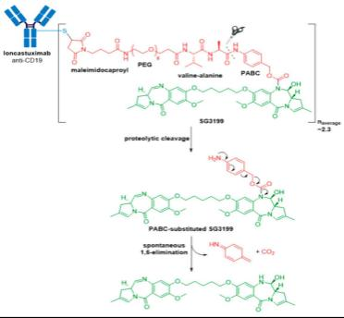

**Mechanism of action:**

Antibody-drug conjugates (ADCs) work by combining the targeting specificity of monoclonal antibodies (mAbs) with the cytotoxic potency of small-molecule drugs, providing a targeted “biological missile” effect against cancer cells. Here is a breakdown of the mechanism of action of ADCs:

1.Target Binding: ADCs consist of a monoclonal antibody attached to a potent cytotoxic drug via a chemical linker. The antibody component is designed to recognize and bind specifically to antigens that are overexpressed on the surface of cancer cells.

2.internalization: Upon binding to the target antigen, the ADC-antigen complex is internalized by the cancer cell through . This process forms an early endosome within the cell.

3.Endosomal Maturation: The early endosome matures into a late endosome and ultimately fuses with a lysosome. The acidic environment in these cellular compartments can lead to the cleavage of the linker (if it is pH-sensitive) or degradation of the antibody, which releases the cytotoxic drug.

4.Drug Release: The cytotoxic payload is released inside the cancer cell, where it can interfere with cellular functions. Common payloads include microtubule inhibitors, DNA-damaging agents, or other cell cycle disruptors. This targeted delivery minimizes damage to healthy cells, thereby reducing off-target effects.

5.Cell Death: The released drug induces cell death, either by causing DNA damage, disrupting microtubules, or other mechanisms specific to the payload. This leads to apoptosis or other forms of cell death in the cancer cell.

Overall, ADCs combine the precision of monoclonal antibodies with the potent effects of cytotoxic drugs, improving the therapeutic window and aiming to reduce systemic toxicity commonly associated with traditional chemotherapy.

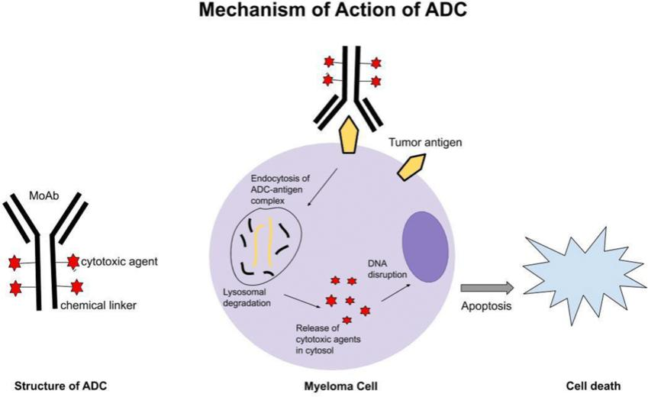

**Synthesis for development of ADC compound:**

1. **Coppercatalyzedazidealkayneb[3+2]cycloaddition**

The copper-catalyzed azide-alkyne [3+2] cycloaddition, also known as the “click” reaction, was indeed groundbreaking for its versatility and reliability in organic synthesis. This reaction, pioneered by Tornoe, Christensen, and Meldal, enables the efficient creation of 1,2,3-triazoles—a class of compounds widely useful across numerous fields. Due to its high specificity and compatibility with a range of functional groups, it has become indispensable for applications in bioconjugation, peptide modification, pharmaceuticals, and even polymer and nanostructure synthesis. One of the remarkable features of azides and alkynes is their inertness in biological settings; because they are minimally reactive toward cellular components, they are particularly suitable for in vivo applications. This allows scientists to “click” molecules together without disturbing other biochemical processes, enabling selective modifications within complex biological systems. This utility in bioorthogonal chemistry makes the reaction invaluable for constructing biomolecule-based materials, modifying drug molecules, and advancing molecular labeling techniques.Let me know if you need further details on any specific application or mechanism!

Copper (I) ions play a crucial role in activating alkynes to react with azides or other dipolar compounds, which makes copper-catalyzed azide-alkyne cycloaddition (CuAAC) a powerful bioconjugation tool. This reaction’s high speed, specificity, and bioorthogonality make it particularly attractive for in vivo applications. However, a major drawback is the toxicity associated with free Cu(I) ions, which can generate reactive oxygen species (ROS) and harm biological systems.To mitigate copper-mediated toxicity, researchers have developed strategies such as water-soluble ligands that stabilize the Cu(I) ions, reducing their ROS generation. Examples include:

1.**THPTA (tris(hydroxypropyltriazolyl)methylamine)**

2.**BTTAA(2-[4-{(bis[(1-tert-butyl-1H-1,2,3-triazol-4-yl)methyl]amino)methyl)-1H-1,2,3-triazol-1-yl]acetic acid)**

3.**Bis-L-histidine**

These ligands effectively shield cells from copper toxicity while maintaining the efficiency of the reaction.Another approach involves using copper-chelating azides, which enhance the reaction rate and reduce the necessary copper concentration. Alternatively, a copper-free azide-alkyne cycloaddition, known as strain-promoted azide-alkyne cycloaddition (SPAAC), is sometimes preferred. In SPAAC, strain energy in the alkyne drives the reaction without needing a copper catalyst, making it inherently safer for biological applications and ideal for in vivo bioconjugation where toxicity is a concern.Each of these adaptations has expanded the utility of azide-alkyne cycloadditions, especially in delicate biological environments.

It looks like you’re referring to antibody-drug conjugates (ADCs) where pyrrolobenzodiazepine (PBD) and monomethyl auristatin E (MMAE) serve as payloads, attached to antibodies via bioorthogonal chemistry. Here’s a breakdown of the approach:

1.Antibody and Drug Payloads:

EphA2 Targeting (Anti-EphA2, SG3364): Modified with an azide group that can selectively react with an alkynyl-modified drug such as PBD.

2.Synthesis of novel antibody drug using glycoengineering and cuAAC:

In the study by Vatansever et al., the researchers aimed to create novel antibody-drug conjugates (ADCs) through copper-catalyzed azide-alkyne cycloaddition (CuAAC), a click chemistry technique. They experimented with various reaction setups involving alkyne, metal-chelating azide, and non-metal-chelating azide, with each incorporated into either the antibody or the drug. Their findings indicated that the most effective approach involved linking a metal-chelating azide to the drug and incorporating an alkyne into the antibody. This preference was based on observed challenges when attaching a metal-chelating azide to the antibody. Such a configuration can necessitate specific reaction conditions, increasing the heterogeneity of the resulting ADCs, potentially diminishing their activity and raising toxicity risks. In contrast, antibodies with an alkyne attachment avoid these issues, are easier and less costly to produce, and provide a more straightforward synthesis route.

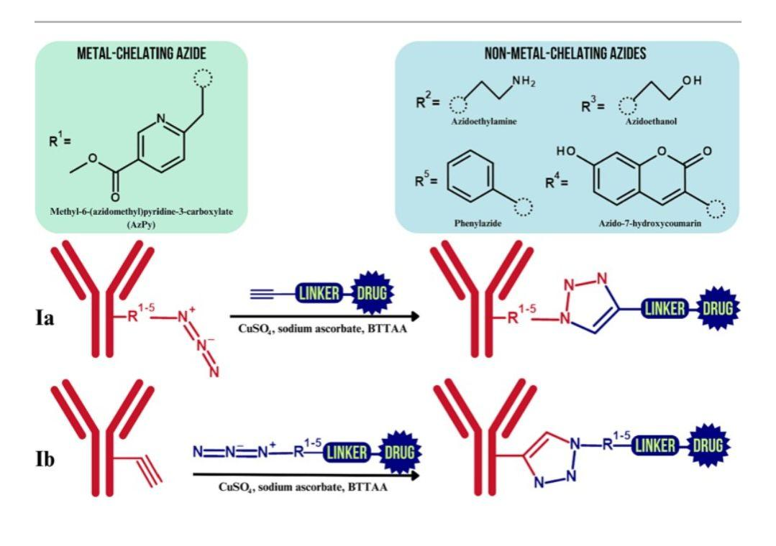

3**. The scheme of synthesis of the novel ADCs between: Ia – azide-incorporated antibody and alkyne-containing drug- linker construct; Ib – alkyne-incorporated antibody and azide-containing payload:**

In this study, the authors used a copper-catalyzed azide-alkyne cycloaddition (CuAAC) reaction to create a conjugate of the PIKK inhibitor Neolymphostin and a cysteine-mutant form of the antibody Trastuzumab (A114C). The goal was to improve the bioavailability and physicochemical properties of Neolymphostin, which typically has limited effectiveness when used alone.The process Involved modifying Neolymphostin with an azide group, then linking it to an alkyne-bearing maleimide through the CuAAC reaction. This reaction took place in the presence of copper sulfate (CuSO₄), sodium ascorbate, and dimethylformamide (DMF) to produce a stable linker-payload structure. Afterward, this linker-payload was attached to the antibody by a 1,3-addition of the maleimide to the cysteine residue at position 114 on Trastuzumab-A114C. This site-specific approach ensured that the therapeutic payload was selectively conjugated, potentially enhancing the delivery and efficacy of the antibody-drug conjugate (ADC).The described study involved the conjugation of maleimide to a specific cysteine residue (A114C) on the antibody trastuzumab, yielding antibody-drug conjugates (ADCs) with a drug-to-antibody ratio (DAR) of approximately 1.7–1.9. These ADCs were evaluated for cytotoxic efficacy on HER2-positive cell lines, including BT474 and N87 (breast and gastric cancer, respectively), as well as MDA-MB-361-DYT2 (another breast cancer cell line). They were also tested on HER2-negative MDA-MB-468 cells. The ADCs exhibited significant cytotoxic activity against HER2-expressing cells, indicating their potential effectiveness. Additionally, the CuAAC (copper-catalyzed azide-alkyne cycloaddition) reaction was highlighted as a recent method in ADC synthesis, showcasing its ongoing relevance in bioconjugation approaches for targeting specific antigens.

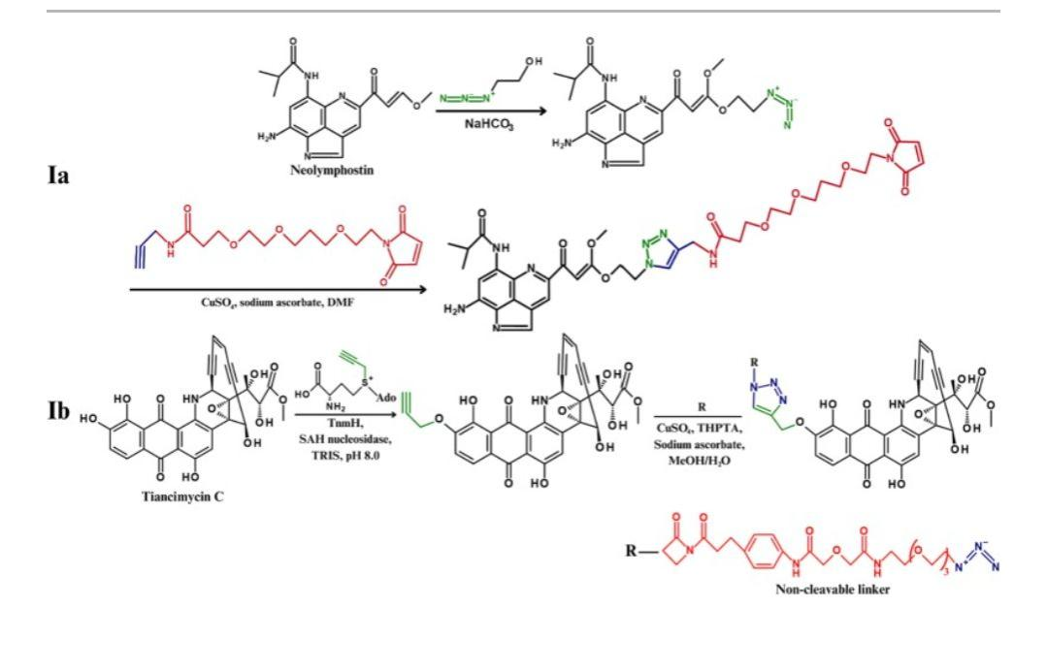

**4.The synthesis of dual-labelled antibody-drug conjugate using strain-promoted cyclooctyne-1,2-quinone cycloaddition (SPOCQ) and SPAAC (based on [38]). Tyrosinase – oxidizes tyrosine of the G4Y-tag to ortho-quinone:**

**1.Oxime bond formation:**

Oxime bond formation is a chemical reaction where a nucleophile attacks the carbonyl carbon of an electrophile in a proton-catalyzed manner, leading to the creation of an oxime. This process, first named by Meyer and Janny in 1882, follows a series of steps:

1.Nucleophilic Attack: A nucleophile attacks the carbonyl carbon of the electrophile, aided by a proton catalyst.

2.Formation of Tetrahedral Intermediate: This attack generates a tetrahedral intermediate, characterized by a temporary proton relocation.

3.Water Elimination: The intermediate undergoes dehydration, releasing a water molecule and forming a protonated intermediate.

4.Deprotonation: Finally, this protonated intermediate loses a proton, resulting in the formation of an oxime bond.

The final oxime structure consists of a C=N-OH group, typically formed by reacting a carbonyl-containing compound with a hydroxylamine. This type of bond formation is useful in organic synthesis and bioconjugation due to its stability and efficiency.

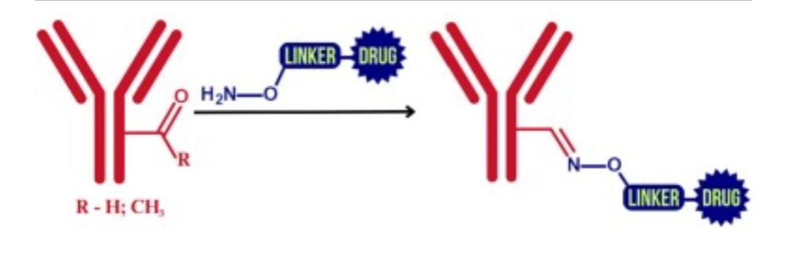

**5 .Michael addition:**

The Michael addition reaction, a foundational process in organic chemistry, was first introduced by Arthur Michael in the 1880s. Originally, Michael used this reaction to synthesize a cyclopropane derivative through the interaction of diethyl 2,3-dibromopropionate with sodium diethyl malonate. Since then, Michael addition has become valuable across various fields such as drug discovery, gene and drug delivery, bioconjugation, and polymer synthesis. In the Michael addition, factors like catalyst choice, solvent, and substrate strongly influence reaction kinetics. The reaction mechanism involves a nucleophilic donor (such as an enolate, amine, or thiol) attacking an electrophilic, α, β-unsaturated carbonyl compound. Specific types of Michael additions are named based on the donor involved: if the donor is nitrogen, it is termed the aza-Michael reaction, and if it is a thiol, it Is known as the thiol-Michael addition

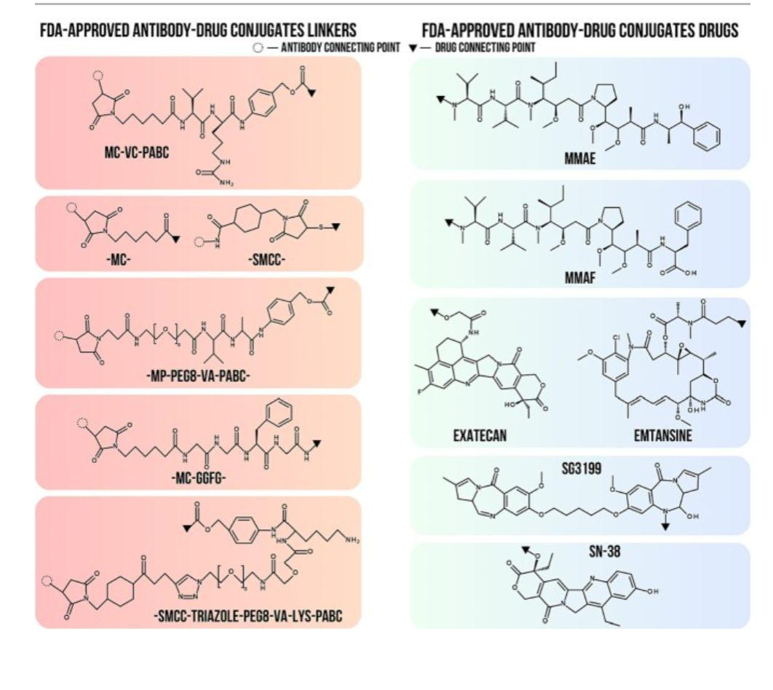

**Clinical development of ADC:**

Antibody-drug conjugates (ADCs) are targeted cancer therapies that combine the selectivity of monoclonal antibodies with the potency of cytotoxic drugs, improving the therapeutic window. As of December 2021, 14 ADCs have been approved worldwide for clinical use, with about half targeting hematological malignancies and the other half for solid tumors.

**Key Points in ADC Development and Approval:**

1.**ADC Components and Design:** ADCs have three main components—antibody, linker, and cytotoxic payload—designed to maximize selectivity and reduce off-target toxicity. Advances in these areas have significantly influenced ADC efficacy and safety.

2.**Therapeutic Areas**: Approved ADCs cover a range of indications, from hematological cancers (e.g., lymphomas and leukemias) to solid tumors (e.g., breast, lung, and bladder cancers).

3.**Clinical Development and Market Presence**: With over 100 ADCs in various stages of clinical trials, pharmaceutical companies are actively optimizing ADC profiles to expand therapeutic options. These approved ADCs are marketed across multiple countries, each undergoing rigorous clinical testing and regulatory review before approval.

4.**Future Prospects:** Continued advancements in linker technology, antibody engineering, and payload potency hold promise for expanding the application of ADCs to more cancer types and potentially other disease

1.**Hematological malignancy:**

Gemtuzumab ozogamicin (Mylotarg®, Pfizer) is a groundbreaking antibody-drug conjugate (ADC) approved for treating certain hematological malignancies, specifically acute myeloid leukemia (AML). This ADC combines a humanized monoclonal IgG4 antibody that targets the CD33 antigen, commonly expressed on AML cells, with a potent cytotoxic agent, N-acetyl-γ-calicheamicin, linked via a cleavable hydrazone linker. The drug-to-antibody ratio (DAR) of gemtuzumab ozogamicin is typically around 2–3, meaning there are 2–3 cytotoxic molecules attached to each antibody.Initially approved by the FDA for patients aged 60 and older with CD33-positive AML in first relapse who were not eligible for other chemotherapies, gemtuzumab ozogamicin showed a 26% response rate in these patients. Since its first approval, it has paved the way for the development and approval of other ADCs, marking a significant milestone in targeted cancer therapy.

2 . **Solid tumors:**

Ado-trastuzumab emtansine (Kadcyla®, Roche), also known as T-DM1, is a targeted antibody-drug conjugate (ADC) used for treating HER2-positive breast cancer, which occurs in approximately 15%-20% of breast cancer cases. This subtype of breast cancer is often more invasive due to the overexpression of the HER2 receptor. Ado-trastuzumab emtansine is the first ADC approved for treating a solid tumor, specifically HER2-positive metastatic breast cancer. This ADC is composed of a humanized monoclonal antibody that targets HER2, linked to the cytotoxic agent DM1 via a non-cleavable linker called SMCC (succinimidyl-4-(N-maleimidomethyl) cyclohexane-1-carboxylate). With an average drug-to-antibody ratio (DAR) of 3.5, this non-cleavable linker provides enhanced stability in plasma, ensuring the payload remains intact until it reaches its target site.

**Current challenges and next generation of ADCs:**

Despite advancements in antibody-drug conjugates (ADCs) and the development of newer generations with improved specificity and cytotoxicity, several significant challenges persist in their design, pharmacokinetics, and clinical application. Here are some of the major challenges facing ADCs:

1.Complex Pharmacokinetics: ADCs have intricate pharmacokinetic profiles due to their composite structure, combining antibody and cytotoxic drug properties. This complexity can lead to unpredictable distribution, clearance, and metabolism, making dosage optimization challenging.

2.Tumor Targeting and Payload Release: Effective ADC therapy depends on selective binding to tumor cells, followed by internalization and release of the cytotoxic payload within the tumor. However, some ADCs face issues with off-target effects or inadequate delivery of the payload to the intended cells, reducing treatment efficacy.

3.Drug Resistance: Similar to traditional chemotherapies, ADCs can face drug resistance over time. Tumor cells may develop mechanisms to evade ADC action, such as downregulating target receptors, increasing drug efflux, or enhancing repair pathways for drug-induced damage.

**Pharmacokinetic and dynamic properties of Zynlonta:**

It sounds like you’re detailing the pharmacological profile of an antibody-drug conjugate (ADC) similar to Zynlonta. Here’s a more organized summary of the key propertie” and pharmacokinetics/pharmacodynamics:

**Key Properties**

High Affinity for CD56: Ensures effective targeting, particularly important for minimizing off-target effects.

Targeted Delivery of Cytotoxic Agent: Designed to deliver a cytotoxic payload specifically to cancer cells, reducing impact on healthy cells.

Minimized Damage to Healthy Cells: The design limits cytotoxic exposure outside of targeted cancer cells.

**Pharmacokinetic Profile:**

1.Absorption: Given intravenously, leading to rapid entry into the bloodstream and high bioavailability.

2.Distribution: Broad distribution with specificity to target sites like myeloma cells, supporting concentrated effects at disease sites.

3.Metabolism: Undergoes metabolic breakdown, with pathways involving hepatic and extra-hepatic processes.

4:Excretion: Predominantly excreted via the kidneys and feces, indicating renal and hepatic involvement in drug clearance.

**Pharmacodynamic Profile:**

Mechanism of Action: Specifically targets myeloma cells via CD56, leading to internalization and release of the cytotoxic payload inside the cancer cells.

Therapeutic Effects: Primarily induces apoptosis in target cells, leading to tumor cell death.

Side Effects: Potential side effects may result from off-target interactions but are minimized by high specificity.

**Scale up techniques of Zynlonta:**

Zynlonta (loncastuximab tesirine-lpyl) is an antibody-drug conjugate (ADC) used to treat certain types of large B-cell lymphoma. When considering scale-up techniques for producing Zynlonta, the process must carefully handle both the monoclonal antibody (mAb) and the cytotoxic payload, as well as their conjugation. Here are key areas to focus on for scaling up Zynlonta production:

1.**Monoclonal Antibody Production:**

1.**Cell Line Development and Optimization:** Optimizing the cell line used to express the monoclonal antibody to achieve high yields and consistent product quality. This often involves screening multiple clones for high productivity and robust growth in larger bioreactors.

2.**Fed-Batch or Perfusion Cultures**: Scaling from bench-top to large bioreactors requires adjustments to media composition, feeding strategies, and potentially switching to perfusion systems for continuous antibody production.

3.**Bioreactor Scale-Up:** Transfer of production from small to large bioreactors involves optimizing parameters like pH, dissolved oxygen, and temperature to maintain cell health and product consistency. Process modeling can be used to predict the behavior in larger bioreactors.

**2DrugConjugationProcess(Linker-Payload Attachment):**

1.**Reaction Optimization**: The process for conjugating the cytotoxic payload to the antibody through a linker must be optimized for larger scales. Ensuring efficient, selective binding with minimal by-products is key to maintain ADC stability and efficacy.

2.**Quality Control:** Analytical methods, like high-performance liquid chromatography (HPLC) and mass spectrometry, are essential to monitor conjugation efficiency, linker stability, and overall product purity. Scaling up may require parallel quality control adjustments to maintain standards.

3.**Process Yield and Consistency**: The yield and consistency of the linker-payload conjugation can be improved by optimizing the stoichiometry and reaction conditions (e.g., pH, temperature).

**3.Downstream Processing**

1.**Purification**: Larger-scale purification steps need to handle both the mAb and conjugated ADC. Techniques like affinity chromatography (e.g., Protein A), ion exchange, and hydrophobic interaction chromatography (HIC) must be optimized to handle larger volumes and maintain purity.

2.**Filtration and Concentration:** Filtration techniques such as tangential flow filtration (TFF) are adapted for larger volumes to remove impurities, concentrate the product, and ensure sterility.

3.**Buffer Exchange and Formulation:** Scaling up requires optimized buffer exchange to maintain product stability. Formulation buffers must be tested at scale to ensure they support the stability and bioactivity of Zynlonta.

**4.Analytical Characterization and Quality Control**

1.Process Analytical Technology (PAT): Using PAT helps monitor critical quality attributes (CQAs) in real-time, ensuring consistency during scale-up. Techniques like real-time UV-Vis monitoring, in-line pH and conductivity probes, and near-infrared (NIR) spectroscopy aid in maintaining control at scale.

2.Characterization of ADC Attributes: Ensuring consistency in attributes like the drug-to-antibody ratio (DAR), aggregation, and stability of the ADC is critical. Analytical techniques may need adjustments for larger scale sensitivity and resolution.

3.Manufacturing Considerations and Compliance Good Manufacturing Practice (GMP): Scale-up for clinical and commercial production must follow strict GMP guidelines. This includes comprehensive documentation, validation of equipment, and process qualification to ensure that each batch meets regulatory standards.

4.Facility Design and Equipment Suitability: Scale-up may require specialized facilities and containment strategies, especially when handling highly potent cytotoxic drugs. Facility design should allow safe handling, with dedicated equipment for ADC processing to prevent cross-contamination

**Uses**:

1.**Relapsed or refractory multiple myeloma:**

It seems there might be a mix-up with Zynlonta’s indications. Zynlonta (loncastuximab tesirine-lpyl) is actually indicated for the treatment of adult patients with relapsed or refractory large B-cell lymphoma, including diffuse large B-cell lymphoma (DLBCL), after at least two prior therapies.

2.**combinational therapy:**

Zynlonta is not indicated for multiple myeloma; instead, it is used in lymphomas, particularly in patients whose large B-cell lymphoma has either relapsed after treatment or proven resistant to prior therapies. It’s usually administered as a monotherapy but could be explored in combination regimens in clinical settings to potentially improve outcomes.

3**.Patient selection:**

If you need information on therapies for relapsed or refractory multiple myeloma, I’d be happy to help with that too.

**Side effects of Zynlonta:**

Zynlonta (loncastuximab tesirine-lpyl) is a targeted antibody-drug conjugate used to treat relapsed or refractory diffuse large B-cell lymphoma (DLBCL). While effective, it can have a range of side effects, some of which may be serious. Here are the main side effects associated with Zynlonta:

**Common Side Effects**

1.Fatigue – Feeling unusually tired or weak.

2.Nausea and vomiting – Common gastrointestinal symptoms.

3.Swelling and fluid retention – Particularly in the arms, legs, or other areas.

4.Rash – Skin rash or irritation.

5.Decreased appetite – Often leading to mild weight loss.

6.Muscle and joint pain – Generalized aches or stiffness.

7.Fever – Low-grade fever or chills.

**Serious Side Effects**

1.Low Blood Counts (Cytopenias) – This includes low white blood cells (increasing infection risk), low platelets (raising bleeding risk), and low red blood cells (leading to anemia).

2.Liver Toxicity – Elevated liver enzymes or liver injury, which can be serious.

3.Infusion-related Reactions – Symptoms during or after the infusion, such as fever, chills, or difficulty breathing.

4.Capillary Leak Syndrome – A rare but serious condition where fluid leaks from blood vessels, leading to low blood pressure, swelling, and difficulty breathing.

**Adverse drug reactions of Zynlonta:**

Adverse drug reactions (ADRs) to Zynlonta (loncastuximab tesirine-lpyl) can vary in severity and type. Here’s a breakdown of some of the primary ADRs reported with Zynlonta:

1**.Hematologic Reactions**

Neutropenia: A significant reduction in neutrophils, which increases infection risk.

Thrombocytopenia: Lowered platelet levels, which can lead to bleeding.

Anemia: A decrease in red blood cells, potentially causing fatigue and weakness.

2.**Liver Toxicity**

Elevated Liver Enzymes: Increased AST, ALT, or bilirubin levels can indicate liver stress or injury, potentially requiring dose adjustments.

Hepatotoxicity: In severe cases, this may lead to jaundice or other signs of liver dysfunction.

**3.Infusion-related Reactions**

Reactions can occur during or shortly after the infusion, including fever, chills, flushing, shortness of breath, or drop in blood pressure.

4**.Capillary Leak Syndrome**

Symptoms: Sudden weight gain, swelling, low blood pressure, and breathing difficulties due to fluid leaking from blood vessels.

Severity: This can become life-threatening and requires prompt medical attention.

5**.Infections**

Due to its immunosuppressive effects, Zynlonta may increase the risk of infections, including respiratory infections and urinary tract infections.

6.**Skin Reactions**

Rashes: Some patients develop rashes, which can range from mild to severe.

Pruritus: Intense itching can also occur, sometimes requiring medication.

7.**Gastrointestinal Reactions**

Nausea, vomiting, constipation, or diarrhea, which can generally be managed with supportive care.

**Toxicity of Zynlonta:**

Zynlonta (loncastuximab tesirine-lpyl) is an antibody-drug conjugate (ADC) approved to treat relapsed or refractory large B-cell lymphoma after two or more prior treatments. Like many ADCs, Zynlonta has notable toxicities, which can impact its tolerability and require close monitoring and supportive care. Key toxicities include:

1**.Hematologic Toxicities**:

Neutropenia is common, which can raise the risk of infections.

Thrombocytopenia (low platelet count) and anemia may also occur.

Blood counts are closely monitored, and patients may require dose adjustments, delays, or supportive medications (e.g., growth factors).

2.**Liver Toxicity:**

Liver enzyme elevations (e.g., ALT, AST) are relatively common.

Monitoring of liver function tests is standard, with dose modifications if significant changes occur.

3.**Skin Reactions:**

Rash or erythema is common and can vary in severity. Topical or oral corticosteroids may be prescribed for management.

4.**Fluid Retention and Edema**:

Patients may experience peripheral edema or other signs of fluid retention. Monitoring weight and considering diuretics may be necessary.

**5.Photosensitivity:**

Zynlonta can make the skin more sensitive to sunlight, so patients are advised to limit sun exposure and use protective clothing and sunscreen.

**Conclusion:**

In conclusion, it is clear that click chemistry plays a crucial role in the development of antibody-drug conjugates (ADCs).

However, click chemistry faces notable challenges due to issues like the unstable nature of the thiosuccinimide linkage, which can undergo a retro-Michael reaction when exposed to other thiol-containing compounds in the human body. This instability can lead to a loss of activity and increased toxicity, posing a significant hurdle in ADC development . To overcome these limitations, researchers are working on multiple strategies. Some approaches involve enhancing the thiol-maleimide reaction, such as creating “link-opened” linkers, using innovative reagents, or “locking” the thioether moiety to prevent retro-Michael reactions. Additionally, alternative click reactions like copper-catalyzed azide-alkyne cycloaddition (CuAAC), strain-promoted azide-alkyne cycloaddition (SPAAC), oxime bond formation, hydrazone-initiated polymerization of synthetic peptides (HIPS), and Diels-Alder reactions are being explored to improve ADC stability and efficacy. These approaches collectively contribute to advancing the field of novel antibody-drug conjugates, addressing the limitations of traditional methods.

Reference:

1.C. Rao, C. Rao, V.S. Rangan, S.V. Deshpande, S. DeshpandeChallenges in antibody-drug conjugate discovery: a bioconjugation and analytical perspective Bioanalysis, 7 (13) (Jul. 2015).

2..K. New, K. New, M.W. Brechbiel, M.W. Brechbiel, M.W. BrechbielGrowing Applications of ‘Click Chemistry’ for Bioconjugation in Contemporary Biomedical ResearchCancer Biother. Radiopharm., 24 (3) (Jun. 2009).

3.H.C. Kolb, M.G. Finn, K.B. sharpless Click Chemistry: DiverChemical

Function from a Few Good Reactions.Angew. Chemistry40 (11) (

4.Lambert, J. M. & Berkenblit, A. Antibody-drug conjugates for cancer treatment. Annu. Rev. Med. 69, 191-207 (2018).

5.Norsworthy, K. J. et al. FDA approval summary: mylotarg for treatment of patients with relapsed or refractory CD33-positive acute myeloid leukemia. Oncologist 23, 1103 (2018).

6.Ethan Ennals For The Mail On Sunday. New breed of drug which reduces bladder cancer deaths could replace chemotherapy in other cases. At dailymail.co.uk (2021).

7.Damelin, M., Zhong, W., Myers, J. & Sapra, P. Evolving strategies for target selection for antibody- drug conjugates. Pharm. Res. 32, 3494-3507 (2015).

8.Diamantis, N. & Banerji, U. Antibody-drug conjugates an emerging class of cancer treatment. Br. J. Cancer 114, 362-367 (2016).

9.Ritchie, M., Tchistiakova, L. & Scott, N. Implications of receptor-mediated endocytosis and intracellular trafficking dynamics in the development of antibody drug conjugates. MAbs 5, 13-21 (2013).

10.Donaghy, H. Effects of antibody, drug and linker on the preclinical and clinical toxicities of antibody-drug conjugates. MAbs 8, 659-671 (2016).

11. Beck, A., Goetsch, L., Dumontet, C. & Corvaïa, N. Strategies and challenges for the next generation of antibody-drug conjugates. Not. Rev. Drug Discov. 16, 315-337 (2017).

12.Xiao, Y. & Yu, D. Tumor microenvironment as a therapeutic target in cancer. Pharmacol. Ther. 221, 107753 (2020)..

13.. Rummel, S. et al. Genomic (in) stability of the breast tumor microenvironment. Mol. Cancer Res. 10, 1526-1531 (2012).

14.De Cecco, M., Galbraith, D. N. & McDermott, L. L. What makes a good antibody-drug conjugate? Expert Opin. Biol. Ther. 21, 1-7 (2021).

15. Hock, M. B., Thudium, K. E., Carrasco-Triguero, M. & Schwabe, N. F. Immunogenicity of antibody drug conjugates: bioanalytical methods and monitoring strategy for a novel therapeutic modality. AAPS J. 17, 35-43 (2015).

16.Abdollahpour Alitappeh, M. et al. Antibody-drug conjugates (ADCs) for cancer therapy: Strategies, challenges, and successes. J. Cell. Physiol. 234, 5628-5642 (2019).

17.Natsume, A., Niwa, R. & Satoh, M. Improving effector functions of antibodies for cancer treatment: enhancing ADCC and CDC. Drug Des. Devel. Ther. 3, 7 (2009).

18. Stapleton, N. M. et al. Competition for FcRn-mediated transport gives rise to short half-life of human IgG3 and offers therapeutic potential. Nat. Commun, 2, 1-9 (2011).

19.. Zhang, J. et al. Structural changes and aggregation mechanisms of two different dimers of an IgG2 monoclonal antibody. Biochemistry 57, 5466-5479 (2018).

20.Spiess, C. et al. Development of a human IgG4 bispecific antibody for dual targeting of interleukin-4(IL-4) and interleukin-13 (IL-13) cytokines. J. Biol. Chem. 288, 26583-26593 (2013)

21. Rispens, T., Ooijevaar-de Heer, P., Bende, O. & Aalberse, R. C. Mechanism of immunoglobulin G4 Fab-arm exchange. J. Am. Chem. Soc. 133, 10302-10311 (2011).

22. Xu, S. Internalization, trafficking, intracellular processing and actions of antibody-drug conjugates.Pharm. Res. 32, 3577-3583 (2015).

23. Singh, A. P. et al. Antibody coadministration as a strategy to overcome binding-site barrier for ADCs: a quantitative investigation. AAPS J. 22, 1-13 (2020).