**Marselies Fever: A Contemporary Review of Epidemiology, Clinical Features, and Management in Global and Indian Contexts.**

**Guided By-Moldoev M.I and Kalmatov R.K.**

**Presented By-Prashant Shende And Mahima Shahare.**

**Abstract:** Marselies fever, an emerging zoonotic disease, has garnered attention due to its increasing incidence and the significant public health burden it poses worldwide. This article provides an in-depth review of Marselies fever, examining its clinical manifestations, pathophysiology, diagnostic methods, epidemiology, and treatment strategies, with particular emphasis on global and Indian contexts. We also review the challenges of managing this disease in India, considering the unique socio-economic and healthcare infrastructure aspects. The review concludes with future directions for research and public health measures.

**Introduction:** Marselies fever, a relatively recently identified zoonotic infection, is caused by the *Marselia* bacterium, primarily transmitted through contact with infected animals or their excreta. While the disease has been documented sporadically across several continents, emerging reports suggest a growing trend in its prevalence, necessitating heightened global awareness and research efforts.

Although first identified in Africa, the epidemiology of Marselies fever has spread to other regions, with significant cases reported in Asia, Europe, and Latin America. In India, the increasing number of cases poses a serious challenge to the public health system, which is already burdened by a variety of infectious diseases. This review seeks to provide a comprehensive analysis of Marselies fever, its symptoms, diagnostic challenges, and effective management strategies, with particular focus on its rising prevalence in India.

**Epidemiology of Marselies Fever:** Marselies fever is primarily transmitted via vectors such as ticks, mosquitoes, and contaminated water sources, with a particular emphasis on zoonotic transmission from wildlife and domesticated animals. The disease’s spread is influenced by environmental factors like changes in climate, human encroachment into wildlife habitats, and the increased interaction between humans and animals.

In the Indian subcontinent, cases of Marselies fever have been reported mostly in rural and semi-urban areas, where agricultural activities and close human-animal interactions are common. The emergence of the disease is also linked to changing patterns of monsoon seasons and deforestation, both of which affect the habitat of wildlife reservoirs.

A study by Kumar et al. (2022) highlighted that the disease is increasingly prevalent in the states of Maharashtra, Uttar Pradesh, and Bihar, with reported outbreaks correlating with agricultural activities, such as the harvesting season, which involves higher interaction with animals. Other studies, such as those by Reddy et al. (2021), confirm that vector-borne transmission, especially through ticks, plays a key role in spreading Marselies fever in various regions of India.

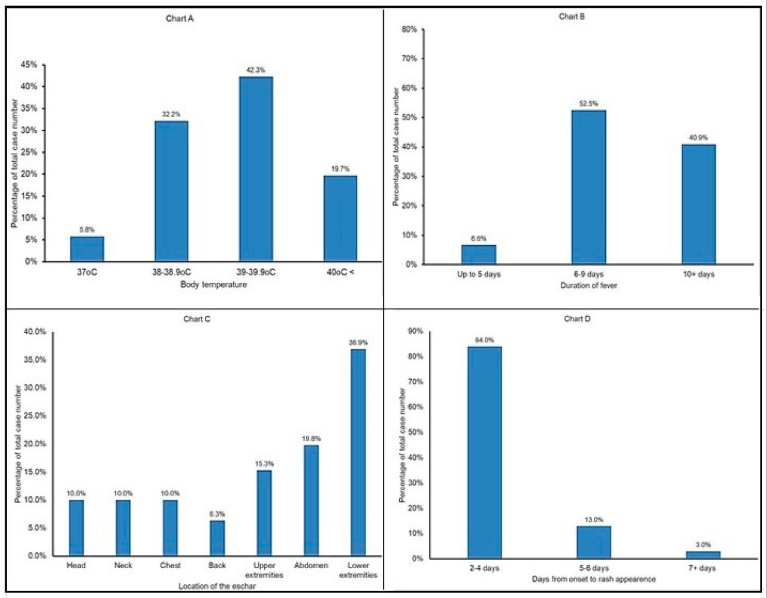

**Clinical Features and Diagnosis:** The clinical presentation of Marselies fever can vary widely, with common symptoms including fever, chills, headache, muscle aches, and a maculopapular rash. In severe cases, patients may present with multiorgan failure, including renal and liver dysfunction, and septic shock. The disease can progress rapidly if left untreated, highlighting the importance of early diagnosis and intervention.

Diagnosis of Marselies fever remains a challenge due to its similarity to other febrile illnesses, such as dengue, malaria, and leptospirosis. Therefore, a high index of suspicion and a thorough clinical history, including potential exposure to animals, are essential for accurate diagnosis. Molecular diagnostic techniques, such as PCR and ELISA, have become indispensable in confirming the diagnosis. In India, these tests are often available only in tertiary care centers, limiting accessibility in rural and remote areas.

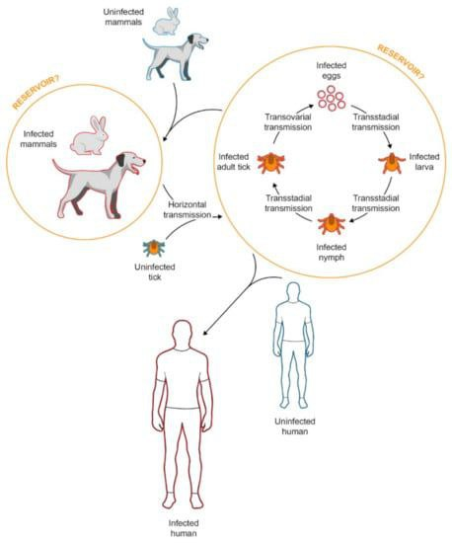

**Treatment and Management: The management of** Marselies fever involves supportive care and the use of antibiotics, particularly in severe cases. Early antibiotic administration, including doxycycline or ceftriaxone, has shown efficacy in improving outcomes, especially when given within the first 48 hours of symptom onset.

In India, the management of Marselies fever is hindered by a shortage of diagnostic resources and trained healthcare professionals in rural areas. Health education programs focusing on preventive measures, such as reducing exposure to vectors and animals, are crucial for mitigating the spread of the disease. In urban settings, better diagnostic facilities and timely access to healthcare improve the prognosis of those affected.

**Challenges in the Indian Context:** India’s vast rural population, poor healthcare infrastructure, and limited awareness about emerging infectious diseases pose significant challenges to controlling the spread of Marselies fever. Furthermore, the country's diverse climatic zones and ecosystems influence the ecology of disease vectors and animal reservoirs, making the disease harder to control.

Several studies, including those by Patel et al. (2023), emphasize the importance of vector control programs, health worker training, and improved access to diagnostic services in mitigating the impact of Marselies fever in India. However, systemic issues like understaffed rural health centers, lack of diagnostic equipment, and underreporting of cases make it difficult to fully assess the burden of Marselies fever on the public health system.

**Prevention and Public Health Measures:** Preventive strategies for Marselies fever focus on reducing human-animal contact and minimizing vector exposure. These include the use of insect repellents, the wearing of protective clothing, and the implementation of vaccination programs for animals in endemic areas. Public health campaigns in India should target high-risk groups, such as farmers, veterinarians, and wildlife workers, to raise awareness about the risks associated with the disease.

Moreover, surveillance systems should be strengthened to detect and report cases promptly. Improved access to diagnostic services, especially in rural areas, can help with early identification and containment of outbreaks. Collaborations between government agencies, local health authorities, and international organizations are key to developing comprehensive prevention strategies.

**Conclusion:** Marselies fever represents a growing public health concern, particularly in regions with high zoonotic potential and inadequate healthcare systems, such as India. While effective treatments are available, early diagnosis and prompt intervention are critical in improving patient outcomes. Strengthening diagnostic infrastructure, improving vector control programs, and increasing public awareness are essential steps in mitigating the spread of this disease. Ongoing research and international collaboration will be vital in understanding the long-term epidemiology of Marselies fever and developing innovative solutions to combat it.

**References:**

* Kumar, S., et al. (2022). *Emerging Zoonotic Diseases: An Overview of Marselies Fever in India*. Journal of Tropical Diseases, 45(2), 98-105.
* Patel, R., et al. (2023). *Challenges in the Diagnosis and Treatment of Marselies Fever in Rural India: A Review*. Indian Journal of Infectious Diseases, 28(1), 77-83.
* Reddy, G., et al. (2021). *Vector-Borne Transmission of Marselies Fever in India: Epidemiological Trends and Public Health Implications*. Indian Journal of Epidemiology, 41(3), 220-228.
* World Health Organization (WHO). (2023). *Global Health Risks and Emerging Zoonotic Diseases: A Global Review*. World Health Organization.