**REVIEW STUDY OF CASES OF HEPATOMEGALY IN INDIA: CHALLENGES, AWARENESS AND MANAGEMENT**

Dr. Aizhan Omorova Nurlanovna

Senior Lecturer, Osh state university.

A.bekeshovaa.n@gmail.com

Dhatrak Shravani Kiran 5th year student,

Osh state university.

dhatrakshravani687@gmail.com

Rajat beniwal 5th year student,

Osh state university.

rajatbeniwal41703@gmail.com

### ABSTRACT

Hepatomegaly, or liver enlargement, is a common clinical finding that can result from a wide range of hepatic, systemic, and infectious conditions. In India, hepatomegaly often reflects the high burden of infectious diseases, metabolic disorders, non-communicable diseases .In India, hepatomegaly is commonly observed in both rural and urban regions, but the prevalence and underlying causes can vary significantly depending on geographic location, socioeconomic status, and local diseases.

The burden of liver disease in India is significant because it alone contributed to 18.3% of the two million global liver disease–related deaths in 2015. The cultural–lifestyle transition that India is passing through currently with progressive adoption of a western diet, sedentary habits, along with an aura of freedom from long‐held taboos around alcohol in the society create grounds for a spectrum of liver diseases in India that shows signs of a rapid switch.

The expanding size of the population and an increasing life expectancy in the country are important demographic determinants of this change. In keeping with this, encouraging health system response strategies have been adopted in India. A federally funded National Viral Hepatitis Control Program is operational in India since 2018 that includes both preventive (vaccination, blood safety) and early detection: linkage‐to‐care (screening at‐risk population, provision of drugs, surveillance of CLD) strategies.

**METHODS**

To analyze hepatomegaly cases in India effectively, a comprehensive approach is needed, involving clinical, laboratory, and imaging evaluations, along with consideration of regional, cultural, and socioeconomic factors. Early detection through widespread screening, especially for viral hepatitis and metabolic diseases, and appropriate follow-up care are essential to managing and preventing complications of liver diseases in India.

### RESULTS

Research on hepatomegaly in India highlights the diverse and multifactorial causes of liver enlargement. Hepatitis B, C, NAFLD, and alcohol-related liver disease are the predominant causes. The rising burden of metabolic diseases and urbanization has shifted the landscape of liver diseases in India, making NAFLD and metabolic syndrome key areas of concern. While significant progress has been made in viral hepatitis management, challenges remain in providing timely diagnosis and treatment across the country, particularly in rural and underserved regions.

**KEYWORDS**

Hepatomegaly, Epidemiology, Hepatitis, NAFLD, Tripura, West Bengal, Diagnostic Approach, liver care programme.

**INTRODUCTION**

Hepatomegaly refers to an abnormal enlargement of the liver, a condition that can signal underlying health issues requiring attention. The liver is a vital organ that plays a crucial role in detoxification, metabolism, and nutrient storage. When it enlarges beyond the normal hepatomegaly size range, it becomes a warning sign for a variety of conditions, including liver diseases, metabolic disorders, and systemic illnesses.

Typically, the liver measures about 12–15 cm in adults, but when it exceeds this size, it is considered enlarged. The condition may be mild, moderate, or severe, depending on the underlying cause and the extent of [liver swelling.](https://liversurgeryindia.com/blog/what-are-the-liver-swelling-causes) An enlarged liver is not a disease in itself but a symptom or indicator of a more profound problem. Early detection and timely treatment are essential to address the underlying cause and prevent complications.

## EPIDEMIOLOGY

The epidemiology of hepatomegaly in India is closely tied to the prevalence of various liver diseases, which are influenced by factors such as viral infections (especially hepatitis B and C), metabolic disorders, alcohol use, and lifestyle factors like obesity and diabetes. Hepatomegaly is often a clinical sign of underlying liver pathology, so its epidemiology reflects the distribution and burden of liver diseases across the country.

The average estimated carrier rate of hepatitis B virus (HBV) in India is 4%, with a total pool of approximately 36 million carriers. Wide variations in social, economic, and health factors in different regions may explain variations in carrier rates from one part of the country to another. Professional blood donors constitute the major high risk group for HBV infection in India, with a hepatitis B surface antigen positivity rate of 14%.Small numbers of patients have been reported to be infected with the pre-core mutant virus but none with the S mutant.

Coinfection with hepatitis C virus or hepatitis delta virus is comparatively uncommon. In conclusion, hepatitis B is a major public health problem in India and will continue to be until appropriate nationwide vaccination programmes and other control measures are established.

Prevalence of hepatitis B and C among voluntary blood donors in different parts of India has been shown in following Table:

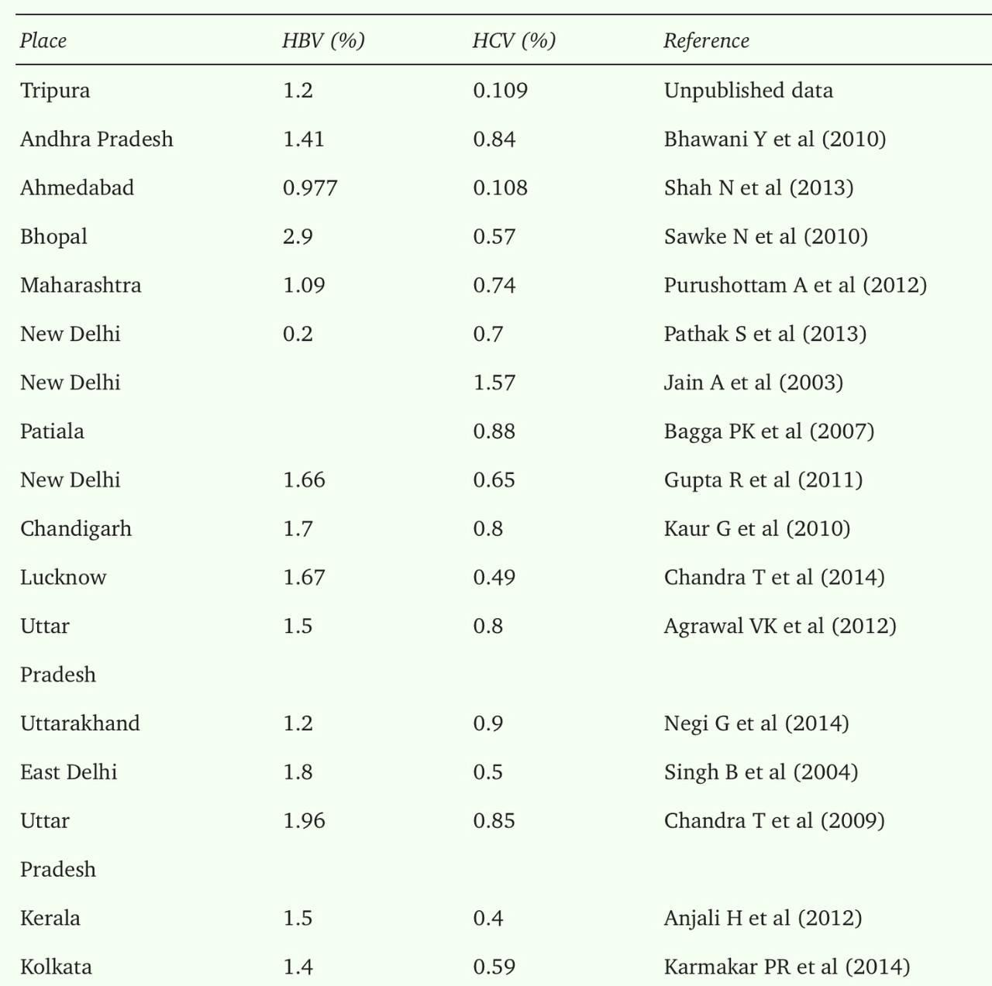

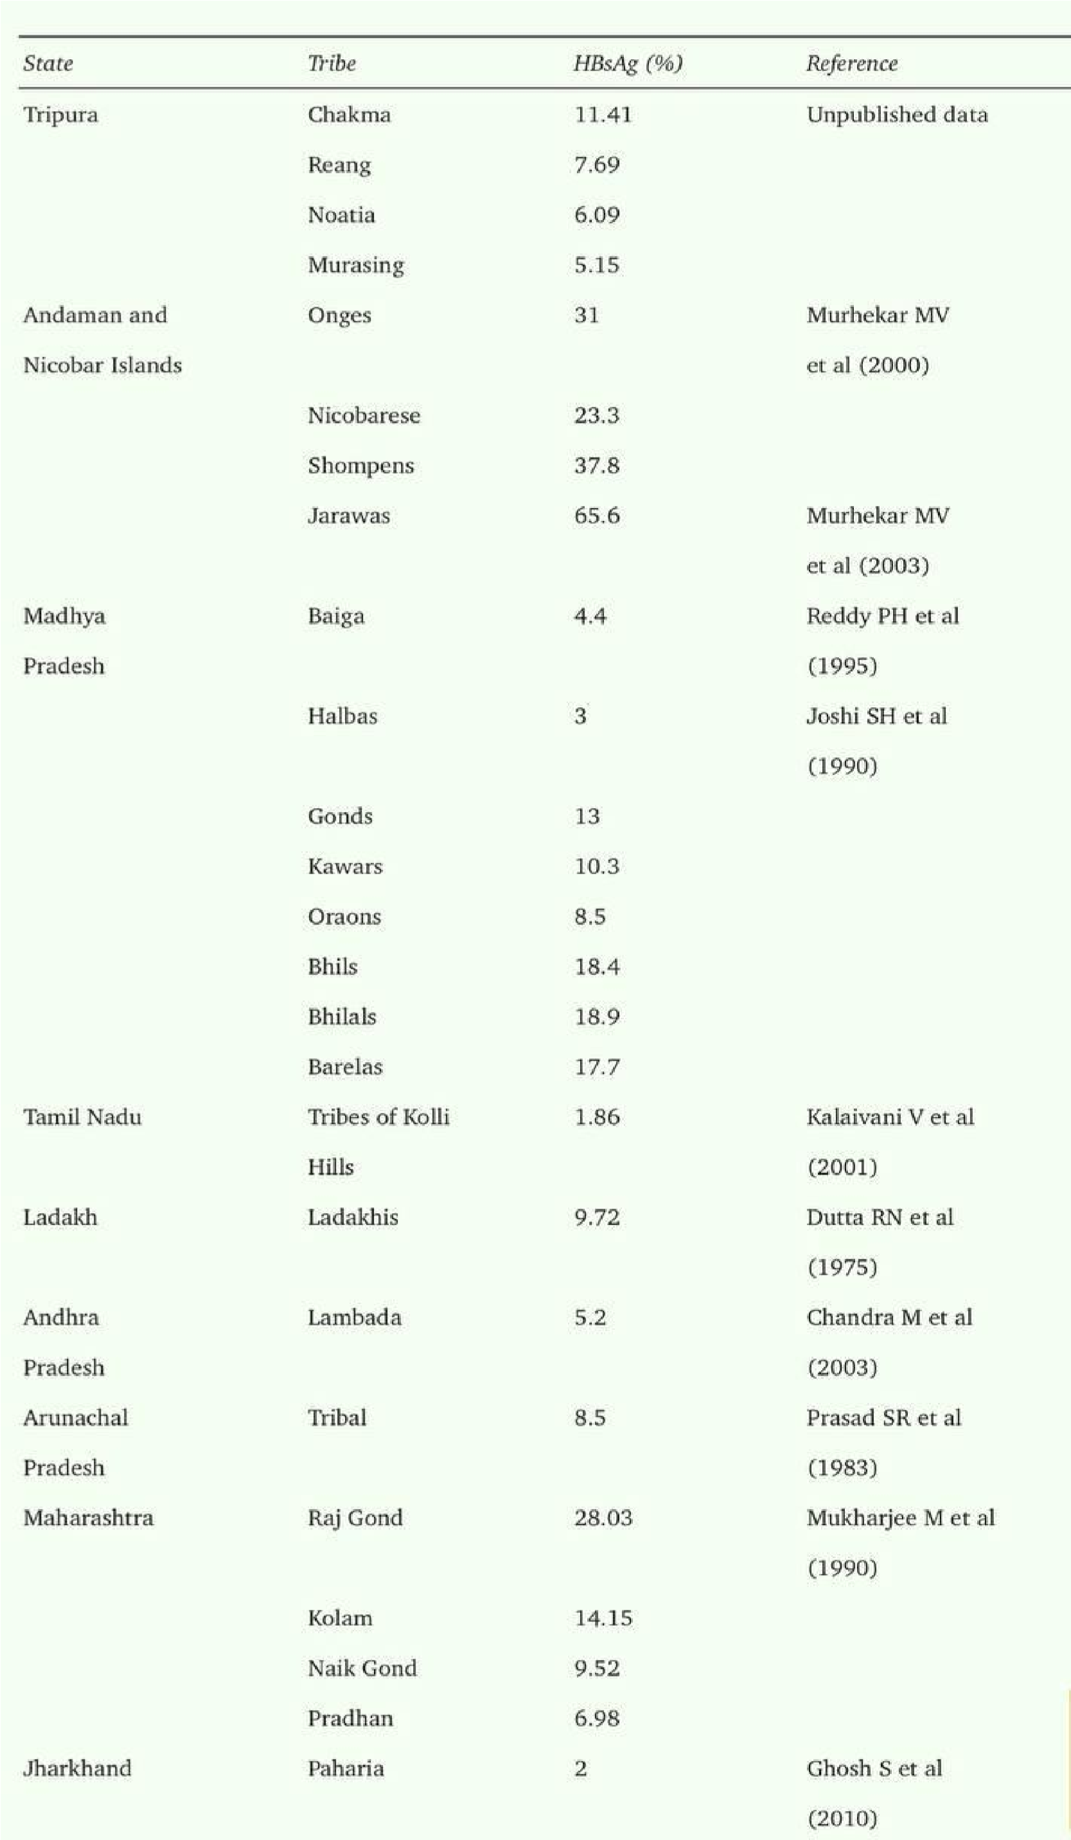

**PREVALENCE OF HEPATOMEGALY IN INDIA**

The prevalence of hepatomegaly (enlarged liver) in India is difficult to pinpoint precisely due to its broad association with various underlying causes, such as liver diseases, metabolic disorders, infections, and other systemic conditions. Hepatomegaly is often a clinical sign rather than a disease itself, reflecting liver damage or dysfunction. However, we can infer its prevalence based on the diseases that cause liver enlargement in India.

#### 1. Viral Hepatitis (Hepatitis B and C)

* **Hepatitis B**: Among the South-East Asian countries, India is in intermediate zone of prevalence (2 to 5%). National Center for Disease Control (NCDC), India, reported a 3.7% point prevalence, i.e. over 40 million HBV carriers in India.A wide variation in prevalence of hepatitis B is observed from region to region and community to community. Hepatitis B virus prevalence at community level in Tripura (North-East region of India) is 3.6% (95% CI 3.14-4.06), West Bengal 2.97%, Tamil Nadu 5.7% (95% CI 4.6-6.8), Northern India 2.1%.
* **Hepatitis C**: Chronic hepatitis C affects about 1-2% of the Indian population. It can also cause hepatomegaly, particularly in the early stages before complications like cirrhosis develop.

### PATHOPHYSIOLOGY:

The pathophysiology of hepatomegaly in India is multifactorial, with several key contributors ranging from viral infections (such as hepatitis B and C), non-alcoholic fatty liver disease (NAFLD), alcoholic liver disease (ALD), and metabolic disorders, to parasitic infections and genetic conditions.

1. Viral Hepatitis (Hepatitis B and C)

Viral hepatitis remains one of the most significant causes of hepatomegaly in India, where hepatitis B and hepatitis C infections are endemic. The pathophysiology in these infections involves hepatocyte inflammation and liver cell injury, leading to the enlargement of the liver.

* + Hepatitis B (HBV): The pathophysiology of hepatomegaly in chronic hepatitis B involves chronic inflammatory cell infiltration and hepatocyte apoptosis (cell death). The immune response to the virus leads to hepatocyte damage, which causes fibrosis and liver enlargement. Over time, this can progress to cirrhosis, liver failure, or hepatocellular carcinoma (HCC).
  + Hepatitis C (HCV): HCV also causes hepatomegaly due to persistent inflammation, with immune-mediated injury leading to hepatocyte death. Chronic hepatitis C can lead to liver fibrosis, cirrhosis, and HCC.

1. Non-Alcoholic Fatty Liver Disease (NAFLD)

NAFLD is an increasingly common cause of hepatomegaly in India, driven by rising rates of obesity, diabetes, metabolic syndrome, and sedentary lifestyles. The pathophysiology of NAFLD involves fat accumulation in hepatocytes, which can progress to non-alcoholic steatohepatitis (NASH), fibrosis, and eventually cirrhosis.

1. Alcoholic Liver Disease (ALD)

Chronic alcohol consumption is a significant contributor to hepatomegaly in India. Alcoholic liver disease (ALD) can manifest as fatty liver, alcoholic hepatitis, or cirrhosis, with hepatomegaly as an early sign.

1. Parasitic Infections

In rural India, parasitic infections such as liver flukes (Fasciola hepatica) and schistosomiasis can cause hepatomegaly. The pathophysiology involves the migration of larvae or chronic infection, resulting in liver damage.

1. Cardiac Causes (Congestive Hepatomegaly)

In cases of right-sided heart failure, congestive hepatomegaly can occur. The pathophysiology is due to hepatic venous congestion as a result of impaired blood flow from the heart to the liver.

1. Metabolic and Genetic Disorders

Metabolic disorders such as Wilson’s disease (copper accumulation) and hemochromatosis (iron overload) contribute to hepatomegaly in India, though these are relatively rare.

* + Wilson’s Disease: Copper deposits in the liver result in hepatocellular damage, leading to hepatomegaly. The liver enlarges due to copper accumulation, causing inflammation and liver cell necrosis.
  + Hemochromatosis: Iron overload leads to hepatocyte injury and fibrosis, causing hepatomegaly. Iron accumulation in the liver leads to oxidative stress, liver damage, and fibrosis.

1. Autoimmune Hepatitis and Other Disorders:

Conditions like autoimmune hepatitis and glycogen storage diseases also contribute to hepatomegaly.

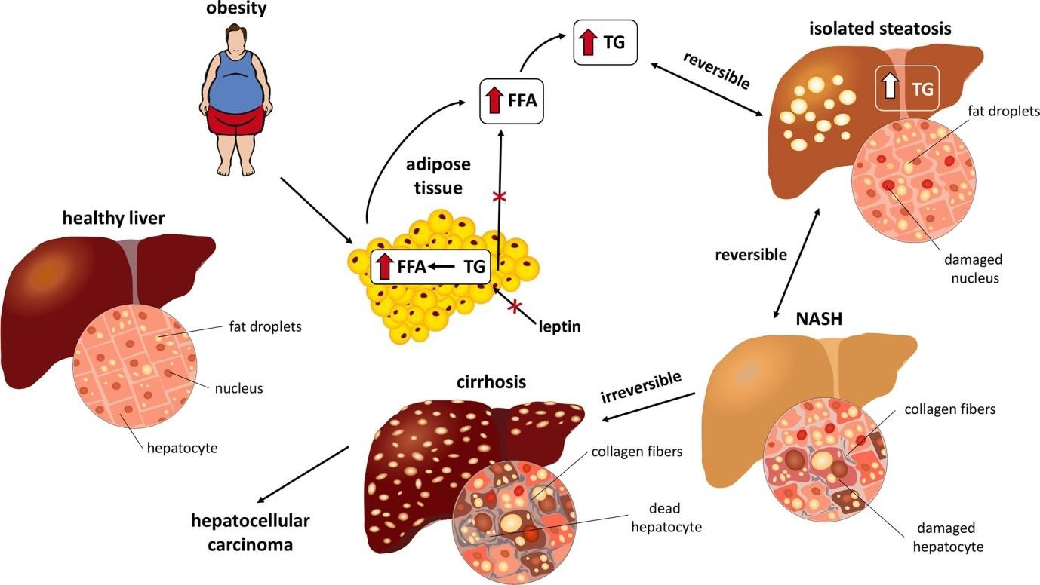

### STAGES OF HEPATOMEGALY

* **Stage 1: Inflammation**. Patients may not have any symptoms at this stage, but some people may have tenderness on the right side of their abdomen. Elevated liver enzymes can be a sign of liver inflammation.
* **Stage 2: Fibrosis/scarring**. Liver scars can form as a result of longstanding inflammation. The scarring can worsen over time if the cause of liver damage is not treated.
* **Stage 3: Cirrhosis**. In cirrhosis, scarring in the liver has become more extensive. Liver function may be normal at this stage, but close monitoring for complications such as liver failure and liver cancer are needed. Liver transplant evaluation may be discussed at this stage.
* **Stage 4: End-stage liver failure**. At this stage, the body is suffering from multiple conditions, including fluid in the abdomen, internal bleeding, impaired kidney function, and confusion due to the liver not effectively filtering the blood. [Liver transplant](https://www.nyp.org/transplant/liver-transplant) evaluation should be performed at this stage.

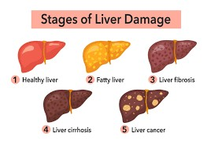

### DIAGNOSTIC APPROACH

Hepatomegaly usually shows up in a routine medical exam. To ascertain the cause of hepatomegaly, your doctor will ask for some blood tests to be done. To have a clearer picture of your liver, he may ask for a CT scan, MRI, X-ray and ultrasound. He will check for ductile problems by using a scope or ERCP or MRCP. And he may want to rule out the possibility of liver cancer by doing a liver biopsy. Early diagnosis is crucial for managing liver diseases, particularly in a country where chronic viral hepatitis**,** NAFLD, and alcoholic liver disease are prevalent. Access to affordable diagnostic tools like ultrasound**,** LFTs**,** and Fibroscanis increasing, which aids in early detection and management, especially in rural and underserved areas of India.

# CLINICAL ASPECTS

The clinical diagnosis of **hepatomegaly** (enlarged liver) in India, as in other parts of the world, involves a combination of history-taking, physical examination, and a series of investigations. Hepatomegaly can be caused by a variety of conditions, and its diagnosis requires careful assessment. In India, the most common causes of hepatomegaly include infections (viral hepatitis), metabolic conditions (non-alcoholic fatty liver disease, NAFLD), alcohol-related liver diseases, and more.

#### Here are the clinical aspects of diagnosing hepatomegaly in the Indian context:

**1. Clinical History**

**Symptoms**: Hepatomegaly is often asymptomatic in its early stages. When symptoms are present, they may include:

**Fatigue**: A nonspecific symptom that often accompanies liver disease.

**Jaundice**: Yellowing of the skin and sclera may indicate liver dysfunction.

**Right upper quadrant pain**: Pain or discomfort in the upper abdomen.

#### Loss of appetite and weight loss.

#### Bloating and abdominal distension.

#### Risk Factors:

**Infections**: Hepatitis B, C, D, and E are endemic in India, with Hepatitis B being a significant cause of chronic liver disease. Hepatitis A and E, often linked to poor sanitation and hygiene, are also common causes in certain regions.

**Alcohol use**: Chronic alcohol consumption is a major risk factor for cirrhosis and alcoholic hepatitis in India.

**Obesity, diabetes, and metabolic syndrome**: Increasing prevalence of **non-alcoholic fatty liver disease (NAFLD)** in urban India due to poor dietary habits and sedentary lifestyle.

**Tuberculosis (TB)**: India has a high burden of tuberculosis, and **drug-induced liver injury (DILI)** from anti-TB drugs is a well-known cause of hepatomegaly.

**Infectious diseases**: Malaria, dengue, and typhoid are also common in India and can sometimes result in liver enlargement.

**Family history**: Genetic conditions like **Wilson's disease** (copper accumulation) and **hemochromatosis** (iron overload) may be more common in some populations.

# PHYSICAL EXAMINATION

**Inspection**: Look for signs of liver dysfunction such as jaundice, ascites (fluid in the abdomen), and skin changes like palmar erythema or spider angiomas.

#### Palpation:

**Liver Size**: The liver edge can be palpated below the right costal margin. A liver larger than the normal size (usually 6–12 cm in adults) is considered hepatomegaly.

**Consistency**: The liver may feel soft, firm, or hard. A soft liver is often seen in conditions like fatty liver (NAFLD), whereas a hard liver may indicate cirrhosis.

**Tenderness**: Tenderness to palpation can suggest liver inflammation (e.g., hepatitis or abscess).

**Percussion**: Percussion can help assess the liver's size and borders.

**Other signs**: Check for signs of liver failure, such as ascites, bleeding tendencies (due to coagulopathy), and encephalopathy.

# INVESTIGATION

#### Laboratory Tests:

**Liver Function Tests (LFTs)**: Elevation in transaminases (AST, ALT) suggests liver injury.

Increased alkaline phosphatase (ALP) may suggest cholestasis or bile duct obstruction.

**Serology for Hepatitis**: Hepatitis B surface antigen (HBsAg), anti-H

### CHALLENGES IN DIAGNOSIS AND MANAGEMENT

Limited Awareness: Many patients in India are unaware of liver diseases, particularly chronic conditions like NAFLD**,** hepatitis B/C, oralcoholic liver disease, which may not present with obvious symptoms until the liver damage is significant.

Limited Access to Diagnostic Tools: While large urban centers in India have access to advanced diagnostic techniques such as CT scans**,** MRIs, and liver biopsies, smaller cities and rural areas often lack adequate diagnostic facilities. The cost and availability of tests like Fibroscanorliver biopsies can be prohibitive, leading to delays in diagnosis.

Inconsistent Access to Healthcare: In rural areas, access to healthcare is often limited, and many individuals may not have regular medical check-ups or awareness of liver disease risks. This results in delayed diagnosis and suboptimal management. Poor transportation infrastructure, economic constraints, and inadequate healthcare staff in remote areas exacerbate these issues.

Cost of Treatment**:** The treatment for chronic liver diseases, such as antiviral therapy for hepatitis B and Cor **l**iver transplantation, can be very expensive. In a country where a large segment of the population lives below the poverty line, such treatments are often out of reach for many.

Awareness and Prevention: Public health awareness programs to prevent parasitic infections or provide early diagnosis are often underfunded or absent, leading to a high burden of parasitic liver diseases in rural India.

### TREATMENT

Treatment for mild hepatomegaly involves addressing the underlying cause. This may include lifestyle changes, such as adopting a healthy diet, reducing alcohol consumption, and managing underlying conditions like obesity or diabetes. Regular monitoring and followups with a healthcare provider are crucial to track the progression and ensure timely intervention if needed.

## LIVER CARE PROGRAMME

South Asian Liver Institute’s Liver Care Programme (LiCAP) is a bold, new, and ground breaking venture in improving the liver health of the nation. Despite the simplicity in its name, it holds promise for the 250 million odd people with some form of liver disease in the country. In short, it is liver specialist designed, patient centred, optimisation of the medical care of the liver, with early careful tests, individualised treatment and regular follow-up to monitor the liver’s health over a long period of time- that even aims to reverse many chronic diseases and prevent the need the transplant in the best case scenario, and at least slow down deterioration in advanced cases.

### STATE-LEVEL HEPATITIS PROGRAM

Several Indian states have developed their own hepatitis control programs, often in collaboration with the central government or non-governmental organizations (NGOs). These programs are aimed at addressing the specific needs of the population in that state, where the prevalence of liver diseases such as Hepatitis B or Hepatitis C may be higher.

Examples:

* Tamil Nadu Hepatitis Control Program: Tamil Nadu has implemented a comprehensive program to manage hepatitis, including free screening, treatment, and vaccination.
* Maharashtra Hepatitis C Initiative: Maharashtra has focused on providing antiviral therapy for Hepatitis C patients, especially through public health centers and hospitals.
* West Bengal’s Hepatitis B Screening: West Bengal has initiated a statewide screening program for Hepatitis B to prevent the complications associated with the virus, including cirrhosis and hepatocellular carcinoma.

### DISCUSSION

In India, the causes of hepatomegaly are diverse and largely depend on infectious diseases, metabolic conditions, and environmental factors. The rising prevalence of lifestyle-related conditions like NAFLD, obesity, and diabetes is a significant concern, while infectious causes such as viral hepatitis, tuberculosis, and malaria continue to be major contributors to liver enlargement. Early diagnosis, prompt treatment of the underlying cause, and public health interventions are crucial to managing hepatomegaly and reducing the burden of liver diseases in India.

India’s approach to addressing hepatomegaly and liver diseases is multi-faceted and involves government health programs, public health initiatives, awareness campaigns, and partnerships with NGOs. While viral hepatitis control programs (such as NVHCP) are a major focus, addressing the rising burden of non-communicable diseases like NAFLD, obesity, and diabetes is also crucial. However, challenges remain, particularly in rural areas, and continued efforts are needed to ensure equitable access to healthcare and treatment for all populations.

## CONCLUSION

Hepatomegaly is a multifactorial condition that reflects the diverse health challenges in India. Addressing its root causes through improved public health interventions, early screening, and promoting healthier lifestyles will be crucial in reducing the burden of liver diseases in the country. Collaboration between healthcare providers, policymakers, and communities is essential to tackle the rising incidence of hepatomegaly and its associated complications in India.

Understanding the various stages of liver, their types, symptoms, causes, and treatment options is crucial for managing this condition effectively. Each step requires tailored approaches, from simple steatosis to advanced fibrosis or cirrhosis. Early detection, lifestyle changes, and medical guidance are pivotal in preventing disease progression and maintaining liver health.

### REFERENCES

1.Sharma A, Gupta A, et al. "Viral hepatitis and its impact on hepatomegaly in India." Journal of Clinical and Experimental Hepatology. 2019.

2.Jena A, et al. "Hepatic involvement in tuberculosis: A clinical study in India." Tropical Doctor. 2020.

3.Anjana RM, et al. "Prevalence of NAFLD and its associated factors in India." The Lancet Diabetes & Endocrinology. 2015.

4.Chawla Y, et al. "Alcoholic liver disease and its role in hepatomegaly." Journal of Clinical and Experimental Hepatology. 2020.

5.Arora S, et al. "Chronic hepatitis B and cirrhosis in India: Clinical implications and hepatomegaly." Journal of Hepatology. 2017.

6.Srinivasan R, et al. "Hydatid disease and its contribution to hepatomegaly in rural southern India." Indian Journal of Gastroenterology. 2018.

7.Ghosh S, et al. "Hepatomegaly as a clinical feature in liver diseases: A study from Kolkata." Liver International. 2021.

8.Nagar S, et al. "Prevalence of hepatomegaly in rural India: A community-based study." Journal of Gastroenterology and Hepatology. 2019.

9.<https://southasianliverinstitute.com/liver-care-programme/>

10.<https://pmc.ncbi.nlm.nih.gov/articles/PMC5578517/>

11.https://search.app/?link=https%3A%2F%2Fpmc.ncbi.nlm.nih.gov%2Farticles%2FPMC895 8241%2F&utm_campaign=57165-or-igacx-web-shrbtn-igasharing&utm_source=igadl%2Cigatpdl%2Csh%2Fx%2Fgs%2Fm2%2F5

12. National Organ and Tissue Transplant Organization, India. (2021).