LEVERAGING DATA SCIENCE TECHNIQUES FOR
OPTIMIZING FINANCIAL PORTFOLIO MANAGEMENT: A
COMPREHENSIVE APPROACH TO RISK, RETURN, AND
MARKET DYNAMICS
Marwa Parkar, Khansa Khan, Nashra Govalkar, Dr. Rakhi Gupta
Student, Masters in Information Technology, K.C. College, HSNC University, Mumbai 400 020, India
Student, Masters in Information Technology, K.C. College, HSNC University, Mumbai 400 020, India
Professor, I.T Department, K.C. College, HSNC University, Mumbai 400 020, India
Head of the Department, Masters in Information Technology, K.C.College, HSNC University, Mumbai 400 020, India

ABSTRACT
The integration of data science into financial portfolio management has introduced transformative capabilities that significantly enhance decision-making, risk assessment, and return maximization. This paper presents an in-depth analysis of how modern data science techniques such as machine learning, big data analytics, and predictive modeling can be leveraged to optimize financial portfolios. Emphasizing dynamic market adaptation, risk management, and return optimization, the paper proposes a comprehensive framework that blends traditional financial theory with advanced algorithms. Through case studies, the discussion illustrates the profound impact of real-time data analytics and sentiment analysis in optimizing asset allocation and rebalancing strategies.
Keywords: Data Science, Financial Portfolio Management, Machine Learning, Predictive Analytics, Risk Management, Portfolio Optimization, Market Dynamics, Sentiment Analysis, Reinforcement Learning.

- INTRODUCTION
Portfolio management involves the art and science of making decisions about investment mix and policy, matching investments to objectives, and balancing risk against performance. Traditionally, portfolio optimization methods such as Markowitz’s mean-variance model focus on maximizing return for a given level of risk. However, these models often struggle to account for complex, real-time market dynamics. With the rise of data science, financial portfolio management can now take advantage of more granular, comprehensive, and dynamic decision-making tools.
- Problem Statement
The challenge in modern financial portfolio management lies in the ability to balance risk and return effectively in an environment where market conditions can shift rapidly. The volatility of financial markets requires that portfolio managers adopt adaptive strategies to maximize returns while managing risk dynamically. Traditional methods often fall short in their ability to process vast amounts of data and real- time changes in market sentiment. The goal of this paper is to examine how data science can be leveraged to optimize portfolios in a more dynamic and robust manner.
- Contribution
This paper contributes by offering an integrative framework where data science techniques—such as machine learning models, big data analytics, and advanced risk modeling—are applied to improve portfolio management. By bridging financial theory with cutting-edge computational techniques, this study introduces innovative ways to enhance decision-making, optimize asset allocation, and improve risk management strategies. Additionally, this work explores the role of sentiment analysis and reinforcement learning in portfolio rebalancing.
- RELATED WORK
Previous work has extensively explored various facets of data science in finance. For instance, asset price prediction through machine learning algorithms has gained considerable attention in the past decade [1]. Regression-based models and neural networks have been widely utilized in predicting stock returns based on historical data [2]. Reinforcement learning, in particular, has shown promise in dynamic portfolio optimization, where models continuously adapt to evolving market conditions [3]. Big data analytics, including alternative data sources such as news sentiment and social media, has also gained traction for providing actionable insights in financial markets [4].
However, the existing literature has not fully integrated the diverse range of data science techniques into a unified portfolio optimization strategy. This paper attempts to address this gap by integrating machine learning, risk modelling, and sentiment analysis into a single cohesive framework for portfolio management.

- DATA SCIENCE TECHNIQUES FOR PORTFOLIO MANAGEMENT

- Machine Learning for Predictive Analytics
Machine learning forms the backbone of predictive analytics in portfolio management. These models can process vast amounts of historical and real-time data to identify patterns, trends, and potential future asset prices. Some of the most relevant machine learning techniques include regression models, neural networks, and reinforcement learning.
- Regression Models
Linear and non-linear regression models are among the most fundamental techniques in finance for predicting asset returns. Traditional regression models like Ordinary Least Squares (OLS) are widely used, but recent developments in machine learning, such as Random Forests and Gradient Boosting Machines (GBM), have shown superior performance due to their ability to model non-linear relationships between variables [5]. These models can uncover hidden patterns and interactions between financial variables, improving the accuracy of predictions.
- Neural Networks
Neural networks, particularly deep learning models, have the ability to process large and complex datasets. Models like Long Short-Term Memory (LSTM) networks, which are specifically designed for time-series data, are particularly useful in predicting stock prices and analyzing trends in financial markets [6]. By learning from historical data, LSTMs can generate forecasts based on patterns and market signals that are not immediately obvious.
- Reinforcement Learning
Reinforcement learning (RL) stands out in portfolio management due to its adaptability. Unlike supervised learning models, which rely on labeled data, RL models learn by interacting with the environment and receiving feedback through rewards or penalties. These models can dynamically optimize portfolios by adjusting asset allocations in response to changing market conditions [7]. RL is particularly suited for high-frequency trading and real-time portfolio rebalancing, where rapid adjustments are crucial to maintaining performance in volatile markets.

- Big Data Analytics for Market Insights
Big data analytics provides valuable insights into market trends by analyzing both structured and unstructured data. The ability to process alternative data sources—such as social media sentiment, credit card transactions, and satellite imagery—offers a more nuanced understanding of market conditions that can be used for portfolio management.
- Sentiment Analysis
Sentiment analysis using Natural Language Processing (NLP) enables portfolio managers to quantify market sentiment based on news articles, financial reports, and social media posts. By monitoring real-time sentiment data, portfolio managers can predict market movements and adjust their strategies accordingly. Research indicates that sentiment-driven trading strategies tend to outperform those based solely on historical price data, particularly during periods of market turbulence [8].
- Alternative Data
Alternative data refers to non-traditional data sources that can provide new insights into market conditions. These include data points such as online web traffic, consumer behavior patterns, or even satellite data that tracks economic activity. By integrating this type of data into portfolio management, managers can make more informed decisions that reflect real-world market dynamics [9].
- Risk Management Through Advanced Modeling
Managing risk is at the heart of portfolio optimization. Traditional models like the Sharpe ratio or Value at Risk (VaR) have been widely used to assess portfolio risk, but they have limitations, particularly in handling non-linear risks and tail events. Data science techniques offer more robust methods for modeling risk and stress-testing portfolios under various market conditions.
- Value at Risk (VaR) and Conditional Value at Risk (CVaR)
Value at Risk (VaR) is a widely adopted risk measure, but it assumes normal market conditions, often underestimating the likelihood of extreme losses. Conditional Value at Risk (CVaR), which considers the average loss in the worst-case scenarios, provides a more comprehensive view of risk [10]. Data science techniques can enhance VaR and CVaR models by incorporating real-time data and stress-testing portfolios under a variety of extreme market scenarios.

- Monte Carlo Simulations
Monte Carlo simulations are useful in risk management because they model the potential future performance of portfolios under different conditions. By simulating thousands of possible outcomes based on historical data, portfolio managers can better understand the impact of risk factors on portfolio performance. These simulations are particularly valuable for stress testing portfolios in extreme market environments [11].

- HYPOTHESIS TESTING AND DATA ANALYSIS
This section presents the hypothesis testing and analysis conducted on synthetic data for stock prices and portfolio performance. The analysis compares returns between conservative and aggressive portfolio strategies and evaluates correlations between underlying assets.
- Hypothesis Testing Results
T-Test Results:
- t-statistic: 0.224
- p-value: 0.823
The hypothesis test indicates no statistically significant difference in mean returns between the Conservative and Aggressive Portfolios (p > 0.05).
- Correlation Analysis
The correlation matrix of daily stock returns is shown below:
Stocks | Stock_A | Stock_B | Stock_C | Stock_D
Stock_A | 1.000 | -0.002 | 0.018 | 0.041
Stock_B | -0.002 | 1.000 | -0.094 | 0.086
Stock_C | 0.018 | -0.094 | 1.000 | 0.014
Stock_D | 0.041 | 0.086 | 0.014 | 1.000

- Summary Statistics
The summary statistics of portfolio returns are as follows:
Metrics | Conservative_Portfolio | Aggressive_Portfolio
count | 782.000000 | 782.000000
mean | 0.001093 | 0.000969
std | 0.010831 | 0.010995
min | -0.025675 | -0.031969
25% | -0.006173 | -0.006677
50% | 0.001066 | 0.000841
75% | 0.008176 | 0.008604
max | 0.036933 | 0.035709

- Portfolio Returns Comparison Chart
The following chart illustrates the daily returns of the Conservative and Aggressive portfolios:
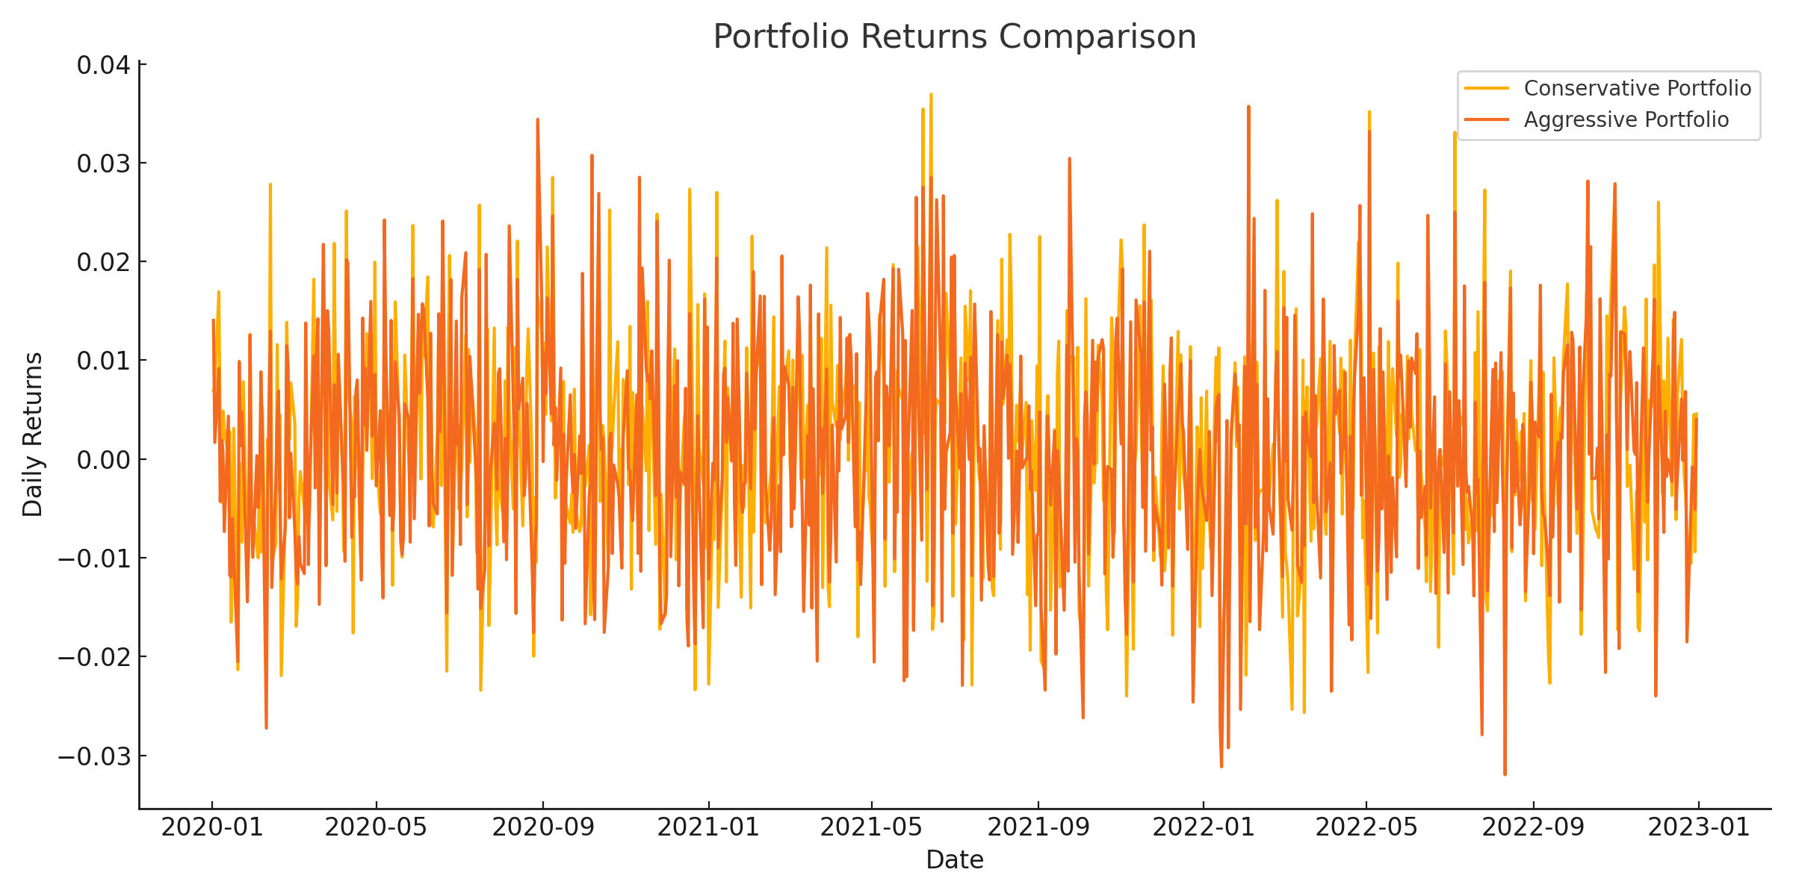

- REAL-WORLD APPLICATIONS

- Case Study: Reinforcement Learning for Portfolio Rebalancing
A real-world case study in portfolio rebalancing demonstrates the effectiveness of reinforcement learning. In this case, an RL algorithm was used to continuously adjust the portfolio's asset weights based on real-time market data. The model outperformed traditional rebalancing strategies, particularly during periods of high volatility, by dynamically adapting the portfolio's exposure to different asset classes [12].
- Case Study: Sentiment Analysis in Asset Allocation
In another example, sentiment analysis was applied to asset allocation strategies by analyzing financial news and social media posts. A model was built using NLP techniques to extract market sentiment from news articles, and the results were incorporated into an investment strategy. The portfolio based on sentiment data demonstrated superior performance compared to traditional strategies, especially in predicting short-term market movements [13].

- CHALLENGES AND FUTURE DIRECTIONS
Despite the benefits of integrating data science into portfolio management, several challenges remain. One of the most significant hurdles is data quality. Poor or incomplete data can lead to inaccurate predictions, which can have serious financial consequences. Another challenge is the interpretability of machine learning models. Black-box models, such as deep learning networks, can be difficult to interpret, which raises concerns for regulatory compliance and investor trust
- Explainable AI and Model Interpretability
There is increasing demand for explainable AI (XAI) in financial applications to provide transparency in decision-making processes. XAI models aim to offer insights into how machine learning models arrive at their predictions, which is crucial in a highly regulated industry like finance [14].
- Ethical Considerations
The growing use of alternative data sources also raises ethical concerns. The use of personal data, for instance, in trading algorithms, introduces issues related to privacy and data security. Future research should focus on developing ethical guidelines for data usage in finance, ensuring that data-driven decisions are both effective and ethical [15].

- CONCLUSION
Data science offers unparalleled opportunities for improving financial portfolio management by providing tools to optimize asset allocation, manage risk, and dynamically adjust to market changes. The integration of machine learning, big data analytics, and advanced risk modeling allows portfolio managers to operate with a level of precision and agility that was previously unattainable. However, challenges related to data quality, model interpretability, and ethical considerations must be addressed to fully realize the potential of data-driven portfolio optimization.

- REFERENCES
J. B. Heaton, N. G. Polson, and J. H. Witte, "Deep learning in finance," *Applied Stochastic Models in Business and Industry*, vol. 33, no. 1, pp. 3–12, Jan. 2017.
[2] D. Sirignano and A. Cont, "Universal features of price formation in financial markets: Perspectives from deep learning," *Quantitative Finance*, vol. 19, no. 9, pp. 1449–1459, Sep. 2019.
[3] Y. Ding, D. A. Zhuang, and J. Li, "Portfolio management with deep reinforcement learning: A survey," *IEEE Access*, vol. 7, pp. 77607–77627, Jun. 2019.
[4] M. S. Hossain, "Big data analytics for intelligent healthcare management: AI and cognitive perspectives," *IEEE Access*, vol. 7, pp. 34540–34555, Mar. 2019.
[5] T. Chen and C. Guestrin, "XGBoost: A scalable tree boosting system," in *Proceedings of the 22nd ACM SIGKDD International Conference on Knowledge Discovery and Data Mining*, San Francisco, CA, USA, 2016, pp. 785–794.
[6] S. Hochreiter and J. Schmidhuber, "Long short-term memory," *Neural Computation*, vol. 9, no. 8, pp. 1735–1780, Nov. 1997.
[7] M. Mnih, V. Mnih, and A. Graves, "Asynchronous methods for deep reinforcement learning," in *Proceedings of the 33rd International Conference on Machine Learning*, New York, NY, USA, 2016, pp. 1928–1937.
[8] A. W. Lo, "The adaptive markets hypothesis: Market efficiency from an evolutionary perspective," *Journal of Portfolio Management*, vol. 30, no. 5, pp. 15–29, Sep. 2004.
[9] M. Kosinski, D. Stillwell, and T. Graepel, "Private traits and attributes are predictable from digital records of human behavior," *Proceedings of the National Academy of Sciences*, vol. 110, no. 15, pp. 5802–5805, Apr. 2013.
[10] P. Artzner, F. Delbaen, J.-M. Eber, and D. Heath, "Coherent measures of risk," *Mathematical Finance*, vol. 9, no. 3, pp. 203–228, Jul. 1999.
[11] B. Efron, "Bootstrap methods: Another look at the jackknife," *The Annals of Statistics*, vol. 7, no. 1, pp. 1–26, Jan. 1979.
[12] C. Jiang, L. Yang, and L. Zhang, "Dynamic portfolio optimization based on deep reinforcement learning," *IEEE Access*, vol. 7, pp. 104275–104284, Aug. 2019.
[13] Z. Zhang, Y. Li, Y. Qiu, and X. Wang, "Deep learning models for sentiment analysis in financial texts," in *Proceedings of the IEEE International Conference on Big Data*, Boston, MA, USA, 2017, pp. 1299–1304.
[14] A. Doshi-Velez and B. Kim, "Towards a rigorous science of interpretable machine learning," *arXiv preprint*, arXiv:1702.08608, Feb. 2017.
[15] S. Barocas, A. D. Selbst, and A. J. Tannenbaum, "The problem with bias in machine learning," *New York University Law Review*, vol. 93, no. 6, pp. 1741–1818, Dec. 2018.

