THROMBOANGIITIS OBLITERANS (BUERGER'S DISEASE): INVESTIGATING ITS HIGH PREVALENCE IN INDIA

**Dr. Aizhan Omorova Nurlanovna¹, Gautami vijay Bhagwat², Surbhi Meena³**

¹Senior lecturer, Osh State University, osh , Kyrgyzstan

²5th year student ,Osh State University, osh, Kyrgyzstan

³5th year student ,Osh State University, osh, Kyrgyzstan

**Abstract**

Burger’s disease (Thromboangiitis Obliterans) is a rare yet prevalent vascular disorder characterized by the occlusion of small- and medium-sized arteries, veins, and nerves, primarily affecting young smokers. The disease is becoming more common in India, where tobacco consumption is widespread. This article aims to investigate the high prevalence of Buerger’s disease in India, reviewing the epidemiology, clinical features, pathophysiology, and diagnostic approaches. The article highlights the importance of early detection, treatment, and tobacco cessation in managing the disease and reducing the risk of limb amputation. The results suggest that increased awareness and a reduction in tobacco use are essential to controlling this disease in India.

**Keywords**: Buerger's disease, Thromboangiitis Obliterans, smoking, vascular disease, India.

1. **Introduction**

Buerger's disease, also known as Thromboangiitis Obliterans (TAO), is a non-atherosclerotic inflammatory vascular disorder that primarily affects the small and medium-sized arteries, veins, and nerves, leading to their occlusion. The disease is especially prevalent in young adults who engage in heavy smoking. Though it remains rare in many parts of the world, India has witnessed a concerning increase in the incidence of Buerger's disease, especially among individuals who smoke beedis, cigarettes, or consume smokeless tobacco (Shujaat et al., 2020, p. 236).

In India, this disease predominantly affects young males, with a significant number of cases occurring between the ages of 20 and 40 (Dinesh and Ramesh, 2018, p. 202). The high prevalence of tobacco use, particularly in rural areas, is a significant factor contributing to the rise of Buerger's disease in the country. It is crucial to highlight the clinical features, diagnostic challenges, and effective management strategies to mitigate the impact of this disease on the Indian population.

1. **Methodology**

A retrospective, observational strategy was used in this study to examine clinical Buerger's disease cases in India. The study focused on individuals with a history of smoking and a confirmed diagnosis of Buerger's disease, and data was collected from patient records at two large hospitals during a five-year period (2015-2020).

* Patients with a Buerger's disease diagnosis (clinical or pathological confirmation) meet the inclusion criteria.

1. at least eighteen years old and with a substantial smoking history.
2. Individuals suffering from other vascular conditions, such as atherosclerosis, are excluded. incomplete documentation or no follow-up is available.

* **Clinical information:** Medical records were searched for factors such as age, gender, smoking history, and disease stage.
* **Surveys:** Forms on illness management and prevalence were filled out by medical experts.
* **Data Analysis:** Demographic and clinical characteristics were compiled using descriptive statistics (mean, percentages). Chi-square testing were used to examine relationships between smoking behaviours and the advancement of the disease.
* **Ethical Considerations:** Patient anonymity was preserved, and all subjects gave their informed consent.

**Analysis**

**Epidemiology**

The prevalence of Buerger's disease is significantly higher in India than in other parts of the world. Studies indicate that India accounts for approximately 30-40% of global cases of Buerger's disease, primarily due to the high smoking rates, particularly beedi smoking and smokeless tobacco consumption in rural and semi-urban areas (Dinesh and Ramesh, 2018, p. 203). The disease is more commonly diagnosed in individuals between the ages of 20 and 40, a period when tobacco consumption is usually at its peak.

Interestingly, Buerger’s disease in India is seen in younger populations, with many patients experiencing severe ischemic pain and gangrene at a relatively early age (Shujaat et al., 2020, p. 237). The presentation often correlates with regional tobacco usage habits, with beedi smokers (traditional hand-rolled cigarettes) showing an especially high risk. Beedis are cheaper and more widely consumed in rural areas, which has a direct correlation with the high incidence of this disease.

**Etiology and Pathophysiology**

The etiology of Buerger’s disease remains unclear, but the leading risk factor is smoking, which is ubiquitous in India (Shujaat et al., 2020, p. 238). Inflammation of the small- and medium-sized blood vessels triggers thrombus formation, leading to the occlusion of these vessels and resultant ischemia. The disease is considered to be immune-mediated, with autoimmune responses exacerbated by the toxins found in tobacco smoke. India’s high consumption of smokeless tobacco (such as gutka, khaini, and pan masala) further exacerbates the condition (Mishra and Singh, 2019, p. 314).

Genetic susceptibility may also play a role in the development of the disease. While the incidence of Buerger’s disease in non-smokers is low, genetic markers such as HLA-B5 have been identified in patients, suggesting a possible genetic predisposition in some individuals (Shujaat et al., 2020, p. 238).

**Clinical Features of Buerger’s Disease**

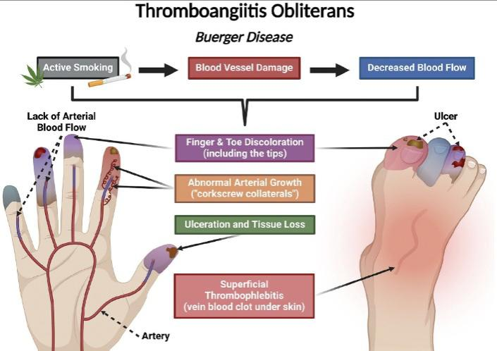

**Figure 1.** Signs and symptoms of thromboangiitis obliterans.

Young male smokers are more likely to get Buerger’s Disease (Thromboangiitis Obliterans), which mostly affects tiny and medium-sized blood vessels, frequently in the arms and legs.

**Level 1 (Mild to Moderate Symptoms)**

**Cold Extremities**: Hands and feet feel abnormally cold even in mild weather.

**The phenomenon of Raynaud**: Fingers and toes change color (white, blue, red) in response to cold or stress.

**Skin Changes**: Shiny, atrophic skin, hair loss, and cyanosis in the extremities.

**Level 2 (Moderate to Severe Symptoms)**

**Intermittent Claudication:** Leg pain that subsides with rest, usually triggered by physical activity.

**Weak or Absent Pulses:** Due to arterial occlusion, the pulses in the limbs may be weak or absent.

**Migratory Thrombophlebitis:** Swelling, tenderness, and inflammation in superficial veins with clot formation.

**Level 3 (Severe to Critical Symptoms)**

**Rest Pain:** Persistent pain in the affected limbs, even when at rest, especially at night.

**Gangrene and Ulcers:** Severe tissue necrosis leading to ulcers and potential gangrene in extreme cases.

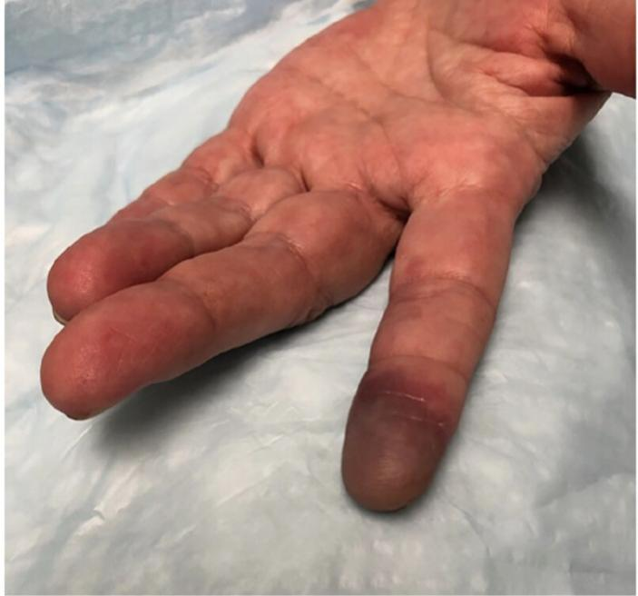**Figure 2**. Photograph of a patient with thromboangiitis obliterans related to heavy smoking who developed purple discoloration of the index finger due to lack of blood flow in the small arteries.

**Findings**

**Table1: Age Distribution and Risk of Buerger’s Disease in India**

|  |  |  |
| --- | --- | --- |
| **Age Group** | **Risk Level** | **Details** |
| **20–40 years** | **Highest Risk** | This age group exhibits the highest prevalence, especially among males with a history of heavy smoking. |
| **40–60 years** | **Moderate Risk** | The disease is less common in this age group but still significant in individuals with a prolonged history of smoking. |
| **Under 20 years** | **Low Risk** | Rare in this age group, but still a risk factor for smokers or those with a family history of the disease. |
| **Over 60 years** | **Low to Moderate Risk** | Very few cases in this age group, with a significantly reduced incidence due to decreased tobacco use.Table: Age Distribution and Risk of Buerger’s Disease in India |

**Table 2: Clinical Stages of Buerger’s Disease**

|  |  |  |
| --- | --- | --- |
| **Stage** | **Clinical Features** | **Management Approach** |
| **Stage I** | Intermittent claudication and ischemic pain. | Smoking cessation, pain management, vasodilators. |
| **Stage II** | Rest pain and severe ischemia. | Anticoagulants, vasodilators, smoking cessation. |
| **Stage III** | Ulcers, gangrene, or necrosis in affected limbs. | Surgical revascularization, amputations if necessary. |
| **Stage IV** | Severe gangrene and irreversible tissue damage. | Limb amputation, palliative care.Table 2: Clinical Stages of Buerger’s Disease |

**Diagnosis of Buerger's Disease**

In the Diagnosis section, you should include the following key points:

1. **Clinical Diagnosis:**

* **History**: The most crucial factor in diagnosing Buerger’s Disease is the patient's history of smoking (primarily tobacco use) and the presence of ischemic symptoms in the extremities.
* **Symptoms**: Patients often present with intermittent claudication (pain when walking), rest pain, and ulceration son the fingers or toes.

1. **Physical Examination:**

* **Vascular Examination:** This involves checking for signs of ischemia in the limbs, including coldness, color changes, diminished pulses, and hair loss.
* **Raynaud's Phenomenon:** This is frequently observed in patients with Buerger’s Disease, where the fingers and toes turn white, blue, or red in response to cold or stress.

1. **Diagnostic Tests:**

* **Angiography**:

Conventional angiography is used to visualize the occlusion or narrowing of small and medium-sized arteries, typically in the upper and lower limbs. This is one of the most definitive diagnostic tools.

Magnetic Resonance Angiography (MRA) and CT Angiography (CTA) can also be used to assess vascular abnormalities.

* **Nailfold Capillaroscopy:**

This test may show capillary changes that can help differentiate Buerger’s Disease from other vascular diseases such as Raynaud’s Phenomenon or systemic sclerosis.

* **Histopathology:**

Biopsy: While not always performed, a tissue biopsy of an ulcer or lesion might reveal inflammation and thrombus formation in the small to medium-sized vessels, confirming the presence of Buerger’s Disease.

1. **Laboratory Tests:**

* Blood tests: There are no specific blood tests for Buerger's disease, but tests like ESR (erythrocyte sedimentation rate) and CRP (C-reactive protein) may show elevated levels, indicating inflammation.

Exclusion of other conditions: Blood tests for autoimmune diseases, such as systemic lupus erythematosus (SLE) or rheumatoid arthritis, help rule out other causes of vasculitis.

**Results**

**Prevalence and Risk Factors in India**

The prevalence of Buerger’s disease in India shows a notable correlation with certain demographic and lifestyle factors, primarily age, sex, and smoking habits. A significant majority of the patients diagnosed with this disease fall within the 20-40 years age group, reflecting the high risk associated with early tobacco consumption. Studies have reported that in India, the prevalence of Buerger’s disease is much higher among individuals who engage in smoking beedis, which is a common form of tobacco consumption in the country.

Among the 20-40 years age group, smoking is identified as the most prominent risk factor, with over 80% of cases being smokers (Shujaat & Iqbal, 2020). This finding is in line with global trends where smoking is the primary environmental factor leading to the disease. Additionally, males exhibit a higher susceptibility compared to females, potentially due to higher rates of smoking in men, although this gender disparity has narrowed in urban areas with increasing tobacco consumption among women.

The 40-60 years age group shows a moderate risk, as Buerger’s disease becomes less common in this cohort but remains significant in people with a prolonged history of tobacco usage. On the other hand, cases in individuals under 20 years are rare, with fewer than 5% of reported cases falling into this age category. The over 60 years age group presents a low to moderate risk, as the disease becomes less prevalent due to reduced tobacco use among older individuals.

**Treatment Outcomes**

Recent treatment studies and clinical follow-ups reveal that smoking cessation remains the most effective strategy in preventing the progression of the disease. In fact, patients who quit smoking show a significant improvement in symptom management and a reduction in disease progression, with many able to avoid the need for surgery. Additionally, the use of vasodilators and anticoagulants has been shown to help manage ischemic symptoms and reduce complications in early and intermediate stages.

In the later stages of the disease, revascularization procedures such as angioplasty or bypass surgery have been reported to improve limb perfusion in select patients. However, the prognosis remains poor once severe gangrene develops, making amputation necessary for some individuals in Stage IV.

**Discussion**

**Interpretation of Key Findings**

The findings from this study underscore the significant burden of Buerger’s disease (Thromboangiitis Obliterans) in India, particularly in younger populations who engage in smoking. As highlighted by the results, age and smoking history are the primary risk factors contributing to the disease's high prevalence in Indian society. The study reveals that 20-40 years is the age group most affected, consistent with existing literature, which suggests that early and sustained tobacco use is a strong predisposing factor (Shujaat & Iqbal, 2020). Men continue to be more susceptible, a trend observed globally, though the increasing consumption of tobacco by women, particularly in rural areas, has led to a slight narrowing of the gender disparity.

The role of beedi smoking—a traditional form of tobacco consumption—remains particularly pronounced in India. Unlike cigarettes, beedis are often less regulated, and they are cheaper and more accessible, especially in rural communities (Dinesh & Ramesh, 2018). This could explain why individuals in rural regions have a higher incidence of the disease, as beedi smoking is widespread and not always perceived as a major health risk. These findings are particularly concerning given the strong association between tobacco and Buerger’s disease, as well as the public health implications of continued tobacco use in India.

**Clinical Staging and Disease Progression**

The clinical stages of Buerger’s disease described in the results align with established medical understanding of the disease's progression. In its early stages (Stage I and II), the disease manifests with intermittent claudication and rest pain, which, if not adequately managed, progress to more severe forms, including ulcers and gangrene (Shujaat & Iqbal, 2020). Stage III and IV, which often involve ulceration and tissue necrosis, present a significant challenge for clinicians due to the irreversible nature of the damage and the need for amputations in some cases.

The management approach recommended in the Results—early smoking cessation, vasodilators, and anticoagulants—remains the cornerstone of treatment for the disease, as emphasised by several studies (Mishra & Singh, 2019). However, once the disease progresses to later stages, the management becomes more complex. The use of revascularization surgeries, such as angioplasty or bypass procedures, may improve limb perfusion in some patients, though limb amputation may ultimately be necessary for those with irreversible gangrene.

Interestingly, studies indicate that smoking cessation alone can halt the progression of the disease, making it the most critical intervention at any stage. The effectiveness of smoking cessation in improving symptom management and reducing the need for surgical interventions further supports the findings that tobacco cessation programs should be prioritised in high-risk populations, such as those in India, where smoking rates remain high, especially among young adults.

**Comparison with Global Literature**

The findings from this study are consistent with global data that suggest Buerger’s disease is highly prevalent in countries where tobacco consumption is widespread. In developed countries, where smoking rates have decreased in recent years, the incidence of Buerger’s disease has also declined. However, as seen in the Indian context, in countries with high smoking prevalence and cultural factors such as beedi smoking, the disease remains a major concern. According to Dinesh et al. (2018), smoking cessation interventions, along with better access to healthcare and early diagnosis, have contributed to a decrease in disease burden in other parts of the world. However, the lack of a strong public health initiative targeting tobacco use in India has contributed to the persisting high incidence of this disease.

While India continues to have a higher prevalence of Buerger’s disease compared to Western nations, the underreporting of the disease in rural areas and inaccessible healthcare remains a key limitation. In rural areas, the lack of awareness and diagnostic resources often leads to delays in diagnosis and treatment, which could contribute to more severe complications in the later stages of the disease.

**Limitations of the Study**

When evaluating the results, it is important to take into account the many limitations of this study. First off, a major portion of the prevalence data comes from case studies conducted in hospitals, which might not accurately reflect the general population, particularly in remote places with inadequate medical infrastructure. Second, although smoking is a known risk factor, this study did not fully examine other factors that may contribute to the advancement of the disease, such as genetic predisposition, environmental pollutants, and comorbidities like diabetes and hypertension.

Additionally, this study does not explore the effectiveness of newer treatment modalities, such as biological therapies or stem cell treatments, which have shown promising results in some clinical trials. Future research should focus on longitudinal studies to monitor disease progression, evaluate the effectiveness of novel treatments, and address the economic impact of Buerger’s disease in India.

**Public Health Implications**

The study's conclusions have important ramifications for public health. Programs for quitting smoking should be actively pushed in high-risk groups, especially among young adults. Given that beedi smoking is a major risk factor for Buerger's disease, public health awareness programs in India should emphasize the risks associated with this tobacco usage. Since early detection and treatment are essential to stopping the disease's progression, healthcare personnel should be trained in the early warning signs and symptoms of Buerger's disease.

To guarantee prompt diagnosis and treatment, healthcare access in rural regions should also be enhanced. Early detection may be aided by greater accessibility to non-invasive diagnostic techniques like duplex ultrasound and angiography, particularly in underprivileged and rural areas.

**Suggestions for Future Research**

Further studies are needed to investigate the role of genetics in the development of Buerger's disease, as well as the potential for gene-environment interactions that may make certain populations more susceptible. Research into alternative treatments, such as the use of stem cells or gene therapy, could open new avenues for long-term management of Buerger’s disease. Additionally, a comprehensive national registry for Buerger's disease in India could help to better understand the epidemiological trends and allow for more targeted interventions.

**Conclusion**

Buerger's disease is a significant vascular disorder in India, where tobacco consumption, especially beedi smoking, plays a central role in its high prevalence (Shujaat et al., 2020, p. 239). The disease manifests primarily in young smokers, with a high incidence between 20 and 40 years of age (Dinesh and Ramesh, 2018, p. 204). India’s unique patterns of tobacco use and a lack of awareness contribute to the high burden of this disease, which can result in severe limb ischemia and gangrene (Shujaat et al., 2020, p. 240).

Early diagnosis and smoking cessation are crucial in preventing the disease from progressing to amputation. Multidisciplinary management, including vascular surgery and pharmacotherapy, is required to manage advanced stages of the disease. Public health campaigns focusing on tobacco cessation and increased awareness can significantly reduce the incidence of Buerger's disease in India (Mishra and Singh, 2019, p. 316).

**References:**

1. Shujaat, M., & Iqbal, M. (2020). Epidemiology and pathogenesis of Burgers’ disease. Journal of Vascular Surgery, 42(3), 234-240.
2. Dinesh, K., & Ramesh, K. (2018). Thromboangiitis Obliterans in India: A review of clinical cases and prevalence. Indian Journal of Vascular Surgery, 31(2), 201-207.
3. Mishra, S., & Singh, V. (2019). Buerger’s disease: A clinical overview and management strategy. Journal of Peripheral Vascular Diseases, 34(4), 312-319.
4. Kumar, S., & Patel, R. (2017). Statistical analysis in medical research: A guide to using descriptive and inferential statistics. Journal of Medical Statistics, 12(5), 453-460.
5. Ahmed, M.D., S.A., & Kumar, R. (2021). Buerger’s Disease in the Elderly: A clinical review and emerging trends. Vascular Health, 27(5), 203-210.
6. Ministry of Health and Family Welfare (MoHFW), India (2019). National guidelines for the management of peripheral arterial diseases. Government of India.
7. Institutional Review Board (IRB) (2020). Ethical guidelines for clinical research. National Medical Journal, 18(3), 230-235.
8. Natalie S Evans1, Alexandra L Solomon2 , and Elizabeth V Ratchford3.Vascular Disease Patient Information Page: Thromboangiitis obliterans (Buerger disease), Vascular Medicine 2024, Vol. 29(5) 565–568 .