# “A BRIF REVIEW ON TECOMELLA UNDULATA AND ITS PHARMACOLOGICAL POTENTIAL”

# ABSTRACT

Tecomella undulata , an indigenous tree species found in the arid regions of North- west India, Pakistan, and Arabia, particularly in Rajasthan, is recognized for its significant medicinal and ecological value. The plant is widely used in traditional medicine, with various parts such as the bark, leaves, flowers, and roots utilized to treat ailments like liver diseases, wounds, and digestive disorders. It contains bioactive compounds like iridoid glucosides, flavonoids, and triterpenoids, which enhance its therapeutic properties. In addition to its medicinal uses, Tecomella undulata plays an essential role in Ayurvedic formulations, offering potential benefits for treating liver and spleen disorders.

Pharmacologically, Tecomella undulata demonstrates a broad range of beneficial activities, including anticancer effects, hepatoprotective properties, anti- inflammatory and analgesic effects, antimicrobial activities, and potential HIV inhibition. The plant’s bark, rich in quercetin, has shown significant tumor- suppressing properties. Its extracts have proven effective in alleviating liver damage in rodent models, and methanolic extracts have demonstrated anti-inflammatory and analgesic effect. The plant also exhibits strong antimicrobial activity, particularly against Gram-positive bacteria and fungi, and its ethanolic extract has shown promise in managing diabetes. These diverse pharmacological effects highlightTecomella undulata’s potential as a source for developing novel therapeutic agents for a variety of diseases, further solidifying its value in both natural medicine and ecological systems.

# Keyword

Tecomella undulata, Medicinal plant, analgesic effect, anti-microbial acti

# 1 INTRODUCTION

Tecomella undulata, a member of the bignoniaceae family, is a shrub or small tree commonly found in regions of india such as punjab, rajasthan, gujarat, and sind. Known by various names like rugtrora, rohira, and rakhtroda, this plant is recognized for its medicinal properties. It has been traditionally used in ayurvedic medicine for treating conditions like leucorrhoea, leucoderma, spleen enlargement, and liver diseases. The plant's bark has been used for syphilis, painful swellings, and cancer treatment. It is also noted for its antibacterial, anti-inflammatory, and hepatoprotective activities. 1

Tecomella undulata, commonly known as rohida, is a medicinal plant from the bignoniaceae family, found primarily in arid regions of india. It typically grows as a shrub but can reach up to 12 meters in height when cultivated. The plant is valued for its environmental benefits, such as stabilizing sand dunes and aiding afforestation due to its drought and fire-resistant properties. In traditional ayurvedic medicine, various parts of the plant, including the heartwood, stem bark, leaves, and seeds, are used to treat conditions like liver and spleen diseases, jaundice, anemia, and leucorrhoea. It contains several bioactive compounds, including lapachol and sitosterol, which contribute to its medicinal properti

# TAXONOMICAL CLASSIFICATION

Kingdom: Plantae

Division: Angiosperms/Magnoliophyta Subdivision: Eudicots

Class: Asterids Order: Lamiales Family: *Bignoniaceae* Genu: Tecomella Species: Undulate 3

# VERNACULAR NAMES

Hindi: Raktarohida, Roheda, Ragatrohada Sanskrit: Rohitak, Rohi, Plihghna Panjabi: Ruheda

Gujrati: Rohido, Ragatarohida, Swetrohido Tamil: Karelchuvarama, vangul Malayalam: Chem

Udiya: Pleehasama Telagu: Themmaram

Kannad: Padiri, Muttalgid, Mardumala, Muttala

Bangali: Rodha,Vihagani, Pittaraj,Tiktaraj, Nayana, Kadar

Marathi: Raktarohida, Rohida 4

# GEOGRAPHICAL SOURCE

Tecomella undulata is tracked down in the drier areas of North-west India up to a height of 1200 meters, Arabia and Pakistan (Southern parts, Sindh and Baluchistan 5 Tecomella undulata is an important indigenous tree species found in the hot desert areas of Rajasthan State in India. Data from 22 sample plots were used to model the dominant height growth of Tecomella undulata It is chiefly disseminated in western locale of Rajasthan all through the areas of Ajmer, Pali, Jodhpur, Barmer, Jaisalmer, Nagpur, Bikaner, Churu and Sikar

# MORPHOLOGY:-

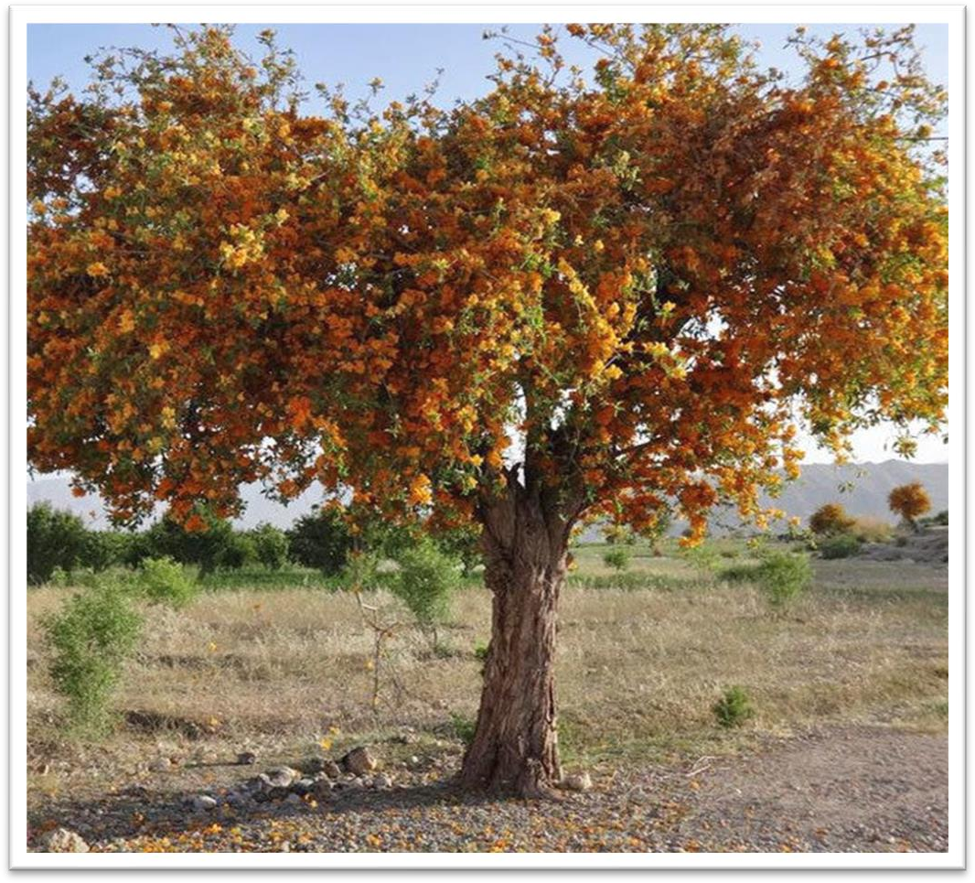

**Fig no.1-** Tecomella undulata

* 1. **LEAVES:-**

Leaves of Tecomella undulata are basic, barely oval, inhumane and having undulating edges all through. These leaves are around 5 to 12.5cm long and 1 to 3.2cm wide.

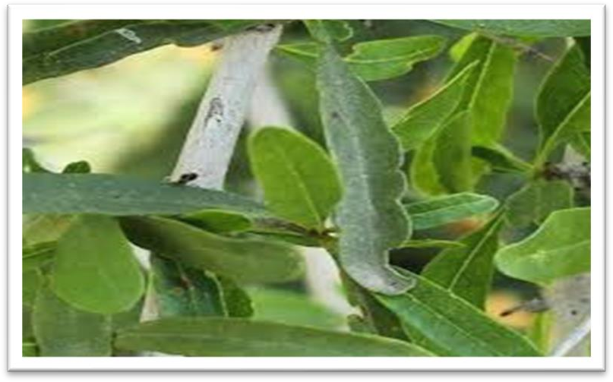

Fig. Leave Tecomella undulata

* 1. **FLOWER:-**

Tecomella undulata is having extremely gorgeous conspicuous blossoms in yellow, orange and red tones. Blossoms are scentless and long (around 6.5 to 7.5 cm). Blossoms are organized in corymbose few bloomed racemes, ending short sidelong branches, length of pedicles is around 6 to 13 mm. Calyx is campanulate having length of 9.5 to 11mm, curves are 3mm long, extensively applaud, inhumane, mucronate. Corolla is orangish yellow in variety having length of 3.8 to 6.3cm, campanulate, veined, curves are 5 subequal and adjusted. Stamens are applied and fibers are glabrous. Disgrace are 2 lamellate, curves are spathulate-elongated and adjusted

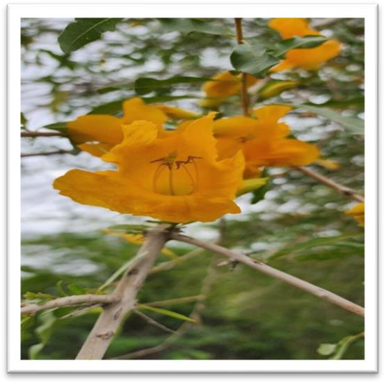

Fig. yellow flower Tecomella undulata

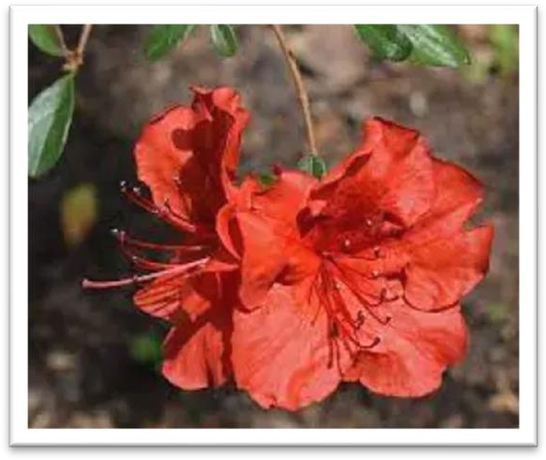

Fig. red flower Tecomella undulata

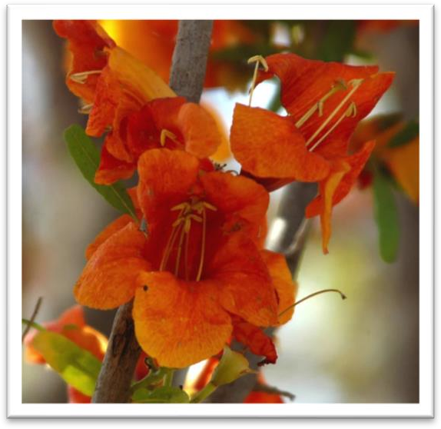

Fig. orange flower Tecomella undulata

* 1. **FRUIT:-**

The tree sprouts in the long stretch of April or May and bears natural products, from there on. Organic product is case, somewhat bended, linearoblong, intense and smooth. Valves are flimsy and seeds are winged, 2 cm long and 1 cm wide 7

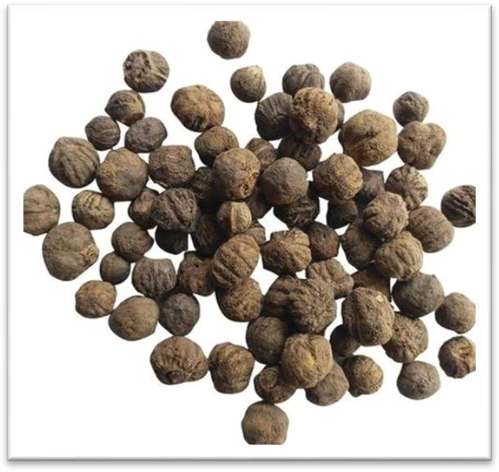

Fig. fruit

* 1. **BARK:-**

Tecomella undulata bark is utilized for therapeutic reason, remotely as well as inside. Remotely, the glue of its bark skin is applied on awful injuries, related with haematoma. It additionally advances wound recuperating. In conjunctivitis, the juice is imparted into eyes, with extraordinary advantage. Inside, the powder of bark skin is given alongside ghee in gaematoma. It is extraordinarily suggested in ascites with hepatosplenomegaly. It is a brilliant blood purifier and cholegogue, consequently, remunerating in hepatitis. It is likewise utilized in restoring urinary confusion, expansion of spleen, gonorrhea, leucoderma, liver sicknesses and solution for syphilis. Youthful plant of Tecomella undulata bears delicate and greenish-earthy colored bark however it turns out to be hard and becomes a brilliant shade of brown in variety as the plant becomes and ages significantly. Thickness of bark is around 8 mm in a completely developed plant.

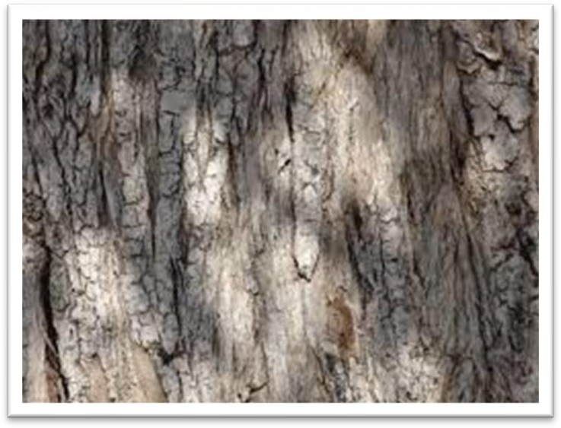

Fig.bark

* 1. **ROOT:-**

The paste of Tecomella undulata root is given internally in leucorrhoea some time its pulp is given along with rice water. 8

* 1. **SEEDS**:-

Tecomella undulata seeds squashed with pinus leaf remove are taken to fix hemorrhoids. It is likewise utilized against boil.

# AYURVEDIC FORMULATIONS

**ROHITAKAARISHTA**

Different definition of Tecomella undulata is accessible in market. Rohitakaarishta is the main traditional compound available without a prescription and is being endorsed in liver and spleen illnesses, oedema and frailty. 9

# PHYTOCHEMISTRY

phytochemical studies were performed to explore the structure of various plant removes, prompting the seclusion and recognizable proof of pharmacologically significant mixtures, for example, unsaturated fat ,iridoid glucoside, naphthoquinone, 10 phytosterols, greasy liquor, flavonoid glycoside, flavonol , and triterpenoids.

Phytochemical constituents isolated from different parts of the plant are as below:

# HEARTWOOD:-

* Radermachol
* 2-Isopropenylnaphtho [2,3-b] furan-4,9-quinone
* Tecomaquinone-I
* α-Lapachone
* β-Lapachone
* Dehydro-alpha-Lapachone
* Cluytylferulate
* Undulatin
* Tectoquinone
* Deoxylapachol
* Octacosanylferulate

1. **BARK**:-

* β-sitosterols
* Ester glucoside
* Tecomin
* Alkanols
* Alkenes
* Undulatoside A And B
* Chromone glycosides
* Iridoid glucosides
* Tecoside
* Lapachol
* Veratric acid

1. **ROOT**:-

* Lapacol
* Tricontanol-1
* β-sitosterol
* Tectol
* Veratric acid
* 6-O-veratryl catalposide
* Quinines

1. **LEAVES**:-

* Deterpene
* Aphanamixol
* Triacontanol
* Betulinic acid
* Oleanolic acid
* Ursolic acid

1. **FLOWERS**:-

* Rutin
* Quercetin
* Luteolin-7-glucoside

1. **SEED**:-

* Alimonoid
* Rohitukin
* Linoleic acid
* Oleic acid
* Stearic acid
* Palmitic acid 12-16

# PHARMACOLOGY ACTIVITY

Various pharmacological acitivites are mentioned below:

# ANTICANCER ACTIVITY:-

The bark of the plant Tecomella undulata has antitumor movement. Quercetin, present in rose of plant is likewise known to have hostile to malignant growth action 17 As of late assessed enemy of malignant growth capability of a polyherbal definition arranged from concentrates of stem bark of Tecomella undulata 18 Results obviously showed critical restraint of development by TU in K562, COLO-205, MDA-MB231, HepG2 cells in a portion scope of 10-100 mg/ml. Further, the impact was viewed as portion subordinate. 19

# HEPATOPROTECTIVE ACTIVITY:-

assessed hepatoprotective possibilities of chloroform, CH3)2CO and methanol solvent parts and, methanol insoluble part of ethanolic concentrate of TU bark involving paracetamol prompted hepatotoxicity in rodents. That's what results portrayed, methanol solvent division showed critical hepatoprotective movement against paracetamol incited hepatic harm as proven by standardization of significantly raised degrees of AST, ALT, High mountain and complete bilirubin, diminished degree of absolute protein , expanded wet liver weight and volume, expanded thiopentone sodium initiated resting time and close to typical histopathology.First report on hepatoprotective capability of TU leaves utilizing a methanolic remove was by Singh and Gupta, 201120 Tecomella undulata was successful against thioacetamide instigated hepatotoxicity. Histology of the liver areas of the creatures treated with the concentrates likewise showed portion subordinate decrease of rats. 21

# ANTI-INFLAMMATORY ACTIVITY:-

Methanolic concentrate of entire plant is known to display anti-inflammatory potential.Tecomella undulata entire plant methanolic remove utilizing carrageenan- actuated rodent paw edema as a trial model. Creators revealed that oral organization of TU remove at portions of 300, 500 or 1000 mg/kg bodyweight fundamentally diminished paw edema volume in a portion subordinate way. These outcomes were similar to that of acetylsalicylic corrosive treated rodents.

# ANALGESIC ACTIVITY:-

Methanolic concentrate of entire plant was found to have pain relieving action when it was tried in mice utilizing high temp water tail drenching test. Result showed that oral organization of TU separate (300, 500 or 1000 mg/kg) kept critical decrement in tail flick reaction. were equivalent to that of standard medication, acetylsalicylic corrosive. In any case, further examinations are expected on portrayal of dynamic standard from Tecomella undulata separate and its ensuing use as a pain relieving specialist.22

# ANTI-HIV ACTIVITY:-

Tecomella undulata leaves have oleanolic corrosive, ursolic corrosive and betulinic corrosive, intensifies that are solid HIV prohibitors. Octadimethyl succinate subsidiaries of oleanolic corrosive and betulinic corrosive have hostile to HIV action further examinations are expected to lay out the basic system of Tecomella undulata in relieving Helps in order to foster a clever treatment of home grown beginning.23

Tecomella undulata is viewed as multiple times more dynamic than azidothymidine (AZT) which is an antiretroviral drug used to forestall and treat HIV/Helps is viewed as multiple times more dynamic than azidothymidine (AZT) which is an antiretroviral drug used to forestall and treat HIV/AIDS.24

# ANTIMICROBIAL ACTIVITY:-

It has additionally shown huge enemy of microbial impact on bacterial strains like Salmonella paratyphi, Salmonella paratyphia, Bacillus subtilis, Bacillus thuringiensis and parasitic strains like Aspergillus niger and Aspergillus flavus.25-26 Tecomella undulata t separates were more dynamic against Gram-positive microorganisms than against Gram-negative microscopic organisms. The most vulnerable microbes were B. subtilis, trailed by S. epidermidis, while the most safe microscopic organisms were P. vulgaris, trailed by S. typhimurium. The antibacterial action of watery and methanol still up in the air by agar circle dissemination and agar well dispersion technique.

# ANTIDIABETIC ACTIVITY:-

Ethanolic concentrate of the plant is known to show the antidiabetic properties when it was analyzed by streptozotocin nicotinamide induced type 2 diabetic rodents.27

# MACROSCOPIC CHARACTERISTICS OF TECOMELLA UNDULATA

**Macroscopic Characteristics Of Stem Bark Of Tecomella Undulata:-**

* + - Shape- Curved
    - Size- 13–14 cm
    - Surface- Longitudinally irregularly fissured, attached rhytidoma
    - Color- Outer surface - blackish , inner surface - blackish brown
    - Taste -Bitter
    - Odour -Not characteristics
    - Fracture- Outer splintery, inner fibrous
    - Texture- Rough 2

# CONCLUSION:-

Tecomella undulata is an important medicinal plant found in arid regions of North-west India, Pakistan, and Arabia. It is used in traditional medicine to treat liver diseases, skin conditions, and digestive disorders. Rich in bioactive compounds, the plant exhibits various pharmacological properties, including antitumor, hepatoprotective, anti-inflammatory, analgesic, antidiabetic, antimicrobial, and anti-HIV activities. These findings support its traditional uses and highlight its potential for developing new treatments for cancer, liver disorders, infections, and chronic diseases like diabetes.

# REFRENCE:-

1. Jagbir Chal, Vinod Kumar, Sunil Kaushik, A Phytopharmacological overview on Tecomella undulata G. Don. Journal of Applied Pharmaceutical Science 2011;01 (01):11-12
2. Nagpal N, Arora M, Rahar S, Swami G and Kapoor R. Pharmacological and Phytochemical Review on Tecomella undulata. Research Journal of Pharmacognosy and Phytochemistry 2010; 2(5): 354-358
3. Chatterjee D, D. Heller & Heyn, Fischer.E, Theisen.I & Lohmann, L.G, Kotiya.A, Solanki.Y & Reddy, Rechniger K.H, *Tecomella undulata* (Sm.) Seem.journal of royal botanic garden,1862;1;1-3.
4. Hegde P.L. A Text Book of Dravyaguna Vijnana, reprint edition, New Delhi: Chaukhambha Publications, 2016; 2: 708-714.
5. Tewari V.P. Comparing the Model Forms Estimating Generalized Diameter-Height Relationships in Tecomella undulata Plantations in Hot Arid Region of India. Journal of Forestry Research, 2007; 18: 255-260.
6. Dhir R, Shekhawat G.S. Critical Review on Tecomella undulata: A Medicinally Potent Endangered Plant Species of Indian Thar Desert. International Journal of Current Research, 2012; 4(6): 36-44.
7. Wilfred Dias, Renu Rathore. Therapeutic Effects of Tecomella undulata - An Overview. Chemistry Research Journal, 2021, 6(5): 40-46.
8. Mahendra Jain, Rakhee Kapadia, Ravirajsinh Navalsinh Jadeja, Menaka Chanu Thounaojam, Ranjitsinh Vijaysinh Devkar, Shri Hari Mishra. Traditional Uses, Phytochemistry and Pharmacology of Tecomella undulata - A Review. Asian Pacific Journal of Tropical Biomedicine, 2012;1918-1923.
9. Muhammad I.H, Khan M.A. An Ethnomedicinal Inventory of Plants Used for Family Planning and Sex Diseases in Samahni Valley, Pakistan. Indian Journal for Traditional Knowledge, 2008; 7: 277-283.
10. Mahup Singh, Poonam Khandelwal, Noriyuki Hara, Teigo Asai, Yoshinori Fujimoto. Radermachol and Naphthoquinone Derivatives from Tecomella undulata: Complete 1H and 13C NMR Assignments of Radermachol with the Aid of Computational 13C Shift Prediction. Indian Journal of Chemistry, 2008; 47: 1865- 1870.
11. Verma K.S, Jain A.K, Gupta S.R. Structure of Undulatin New Iridoid Glycosides from Tecomella undulata. Planta Med, 1986; 52: 359-362.
12. Joshi K.C, Singh P, Pardasani R.T. Quinones and Other Constituents from the Roots of Tecomella undulata. Planta Med, 1977; 31: 14-16.
13. Taneja S.C, Bhatnagar R.P, Jiwari H.P. Chemical Constituents of Flowers of Tecomella undulata. Indian Journal of Chemistry, 1975; 13: 427-428.
14. Rekhee Kapadia, Mahendra Jain, Sharma P.C, Rohitaka. In Database on Medicinal Plants Used in Ayurveda. New Delhi: Central Council for Research in Ayurveda and Siddha, 2002; 6: 321-324.
15. Rohitaka (St.Bk) The Ayurvedic Pharmacopoeia of India, Part I edition, Vol VI, New Delhi: Government of India, Ministry of Health and Family Welfare, Department of AYUSH, 2008; 135-136.
16. Pandey V.B, Dasgupta B. A New Ester Glycoside from the Bark of Tecomella undulata. Experentia, 1970; 26: 1187-1188.
17. Ravi A, Malika A, Venkatesh Sama. Antiproliferative Activity and Standardization of Tecomella undulata Bark Extract on K562 Cells. Journal of Ethnopharmacology, 2011; 137: 1353-1359.
18. Savjiyani J.V, Dave H, Trivedi S, Rachchh M.A, Gokani R.H. Evaluation of Anti- Cancer Activity of Polyherbal Formulation. Institute of Cancer Research and Development, 2012; 8: 27-36.
19. Ravi A, Mallika A, Sama V, Begum A.S, Khan R.S, Reddy B.M. Antiproliferative Activity and Standardization of Tecomella undulata Bark Extract on K562 Cells. Journal of Ethnopharmacology, 2011; 137: 1353-1359.
20. Patel K.N, Gupta G, Goyal M, Nagpri B.P. Assessment of Hepatoprotective Effect of Tecomella undulata Seem, Bignoniaceae, on Paracetamol-Induced Hepatotoxicity in Rats. Journal of Rev Bras Farmacogn, 2011; 21: 133-138.
21. Khatri A. Evaluation of Hepatoprotective Activity of Aerial Parts of Tephrosia purpurea L and Stem Bark of Tecomella undulata. Journal of Ethnopharmacology, 2009; 122: 1-5.
22. Ahmad F, Khan R.A, Rasheed S. Preliminary Screening of Methanolic Extracts of Celastrus paniculatus and Tecomella undulata for Analgesic and Anti-Inflammatory Activities. Journal of Ethnopharmacology, 1994; 42: 193-199.
23. Azam M.M. Anti-HIV Agents and Other Compounds from Tecomella undulata. Orient Journal of Chemistry, 1999; 15: 375-377.
24. Bhau B.S, Negi M.S, Jindal S.K, Singh M. Assessing Genetic Diversity of Tecomella undulata (Sm.) - An Endangered Tree Species Using Amplified Fragment Length Polymorphisms-Based Molecular Markers. Current Science, 2007; 93(1): 67-72.
25. Thanawala P.R, Jolly C.L. Pharmacognostical, Phytochemical, and Antimicrobial Studies on Stem Bark of Tecomella undulata Seem. Anc. Sci Life, 1993; 12(3-4): 414-419.
26. Unish Garg, Ruby Rohilla. Phytochemistry and Pharmacology of Tecomella undulata. International Journal of Green Pharmacy, 2014; (1): 1.
27. Rao K.K, Mahendra J, Rakhee K. Antibacterial Activity of the Extract from Tecomella undulata (G.Don) Seem. Asian Pacific Journal of Tropical Biomedicine, 2012; 2: S1918-S1923.
28. Puneshwar Keshari, Pradeep, Suchitra N Prabhu Comparative pharmacognostic evaluation of Tecomella undulata and Rhododendron arboreum as two different sources of Rohitaka. International Journal of Green Pharmacy 2018 ;12(4):242-244