***A New Paradigm in Employee Evaluation: Leveraging Project Management Insights for Promotions and Rewards***

***Ms. Rita Jain***  *Student of MSc. (IT)   
K. C. College, Churchgate* [*ritajain11969@gmail.com*](mailto:ritajain11969@gmail.com)

***Ms. Mahek Merchant***  *Student of MSc. (IT)   
K. C. College, Churchgate* [*merchantmahekfatima@gmail.com*](mailto:merchantmahekfatima@gmail.com)

***Ms. Nashrah Gowalker***  *Assistant Professor Dept. of IT   
K. C. College, Churchgate* [*nashrah.gowalker@kccollege.edu.in*](mailto:nashrah.gowalker@kccollege.edu.in)

***Dr. Rakhi Gupta***  *Chairperson HOD Dept. of IT  
K. C. College, Churchgate* [*rakhi.gupta@kccollege.edu.in*](mailto:rakhi.gupta@kccollege.edu.in)

*Abstract* — [1]This research presents an application designed to enhance task management within organizations using Django / Python framework and Agile Methodology. The main aim is to provide a streamlined approach to assign tasks, set deadlines, monitor progress. while employees can update statuses and communicate within the platform. By generating reports on task completion and individual performance metrics, the system aids in assessing employee skills and efficiency. This tool is essential for Information Technology organizations, enhancing productivity and facilitating informed decisions regarding task allocation and employee recognition.

*Keywords* — Project management, Collaboration, Bug tracking software, Task tracking, Goal Clarity, Agile methodology, Scrum Framework, Employee Promotion, Communication, priorities.

# ***INTRODUCTION***

[1]In the current dynamic and fast-paced work environment, organizations may find it difficult to properly manage and monitor the status of tasks assigned to workers. Handwritten lists or spreadsheets are examples of manual tracking techniques that are frequently laborious, error-prone, and time-consuming.

To ensure there are records of the employees' work, the manager can provide the assignment to the employee and evaluate their performance. An organization's asset can be managed by using an employee monitoring software solution that is user-friendly and adaptable for medium-sized and small businesses. It offers modules for managing personnel information. Re-engineering and alignment with organizational goals are made possible in an ideal environment through the merging of modules into a single application. The employee task tracking system provides enhanced functionality.

[2]This research paper focuses on managing the daily, weekly, and monthly tasks inside a business and evaluating employee competency for completed tasks, which are completed using the Django framework. ***"Getting things on time with more prominent efficiency"*** is the standard that this framework would adhere to. The employee will receive more remarkable and appreciative proficiency the faster they complete the task.

# ***PROBLEM STATEMENT***

[1] Many organizations struggle with tracking employee tasks and projects, resulting in inefficiencies, missed deadlines, and reduced transparency. This highlights the need for a centralized task management system that allows for seamless task creation, assignment, and tracking. Such a system would provide real-time visibility into task progress, enabling managers to monitor workloads, identify bottlenecks, and allocate resources effectively, thereby enhancing overall productivity and accountability.

# ***LITERATURE REVIEW***

[3]This research paper introduces a streamlined employee management and task tracking system for small to medium-sized organizations. It allows administrators to register employees, assign tasks, track progress, and manage data, featuring task assignment, status tracking, and performance evaluation using algorithms like Logistic Regression and SVM. Aiming to boost productivity, the system highlights areas for improvement, such as automation and user interface design, ultimately providing a flexible and user-friendly task management solution.

[4]This research paper develops a task monitoring and evaluation system using the Django framework. It tracks task progress, assigns tasks, and generates performance reports. The system enhances productivity by assessing task efficiency and employee skills, aiding management in predicting future completion capabilities. It is especially beneficial for IT organizations aiming to improve workflow efficiency and employee appraisals.

[1] The research paper "Employee Task Tracking System" introduces a Python-based solution for efficient task management in organizations. It enables administrators to assign tasks, set deadlines, and track employee progress in real-time, enhancing transparency and productivity. Utilizing tools like Django, TensorFlow, and Scikit-learn, the system incorporates machine learning for improved task tracking. The paper emphasizes its potential to reduce inefficiencies in traditional methods and enhance decision-making through analytics and reporting.

[5]The research focuses on the development of an automated Task Management System (TMS) using the Analytical Hierarchy Process (AHP) to help university students manage tasks and improve academic performance. A preliminary investigation identified poor time management as a key issue affecting students, which can lead to stress and lower grades. The proposed TMS addresses these challenges by incorporating task monitoring, prioritization, and alert features. It aims to reduce procrastination and improve productivity through better planning, prioritization, and organization, helping students meet deadlines and enhance academic outcomes.

[2]The study presents an automated Task Management System (TMS) for evaluating employee performance at Shaqra University. It tracks assigned, completed, and overdue tasks to assess faculty and staff efficiency, aiding administration in monitoring performance and generating reports while reducing costs. Key objectives include improving task management and supporting the shift to electronic administration, providing timely statistical reports to measure employee productivity and institutional effectiveness.

# ***OBJECTIVES OF PROPOSED SYSTEM***

* [2]To reduce the time and effort exerted in achieving tasks and projects.
* To help managers by generating reports on task completion and individual performance.
* To reduce the cost resulted from the lack of information.
* To computerize administrative tasks and to reduce the use of paper at university.
* To increase performance effectiveness and to measure performance indicators.
* To get reports in the appropriate time with the

least cost and effort.

# ***WORKFLOW***

Step 1: During Sprint Planning, manager assigns task to its employee.

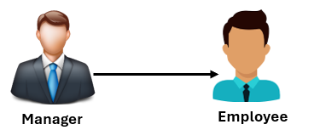

Step 2: Everyday, Daily standup meeting is scheduled to understand the status of tasks assigned to employee.

***Agenda:***

* Number of tickets completed.
* If tickets are put on hold, then why?
* If any functionality was developed earlier, then can be moved to cancelled status.
* If any functionality is dependent on other functionality, then postponed it.

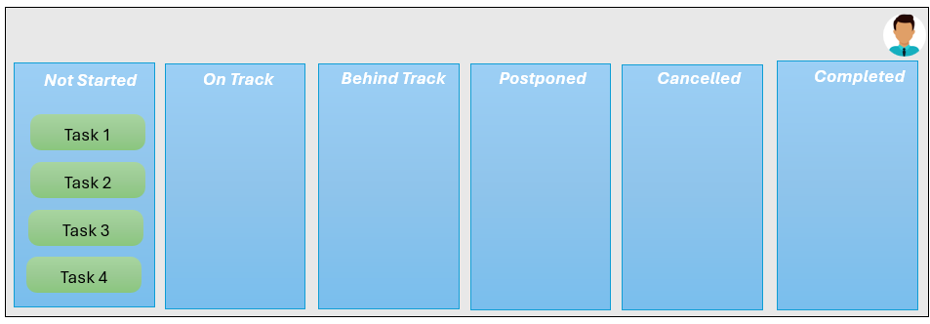

Step 3: In Sprint Review, we understand that

* Task 1 is completed successfully.
* Task 2 was subdivided into 3 tasks
* Task 2C is cancelled as it was delivered in earlier sprints
* Task 2B is dependent on some functionality hence postponed to next sprint
* Task 2A successfully delivered.
* Task 3 was completed, but escalation received hence manager reopened ticket (Behind Track).
* Task 4 employee is working on currently.

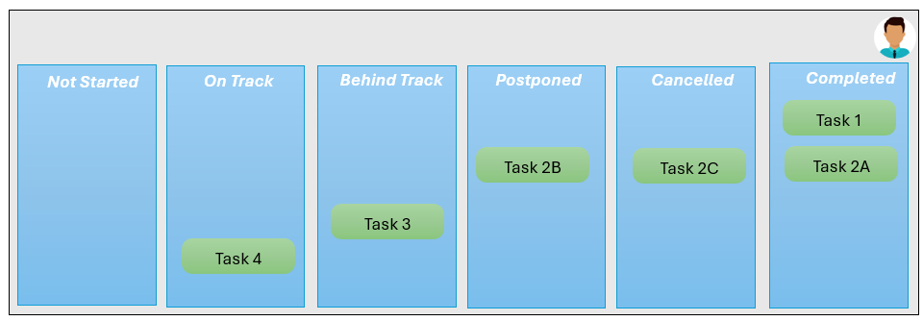

Step 4: This helps manager to understand employee performance and can be rewarded quarterly or promoted.

# ***COMPARISON***

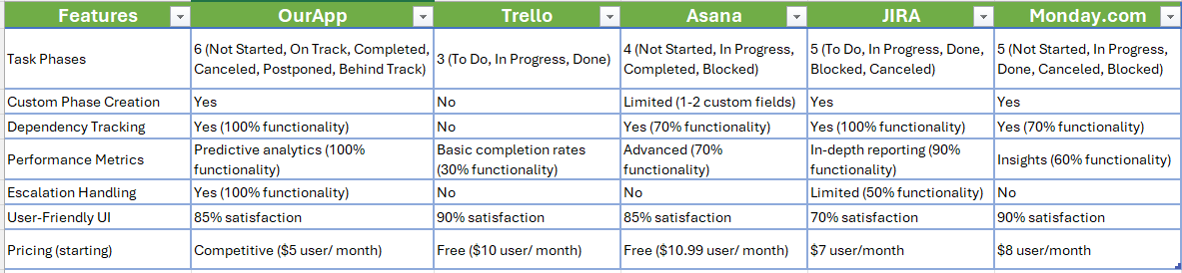

# ***ANALYSIS***

Using [employee.csv](https://github.com/JainRita/repo-exercise/blob/main/employee.csv) below are our statistical analysis:

1. ***T-test analysis (Escalation vs performance score)***

Performs an independent t-test to compare the means of the two groups' performance scores.

T-statistic for escalation vs. performance score: 2:39

P-value: 0.0038

Interpretation: There is a statistically significant difference in performance scores between tasks with and without escalation.

1. ***ANOVA test (Phase vs Performance Score)***

Conducts a one-way ANOVA test to determine if there are any statistically significant differences in performance scores among different status categories.

F-statistic: 2.51

P-value: 0.0437

Interpretation: There is a statistically significant difference in performance scores across task phases.

1. ***Chi-square test (Completion Status vs Escalation)***

Performs the test to check for independence between the two categorical variables and creates a contingency table to summarize the relationship between completion Status and Escalation.

Chi-square statistic: 102.75

P-value: 3.8 * 10-24

Degrees of freedom: 1

Interpretation: Completion status and escalation are significantly associated.

# ***CONCLUSION***

This study proposes a novel methodology for task management to enhance team collaboration and meet key business objectives like competitiveness, productivity, and cost reduction. It aims to improve collaboration between employees and employers, facilitating work monitoring and team activities. Results help managers track workflow and task completion times, boosting overall productivity and efficiency. Future work may involve developing a task management tool for cross-department collaboration on various processes.

# ***REFERENCES***

|  |  |
| --- | --- |
| [1] | M. S. S. K Sandhya, "EMPLOYEE TASK TRACKING SYSTEM," *International Research Journal of Modernization in Engineering Technology and Science,* vol. 05, no. 7-July-23. |
| [2] | A. S. A. O. a. A. S. A. Osman, "Evaluating Employee Performance using Automated Task Management System," *Indian Journal of Science and Technology,* March 2019. |
| [3] | D. K. M. Akshatha, "Employee Task Tracking System," *International Advanced Research Journal in Science, Engineering and Technology,* vol. 10, no. 7, July 2023. |
| [4] | D. R. D. k. K. H. V. K. N. Selvakumar G, "Intelligent Framework for Task Maintenance and Appraisal," *International Journal of Innovative Technology and Exploring Engineering (IJITEE),* vol. 9, no. 6, April 2020. |
| [5] | M. B. P. M. D. O. A. Sonya Meitarice, "AUTOMATED TASK MANAGEMENT SYSTEM USING ANALYTICAL HIERARCHY PROCESS," *Jurnal Teknik Informatika,* 2, Oktober 2020. |