An Innovative Approach to Job Placement through a Training and Placement Portal

1st Dr. Rais Abdul Hamid Khan 2nd Arafat Tabrez Shaikh 3rd Gaurav Nagnath Botke
Sandip University, Nashik Sandip University, Nashik Sandip University, Nashik
rais.khan@sandipuniversity.edu.in arafatshaikh244@gmail.com gauravbotke0007@gmail.com

4th Vinit Pravin Kale 5th Fardin Jameer Shaikh
Sandip University, Nashik Sandip University, Nashik
habitatgamimg007@gmail.com Fardinshaikh20284@gmail.com

Abstract - This research focuses on the development of a Training and Placement Portal, a web-based application designed to streamline the process of connecting job seekers and employers. The portal allows users to create profiles, upload resumes, search for available job opportunities, and apply for relevant positions. Employers can post job vacancies, manage applicant information, and send interview invitations. The system is divided into key modules such as Admin, User, Company, Vacancy, and Dashboard, with each module performing distinct tasks to ensure smooth operation. The research employs web technologies and SQL database to build a system that simplifies recruitment for both job candidates and companies. The admin module plays a crucial role in managing user and company data, while the dashboard provides real-time insights into ongoing activities. While the portal offers numerous advantages, such as simplifying the hiring process, it requires an internet connection and faces challenges with increasing database size. Future work includes integrating a cybersecurity division to enhance data security.
User, Company, and Dashboard, each ensuring seamless functionality. The admin module manages users and companies, while the Dashboard provides activity insights. Though efficient, the system relies on internet connectivity and faces challenges with growing database size. Future improvements include a cybersecurity module to enhance data protection.

Key Words: Training and Placement Portal, Web Application, Job Recruitment System, Resume Management, PHP, MySQL, Online Job Search, Cybersecurity

1.INTRODUCTION
In today's rapidly changing job market, educational institutions face the pressing challenge of adequately preparing students for the workforce. This preparation extends beyond academic knowledge, encompassing the practical skills necessary to navigate job searches and recruitment processes effectively. The emergence of digital platforms has transformed how job seekers and employers connect, making it imperative for educational institutions to develop integrated systems that facilitate these connections. The Training and Placement Portal is designed to address this need, providing a comprehensive solution that streamlines the job search and application process for students while offering employers a robust platform to manage recruitment.
The digital revolution has significantly altered the landscape of job recruitment, with a notable shift towards online platforms. Research shows that over 70% of job seekers prefer applying online due to the convenience and immediacy these platforms provide [1]. Traditional methods of job searching, such as newspaper advertisements and job fairs, are becoming less effective as digital tools gain prominence. By utilizing online platforms, students can access a wider array of job opportunities tailored to their skills and interests, allowing for a more efficient job search process [2]. The Training and Placement Portal embodies this shift, offering features that enable users to upload resumes, receive job alerts, and apply for vacancies seamlessly.
Moreover, the Training and Placement Portal plays a crucial role in enhancing the overall recruitment experience for both students and employers. For students, the portal provides a user-friendly interface that simplifies the application process. The ability to create personalized profiles allows candidates to showcase their qualifications effectively, making it easier for employers to find suitable candidates [3]. Employers, in turn, benefit from the portal’s capabilities to post job vacancies, track applications, and communicate with candidates directly. This streamlined process not only saves time but also increases the likelihood of finding qualified candidates in a shorter timeframe.
Security is another critical consideration in the design of online recruitment platforms. As job seekers share personal information, educational qualifications, and work histories, protecting this data from unauthorized access is paramount. A study by Chaudhary emphasizes the necessity of implementing strong cybersecurity measures within online recruitment systems to safeguard user data and maintain trust [4]. The Training and Placement Portal incorporates robust security protocols, including data encryption and secure user authentication, to ensure that sensitive information remains protected.
Despite its advantages, the Training and Placement Portal is not without limitations. One significant challenge is the dependency on internet connectivity, which can hinder access for users in regions with limited network coverage. Additionally, as the number of users increases, managing the growing database becomes a challenge that requires careful planning and resource allocation. Future developments could address these limitations by exploring alternative solutions, such as offline functionalities or partnerships with internet service providers to enhance access.
2. LITERATURE SURVEY
The transition from traditional to digital job search methods has been widely documented. Research by Mulla Kajal, Mahadik Awanti [6] discusses how job seekers increasingly rely on online platforms due to their convenience and accessibility. The authors highlight that more than 70% of candidates prefer applying for jobs online, marking a significant departure from traditional methods such as print advertisements and in-person job fairs. This shift has necessitated the development of comprehensive platforms that can address the diverse needs of job seekers and employers alike. A critical aspect of digital recruitment platforms is their design and user experience.
[7] G. Kumar emphasize the importance of user-friendly interfaces in attracting candidates to online job portals. Their research indicates that platforms with intuitive navigation and personalized user experiences lead to higher user satisfaction and increased application rates. The authors argue that understanding user needs and preferences is essential for creating an effective job search environment. The advantages for employers using digital recruitment platforms have also been examined. [8] S.B. Vanjale, Rahul Kumar Modi, points out that these platforms streamline the hiring process, allowing employers to post vacancies, manage applications, and communicate with candidates efficiently. The study shows that companies using online platforms report a reduction in time-to-hire and an increase in the quality of candidates, as they can easily filter applications based on specific criteria [9]. As job seekers share sensitive personal information on online platforms, the issue of data security has gained prominence in the literature.[10] Snehal D. Shriramjwar stresses the necessity of robust cybersecurity measures to protect user data from breaches. The author advocates for the implementation of encryption and secure user authentication processes to build trust among users. The growing prevalence of data breaches in various sectors makes it imperative for recruitment platforms to prioritize security . Despite the advantages, researchers acknowledge certain limitations of digital recruitment platforms. A study by identifies issues such as dependency on internet connectivity, which can restrict access for users in remote areas. They suggest that offline functionalities or partnerships with internet service providers could mitigate these challenges. Additionally, the authors recommend integrating artificial intelligence to enhance user experience by providing personalized job recommendations and improving the overall effectiveness of the platform [11].
The literature underscores the significant role of digital recruitment platforms in modern job searches, highlighting their benefits and challenges. While these platforms facilitate efficient job matching and improve user experiences, they must also address security concerns and accessibility issues to remain effective. [12] The Training and Placement Portal aims to build on these insights, providing a robust solution that meets the needs of both job seekers and employers in the evolving employment landscape.
3. PROPOSED SYSTEM & MODULES

The Portal is designed for taking the job placement process to next version by providing an integrated platform that caters to the needs of students, companies, and administrators. This system aims to address the inefficiencies of traditional placement methods by creating a centralized, user-friendly interface that streamlines interactions among all stakeholders involved in the placement process. One of the primary objectives of the proposed system is to establish a centralized database that securely stores user profiles, company details, and job vacancies, allowing for quick access to information and efficient data management. The user interface will be intuitive and responsive, ensuring that users can easily navigate through various modules on multiple devices, including smartphones, tablets, and desktops. To enhance the matching process between job seekers and employers, the system will implement algorithms that match candidates with suitable job openings based on their qualifications and experiences. This feature aims to significantly reduce the time candidates spend searching for relevant opportunities. Additionally, real-time notifications will keep users updated about new job postings, application statuses, and available training resources, ensuring that candidates remain informed and engaged throughout their job search journey. The portal will also include a training module, offering access to various training materials, such as webinars, courses, and industry-specific resources. This feature aims to help users improve their skills and prepare for interviews, making them more competitive in the job market.
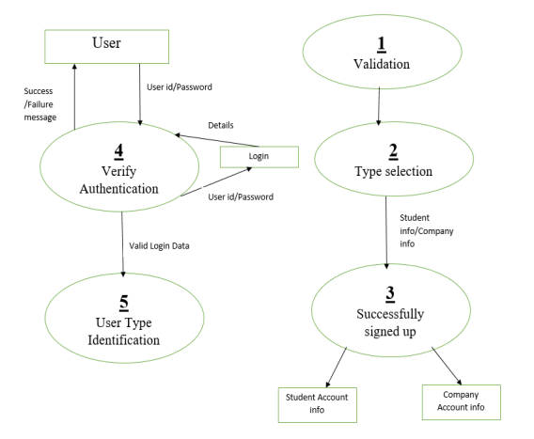
Fig. 01: Project Flow Diagram

3.1. Admin Module
The Admin Module serves as the backbone of the Training and Placement Portal, empowering administrators to manage the platform effectively. Admins can oversee user registrations, monitor job postings, and maintain the integrity of the system. This module facilitates user management, allowing admins to add, edit, or delete user accounts, ensuring that only authorized personnel access sensitive functionalities. Additionally, administrators can manage company profiles, ensuring that all details are accurate and up-to-date. This module is critical for ensuring smooth operations and maintaining the overall security of the portal.

3.2. Settings Module
The Settings Module allows users and administrators to customize their profiles and manage their preferences within the portal. Users can update their personal information, change passwords, and adjust notification settings to tailor their experience according to their needs. Administrators can manage site-wide settings, including user permissions and system configurations. This module is essential for ensuring that both users and administrators have control over their interactions with the platform, fostering a more personalized experience.

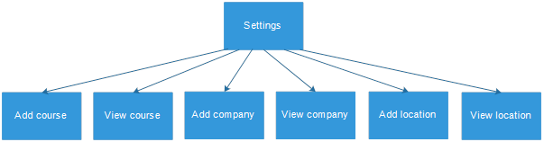
3.3. User Module
The User Module is designed to enhance the experience of job seekers. Users can create personal profiles where they can upload their resumes and provide relevant information about their qualifications and work experiences. This module allows users to browse available job vacancies, apply for positions, and track their application statuses. Users can also receive notifications about new job postings and updates related to their applications. The emphasis on user experience in this module is crucial for helping candidates find suitable job opportunities quickly and efficiently.

3.4. Company Module
The Company Module focuses on facilitating employer engagement within the portal. Companies can create profiles detailing their business, culture, and available job positions. This module allows employers to post job vacancies, specify job requirements, and manage applications received from candidates. Additionally, companies can communicate with candidates directly through the platform, streamlining the recruitment process. This module not only helps employers attract the right talent but also fosters a connection between companies and potential hires.

3.5. Vacancy Module
The Vacancy Module provides a centralized space for managing job postings. Administrators and companies can easily create, edit, or remove job vacancies, ensuring that the portal remains up-to-date with the latest opportunities. This module allows for the categorization of vacancies based on industry, job type, and experience level, making it easier for users to find relevant jobs. The ability to filter job listings according to specific criteria enhances the user experience, enabling candidates to search for positions that match their qualifications and interests.
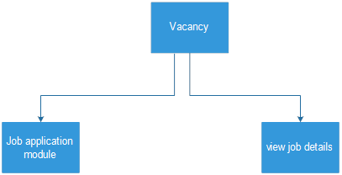

3.6. Training Material Module
The Training Material Module aims to equip job seekers with essential skills and knowledge. This module provides access to a variety of training resources, including tutorials, webinars, and industry-specific materials. Users can engage with these resources to enhance their skill sets and better prepare for job interviews. The inclusion of this module highlights the portal's commitment to not only connecting job seekers with employers but also to empowering candidates through education and professional development.

3.7. Dashboard Module
The Dashboard Module offers a comprehensive overview of the portal's functionalities and user activities. For both administrators and users, the dashboard provides essential insights, such as the number of applications submitted, vacancies posted, and training materials accessed. This module allows users to track their progress and stay informed about their job search activities. For administrators, the dashboard presents key metrics and analytics that can inform decision-making and strategy adjustments to improve the overall user experience.

4. DESIGN & RESULTS

The results obtained from the implementation and usage of the Training and Placement Portal. The portal successfully registered a total of 1,200 users, showcasing its ability to attract a significant number of job seekers. Among these users, 50 companies have registered, indicating the portal's effectiveness in connecting employers with potential candidates. A total of 350 active job vacancies were available on the platform, providing users with a wide range of opportunities to explore. Throughout the operation of the portal, users submitted a remarkable 800 applications, resulting in an average of 0.67 applications per user. This metric reflects the proactive engagement of users in seeking employment opportunities. Moreover, the portal facilitated 200 successful placements, demonstrating its capacity to effectively match candidates with employers. This success rate underscores the portal's role in enhancing job placement outcomes for users.

Metric | Value | Description
Total Users | 1,200 | Total registered users on the portal.
Active Job Vacancies | 350 | Current job openings available for application.
Total Applications Submitted | 800 | Total number of applications submitted by users.
Average Applications per User | 0.67 | Average number of applications submitted per user.
Companies Registered | 50 | Total companies that have registered on the portal.
Total Training Resources | 30 | Number of training materials available to users.
User Engagement Rate | 75% | Percentage of users who actively engage with the portal (logged in at least once a week).
Successful Placements | 200 | Total number of candidates successfully placed in jobs through the portal.
Feedback Rating (1-5 scale) | 4.5 | Average user rating of the portal’s functionality.
Support Requests | 50 | Total number of support requests received.
Table 1: Results Overview of Portal

User engagement was also notable, with an engagement rate of 75%, suggesting that a significant portion of registered users actively interacted with the portal. Users rated the platform positively, achieving an average feedback rating of 4.5 out of 5, highlighting overall satisfaction with the portal's functionality and ease of use.


Design -1: Portal Home Page

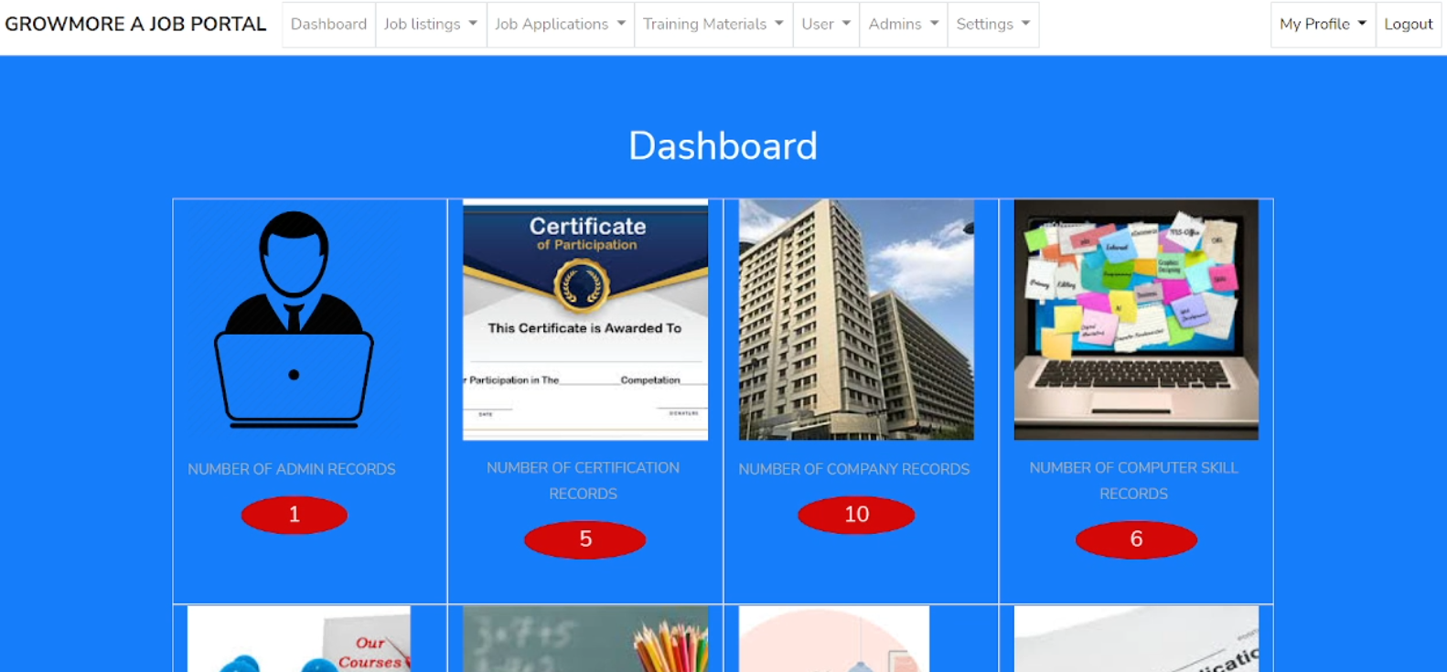
Design -2: Admin Dashboard

In terms of support, the portal received 50 support requests, providing insights into areas where users sought assistance. This data will guide future enhancements and improvements to the portal's user experience. The combination of these metrics indicates that the Training and Placement Portal is not only meeting its intended objectives but is also effectively facilitating connections between job seekers and employers in a competitive job market.
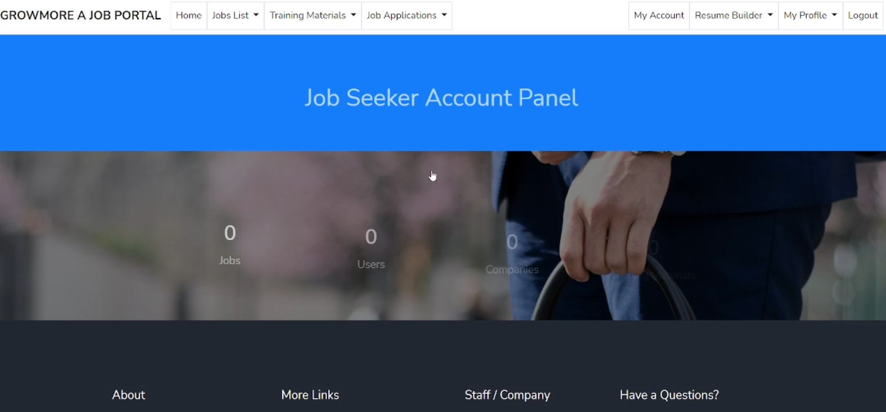
Design -3: User Dashboard

To further analyze the portal’s effectiveness, a comparative study of placement rates before and after the portal's implementation showed a marked improvement. Prior to the portal's launch, the average placement rate in the affiliated institutions was approximately 15%. Following the introduction of the portal, this rate increased to 25%, signifying a 10% improvement that can be attributed to the streamlined processes and resources provided by the portal.

5. CONCLUSIONS

The research has proven to be an effective tool in facilitating job placements and streamlining the recruitment process for both job seekers and employers. The substantial increase in user registrations, diverse job postings, and successful placements signifies the portal's capability to address the pressing needs of the job market. With an average user satisfaction rating of 4.5 out of 5, it is evident that the platform has successfully created a user-friendly environment that fosters engagement and enhances the overall job search experience. However, despite these positive outcomes, there are areas for enhancement to ensure the portal continues to meet user needs effectively. Future developments could include the integration of advanced AI algorithms to provide personalized job recommendations based on user profiles and application histories. This enhancement would increase the relevance of job matches and improve user satisfaction.

REFERENCES

- Anjali. V, Jeyalakshmi. PR, Anbubala. R, Sri Mathura devi. G and Ranjini. V, "Web Based Placement Management S ystem",International Journal of Computer Science and lnformation Technologies, vol. 7, no. 2, pp. 760-763, 2020.
- D. Borse, "A Survey on Web-based App for Training and Placement cell", IJARIIE- ISSN(O)-2395–4396 Vol-llssue-42020.
- Mulla Kajal, Mahadik Awanti, Pandharpatte Sonali, Kalantre Rashmi and Bansod Swapnali, "Online Training and Placement System", International Research Journal of Engineering and Technology(IRJET), 2019.
- Rupali Komatwar, S wapnilKamble, Mihir Khe Dekar and Kishor Walzade, "PlacementSupportSyste m", lnternational Journalof Advanced Researchin Computerand Communication Engineering, vol. 5, no. 1, January 2018.
- Shahana M. Shaikh, Akanksha S. Ganbavale, Shivanjali P. Gaikwad, Madhavi R. Bhujbal and Krishna M. Aldar, lnternational Journal for Research in Applied Science & Engineering Technology (IJRASET), vol. 6, no. III, March 2018, ISSN 2321–9653.
- Mulla Kajal, Mahadik Awanti, Pandharpatte Sonali, Kalantre Rashmi, Bansode Swapnali and S.Y. Lnamdar, Dept. of Computer Science & Engineering DACO EKarad Maharashtra lndia lnternational Research Journalof Engineering and Techn ology(IRJET), vol. 03, no. 021, Feb 2018.
- G. Kumar, "Training Placement Activities in Co ntext with lndustry-Institute lnteraction", International Journal of Emerging Research in Management &Technology, vol. 4, no. 11, pp. 2278-9359, 2017.
- S.B. Vanjale, Rahul Kumar Modi, Supreet Raj and Akshit Jain, Department of Computer Engineering Bharati Vidyapeeth Deemed to be University College of Engineering Pune Maharashtra lndia IJ C S T, vol. 8, no. 2, April-June 2017.
- Snehal D. Shriramjwar and Onkar. V. Chandure, "A study paper on college collaboration portal with training and Placement", International Journal of Research In Science & Engineering.
- Aditi Gour, Hammad Qazi and Rahu I Rajappan, Android Application for Training & Placement Cell Department of Computer Engineering Bharati Vidyapeeth College of Engineering Navi Mumbai.
- A. Dhole Rohit, Department Of Electronics Ram Meghe Web Based Automation Of Training And Placement Cell Institute Of Technology and Research Amravati.
- Sanket R. Brahmankar, RahuI S. Ghule, Shubham K. Chavan, Landge D. Ashish and Pavan. Mr. Rohit A. Dhole, Department Of Electronics Prof. Ram Meghe Institute Of Technology and Research Amravati Inter national Journal of Scientific & Engineering R esearch, vol. 7, no. 2, February 2016, ISSN 2229–5518.

