Digital and remote teams: Their roles in project management

Ms. Dipal Gohil,

Research Scholar,

Gujarat Technology University

Ahmedabad.

Dr. Vijay Pithadia

GTU Ph.D. Guide,

Director, SSIM & IT, Porbandar – 360578.

**Abstract:**

A virtual team is a collection of geographically dispersed individuals that collaborate to accomplish a common objective for a single enterprise. Global project management is a notion that has developed over the last few years from this premise. Virtual teams have helped improve internationalization, reduce costs, and hire qualified workers. Although virtual teams are advantageous for an organization, they are challenging to efficiently manage and oversee. There may be a number of difficulties, including communication gaps, cultural barriers, and time zone differences. These difficulties are manageable, and with the right project management techniques (right communication and HR management), we can get beyond them. By comparing the survey results of traditional and virtual teams, these talents will be identified as the success criteria for virtual teams.

**Keywords:** Traditional teams, Virtual teams, working remotely, Communication management, HR management.

# INTRODUCTION

Modern communication has made the world into a small, interconnected village. People have used this development for various processes in addition to making it easier for people to interact and communicate more globally. So much so that, despite physical distances, people prefers to collaborate with others worldwide.

For this, virtual teams are designed. The term "virtual team" (VT) refers to groups of people who work together virtually rather than in person to accomplish shared objectives (Zofi et al., 2011). These teams are created by bringing together individuals who, while being separated by time, culture, and geography, work together to accomplish a similar objective (Edwards et al., 2004). Different circumstances can result in geographical distance. There are situations where the leader and some team members may be in one location while others are geographically distant, or where a leader may have a larger team at one location while the other teams, which are smaller in size, may be in a variety of geographically distant locations. In some cases, only the team leader may be in one location while the team members may be in another (Settle-Murphy et al., 2012).

Geographic distance can be the result of various factors. A leader may have a larger team at one place while the other teams, which are smaller in size, may be in a range of geographically different locations. In other cases, the leader and some team members may be in one area while others are geographically far. Sometimes, the team members may be in a different place from the team leader (Settle-Murphy et al., 2012).

Virtual teams have grown to be a crucial component of many small and major businesses throughout the world. To accomplish particular goals, many people work in remote teams. This idea of a virtual team has advanced communication and expanded business opportunities for people all over the world. Having virtual teams gives your company exposure from an informational and cultural standpoint.

# Global Virtual Teams

Global virtual teams are evolving into the "new normal" as organizations across international borders and are compelled by skill shortages to access a wider range of talent. The global virtual team, made possible by technological advancements, has many benefits, including: getting a global perspective on business challenges and solutions; scaling up; utilizing complementary work cycles that allow 24/7 productivity; utilizing best talent, wherever it may be; accelerating innovation and product launches; and improving local knowledge and presence.

Companies are relying more and more on worldwide virtual teams to promote innovation and growth, but far too frequently these teams are formed without a clear procedure to guarantee success. Global virtual teams must have a tested structure to encourage optimal performance because they involve a high level of commitment.

The D&I, Purpose, People, and Process sections all cover the global virtual team paradigm as shown in figure 1.

* + 1. D&I (Diversity & Inclusion (D&I)

To successfully utilize D&I in all of its parts to capture the finest ideas, use complimentary skill sets, and foster cohesion, a diverse leader is crucial.

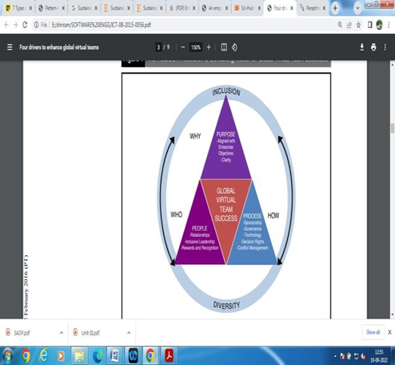

Figure 1: Model for Global Virtual Team Success

* + 1. Purpose

In order to achieve an organizational objective (such as the introduction of a new product, the resolution of an organizational procedure, or the development of a new application), global virtual teams are formed. It is crucial to make clear how the global virtual team's purpose fits into the overall goals of the company. Purpose-driven teams are more motivated, set important project milestones, and keep progress in the forefront when purpose is stressed.

The goal of the global virtual team should be clear, attainable, measurable, a major factor in project milestones, and, if necessary, updated as conditions change.

* + 1. People

The overarching goal of the global virtual team should be used to define the team's makeup, as this will provide guidelines for selecting the best team members with the ideal combination of knowledge and expertise. Of course, a variety of elements, such as accessibility,

Motivational factors, and technological aptitude, will be taken into consideration during the selection process.

* + 1. Process

Global virtual teams require executive-level sponsorship to achieve alignment with bigger corporate goals and to provide the mandate for performance. Sponsors can intervene as necessary to make sure the team has access to the tools, information, technology, and approvals they need to accomplish their goals.

# LITERATURE REVIEW

A successful product for a company is developed using the global software development (GSD) paradigm, which involves professionals stationed in many places across the world carrying out development tasks (Sinha et al., 2006). GSD presents some challenges for specialists that do not arise in programming projects developed at the collocated location (Sinha et al., 2006). Due to the group's location in a few different geographic places, correspondence and coordination are negatively impacted by ethnic and time zone differences (Akbar et al., 2017). Virtual groups are becoming more common in the software industry globally as associations compete fiercely (Maznevski et al., 2000).

The two primary issues that develop due to the rapid growth of worldwide virtual teams are:

(1) Lack of communication (2) Lack of collaboration

Collaboration issues are always a result of a lack of communication (Hailu et al., 2012).

# Extracted Issues

Working in a team and improving communication remain tough tasks, but when we discuss remotely placed teams, these concerns constantly demand attention (Berry et al., 2011). Even though it is well known that regular communication among employees is crucial and necessary, it is becoming more and more difficult in most firms today to stay in touch with team members on a regular basis. Adding members or concerned domain consultants to project teams who are not normal employees of the parent firm is one trend that is growing more prevalent today (Gurung et al., 2011; Abro et al., 2020).

Here are some typical difficulties that virtual teams have encountered, as compiled by researchers.

* Because there is little interaction, establishing trust in virtual teams is challenging.

Virtual team members experience loneliness and disengagement because they are not physically present for the organization's social events.

* In any virtual collaboration, establishing positive group dynamics and ensuring their sustainability is becoming increasingly challenging and complex.
* Because it might be difficult to define clear responsibilities and expectations, virtual teams will struggle to work together effectively.
* Physical communications cannot be replaced by virtual ones. No one can dispute the value of face-to-face interactions, and no amount of technological advancement can make them obsolete.
* Assessment and reporting are limited because managers must create improved methods for receiving feedback and assistance.

We've talked about a few frequent problems; these problems don't make development less necessary or worthwhile; they just make it more difficult. And in order to increase the

Effectiveness and success of a virtual team, these identified difficulties must be addressed seriously. So, managers can rely on the following success elements while working with virtual teams.

# Success Elements

As we previously indicated, there may be several problems that hinder the performance of virtual teams, but these are not the only factors that could go wrong. As a result, we have defined a few success characteristics in the context of project management expertise. To be more precise, we have divided the success criteria into the knowledge domains. Using this kind of categorization is usually beneficial when putting those success characteristics into practice. The project management knowledge areas are classified according to the success elements listed below.

1. Communication Management: In terms of the success of virtual teams, this knowledge area is the most crucial. As we all know, effective communication is the most important task, factor, or criterion for any project's success. As a result, we can separate it into two groups based on the different kinds of teams a project manager may oversee.

* Interaction with Local Teams:
* Interaction with online teams

1. Keeping the Teams Engaged: Maintaining the team's commitment to the project, the business, and their jobs is one of the most crucial tasks for the project's success. For the success of the project being produced, the teams must be frequently updated. It is the responsibility of the project manager to keep the team informed, involved, and motivated in their work so that their performance can be improved more efficiently. A project manager must also keep in mind the value of each team member, which necessitates communication with every member of the virtual teams. The people will perform better as a result of this.
2. Improved meeting criteria and methods: Maintaining the team's commitment to the project, the business, and their jobs is one of the most crucial tasks for the project's success. For the success of the project being produced, the teams must be frequently updated. It is the responsibility of the project manager to keep the team informed, involved, and motivated in their work so that their performance can be improved more efficiently. A project manager must also keep in mind the value of each team member, which necessitates communication with every member of the virtual teams. The people will perform better as a result of this.
3. Build Strong Trust: Lack of trust is a serious problem that makes the virtual teams fail. Since co-located teams don't have to deal with this issue as severely as virtual teams do, there are some goals that can be accomplished to foster trust among team members.
4. HR Management: When it comes to managing virtual teams, HR management is another key job. To create successful virtual teams, the project manager must ensure that he is effectively managing his human resource.
5. Procurement Management: In the majority of cases, there may be specific circumstances where it's critical to effectively manage your resources so that your team can make the most of them.
6. Scope Management: The success of virtual teams can depend in large part on the management of the project's scope. Matrix for one of the success element i.e. Communication and Collaboration is shown in figure 2.

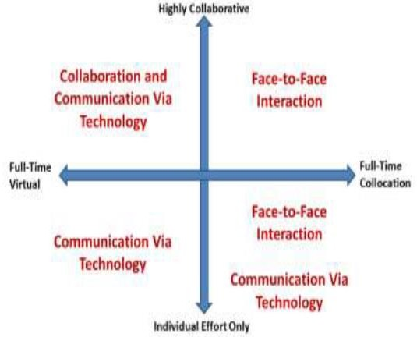

Figure 2: Communication and collaboration matrix (Chen et al., 2015)

# ANALYSIS

The main objective of this study is to examine the difficulties associated with managing software projects in a remote or virtual setting. Particular attention will be paid to how these difficulties affect the relationships and productivity of virtual teams, how to foster mutual trust among team members, and how higher levels of leadership affect a virtual environment. First, using a theoretical framework, we came to certain conclusions about virtual teams that aided in the creation of a questionnaire. We handed out our survey to several individuals who worked remotely for some organizations. In order to determine the success elements for managing virtual teams, we then examined each questionnaire.

# CONCLUSION AND FUTURE WORK

The problems that project development organizations encounter in the context of GSD are highlighted by this study. Organization’s effective communication and teamwork among the virtual team members are essential to the project's success. The study assists in identifying significant communication shortcomings and how they affect teamwork. This study found that excellent communication is a constant requirement for effective teamwork. Lack of collaboration and communication affects every area of software project management expertise, which causes the project to fail. There are some countermeasures that should be taken in order to improve communication and collaboration, even though there is a complete process for managing communication but a gap for managing collaboration. Collaboration management is required in order to increase the effectiveness of software development in the context of GSD. However, there are two distinct project types to which collaboration management can be formally applied: internal development environments and virtual teams, each of which will employ various strategies.

# REFERENCES

1. Akbar, Muhammad Azeem, et al. Improving the quality of software development process by introducing a new methodology–AZ-model. IEEE Access 6 (2017): 4811-4823.
2. Akram, F., Abrar-ul-Haq, M., & Surjit, V. (2018). Work-Life Balance among dual working couples in Pakistan. International Journal of Innovative Knowledge Concepts, 9(11). Chen, Weiya. Collaboration in Multi-user Immersive Virtual Environment. Diss (2015).
3. Abro, S., Shaikh, S., Abro, R. A., Soomro, S. F., & Malik, H. M. (2020). Aspect Based Sentimental Analysis of Hotel Reviews: A Comparative Study. Sukkur IBA Journal of Computing and Mathematical Sciences, 4(1), 11-20.
4. Edwards, Abigail, and John R. Wilson. Implementing virtual teams: A guide to organizational and human factors. Gower Publishing, Ltd. (2004).
5. Ferronato, Betsy. Emotional intelligence in leadership and project success within virtual teams (2017).
6. Gregory R. Enhancing effectiveness on virtual teams: Understanding why traditional team skills are insufficient. The Journal of Business Communication (1973) 48.2 (2011): 186-206.
7. Gurung, Anil, and Edmund Prater. A research framework for the impact of cultural differences on IT outsourcing. Global sourcing of services: strategies, issues and challenges. (2017). 49-82.
8. Hailu, Alemayehu, and Syed Rahman. Evaluation of key success factors influencing ERP implementation success. 2012 IEEE Eighth World Congress on Services. IEEE (2012).
9. Khan, Siffat Ullah, Mahmood Niazi, and Rashid Ahmad. Factors influencing clients in the selection of offshore software outsourcing vendors: An exploratory study using a systematic literature review. Journal of systems and software 84.4 (2011): 686-699.
10. Mackey, S. Virtual success: The dark side of virtual teams. Retrieved July 23 (2012): (2015).
11. Maznevski, Martha L., and Katherine M. Chudoba. Bridging space over time: Global virtual team dynamics and effectiveness. Organization science 11.5 (2000): 473-492.
12. Muhammad, F., Bhatti, Z., Chand, J., Bachal, M., & Nawaz, A. (2021). Multimedia based Learning using Animation for Sindhi language. iKSP Journal of Computer Science and Engineering, 1(1).
13. Nawaz, A., Haseeb, A., Malik, H. A., Ali, Q., & Malik, A. (2020). Genetic association among morphological traits of Zea mays seedlings under salt stress. Biol Clin Sci Res J, 21.