**Sickle Cell Anemia in India: Challenges, Awareness and Management**

Bharat Pareek1, Sandip Ashok Bodakhe2

12Medical Students, Department of Public Health,

Osh State Medical University

**Abstract**

Sickle Cell Anemia (SCA) is a genetic blood disorder brought about by a mutation within the haemoglobin gene. It expresses itself through the generation of abnormal haemoglobin known as HbS, which changes the shape of the red blood cells into a characteristic sickle shape. This results in reduced oxygen-carrying capacity, painful crises, organ damage, and increased vulnerability to infections. The main geographic regions where SCA prevails include sub-Saharan Africa, the Mediterranean, and parts of Asia, with a high incidence in India among tribal populations. In India, around 2-3% of the population carries the sickle cell trait, while 0.2-0.4% is affected by the disease, although the prevalence rate is far higher in areas like Madhya Pradesh, Chhattisgarh, Gujarat, and Maharashtra. Despite being a genetic condition, the lack of awareness and delayed diagnosis, coupled with poor access to healthcare in rural areas, make SCA a major public health challenge. Management essentially consists of pain relief, blood transfusions, and the use of hydroxyurea, while bone marrow transplantation is a curative option for selected cases. The effort of early diagnosis by various screening programs and genetic counselling will help reduce the incidence and improve the quality of life. This review describes the prevalence, challenges in the management, and efforts at control of SCA in India, with emphasis on the need for increased access to healthcare and public awareness.

**Introduction** SCA is a genetic blood disorder caused by the production of abnormal sickling haemoglobin, which leads to the distortion of the RBCs into a sickle shape. This condition leads to a host of health-related problems, including pain, fatigue, organ damage, and increased risk of infections. Although Sickle Cell Anemia is common in every part of the world, India shares a major burden of the disease, particularly in tribal populations. This review discusses the prevalence, genetics, challenges in management, and efforts toward awareness and treatment in India.

**Prevalence of Sickle Cell Anemia in India**

Sickle Cell Anemia mainly occurs in areas with consanguinity and in populations having genetic isolates. The prevalence of SCA among the tribal population is strikingly high, especially within states such as Madhya Pradesh, Chhattisgarh, Gujarat, Maharashtra, Odisha, Rajasthan, and Jharkhand. About 2-3% of Indians are carriers of the sickle cell trait, and 0.2-0.4% of the population is affected by this disease.

In these areas, the genetic mutation that leads to SCA is more common because of evolutionary advantages. For example, the sickle cell trait provided resistance to malaria in regions that are endemic to the parasite, thus conferring a survival advantage. This advantage comes with increased disease rates when two sickle cell trait carriers have offspring.

**Genetic Basis and Pathophysiology**

Sickle Cell Anemia results from a mutation in the beta-globin gene, or HBB, on chromosome 11. In this case, the HBB mutation replaces glutamic acid with valine at position six in the beta-globin chain of hemoglobin, which changes the properties of the hemoglobin molecule; under conditions of low oxygen, the deoxygenated sickle-shaped hemoglobin polymerizes and the red blood cells assume characteristic sickle shapes. These sickled cells are rigid and may block blood flow. The blockage of blood flow can cause painful crises, organ damage, and other complications. Symptoms and Complications SCA can be variable between individuals, but common symptoms include the following: Pain crises-acute episodes of severe pain, often in bones, chest, or abdomen Anemia-decreased number of red blood cells leading to symptoms of tiredness and generalized weakness Increased risk of infections, especially due to spleen dysfunction, Organ damage, especially to the liver, kidneys, lungs, and heart; stroke due to impaired blood flow in the brain; and delayed growth and development in children. If left untreated, SCA results in premature death, especially when there is no effective medical intervention.

**Challenges in Diagnosis and Management**

• *Delayed Diagnosis*:

The diagnosis in SCA is often delayed because rural and tribal areas have insufficient facilities for healthcare, low levels of awareness, and also a lack of early screening. This results in many instances when the disease is usually identified only during acute attacks or after complications have arisen.

•*Lack of Resources*:

The availability of specialized care is limited in many parts of India. Bone marrow transplants, which can offer a potential cure, are not widely accessible due to their high cost. The healthcare infrastructure, particularly in rural areas, remains inadequate for the management of chronic conditions like SCA.

•*Awareness and Education*:

Awareness about Sickle Cell Anemia is low in rural and tribal communities. This lack of knowledge hinders early detection and proper management, often leading to preventable complications.

• *Genetic Counselling*:

Sickle Cell Anemia is a genetic condition, and the carriers of the sickle cell trait run the risk of passing on the disease to the next generation. Genetic counseling and screening programs are imperative and yet are at a nascent state in most regions. Most families are unaware of the risks posed by consanguineous marriages or union between carriers of the sickle cell trait.

**MANAGEMENT :**

Once the individual is confirmed positive for sickle cell disease ,the treatment shall be initiated at the PHC-HWC/UPHC-HWC level and at SHC-HWC level in consultation with medical officer. The goal for management should be patient centric focusing on life course approach with appropriate counseling of patient, educating regarding possible complications, pre-marital and pre-conception counselling.

General principals of management

• To improve quality of life and life expectancy of the affected individuals.

• Prevent and reduce the number of crises and complications

• Treat crises and complications promptly and effectively

• Promote a healthy lifestyle.

1. *Prophylactic management*: Folic acid and penicillin treatment shall be considered for prophylactic management. Dose of Folic Acid recommended for patients more than 1 year old is 5mg daily.

For patients who are less than 1 year dose should be 2.5 mg daily.

SCD patients develop functional hyposplenia therefore oral Penicillin is recommended for children upto 5 years of age or lifelong for those who had splenectomy. The dosage of penicillin will be:

• Oral Penicillin V potassium 62.5mg/bid for 1 year

• 125mg/day after 1 year until the age of 2 years

• 250mg/day till 5 years

SCD patients are at risk of severe infections due to hyposplenia especially infections due to encapsulated bacteria therefore, early vaccination shall be instituted to prevent infection and complications in later stages of life. For newborn children, vaccination as per schedule in the National

Immunization schedule. For adults vaccination, national guidelines needs to be followed

b) *Preventive Management*: To avoid crisis, nutrition, health maintenance, and comprehensive care is important. Education of both patients and caregivers about sickle cell disease including'Do's and Dont's in acute conditions before coming to the hospital, shall be undertaken.

c)*Treatment for severe symptoms*: Hydroxyurea should be recommended to the patients having repeated episodes of acute chest syndrome or with more than three crises per year requiring hospitalization. Hydroxyurea has been proven to decrease complications in children, such as - pain crisis, acute chest syndrome and strokes. Hydroxyurea can be initiated by PHC MO at PHC-HWCs and the starting dose of Hydroxyurea is 10-15 mg/kg/ day in a single daily dose. Once started on hydroxyurea, the MO should follow up patient with the complete blood count (CBC) every 2 weeks; serum biochemistries every 2-4 weeks. Children below 2 years should be referred to a higher centres for Paediatric consultation.

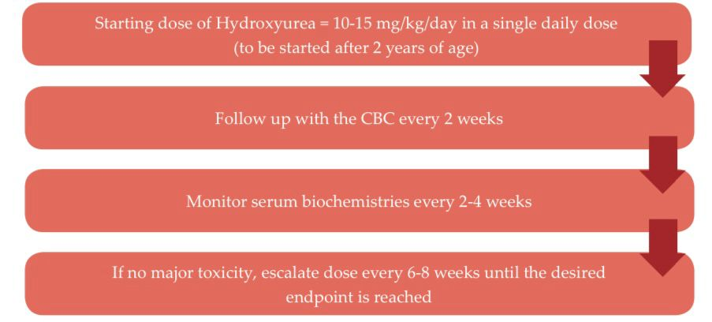

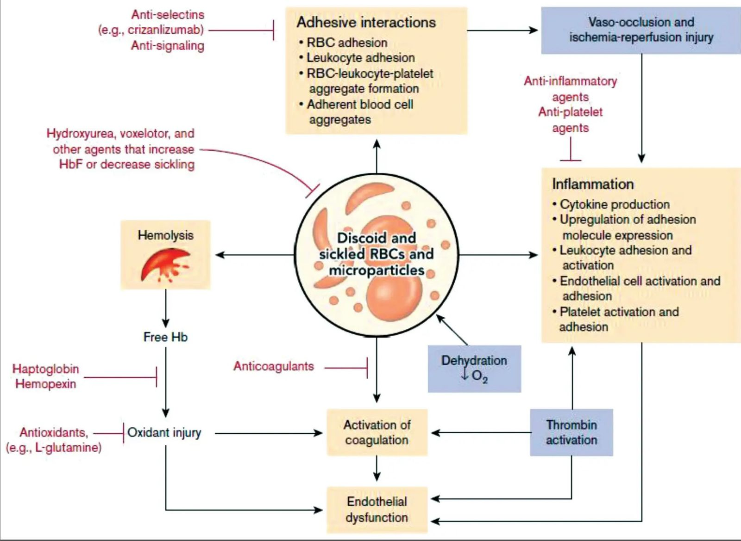

**Government and Non-Governmental Efforts**

The Indian government has started several programs to help with the increasing burden of Sickle Cell Anemia. A few of them are:

National Sickle Cell Anemia Control Program: A national program for the control of sickle cell disorders was initiated in 2013 by the Government of India, providing for screening, diagnosis, and counseling. It focuses on tribal populations in endemic areas and hopes to reduce disease incidence through genetic counseling and prenatal screening.

Awareness Campaigns: Many state governments, NGOs, and health organizations are carrying out awareness programs among the tribals. The campaigns focus on the need for early diagnosis, genetic aspects of the disease, and the need for screening and counseling before marriage.

Health Ministry Guidelines: The Health Ministry guidelines on diagnosis and management of SCA have provided guidelines on how healthcare professionals shall go about treating the affected individuals.

Non-Governmental Organizations: Many NGOs like Sickle Cell Society, Samarthanam Trust for the Disabled, and Baba Amte's Anandwan have worked extensively in raising awareness, providing counseling, and supporting families affected by SCA.

**The Role of Genetics and Screening**

Early screening of the newborns and adolescents for the sickle cell trait could reduce SCA incidence considerably. This program has been incorporated into government initiatives by training health workers for the identification of such sickle cell traits among people and counseling them to avoid passing on the disease. In fact, genetic screening and counseling in areas of high risks have shown some promise where fewer new cases are emerging along with improved overall outcomes.

As of June 18, 2024, the National Sickle Cell Anemia Elimination Mission has reported remarkable achievements in the screening and detection of Sickle Cell Disease cases in India. The progress reported is as follows:

More than 3.37 crore people have been screened under the programme so far.

• More than 3.22 crore people have been confirmed negative for sickle cell disease.

• Around 9.75 lakh carriers of the sickle cell trait have been identified.

• Over 1.40 lakh people with sickle cell disease have been diagnosed according to the screening.

• Over 3.59 lakh are still in the confirmation process for their status regarding sickle cell.

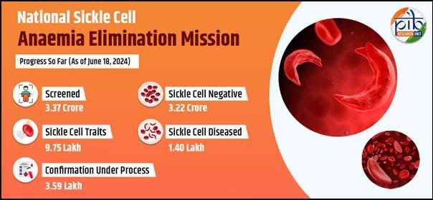

**National Sickle Cell Anemia Elimination Mission**

The National Sickle Cell Anemia Elimination Mission: The Union Budget 2023 has announced a national mission to address the health challenges posed by Sickle Cell Disease, which affects a large number of tribal populations in the country. It was launched by the Hon'ble Prime Minister Shri Narendra Modi from Madhya Pradesh on July 1, 2023, with the goal to eliminate sickle cell disease as a public health problem in India before 2047.

The mission aims to improve the care of all Sickle Cell Disease patients for a better future and to lower the prevalence of the disease through a multi-pronged coordinated approach towards screening and awareness strategies. Achieving this goal requires comprehensive efforts across diagnosis, treatment, and community engagement to effectively manage and eventually eradicate SCD's impact on public health in the country.

**Conclusion**

Sickle Cell Anemia remains a major public health problem in India, especially among the tribal populations. Increasing awareness, early screening, and the use of better treatment modalities help to decrease the burden of the disease. However, accessibility to healthcare, genetic counseling, and overall awareness remain great challenges. Public and private sectors should work together to enhance the living standards of those affected by SCA and providing best medical treatment, with the ultimate aim of reducing the prevalence of this genetic disorder through targeted interventions.

**References:**

1. Bhattacharya, S., & Reddy, P. (2019). Sickle Cell Disease in India: A Review. Indian Journal of Hematology and Blood Transfusion, 35(2), 221-226.
2. Banerjee, M., & Ghosh, S. (2017). Genetic screening for sickle cell disease: Current status and future perspectives. Indian Journal of Human Genetics, 23(1), 10-13.
3. Das, S., & Misra, S. (2020). Management of sickle cell disease in India: Current strategies and future challenges. Journal of Clinical and Diagnostic Research, 14(7), 7-10.
4. Ghosh, K., & Agarwal, D. (2022). Sickle Cell Disease in India: An Overview of the Prevalence and Management. Asian Journal of Medical Sciences, 13(2), 13-18.
5. Sickle Cell Society (2023). Overview of Sickle Cell Anemia in India. Sickle Cell Society Report.
6. <https://pib.gov.in/PressNoteDetails.aspx?NoteId=151898&ModuleId=3>
7. <https://www.ishbt.com/ich/assets/pdf/scd-guideline.pdf>
8. <https://sickle.nhm.gov.in/uploads/english/OperationalGuidelines.pdf>