**Respiratory Allergies in Children: An Emerging Global Issue**

Bharat Pareek¹, Shiv Dayal Pandey², Surbhi Meena³, Rajat Beniwal4, Sandip Ashok Bodakhe5, Sonu6

Medical Students, Department of Paediatrics, Osh State Medical University

**Abstract**

Respiratory allergies, such as asthma, allergic rhinitis, and allergic bronchitis, pose a significant health concern for children worldwide. Factors such as increasing environmental pollution, lifestyle changes, and genetic predispositions have contributed to a rise in the prevalence of these allergic conditions. This article delves into the causes, symptoms, global implications, and strategies for managing respiratory allergies in children.

**INTRODUCTION**

Respiratory allergies occur when the immune system reacts excessively to allergens, substances typically harmless to most individuals. Common airborne allergens include pollen, dust mites, mold, animal dander, and pollutants like cigarette smoke. When children with respiratory allergies come into contact with these allergens, their immune system generates antibodies (IgE) that result in symptoms such as sneezing, coughing, wheezing, and breathing difficulties.

**Common Respiratory Allergies in Children**

1. Asthma: Asthma, a prevalent chronic respiratory condition in children affecting roughly 1 in 10 globally, is characterized by airway inflammation leading to breathing issues, wheezing, chest tightness, and coughing. Triggers can include allergens, respiratory infections, cold air, or exercise.

2. Allergic Rhinitis (Hay Fever): Allergic rhinitis manifests as symptoms like sneezing, a runny or congested nose, itchy eyes, and a scratchy throat. While pollen from trees, grass, and weeds are common triggers, dust mites, mold, and animal dander can also play a role.

3. Allergic Bronchitis: This condition involves airway inflammation in the lungs triggered by allergens like dust, pollen, or pet dander. While similar to asthma, it may not always involve the same airway constriction, with symptoms including a persistent cough, wheezing, and chest discomfort.

**Global Prevalence and Trends:**

Respiratory allergies in children are a prevalent global issue influenced by geographic location, lifestyle choices, and environmental considerations.

* Developed countries:

Allergic diseases, notably asthma, have been increasing in countries like the United States, the UK, and Australia due to factors such as heightened exposure to air pollution, urbanization, and dietary changes. Urban children are more likely to encounter allergens like vehicle emissions and indoor pollutants that can exacerbate allergic responses.

* Developing countries:

Conversely, regions in Africa, Southeast Asia, and Latin America exhibit lower rates of allergic diseases compared to the West. However, with increasing urbanization, these areas are witnessing a rise in allergies, especially in cities with poor air quality and Westernized lifestyles.

* Climate change:

Escalating temperatures and shifting weather patterns are extending pollen seasons, worsening allergic rhinitis and asthma globally. Moreover, heightened humidity can foster more mold growth, a common allergen for children.

**Risk Factors for Respiratory Allergies**

Various factors can heighten a child's susceptibility to developing respiratory allergies:

* Genetics:

A family history of asthma or allergies notably increases the risk of similar conditions in a child, with even higher risk if both parents have allergies.

* Environmental exposures:

Exposure to second hand smoke, air pollution, and allergens like pet dander or mold during early childhood can elevate the likelihood of developing respiratory allergies.

* Hygiene hypothesis:

This theory suggests that children in cleaner, more sanitized environments, typical in developed nations, may face a higher allergy risk due to inadequate early exposure to pathogens, resulting in an overly active immune response to harmless substances.

* Early life factors:

Factors like early antibiotic exposure, lack of breastfeeding, or poor diet may contribute to respiratory allergy development, underscoring the role of breast milk containing immune system-boosting antibodies.

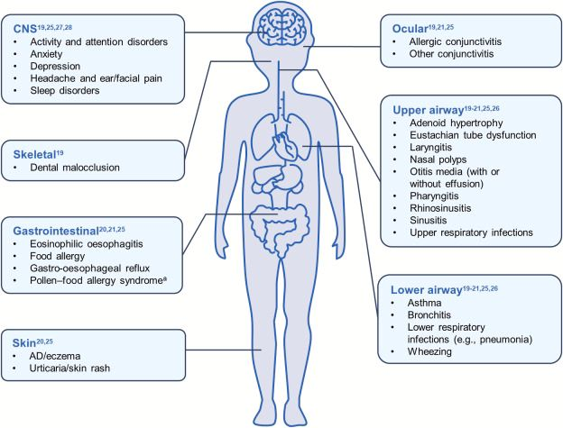

**Symptoms to Monitor**

Identifying respiratory allergy symptoms in children is pivotal for early detection and management. Key signs include:

- Persistent sneezing, runny or congested nose

- Frequent night time coughing

- Wheezing or shortness of breath

- Chest tightness or discomfort

- Itchy, watery eyes

- Sleep disruptions due to nasal congestion or coughing

**Diagnosis and Treatment**

Seeking medical advice for proper diagnosis is critical if a child exhibits respiratory allergy symptoms. Healthcare providers may conduct skin prick tests or blood tests to pinpoint specific allergens.

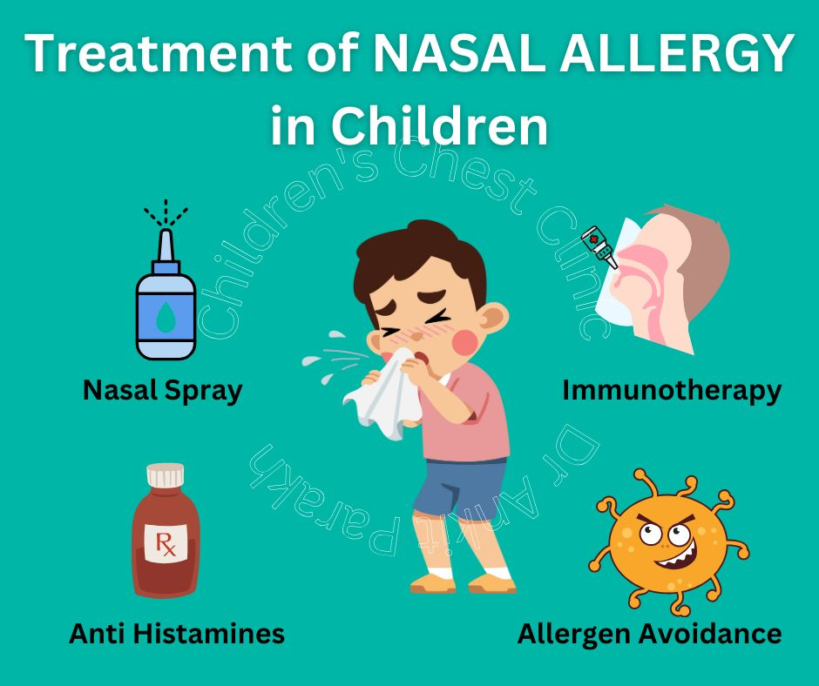

Tailored treatment plans may entail:

- Allergen avoidance: Managing respiratory allergies starts with minimizing exposure to known allergens, like keeping windows shut during peak pollen seasons, utilizing air purifiers, regular cleaning to curb dust mites, and ensuring pets stay out of the child's sleeping area.

**Medications:**

Medications like antihistamines, nasal corticosteroids, decongestants, and leukotriene modifiers are commonly prescribed for symptom management. Inhalers and nebulizers are typical for asthma to reduce airway inflammation and widen the airways.

- Immunotherapy: Severe allergic cases may warrant allergy shots (immunotherapy) involving gradual allergen exposure to desensitize the immune system.

- Breathing exercises: For asthma-related symptoms, pulmonary rehabilitation and breathing techniques can aid children in symptom management and enhancing lung function.

**Prevention methods**

Though complete prevention of respiratory allergies may not be feasible, parents and caregivers can adopt measures to minimize risks and symptom severity:

- Foster a healthy environment: Keep children's living spaces free of allergens by regular cleaning, dust reduction, and mold growth control.

- Encourage outdoor activities: Regular physical activity can enhance lung function and overall health, with caution advised during peak pollen hours or windy days.

- Maintain a balanced diet and hydration: A diet rich in fruits, vegetables, and omega-3 fatty acids can bolster the immune system and reduce inflammation. Adequate hydration is crucial for respiratory health.

- Educate schools and caregivers: Inform teachers, coaches, and caregivers about a child's allergies to ensure proper support in managing triggers during school and extracurricular activities.

**Conclusion**

Respiratory allergies in children present a mounting global health challenge, driven by environmental, genetic, and lifestyle factors. Timely diagnosis and tailored treatment play pivotal roles in symptom management and enhancing affected children's quality of life. By raising awareness, improving environmental conditions, and advocating healthier lifestyles, the burden of respiratory allergies among the younger populace can be alleviated. Continued research into allergy causes and treatments offers hope for better solutions to mitigate these conditions' impact on children's well-being.

**References :**

1. Asher MI, Pearce N. Global burden of asthma among children. The Lancet. 2014; 383(9911): 519-529.
2. Williams HC. The epidemiology of atopic dermatitis. Clinical and Experimental Dermatology. 2000; 25(8): 565-572.
3. von Mutius E, Sherrill DL, Mielck A, et al. International variations in asthma prevalence and the environment. European Respiratory Journal. 1998; 12(5): 1154-1164.
4. Arshad SH, Van den Bergh R, Bruckner T. Environmental and genetic factors influencing the development of allergic diseases in children. Immunology and Allergy Clinics of North America. 2016; 36(4): 661-679.
5. 5.Peat JK, Tovey E, Yang I, et al. Allergies and asthma in childhood: the role of early-life exposures. Environmental HealthPerspectives. 2007; 115(8): 1230-1235.
6. <https://www.sciencedirect.com/science/article/pii/S0954611124002877>
7. https://www.ankitparakh.com/treatment-of-allergic-rhinitis-or-nasal-allergy-in-children/