##### DESIGN OF CIRCULAR WATER TANK BY USING STAAD PRO V8i aChilumula Nagesh, bDhanavath Manoj, cKethavath Bharadhwaj, dNarender Reddy.

a U.G. Student, Department of Civil Engineering,, Guru Nanak Institutions Technical Campus, Ibrahimpatnam, Telangana, India.

b Assistant Professor, Department of Civil Engineering, Guru Nanak Institutions Technical Campus, Ibrahimpatnam, Telangana, India.

**ABSTRACT**

The design of a circular water tank using STAAD Pro V8i involves creating a structural model to analyze and optimize the tank's geometry, material properties, and load-carrying capacity under various conditions. This process includes defining the tank's dimensions, such as diameter and height, material properties (e.g., concrete or steel), and loads, such as hydrostatic pressure, self weight, wind, and seismic forces. STAAD Pro V8i enables precise structural analysis by simulating real-world loading conditions and determining critical parameters like stresses, deflections, and reinforcements. The software facilitates efficient design through automated calculations, ensuring safety, durability, and cost-effectiveness in compliance with relevant codes and standards.

**Keywords:** STAAD PRO V8i IS 3370 (PART 1-4) IS 456-2000

1. **INTRODUCTION**

The design of a circular water tank involves the engineering of an efficient, durable, and cost-effective structure to store water for domestic, industrial, or agricultural purposes. Circular tanks are preferred for their ability to evenly distribute hydrostatic pressure, minimizing material usage and stress concentrations. Key aspects of the design include determining the required capacity, selecting appropriate materials (commonly reinforced concrete), ensuring adequate wall thickness, reinforcement, waterproofing, and structural safety to withstand water pressure, environmental loads, and seismic forces. These tanks are widely used for their practicality, strength, and long-term reliability. The design of a circular water tank involves creating an efficient and durable structure to store water for various applications, such as domestic use, agriculture, and industrial processes. Circular tanks are favored for their ability to evenly distribute hydrostatic pressure, reducing material requirements and stress concentrations. The design process includes determining the required capacity, calculating dimensions, ensuring adequate wall thickness, and incorporating reinforcement to withstand water pressure and environmental loads. Proper foundation design, waterproofing, and adherence to safety codes are essential to ensure the tank's structural stability and longevity.

1. **LITERATURE**

Literature Review on the Design of Circular Water Tanks Using STAAD Pro V8i The design of circular water tanks is a critical aspect of civil engineering, focusing on structural stability, durability, and cost efficiency. Traditional methods of designing tanks relied on manual calculations based on guidelines provided in codes such as IS 3370 (for reinforced concrete water tanks). However, modern structural analysis software like STAAD Pro V8i has revolutionized the design process by offering advanced tools for modeling, analysis, and optimization. STAAD Pro V8i allows engineers to account for complex loading conditions, including hydrostatic pressure, seismic loads, and wind forces, while ensuring compliance with relevant design codes. Research has demonstrated the effectiveness of STAAD Pro V8i in reducing design time and improving accuracy compared to manual methods. Studies highlight its ability to handle non linear analyses, optimize reinforcement, and predict failure modes under dynamic and static loading conditions. Additionally, its 3D visualization features enable better understanding of stress distributions and deformation patterns in circular water tanks. The software's integration with design codes and its user-friendly interface make it a preferred choice for structural design in water infrastructure projects. Figures shows the result of the layout of the farm house using AutoCAD and 3ds max software. Divyaraj Sinh M. SOLANKI et. al 2023[1]: The study highlights the transformative role of Virtual Reality (VR) and Augmented Reality (AR) in civil engineering, improving construction processes, education, and project management. These technologies enable efficient design and planning, early error detection, and collaboration, reducing costs by 43-45% for project mock-ups. VR enhances education with immersive 1 environments and virtual site visits, while 2D plans can be converted into 3D interactive models for sustainable marketing and sales. VR and AR are poised to revolutionize civil engineering, delivering educational, and operational benefits. significant economic, Chen Wang et. al 2022[2]: Examines the use of Virtual Reality (VR) as an innovative tool to enhance civil engineering education. VR creates immersive and interactive environments, enabling students and educators to simulate real-world construction processes, analyze planned sequences, and visualize detailed architectural components. By integrating VR into both classroom and e-learning contexts, the study highlights its potential to increase engagement, efficiency, and effectiveness in teaching complex engineering 21 concepts, offering a transformative approach to civil engineering education. Philipp A. Rauschnabel et. al 2022[3]: The emerging field of Augmented Reality (AR) Marketing, defining it as a strategic subdiscipline in marketing that integrates AR experiences with brand-related media. The authors propose a customer journey model for AR Marketing and introduce the BICK FOUR framework (branding, inspiring, convincing, and keeping) to organize key marketing objectives. They distinguish AR Marketing from traditional digital marketing, emphasizing its unique characteristics, such as the blending of real and virtual worlds and its potential for disruption. Insights from 127 managers help inform current practices, while the paper also discusses ethical and legal considerations. The authors call for further research to deepen the understanding of AR's role in marketing and its potential impact on consumer behavior and brand engagement. Harikrishnan et. al 2021[4]: This research explores the use of virtual reality (VR) technology to enhance architectural education, specifically in building construction courses at Jordan University of Science and Technology (JUST), which traditionally rely on teacher-centered methods. The study developed BC/VR software that uses a 4D model (3D model with time) to simulate construction phases, providing immersive and non-immersive experiences for students. Through a structured questionnaire, the study evaluates the effectiveness of this VR tool in providing building construction information, increasing student enjoyment, and integrating with other courses. Results indicate that VR technology significantly outperforms traditional methods in all areas. The research also highlights VR's evolution and its potential to transform educational approaches by offering more interactive and engaging learning experiences. Xiong j. et. al 2021[5]: The potential of augmented reality (AR) and virtual reality (VR) to transform digital interaction, while highlighting engineering challenges such as the need for high performance displays in compact, wearable modules. It mentions significant advancements in optics and photonics, including ultra-thin optical elements like PPHOEs and LCHOEs, which offer innovative solutions and expanded possibilities for wavefront modulation. Additionally, nanoscale-engineered metasurfaces and micro-LEDs are noted for their potential to enable more compact, high-performance displays with improved brightness and stability. Future developments in device engineering and manufacturing are expected to further enhance the performance of these technologies for AR and VR applications. Arif, F et.al 2021[6] This study explores the use of Virtual Reality (VR) in teaching infrastructure management to civil engineering students. A bridge inspection module was developed for a Cave Automatic Virtual Environment (CAVE) system at NED University. The study involved 69 senior-year students enrolled in a structural design course, who provided feedback through structured assessments. Results indicated that students had better focus in VR environments and found the experience engaging, comfortable, and easy to use. The study suggests that more exposure to VR can improve students' learning experiences, though real-world applications may require advanced modeling techniques, such as LIDAR scanning, to address hidden structural damages. Yue Pan et. al 2021[7]: Artificial intelligence (AI) applications in construction engineering and management (CEM), focusing on both scientometric and qualitative analyses. The review explores the current state of AI adoption in CEM by analyzing 4,473 journal articles published between 1997 and 2020, highlighting a surge in research over the past decade. Key areas of AI's impact on CEM include automation, risk mitigation, efficiency, and digitalization, with a particular emphasis on six hot research topics: knowledge representation, information fusion, computer vision, natural language processing, optimization, and process mining. The paper also identifies six future research directions smart robotics, cloud VR/AR, AIoT, digital twins, 4D printing, and blockchains that aim to enhance automation and intelligence across the construction project lifecycle. The study underscores AI's transformative potential in improving labor productivity, safety, and overall project performance in the construction industry. Serkan Solmaz et. al 2020[8]: The study explores the integration of multiphysics computational fluid dynamics (CFD) simulations with augmented reality (AR) and virtual reality (VR) to enhance educational content in chemical reaction engineering (CRE). It discusses how interactive CFD simulations can improve understanding of complex engineering concepts, making them more accessible and engaging through AR/VR technologies. The paper highlights the challenges of integrating CFD with AR/VR, particularly in terms of system architecture, data handling, and real-time simulations. A methodology for a robust, sustainable system architecture is proposed, and a case study demonstrates its application in visualizing CFD results using AR. The study emphasizes the potential of AR/VR to create an immersive, interactive learning environment for students, improving both comprehension and interest in engineering simulations. Juan Manuel Davila Delgado et. al 2020[9]: This study provides valuable insights for both practitioners and researchers on the adoption of Augmented Reality (AR) and Virtual Reality (VR) in the construction industry. For practitioners, it offers clear use-cases, benefits, and challenges of AR/VR technologies, helping companies make informed adoption decisions and align with industry trends. For researchers, it formalizes and categorizes the current AR/VR research landscape, identifying gaps and providing a roadmap for future studies. However, the study is limited by its small sample size, restricted to UK-based professionals. Future work should include broader regional comparisons, cross disciplinary research, and exploration of worker upskilling for successful technology adoption. Noghabaei Met. al 2020[10]: A virtual safety training system using immersive virtual environments (IVE) to enhance workers' hazard recognition skills in construction sites. Workers wear virtual reality (VR) devices equipped with eye 2 tracking and brainwave-sensing technology to identify hazards in simulated construction settings. The platform analyzes workers' performance in hazard recognition tasks and provides personalized feedback, identifying areas where additional intervention is needed. This approach offers new insights into how a worker’s brain and eyes function together during hazard recognition and aims to improve safety training by providing tailored, real-time feedback to workers. Tang et. al 2020[11]: The increasing use of virtual reality (VR) in architecture, engineering, and construction (AEC), focusing on its application in both the industry and educational environments. VR has become a valuable tool for training architecture and civil engineering students, helping them navigate the complexities of construction projects. The paper 22 3. METHODOLOGY: reviews recent VR systems and evaluates their impact through a literature review and interviews with Master of Project Management (MPM) students. It aims to offer insights and a roadmap for integrating VR into AEC education and industry practices. Delgado et. al 2020[12]: This paper presents a study on the current use of augmented reality (AR) and virtual reality (VR) in the architecture, engineering, and construction (AEC) sectors and proposes a future research agenda. The study involved workshops and surveys with 54 experts from 36 organizations. Based on the data, six key use-cases for AR and VR in AEC were identified: stakeholder engagement, design support, design review, construction support, operations management, and training. The paper suggests three main research areas: engineering-grade devices for harsh construction environments, efficient workflow and data management, and the development of new capabilities to meet specific industry needs. The study aims to provide a foundation for practitioners to make informed adoption decisions and a roadmap for researchers to guide future efforts in AR and VR applications in AEC. Michelangelo Scorpio et. al 2020[13]: This study examines how immersive virtual reality (IVR) can improve smart city lighting design by addressing both technical and user-centered factors. Traditional tools focus on photometric parameters but overlook subjective user responses like comfort and emotional impact. IVR allows designers to create realistic, interactive virtual environments for evaluating lighting systems in key urban areas such as roads, green spaces, and buildings. Using the Unreal game engine, the study highlights VR’s ability to incorporate both objective and subjective lighting criteria, demonstrating its potential to enhance user-focused lighting designs. While VR shows promise, further research is needed to ensure its reliability in accurately simulating lighting effects. The paper emphasizes IVR’s role in creating innovative and collaborative lighting solutions for smart cities. Yong K. Cho et. al 2019[14]: This study examines the technology maturity gap between academia and the construction industry, focusing on how both sectors accept and reject emerging technologies differently. Through a partnership with the Construction Industry Institute's Horizon 360 team, the study surveyed academic research and the architecture, engineering, construction, and facilities management (AEC/FM) industry to assess their views on various technologies. The results highlight differences in how academia and industry perceive the relevance and maturity of these technologies. The findings aim to facilitate more active collaboration between academia and industry in adopting emerging technologies. Pratama et. al 2019[15]: investigates how Architecture, Engineering, and Construction (AEC) firms integrate virtual reality (VR) technology into their workflows, particularly during design and pre-construction phases. The study identifies the main use of VR in AEC as building walkthroughs, supported by a variety of software tools ranging from quick, off-the-shelf solutions to in-house developments tailored to specific needs. Through semi-structured interviews, the authors analyze the challenges and workflows of VR implementation, highlighting how modern VR systems enhance visualization while requiring customized solutions for features like model annotation and multi-user environments.

1. **METHODOLOGY**

Methodology for Designing a Circular Water Tank Using STAAD Pro V8i the design methodology for a circular water tank using STAAD Pro V8i involves the following steps:

1. Preliminary Design and Data Collection Define the tank’s functional requirements, such as capacity, height, and diameter. Determine site conditions, including soil type, seismic zone, and wind parameters. Gather design codes and standards (e.g., IS 3370 for water tanks, IS 456 for concrete).

2. Material Selection Specify materials for construction, such as concrete grade, reinforcement type, and steel properties.

3. Geometric Modeling in STAAD Pro V8i Create a 3D model of the circular water tank, including base slab, walls, and roof (if required). Define dimensions, such as wall thickness, tank height, and radius.

4. Load Application Apply various loads, including: Hydrostatic Load: Water pressure distribution. Dead Load: Self-weight of the structure. Live Load: Operational load. Seismic Load: Based on site-specific seismic data. Wind Load: For tanks exposed to wind forces.

5. Structural Analysis Use STAAD Pro V8i to analyze the tank under all applied loads. Evaluate stress distribution, displacement, and structural stability.

6. Design of Reinforcement Based on analysis results, design reinforcements for tank walls, slab, and roof to resist tensile and compressive stresses.

7. Optimization and Validation Optimize the design for material efficiency and cost effectiveness. Verify compliance with relevant codes and standards.

8. Output and Documentation Generate reports, including design calculations, drawings, and structural details.

9. Finalization Review the design and incorporate feedback from stakeholders before construction. This methodology ensures the structural safety, durability, and functionality of the circular water tank, leveraging STAAD Pro V8i's advanced analysis and design capabilities.

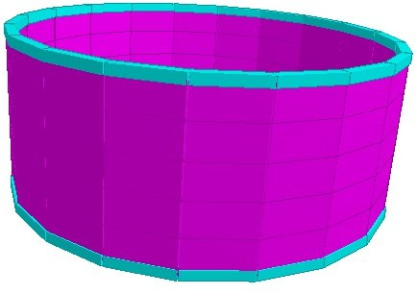

**Figure 1.** 3D Rendering View of Water Tank

Design of an intez tank for a capacity of 250,000lts Assuming height of tank floor above G.L 12m.

Safe bearing capacity of soil 100kn/m^2 Wind pressure as per IS875 1200N/m^2 Assuming M20 concrete

For which σcbe = 7N/mm^2 , σcc = 5N/mm^2 Direct tension σt = 5N/mm^2

Tension in bending = 1.70 N/mm2 Modular ratio *m =* 13

For Steel stress,

Tensile stress in direct tension =115 N/mm2

Tensile stress in bending on liquid face =115 N/mm2 for *t*

*<*225 mmand 125 N/mm2 for / > 225 mm.

**Solution:** Taking the volume as 0.585 *D3* for proportion given in Fig.

D = 7.50 m. The dimension of the Tank is shown in fig.

**Design of Roof Dome:**

Considering a rise of 1.50 m, radius of the roof dome is given from

1.50(2R-1.50) = (3.75)2 R = 5.4375m.

Cos φ = (5.4375 – 1.50)/5.4375

= 0.7241

and φ= 43.602 < 51.8°

Hence no tension Assuming t = 100mm. Self -wt. =2400N/m^2

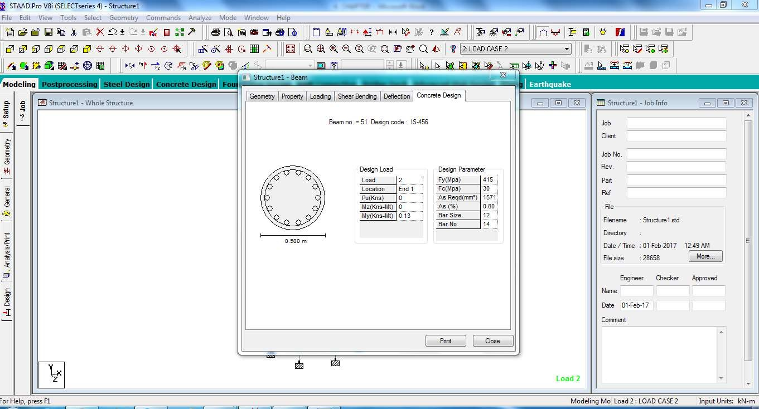

**Figure 2.** Design of Columns Detailing

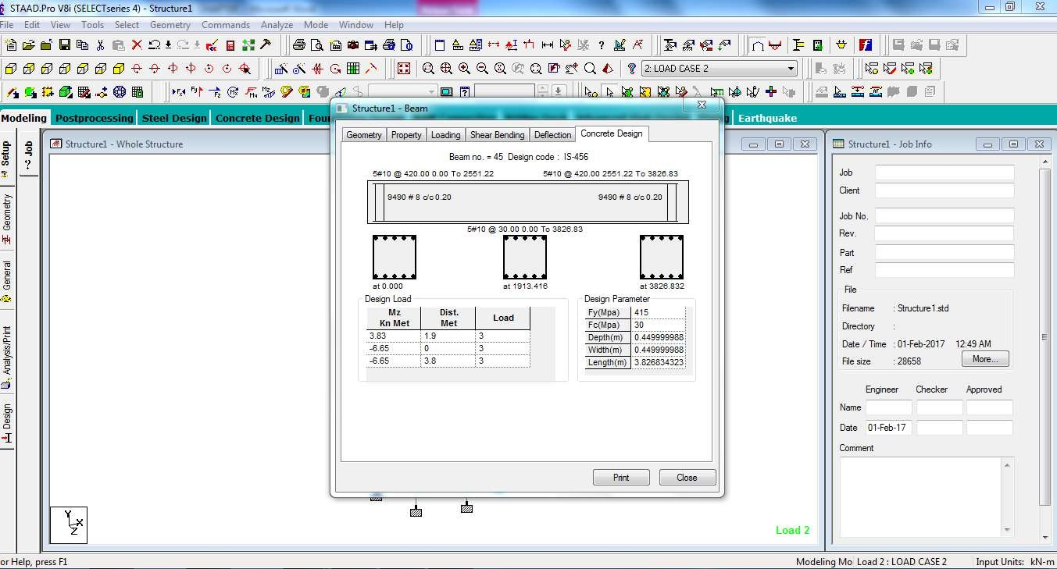

**Figure 3.** Design & Detailing of Beams

**CONCLUSION**

Conclusion for the Design of a Circular Water Tank Using STAAD Pro V8i The design of a circular water tank using STAAD Pro V8i proves to be an efficient and reliable approach for ensuring structural safety, durability, and cost-effectiveness. The software enables accurate modeling, analysis, and optimization by considering various loading conditions such as hydrostatic pressure, seismic forces, and wind loads. Its ability to comply with design codes and perform detailed stress analysis helps in designing an optimal reinforcement layout, minimizing material waste, and ensuring structural stability. Furthermore, STAAD Pro V8i simplifies the iterative design process, reduces manual errors, and provides detailed reports and drawings for construction. Overall, STAAD Pro V8i enhances the precision and efficiency of water tank design, making it an essential tool for modern structural engineering practices

1. **REFERENCES**

1. Solanki, DivyarajSinh M. Laddha, Hrushikesh Kangda, Muhammed Z, Noroozinejad Farsangi, Ehsan. Augmented and virtual realities: the future of building design and visualization 2023, E-ISSN 2450-8594 , <https://doi.org/10.59440/ceer-2023-0002>

2. Chen Wang, Yutong Tang, Mukhar A. kassem, Heng Li, Bingqing Hua, Application of VR Technology in Civil Engineering Education-2022, <HTTPS://DOI.ORG/10.1002/CAE.22458>

3. Rauschnabel, PA, Babin, BJ, Tom Dieck, MC, Krey, N and Jung, T 2022. What is augmented reality marketing? Its definition, complexity, and future. Journal of Business Research, 142, 1140-1150, <https://doi.org/10.1016/j.jbusres.2021.12.084>

4. Xiong, J, Hsiang, EL, He, Z, Zhan, T and Wu, ST 2021. Augmented reality and virtual reality displays: emerging technologies and future perspectives. Light: Science & Applications 10, Article [https://doi.org/10.xxxx/yyyyy number 216](https://doi.org/10.xxxx/yyyyy%20number%20216),

5. Harikrishnan, A, Abdallah, AS, Ayer, SK, El Asmar, M and Tang, P 2021. Feasibility of augmented reality technology for communication in the construction industry. Advanced Engineering Informatics, 50, 101363, <https://doi.org/10.xxxx/yyyyy>

6. Pan, Y., & Zhang, L. (2021). Roles of artificial intelligence in construction engineering and management: A critical review, <https://doi.org/10.xxxx/yyyyy>

7. Arif, F 2021. Application of virtual reality for infrastructure management education in civil engineering. Education and Information Technologies, 26(4), 3607 3627, <https://doi.org/10.xxxx/yyyyy>

8. Serkan Solmaz, Tom Van Gerven (2020). Integration of interactive CFD simulations with AR and VR for educational Use in CRE, volume [https://doi.org/10.1016/B978-0-12 823377-1.50336-0 48](https://doi.org/10.1016/B978-0-12%20823377-1.50336-0%2048),

9. Delgado, JMD, Oyedele, L, Demian, P and Beach, T 2020. A research agenda for augmented and virtual reality in architecture, engineering and construction. Advanced Engineering Informatics, 45, https://doi.org/10.1016/j.aei.2020.101122 101122,

10. Noghabaei, M and Han, K 2020, November. Hazard recognition in an immersive virtual environment: Framework for the simultaneous analysis of visual search and EEG patterns. In Construction Research Congress 2020: Computer Applications (pp. 934-943). Reston, VA: American Society of Civil Engineers.

11. Tang, YM, Au, KM, Lau, HC, Ho, GT and Wu, CH 2020. Evaluating the effectiveness of learning design with mixed reality (MR) in higher education. Virtual Reality, 24(4), 797- 807, <https://doi.org/10.xxxx/yyyyy>

12. Delgado, JMD, Oyedele, L, Demian, P and Beach, T 2020. A research agenda for augmented and virtual reality in architecture, engineering and construction. Advanced Engineering Informatics, 45, [https://doi.org/10.1016/j.aei.2020.101122 101122](https://doi.org/10.1016/j.aei.2020.101122%20101122),

13. Michelangelo Scorpio, Roberta Laffi, Massimiliano Masullo, Giovanni Ciampi, Antonio Rosato, Luigi Maffei and Sergio Sibilio 2020, Virtual Reality for Smart Urban Lighting Design, Energies 2020, https://doi.org/10.3390/en13153809 13(15).3809,

14. Pratama, L.A., Dossick, C.S. (2019). Workflow in Virtual Reality Tool Development for AEC Industry. In: Mutis, I., Hartmann, T. (eds) Advances in Informatics and Computing in Civil and Construction Engineering. Springer, Cham. https://doi.org/10.1007/978-3-030 00220-6_36

15. Cho, YK, Jang, Y, Kim, K, Leite, F and Ayer, S 2019. Understanding different views on emerging technology acceptance between academia and the AEC/FM industry. In Computing in Civil Engineering 2019: Data, Sensing, and Analytics (pp. 614-621). Reston, VA: American Society of Civil Engineers. 26