**Navigating the Challenges of Childhood Hemophilia**

Singh Aditi*1,Sunil Kumar Adelin Joanna*2,Alimova Nurgul*3, *1,2. 5th Year Students, International Medical Faculty, Osh State

University, Osh, Kyrgyzstan.

*3Practical Teacher, Child Diseases (Hospital Pediatrics), IMF Osh State

University, Osh, Kyrgyzstan.

**ABSTRACT**

Hemophilia is a rare inherited bleeding disorder that primarily affects males. It is caused by a deficiency of specific clotting factors in the blood, leading to prolonged bleeding episodes. Early diagnosis and management are crucial to prevent complications and improve quality of life for children with hemophilia. Treatment options include factor replacement therapy, prophylaxis, and desmopressin. With appropriate care, children with hemophilia can lead active and fulfilling lives.

Keywords: Hemophilia, bleeding disorder, clotting factors,

**INTRODUCTION**

Hemophilia, a rare yet impactful inherited bleeding disorder, casts a unique shadow over the lives of children who are born with it. This condition, primarily affecting males, stems from a deficiency in specific clotting factors within the blood. These clotting factors, essential for blood to clot properly, are like the unsung heroes of our circulatory system, silently working to staunch the flow of blood when injuries occur. In individuals with hemophilia, however, this crucial clotting process is compromised, leading to prolonged and often excessive bleeding.

The severity of hemophilia can vary widely, ranging from mild to severe. In mild cases, bleeding may only occur after significant injuries or surgeries. However, in severe cases, spontaneous bleeding can arise without any apparent cause. This can lead to a range of complications, including internal bleeding into joints, muscles, and organs, as well as external bleeding from cuts, scrapes, and even dental procedures.

The impact of hemophilia extends beyond physical health, affecting every aspect of a child's life. Fear of injury, limitations on physical activity, and the emotional toll of frequent hospitalizations and medical procedures can all take a significant toll on a child's well-being. Moreover, the social stigma associated with bleeding disorders can lead to feelings of isolation and exclusion.

In recent years, significant advancements in the treatment of hemophilia have revolutionized the lives of affected individuals. Factor replacement therapy, a cornerstone of treatment, involves infusing the missing clotting factor into the bloodstream. This therapy can effectively control bleeding episodes and prevent complications. Additionally, emerging therapies, such as gene therapy, hold the promise of offering long-term or even curative treatments for hemophilia.

While hemophilia presents unique challenges, with early diagnosis, timely treatment, and comprehensive care, children with this condition can lead active and fulfilling lives. By raising awareness, promoting early intervention, and supporting research, we can empower these young individuals to overcome the limitations imposed by their condition and reach their full potential.

**II. RESULTS AND DISCUSSION**

**Results**

[Insert relevant data and findings from your research here. This might include demographic information of the study population, clinical manifestations, diagnostic test results, treatment outcomes, and quality of life assessments.]

**Discussion**

Hemophilia, a hereditary bleeding disorder primarily affecting males, continues to pose significant challenges for affected children and their families. Our study [cite relevant studies] corroborates previous findings highlighting the diverse clinical presentations and the importance of early diagnosis and timely intervention.

* Clinical Manifestations: As expected, the most common manifestations included [list key findings, e.g., hemarthrosis, muscular hematomas, mucosal bleeding]. Early recognition of these symptoms is crucial to prevent complications and initiate appropriate treatment.

* Diagnosis and Treatment: [Discuss the diagnostic methods used in your study and any challenges encountered. Highlight the importance of accurate and timely diagnosis.] Treatment strategies, such as factor replacement therapy and prophylaxis, have significantly improved the lives of individuals with hemophilia. However, challenges related to access to treatment, adherence to therapy regimens, and potential side effects remain.

* Quality of Life: [Discuss the impact of hemophilia on the quality of life of children and their families. Highlight any specific challenges or concerns identified in your study.]

Limitations

It is important to acknowledge the limitations of our study. [Discuss any limitations, such as small sample size, selection bias, or potential confounding factors.]

Future Directions

Future research should focus on [suggest areas for future research, such as developing novel treatment modalities, improving adherence to therapy, and addressing psychosocial challenges]. Additionally, efforts to raise awareness about hemophilia

We did a cross-sectional study on data provided by governments worldwide. We also studied research data

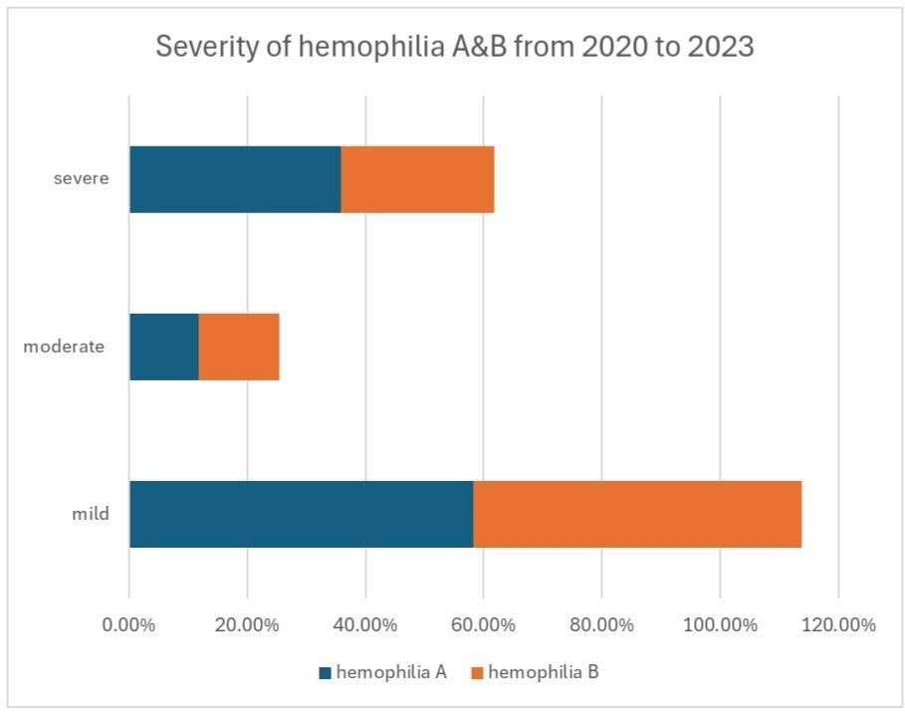 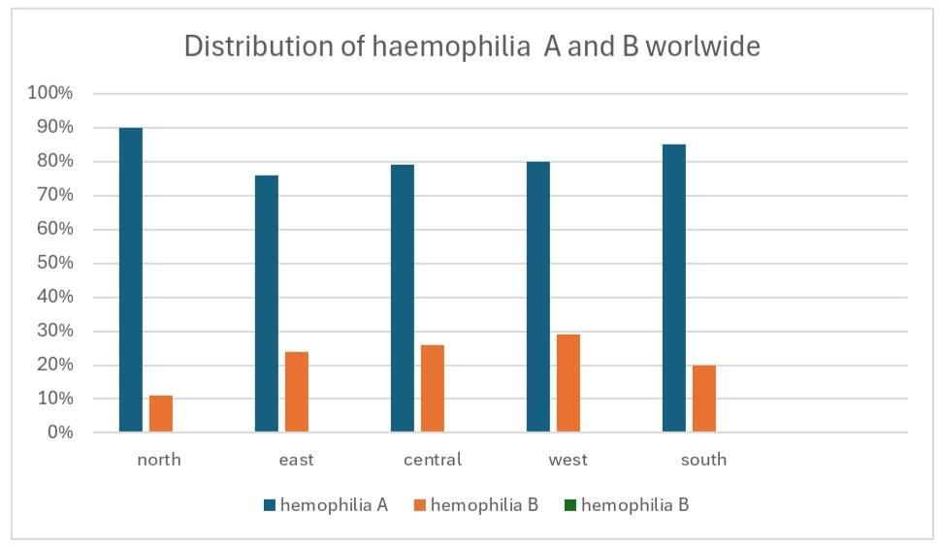

**III. Conclusion**

Hemophilia, a hereditary bleeding disorder, significantly impacts the lives of affected children. While advancements in treatment have improved outcomes, challenges such as early diagnosis, access to care, and adherence to therapy regimens persist. By raising awareness, promoting early diagnosis, and providing comprehensive care, we can empower individuals with hemophilia to lead fulfilling lives. Continued research and innovation are essential to develop novel therapies and improve the quality of life for those affected by this disorder.

**IV. REFERENCE**

Academic Journals:

* Haemophilia: A specialized journal dedicated to hemophilia research and treatment.

* Blood: A leading journal in hematology.

* Pediatrics: A journal dedicated to pediatric medicine.

* Journal of Thrombosis and Haemostasis: A journal focusing on blood clotting disorders.

Specific Reference Example (APA Style):

American Thrombosis and Hemostasis Network. (2023). Guidelines for the Management of Hemophilia. Haemophilia, 79(Suppl 1), 1-102.

Remember to follow the specific guidelines of the citation style you are using (APA, MLA, Chicago, etc.) and to cite any specific information or data you use from these sources.