**AN OVERVIEW ON HEART TRANSPLANTATION IN ADVANCE HEART FAILURE**

**Dr. D. Rama Brahma Reddy*1, Ch. Anuradha*2, S. Hymavathi*3**

1* Principal, Dept. of Phytochemistry, Nalanda Institute of Pharmaceuticals sciences, Guntur

2*Assistant professor, Dept. of Pharmaceutical analysis and Quality assurance, Nalanda Institute of Pharmaceutical Sciences, Guntur

3*Student, B. Pharmacy, Nalanda Institute of Pharmaceutical Sciences, Guntur

**ABSTRACT:**

Heart transplantation (HTx) remains the last therapeutic resort for patients with advanced heart failure. The present work is a clinically focused review discussing current issues in heart transplantation. Several factors have been associated with the outcome of HTx, such as ABO and HLA compatibility, graft size, ischemic time, age, infections, and the cause of death, as well as imaging and laboratory tests. In 2018, united network for organ sharing (UNOS) changed the organ allocation policy for HTx people . Advanced heart failure and resistant angina are among the main indications of HTx, whereas active infection, peripheral vascular disease, malignancies, and increased body mass index (BMI) are important contraindications. The main complications of HTx include graft rejection, graft angiopathy, primary graft failure, infection, neoplasms, and retransplantation. Recent advances in the field of HTx include the first two porcine-to-human xenotransplantation, the inclusion of hepatitis C donors, donation after circulatory death, novel monitoring for acute cellular rejection and antibody-mediated rejection, and advances in donor heart preservation and transportation.

**Key words:**

Heart transplantation, heart failure, indications, contraindications, complications, xenotransplantation.

**INTRODUCTION:**

The first attempt was made 118 years ago, in 1905, by Alexis Carrel and Charles Guthrie at the University of Chicago, and the second attempt was made by Mann in 1933, both in dogs. Twenty years later, Marcus at the Chicago Medical School studied methods of preserving grafts while developing techniques to make the graft act as a pump. The next great scientist was Demikhov; from 1951 to 1962, he laid the foundations for heterotopic HTx with experiments in dogs. In 1953, Neptune applied hypothermia to the recipient and donor. In 1957, Webb and Howard applied the preservation of grafts to potassium solutions, and in 1959, Goldberg at the University of Maryland performed the first orthotopic HTx in dogs. The same year, Cass and Brock at the Guy’s Hospital in London performed auto transplantation and homologous transplantation and essentially introduced the bicaval technique, while in 1950, Dr. Shumway at Stanford performed orthotopic HTx in dogs with cardiopulmonary bypass. 1960, as the concept of graft rejection was beginning to be understood, lower achieved a recipient dog lifespan of more than 6 months with the administration of corticosteroids and azathioprine. In 1964, Hardy at the University Hospital in Jackson, Mississippi, performed the first human transplantation (xenotransplant) using a chimpanzee heart. Then, in 1967, the first interhuman HTx was performed by Dr. Christiaan Nethling Barnard at Groote Schuur Hospital in Cape Town, South Africa.

**HISTORY:**

The history of heart transplantation is broad, partly because of the time it took to solve such a complex problem. The prehistory of transplantation can be divided into three periods: the mythologic (before 500 B.C.), before anatomy and surgical techniques were practiced; the miraculous (500-1300 B.C.), during which the surgical method was alluded to but subverted by divine intentions; and the Renaissance (after 1300), when the knowledge of anatomy and surgery blossomed and realistic notions of transplantation were formed. Mythologic.

**ANOTOMY & PHYSIOLOGY:**

Through a knowledge of the heart and major vessels in the mediastinum is required to understand the procedure. Historically two types of transplant procedure have been described.

* Orthotopic heart transplantation involving excision of the recipients.
* Outline the selection process of the patient considers appropriate condidates for cardiac transplantion.

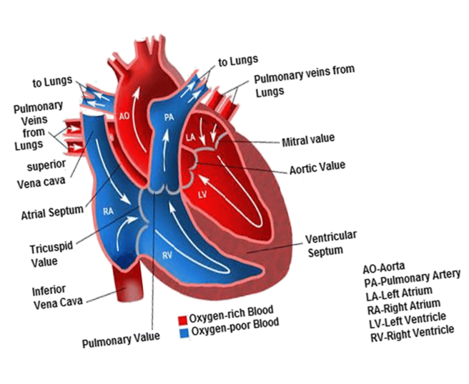

**FIGURE: 01 ANOTOMY & PHYSIOLOGY**

**INDICATIONS OF HEART OF FAILURE:**

The indications of heart failure refer to the signs, symptoms, and diagnostic findings that suggest the person of heart failure. In other words, they are red flags that indicate some one may be experiencing heart failure.

Indications of heart failure can be divided into several categories, including:

**1.CLINICAL INDICATIONS:**

Symptoms and signs that can be observed or reported by the patient, such as shortness of breath, fatigue, or swelling.

**2.DIAGNOSTIC INDICATIONS:**

Abnormalities in found on diagnostic tests, such as echocardiogram, electrocardiogram (ECG), Chest X-ray, or blood tests.

**3.LABORATORY INDICATIONS:**

Abnormalities in blood test results such as elevated B-type natriuretic peptide (BNP) levels or abnormal kidney function tests.

* **CHRONIC HEART FAILURE:**

Chronic heart failure (CHF) is a progressive syndrome that results in a poor quality of life for the patient and places an economic burden on the health care system. Despite advances in the control of cardiovascular diseases such as myocardial infarction (MI), the incidence and prevalence of CHF continue to increase.1 An accurate estimate of disease burden is difficult to gather because of the vast number of patients with asymptomatic left ventricular (LV) dysfunction. As the population ages, there is an epidemiological shift toward a greater prevalence of clinical heart failure with preserved LV function, the so-called stiff-heart syndrome. In fact, heart failure with preserved systolic function may account for up to two-thirds of cases in patients older than 70 years.2 Regardless of age, the lifetime risk of developing heart failure is approximately 20% for all patients older than 40 years.

* **ACUTVE HEART FAILURE:**

Acute heart failure (AHF) is defined by a rapid or gradual onset of symptoms and/or signs of heart failure (HF) leading the patient to seek urgent medical attention with con sequent unplanned hospitalization or an emergency department visit. This condition typically requires initiation or intensification of treatment. Acute heart failure may present as a clinical deterioration in patients with a previous diagnosis of HF (acute decompensated HF) or ‘de novo’ in patients without a previous history of HF, and all these clinical presentations may occur as a new onset or exacerbation of pre-existing HF.

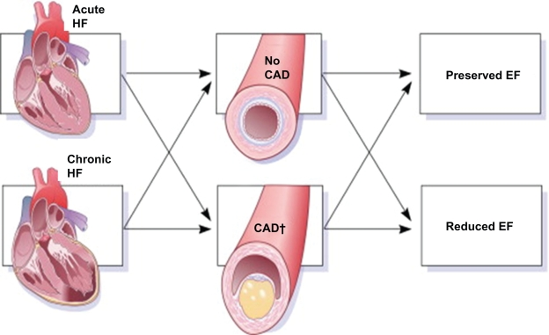

**FIGURE NO:2- Acute and Chronic heart failures.**

**EPIDEMIOLOGY OF HEART FAILURE:**

The epidemiology of heart failure (HF) has been the subject of sustained interest since it was designated as a new epidemic in 1997. This designation was grounded in the observation of an exponential increase in HF hospitalizations and generated a provocative hypothesis examined in several epidemiological investigations. These investigations convincingly demonstrated that, since the middle of the 20th century, the incidence of HF had not increased in White populations, and that the increase in hospitalizations was related to improvement in survival after the diagnosis of HF, leading to an increase in the pool of persons living with HF and candidates for recurrent hospitalizations. Further, the heterogeneity of the HF syndrome became widely recognized including, specifically, the fact that HF could present with preserved or reduced left ventricular ejection fraction (EF). HF with preserved EF represents ≈50% of all HF cases in most studies, and therapeutic trials failed to identify effective treatments for HF with preserved EF. These epidemiological observations have been summarized in several comprehensive reviews including in *Circulation Research* in 2013. Importantly, these reviews highlighted major gaps in our knowledge of the epidemiology of HF in diverse populations.

**ETIOLOGY OF HEART FAILURE:**

The diseases that can lead to HF are very different and their detection is of great importance, as this can modify the diagnostic, therapeutic and preventive approach, as well as determine prognosis.Thus, a nonspecific diagnosis of "heart failure" in patient reports is unacceptable; the type of structural cardiac abnormality and the risk factors that caused it must be included as well as the factors triggering the acute decompensation when relevant.

**EQUIPMENTS OF HEART TRANSPLANTATION:**

The key equipment needed is a well-preserved donor heart and an eligible recipient. Cardiopulmonary bypass is required during the procedure. Along with this, various other surgical instruments including but not limited to surgical blades and saw to open and dissect the chest, clamps to retract while dissecting, cannulas to engage the major vessels, and sutures to perform anastomosis as well as to close the chest post-procedure are needed**.**

**The Donor's Heart:**

Donor heart excision begins with joining pulmonary veins and then trimming the left atrial cuff, so it corresponds to that of the recipient. The mitral valve is inspected and the foramen ovale to determine if it is patent or closed. The great vessels, including the aorta and pulmonary artery, are excised.

* **Organ selection:**

Liberal donor acceptance practices have been implemented in the context of advances in allograft preservation, innovations in perioperative care, and in post-transplant management . When a donor is identified, cardiac function is evaluated with echocardiography (to also evaluate valvular pathology), and in older donors (>40 years) evaluating for pre-existing coronary artery via invasive or non-invasive angiography disease is recommended but not always feasible. Once cardiac function is assessed as satisfactory, donor–recipient size and sex match, best approximated by the calculated donor–recipient predicted heart mass ratio is evaluated, since discrepancy in size between the recipient and the donor (a predicted heart mass ratio of <0.86) leads to increased adverse events. Using predicted heart mass may increase the acceptable pool by a third. Although increased donor age is associated with higher recipient mortality risk, favourable survival has been shown with organs from donors >50 or even >60 years old, a practice primarily in Europe. Donor comorbidities such as diabetes mellitus and hypertension affect post-transplant outcomes.

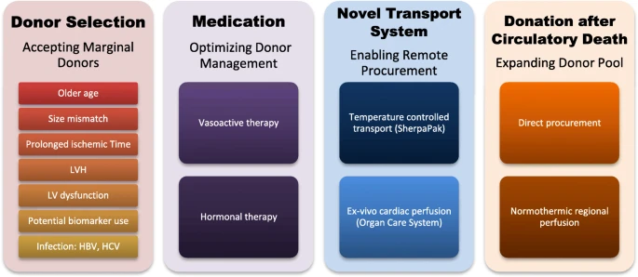

**FIG: 3 Simultaneous expansion of the donor pool and recipient phenotypes in heart transplantation**.

* **Heart transplantation from donation after circulatory death donors:**

After the first report of successful distant retrieval and transplantation of three adult donation after circulatory death (DCD) hearts in 2014, DCD heart transplant programmes commenced in the UK, Europe, and North America. While the upper age limit for acceptance of DCD donors for HT varies between centres, it is lower than for brain death donors (typically <50 years). This is due to the limited ability to screen the DCD donor for pre-existing heart disease and the concern regarding susceptibility of the heart from older donors to the obligatory period of warm ischaemia intrinsic to the DCD pathway. An echocardiogram demonstrating normal biventricular and valve function before withdrawal of life-support therapy (WLST) is the major requirement.

* **Immunological considerations:**

An increasing number of heart transplant candidates have circulating anti-HLA antibodies as a result of exposures that result in all sensitization such as multi-parous women, those with MCS due to associated use of blood products or those operated with congenital heart disease. The ideal outcome in all sensitized patients after transplant is the absence of donor-specific antibody (DSA).

* o**rgan preservation techniques and distant procurement:**

Successful cardiac transplantation is still largely dependent on the viability and condition of the donor myocardium at the time of implantation. Following organ procurement, ischaemia is the main cause of tissue injury. Therefore, cardiac preservation is a key component for distant procurement and successful outcomes. After cardioplegia, the heart is excised, placed in preservation solution, and stored on ice, in commercially available cooling boxes, at a temperature range of 4–8°C. Three general principles guide the formulation of cardioplegic and preservation solutions: rapid reduction of tissue metabolic rate by profound hypothermia and electro-mechanical arrest of the heart, (ii) provision of a biochemical medium that maintains tissue viability and structural integrity, and (iii) prevention of reperfusion injury. There are a number of preservation solutions available; however, there is no consensus regarding the optimal composition of the preservation solution, with widespread variability among transplant centres worldwide.

* **Heart transplantation from donation after circulatory death donors:**

After the first report of successful distant retrieval and transplantation of three adult donation after circulatory death (DCD) hearts in 2014, DCD heart transplant programmes commenced in the UK, Europe, and North America. While the upper age limit for acceptance of DCD donors for HT varies between centres, it is lower than for brain death donors (typically <50 years). This is due to the limited ability to screen the DCD donor for pre-existing heart disease and the concern regarding susceptibility of the heart from older donors to the obligatory period of warm ischaemia intrinsic to the DCD pathway. An echocardiogram demonstrating normal biventricular and valve function before withdrawal of life-support therapy (WLST) is the major requirement.

**GRAFT SELECTION:**

Whether HTx is successful or not depends on several factors. The most important factors are discussed below.

* **ABO and HLA Compatibility:**

ABO blood group antigens are in the membranes of erythrocytes and endothelial cells of tissues. Despite the tolerance shown by the immune system of newborns with transplants incompatible with the ABO system, in adults, ABH antibodies bind to the endothelium of the graft with activation of the complement leading to injury and necrosis of the allograft in the process of hyperacute rejection.

* **Graft Size:**

Probably the most important parameter in graft selection is matching the appropriate graft size to the candidate recipient. Multiple measurements have been used in the past, such as height, body weight, body mass index (BMI), and body surface area (BSA) [[7](https://www.mdpi.com/2077-0383/13/2/558#B7-jcm-13-00558)]. Now, in many centres, a relatively new measure called “Predicted Heart Mass (PHS)” is used, which is the sum of the calculated mass of the left and right ventricles.

* **Ischemic Time:**

The time during which the graft is removed from the donor until it is transplanted into the recipient is called ischemic time, and this plays a very important role in both the viability of the graft and the survival of the recipient. The usual tactic is to transfer the grafts using the static cold storage technique, in which the heart is placed in a cold preservation solution and transferred to a special icebox. However, hypothermia can also have harmful effects as it causes a redistribution of cell membrane lipids, affecting its integrity while diverting its metabolism from aerobic to anaerobic, increasing oxidative stress. The mechanism of damage that the graft is subjected to due to transfer from the donor to recipient is called ischemia/reperfusion injury. During hypoxia, there is a deficit in adenosine triphosphate (ATP) production, leading to dysfunction of Na+/Ca++ channels, resulting in an increase in the intracellular concentration of Ca++ which causes the production of an increased amount of free radicals. At the same time, the endothelium produces vasoconstrictor and pro-inflammatory factors that increase the damage to the ischemic area. On the other hand, during reperfusion, the activation of leukocytes is promoted by the produced cytokines and proteases, while the restoration of the function of the Na+/Ca++ channels leads to an increased uptake of intracellular Ca++. This results in increased free radical production and mitochondrial swelling.

* **Age:**

Age plays an important role in donor selection. The upper age limit is 60 years old to ensure better and longer-term function of the graft and reduce mortality after transplantation. Research has found an inversely proportional relationship between donor age and recipient survival. The most likely mechanisms are the increased atherosclerosis to which these grafts are subjected, the greater rate of fibrosis, greater vulnerability to cold ischemic time, and valvular lesions. This is confirmed by studies that showed that groups of elderly patients who received grafts from older donors showed a negative impact on one-year survival.

* **Cause of Death:**

Cause of death is an important criterion for transplant eligibility. The main “source” is from donors who are victims of circulatory accidents, fatal gunshot wounds without damage to cardiac structures, brain death from anoxic conditions, or histological pathologies of the parenchyma, such as tumours (exceptions are gliomas and medulloblastomas).

* **Laboratory-Imaging Tests:**

During brain death due to dysautonomia of the autonomic nervous system, hemodynamic instability occurs with parallel electrolyte and acid–base balance disturbances. Many consensus papers recommend targeting a donor’s mean arterial pressure > 65 mmHg with the lowest possible dosage of inotropic and vasoconstrictor drugs. Additionally, if an ejection fraction is found to be <45%, it is re-checked in 6 h, and the donor is put under more extensive control.

**Allocation System—Graft Distribution:**

In 2018, UNOS renewed the transplantation system for patients on the heart transplant waitlist. The purpose of this was to prioritize patients with a more severe clinical condition in order to achieve a reduction in the mortality of people on the waiting list. These changes were necessitated by the increase in the number of candidate recipients and the increase in the use of mechanical circulatory support devices (MCSD). The 3-tiered system (1A,1B, C) was modified to a 6-tiered system (1–6). LVADs who have been using them for more than one month, retransplants, and patients with cardiomyopathies as well as ischemic heart disease with intractable angina pectoris. Finally, category 2 was divided into two others: the 5th for patients on the list for transplantation for more than one organ, and the 6th for the remaining candidates.

**TRANSPLANTATION TECHINIQUES/ TRETEMENT:**

**SURGICAL:**

 In the situation where only, the heart is being retrieved for transplantation, the entire donor left atrium can be excised with the donor heart. The pulmonary veins are individually transacted at the pericardial reflection and a cuff of left atrium is created by connecting incisions in these transacted pulmonary veins. In this situation, much of the posterior wall of the left atrium needs to be removed to prevent redundancy in the anastomosis.

The heart is reflected cephalad and to the right, exposing the entry of the left inferior pulmonary vein into the pericardium. Incision is made in the left atrium, midway between the coronary sinus and the origin of the inferior pulmonary vein from the left atrium.

He ascending aorta is cross-clamped just proximal to the aortic cannula and excision of the diseased heart proceeds. Incision is made in the right atrial appendage. This incision is extended inferiorly, anterior to the inferior vena cava cannula. It is also extended posteriorly toward the aorta root. The left atrium is entered through the superior limb of the fossa ovalis. Aorta and pulmonary artery are transacted just above the respective semilunar valves. The interatrial septum is divided down to the level of the coronary sinus.

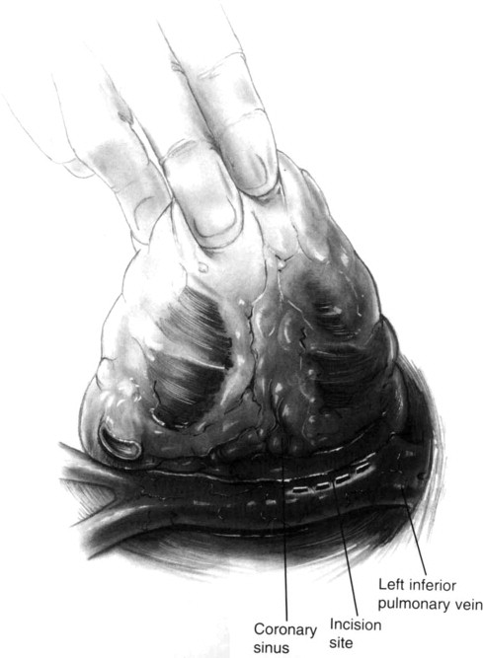

**FIG:4 surgical technique**

The coronary sinus demarcates the atrioventricular sulcus. The scissor is placed in the coronary sinus and the diseased heart removed in the line of the AV groove. The atrial appendage is also removed. Here is depicted the appearance of the recipient mediastinum after excision of the diseased recipient heart.

Implantation of donor heart. The implant procedure begins with anastomosis of donor and recipient left atria. Using a 3–0 monofilament suture, anastomosis is begun at the level of the left atrial appendage. Continuous suture technique is employed with care taken to appropriately align the interatrial septum. An easy manoeuvre, and one that may prolong the period of safe myocardial ischemia, is the insertion of a retrograde coronary sinus catheter for the administration of retrograde cold blood cardioplegia. This has become routine in our practice.

Right atrial anastomosis between donor and recipient is initiated next. Incision is made in the donor right atrium, beginning at the inferior vena cavel orifice and extending toward the atrial appendage. Special care must be exercised to avoid the area of the sinus node. This incision is sized to approximate the cuff of recipient right atrium to which it is to be connected. 4–0 monofilament suture is employed to join donor and recipient right atrium. The anastomosis is begun at the midpoint of the interatrial septum and carried cephalad and caudad in such a manner as to accurately align the interatrial septum and reperfusion are being accomplished.

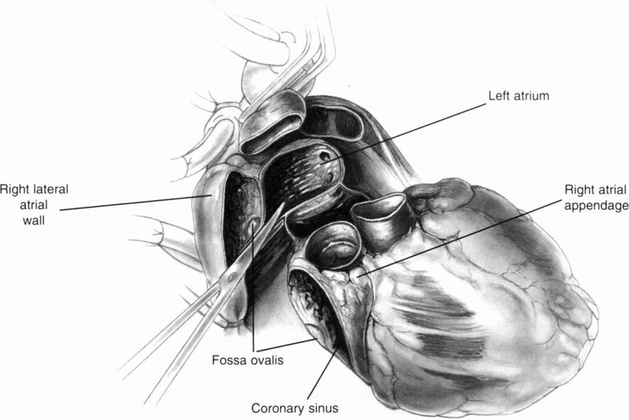

FIG:5 surgical technique

**RISKS OF HEART TRANSPLANTATION:**

The most common risks and complications of heart transplant surgery include:

* Organ rejection.
* Infections (because of immune system suppression).
* Graft failure (where part of the connection between your body and the donor heart fails for any reason).
* Cardiac allograft vasculopathy (CAV).
* [Kidney disease](https://my.clevelandclinic.org/health/diseases/15096-kidney-disease-chronic-kidney-disease) and [kidney failure](https://my.clevelandclinic.org/health/diseases/17689-kidney-failure).
* Osteoporosis.
* [High blood pressure (hypertension)](https://my.clevelandclinic.org/health/diseases/4314-hypertension-high-blood-pressure).
* [Nerve damage.](https://my.clevelandclinic.org/health/diseases/14737-peripheral-neuropathy)
* [Irregular heart rhythms (arrhythmias)](https://my.clevelandclinic.org/health/diseases/16749-arrhythmia).

Other possible complications include:

* [Stroke](https://my.clevelandclinic.org/health/diseases/5601-stroke-understanding-stroke).
* Delirium.
* Pain.
* [Depression](https://my.clevelandclinic.org/health/diseases/9290-depression).

**CONCLUSION:**

Heart transplant is the definitive gold standard surgical approach to treat refractory heart failure. However, the scarcity of donors limits the performance of a greater number of heart transplants, a situation that has been increasing the use of mechanical circulatory assistance devices. With well-established indications and contraindications, besides the diagnosis and treatment of rejection by means of defined protocols of immunosuppression, the results of heart transplantation are very favourable. Among the early complications that can impact on survival, we highlight primary graft failure, right ventricle dysfunction, and infections; whereas late complications include CAV and neoplasms. Despite the difficulties in performing heart transplants, especially due to scarcity of donors and the high mortality in the waiting list in Brazil, there is great potential both in the growth of effective donors, and in the use of circulatory assistance devices, which could positively impact the number and results of cardiac transplantation.

**REFERENCE:**

1. Nikolaos Chrysakis1, Dimitrios E. Magouliotis2 Kyriakos Spiliopoulos3 etal…, Heart Transplantation, MDPI, 2024, 13(02), 558_564.
2. Talha Ahmed; Ankit Jain, Heart Transplantation, National Library of Medicine, 2023, 1(22), 5-7.
3. Gautam V Ramani1, Patricia A Uber2, Mandeep R Mehra3 Chronic Heart Failure: Contemporary Diagnosis and Management, National Library of Medicine,2010, 85(2), 180-195.
4. Mattia Arrgio1, Mariell Jessup2, Wilfried Mullens etal…, Acute heart failure, National Library of Medicine, 2021, 5(1), 1-6.
5. Veronique L. Roger etal…, Epidemiology of heart failure: A Contemporary Prospective, AHAIASA, 2021, 4(10), 128-130.
6. Javiersegovia Cubero, Luis Alonso-Pulpon Rivera, Roberto Periaramoral etc, Heart Failure: Etiology and approaches to diagnosis, Cardiologia, 2024, 57(3), 250-259.
7. Maria Generosa Crespo-Leiro, Maria Rosa Costanzo, Finn Gustafsson etal…, Heart transplantation: focus on donor recovery strategies, left ventricular assist devices, and novel therapies, European Heart Journal, 2022, 43(23), 2237-2246.
8. R. Mortan Bolman, Heart Transplantation Technique, Operative Techniques, 1999, 4(2), 113-120.
9. Alraies MC, Eckman.P, Adult heart transplant indications and outcomes, Indian Journal of Pharmaceutics, 2024, 6(8), 1120-1128.