**SMART DOORBELL SYSTEM**

**Dr. Prabha R1, Remshiya Kauser2, Rajamma3, Arjun CM4, Mahananda MS5**

1Associate Professor, Computer Science and Engineering, T. John Institute of Technology, Bengaluru, Karnataka, India.

2,3,4,5Students, Computer Science and Engineering, T. John Institute of Technology, Bengaluru, Karnataka, India.

**ABSTRACT**

This study investigates a smart doorbell system designed to enhance home security and automation efficiently. The system integrates an ESP32-CAM module for real-time video streaming, a servo motor for automated door locking, and a push button for visitor notifications, all managed through the Blynk app. The design incorporates microcontrollers and wireless communication technology to provide users with instant alerts and remote control capabilities via a smartphone. The analysis highlights the effectiveness of the system in enabling real-time monitoring, secure access management, and enhanced interaction with visitors. Results demonstrate significant improvements in user convenience and security, with a notable reduction in unauthorized access risks. The study concludes that the proposed system offers a cost-effective and innovative solution, contributing to modern home automation and security standards.

**Keywords:** IoT-based, Home automation, ESP32-CAM, Live video streaming, Notifications, Innovative solution.

1. **INTRODUCTION**

Effective home security is a critical aspect of modern living, essential for ensuring safety, convenience, and peace of mind. Traditional doorbell systems often lack advanced features, requiring physical presence and offering limited functionality, which can lead to inefficiencies and vulnerabilities in home security. The integration of Internet of Things (IoT) technologies provides a transformative solution, enabling real-time monitoring, remote access, and control of home security devices. Current advancements emphasize the use of IoT-enabled components such as cameras, sensors to enhance interactivity and streamline security operations. This study introduces a Smart Doorbell System that leverages the ESP32-CAM module, servo motor, push button, and the Blynk app to enable real-time video streaming, remote door locking, and visitor notifications. By combining convenience, safety, and automation, the proposed system represents a significant advancement in modern home security and automation technologies.

1. **METHODOLOGY**

The methodology for the IoT-Based Smart Doorbell System involves phases such as literature review, requirement analysis, system design, and software development. It focuses on integrating hardware and software components to ensure security, reliability, and user convenience. Testing, deployment, and performance evaluation ensure optimal functionality and user experience.

**Literature Review & Requirement Analysis**: Conducted a comprehensive review of existing smart doorbell solutions to identify their advantages and limitations. Engaged with potential users to gather practical requirements, ensuring the proposed system meets expectations for convenience, safety, and reliability.

**System Design**: Selected hardware components, including the ESP32-CAM module, servo motor, and push button, to form the core of the system. Designed a seamless and reliable circuit that integrates these components for optimal functionality.

**Software Development**: Programmed the ESP32-CAM module to enable live video streaming, visitor detection, and interaction capabilities. Ensured efficient communication between the ESP32-CAM and other system components to deliver real-time responses.

**Mobile App Development**: Configured and set up the Blynk app to provide a user-friendly interface for remote monitoring, notifications, and control of the door-locking mechanism, enhancing the system’s interactivity and usability.

**Testing**: Conducted rigorous testing to validate hardware-software integration and system performance. Collected user feedback to identify potential improvements and address any technical challenges.

**Deployment**: Assembled all hardware components into a compact, functional unit. Verified the functionality of notifications and evaluated overall system performance under real-world conditions.

**Evaluation & Optimization**: Monitored the system’s performance in practical scenarios, collected data, and implemented necessary optimizations to improve efficiency, reliability, and the overall user experience.

1. **PROJECT OVERVIEW**

The IoT-Based Smart Doorbell System is an advanced home automation project designed to enhance the security and convenience of modern households and small businesses. It integrates innovative technologies, including the ESP32-CAM module, servo motor, push button, and the Blynk app, to provide real-time video monitoring, remote access control, and instant notifications. By addressing the limitations of traditional doorbells, the system ensures users can monitor and interact with visitors remotely, control door access through a mobile app, and receive immediate alerts. This project offers a practical, affordable, and user-friendly solution for improving safety and interactivity in everyday living spaces.

1. **SYSTEM** **OVERVIEW**

The system utilizes the ESP32-CAM module for live video streaming, enabling users to view and communicate with visitors in real time. A servo motor is incorporated to automate the door-locking mechanism, which can be controlled remotely via the Blynk app. When a visitor presses the push button, the system triggers a buzzer for auditory notification and sends a real-time alert to the user's smartphone. The Blynk app acts as the interface, allowing seamless interaction with the system, including video surveillance, door control, and notification management. This compact and efficient system ensures robust performance and ease of use, making it a reliable solution for modern home security needs.

1. **KEY FEATURES**

* **Home Automation**: Enhances convenience and security with smart technology integration.
* **ESP32-CAM**: Enables cost-effective real-time video streaming and image capture.
* L**ive Video Streaming**: Provides remote monitoring of visitors via a mobile app.
* **Notifications**: Sends instant alerts for visitor interaction or motion detection.
* **Innovative Solution**: Combines affordability and advanced functionality for modern security.

1. **LITERATURE SURVEY**

The literature survey explores advancements in IoT-based smart door automation and security systems. Kumar and Patel (2022) developed a smart door automation system that utilized a servo motor for door locking and mobile app-based control on open-source platforms. While the system introduced integrated mobile control and addressed energy consumption in IoT devices, it lacked video monitoring and comprehensive cloud-based notifications. Verma and Mehta (2023) conducted a survey on IoT-based security systems, emphasizing the need for cloud integration and remote access to enhance functionality. They discussed the high costs and privacy challenges of commercial systems while advocating for cost-effective solutions to increase accessibility. However, their study lacked experimental validation and primarily focused on commercial systems without addressing DIY implementations. These studies highlight the evolving nature of IoT-based security solutions, their potential, and the need for innovative designs that overcome existing limitations.

1. **ARCHITECTURE**

The architecture of the Smart Doorbell System integrates hardware and software components to deliver a seamless IoT-based solution for modern home security. At its core, the ESP32-CAM module captures and streams live video of visitors to the user's smartphone via Wi-Fi, while the ESP32 serves as the central processing unit for video streaming, Wi-Fi connectivity, and communication with the Blynk app. A push button acts as the primary input, triggering a buzzer for local sound alerts and sending notifications to the user's smartphone. The system's modularity allows for the optional inclusion of an Arduino Uno to handle tasks such as reading button signals, operating a servo motor for the door lock, and controlling the buzzer, optimizing the ESP32 for networking tasks. Output components, including a buzzer and servo motor, enable sound alerts and door-lock control, while the smartphone provides a user-friendly interface for receiving notifications, viewing live video, and remotely operating the lock. The architecture ensures real-time monitoring, efficient communication, and remote control, offering a scalable, cost-effective, and user-friendly home security solution.

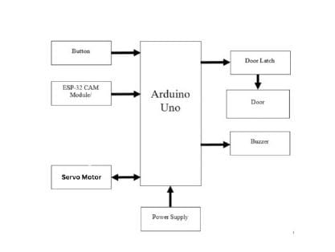

Architecture Diagram

1. **DESIGN**

The design of the IoT-Based Smart Doorbell System integrates advanced technologies to enhance home security and user convenience. The system utilizes an ESP32-CAM module for live video streaming and features a push button for visitor interaction. Upon activation, the system triggers a buzzer for local alerts and sends notifications to the user’s smartphone through the Blynk app, enabling remote access and control. A servo motor is used to manage the door lock, providing users with the ability to unlock the door remotely.

This modular design ensures real-time communication, efficient monitoring, and seamless door management, offering a cost-effective and scalable solution for modern home security needs.

1. **INTEGRATION**

The integration process involves combining both hardware and software components to ensure seamless operation. The ESP32-CAM module is connected to the Wi-Fi network, enabling it to communicate with the Blynk app. The servo motor, push button, and buzzer are properly interfaced with the ESP32-CAM to ensure coordinated functionality. This integration enables real-time video streaming, alert notifications, and remote door control, providing a complete IoT-based solution.

1. **TESTING**

To ensure the system operates as intended, comprehensive testing was conducted:

* **Unit Testing:** Individual components, including the camera, servo motor, push button, and buzzer, were tested to ensure each functioned correctly.
* **Integration Testing:** The interaction between hardware and software components was verified, confirming that all elements communicated effectively and performed their designated tasks.
* **Functional Testing:** Functional testing focused on verifying the core features of the system. Live video streaming was tested by ensuring the ESP32-CAM module successfully transmitted real-time video to the Blynk app. The push button functionality was tested to confirm it triggered notifications on the user's smartphone. Finally, the remote door-locking feature was tested by checking if the servo motor responded correctly to commands from the Blynk app, allowing door control remotely. All features performed as expected, validating the system's functionality.
* **Performance Testing:** Performance testing focused on evaluating the system's efficiency in handling video streaming and command response. The latency and quality of the live video stream were tested to ensure smooth and timely delivery of video feeds to the Blynk app, with minimal delays or interruptions. Additionally, the response time for commands sent from the Blynk app, such as door-locking and unlocking actions, was evaluated to ensure real-time interaction. The system demonstrated quick response times and high-quality video streaming, confirming its effectiveness in real-world use.

1. **IMPLEMENTATION**

The implementation of the IoT-based Smart Doorbell System involved integrating the ESP32-CAM module for live video streaming and Wi-Fi connectivity. The push button triggered the system to activate a buzzer and send notifications to the user’s smartphone. The servo motor was used for remote door locking and unlocking, while the Blynk app served as the interface for controlling and viewing the system. The system was tested for functionality, ensuring smooth video streaming, accurate notifications, and timely door control, resulting in a scalable and efficient home security solution.

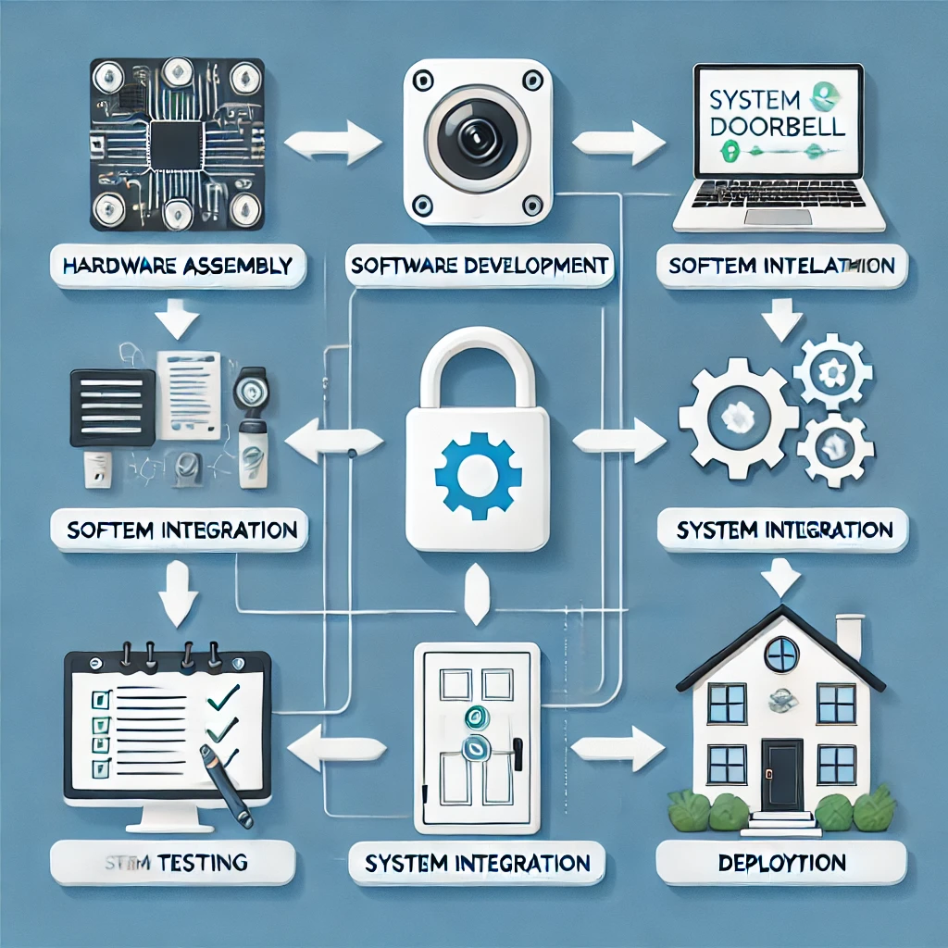

Implementation and Design

1. **CONCLUSION**

The IoT-based Smart Doorbell System provides an innovative and cost-effective solution for enhancing home security. By integrating real-time video streaming, remote door control, and instant notifications, the system offers improved convenience and safety for users. The successful implementation and testing of the system demonstrate its reliability and scalability, making it an ideal choice for modern households and small businesses seeking an accessible and efficient home automation solution.

1. **REFERENCES**

[1] Kumar, R., & Patel, S. "Development of Smart Door Automation Using IoT and Mobile Application." *2022*.

[2] Verma, A., & Mehta, R. "A Survey on IoT-Based Security Systems." *2023*.

[3] Sharma, R., & Verma, A. "IoT-Based Smart Doorbell System with Real-Time Visitor Notification and Remote Door Unlocking Mechanism." 2022.

[4] Gupta, P., Kumar, R., & Singh, D. "Design and Implementation of a Smart Doorbell System Using IoT and AI for Home Automation." 2023.

[5] Lee, J., & Kim, S. "A Cost-Effective IoT-Based Smart Doorbell System with Integrated Face Recognition and Notification Features." 2023.