**COMPARATIVE ANALYSIS & DESIGN OF G+20 FLOOR STEEL STRUCTURE WITH BRACING & SHEAR WALL**

**Hussain Imran.K.M S1, Rabbani.A.B S2**

**1 Assistant Professor, Department of Civil Engineering, SJM Institute of Technology, Chitradurga, Karnataka,**

**2 P G scholar, Department of Civil Engineering, SJM Institute of Technology, Chitradurga, Karnataka, India**

**ABSTRACT**

In our country “REINFORCED CONCRETE” structures are very universally made use of for convention constructions like residential & apartment towers. however, in various nations “Steel Sections” are favored for the similar erections rather than going for concrete Columns & Beams with the intent of closing the erection quickly & achieve cut back & also to trim down the “Section sizes”. In here a challenge has been crafted to form a set of models in E tabs. All with steel sections for a G+20 model for “Earthquake” Zone V. “Equivalent Static Method” is used for seismic analysis. Shear wall structures consisting of braced panels (shear panels) to resist the lateral load effects acting on the structure. Shear walls are considered to carry wind and seismic loads. It is one of the excellent methods for earthquake resistance design of R.C buildings. During earthquake motion, some of the parameters like weight distribution, strength and stiffness in both horizontal and vertical plane of a building may affect the behavior of a structures Reinforced concrete shear walls are provided in RC framed buildings to reduce the effect of earthquake and also to improve the seismic response of a structure. Bracing system is the one of lateral load resistant concepts in tall structures. This system helps to reduce buckling of beams and columns but increases the strength and stiffness of the structure. Space occupied by the bracings is less and it is easy to erect and also has the flexibility in design for fulfilling the desired stiffness of the structure and also its strength. Bracings may be eccentric or concentric based on the shape; bracings may be classified as X bracings, V bracings, K bracings, and Inverted V bracings. In reinforced concrete structures bracing system is viable solution for resisting lateral loads.

**INTRODUCTION**

High rise towers are increasingly trendy in urban areas due to space limits. Far & wide utility of steel structures high rise towers due to their “Strength”, “Durability” plus “design flexibility”. Lateral loads like wind & seismic forces pretense noteworthy tests to high rise structures. Bracing &shear walls are two “widespread” lateral “load-resisting” systems used in structures. The defenselessness of the structures designed scantily represents “Seismic risk” to existence of dwellers & dent of possessions. Hurried “urbanization” & dearth of pots has led to the execution of large quantity of Multi story towers. The towers should be “Designed” with the sight in brain to defy minor, or moderate & even major Earthquake with bare minimum structural dent& without “Structural collapse”. Single footings are obligatory on weak sub surfaces for raising structures. In such state of affairs, the “Raft-foundation” will be apt for raising low or medium tall towers. To make certain the security against the seismic forces a try is tasked to design a “Multi story” steel towers having shear walls or bracings & by adhering to Indian standard code provision IS: 1893:2002 & structure design by ETABS

Steel structures are extensively deployed in building towers as they have plentiful benefits, as:

**Strength & Durability**: It has high strength vs. weight ratio that makes it an Idyllic substance for towers either large or heavy structures.

**Flexibility & Versatility**: It can easily be shaped & molded to generate multifaceted designs & structures.

**Cost-efficiency**: Steel structures are time& again more cost-efficient than concrete structures chiefly for bulky projects.

**Sustainability**: It is eco-friendly& reusable also reduces the waste & ecological blow.

**Construction speed**: Steel structures may be swiftly pulled together & raised, which helps in bringing down the construction time.

**Confrontation to Natural calamities**: These can be designed to tolerate hurricanes, quakes, or other natural calamities.

**Lesser repairs**: These need lesser maintenance& can stay for years.

“Steel- structures” are predominantly used in:

* Tall towers
* Industrial facilities
* Bridges
* Warehouses
* Stadiums & arenas
* Commercial towers

The plus of “steel-structures” is they make an attractive choice for planners, architects &engineers, letting for inventive & proficient designs that congregate diverse project requisites. A “shear wall” is the one which stand firms against sideways forces, such as wind or seismic by reassigning them to the “Foundation”. It is a critical cog (critical part) of a tower “lateral” load-resisting system, providing permanence & prop up (lift and give support) to the structure.

Key distinguishing of a shear wall:

* Vertical element: ─It is an upright ingredient that spans from the base to the apex of towers.
* Lateral load resistance: ─ Its prime task is to defy (refuse) lateral forces, such as wind, Earthquakes or soil pressure.
* Load transfer: ─ It conveys the lateral forces to base, guaranteeing structure's stability.
* Structural integrity: ─It preserves the structural integrity of the towers by offering an unbroken load lan

Types of shear walls (Based on Materials):

* Reinforced concrete
* Masonry
* Steel
* Wood
* Composite

Functions of a shear wall:

* Wind
* Resisting quakes
* Transferring Gravity load
* Lateral load resistance
* Structural strength enrichment

In summary, a shear wall is an imperative structural facet to guarantees a tower's firmness& resistance to sideways forces, making it an indispensable module of tower’s design & erection

Structural Systems

A “Structural-system” is a “Framework” of inter-connected facets that exertion jointly to hold & convey loads in a tower. The chief task of a “Structural-system” is to grant steadiness (quality of the study), strength, & rigidity to the structure, ensuring it can endure assorted loads plus stresses.

Types of “Structural Systems”

* Skeleton System
* “Load Bearing” Wall System
* Frame System
* Truss System
* Cable System

**Bracings**

“Steel bracing” is a system used to offer “sideways” prop up & firmness to any structures. It compiles of “steel members” like Beams, Columns, & diagonal bracing, coordinated in a “triangulated” pattern to defy wind, seismic, & other outside loads.

Key characteristics:

**Triangulated structure**: It forms a truss formation, offering first-rate resistance to “sideways” forces.

**Sideways load resistance**: It defies wind, seismic, & other “sideways-loads”, guaranteeing structures’ steadiness.

**Flexibility**: It can be designed as stretchy, letting for movement & deflection beneath load.

**Strength & tautness**: It offers high strength & tautness, making it apposite for bulky structures.

It is a broadly chosen structural system, proffering exceptional “Sideways” load resistance & steadiness to diverse structures. Its design & fixing entail chary contemplation of loads, materials, & construction techniques.

**Forms of Bracing**

a) Single diagonals

Trussing/triangulation will be developed while popping in a “diagonal” element into a “rectangular” part of a “structural-frame”, this helps in alleviating the frame-structure. If we use “single” brace system, it should be ample enough to resist tension plus compression.

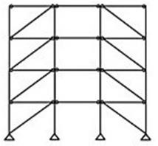

**Figure 1 Single Diagonal Bracing**

b) X Bracing

Here, it makes-use of two slanting limbs which will cross one other. These should only mind about tension forces. One member will be functional at a time to defy the “sideways” forces& which relies on the path of loads. As an outcome of this, “steel cables” could also be considered for “cross bracing” system. The slanting bracings that are placed in the “structural-frame” with the girders will shape a web sort of as outline & this outline as “chords” with the Column of the upright members & these will have a very essential task to defy the “lateral shear”, compressed plus lateral loads. The bracing in any configuration will principally be added using steel seeing as they are primarily having to face tension. In some conditions it is also added using RC as double slanting & each slanting will carry out as a “compression” member &entirely these will defy the “external shear”. Now days “X” type is universally perceived in RĊ where turn of the bear in slanting direction intersects. Bracing will be dreadfully critical in seismically resistant structures as it maintains the safe.

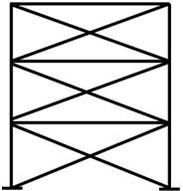

**Figure 2 X Bracing**

c) “K” bracing

K bracing system will inter-link the Columns at mid height. This type “frame-system” will boast higher flexibility for adding the openings if necessitated & lend hands in the least deflection of floor Beams. K bracing is commonly not used in seismic areas as it is more prone to structural failure of the Columns if at all the compression bracing buckles.

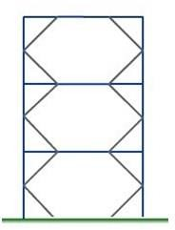 **Figure 3 K Bracing**

d)V-bracing

Two slanting bracing constituents will shape a V form which will be lengthening from apex to foot. These two bracings will commence at the bends of last parts of the apex constituents & convene a center of the straight element at the foot. Inverted V bracing system consist of the two bracings but it will be other way compared to V type bracing i.e., the V figure will be upturned. Both the systems can diminish hugely the crumpling probability of any “compression” bracing so that it is slighter than the “tension-yield” capacity of the tension bracing. Meaning that when the bracing reaches its resistance capacity, the load should be rather be defied in the bending of the straight structural member. In seismic area centric bracing is very often used. It is nearly alike to V bracing yet bracing element won’t meet at the central point.

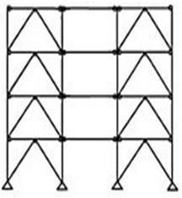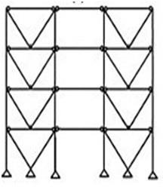

**Figure 4V Bracing Figure 5 Invert V Bracing**

Advantages

* When bracing is added, story drift, bending moment, story displacement, axial force in structural Columns will lessen hugely.
* A tower added with bracing will resist horizontal forces in a better way than the one without it.
* It can be designed in “cost effective” way, easy to install &flexible while designing to achieve required strength & stiffness.

Disadvantages

* If bracings are not added in tactical spots it may pressurize in not adding the openings as architects wants.
* It may influence the elevation of the towers if not added at apt spots or wrapped rightfully.
* The extent of the bracings will usually be limited to 40’if it is RCC.

Seismic Analysis Earthquake analysis is a vital ingredient of all structural analysis & it will assess the of there tort of every structure below the land accelerations. It is presumed as solitary process of structural design in places where seismic activities are prevalent.

* This may be mulled out into four assemblages.
* Linear static / Equivalent static analysis
* Nonlinear static / Pushover analysis
* Linear dynamic / Response spectrum analysis
* Nonlinear dynamic / Time history analysis

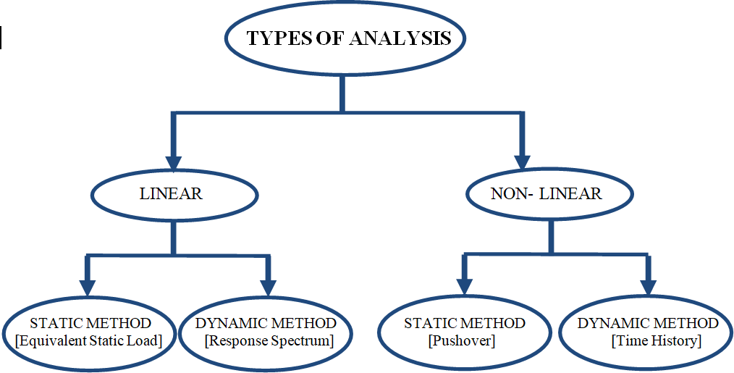

**Figure 6 Analysis─ Types**

Linear Static Analysis [LSA]

This procedure crafts by developing pseudo-lateral static load sit to weigh up the horizontal force& lateral displacement stipulates on every element of the entire structure which may crop up from burly earth action. These stipulate are then contrasted with the structural aptitude of each element. It has to be noted that this method cannot be considered if the structures are irregular, in terms of stiffness, shape, mass & load distribution, strength, etc., if the structural elements have large ductility stipulate or the horizontal force renitent system is non-orthogonal

**LITERATURE SURVEY**

**DEVIPRASAD, BHARATH.V. B, SHIVA PRATHAP.H.K., SOMESH P -JULY 2019** Buildings are mostly exposed to many sorts of loading situations such as quake & wind loads. For the seismic Zone areas, the buildings are mainly designed considering seismic forces. A few retrofit techniques or the inclusion of components to make the constructions stronger against seismic pressures are done to enhance the safety of these buildings as they are accountable for getting greater collapses in higher magnitude Earthquake areas. However, the efficiency and effectiveness of braced frames largely hinge on the careful selection of the specific bracing system.

**M.MOUZZOUN ET.AL (2013)** Assessed seismic performance of a five-story reinforced concrete building designed according to the Moroccan seismic code RPS 2000. In the first time a set of dynamic analysis are carried out to compute dynamic properties of the building (fundamental period, natural frequencies, deformation modes), in the second time a pushover analysis is performed to assess the seismic action of the building and detect the locations of the plastic hinges. By using SAP2000Pushover analysis is carried out. The results obtained from study show that designed building perform well under moderate Earthquake, but is vulnerable under severe Earthquake.

**KADID ET.AL., (2008)** presents the study on three framed buildings of five, eight and twelve stories respectively and these are analyzed using pushover analysis program in SAP 2000.They decided that the causes of failure of reinforced concrete during the Boomers Earthquake may be attributed to the quality of the materials of the used and also to the fact that most of buildings constructed in Algeria are of strong Beam and weak Column type.

**JAY KUMAR**ﹻ**SAH, PREM SHANKAR**ﹻ**SINGH, CHINMAY KUMAR**ﹻ**KUNDU (2018)** The main objective of the study is to design a “quake resistance” multi leveled towers. To analyze the towers using STAAD. Pro V8i& design the raft foundation by “S.A.F.E”. To get the practical Knowledge to plan & complete the project on earthquake resistant framed structural multistory towers. To design the structural elements like Beam, Column, slab, raft foundation, shear wall etc. To provide a structure this will be secure, serviceable, inexpensive& aesthetical. To build up selfﹻconfidence” as professional to face the alike tasks& to give the patron packed contentment in the close by outlo

**RAJAT**-**BONGILWAR V**ﹺ **R HARNE& ADITYA**ﹻ**CHOPADE** Ample “stiffness” is crucial in tall standing towers to defy the “lateral-loads” brought by wind / seismic. RC shearﹻwalls are designed for towers standing in seismic hotspots, as of their lofty strength, stiffness &lofty ductility. A great bit of the “lateral-load” on a tower as well as the shear force out shooting from load are habitually dispensed to structural bits made of RCC. Shear walls have very large in plane stiffness & hence it canned defy lateral load &manage deflection very ably. Using of shear walls or their alike be falls key in certain tall standing towers, if inter story deflections reasoned by lateral loadings are to be controlled. Properly designed walls not only present protection but also grant an apt guard beside pricey structural as well as non-structural damage during seismic activity. These supply outsized firmness & strength to towers, which successfully shrinks sideways warp & hence trim downs dent. Here, first sculpt is a “bare frame” residential towers with no shear wall &next one has shear wall with openings. Engaging ETABS, its efficacy is tested out. The L.S.A method is used where sculpt is facing “linear-force” which says sculpt is in elastic state. Assessment is crafted between 2 sculpts & lateral displacement, story drift, base shear, bending moment, sheer force of the structure. Conclusions In multi store towers, proviso of shear walls is seen to be valuable in building the largely seismic response& characteristics of the structure. These are judged for analysis of RC frame in which “equivalent-static” method can well be deployed. It at the end boosts the firmness & strength of the structure & shapes the seismic manners of the structure. From the analytical upshots, it is scrutinized that “base-shear” boosts in the sculpt with “shear wall” when tallied with the one without it. This is due to raise in firmness of tower. The size able lessening in lateral displacement is observed in the “shear wall model” when tallied. The drop in “displacement” is due to boost in firmness. For healthier seismic performance, towers need lateral stiffness. Squat lateral stiffness escorts to large warp & strains, dent to “nonstructural” elements. Therefore, it is vital to deem the shear walls in the seismic analysis which noticeably augments the strength & drops the odds of subside of the structure.

**PRADEEP PUJAR & AMARESH** the Objective was to do “irregular” shape 3D sculpt with Shear walls by deploying E-tabs. To do demo of I, L & C shape sculpts with & without Shear walls. To theory test the structures with & without Shear walls the static method that is “Equivalent static lateral” force method is deployed. To ponder the basics & conduct at acute “seismic analysis” & looking at judgments of base shear, story displacement, conclusion was the Shear walls building showed greater “effectiveness” in reduction of “story uprooting” because it dropped 50.00% to 70.00% with distinguishing exposed “edge” structures. L&C shape sculpts with Shear walls showed greater response or better upshots in base shear, story drift and displacement. It says that in X direction in all sculpts L shape is demonstrated lower displacement. In Y direction in all sculpts I shape showed lower displacement with shear wall. Among all, I shape sculpt has baser shear both on both sided and the L shape has less base shear. Among all, from 8 to 10 lvls the story drift is topping& below 8 level it is dropped. From the assessment it reveals that the sculpt gives enhanced execution by taking the in it for defying tremor contradicting to the one without shear wall from the assessment it reveals that the Y Direction esteemed in all para of all sculpts are lofty. By adding shear walls, sculpt will defy tremor adeptly with Our Indian ambiance. By adding shear walls, we can cut down the c/s area of elements probably

**K VENKATESH & T. VENKATDAS** Objective was to do the analytical study on the “lateral behavior” of the sculpt is chiefly pondered and how it alters in Zone II & III with diverse story tallness of a 6, 11&16 leveled structure. The lesson also engrosses the direction of shear wall. Methodology The [OMRF and SMRF] mocks of G plus 5, G plus 10& G plus 15, levels are developed the seismic analysis of these mocks is done by Seismic Coefficient with above modus operandi for Zone II & III. The acquired upshots of both mockups are correlated with each other. Conclusion was for ZONEIII. When mulling about G plus 5 mock the disparity of story drift b/w Ordinary RC Moment Resisting Frame (OMRF) & Special RC Moment Resisting Frame (SMRF) mocks is0.150 %When mulling about G plus 10 mock the disparity of story drift b/w OMRF & SMRF mocks is0.420 %When mulling about G plus 15 mock the disparity of story drift b/w OMRF & SMRF mocks is0.660 %. For ZONE-II When mulling about G plus 5 mock the disparity of story drift b/w OMRF & SMRF mocks is0.004%. When mulling about G plus 10 mock the disparity of story drift b/w OMRF & SMRF mocks is0.210 %. When mulling about G plus 15 mock the disparity of story drift b/w OMRF & SMRF mocks is0.410 %. When contrasted to ZONEII & III the “lateral displacement” is lower in ZONEII.

**UMAMAHESHWARA B & NAGARAJAN P** Structural analysis was done in E-tabs by “linear structural” analysis of mocks subjected to “static” & “dynamic” loads, is noted. Efficient mocks “formulation” & problems solution is realized by idealize the mock as a “system of frame” &shear wall bases “inter-linked” by “floor diaphragms”. Design of 15 levels mock and optimized of shear wall is done by E tabs. Plan produced in cad is “imported” mocked in E tab. This mock is analyzed for axial plus lateral loads & the upshots are ascertained. For optimization of shear wall spotting shear wall is poisoned in 3dissimilarspots & the upshots gained such as displacements, drifts, story shears are ascertained and co-related. A great bit of the “lateralﹻload” on a tower as well as the shear force outshot from load are habitually dispensed to structural bits made of RCC. Shear walls have very large in plane stiffness & hence it canned defy lateral load & manage deflection very ably. Using of shear walls or their alike befalls key in certain tall standing towers, if inter story deflections reasoned by lateral loadings are to be controlled. The conclusion was, it is comprehensible to utter that as shear walls added and their spot in the mock played a critical act in building of a mock. The up shots obtained demos that shear wall array offered best upshot towards the mock elements like story displacement, inter story drift, base shear, lateral forces contrast to bare frames. The mock with shear wall @ corners of the mock exhibit’s fewer displacements and drifts and thus deemed as optimum location. It is noted that the apex deflected was condensed and attained inside the permissible deflection after providing the shear wall sat potential “failure spots” such as the “shorter directions”. Increaseing “axial load” level diminishes R factor. So, design base shear will be topped up and I value of the section need augmentation in other face, the smaller the “axial load”, the smaller the c/s area. Imprisonment of concrete in shear walls is a good way to offer more echelon of “ductility” and to obtain higher “secure behavior”. So, the “designer” would be tolerated to boot the echelon of “axial stresses” to have a “rational design”. Not only “main walls” are presupposed to cart “seismic loads” but also, they will tweak noteworthy % of “Gravity loads”.

**RAHIMAN G. KHAN, ET AL., (2013) studied** on Push Over Analysis of high rise Building with Soft Stories at various Levels. RC frames buildings which are known to perform poorly during strong ground acceleration, due to masonry infill wall influences the overall behavior of the structure when subjected to lateral loads, when masonry infill is connected with the frames then the lateral load carrying capacity and lateral stiffness of structure is increase. In this paper the seismic resistance of building is shown with an Example of G+20. By using the ETABS12.Software Seismic analysis of moment resisting framed structures without Infill wall at the different story levels. From this study it is concluded that, as a soft story is placed to higher level the intensity of formation of hinge becomes less and base shear also increases with displacement. Maximum yielding occurs at the base story, because of soft stories maximum plastic hinges are forming though the base force is increasing.

**ABHIJEET A. MASKE, ET AL., (2014) Carried** out the non-linear static pushover analysis of R.C frame structures. This study is to carry out the Earthquake action of frame structures i.e., 5 story’s and12 story using pushover analysis methods. The performance of R.C frames was investigated using the pushover analysis. The capacity curves shows that no decline in the load carrying capacity of structural members indicates that good behavior of structures. The demand capacity curve shows that demand curve get intersects the capacity curve at the point B. So, we can say that the margin safety is high against collapse and there are enough displacement and strength is reserves. The performance of properly detailed R.C frame building is sufficient as it designated by the intersection of the capacity and demand curves and the formation of hinges in the Beams and the Columns. Many of the hinges are formed in the Beams and a smaller number of hinges are formed in the Columns but damage limited.

**OBJECTIVES**

* Generating the two models and doing the comparison of the efficiency of shear wall &bracing systems in defying earthquake load which is one of the lateral loads.
* Performing the analyzing then carrying out the designing manual as well as using software for a G+20 levelled steel structure using above highlighted systems.
* Comparing the structural performance in the form of graphs tables and charts by taking out the various analysis results like base shear, story displacements and story drift of both types.
* Recommendation of the most appropriate lateral load resisting system for the selected seismic zone, earthquake loads, type of building and load type as per the code.

**METHODOLOGY**

* Literature review: Study readily available studies on bracing as well as shear wall systems.
* Structural modelling: Generating steel structural 3D models of “G+20” levels 3 with shear wall & 4 with bracing systems.
* Load calculations: Calculating seismic loads as per IS codes.
* Structural analysis: Performing linear̵ static analysis using software.
* Designing & optimization: Designing the section sizes, Shear walls & bracing systems, & optimizing where needed
* Comparison: Compare “structural performance” based on the analysis results like base shear, story drift, and story displacement of both systems.

**Software Used**

* For generation of drawings: Auto-CAD: 2024
* For analysis plus design: ETAB

**PROBLEM STATEMENT**

In this report we have taken into consideration 7 steel models which are alike in outline & size in diagram. The only dissimilarity will be bracing nature or shear wall position. These steel towers consist of G + 19 floors plus terrace. Lowest flooring is allocated for motor vehicle parking whereas 1st floor onwards it typical. The measurements of all levels are elucidated in succeeding pages in specify. Arrangements of all Columns are warily placed so that they won’t be a reason for any interruption while using the towers by the end users.

After architectural plans are frozen Columns are positioned at appropriate spots aswehave4 steel bracing types are of different shapes& 3 dissimilar shear wall combo. Bricks are used for erecting walls. The standard width of a brick is 0.115m. After Columns are placed the Beams are positioned wherever necessitates. Additional concern was taken when positioning the Beams so that they are located under the walls. But in locations like wash rooms a couple of Beams are noticeable.

These 7 framed models are developed with the assist of popular analysis & design tool Etabs. As mentioned prior7 models were developed. All the7 models were assigned with brick wall wherever needed. All other creations like dimensions, Column & Beams properties, material, concrete grade, live load, analysis method are preserved as same.

After modelling, the analysis is performed for all 7 models analysis parameters like story, drift, base, shear, story, displacement, story, shear, base reactions etc. Are furnished as of tables, charts & graphs.

Model Details

* In the final chapter the help of graphs & charts is taken to appear at the conclusions.
* Towers dimensions: 58.45m x 34.40m x 80m (G+20 floors)
* height @ Ground floor: 3.00 m; other floors » 3.35 m
* Total Height of Model from GF level
* (G +20) » (3.00+ [3.35X19]) » 66.65 m
* Structural system: Steel frame with bracing/shear wall
* Assuming the SBC as 320 KN/sqm.

Loadings:

* Dead load: 1.50KN/m² (partition load → 1.00 + Finishes →0.50 KN/m²)
* Live load: 3.00 KN/m²
* Seismic load: Zone V (IS: 1893: →2002)
* Material properties:
* Rebar: Fe500
* Concrete grade: M40
* Steel Section: 240
* Concrete Density » 25KN/m3

Design codes:

* IS→ 800: →2007 (Steel structures)
* IS→ 1893: →2002 (Seismic design)
* IS→ 456: →2000 (Concrete structures)
* In X » 17 bays of dissimilar measurement
* In Y » 11 bays of dissimilar measurement

Section Sizes

* Beam» ISMB-250
* Column» ISWB600mm
* Slab » 100mm Thick
* Wall » 200mm & 100mm Thick
* Concrete block density »17.65 KN/m3 (From IS→875 part→2 Table: 1, Sl.No 11. Page 5)

Wall Load

* Load from 0.200m wall (main)
* Thickness ҳ (height – beam depth) ҳ density
* » 0.20 ҳ (3.35-0.25) ҳ 17.65 KN/cum → 10.940 KN/m
* Load from 0.100m wall (Partition)
* Thickness ҳ (height – bam depth) ҳ density
* » 0.10 ҳ (3.35-0.25) ҳ 17.65 KN/cum → 5.47 KN/m
* Load from 0.100m wall (Parapet)
* Thickness ҳ height ҳ density
* » 0.10 * 0.6 * 17.65 KN/cum → 1.06 KN/m

**Table 1 Load─ Combo**

| **Sl.No** | **Load Combo** |
| --- | --- |
| 1 | 1.50*{DL+ LIVL} |
| 2 | 1.20*{DL+ LIVL +EqX} |
| 3 | 1.20*{DL+ LIV.L - EqX} |
| 4 | 1.20*{DL+LIV.L + EqY} |
| 5 | 1.20*{DL+ LIV.L - EqY} |
| 6 | 1.50*{DL+EqX} |
| 7 | 1.50*{DL- EqX} |
| 8 | 1.50*{DL+EqY} |
| 9 | 1.50*{DL- EqY} |
| 10 | 0.90*DL+1.50*EqX |
| 11 | 0.90*DL- 1.50*EqX |
| 12 | 0.90*DL+ 1.50*EqY |
| 13 | 0.90*DL- 1.5*EqY |

**Table 2 Building─ Type**

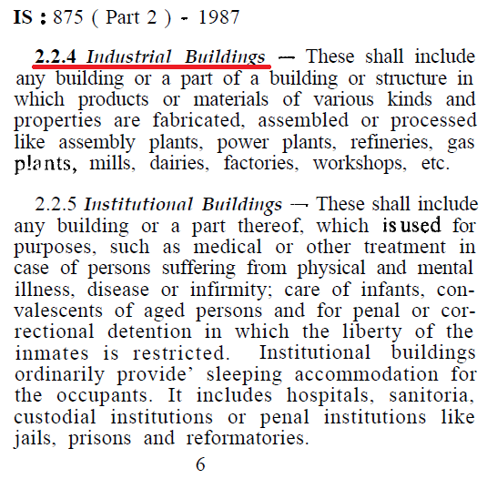 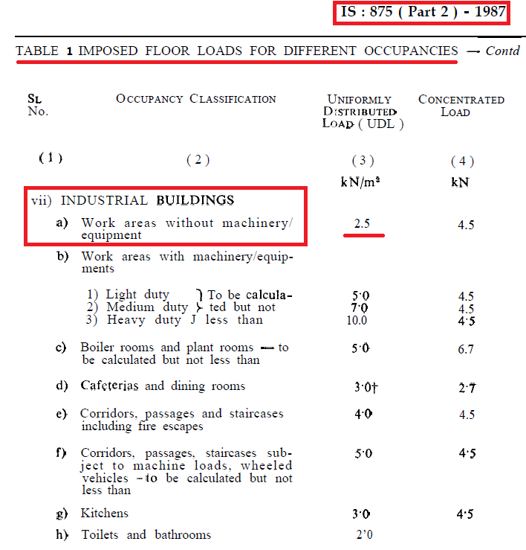

**Table 3 Imposed─ Load Selected**

**Table 4 Terrace Imposed─ Load**

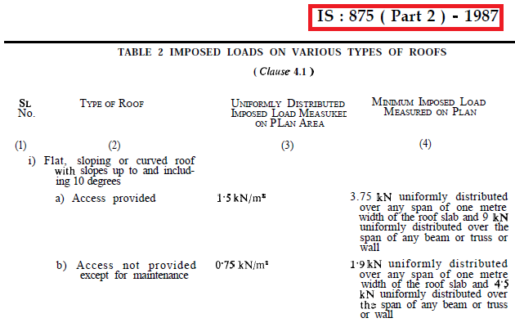

**MODELLING SECTION**

**Floor Plan**

A public Building with Library, income tax office, accounts and finance office, event management office etc. is selected for the purpose.

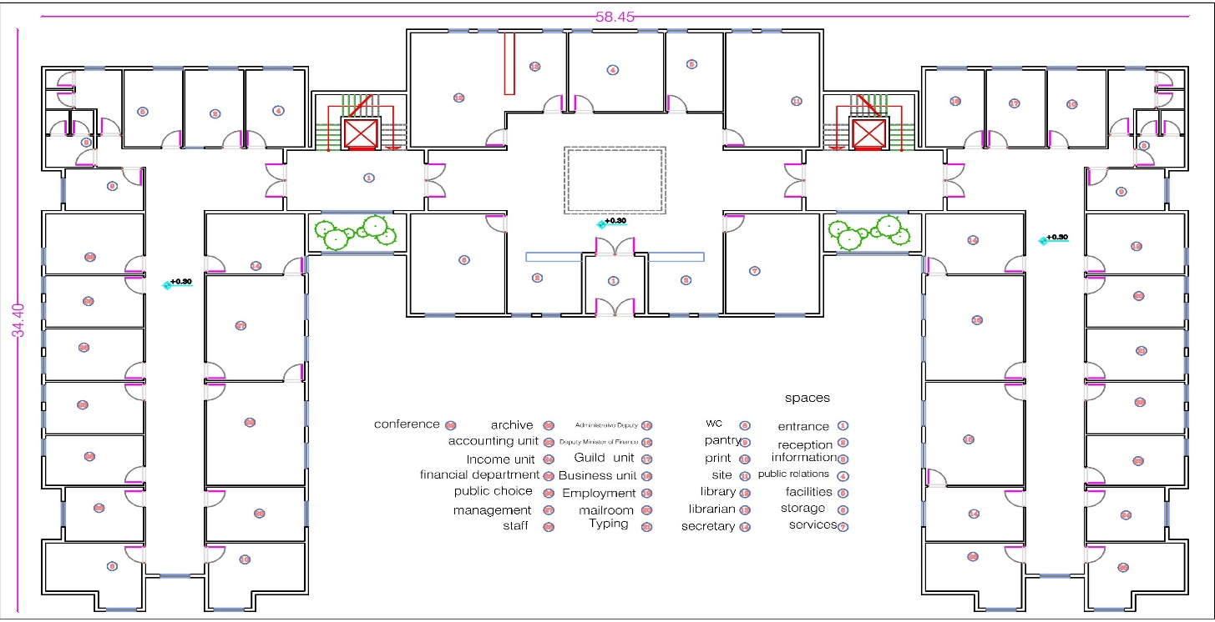

Figure 7 Floor Plan

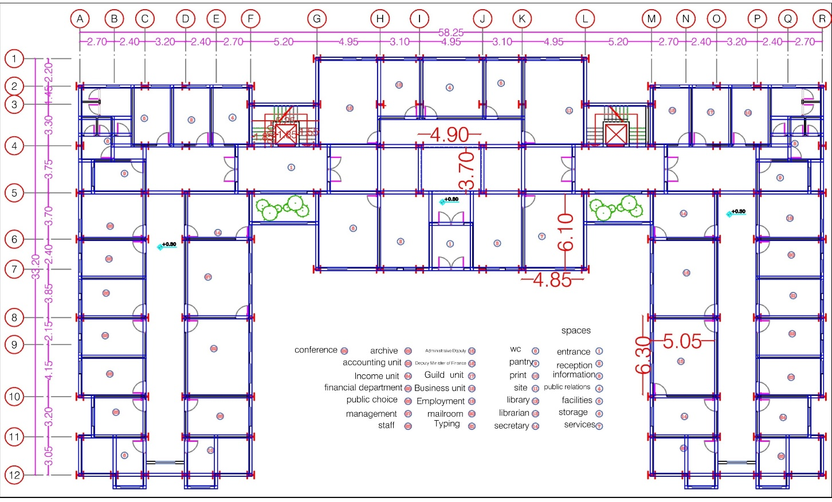

Figure 8 Plan with Grid dimensions

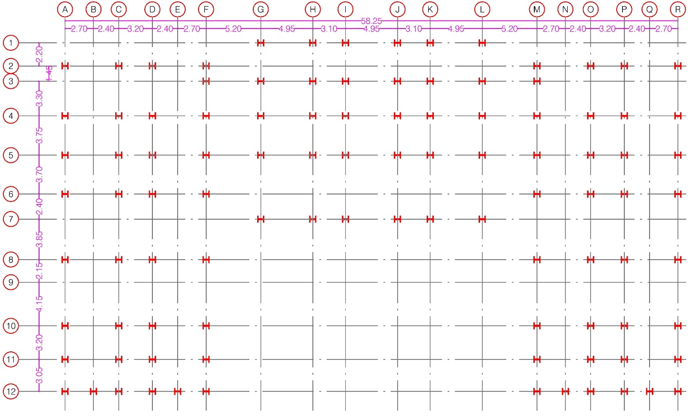 Figure 9 Column &Grid Spacing

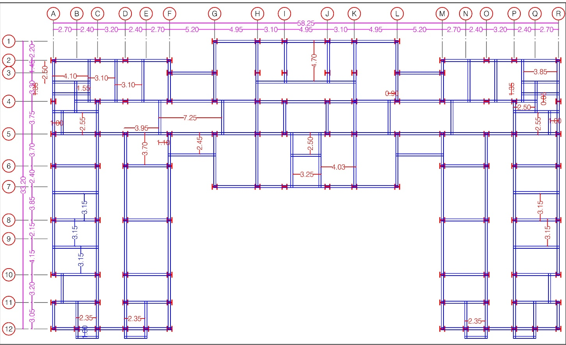

Figure 10 Beam Layout

**E tabs Steps**

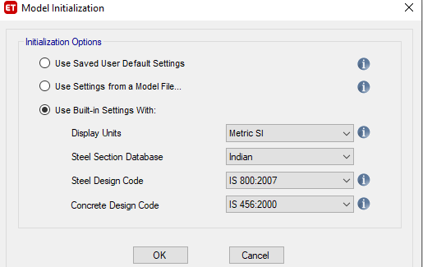 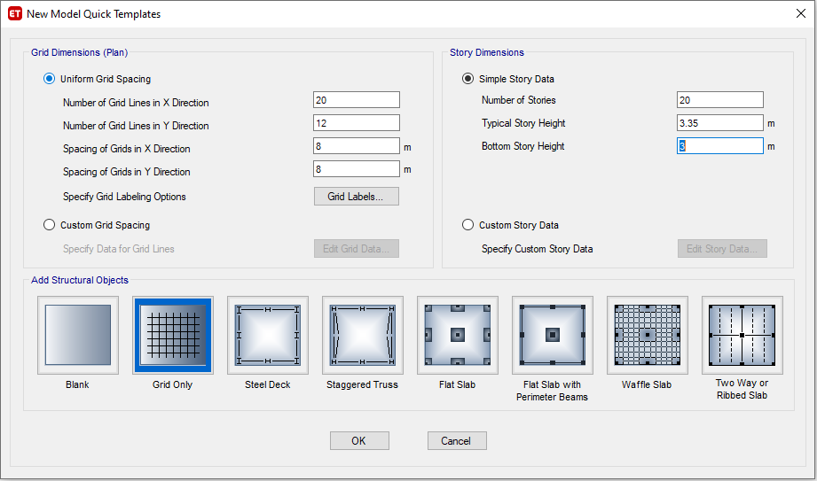

Figure11 Units Setting Figure 12 Floor & Dim setting

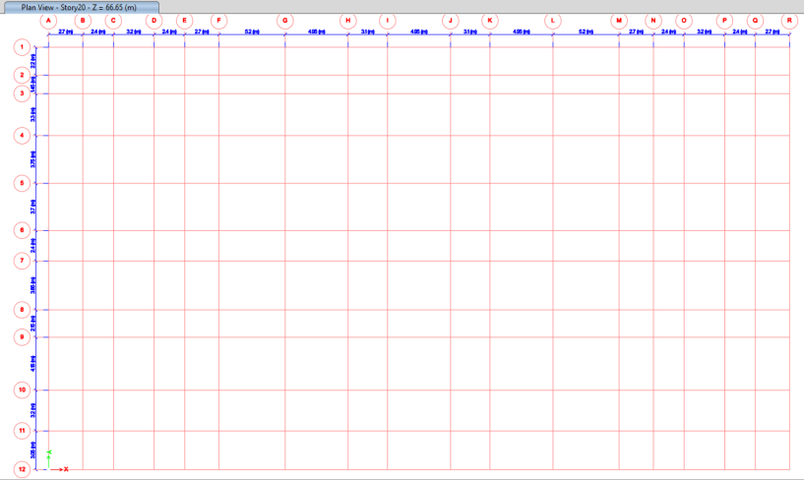 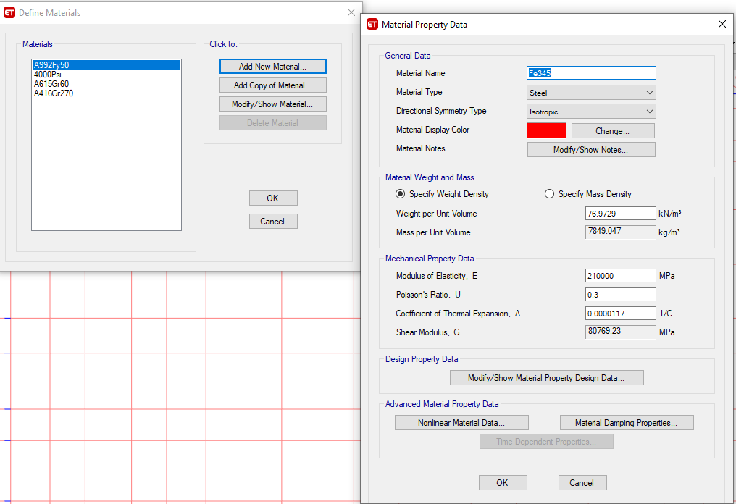

Figure 13 Grid Setting Figure 14 Material definition

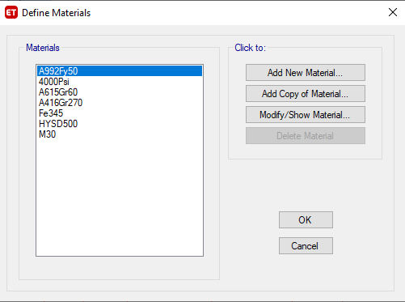 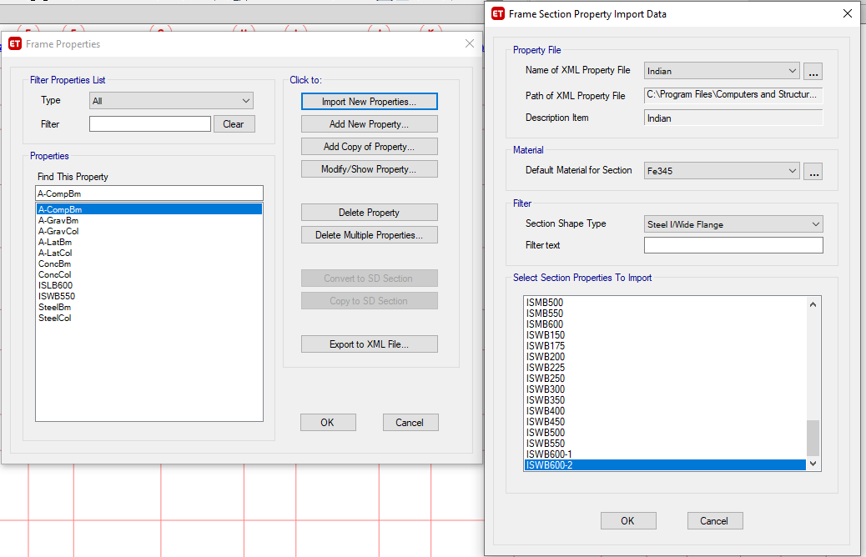

Figure 15 Materials Defined Figure 16 Sections Defined

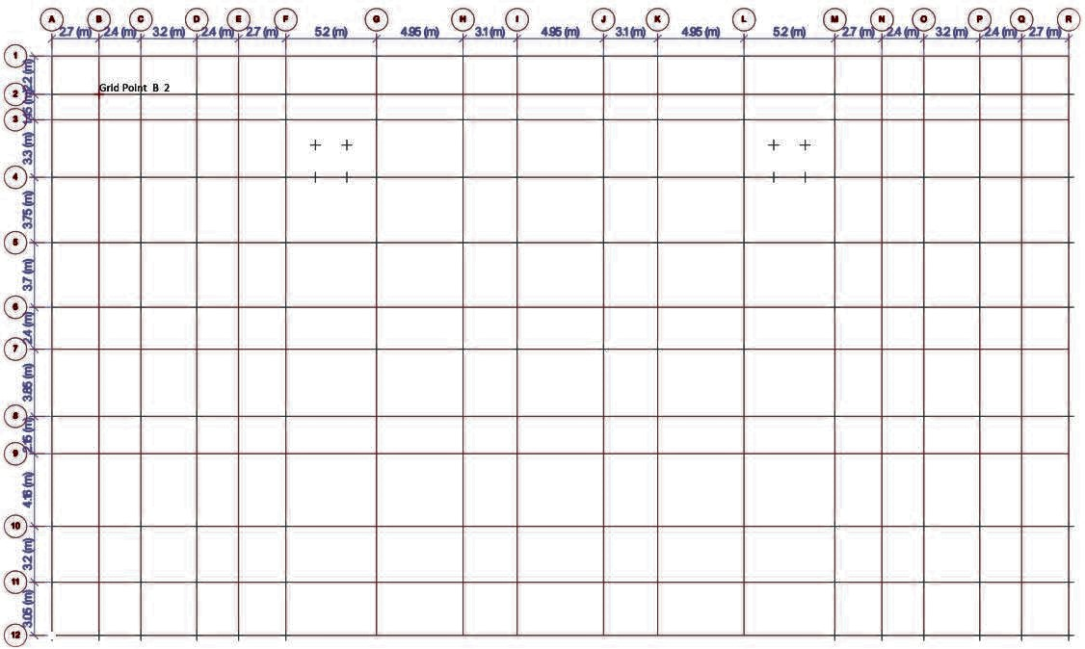

Figure 17 Grids created in E tabs



Figure 18 Column Layout in E tabs

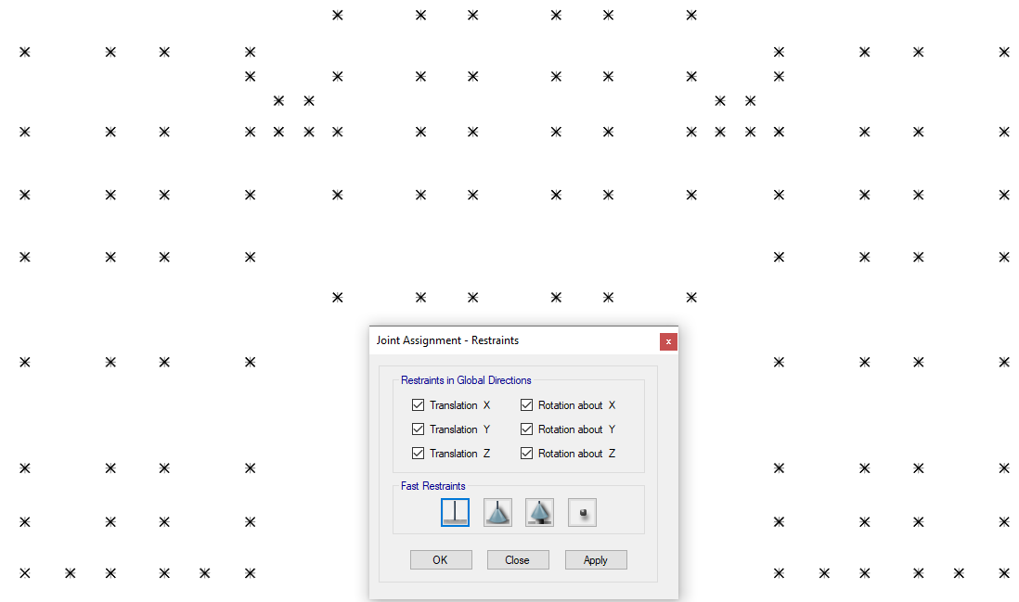

Figure 19 Fixed Support

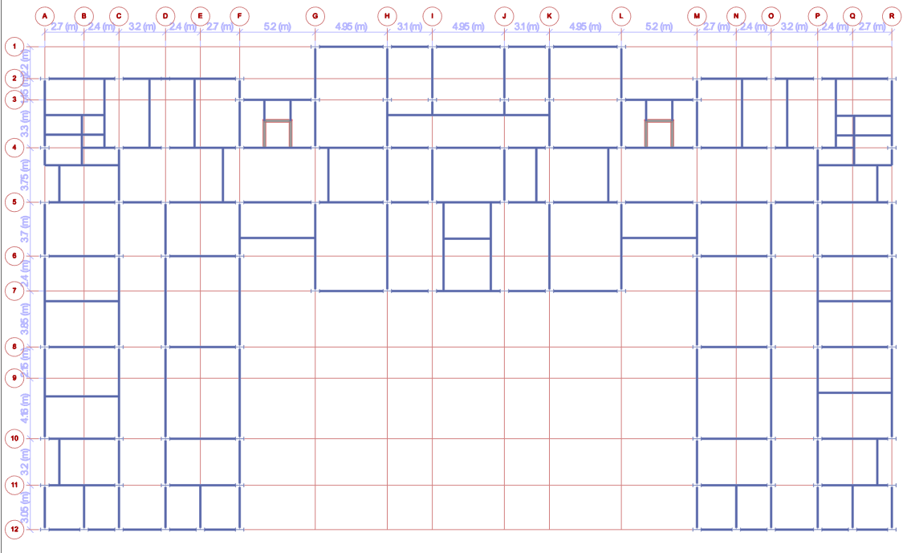

Figure 20 Beam Layout in E tabs

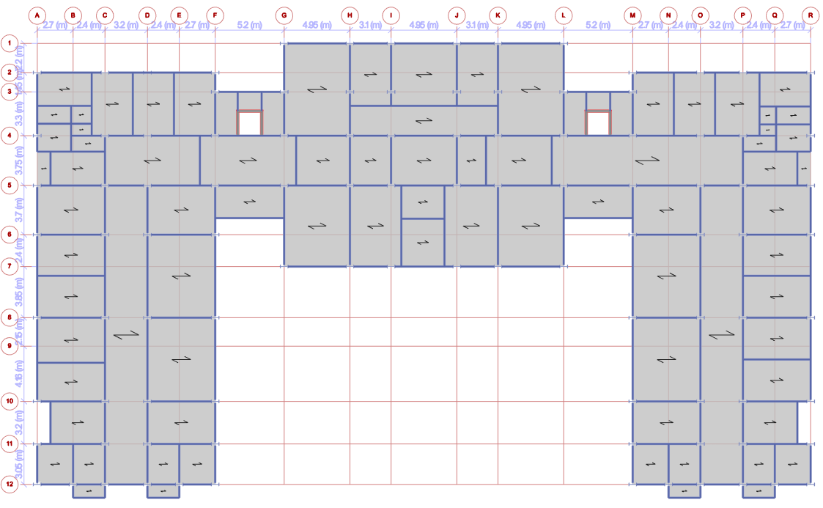

Figure 21 Slabs in E tabs

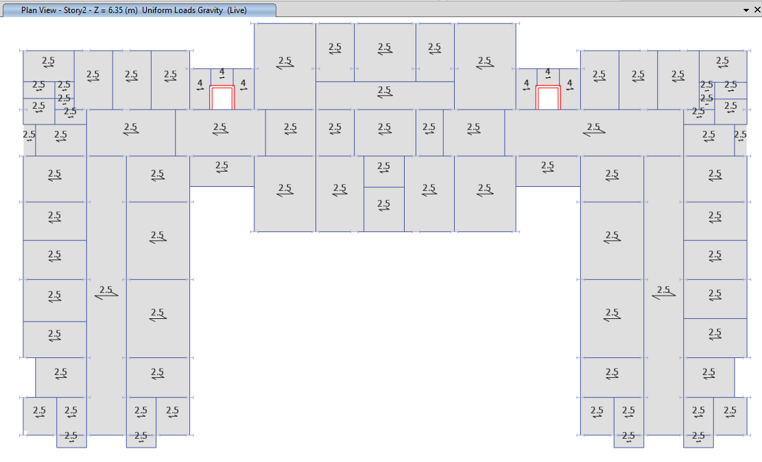

Figure 22 Imposed Load in E tabs, KN/sqm

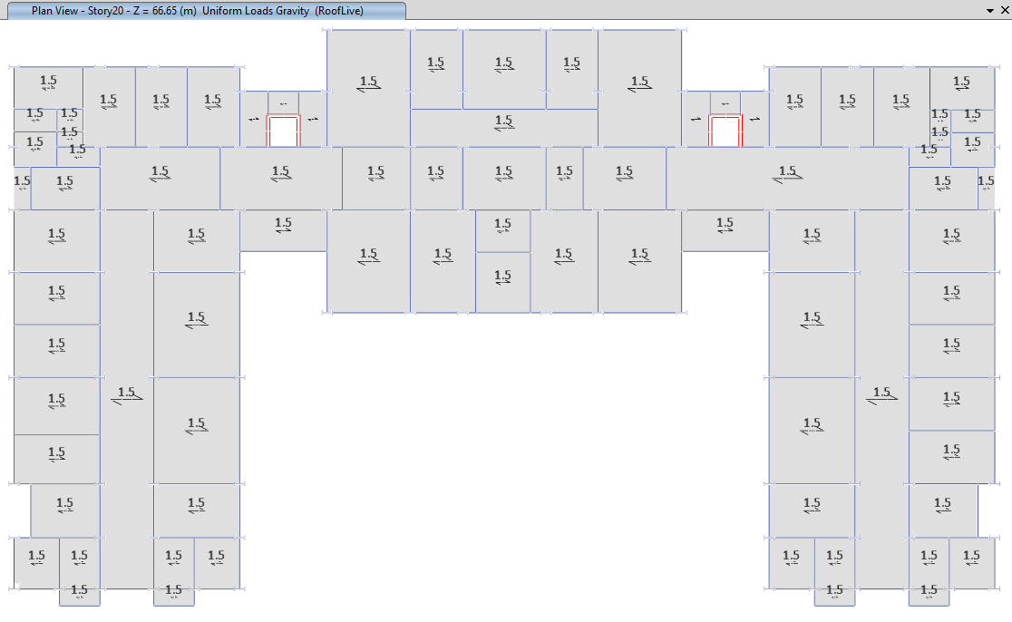

Figure 23 Roof Imposed Load, KN/sqm

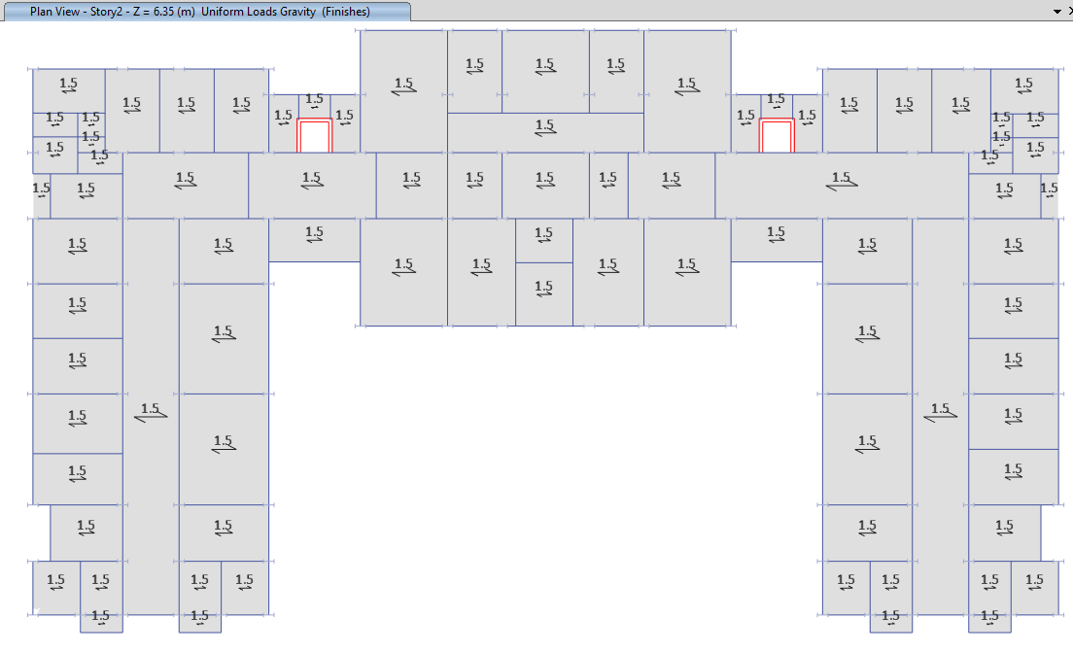

Figure 24 Floor Finishes, KN/sqm

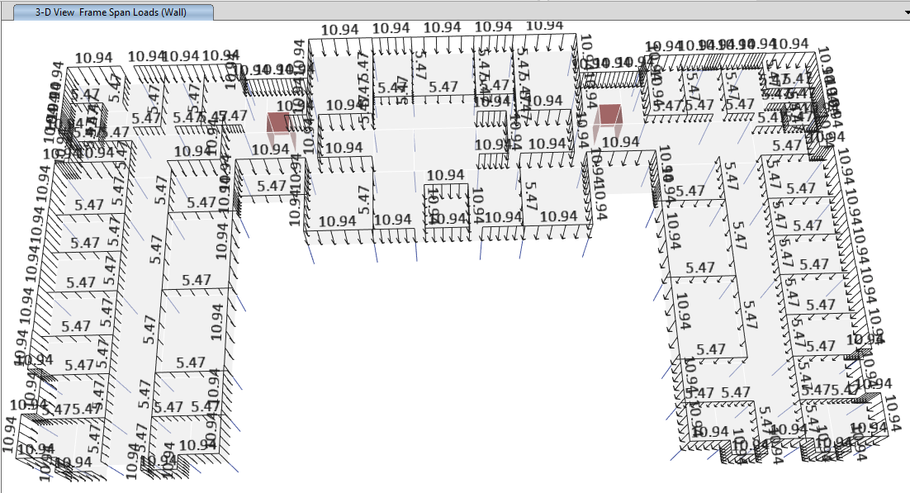

Figure 25 Wall Load, KN/m

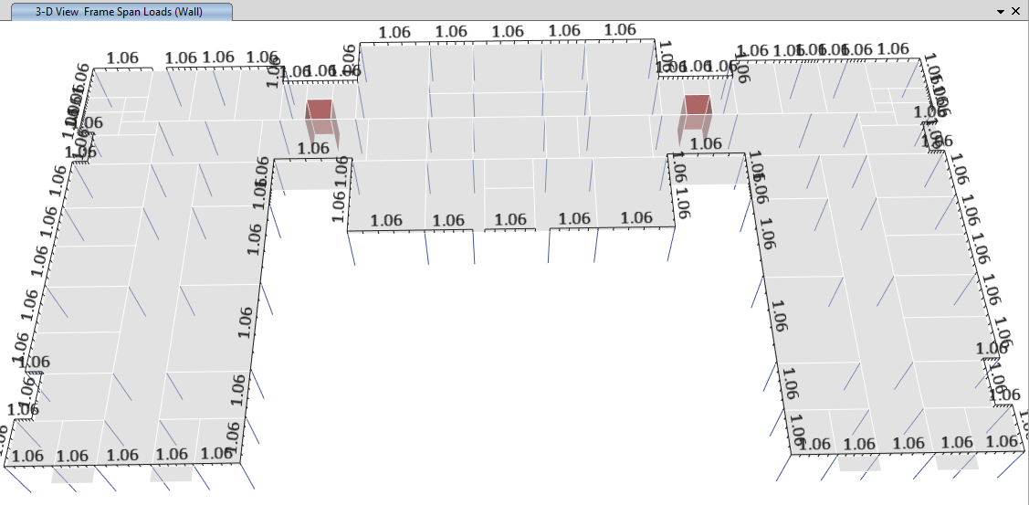

Figure 26 Parapet Load, KN/m

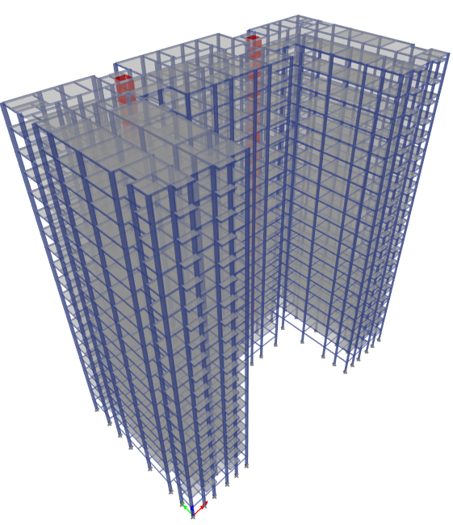 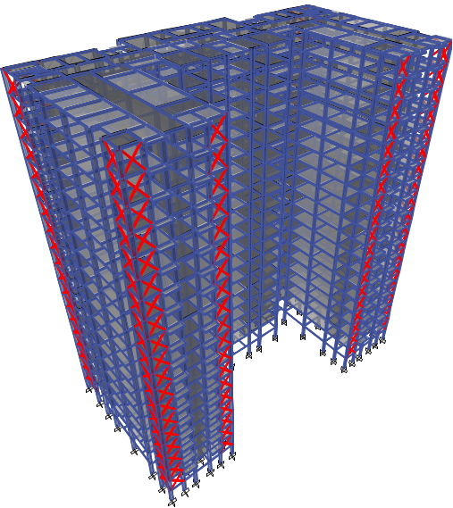

Figure 27 Isometric View Figure 28 Front part of building with X Bracing

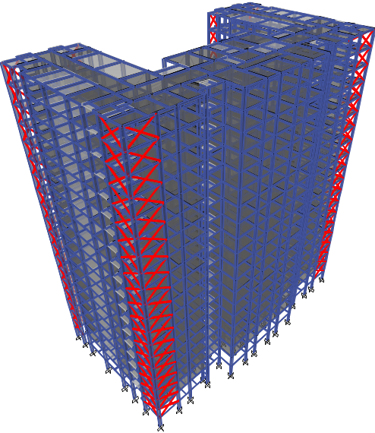

Figure 29 Rare part of the building with X bracings

**RESULTS & DISCUSSION**

**Analysis Results**

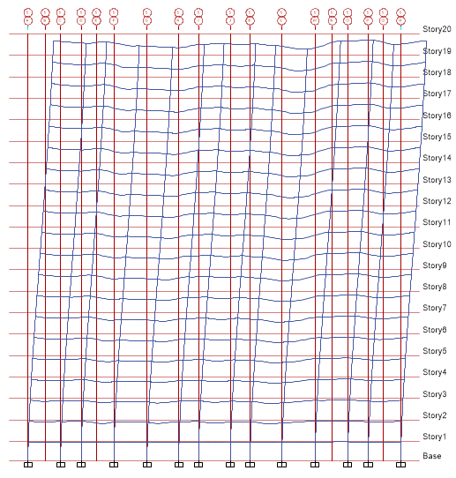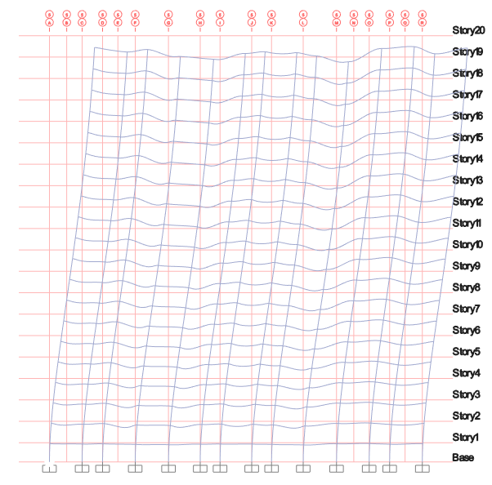

Figure 30 Deformed Shape of shear wall building at grid 5 Figure 31 Deformed Shape of X bracing building at grid 5

Above pics shows the deflection shape and bending movements at grid 5 for both the buildings

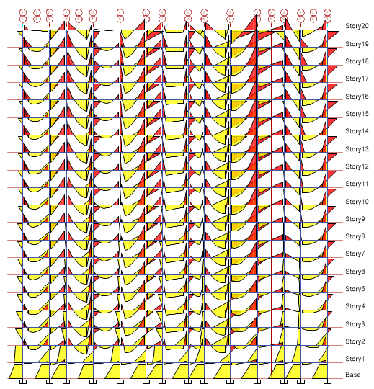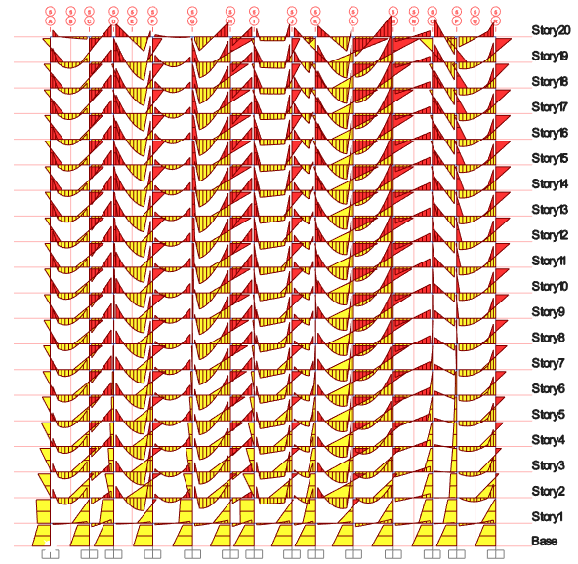

Figure 32 BM for Shear Wall building @ grid 5 Figure 33 BM for X Bracing Building @ grid 5

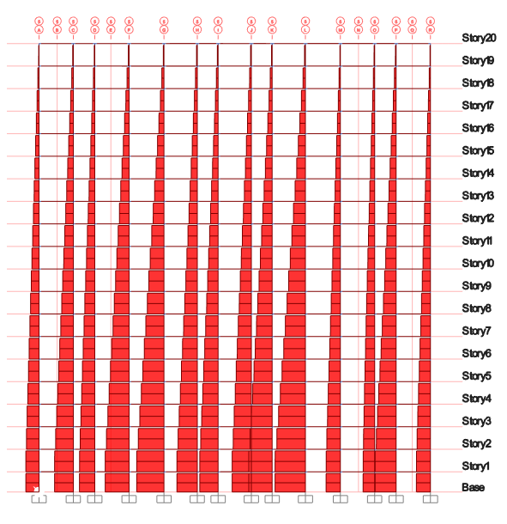

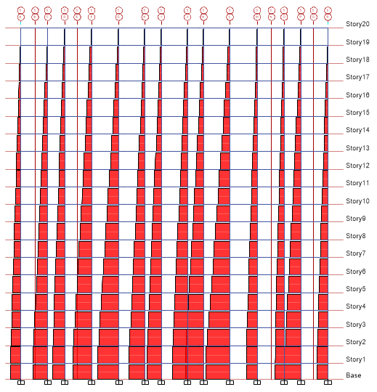

Figure 34 Axial Force for Shear Wall building @ grid 5 Figure 35 Axial Force for X Bracing Building @ grid 5

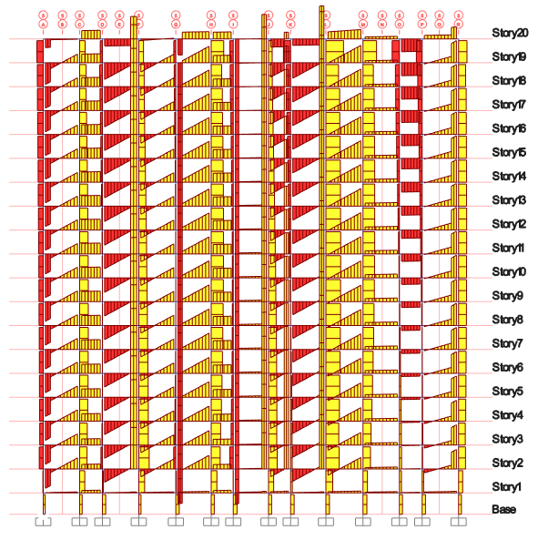 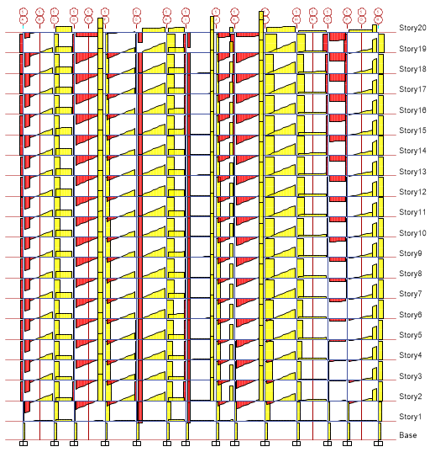

Figure 36 SF for Shear Wall building @ grid 5 Figure 37 SF for X Bracing Building @ grid 5

**Base Reaction**

Table 5 Base Reactions in X direction, KN

|  |  |
| --- | --- |
| **Base Reactions, KN for 1.2(DL+LL+EQX)** | |
| **With Shear Wall** | **With X Bracings** |
| 1543.07 | 1635.33 |

Figure 38 Base Reactions in X direction, KN─ chart

Table 6 Base Reactions in Y direction, KN

|  |  |
| --- | --- |
| **Base Reactions, KN for 1.2(DL+LL+EQY)** | |
| **With Shear Wall** | **With X Bracings** |
| 1419.72 | 1375.24 |

Figure 39 Base Reactions in Y direction, KN─ chart

The graphs above show the values of base reactions in X and Y direction for the selected load combinations

**Modal Periods & Frequencies**

Table 7 Modal Periods

|  |  |  |
| --- | --- | --- |
| **Modal Periods** | | |
| **Mode** | **With Shear Wall** | **With X Bracings** |
| 1 | 4.99 | 4.591 |
| 2 | 4.499 | 3.364 |
| 3 | 3.68 | 3.189 |
| 4 | 1.501 | 1.397 |
| 5 | 1.394 | 0.968 |
| 6 | 1.074 | 0.899 |
| 7 | 0.766 | 0.721 |
| 8 | 0.742 | 0.485 |
| 9 | 0.528 | 0.469 |
| 10 | 0.475 | 0.45 |
| 11 | 0.472 | 0.369 |
| 12 | 0.37 | 0.343 |

Table 8 Modal Frequencies

|  |  |  |
| --- | --- | --- |
| **Modal Frequencies** | | |
| **Mode** | **With Shear Wall** | **With X Bracings** |
| 1 | 0.2 | 0.218 |
| 2 | 0.222 | 0.297 |
| 3 | 0.272 | 0.314 |
| 4 | 0.666 | 0.716 |
| 5 | 0.717 | 1.033 |
| 6 | 0.931 | 1.112 |
| 7 | 1.305 | 1.388 |
| 8 | 1.347 | 2.062 |
| 9 | 1.895 | 2.133 |
| 10 | 2.104 | 2.224 |
| 11 | 2.117 | 2.709 |
| 12 | 2.704 | 2.914 |

Figure 41 Modal Frequencies Graph

The graphs above show the values of mode vs frequency

### **Max Story Drift**

Table 9 Story Drift in X direction,

|  |  |  |
| --- | --- | --- |
| **Max Story Drift for 1.2(DL+LL+EQX)** | | |
| **Story** | **With Shear Wall** | **With X Bracings** |
| 20 | 3.309 | 4.274 |
| 19 | 3.561 | 4.435 |
| 18 | 3.97 | 4.717 |
| 17 | 4.487 | 5.025 |
| 16 | 4.994 | 5.329 |
| 15 | 5.468 | 5.61 |
| 14 | 5.899 | 5.854 |
| 13 | 6.275 | 6.053 |
| 12 | 6.582 | 6.196 |
| 11 | 6.819 | 6.276 |
| 10 | 6.985 | 6.288 |
| 9 | 7.074 | 6.226 |
| 8 | 7.08 | 6.083 |
| 7 | 7.002 | 5.851 |
| 6 | 6.821 | 5.517 |
| 5 | 6.499 | 5.068 |
| 4 | 5.968 | 4.581 |
| 3 | 5.086 | 4.037 |
| 2 | 3.69 | 3.237 |
| 1 | 1.38 | 2.189 |
| 0 | 0 | 0 |

**Figure 42 Story Drift in X direction, ─ graph**

Table 10 Story Drift in Y direction,

|  |  |  |
| --- | --- | --- |
| **Max Story Drift for 1.2(DL+LL+EQY)** | | |
| **Story** | **With Shear Wall** | **With X Bracings** |
| 20 | 6.162 | 5.347 |
| 19 | 6.6 | 5.534 |
| 18 | 7.338 | 5.932 |
| 17 | 8.112 | 6.333 |
| 16 | 8.882 | 6.712 |
| 15 | 9.598 | 7.053 |
| 14 | 10.232 | 7.343 |
| 13 | 10.769 | 7.57 |
| 12 | 11.199 | 7.725 |
| 11 | 11.516 | 7.8 |
| 10 | 11.715 | 7.79 |
| 9 | 11.787 | 7.69 |
| 8 | 11.718 | 7.503 |
| 7 | 11.487 | 7.222 |
| 6 | 11.059 | 6.834 |
| 5 | 10.385 | 6.328 |
| 4 | 9.361 | 5.696 |
| 3 | 7.823 | 5.686 |
| 2 | 5.674 | 8.88 |
| 1 | 3.341 | 11.862 |
| 0 | 0 | 0 |

**Figure 43 Story Drift in Y direction, ─ graph**

Above are the values obtained for story displacement displayed as graph and charts for both buildings in X direction for the selected load combination.

**Max Story Displacement**

Table 11 Story Displacement in X direction, MM

|  |  |  |
| --- | --- | --- |
| **Story Displacement, mm for 1.2(DL+LL+EQX)** | | |
| **Story** | **With Shear Wall** | **With X Bracings** |
| 20 | 108.77 | 126.71 |
| 19 | 105.69 | 121.38 |
| 18 | 102.21 | 115.78 |
| 17 | 98.24 | 109.85 |
| 16 | 93.75 | 103.54 |
| 15 | 88.75 | 96.85 |
| 14 | 83.27 | 89.81 |
| 13 | 77.36 | 82.48 |
| 12 | 71.09 | 74.99 |
| 11 | 64.51 | 67.38 |
| 10 | 57.69 | 59.68 |
| 9 | 50.70 | 51.97 |
| 8 | 43.62 | 44.34 |
| 7 | 36.52 | 36.88 |
| 6 | 29.49 | 29.68 |
| 5 | 22.64 | 22.84 |
| 4 | 16.11 | 16.48 |
| 3 | 10.18 | 10.73 |
| 2 | 5.10 | 5.93 |
| 1 | 1.38 | 2.69 |
| 0 | 0 | 0 |

Figure 44 Story Displacement in X direction, MM─ graph

Above are the values obtained for story displacement displayed as graph and charts for both buildings in X direction for the selected load combination

Table 12 Story Displacement in Y direction, MM

|  |  |  |
| --- | --- | --- |
| **Story Displacement, mm for 1.2(DL+LL+EQY)** | | |
| **Story** | **With Shear Wall** | **With X Bracings** |
| 20 | 183.12 | 174.36 |
| 19 | 177.18 | 167.36 |
| 18 | 170.60 | 160.07 |
| 17 | 163.26 | 152.23 |
| 16 | 155.15 | 143.90 |
| 15 | 146.27 | 135.12 |
| 14 | 136.67 | 125.90 |
| 13 | 126.44 | 116.35 |
| 12 | 115.67 | 106.57 |
| 11 | 104.47 | 96.59 |
| 10 | 92.96 | 86.51 |
| 9 | 81.24 | 76.45 |
| 8 | 69.46 | 66.52 |
| 7 | 57.74 | 56.84 |
| 6 | 46.25 | 47.54 |
| 5 | 35.19 | 38.75 |
| 4 | 24.82 | 30.71 |
| 3 | 15.51 | 23.64 |
| 2 | 7.91 | 17.62 |
| 1 | 3.34 | 14.73 |
| 0 | 0 | 0 |

Figure 45 Story Displacement in Y direction, MM─ graph

Above are the values obtained for story displacement displayed as graph and charts for both buildings in X direction for the selected load combination

**Story Shear**

Table 13 Story Shear in X direction, KN

|  |  |  |
| --- | --- | --- |
| **Story Shear, KN for 1.2(DL+LL+EQX)** | | |
| **Story** | **With Shear Wall** | **With X Bracings** |
| 20 | 212.94 | 228.67 |
| 19 | 417.29 | 444.77 |
| 18 | 599.55 | 637.52 |
| 17 | 761.01 | 808.27 |
| 16 | 902.92 | 958.34 |
| 15 | 1026.53 | 1089.07 |
| 14 | 1133.12 | 1201.79 |
| 13 | 1223.94 | 1297.83 |
| 12 | 1300.25 | 1378.54 |
| 11 | 1363.32 | 1445.24 |
| 10 | 1414.41 | 1499.26 |
| 9 | 1454.77 | 1541.95 |
| 8 | 1485.68 | 1574.63 |
| 7 | 1508.38 | 1598.64 |
| 6 | 1524.15 | 1615.32 |
| 5 | 1534.24 | 1625.99 |
| 4 | 1539.91 | 1631.99 |
| 3 | 1542.44 | 1634.66 |
| 2 | 1543.07 | 1635.33 |
| 1 | 1543.07 | 1635.33 |
| 0 | 0 | 0 |

Figure 46 Story Shear in X direction, KN─ graph

Above are the values obtained for story shear displayed as graph and charts for both the buildings in X direction for the selected load combination

Table 14 Story Shear in Y direction, KN

|  |  |  |
| --- | --- | --- |
| **Story Shear, KN for 1.2(DL+LL+EQY)** | | |
| **Story** | **With Shear Wall** | **With X Bracings** |
| 20 | 195.92 | 192.30 |
| 19 | 383.93 | 374.03 |
| 18 | 551.63 | 536.13 |
| 17 | 700.18 | 679.72 |
| 16 | 830.74 | 805.92 |
| 15 | 944.47 | 915.86 |
| 14 | 1042.54 | 1010.65 |
| 13 | 1126.10 | 1091.42 |
| 12 | 1196.31 | 1159.29 |
| 11 | 1254.34 | 1215.38 |
| 10 | 1301.34 | 1260.81 |
| 9 | 1338.48 | 1296.71 |
| 8 | 1366.91 | 1324.20 |
| 7 | 1387.80 | 1344.39 |
| 6 | 1402.31 | 1358.41 |
| 5 | 1411.59 | 1367.39 |
| 4 | 1416.82 | 1372.43 |
| 3 | 1419.14 | 1374.68 |
| 2 | 1419.72 | 1375.24 |
| 1 | 1419.72 | 1375.24 |
| 0 | 0 | 0 |

Figure 47 Story Shear in Y direction, KN─ graph

Above are the values obtained for story shear displayed as graph and charts for both the buildings in Y direction for the selected load combination.

**Max Story Displacement for 1.2(DL+LL+EQX)**

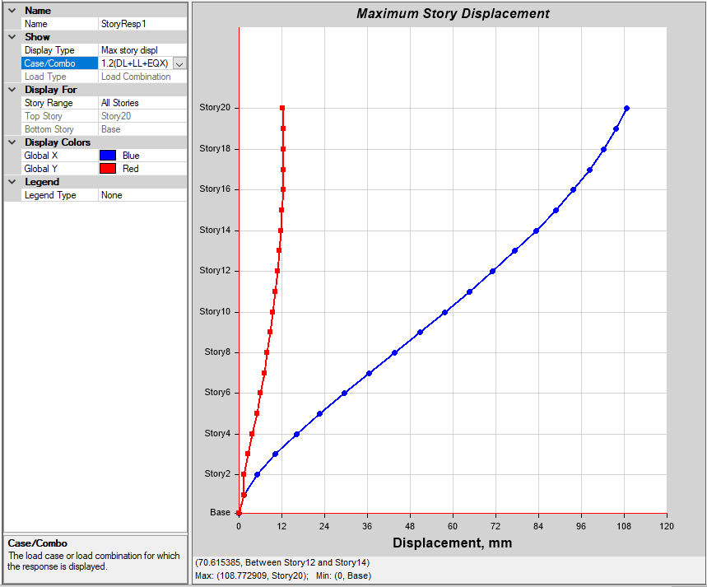 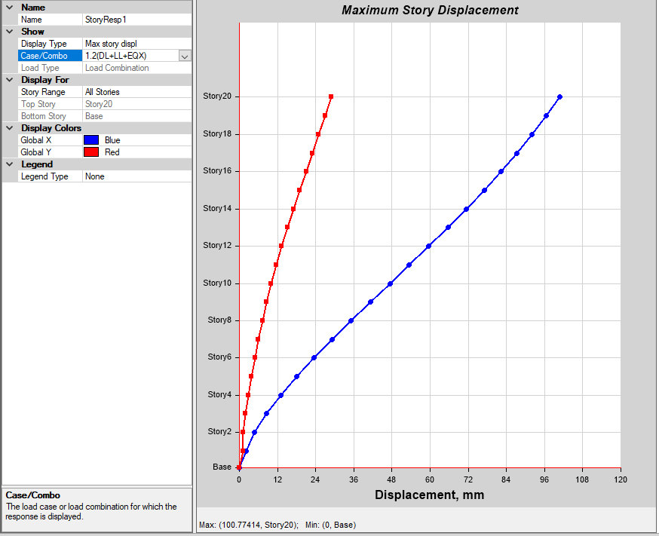

Figure 48 for the building with Shear wall Figure 49 for the building with X Bracing

**Max Story Displacement for 1.2(DL+LL-EQX)**

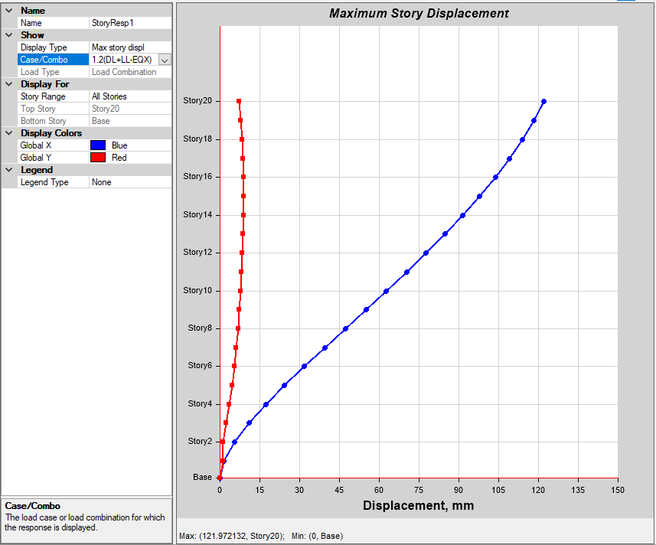 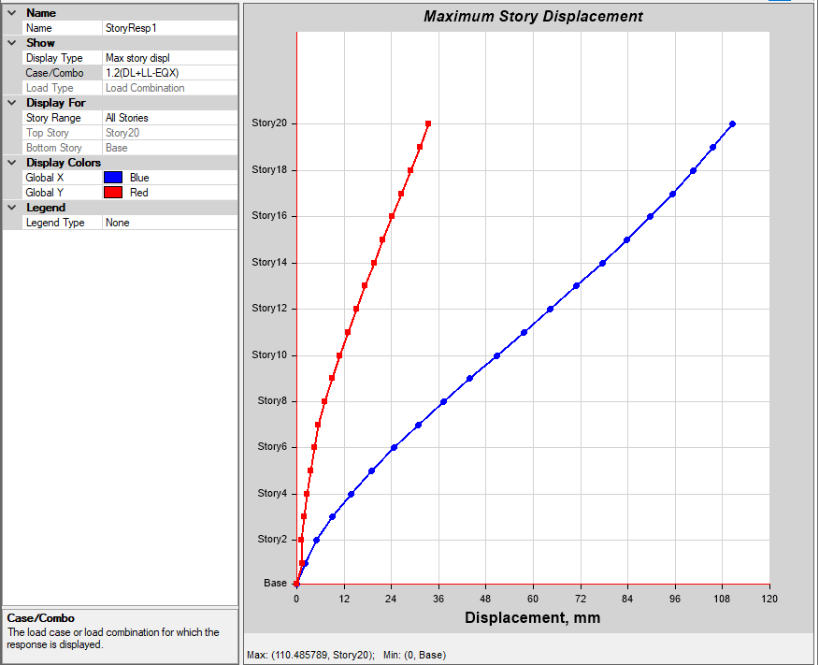 Figure 50 for the building with Shear wall Figure 51 for the building with X Bracing

**Max Story Displacement for 1.2(DL+LL-EQX)**

 

Figure 50 for the building with Shear wall Figure 51 for the building with X Bracing

**Max Story Displacement for 1.2(DL+LL+EQY)**

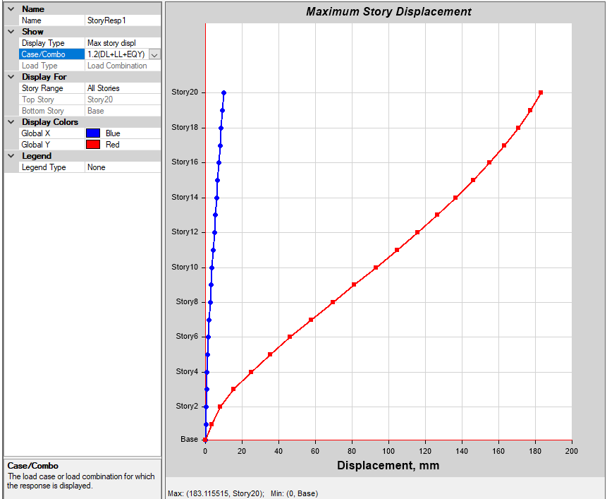 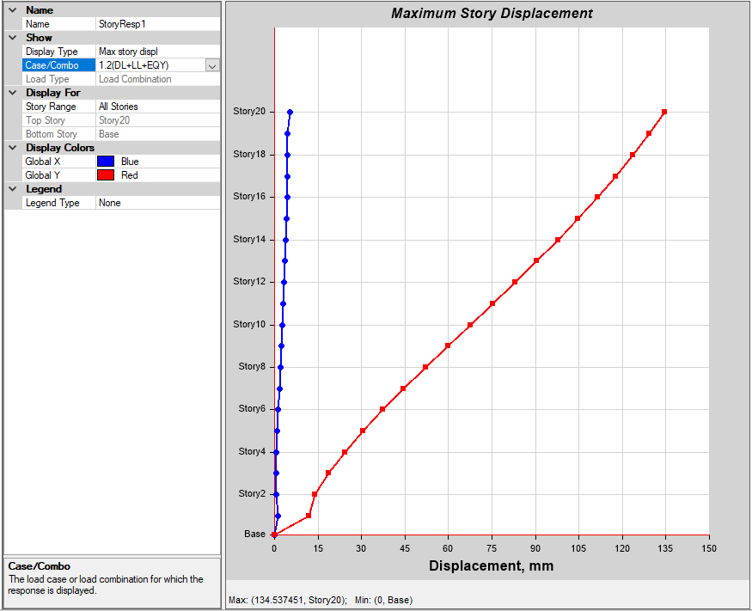

Figure 52 for the building with Shear wall Figure 53 for the building with X Bracing

**Max Story Displacement for 1.2(DL-LL+EQY)**

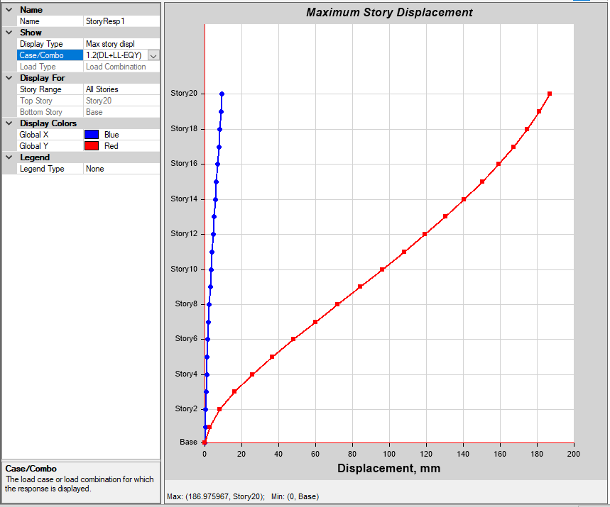 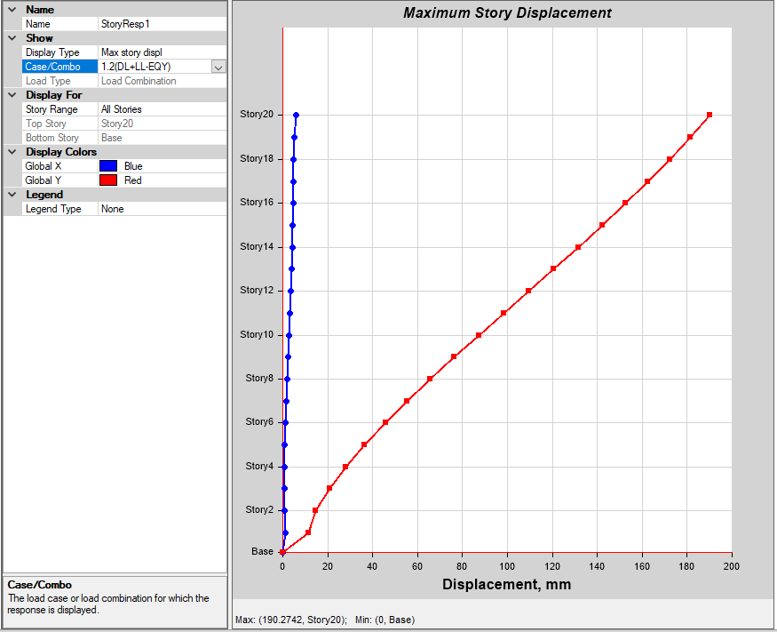

Figure 54 for the building with Shear wall Figure 55 for the building with X Bracing

**Max Story Drift1.2(DL+LL+EQX)**

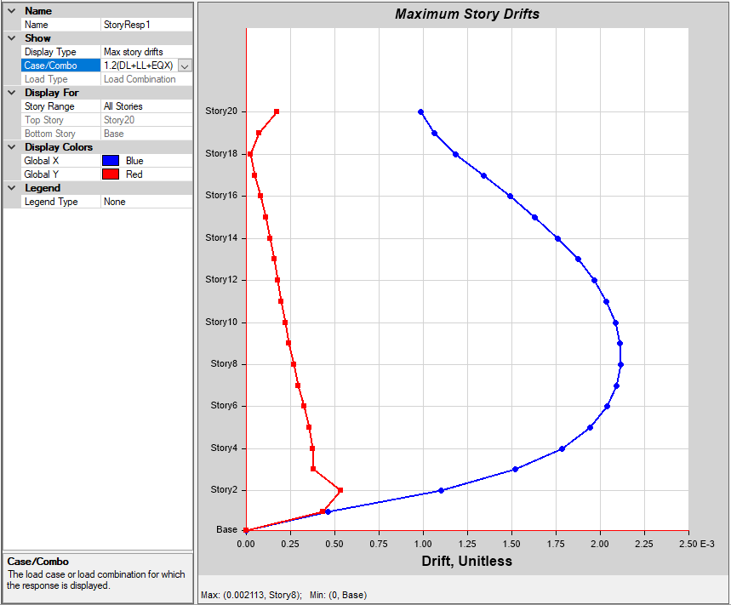 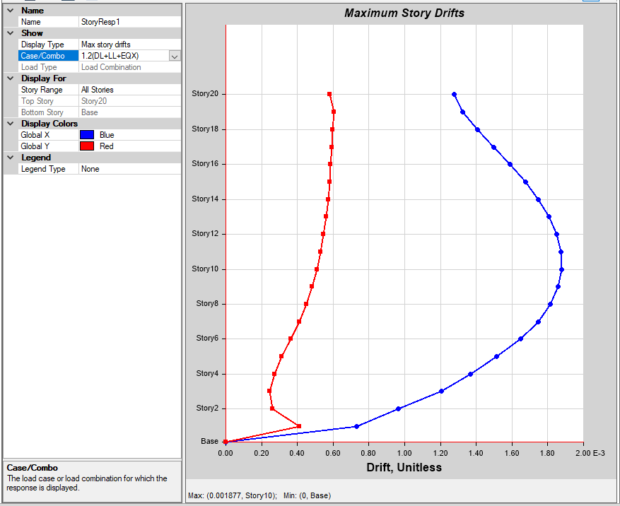

Figure 56 for the building with Shear wall Figure 57 for the building with X Bracing

**Max Story Drift for 1.2(DL+LL+EQY)**

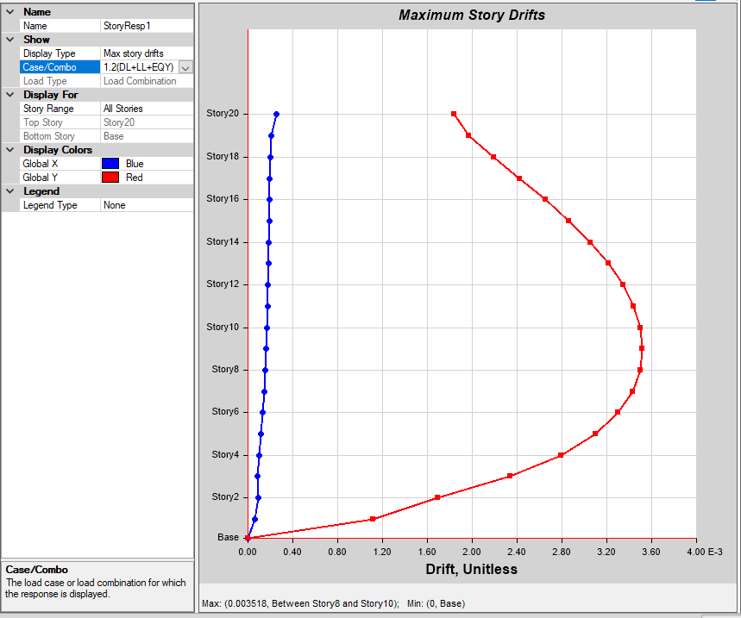 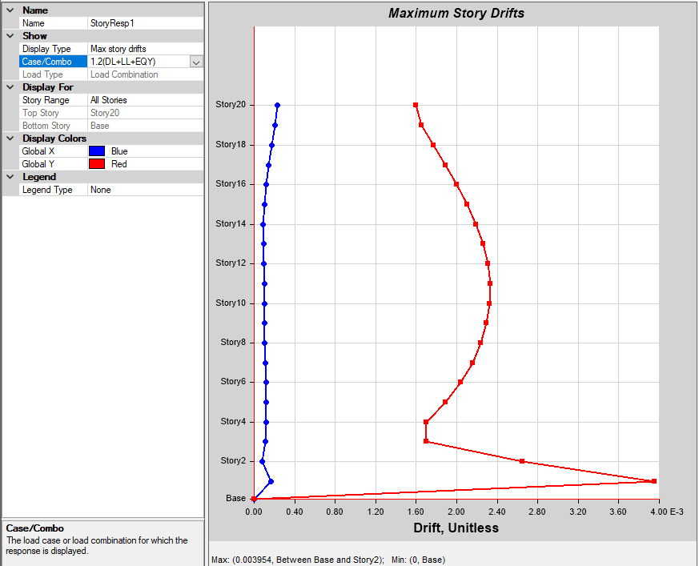

Figure 60 for the building with Shear wall Figure 61 for the building with X Bracing

**Max Story Drift for 1.2(DL-LL+EQY)**

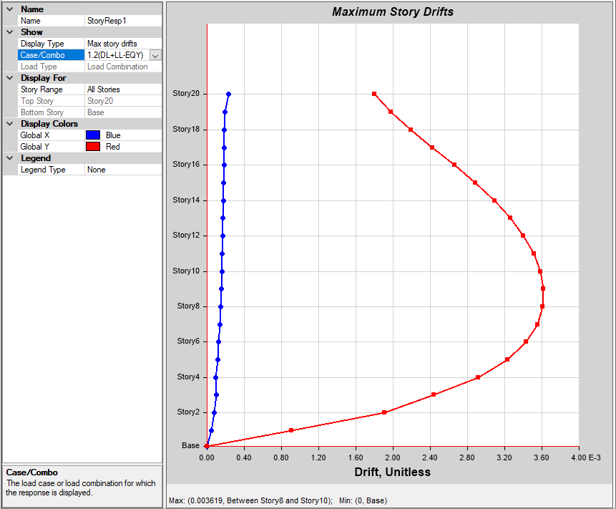 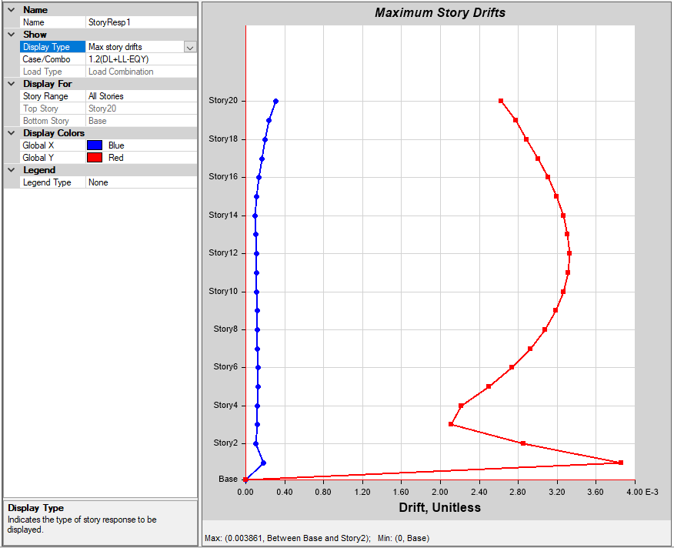

Figure 62 for the building with Shear wall Figure 63 for the building with X Bracing

**Story Shear1.2(DL+LL+EQX)**

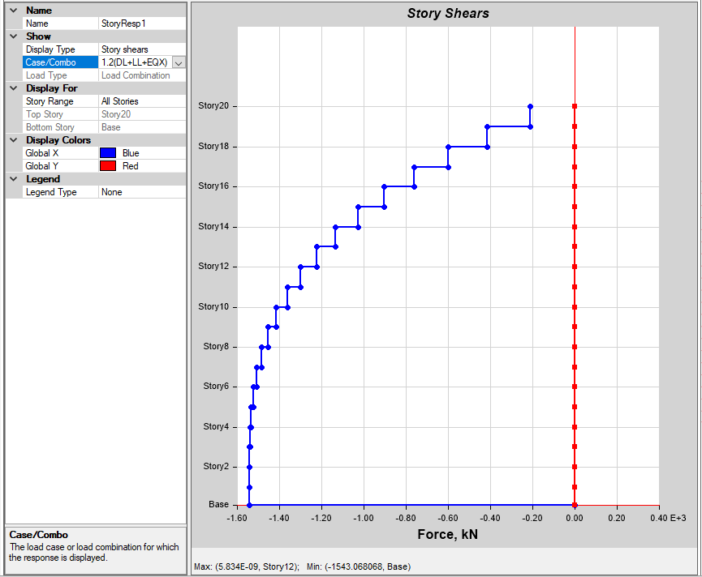 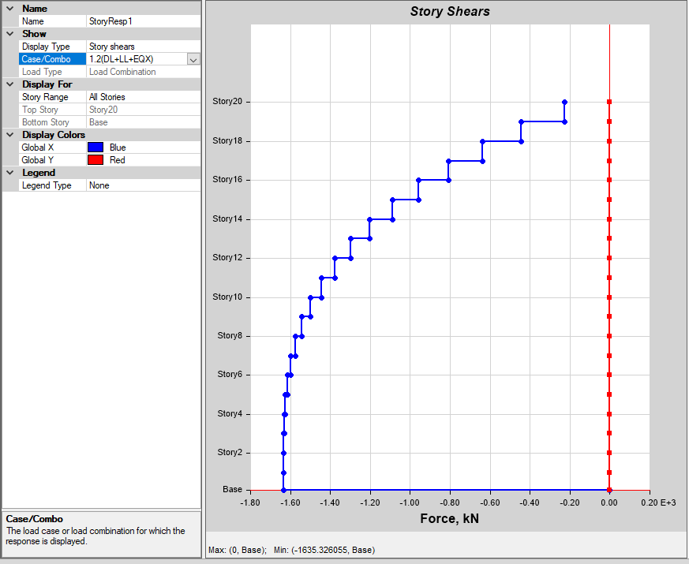

Figure 64 for the building with Shear wall Figure 65 for the building with X Bracing

**Story Shear for 1.2(DL+LL-EQX)**

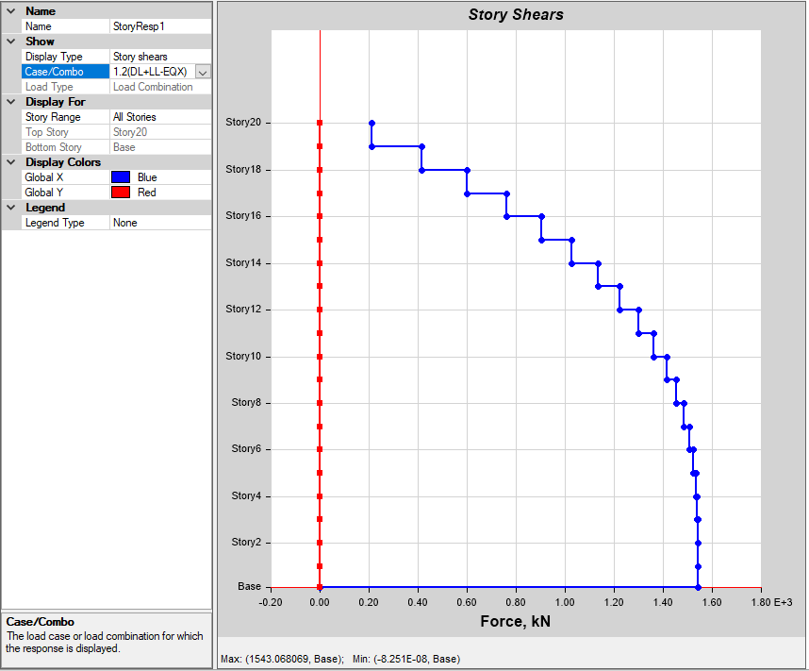 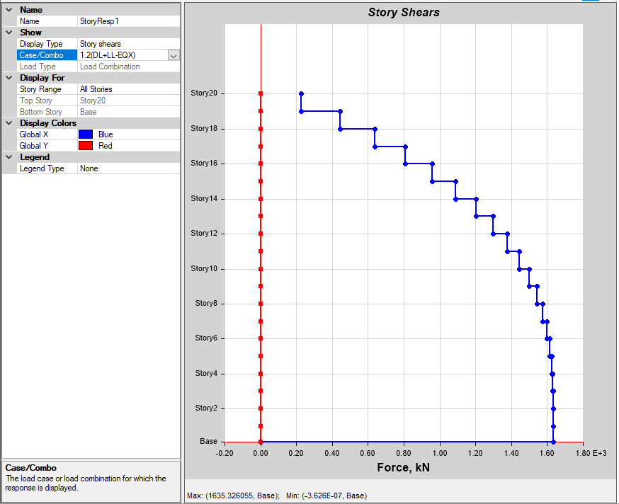

Figure 66 for the building with Shear wall Figure 67 for the building with X Bracing

**Story Shear for 1.2(DL+LL+EQY)**

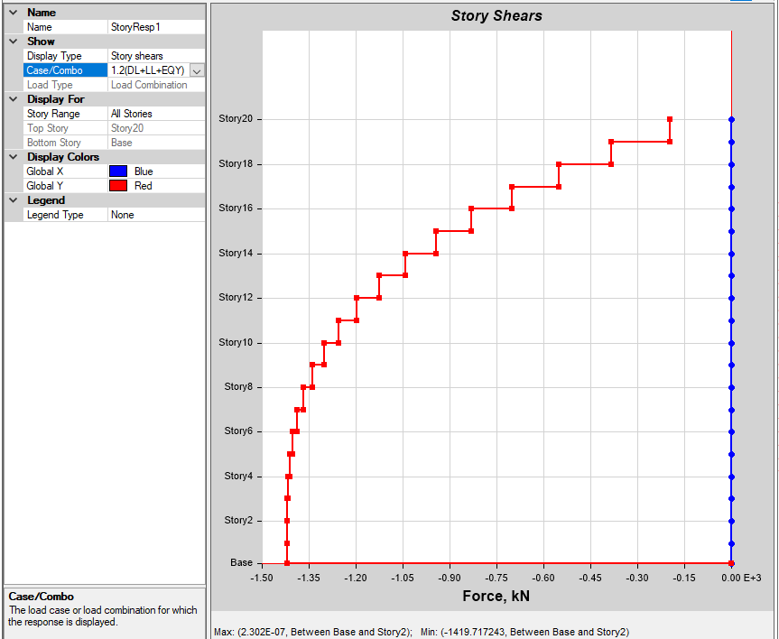 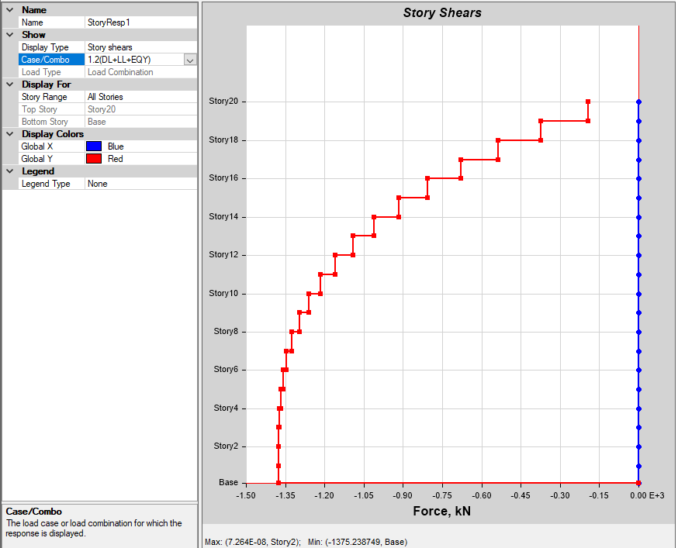

Figure 68 for the building with Shear wall Figure 69 for the building with X Bracing

**Story Shear for 1.2(DL-LL+EQY)**

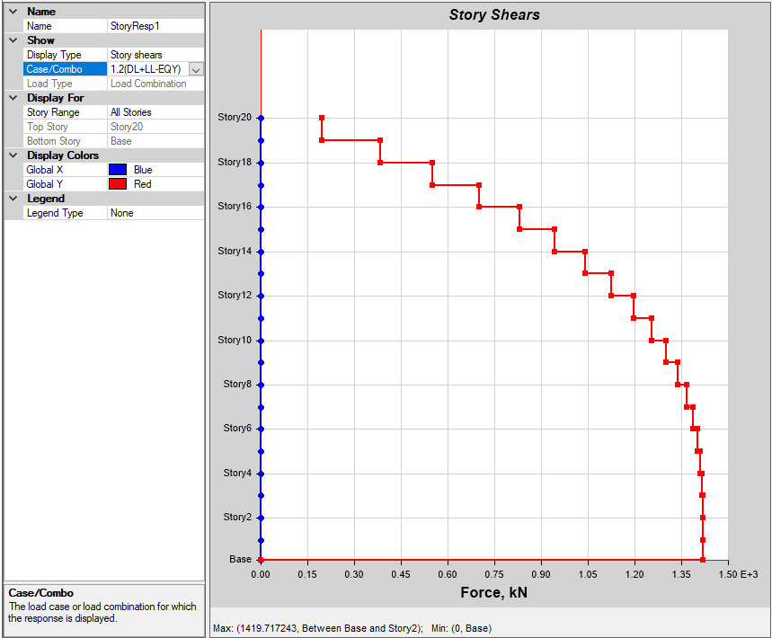 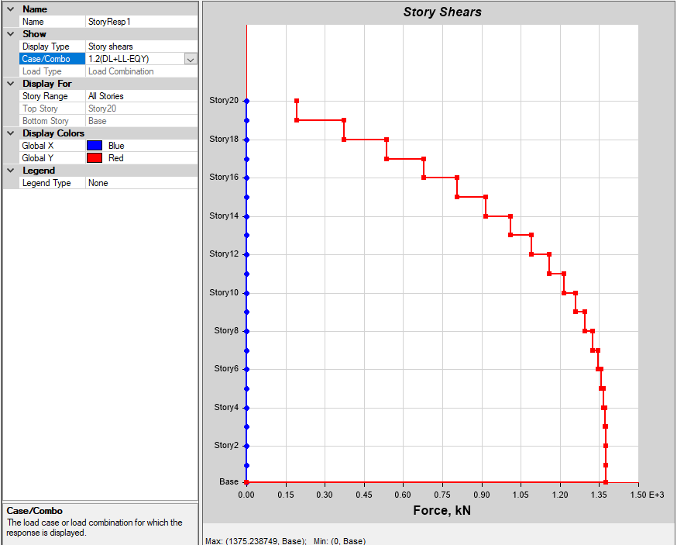

Figure 70 for the building with Shear wall Figure 71 for the building with X Bracing

**Discussions**

|  |  |  |  |
| --- | --- | --- | --- |
| **Particular** | **With Shear Wall** | **With X Bracing** | **Remarks** |
| Base Shear in X | 1543.07 KN | 1635.33 KN | Building with X bracing has more base shear in X |
| Base Shear in Y | 1479.72 KN | 1375.24 KN | Building with shear wall has more base shear in Y |
| Story Displacement in X at 20th Floor | 108.77 mm | 126.71 mm | Building with X bracing has more Story displacement in X |
| Story Displacement in Y at 20th Floor | 183.12 mm | 174.36 mm | Building with shear wall has more Story displacement in Y |
| Story Drift in X at 10th Floor | 6.985 | 6.288 | Building with shear wall has more Story Drift in X |
| Story Drift in Y at 10th Floor | 11.7.15 | 7.69 | Building with shear wall has more Story Drift in Y |
| Modal Period at 1st Mode | 4.99 sec | 4.591 sec | Modal period for the building with X bracing is less |
| Modal Frequency at 12th Mode | 2.704 Hz | 2.914 Hz | Modal Frequency for the building with shear wall is less |

It is evident from observing the result for both the models that the shear wall as well as the X bracing are making value of torsion very low. The story drift for the combination load DL+LL+/-EQX shown same performance for the building, and less value for story drift in all combinations at top story. The value of story drift is very low because of adding shear walls/ bracings to the building. It is evident from the observing result that for the selected load combination, maximum value of moment at story one and minimum value of shear force also at story one. The Moment is maximum when the shear force is minimum or changes sign. Based on the analysis and discussion, shear wall or even the X bracing is very much suitable for resisting Earthquake induced lateral forces in multi storied structural systems when compared to multi storied structural systems without either shear walls or bracings which will contribute in increasing the stiffness of the building as a whole. They can be made to behave in a ductile manner by adopting proper detailing techniques. The vertical reinforcement that is uniformly distributed in the shear wall shall not be less than the horizontal reinforcement. This provision is particularly for squat walls (i.e., Height-to-width ratio is about 1.0). However, for walls whit height-to-width ratio less than 1.0, a major part of the shear force is resisted by the vertical reinforcement. Hence, adequate vertical reinforcement should be provided for such walls. Various section sizes were being tried to optimize them before introducing the shear wall. However, once the shear wall was added then change in section changes was noticeable.

Also Is 1893 Part 1 Codal Provisions for Story Drift Limitations The story drift in any story due to the minimum specified design lateral force, with partial load factor of 1.0, shall not exceed 0.004 times the story height for the purposes of displacement requirements only, it is permissible to use seismic force obtained from the computed fundamental period (T) of the building without the lower bound limit on design seismic force specified in dynamic analysis. From the above we can say that Building which is provided with shear wall at appropriate places will help in reducing the displacement and base shear. Addition of either shear wall or bracing helps in reducing the story drift. Reduction in story displacement and story drift is due to increase in stiffness of the building as a whole. Even though there are various possible combinations of shear wall or bracing system and their placement we chose to place shear wall around lift and stairs for model one and when it comes to bracings, we chose X type bracings that are placed at the corners for this project. This is done because it won’t affect the functionality of the building. Either shear walls or bracing could be considered as one of the effective solution or structure element which helps in taking care of the lateral loads like earthquake and wind.

**CONCLUSION**

Table 15 Allowable & Maximum Story Displacement

|  |  |  |  |  |
| --- | --- | --- | --- | --- |
| **Max Story displacement as per the code** | **With Shear Wall in X Dir** | **With Shear Wall in Y Dir** | **With X Bracings in X Dir** | **With X Bracings in Y Dir** |
| 0.004 X 66.65 m Height  = 266.6 mm | 108.77 mm | 126.71 mm | 183.12 mm | 174.36 mm |

• Both models (with shear wall and with X bracings) are effective in keeping maximum displacement within code limits.

**• X Direction:** Model with shear wall is stronger.

• **Y Direction:** Model with X bracing is stronger.

• Tweaking either model (shear wall in X direction or X bracing in Y direction) can make them effective in both directions.

• Design done manually and using software, with relevant load applications.

• **Footing:** Max size 4.0m x 4.0m x 450mm.

• **Pedestal:** 1.0m x 1.0m for all columns to reduce footing depth.

**• Soil Bearing Capacity (SBC):** Assumed 320 KN/sqm.

**• Steel percentage:** Below 2% for most columns; up to 3.2% at lower floor levels (within 4% code limit).

• Proper placement of shear walls or bracings reduces displacement and story drift, increasing building stiffness.

• Shear wall placed around lift and stairs; X bracing in corners to maintain building functionality.

• Both shear walls and X bracings are effective in resisting lateral loads like earthquakes and wind.

• Introduction of shear wall or bracings significantly reduces story displacement, although it increases base shear due to added dead weight.

**FUTURE SCOPE OF STUDY**

This study gave an idea about the performance of the selected building one with shear wall and another with X bracing.

This study can be helpful in carrying out other analysis like Response Spectrum or Time History Analysis or even Pushover Analysis

We chose to place the shear wall around lift and stairs even though there are various possible combinations of shear wall placement. We can try to place the shear walls at the corners where the two faces meet. We can place the shear wall at the central part of all the four sides of the building.

Also, the shape of bracings we chose is X shape by locating them in the corners for this project. We can place the same X shape bracings at the central part of all the four sides with X bracings of higher section sizes. We can even try placing various other shapes of bracings like V, inverted V, K etc. Or we can even try with the combinations of different sizes.

And at the end of all the trials we can list out the various analysis parameters, compare them and select the best suitable solution for the given building.

**REFERENCES**

S K Jain & SK Thakkar, “Effect of Superstructure Stiffening in Base Isolated Tall Towers, ” IE (I) Journal.CV 85, (2004): pg. 142 to148

Duggal S.K “Earthquake Resistant Design Structure", Tata Mcgraw Hill Publication, 10thEdition, 2004.

Mahesh N. Patil, Yogesh N. Sonawane, “Seismic Analysis of “Multi Storied Towers"

Trevor E Kelly, S˕E (2001) “Design Guidelines on Base Isolation of Structures”, Holmes-consulting group, New-Zealand.

Wang. Y, “Fundamental-of seismic base-isolation”, international-training programs-for seismic design-of towers structures-hosted by “NCREE”. 139-149.

Devi prasad, Bharath V B, Shiva Prathap H K. in (July-2019) Buildings in seismic zones are designed with retrofit techniques and braced frames to enhance safety and prevent collapses during earthquakes.

M. Mouzzoun ET. AL (2013) five story reinforced concrete building design in Moroccan seismic code RPS 2000

Kadid et al. (2008) studied three framed buildings of five, eight, and twelve stories using pushover analysis in SAP 2000,

Jay Kumar Sah, Prem Shankar Singh, and Chinmay Kumar Kundu (2018); earthquake-resistant multi-leveled towers, analysis them using STAAD Pro V8i, and design the raft foundation using S.A.F.E.,

Rajat Bongilwar, V. R. Harne, and Aditya Chopade emphasized the crucial role of stiffness in tall towers to withstand lateral loads from wind and seismic activity, with RC shear walls providing necessary strength, stiffness, and ductility to control deflection and enhance seismic performance.

Pradeep Pujar and Amaresh (2018) aimed to analyze irregular 3D shapes with and without shear walls using E-tabs and the Equivalent Static Lateral force method,

K. Venkatesh and T. Venkatdas analyzed the lateral behavior of structures in Zones II and III with varying story heights (6, 11, and 16 levels). Using OMRF and SMRF models

Umamaheshwara B and Nagarajan P conducted a structural analysis in E-tabs for a 15-level building using static and dynamic loads.

Rahiman G. Khan et al. (2013) conducted a push over analysis of high-rise buildings with soft stories,

Abhijeet A. Maske et al. (2014) conducted a non-linear static pushover analysis on 5-story and 12-story R.C. frame structures

IS:456(2000), Plain & Reinforced Concrete Code of Practice

IS:875 (Part2):1987, Indian Standard “Code of Practice for Design Loads (Other Than Earthquake) For buildings& Structures”, Part2 Imposed Loads (2nd Rev), B.I.S., New Delhi...

Indian Standard Criteria for Earthquake Resistant Design Structure 1839 2002 & IS 875 (Part 2):1987.

Ductility Detailing of RC Structures Subjected to Seismic Forces IS 13920: 1993

Wang. Y, “Fundamental-of seismic base-isolation”, international-training programs-for seismic design-of towers structures-hosted by “NCREE”. 139-149.

IS: 875 (Part 2):1987, Indian Standard “Code-Of Practice For-Design Loads-(Other Than-Earthquake) For-Towers & Structures”, Part2 Imposed-Loads (Second Rev), B.I.S., New Delhi...