**A SYSTEMATIC REVIEW OF LITERATURE ON THE ENABLERS AND CHALLENGES OF HUMAN DEVELOPMENT IN BARMM**

**Hazel Jane R. Ardepolla**

ORCID Number: 0009-0007-7244-6430

Graduate School of College of Development Management, University of Southeastern Philippines

**ABSTRACT**

The Bangsamoro Autonomous Region in Muslim Mindanao (BARMM) is historically and culturally relevant to the Philippines, created by centuries of warfare and socio-political marginalization. This paper explores the facilitators and barriers to human development in BARMM that include governance, socioeconomic empowerment, education, health and infrastructure. The review utilized the Preferred Reporting Items for Systematic Reviews and Meta-Analysis (PRISMA frame) to define, screen and evaluate appropriate studies. Enablers are participatory governance as enshrined in the BOL, fiscal reforms fostering economic growth and reforms in health and education improving regional inequities. Yet, there are still ongoing issues of poor institutional capacity, socio-economic disparities, poor infrastructure, and political instability preventing long-term development. Although there have been developments in terms of governance, economic opportunities and social services, the region is still confronted by major developmental/blockers. It all calls for a holistic solution and this encompasses the enhancement of governance structures, the upgrading of infrastructure and most importantly equitable access to education, to health services and economic prospects (in particular for the most vulnerable people in society).

**KEYWORDS:**

Bangsamoro Autonomous Region in Muslim Mindanao (BARMM), Human development, Governance reforms, Economic, Education and human capital, Healthcare access, Political stability, Infrastructure, Peacebuilding, Socio-economic inequality

**______________________________________________________________________________**

**INTRODUCTION**

The Bangsamoro Autonomous Region in Muslim Mindanao (BARMM) is a region of deep political, religious and social complexity, marked by a long history of indigenous Muslim populations, and by centuries of conflict, from colonial to postcolonial governance. With the ratification of the Bangsamoro Organic Law (BOL) in 2019, the establishment of BARMM constituted a grade break in the region's history that promised self-determination, peace, and development following centuries of armed struggle and socio-political marginalization. The historical background of BARMM is of utmost importance for understanding the driving forces and barriers to the human development in BARMM. The peace initiative that spawned the establishment of the region seeks to settle the complaint of the Bangsamoro community and achieve regional peace and stability through enhanced autonomy. The BOL and the governing environment it created have constituted a major step in the resolution of longstanding problems of governance, of inequality and of identity.

This systematic review will use a multidimensional development framework in order to make certain that research includes a comprehensive exploration of the range of factors shaping human development in the Bangsamoro Autonomous Region in Muslim Mindanao (BARMM). The architecture is multidimensional and is based on governance and political stability, economic empowerment and job creation, human capital and development education, access to healthcare and social safety nets, infrastructure expansion, and political stability and peacebuilding. By examining these interrelated dimensions, the study aims to identify both enablers (such as reforms and policies under the Bangsamoro Organic Law) and challenges (such as poverty, education disparities, and political instability) that affect human development outcomes in BARMM. The use of this procedure permits a unitary view of the ways in which these dimensions interact to inform the developmental path of the region.

**METHODOLOGY**

Identification, Screening, Eligibility, and Inclusion. All stages matter in such a way as to guarantee the quality and the contribution of the studies which are taken into account by the review. In particular, the study will attempt to address the following 3 pivotal questions: (1) What are the main enablers that lead to human growth in BARMM? (2) What are the barriers to human advancement in BARMM? (3) What roles can governance, political stability, economic development, health, education, infrastructure, and peacemaking play in influencing human development in the area? Through a synthesis of the extant literature, the study will deliver a holistic view of the elements promoting or hindering human development in BARMM, which will be useful to policymakers, practitioners, and stakeholders aiming for sustainable development in BARMM.

During the Identification phase, we will use the multidimensional framework to direct the selection and examination of studies that consider the different dimensions of human developmental processes in BARMM. Using this multidimensional framework, we will develop relevant keywords for searching studies across various databases and sources. These keywords will target the main aspects of human development in BARMM so that, as initial results, the search will cover studies on the most diverse aspects of the governance, economy, society, and infrastructure of the region. At this stage, research will be chosen based on the study's relevance to research questions, not on source or database. Through this approach it will be possible to gain a wide array of studies that shed lights on the enablers and barriers to development in BARMM, as well as be equally aware on the interplay of the socio-political and economic complexities of the region.

Following 1802 eligible studies were found, within the Screening phase, there were duplicate eliminations and process of checking the remaining studies by title and abstract. This step was highly important for being directly relevant to the central research questions. After the removal of duplications, 979 studies were left. The studies were screened for their relevance with 214 studies left. At the Eligibility phase, studies were assessed according to four criteria. To begin with, research wanted to supply either empirical data or conceptual frameworks, with empirical evidence (quantitative/qualitative) and/or theoretical perspectives regarding enablers and barriers of human development in BARMM. Additionally, literatures applied study that was published within the last 10–15 years. After going through the eligibility criteria screening, the researcher was left with 108 studies. These databases provide most of the bibliographic data for articles in the journals, conference papers, books, etc. They are highly esteemed within academic and research communities due to their provision of access to authoritative, high-quality resources. Studies that did not fulfill these criteria-i.e., studies without full-text release or studies published in nonpeer-reviewed journals-were removed. This systematic strategy guarantees that only trustworthy and valid studies will be included in the results of this review. Of the 36 studies selected, three are in Scopus, one is in JSTOR and the remaining are in the form of Semantic Scholar and Google Scholar.

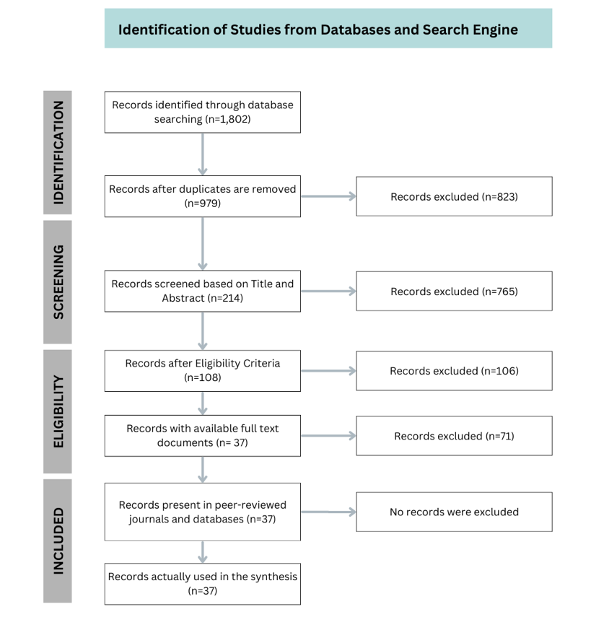

Figure 1. Contextualized PRISMA Model Used in the Study

**RESULTS AND DISCUSSION**

**1. Enablers of Human Development in BARMM**

**1. 1 Governance and Political Stability**

The governance structure placed in effect under the Bangsamoro Organic Law (BOL) has been an important driver of human development in BARMM. The establishment of the Bangsamoro Transition Authority (BTA) has brought about participatory governance systems, thereby enhancing local participation and enhancing accountability (Tagorda, 2024). According to Colicol & Sali-Latif (2023) reforms in governance have achieved greater decision-making inclusivity, with decentralization as a priority and consequently, greater service delivery. In addition, the BOL has created an institutional basis for conflict resolution and has contributed to regional stability (Ragandang & Podder, 2022). Examples of data-driven governance activities, the Bangsamoro Data Challenge for instance, play a crucial role in the development of public policies and efficiency of resource management (Toledo et al., 2022). These efforts break down secrecy and foster transparency and accountability, which then direct the resources and accept the need for evidence-based, targeted developmental interventions, enhance policy outcomes across a range of areas such as healthcare, education and economic growth.

**1. 2 Economic Empowerment and Opportunities**

Economic empowerment is an important component for human development in BARMM. The regional economy has been sustained by fiscal reforms promoted under the BOL, which give block grants and enhanced revenue shares to the regional administration, allowing to invest in priority development areas (World Bank, 2019). Programs to assist small businesses, such as in agriculture, fishing, and e-commerce, have been critical to pulling struggling local economies out of poverty (Jeconiah & Sharon, 2023). Furthermore, the Islamic finance modalities of zakat (almsgiving) and waqf (endowments) have been utilised for poverty relief and for supporting educational and healthcare projects (Daud, 2023). According the Oladapo & Ab Rahman (2016), these financial arrangements, stemming from the culture of the area, at the same time great role in providing social justice and economic empowerment. While these initiatives have had a positive impact, their full potential remains untapped, requiring further institutional support to ensure sustainable economic development.

**1. 3 Education and Human Capital Development**

Education has been recognized as an important facilitator of human development in BARMM. With changes supported by the Bangsamoro Education Code, new considerations in inclusivity and multilingualism have been presented, including the introduction of Arabic and mother tongue languages in the curricula (Jeconiah & Sharon, 2023). In addition, alternative learning systems and vocational training activities have played an important role in closing literacy deficits, especially in very remote and conflict areas (World Bank, 2017). These activities have been developed to overcome educational inequalities and to develop human capital in the area. But as noted in Colicol & Sali-Latif (2023), rural schools in BARMM lack a proper structure, shortage of teaching staff, and insufficient resources. Access to appropriate education is thereby restricted, which in turn reinforces poverty traps and socio-economic exclusion. The introduction of the K-12 Voucher Program has also shed light on great inequalities in school access and deepened the educational inequalities (Colicol & Sali-Latif, 2023).

**1. 4 Healthcare Access and Health Interventions**

In the field of medicine, BARMM has achieved noteworthy developments, thanks to increased immunization and GDM services, mainly at urban centres (World Bank, 2019). However, rural areas continue to face significant challenges due to inadequate healthcare infrastructure, shortages of healthcare professionals, and logistical barriers that hinder service delivery (Solaiman, 2021). The Ministry of Health (MOH) in BARMM has been working to fill these gaps by bundling health services with social protection benefits, and prioritizing maternal and child health (JIPS, 2023). Health interventions are also limited in their impact due to cultural barriers, especially in remote and traditional areas where health education programmes may not necessarily follow local culture (Agga, 2022). However, by way of targeted health education programs success in preventing avoidable illness, there is still much to be done to achieve equitable access to healthcare services throughout the area.

**2. Challenges Hindering Human Development in BARMM**

**2. 1 Governance and Institutional Weaknesses**

Despite advancements in governance, BARMM still has many challenges in institutional capability. Deinla & Taylor (2015) and Colicol & Sali-Latif(2023) point out poor intergovernmental coordination and low governance capacity, which limit the effective implementation of policies. Bureaucratic failures and corruption only make these problems worse, particularly in out of the way areas, where other resources tend to be siphoned off, or misappropriated. These institutional gaps hamper the provision of critical services and constrain development in key areas, including education, health, and infrastructure.

**2. 2 Socio-Economic Inequities**

Poverty continues to be a major problem in BARMM, and this is further aggravated by high levels of inequality in economy. This area is among the poorest in terms of Human Development Index (HDI) in the Philippines and is characterized by troubling income, educational, and health inequities (World Bank, 2017). Marginalised groups, in particular women and indigenous peoples, experience deep-rooted entrenched obstacles to socio-economic advancement, which in turn makes it difficult for them to attain quality education, healthcare, and economic activity (Kumari, 2022). The limited reach of economic empowerment programs, such as livelihood assistance for fishing communities (Pendi, 2022), highlights the uneven distribution of resources and opportunities. While some interventions have shown positive outcomes, their impact remains constrained by logistical and funding limitations, leaving many vulnerable populations underserved.

**2. 3 Educational Inequity**

Educational inequality in BARMM is a major bottleneck for human development. While reforms have been introduced to improve access to education, the region continues to grapple with significant challenges related to infrastructure, teacher shortages, and resource limitations (Colicol & Sali-Latif, 2023). Rural and conflict-stricken regions are often under-equipped for education, and schooling quality varies inconsistently across the region. Linguistic barriers in learning also lead to differences in learning achievement, in particular for children of indigenous or marginalized backgrounds. However, owing to the inclusion of mother tongue and Arabic in the school curriculum, numerous students in remote settings continue to feel disadvantaged to obtain schooling in line with their cultural and linguistic background (Jeconiah & Sharon, 2023).

**2. 4 Health Infrastructure Deficits**

Healthcare in BARMM is [yet] burdened by substantial funding deficiencies and rural populations are deprived of basic healthcare infrastructure. The lack of health care making in these localities, in addition to logistical issues regarding transportation and communication constrain the impact of health interventions and fuel health inequalities (JIPS, 2023). While maternal and child health programs have seen some improvements, the region continues to face challenges in meeting the healthcare needs of its entire population, particularly in conflict-affected areas (Solaiman, 2021).

**2. 5 Inadequate Infrastructure**

The absence of basic infrastructure in BARMM (e.g., roads, power, clean water and communication) still poses a major bottleneck for development. As noted by Prihatin et al. (2022) and Colicol & Sali-Latif (2023) inadequate infrastructure limits access for health care, education, and economic opportunity especially in rural communities. This underdevelopment also hinders local authorities’ ability to respond to not only the needs of the population but also of population themselves (such as in emergencies or displacement due to war).

**2. 6 Political Instability and Conflict**

While the peace process in BARMM has made significant progress, political instability and sporadic violence remain ongoing challenges. Past grievances and unresolved conflict among various social groups still set a roadblock for the attempt of building a stable and firm society. As Oladapo & Ab Rahman (2016) and Solaiman (2021) point out, the history of conflict in the region has eroded governance structures, thereby hampering peace and progress. This instability impacts not only the politics of governance but also socio-economic development, as prolonged war disrupts economic activities and evicts populations, deepening poverty and social stratification.

**STUDY FRAMEWORK**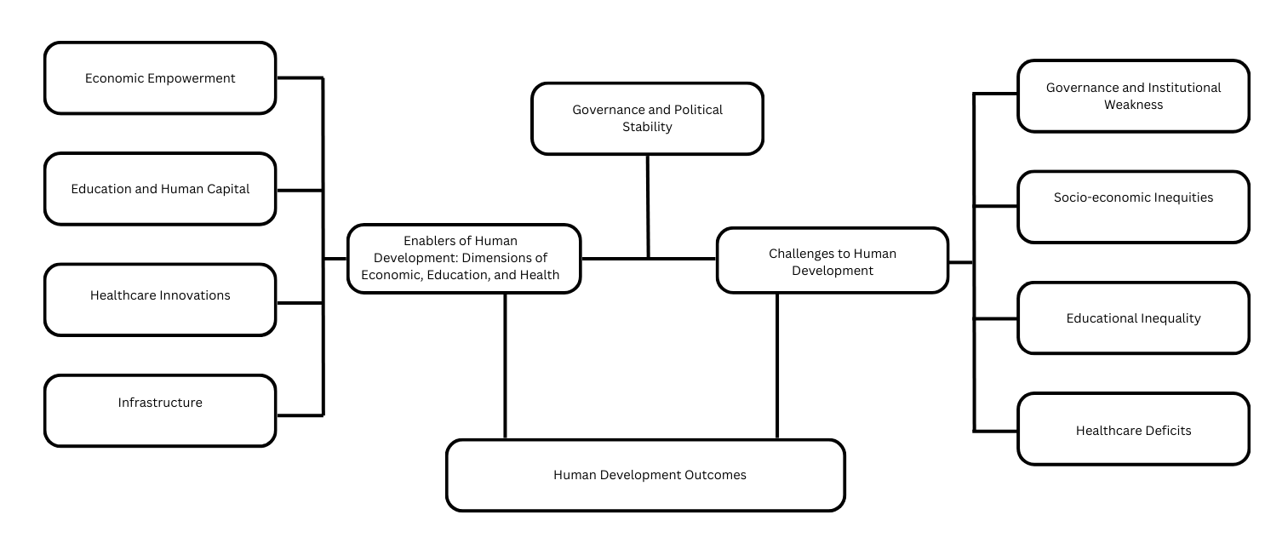

**CONCLUSION**

Development of human beings in BARMM is a complex mix of facilitators and barriers. On the one hand, policy reform measures (such as the BOL and the creation of participatory bodies e.g., the BTA) have enabled to achieve not only an increased but also better governance, and, subsequently, greater autonomy and accountability at the regional level. Yet, issues including poor governance of the institutions, political unrest, economic imbalances, educational discrepancies, poorly provided healthcare facilities, etc. continue to pose challenges. Challenges that these must address demand a comprehensive solution including measures to improve governance, create more economic opportunities, enhance education and the delivery of healthcare services and to develop infrastructure. Through the resolution of these barriers and inclusive and sustainable development, BARMM can realize its potential and raise the standards of living particularly for its Moro people.

**REFERENCES**

1. Abdulgapor, M. T., & Tuya, M. M. (2019). Peace and Conflict Resolution of the Bangsamoro Problem. International Journal of Scientific and Research Publications.
2. Agga, A. O. (2022). Culture-Based Health Practices in Tribal Communities. American Journal of Interdisciplinary Research and Innovation.
3. Colicol, F. L., & Sali-Latif, F. K. (2023). Parental Occupation, Social Class, and School Choice in Southern Philippines. International Journal of Learning, Teaching and Educational Research.
4. Daud, N. M. (2023). Analysis on Zakat Knowledge Awareness Among the Bangsamoro People. International Journal for Multidisciplinary Research.
5. Deinla, I. (2015). Hybrid Justice Systems in Mindanao. RegNet Working Paper Series.
6. Deinla, I. (2020). Hybrid Justice Mechanisms in Mindanao. In: (In)Security and Hybrid Justice Systems in Mindanao, Philippines. Retrieved from [Document 3, ch13.pdf].
7. Deinla, I., & Taylor, V. L. (2015). Towards Peace: Rethinking Justice and Legal Pluralism in the Bangsamoro. RegNet Working Paper Series.
8. Dreisbach, J., & Mendoza-Dreisbach, S. (2023). Language Policies in Bangsamoro Education Code. International Journal of Islamic Thought.
9. FAO. (2020). Strategic Programme for Agriculture, Fisheries, and Agribusiness Development in BARMM (SPAFAD-BARMM). Food and Agriculture Organization. Retrieved from [Document 2, cb2888en.pdf].
10. Kumari, P. (2022). Role of Women Empowerment in Achieving Social Transformation. International Journal of Multidisciplinary Research and Growth Evaluation.
11. Lantong, A., Musnandar, A., & Tuya, M. (2023). Methods of Teaching Islamic Values Education Amid Conflict Situations: The Case of Bangsamoro Development Agency in Mindanao. Al-Wijdán: Journal of Islamic Education Studies.
12. Lantong, A., Musnandar, A., & Tuya, M. (2023). Teaching Islamic Values Education Amid Conflict Situations. Al-Wijdán: Journal of Islamic Education Studies.
13. Malik, U. (2024). Business Sustainability Framework for BARMM. Journal of Electrical Systems.
14. Mendoza, R. U., & Yusingco, M. H. (2019). Dissecting the BARMM Block Grant. Ateneo School of Government.
15. Oladapo, I. A., & Ab Rahman, A. (2016). Maqasid Sharī‘ah: The Drive for an Inclusive Human Development Policy. Jurnal Syariah, 24(2), 287–302.
16. Pendi, N. G. (2022). Socio-Economic Status of Fishing Communities in Bangsamoro. Randwick International of Social Sciences Journal.
17. Prihatin, T. P. (2022). Community Facilitator as Human Capital. International Journal of Scientific Research and Management.
18. Radiamoda, A. M. (2022). Waqf of the Bangsamoro in the Philippines: Issues and Challenges. Innovatio: Journal for Religious-Innovation Studies.
19. Ragandang, P. III, & Podder, S. (2022). Youth Inclusion in Peace Processes. Conflict, Security & Development.
20. Solaiman, S. M. (2021). Challenges of Madaris Education in BARMM. Journal of Social and Political Sciences.
21. Söderberg Kovacs, M., et al. (2021). Autonomous Peace in Bangsamoro. Journal of Peacebuilding & Development.
22. Tagorda, Y. A. (2024). Combatting Child Marriage: A Study of Youth-Led Civil Society Initiatives. Journal of Contemporary Sociological Issues.
23. Tendero, E. J., Jumlail, E., & Rasid, G. (2023). Civilian-military Service through Voluntary Engagement in BARMM. Philippine Army.
24. Toledo, M., Ligot, D. V., & Amores, K. C. (2022). Bangsamoro Data Challenge. Cirrolytix Research Services.
25. Toledo, M., Ligot, D. V., & Amores, K. C. (2022). Bangsamoro Data Challenge - Data-Driven Peace-Building through Collaborative Ideation. Cirrolytix Research Services. Retrieved from https://ssrn.com/abstract=4064329.
26. Wziątek-Staśko, A. (2023). Diversity Management for Regional Development. Regional Formation and Development Studies.
27. World Bank. (2017). Philippines Mindanao Jobs Report: A Strategy of Mindanao Regional Development. World Bank Group.
28. World Bank. (2019). Delivering and Financing Health Services in BARMM. World Bank Group.
29. World Bank. (2019). Unlocking the Potential of the Bangsamoro People. World Bank Group.
30. World Bank. (2020). Delivering and Financing Health Services in the Bangsamoro Autonomous Region in Muslim Mindanao: The Transition to Universal Health Coverage in BARMM. World Bank Group.
31. World Bank. (2020). Boosting Human Capital in the Philippines through Conditional Cash Transfers. Global Delivery Initiative.
32. Yusingco, M. H. L. (2021). Deliberative Democracy and the Bangsamoro Parliament. Ateneo de Manila University. Retrieved from https://ssrn.com/abstract=3791001.