A COMPREHENSIVE STUDY AND REVIEW OF ALOEVERA AND KIWI ENERGY BAR

**Abstract**

The formulation and evaluation of a Kiwi and Aloevera energy bar were investigated to develop a nutritious and functional snack that combines the antioxidant properties of kiwi with the health benefits of Aloe Vera. The energy bar was prepared by incorporating dried kiwi pulp and Aloevera gel into a base made from oats, nuts, and seeds, ensuring a balanced composition of carbohydrates, protein, fiber, and essential micronutrients. The formulation was optimized for taste, texture, and nutritional content. The energy bars were then evaluated for their physical characteristics, including texture, color, and appearance, as well as their nutritional profile, including moisture content, protein, fat, and fiber content.Sensory evaluation revealed high acceptability among panelists, and the bars demonstrated significant antioxidant activity due to the combined effects of kiwi and Aloe Vera. The results suggest that the Kiwi and Aloe Vera energy bar is a promising functional food product with potential health benefits for consumers seeking a convenient, nutritious, and energizing snack.

**Keyword :** Energy bar ,Kiwi ,Aloevera ,formulation, evalution ,Antioxidant.

**Introduction :**

In the modern era, the demand for functional and nutritious snack options has surged, driven by the growing awareness of healthy eating and busy lifestyles. Energy bars have become a preferred choice for consumers seeking convenient, on-the-go nutrition. Among the myriad of innovative formulations, combining aloevera and kiwi offers a unique and health-focused approach to energy bar development.

Aloevera, revered for centuries in traditional medicine, is a treasure trove of bioactive compounds, including vitamins, antioxidants, and amino acids. Known for its hydrating, anti-inflammatory, and digestive health benefits, it is a natural choice for enhancing the functional value of food products. Kiwi, often dubbed a "superfruit," complements aloevera with its rich vitamin C content, potent antioxidants, and natural enzymes that aid in digestion and boost immunity. Together, aloevera and kiwi create a synergy of flavor and nutrition, making them an ideal foundation for a unique energy bar.

This project focuses on the formulation and evaluation of an aloevera and kiwi-based energy bar, emphasizing a balance of taste, texture, and nutritional benefits. The inclusion of natural ingredients such as oats, nuts, and honey ensures a wholesome, energy-boosting snack suitable for diverse consumer needs. By integrating modern food science techniques and sensory evaluation methods, the study aims to develop a product that is not only appealing but also aligns with the growing trend of functional foods.

The aloevera and kiwi energy bar stands as an innovative response to the demand for healthy, convenient, and delicious snack options, paving the way for a product that blends traditional wellness with modern convenience.

**Pharmacognosy :**

1. **Aloevera:**

**Scientific Name:** Aloe barbadensis miller

**Family:** Asphodelaceae

**Morphology:**

Part Used: Leaves (gel and latex).

**Description**: The aloe vera plant is a succulent with fleshy, lance-shaped green leaves that have serrated edges. The clear gel inside the leaves is rich in bioactive compounds. 

**Pharmacological Properties:**

**Wound Healing:** Stimulates fibroblast activity and collagen production.

**Anti-inflammatory:** Inhibits prostaglandin synthesis and reduces inflammation.

**Antioxidant:** Scavenges free radicals and protects cells.

**Immunomodulatory:** Enhances immune response through acemannan.

**Gastroprotective:** Treats ulcers and soothes the gastrointestinal tract.

**Laxative:** Aloin acts as a potent stimulant laxative.

“A NATURAL BOOST FOR VITALITY”

**2-Kiwi:**

**Scientific Name:** Actinidia deliciosa

**Family:** Actinidiaceae

**Morphology:**

Part Used: Fruit (pulp and seeds).

**Description:** The kiwi fruit is oval-shaped with a fuzzy brown outer skin. The inner pulp is vibrant green .



**Pharmacological Properties:**

**Antioxidant:** Protects against oxidative stress and DNA damage.

**Anti-inflammatory:** Reduces inflammation through polyphenolic activity.

**Digestive Health:** Actinidin enhances protein digestion and improves gut motility.

**Cardioprotective:** Lowers blood pressure and reduces cholesterol levels.

**Immunomodulatory:** Boosts immunity with vitamin C and other antioxidants.

**Antimicrobial:** Inhibits the growth of certain pathogens.

**Procedure:**

**1. Ingredient Selection**

Aloe Vera: Use fresh aloe vera gel or commercially available aloe vera powder.

Kiwi: Use fresh or freeze-dried kiwi puree or pieces.

Other Ingredients: Select complementary ingredients such as oats, nuts, seeds, honey, dates, or any binding agents (e.g., peanut butter).

Preservatives: If necessary, add natural preservatives like lemon juice to extend shelf life

**2. Preparation of Ingredients**

Aloe Vera Gel:

Wash the aloe vera leaves thoroughly.

Peel off the outer green layer and extract the clear gel.

Blend the gel into a smooth puree.

Kiwi:

Wash and peel the kiwi fruit.

Blend into a smooth puree or cut into small pieces.

Other Ingredients:

Roast oats, nuts, or seeds (optional) to enhance flavor.

Chop dried fruits (if used) into small pieces

**3. Formulation**

Create a base formula by mixing the following (adjust proportions to achieve desired texture and flavor):

Aloe Vera Gel: 20-30%

Kiwi Puree: 15-20%

Oats: 20-25%

Nuts/Seeds: 10-15%

Binding Agents (e.g., dates, honey, or peanut butter): 10-15%

**Blend all ingredients evenly using a food processor.**

**4. Processing**

1. Shaping: Spread the mixture on a baking tray or mold, ensuring uniform thickness.

2. Cooling/Setting:

If a raw energy bar is preferred, refrigerate for 2-4 hours until firm.

For baked bars, preheat the oven to 180°C and bake for 10-15 minutes.

3. Cutting: Once set, cut into uniform bars using a sharp knife.

**5. Packaging**

Wrap each bar individually in food-grade wrappers or store in an airtight container.

Label with storage instructions and nutritional information (if available).

**6. Evaluation**

A. Physicochemical Analysis

Moisture Content: To determine shelf stability.

pH: Ensure a safe pH range (4-6) for extended shelf life.

Nutritional Analysis: Analyze macronutrients (carbohydrates, proteins, fats) and energy content.

B. Sensory Evaluation

Conduct a sensory panel with 10-20 participants.

Assess attributes like:

Appearance: Visual appeal and uniformity.

Texture: Firmness, chewiness, and smoothness.

Flavor: Balance of aloe vera, kiwi, and other ingredients.

Aroma: Freshness and pleasantness.

Overall Acceptability: General liking and purchase intent.

C. Shelf Life Testing

Store samples at different conditions (room temperature, refrigeration).

Monitor for changes in texture, flavor, and microbial growth over time.

7**. Documentation**

Record all formulation steps, ingredient proportions, and evaluation results.

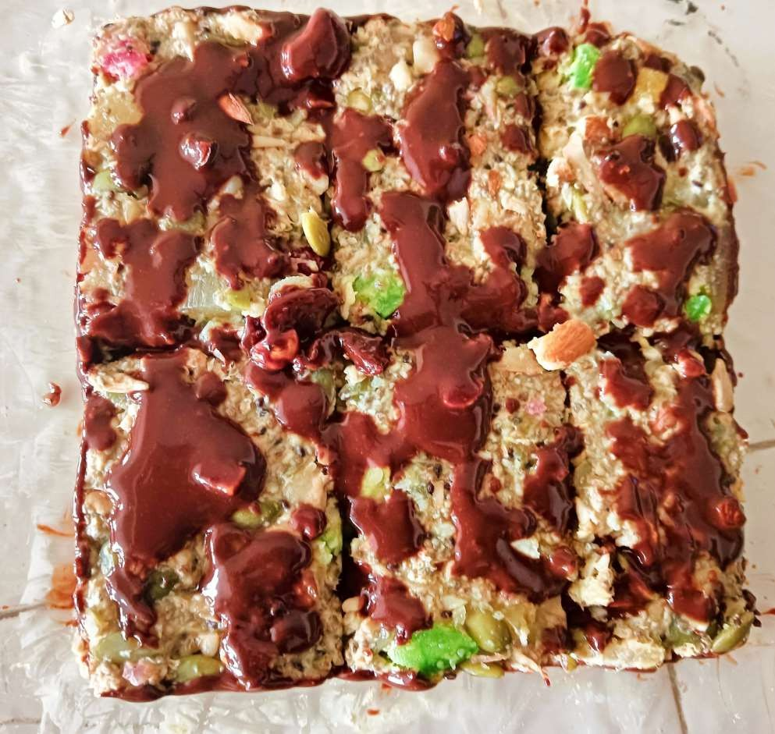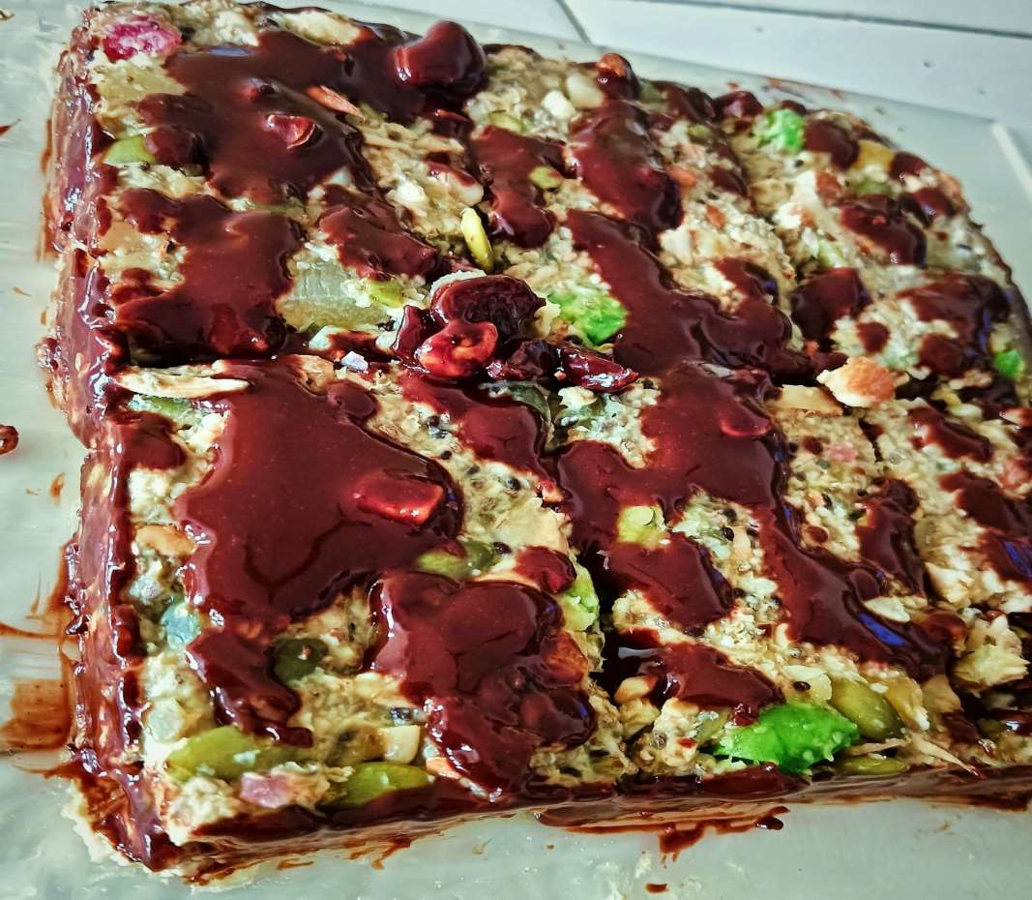

**Conclusion:**

In conclusion, the Aloevera and Kiwi Energy Bar demonstrates a promising potential as a natural energy booster and vitality enhancer. The combination of Aloevera’s digestive benefits and Kiwi’s rich vitamin content offers a healthy and convenient way to improve energy levels and overall well-being. This energy bar can serve as an effective alternative to traditional, processed snacks, contributing to improved hydration, digestion, and vitality. Future research will focus on optimizing the ingredients and exploring the long-term health benefits of this innovative energy bar.

**References:**

1. Nutritional Benefits of Aloe Vera:

Eshun, K., & He, Q. (2004). Aloe vera: A valuable ingredient for the food, pharmaceutical, and cosmetic industries—A review. Critical Reviews in Food Science and Nutrition, 44(2), 91–96.

Choi, S., & Chung, M. H. (2003). A review on the relationship between aloe vera components and their biologic effects. Seminars in Integrative Medicine, 1(1), 53–62.

2. Nutritional Profile and Health Benefits of Kiwi:

Nishiyama, I. (2007). Fruits of the Actinidia genus: Kiwifruit. Advances in Food and Nutrition Research, 52, 293–324.

Ferguson, A. R., & Ferguson, L. R. (2003). Kiwifruit: A healthy fruit with a history of health benefits. Asia Pacific Journal of Clinical Nutrition, 12(1), 35–42.

3. Energy Bar Formulation:

Parn, O. J., Bhat, R., Yeoh, T. K., & Al-Hassan, A. A. (2015). Development of novel fruit bars by utilizing date paste. Food Bioscience, 9, 20–27.

4.Fennema, O. R. (2008). Food Chemistry. CRC Press.

5. Hui, Y. H. (2011). Handbook of Food Science, Technology, and Engineering. CRC Press.

6. Guroo I, Wani SA, Wani SM, Ahmad M, Mir SA, et al. (2017) A Review of Production and Processing of Kiwifruit.

7.Effect of Three Different Aloe vera Gel-Based Edible Coatings on the Quality of Fresh-Cut “Hayward” Kiwifruits - MDPI.