DIGITAL TRANSFORMATION OF HR TECHNOLOGIES

**DR. V. ANITHA**

Assistant professor, Sri Sairam Institute of Management Studies

Sri Sairam Engineering College, Chennai

[anitha.mba@sairam.edu.in](mailto:anitha.mba@sairam.edu.in)

**SUBARAJA.J**

Scholar, Sri Sairam Institute of Management Studies

Sri Sairam Engineering College, Chennai

**ABSTRACT:**

This article examines the degree of digitization of human management technologies based on the 2019 SAP, Deloitte, and Hays report results. The analysis demonstrated how HR automatization was impacted by an organization's size and expertise. The size of a business affects how sophisticated its HRM processes are. The essay defines four phases of digitalization, from the paper approach to the active use of AI systems. Here is a list of the industries with the highest percentage of automation. In-depth discussion of staff hiring, selection, adaptation, and training processes using appropriate tools and programs is provided in this article. One of the most difficult parts of hiring is testing, interviewing, and corresponding with potential candidates. This is especially true when hiring a big number of people. Specialized systems that conduct video interviews, rate resumes, scan applications, and more to optimize recruiters' efforts. The advantages of chat bots and messengers for adjusting to digitalization are emphasized. Adoption of modern computerized HR practices is seen favorably by most executives. The purpose of learning and software training is explained, and the advantages of test builders, webinars, and the use of remote learning are looked at. It has been noted that one- third of Russian companies are actively automating technology for staff training and development. The important human management practices that initially require digital transformation are also emphasized in the article. It makes sense to compute benefits, assess the effectiveness of the current HR system, and automate management accounting. The advantages of gamification are examined in relation to employee assessment, training, and adaptation procedures. Prioritizing the transition to a new level of people management.

Key words: Technological Advancements, Globalization, Changing workforce Expectation.

# Introduction:

The shift to automated people management solutions is driven by the intense competition in the age of global digitalization. HR process transformation is essential due to the rise in the demands placed on people in modern firms about their distinctive characteristics, professional competencies, and multi-potential. Analyzing trends and projecting future developments area technological people management is aim this study. The complexity of HR procedures and the amount of analytical data is rising as the company grows and the workforce increases. The topics of personnel accounting, benefit and compensation computation, hiring staff, adaptability, evaluation, and training are all current.

The complete cycle of human management can be optimized with the introduction of multifunctional automated applications. The following are some benefits of automated programs: better HR decision-making, less complexity and increased accuracy when working with large amounts of data, efficient use of human capacity. Professionals can devote more time to creating fresh concepts and setting ambitious goals for business development when ordinary processes are automated.

The rapid advancement of technology has brought about a considerable upheaval in the human resources (HR) industry. Digital transformation in HR is the intentional use of cutting-edge technology to enhance employee experiences, speed up processes, and boost business performance. This paradigm shift is being driven by the need to adapt to a rapidly changing workforce, stay competitive in the global market, and use data to inform strategic decisions.

Through the use of automation, data analytics, artificial intelligence, and cloud-based technologies, HR departments are evolving from conventional administrative positions to strategic partners that directly influence business outcomes. By automating time-consuming processes like payroll processing, time and attendance management, and other repetitive operations, HR professionals can focus on important initiatives that promote development and innovation.

Since data analytics provides useful information about workforce trends, organizational effectiveness, and employee performance, it is crucial to HR digital transformation. By analyzing vast amounts of HR data, organizations may identify patterns, make data-driven decisions, and evaluate the outcomes of HR projects. Because cloud-based HR solutions are accessible, scalable, and flexible, they make remote work and collaboration easier. These solutions give employees the ability to independently manage their HR-related tasks and data through self- service portals, which boosts output and satisfaction.

Utilization of both artificial intelligence (AI) and machine learning (ML) boosts HR capabilities. AI-driven chatbots can quickly respond to questions from employees, while machine learning algorithms can review resumes and pinpoint the best candidates. HR departments can establish a workplace that is more productive, efficient, and focused on employees by adopting these technologies.

Purpose of the study:

Increasing the efficacy and efficiency of human resource operations in businesses is the goal of research on the digital transformation of HR technology. HR may lessen administrative duties and save time by automating repetitive operations and streamlining procedures, freeing up more time for strategic initiatives. HR managers may make informed decisions on employee engagement, performance, and talent acquisition by utilizing data analytics. Additionally, by offering user- friendly platforms for information and service access, contemporary HR technology enhances the overall employee experience. This modification also makes remote work easier, enabling teams to work together from any location. Through online training solutions, it also helps businesses reduce costs and ensure regulatory compliance while promoting continuous learning. Ultimately, the digital transformation fosters an innovative, adaptable, and agile culture that positions HR departments to effectively handle the shifting needs of the workforce and the business environment.

# Significance of the study:

Researching the digital transformation of HR technology is essential as it has a big impact on employee engagement and business success. As companies depend more and more on technology, HR may adopt solutions that streamline procedures and boost productivity by acknowledging this shift. Better personnel acquisition and management strategies are promoted when HR professionals are empowered to make data-driven choices. Additionally, by enabling remote work and streamlining service access, contemporary HR technology enhances the employee experience.

# Research objectives:

The Digital Transformation of HR Technologies aims to transform human resource management by integrating state-of-the-art digital tools and techniques that enhance operational efficiency and strategic effectiveness. This includes automating repetitive tasks to increase overall productivity by freeing up HR specialists for more strategic functions; the use of data analytics for informed decision-making, which enables businesses to maximize talent acquisition and retention tactics and gain a deeper understanding of employee demands; the establishment of a smooth and satisfying employee experience through user-friendly platforms that facilitate easy access to services and resources; and the facilitation of flexible work arrangements, which will enable remote teams to collaborate effectively.

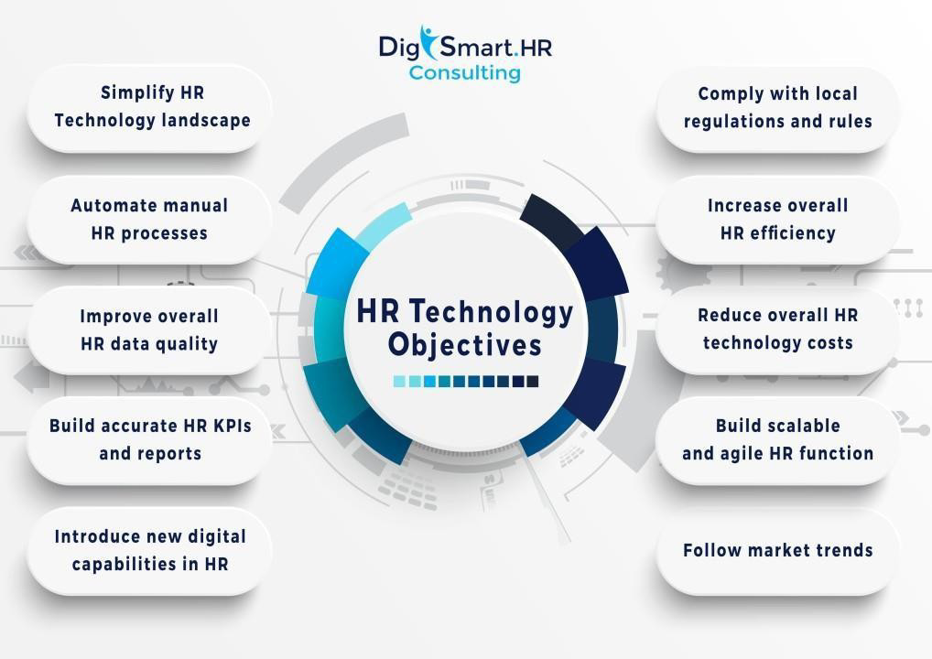

# Review of literature: Efficiency and Automation:

Several studies demonstrate that among the repetitious HR duties that digital technology automate are payroll processing and recruiting. For example, Shuck et al. (2020) stress that automation frees up HR personnel to concentrate on more strategic projects by decreasing administrative duties. For businesses looking to stay competitive in a fast-paced market, this efficiency is essential.

# Data-Driven Decision Making:

The literature highlights the value of data analytics for human resources. Businesses may make informed judgments about hiring and staff performance by utilizing big data. Marler and Fisher (2019) assert that HR may improve overall business efficacy by using data analytics to forecast.

# Employee Experience:

The potential for digital transformation to boost employee engagement and happiness is the subject of an expanding corpus of study. According to Kavanagh and Thite (2018), digital platforms make communication, training, and feedback easier. A more favorable work atmosphere and higher retention rates are two benefits of these improvements.

Agility and Adaptability:

Adaptability and Agility: Because digital transformation fosters organizational agility, HR departments are able to respond swiftly to changing business needs. According to DeSantis et al. (2021), this flexibility is crucial for handling the uncertainties of the modern workforce, such as remote work and shifting employee expectations.

# Learning and Development:

It is also highlighted how technology may support lifelong learning. According to research by Tannenbaum and Sullivan (2019), e-learning platforms help workers stay current in their positions and acquire new skills, which promotes long-term professional development and organizational performance.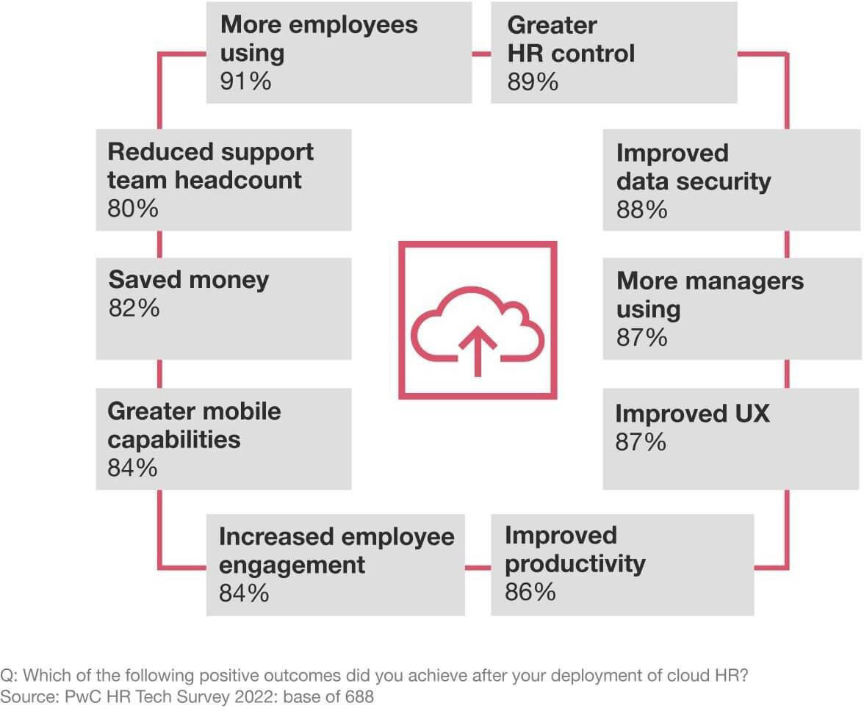

# Research Methodology:

Analyzing and identifying HR technologies at the digital transformation level is the study's goal. The study's data is based on the findings of a research jointly delivered at the 2019 SAP Forum by Deloitte and SAP. The study encompassed 434 organizations operating in several domains,employing between 100 and 10,000 people. Finding out how much human management work in Russian companies has been automated and digitalized was the aim of the SAP and Deloitte survey. The analysis of HR process automation is further supported by an online poll that was completed by HR experts from 487 Russian and foreign organizations by the multinational recruiting firm Hays. In 2019, Hays gave a presentation on the findings of the "Research of IT technologies in the field of HR" [7]. Finding the most automated components of the people management system was the aim of the survey.

# Result and Discussion:

The degree automation of human organization procedures is closely correlated with an organization's size. The following rating concepts form the basis of the automatization evaluation. Companies that handle their workers using paper methods are at the top and bottom of the list. HR process partly automatization is part of the second level. At the third level, a large amount of HR technology digitization is necessary. Businesses with completely automated HR systems make up the fourth group. The requirement for process automation increases with the size of the business. Table 1 shows how the extent of HR technology digital transformation is influenced by the company's size.

# Data Analysis:

**TABLE1:** The size of the company determines how much of the HR technologies are digitized.

| **Digitalization level** | **No. staff,**  **people** |
| --- | --- |
| The first is a paper-based approach to human management and unstructured procedures. | upto100 |
| The second is the use of different systems for different types of data, the partial automation of HR processes, and the absence of a single data processing system. | 100–1000 |
| The third is the capacity to access data from a range of mobile devices, a single database, and the standardization of HR operations. | 1000–10000 |
| The fourth is the application of AI to management, forecasting, data analysis, optimization, a unified interface, and other uses. | morethan10000 |

Standardized procedures and the development of a single database for their analysis, control, and assessment are essential as a corporation expands. The most automated activity regions were shown by the analysis. For the financial industry, mining, metallurgy, and information technology (the fourth level according to SAP and Deloitte), digitizing the complete HR cycle is essential.Retail, media, healthcare, and the internet (ranked third by SAP and Deloitte) are the sectors with the quickest rates of technology automation for people management procedures. Table 2 displays the data collected on the degree of digital transformation of HR technologies according to the industries in which the companies operate.

# TABLE2: The degree of HR technology digital transformation varies based on the business's

| **Digitalization Level** | **Activity of company** |
| --- | --- |
| The level of digital transformation in HR technology varies according to the industry in which the company operates. | Building, education, and the energy industry |
| The second is the use of different systems for different types of data, the partial automation of HR processes, and the absence of a single data processing system. | Oil and gas, manufacturing, professional services, logistics, and transportation |
| The third is the capacity to access data from a range of mobile devices, a single database, and the standardization of HR operations. | Retail, medicine, media and the Internet |
| The fourth is the use of AI in management; data analysis, forecasting, and optimization; a unified interface; and other applications | Finance, banking,  metallurgy, mining, information technologies |

Big businesses like energy and construction, oil and gas, and education (ranked second and first, respectively, by fall in the digitalization systems. According data that was obtained. Meanwhile, Businesses are putting electronic document management into practice. In 35% of businesses, no same data , and 60% them, by own HR process using standard programs is carried out. issue human recourse technologic moving a platform important in the modern corporate world, particularly for major enterprises. Let's examine the automatization procedures for hiring, adapting, and training in more detail. Expanding a company's operations is always linked to the challenges of selecting and employing the necessary expertise. One of the most crucial and time-consuming instruments used in HR services operations is personnel loss. Finding candidates with the necessary personal and professional traits is the recruiter's job. The moment at which the position closes is a crucial one. A recruiter's duties include interacting with candidates on a daily basis to go over questions that are characteristic of the position. This function can now be optimized thanks to the application of information technologies. Especially for major trading organizations, automating the recruitment process is important. Additionally, special programs are frequently employed in recruitment firms, enabling the creation of a database of job seekers.

The most widely used contemporary

hiring platforms include TalentScan, Experium, E-Staff Recruiter, Cleverstaff, Huntflowe, and Skillscanner.Information systems have several benefits beyond just saving recruiters' time. These benefits include keeping track of statistics, processing applications, evaluating responses from online tests, conducting in-depth video interviews, preserving candidate biographies, constructing candidate ratings, spotting duplicate resumes, and maintaining databases that are kept up to date. Functional automatization reduces the amount of time needed to fill a position and enhances the HR division's efficiency. In actuality, just 4% of modern Russian enterprises' hiring processes are automated. A chat is currently utilized and has been implemented in 6% of Russian enterprises. The E-Staff Recruiter system is highly desired as a means of digitizing the hiring process.20% of businesses expect to install software servers in the future. Positive opinions predominate on internal job platforms like Potok and Friend Work Recruiter. Even though SAPHRM has many benefits, smaller businesses cannot afford to use it due to its high cost. SAP is currently implemented in businesses including Severstal, LUKOIL, GAZPROM, and Rosneft. It is the preference of medium-sized businesses to use Experium and Huntflow solutions. HR experts observe the benefits of the Workday and Go Recruit initiatives. Hays research indicates that in 41% of firms, the recruitment block is automated.

The next stage after hiring is acclimating new employees. It is noteworthy that 90% of employees who quit the organization within their first year of employment did so primarily due to a lack of adaptation programs, per the statistics. The main goal of staff adaptation is to ensure that a new hire feels at ease and integrated into the workplace culture of the organization. The automation of adaptation programs minimizes the amount of time it takes a new hire to become accustomed to the work environment, team dynamics, and regulations as well as to comprehend their own job within the organization. A novel approach to adaptation on boarding It enables you to familiarize yourself with the company's core beliefs prior to beginning employment. A chatbot will prepare an employee for their first working day by reminding them of their address, providing links to the major social media platforms, explaining the corporate culture, and informing them of the necessary set of documents after they accept an offer but won't start performing their duties right away. By manipulating messengers, chatbot technology enables users to receive business services or responses to inquiries. The script chatbot has responses to common queries that make sense. A chatbot that uses a neural network can be used to answer a variety of inquiries from users. In this case, artificial intelligence needs to comprehend the request and come up with a sensible answer.

Novice receives an are informed that new employee has joined the organization and that they should give them extra consideration and support at the same time. (LMS) is made possible by the automation of adaptation procedures. An employee watches a film on information security, plays interactive business games, receives training from top professionals, and completes training video courses via suggested links. You can view the

downloaded training package at any convenient moment on a computer or smartphone. Employees can monitor their progress and level on their personal accounts, as well as save for later seeing.

A chance review a newbie, HR executives may make a well-rounded choice about a new hire thanks to the automated system, which enables multiple knowledgeable mentors to give reviews at the conclusion of the trial period. A new employee successfully joins the organization and begins doing business activities considerably faster thanks to chatbots, the LMS program, and online progress assessments, all of which are products of digitalization adaptation. Process automation promotes initiative and experience sharing.

Hays observes that 34% of the organizations that took part in the survey have automated evaluation, adaption, and training units. In the near future, the majority of HR managers intend to automate adaptation programs, enabling the creation of an action plan based on the new employee's position [10]. The two most well-liked digital adaption programs are Workday and Matrix. The benefits of Looop and SAP are mentioned by respondents. The majority of businesses employ corporate social networks to optimize internal interactions through chatbots, online radio, messengers (WhatsApp, Telegram, Skype), intranets (IBM WesSphera, Oracle Web Center Suite, Microsoft SharePoint), and workplace by Facebook and DaOffice.

Performance by employees is directly responsible for an organization's success. Investing in professional development yields more profits for the company than improving manufacturing infrastructure. With fresh insight, an employee can come up with fresh concepts and deal with a variety of issues with ease[4].Text, video, and audio elements can all be combined with electronic or software training. One clear benefit is that it allows you to save an employer money by selecting a time and location that works best for the listener. Online chat during the webinar enables questions receive Is unable attend the lecture due to urgent tasks, they can always watch the tape of it. Through testing, the test constructor makes it possible to swiftly assess knowledge levels and modify recommendations for professional development.

Chatbots can answer queries, register staff members for certain training courses, send out messages about dates, times, and lecturers, and help to organize the training process. They are available around-the-clock. Employees are fully immersed in the learning process through the use of an electronic distance learning system. Benefits include: free access to all types of content; automated knowledge verification; training course archiving; technical support; topical forums and blogs; and the preservation of all resources. According to SAP and Deloitte, only7% of employees Nonetheless, has encouraging data, with over 30% of businesses actively utilizing training technology automation.

74% of managers expressed satisfaction with the training digitalization outcomes. It's also critical to recognize the tendency toward the use of gamification in education. Gaming technologies are used in staff development by 21% of businesses.

HR accounting is ranked as the most important HR process in digital transformation, according to Hays research, with operations 61%, benefits and compensation plans — 49%. Table 3 displays the survey's findings regarding the significance of automating HR technology.

TABLE3: According to the respondents, it was essential to automate high-priority HR tasks

| **Process of HR** | **The importance of automating HR procedures, as reported by the majority of responders (%)** |
| --- | --- |
| Personnel record | 72% |
| Working time estimation | 66% |
| HR system sefficiency analysis | 61% |
| Compensations and benifits | 49% |
| Recruitment | 41% |
| Assessment | 42% |
| Adaptation | 40% |
| Training | 41% |

The significant remember recognize importance the revolution in personnel management. A tiny percentage of people are OK with the status quo or think it's appropriate to outsource HR duties. Excel is the most often used program in practice. The CEO and senior management are still in charge of making the final decision on the deployment of digitalization. IT services and the HR director of the organization both play significant roles. Senior management, HR, and IT collaboration is essential to the degree of digitization of HR technology. A united VTB and VTB24Bank, which employs about 60,000 people, is putting its automated personnel management project into action. The project runs from 2019 to 2021 for three years. For 230 thousand workers, Sberbank provides services worth 300 million rubles.

# Conclusion:

The majority of big businesses use automated tools to maximize HR technologies.Medium-sized businesses likewise aim for it, realizing the advantages and rewards of the initiatives. IT, metallurgy, mining, and finance are among the industries that actively employ more AI elements. Chatbots are a popular tool for recruiting and program adaptation; they allow employees to quickly learn about the company's principles and begin working more quickly. Online training for both new and existing staff is regularly provided by LMSs (Learning Management Systems). Gamification of HR is also a top concern. 69% of businesses utilize gaming technology for staff assessment, aimed at adaption. The most promising program for evaluating efficacy is SAP. Nevertheless, a high cost prevents smaller businesses from implementing it. HR analytics, salary computation, and HR accounting operations are the top priorities for digitization.

**Reference:**

1. N.I. Arkhipova (2019).Contemporary issues with human management: a monograph, Moscow: Prospect, p. 160.

1. S. A. Ganina (2019). Tools for managing the company's intellectual and human capital in the digital economy. The Russian New University Bulletin. Human and society, volume 3, pages 22–25, series.
2. H.H. Kuchmezov (2019).Artificial intelligence technologies within the BPM framework. Innovative mathematical education and modern mathematics, vol. 6, issue 1, pp. 214–222. [4]

A.L. Lazutina (2019).New standards for the quality of human management in the digital economy and management.Vital Issues of the Modern Economy, Volume 5, pages 177–180. [5]

Y.B. Popova (2019).Artificial neural network in the CATS training framework.Digital revolution, pages 53–59, volume 2, issue 7.

1. Markov, A.A. and V.D. Markova (2019).digitalization or data-flow-based management. Innovations, 7(83–87), pp.
2. Is technology stale in Russia?Retail.ru.(2019).taken from https:/[/www](http://www.retail.ru/articles/nuzhny-li-rossiyskomu-hr-tekhnologii/).[retail.ru/articles/nuzhny-li-rossiyskomu-hr-tekhnologii/](http://www.retail.ru/articles/nuzhny-li-rossiyskomu-hr-tekhnologii/) on February 19, 2020.
3. L.A. Strelnikova (2019).Actualizationofdigitaltechnologiesintherecruitment processmanagement.Governmental and local administration. Science notes, volume 1, pages 83– 89.
4. M. A. [Fedotova (2019). The experience, issues, and future prospects of](http://www.retail.ru/articles/nuzhny-li-rossiyskomu-hr-tekhnologii/) practical research with artificial intelligence technology in predicting the effectiveness of teamwork.outcome of science. Social science and management, pages 93–106, volume 5, issue 2.
5. Yashkova,E.V.,Vagin,D.U.andMustafina,D.R.(2019).Human resource management: HR services activities in the changing economic landscape.Significance of contemporary economy, volume 2, issue 3, pages 907-913.
6. https://[www.istockphoto.com/photos/hr-digital-transformation](http://www.istockphoto.com/photos/hr-digital-transformation)
7. https://[www.slideshare.net/slideshow/digital-hrpptx/251921161](http://www.slideshare.net/slideshow/digital-hrpptx/251921161)
8. https://[www.slideteam.net/digital-hr-technology-powerpoint-presentation-slides.html](http://www.slideteam.net/digital-hr-technology-powerpoint-presentation-slides.html)
9. https://[www.slideshare.net/slideshow/hr-digital-transformation/71073834](http://www.slideshare.net/slideshow/hr-digital-transformation/71073834)
10. https://flevy.com/browse/marketplace/hr-digital-transformation- 6441?[srsltid=AfmBOorDzvQLYPkMHZlnm7SVbPUfn23wJ2AcC2hG-Z_9INs72VTiDTds](https://www.slideteam.net/digital-hr-technology-powerpoint-presentation-slides.html)
11. Dr.S.Usha & Dr.D.Jaichitra “A Stress level of Women Employees- A Study with reference to IT sector in Chennai, journal of Advanced Research in Dynamical and Control Systems, 2017, 9(Special Issue 15), pp. 460–464.
12. Jigyasu Kumar, Venkateswara Prasad, Usman Mohideen, Sharmila Singh, Narender Chinthamu & Roshni Jaiswal (2024), Employee Engagement and Retention: Strategies for Success, Journal of Informatics Education and Research,4(2),34003409, DOI:<https://doi.org/10.52783/jier.v4i2.1263>
13. Velayudhan, M., & Maran, D. K. (2013). A study on Mapping Core Competencies and development of Employees for Excellence with reference to HCL Technologies. *Journal of Contemporary Research in Management (JCRM)*, *4*(4). Retrieved from <https://jcrm.psgim.ac.in/index.php/jcrm/article/view/85>
14. Jeyalakshmi RS. Sivarajeswari,  V. Selvalakshmi, Attitudinal Changes Due to Unanticipated Transition to Remote Work, Proceedings of the 2nd International Conference on Sustainability and Equity (ICSE-2021), <https://doi.org/10.2991/ahsseh.k.220105.017>.
15. Baskaran, K., & Rajarathinam, M. (2017). Influence of psychological capital on innovative behaviour among the faculty teaching in online environment. *Asian Journal of Distance Education*, *12*(1), 60-68.
16. Maran, K., and V. Chandra Shekar. "A study on student’s perception of employability skills with respect to engineering institution." International Journal of Research in Engineering, Social Sciences 5.3 (2015): 21-34.
17. Illakya, T., Keerthana, B., Murugan, K., Venkatesh, P., Manikandan, M., & Maran, K. (2024). The role of the internet of things in the telecom sector. 2022 International Conference on Communication, Computing and Internet of Things (IC3IoT), 21, 1–5. https://doi.org/10.1109/ic3iot60841.2024.10550390
18. Manikandan, M., Venkatesh, P., Illakya, T., Krishnamoorthi, M., Senthilnathan, C., & Maran, K. (2024). The Significance of Big Data Analytics in the Global Healthcare Market. 2022 International Conference on Communication, Computing and Internet of Things (IC3IoT). https://doi.org/10.1109/ic3iot60841.2024.10550417

1. Ilakkiya, T., Manikandan, M., Ch, R. K., M, K., Ramu, M., & Venkatesh, P. (2024). Neuro Computing-Based Models of Digital Marketing as a Business Strategy for Bangalore’s Startup Founders. Ieee, 1–3. <https://doi.org/10.1109/incos59338.2024.10527779>
2. Venkatesh, P., Selvakumar, V., Ramu, M., Manikandan, M., & Senthilnathan, C. R. (2023). Measure of Well-Being of Freelancers in it Sector. Ieee. https://doi.org/10.1109/iccebs58601.2023.10448738
3. Sathyanarayana, K. S., and r K. Maran. "Job Stress of Employees." International Journal of Management (IJM) 2.2 (2011): 93-102.