#### A STUDY ON SUSTAINABLE SUPPLY CHAIN MANAGEMENT REDUCING CARBON FOOT PRINT THROUGH GREEN LOGISTICS

**Dr.V. Dhayalan**

Associate professor, Sri Sairam Institute of Management Studies

Sri Sairam Engineering College, Chennai

[dhayalan.mba@sairam.edu.in](mailto:dhayalan.mba@sairam.edu.in)

**AKASH.D**

Scholar, Sri Sairam Institute of Management Studies

Sri Sairam Engineering College, Chennai

## ABSTRACT:

The present study is to analyze the important literature on low carbon supply chain management (LCSCM) in the part of logistics and transportation in green supply chain management (GSCM). The intention of this manuscript is to review the relevant literature on (LCSCM) and its classification. It also aims identifying key decision-making issues in LCSCM. The logistics and transport sector contributes just over a third of global carbon dioxide (CO2) emissions, creating largest-emitting sector in numerous developed countries. The benefits, discredits and complications of low carbon supply chain management are explored based on the supply chain management theory. In conclusion, some public policies are proposed to support the implementation of low-carbon supply chain management.

**Keywords:** Logistics, Low-carbon, CO₂ emissions

## INTRODUCTION:

Global Greenhouse gas (GHG) emissions had followed an increasing trend mainly due to increase in emissions from China and the other emerging economies. They account for 50.1% of global population, 61.2% of global Gross Domestic Product (GDP), 63.4% of global fossil fuel consumption and 61.6% of global GHG emissions [1]. The average worldwide atmospheric carbon dioxide was **419.3** parts per million in 2023, which set all time high record [2]. Worldwide carbon emissions from fossil fuels have significantly increased by 90%, with emissions from fossil fuel combustion and industrial processes contributing about 78% of the total carbon emissions [3]. In India, growing population had rapidly mounted economy, increased fossil energy consumption and have all contributed to emissions in India. This contributes the world’s third-largest GHG polluter, behind the United States and China [4].

The Indian per capita emissions 1.9t CO₂ per person holds the lowest. India’s contribution in cumulative worldwide CO₂ emissions is lower than other major polluters at 3%. According to IPCC report, large burning of fossil fuel produces excessive greenhouse gases which are the principal cause of climate warming. Slowing down global warming is reducing emission of greenhouse gases such as carbon dioxide. Freight transportation contribute vital role in global economy. By means of aircraft, Sea and inland waterways (ship), Road (mainly trucking and urban deliveries), trains, billions of tones of cargo are transported. The transport sector contributes 7.7 giga tones (Gt) of CO2 which contributes 8 % of global greenhouse gas emissions [5]. In India’s motorised travelling has been increased drastically to 1,700 billion passenger-kilometres, by roadways, railways and a small share by air travel. CO2.emissions in Indian transportation zone increased to 42.24 % from 155.9 Mt to 368.2 Mt from 2001 to 2020 [6]. The structure of this study reveals significant contribution in reduction of CO2.emissions that plays a significant role in the evolution to a decarbonised future, as well as adapting to the impacts in climate change associated with greenhouse gas emissions.

#### OBJECTIVE OF THE STUDY:

##### To develop low-carbon economy:

Developing low-carbon economy desires combined efforts of individuals, governments, enterprises, and various social organizations around the world. Shift to lower-carbon modes won’t occur immediately. Success will need noteworthy changes to spatial planning and fuel pricing, services, and technology.

1. **To improve spatial planning:**

Proper planning of economic activity and logistics services jointly together would bring maximize efficiency, reduced goods travelling distance and reduced emissions. Adopting adequate pricing measures, shifting to cleaner transport modes, improving vehicle fuel efficiency and utilising greener fuels, also bring major changes in freight transport. The key factor for reduction in carbon emission is by controlling the carbon emitted during production as well as trading and taking stock of progress.

##### Developing policy for clean trucking:

Clean trucking is a main concern for improving fuel efficiency in diesel trucks. This is essential in limiting future diesel demand and emissions growth. The government has revised fuel economy standards for trucks during 2023. Implementing analogous procurement for medium-sized electric freight trucks, might avoid 3 Mt CO2. This will be 30 kt NOX emissions over the replaced trucks’ life span.

##### Developing regulation for clean tail pipe:

Road transport contributes 20-30% of air pollution. Reducing transport- related emissions which are close to ground have direct public health benefits, given that a large share of emissions occurs in urban areas and directly affecting millions of people [13]. Introduction of Bharat Stage (BS-VI) emission standards in India had regulates vehicle emission in tail pipe. Within three years Indian implemented BS-VI standards had paralleled Euro-VI norms.To encourage climate driven policies:

Vehicle electrification had benefits with improved air quality for human. Implementation of Bharat Stage standards and the gradual arrival of EVs, emissions from road transport turn down by 15-20% by 2030 and expected further fall afterwards. India’s scrappage policy of 2021 has played vital role in reduction of air pollution. The replacing freight trucks Bharat Stage (BS-VI) compliant could avoid up to 11% PM2.5 emissions, 17% of NOX and from trucks.

##### To promote alternative fuel options:

The fuel-based energy consumption by transport sector in India is narrated as below from 1975 to 2022.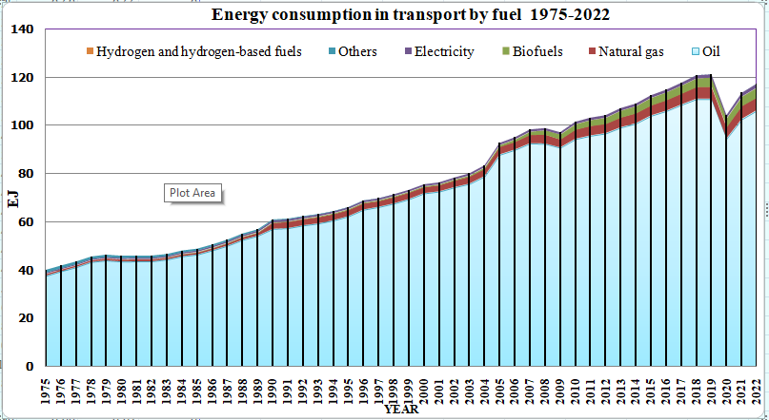

### Figure 1

Figure-1 represents the fuel-based energy-consuming by transport from 1975 to 2022 in India.

In recent years several alternative fuel options are emerging, with varying levels of technical readiness and economic viability, electricity, methane, bio fuels, hydrogen, ammonia, and synthetic carbon-based fuels.Proposing Ambitious policies:

The CO2 gas emissions in India has raise drastically from the year 1972 to 2022.

##### Figure 2

Figure 2 illustrates the Indian CO₂ gas emissions from year 1972 to 2022 [8].

Ambitious policies driven energy demand by 30%, thereby avoiding 60% of the expected CO2 emissions in 2050.

##### Implication of low carbon supply chain management:

Logistics outsourcing was considered to reduce carbon footprints with third- party logistics service providers. Logistics outsourcing better resulted in taking use of Less Than Truckload (LTL) shipping and a consignment may be transported for a part of the cost of hiring an entire truck and trailer for selected shipment. Without reducing the frequency of inventory replacement that could lead to higher inventory level, firms can utilize LTL shipping to lower the transportation cost by outsourcing and thereby reduced emissions. Though, LTL shipping may cause longer lead-time than those delivered by firms own vehicles, as LTL transportation time very much depend on the structure of the network of the third-party logistics provider with junctions and connections. Developing analytical models to scrutinize the effect of logistic outsourcing on carbon neutral and its related cost.

.

#### SCOPE OF THE STUDY:

This study aims to shift to lower-carbon modes. Proposing necessary technical measures to support the change from trucks to lower-carbon modes, such as railways and inland waterways, are among the most impactful. So many benefits are there with recent modal shift

had reduced transport expenditure, congestion, air pollution and other externalities associated with road traffic. The payback of modal shift is happening immediately. Hence so many countries follow this shift as possible.

Even though CO2 emissions expected to reach maximum peak by 2030, then this will fall about 20% below by 2050 with today’s level. Cumulatively, this could evade up to 4 Gt CO2 between 2021and 2050, compared to the current policy frame work. Additional reductions are realised up to 2030, all the way through stronger energy efficiency improvements in vehicles with an internal combustion engine (ICE), accelerated electric vehicle (EV) and higher bio fuel utilisation. Cars and trucks, accounts the most additional reduction potential.

### Review of Literature:

##### Logistics in a Low Carbon Concept: Connotation and Realization Way:

Low carbon logistics has become a mandatory in the fiefd for logistics. This paper classifies the literary work home and abroad the definition of low carbon logistics, implementation mechanisms and low carbon design quantitative models. The research bring forward low carbon logistics desired for both in enterprise ‘macro and micro level. In fact, low carbon logistics promoting models are effective tools for pursuit to apply emission reduction.

##### On low carbon supply chain management:

The thought of the low carbon supply chain management is explained in this paper. The benefits, the difficulties, and the key issues of low carbon supply chain management are look over based on the supply chain management. Public policies are proposed to lower carbon emission in support of implementation of low carbon supply chain management.

##### A literature review on reducing carbon emission from supply chain system:

This study aims to evaluate the literature in reducing carbon emission from supply chain system of past few years, by presenting drivers, barrier, performance indicator and practice. Companies are now trying to minimize environmental impacts by their supply chain operations. With a multiplicity of problems faced, action had taken to reduce carbon emissions. The outcome showed that good management with various means of communication in the supply chain system would be able to achieve common goals in reducing CO2 emissions.

#### RESEARCH METHODLOGY:

In this research, various methodologies have been revealed and result shown significant reduction in CO2 emissions. Evocative research methodology is used here in India to achieve a goal. In 2030, electric vehicle (EV) trade is expected 80% in two wheelers, 30%in private cars, 70% in commercial vehicles, 40% in buses.



##### Figure3

Figure 3 illustrates the Indian clean Technology policy adapted from 2014 to 2024.

The Indian transportation fleet, hauls cargo over long distances, is mainly handled by intermediate sized trucks gross weight between 3.5 tones to 12 tones (ITF 2021) resulting in relatively lower tones carried for a unit of energy consumed.

In India various decarbonisation techniques has been adopted. This is adopted by increasing hybrid vehicles, utilising fuel additives, automatic tyre pressure adjustment, using low rolling resistance tyre, reduction in vehicle height, fitting super singles, regular tire inflation checking, adopting speed limiter in vehicles et**c**.

**.**

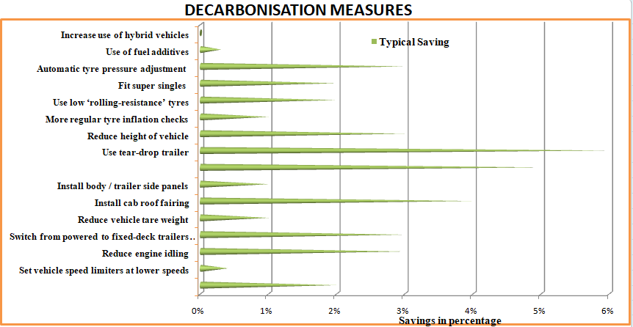

### Figure 4

Figure 4, illustrates the various decarbonisation techniques adopted in India.

By proposing software programming techniques all the way through network, traffic jamming is reduced there by effectively reducing carbon emissions. Information about vehicle movement on road is collected through network so as to provide prior information to drivers about real time traffic to avoid overcrowding. Also, Logistics flow could be controlled with better road net work there by reduced congestion. Environmental pollution caused by vehicle exhaust gas emission has been reduced as well.. Real time scheduling of transport vehicles can fully meet the needs of consumers during the timely change of logistics demand, to take logistics and thereby decrease in rate of empty vehicles. All of these could optimise logistics efficiency and potential of meeting the changes of market condition with minimum energy and carbon emissions.

#### RESEARCH DESIGN:

Research design in this paper reveals, selective plan and techniques that guides a research study in bringing carbon emissions from logistics. Various questionnaires, hypotheses to the collection, analysis and explanation of data in CO2 emissions. The statically data analysis help others to build further analysis to explore reduction in CO2 emissions.

#### DATA COLLECTION:

Data is gathered from a variety of sources such as, websites, research journals, magazines, Government publications and energy agencies**.**Nature of the Study report:

This experimental evocative study aims to understand the environmental concern about CO2 emissions from logistics, The various reduction measured suggested to adopt to reduce CO2emissions reveals clear understanding for the upcoming studies.

##### Data Source: Journals:

The sources for studies are from reputed Journal of System and Management Sciences, Journal of System and Management Sciences. A sequel. Transportation Journal. From these journals data has been revealed to find out findings in the present scenario in reduction of carbon emissions.

##### Publications:

Various publication from Emissions Database for Global Atmospheric Research Community GHG Database, a collaboration between the European Commission, Joint Research Centre (JRC), AIP Publishing, had been gathered and studied for data collection.

##### Government data:

Information from worldwide government data Intergovernmental Panel on Climate Change. Cambridge University Press, UK and New York, has been collected for analysis

##### Conference papers:

##### He latest developments, case studies from International Conference on Enterprise Information System, [IOP Conference Series: Materials Science and Engineering](https://iopscience.iop.org/journal/1757-899X) has been collected for data analysis purpose.

#### FINDINGS:

##### Alternative fuel options:

As alternative fuel options are emerging, with varying levels of technical readiness and economic viability, electricity, methane, bio fuels, hydrogen, ammonia, and synthetic carbon-based fuels has been revealed this option to be studied more to reduce carbon emissions.

##### Providing real-time traffic information:

Collection of information about vehicle movement on road through network so as to provide prior information to drivers about real-time traffic to avoid overcrowding. By this action Logitics flow could be controlled with better road network thereby reduced congestion and hence Environmental pollution caused by vehicle exhaust gas emission has been reduced **Incorporating AI techniques**:

Incorporating AI techniques and projecting analysis will not only create a reasonable benefit. This will also reduce storage and repositioning costs and introduce more sustainable business practices into the society.

#### CONCLUSIONS:

The exploration of carbon logistics in the context of supply chains is a multifaceted effort, which needs a complete understanding of challenges and expertise needs. The combined view of the academy is in reduction of low carbon, not only in logistics and supply chain, but whole logistics system using different technologies and design methods to reduce greenhouse gas emissions as well. Incorporating AI techniques and projecting analysis will not only create a reasonable benefit. This will also reduce storage and repositioning costs and introduce more sustainable business practices into the society. The execution of low carbon logistics desires to be carried out from the macro mechanism and micro enterprise level. The macro mechanism should provide relevant policy support for the scheme energy savings and emission reduction to form a long-term mechanism for the development of low carbon logistics industry. The micro mechanism should firmly look for the way of energy conservation and emission reduction from all aspects of logistics and comprehend the maximization of economic and social advantage of enterprise. Moreover, this study come up with academic discussion by contribution of scholarly frame work for future research in talent development within sustainable supply chain management.

**REFERENCES:**

1. edgar.jrc.ec.europa.eu/report_2023
2. Climate Change: Atmospheric Carbon Dioxide, by Rebecca Lindsey, Climate.gov Science & information for a climate-smart nation, Published April 9, 2024.
3. A literature review on reducing carbon emission from supply chain system: drivers, barriers, performance indicators, and practices, M F Ibrahim1, M M Putri1 andD M Utama2,
4. https:/[/www.iea.org/data-and-statistics.](http://www.iea.org/data-and-statistics)
5. SolomonS, Plattner G K, Knutti R et al. Irreversible climate change due to carbon dioxide emissions. Proceedings of the National Academy of Sciences of the United States of America, Vol.106 (2009) No.6, p.17014-1709.
6. Poist R F. Evolution of Conceptual Approaches to the Design of Logistics System: A sequel. Transportation Journal, Vol.29 (1989) No.4, p.35-39
7. Implementation of Low Carbon Supply Chain Manageme[IOP Conference](https://iopscience.iop.org/journal/1757-899X) [Series:Materials Science and Engineering.](https://iopscience.iop.org/journal/1757-899X)nt Practices (LCSCMP) in Indian Manufacturing Industries Using ISM-DEMATEL, Vivek Gupta 1, Arvind Jayant 2 and Kulwant Singh, 7 May 2024 doi: 10.20944/preprints202405.0298.v1.
8. Transitioning India’s Road Transport Sector Realising climate and air quality benefit, International Energy Agency.
9. Naveen Kumar, & Venkateswara Prasad. (2020). Cash flow analysis with reference to a select public limited company. Studies in Indian Place Names, 40(Issue 40 XI), 185.
10. Dr. R.S.Anantharajan “Investment Decision Making of Share Market Investors In Chennai City” October – December 2013 (Volume 1 , Issue No .11) ISSN : 2248-9711
11. Jeyalakshmi R, Suresh R, Prabaharan T, Keerthana B, Stock reverberation due to international trade related economic factors, International Journal of Accounting and Finance, vol.No 10, issue 1, June 2024, <http://repo.lib.jfn.ac.lk/ujrr/handle/123456789/10634>
12. K. Murugan, V. Selvakumar, P. Venkatesh, M. Manikandan, M. Ramu and K. M, "The Big Data Analytics and its Effectiveness on Bank Financial Risk Management," 2023 6th International Conference on Recent Trends in Advance Computing (ICRTAC), Chennai, India, 2023, pp. 313-316,
13. Sankar S and Baranidharan K, “A study on behaviors of investors with reference to capital market in Chennai”, International Journal of Mechanical and Production, vol. 8, no. 3, pp. 939-945, 2018.
14. Maran, K., and R. Anitha. "Impact of Foreign Direct Investment on Power Sector: An Empirical Study With Refrence to India." East Asian Journal of Business Economics (EAJBE) 3.1 (2015): 8-16.
15. Sankar, S., and K. Maran. "Performance Evaluation of Select Leading Public Sector Banks in India." EDITORIAL ADVISORY BOARD 6 (2015): 326
16. Maran, K., L. Sujatha, and T. P. Kumar. "Impact of foreign direct investment on automobile sector: an empirical study with reference to India." *International Journal of Economic Research* 14.11 (2017): 187-196.
17. Manikandan, M., Venkatesh, P., Illakya, T., Krishnamoorthi, M., Senthilnathan, C., & Maran, K. (2024). The Significance of Big Data Analytics in the Global Healthcare Market. 2022 International Conference on Communication, Computing and Internet of Things (IC3IoT). https://doi.org/10.1109/ic3iot60841.2024.10550417
18. Ilakkiya, T., Manikandan, M., Ch, R. K., M, K., Ramu, M., & Venkatesh, P. (2024). Neuro Computing-Based Models of Digital Marketing as a Business Strategy for Bangalore’s Startup Founders. Ieee, 1–3. https://doi.org/10.1109/incos59338.2024.10527779
19. Murugan, K., Selvakumar, V., Venkatesh, P., Manikandan, M., Ramu, M., & M, K. (2023). The Big Data Analytics and its Effectiveness on Bank Financial Risk Management. Ieee, 13, 313–316. https://doi.org/10.1109/icrtac59277.2023.10480831
20. Venkatesh, P., Selvakumar, V., Ramu, M., Manikandan, M., & Senthilnathan, C. R. (2023). Measure of Well-Being of Freelancers in it Sector. *Ieee*. https://doi.org/10.1109/iccebs58601.2023.10448738
21. Jeyalakshmi R, Monisha Shree P M, Santhosh V, A Study on Awareness of Startup on Young Minds Which Impacts New Innovations and Gross Domestic Product - - IJFMR Volume 5, Issue 6, November-December 2023. DOI 10.36948/ijfmr.2023.v05i06.8998