**OMNICHANNEL MARKETING STRATEGIES FOR RETAIL BUSINESS**

**DR.V.MUTHUKUMAR**

Assistant Professor, Sri Sairam Institute of Management Studies

Sri Sairam Engineering College, Chennai

muthukumar.mba@sairam.edu.in

**S. SOWNDARIYA**

Scholar, Sri Sairam Institute of Management Studies

Sri Sairam Engineering College, Chennai,

**ABSTRACT**

This paper examines the changing dynamics of omnichannel marketing strategies within the retail industry, highlighting their essential importance in improving customer experience and boosting sales. As consumer preferences increasingly lean towards integrated shopping experiences that span both digital and physical platforms, retailers must implement cohesive strategies that align brand messaging, streamline operations, and utilize data analytic. We review successful case studies from top retailers that have effectively adopted omnichannel strategies, emphasizing best practices in customer engagement, inventory management, and personalized marketing. Additionally, we explore the challenges and opportunities that new technologies, such as artificial intelligence and machine learning, present in enhancing multichannel initiatives. Ultimately, this research seeks to offer practical insights for retail businesses aiming to strengthen their competitive edge in a swiftly evolving market.

Keywords : omnichannel , cohesive strategies , customer engagement.

**INTRODUCTION :**

In the fast-paced retail world today, customers interact with brands on various platforms like online, in person, on their phones, and on social media. This interconnected terrain has resulted in the emergence of omnichannel marketing, a tactic aiming to offer a smooth and unified customer experience across all contact points.

Omnichannel marketing surpasses multichannel strategies by combining different channels to develop a cohesive brand experience. It allows retailers to reach customers in their preferred locations, providing tailored interactions that increase involvement and commitment. As customers demand seamless transitions between their online and offline shopping experiences, it is crucial for retail businesses to implement successful omnichannel strategies in order to succeed.

In this summary, we will investigate important elements of effective omnichannel marketing strategies, the advantages they provide, and actionable measures for putting them into practice. Retailers can improve customer satisfaction, increase sales, and establish long-term relationships by grasping and utilizing these tactics.

Technological advancements and changing consumer expectations have greatly transformed the retail industry in recent years. Omnichannel marketing has become essential for retailers as it offers a smooth customer experience on different platforms. This paper examines what omnichannel marketing is, its importance in retail, and the key factors for successful implementation.

Omnichannel marketing is a strategic solution to this need, blending different customer contact points into a unified journey. This method improves customer experience and also helps retailers to better connect with consumers, leading to increased loyalty and sales.

Omnichannel marketing involves integrating all channels like physical stores, e-commerce websites, mobile apps, social media, and customer service platforms to create a unified experience. Multichannel marketing provides various customer interaction options, while omnichannel marketing connects these options for a seamless transition between them.

**REVIEW OF LITERATURE :**

• **Yancheng Cai & C. Lo (2020):**  
Omnichannel retailing has emerged as a key strategy in the evolving retail landscape, driven by advancements in digitalization, social media, big data, and technologies such as Artificial Intelligence (AI), virtual reality (VR), augmented reality (AR), and blockchain. These technologies are revolutionizing traditional retail models. However, both established companies and startups face the challenge of making optimal decisions to adapt effectively to this transformed retail ecosystem.

• **Niklas Arvidsson et al. (2019):**  
For omni-channel retailing to succeed, it is crucial to provide a seamless customer experience, leverage integrated analytics, and ensure an efficient supply chain and logistics. Digitalization acts as a catalyst for changes within the retail industry. This study adopts a business model perspective to explore how omni-channel strategies are intertwined with digitalization, offering insights into how businesses can navigate and benefit from these transformations.

• **Chengshang Ren et al. (2018):**  
This research examines how consumers respond to the omni-channel retail environment, focusing on the concept of consumer empowerment. Empowered consumers experience greater trust and satisfaction in their shopping experiences, which positively impacts their purchasing intentions. Using the stimulus-organism-response (SOR) framework, the study highlights that channel integration enhances consumer empowerment, fostering trust, satisfaction, and loyalty.

**NEED FOR STUDY :**

Advancements in technology and changes in consumer behavior have caused significant changes in the retail industry in the last ten years. The need for successful omnichannel marketing strategies has become crucial as customers continue to seek seamless shopping experiences on multiple platforms. This research is focused on meeting the urgent requirement to comprehend and put into practice these approaches in retail establishments for multiple reasons:

1. Evolving Consumer Expectations

2. Increased Competition

3. Enhanced Customer Experience

4. Data-Driven Decision Making

5. Addressing Implementation Challenges

**OBJECTIVES** :

Omnichannel marketing involves an integrated strategy that ensures customers have a smooth shopping experience on different channels, such as online and offline platforms. Implementing successful omnichannel strategies in retail can boost customer interaction, increase brand loyalty, and drive sales.

1.Utilize customer data for customized suggestions and deals tailored to unique shopping patterns.

2.Create omnichannel loyalty initiatives that incentivize customers for buying from various channels, boosting customer retention.

3.Use analytical methods to understand customer actions, interests, and purchasing trends in various channels.

4.Evaluate the success of omnichannel strategies by tracking key performance indicators (KPIs) like sales increase, customer loyalty rates, and engagement measurements.

5.Establish a centralized system for managing inventory to offer up-to-date information across various sales platforms, enhancing stock availability and order fulfillment.

6.Utilize analysis for forecasting demand and managing inventory to make sure in-demand products are stocked in desired locations and times for customers.

7.Make sure that the brand's message remains the same on every platform to build trust and recognition.

**RESEARCH METHODOLOGY :**

**DATA COLLECTION** : **Primary data** is collected through questionnaire. Secondary data collected from articles , website related to the topics.

**CUSTOMER PERCEPTION ABOUT OMNICHANNEL MARKETING :**

1. Pie chart showing the integration of channels in marketing strategy

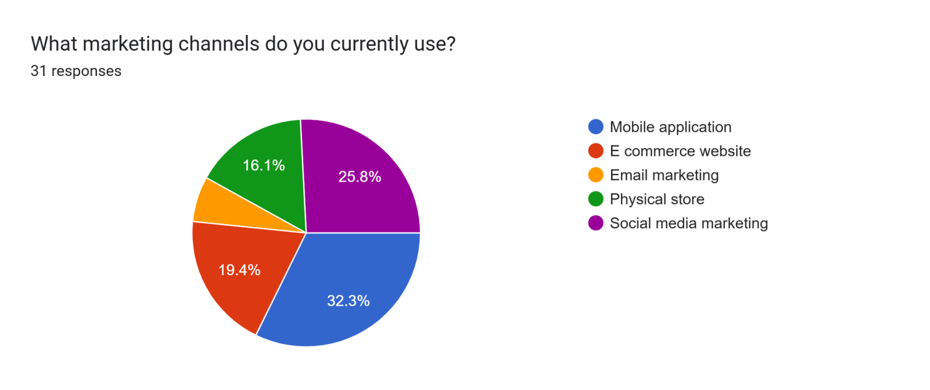

**INTERPRETATION :**

The survey shows 31 respondents fall into the category of using Mobile application with 32.3% for marketing strategy .

1. Bar diagram showing the tools or platforms which used for omnichannel marketing

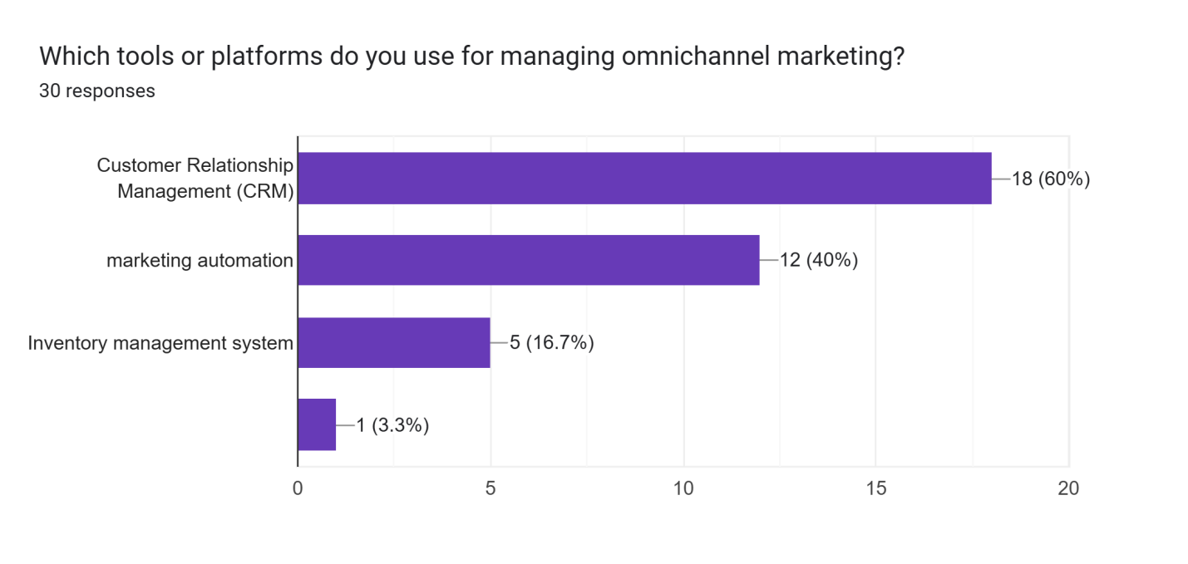

**INTERPRETATION :**

This survey shows the Customer Relationship management (CRM) used for omnichannel marketing with 60%.

1. Pie chart showing the synchronized of channels

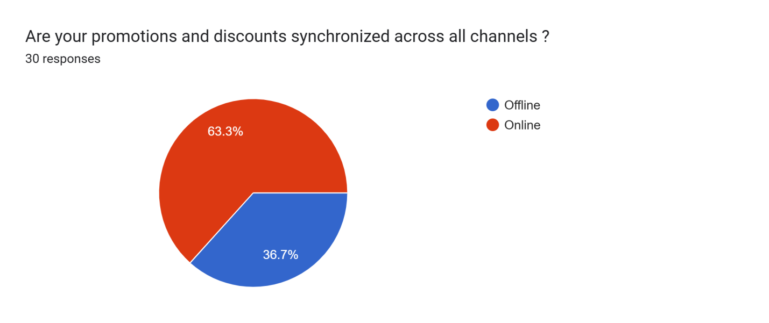

**INTERPRETATION** :

This survey shows the online way of marketing for the promotions and discounts with 63.3%. This results number of people prefer the online marketing .

4.Pie chart showing the customer service through different channels

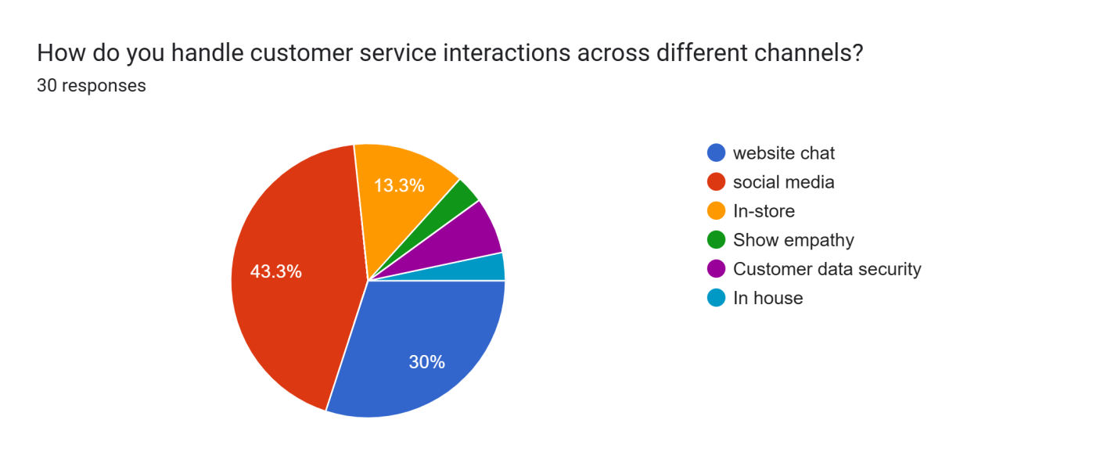

**INTERPRETATION :**

This survey examines the social media (Instagram, twitter, whatsapp and so on) is the best way to manage the customer service. This Pie chart shows 43.3 % of people prefer the social media and immediate next to the following is website chart with 30%.

5.Pie chart showing the challenges in implementing an omnichannel marketing

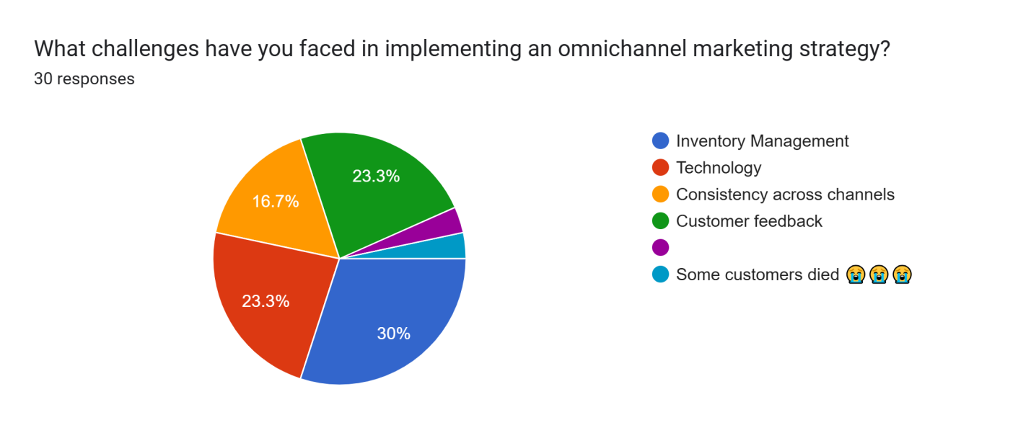

**INTERPRETATION :**

This survey shows the inventory management plays a major role in respect to the challenges faced n implementing the omnichannel marketing.

**CONCLUSION :**

In a world that is becoming more digital, omnichannel marketing has become a crucial tactic for retail companies seeking to address the changing demands of customers. Retailers can improve customer satisfaction and loyalty by offering a consistent shopping experience through various channels such as online, in-store, mobile, and social media. Businesses can personalize interactions, provide swift responses to customer inquiries, and effectively manage inventory through integrating multiple touch-points.

Nevertheless, effectively executing omnichannel tactics demands a dedication to surmounting obstacles like merging technology and adapting organization culture. Retailers have to dedicate resources to strong technology and focus on training their employees to make sure all teams are in line with the omnichannel strategy.

Retail businesses that adopt and enhance their omnichannel strategies will cultivate stronger customer connections and achieve long-term growth as consumer demands increase. In the end, a successfully implemented omnichannel strategy is more than just providing various channels; it involves establishing a cohesive brand experience that connects with customers and prepares for lasting success in the retail industry.

**REFERENCES :**

1. Cai, Y., & Lo, C. (2020). Omni-channel management in the new retailing era: A systematic review and future research agenda. *International Journal of Production Economics*, 229, 107729.
2. P. Verhoef, P. K. Kannan, J. Inman (2015).  From Multi-Channel Retailing to Omni-Channel Retailing: Introduction to the Special Issue on Multi-Channel Retailing. *Journal of Retailing*, 91, 174-181.
3. Milan Jocevski, Niklas Arvidsson, G. Miragliotta, A. Ghezzi, R. Mangiaracina (2019) Transitions towards omni-channel retailing strategies: a business model perspective. *International Journal of Retail & Distribution Management*.
4. Chopra, S. (2016). How omni-channel can be the future of retailing. *DECISION*, 43, 135-144

Ailawadi, K., & Farris, P. (2017). Managing Multi- and Omni-Channel Distribution: Metrics and Research Directions. *Journal of Retailing*, 93, 120-135.

5. Murugan.K, et al. "Patients Satisfaction Towards The Services Of The Hospitals With Reference To Vellore District, Tamilnadu." Journal of Pharmaceutical Negative Results (2022): 1503-1510.

6.Maran, K., J. Badrinarayanan, and P. Kumar. "A study on branded apparels customers purchase behavior with reference to India." *International Journal of Applied Business and Economic Research* 15.21 (2017): 215-221.

7. Anitha, V., & Krishnan, A. R. (2022). Factors ascendant consumers’ Intention for online purchase with special emphasis on Private Label Brands using UTAUT2. Journal of Positive School Psychology, 4724-4736.

8. Suresh, R., & Prasad, B. V. (2020). Problems and Prospects of Self Help Groups Micro Enterprise Activities and its Impact on Empowerment with Reference to Tamil Nadu. *PalArch's Journal of Archaeology of Egypt/Egyptology*, *17*(7), 9997-10007.

9. Dr. Venkatesh P, Dr. Anitha V, Dr. Muthukumar V, & Mr. Dinesh Kannaa K V. (2024). Factors Ascendant Z Generation’s Purchase Decision TOWARDS Apparels. Educational Administration: Theory and Practice, 30(4), 9593–9596.<https://doi.org/10.53555/kuey.v30i4.4456>

10. Suresh, R., & Prasad, B. V. (2020). Problems and Prospects of Self Help Groups Micro Enterprise Activities and its Impact on Empower Kumar, S. D., Soundarapandian, K., & Meera, S. (2022). Sentience of Career Opportunities and Career Development using Social Media–A Study with Reference to Tamil Nadu. *Journal of Big Data Technology and Business Analytics, 1 (1), 7*, *14*.

11. Pooja, S., & Kannaa, K. D. (2024). Influencer marketing: Instagram & YouTube bloggers strategies driving consumer purchases. Asian Journal of Management and Commerce, 5(1), 570–577.<https://doi.org/10.22271/27084515.2024.v5.i1g.306>

13. Murugan.K, et al. "Patients Satisfaction Towards The Services Of The Hospitals With Reference To Vellore District, Tamil Nadu." Journal of Pharmaceutical Negative Results (2022): 1503-1510.

14. T. Ilakkiya, M. Manikandan, R. K. Ch, K. M, M. Ramu and P. Venkatesh, "Neuro Computing-Based Models of Digital Marketing as a Business Strategy for Bangalore's Startup Founders," *2024 Third International Conference on Intelligent Techniques in Control, Optimization and Signal Processing (INCOS)*, Krishnankoil, Virudhunagar district, Tamil Nadu, India, 2024, pp. 1-3,

15. Usman Mohideen, Bharathi, Kanasingam & Sujith Kumar (2020), A Study on Impact of Social Media on Online Shopping Behavior of Youngsters, Ilkogretim Online – Elementary Education Online - UGC Indexed, Vol.19, Issue: 2, pp: 1914-1925, doi: 10.17051/ilkonline.2020.02.696776

16.V Selvakumar, V Dhayalan, S Sivagami, P Venkatesh (2024) [A study on effect of branding on customer buying behaviour with reference to Vellore](https://scholar.google.com/scholar?oi=bibs&cluster=3918867492733225042&btnI=1&hl=en&authuser=1) ,  AIP Conference Proceedings, 2024/7/8, Volume  2965 , Issue 1.

17.Suresh, Vetriselvi, K. Maran, and Shanmuga Priya AR. "A Study On Impact Of An Affiliate Marketing In E-Business For Consumer’s Perspective." SP AR-International Journal of Engineering and Technology 10.2 (2018): 471-475.

18 Manikandan, M., Venkatesh, P., Illakya, T., Krishnamoorthi, M., Senthilnathan, C., & Maran, K. (2024). The Significance of Big Data Analytics in the Global Healthcare Market. 2022 International Conference on Communication, Computing and Internet of Things (IC3IoT). https://doi.org/10.1109/ic3iot60841.2024.10550417

19 Ilakkiya, T., Manikandan, M., Ch, R. K., M, K., Ramu, M., & Venkatesh, P. (2024). Neuro Computing-Based Models of Digital Marketing as a Business Strategy for Bangalore’s Startup Founders. Ieee, 1–3. https://doi.org/10.1109/incos59338.2024.10527779

20 Murugan, K., Selvakumar, V., Venkatesh, P., Manikandan, M., Ramu, M., & M, K. (2023). The Big Data Analytics and its Effectiveness on Bank Financial Risk Management. Ieee, 13, 313–316. https://doi.org/10.1109/icrtac59277.2023.10480831

21 Venkatesh, P., Selvakumar, V., Ramu, M., Manikandan, M., & Senthilnathan, C. R. (2023). Measure of Well-Being of Freelancers in it Sector. Ieee. https://doi.org/10.1109/iccebs58601.2023.10448738

22.Sankar, S., K. Maran, and S. I. M. S. Director. "Market Trading in India-Customer Perception." International Journal of Engineering and Management Research 3.2 (2013): 1-13.