**Improving mathematics performance among children of 6 to 8 years old**

**Kawthar Khaloufi**

Consultant

**Abstract**

This study aims to address the challenge of low mathematics performance among children aged **6-8 years** in primary schools worldwide. It uses both quantitative and qualitative analysis to identify solutions that work best for these children.

**The innovative** approach involves using technology and data analysis to solve existing challenges, rather than relying solely on traditional approaches that cannot keep up with rapid technological advancements. The study proposes a new approach called "**Learn and Excel**" to help the educational system keep up with the technological and scientific advancements of the world while improving mathematics performance.  
  
**The importance** of this research lies in addressing the critical issue of low mathematics performance among children (**6 to 8 years**) due to existing teaching practices worldwide. By solving this challenge, we can build better socioeconomic status for those children at age 42. The research includes samples from countries divided by categories (High Income, Upper Middle Income, Lower Middle Income, and low income), with lower middle income and low income countries benefiting the most.  
  
**The methodological rigor** of this study is founded on systematic, credible, and disciplined approaches that ensure the research's dependability and conformability, as well as the credibility of the findings. We are evaluating a sample of review papers published in government and non-governmental organization reports, as well as peer-reviewed published researches in educational publications.

**This study’ impact** is primarily to help children transition from kindergarten to primary school, improve their problem-solving and analytical skills, boost self-confidence, and develop problem-solving abilities, preparing them for future success. It also provides teachers with opportunities for ongoing learning and has a greater impact on parents working long hours or being illiterate.

The findings can inform policies aimed at improving mathematical performance in children aged 6-8 years, and policymakers can use this information to design new policies. The study's findings are applicable to all countries.

**Keywords: Mathematical practices · Mathematical challenges · Learn & Excel model**

**Background**

The transition to primary school is an important milestone for children and their families. For children, this transition means adapting to a new physical and social environment and continuing to meet new academic demands (Authority, 2024).

An existing study at the university college London found that mathematical skills at age 6-8 years concluded that children are facing more challenges in mathematics compared to other subjects (e.g. reading): 11.1% of children had high attainment in math in contrast to 38% of children who had high attainment in reading. Also, the difference of attainments between mathematics and reading increases during the first two years of primary school (Outhwaite et al., 2022).

A study indicated that children’s math performance in first grade (6/7 years old) has an impact to their math ability that takes place in the upcoming years (Study: Kids Who Are Behind in Math in First Grade Don’t Catch up | Announce | University of Nebraska-Lincoln, 2013)

Parents also expressed that they intend to get their children to help them with their mathematics studies, but that it is difficult to do anything with their children at home due to lack of time, as many people, both men and women, work full-time these days. In some cases, parents are unable to support their children (National Center for Families Learning, 2014), or one or both parents are unable to support them because they are illiterate (Campbell, 2020).

This problem we are analyzing in this research is the low performance of children (6 to 8 years) with mathematics which lead to low performance in math in the following years of primary school. Which countries are facing the math performance challenge among children (6 to 8 years)? Does this current challenge have impact on short, medium and long term? What are the advantages and disadvantages of the current mathematics teaching approach among children (6 to 8 years)? What are the proven best practices we can use to remodel the math teaching approach while taking into consideration the lack of time of parents to support their child’s at home and the cases in which illiterate parents cannot add value to their children’s math performance?

**Methodology**

The study analyzed four categories of countries (high income, upper middle income, lower middle income and low income) and selected three countries from each category to examine the results.

The aim of this analysis is to analyze mathematical performance of children at the end of primary school because it has direct correlation with their previous performance in the first, second and third year of primary school (6-8 years) (Study: Kids Who Are Behind in Math in First Grade Don’t Catch up | Announce | University of Nebraska-Lincoln, 2013)

To understand the source of the problem, we must first examine whether there is a correlation between economic development and children's mathematics performance.

Next, we will analyze the current mathematics teaching methods in the countries selected for this study to evaluate the best practices.

The countries selected for this analysis are (Based on World Bank classification):

**Table 1: Sample countries listed by category**

|  |  |  |  |
| --- | --- | --- | --- |
| High Income | Upper middle income | Lower middle income | Low income |
| United States | Armenia | Zambia | Madagascar |
| Germany | Serbia | Myanmar | Burkina Faso |
| Australia | Indonesia | Philippines | Togo |

**High income countries analysis:**

Proportion of students at the end of primary education achieving at least a minimum proficiency level in mathematics, both sexes (%)

• In the **United States**, **78.6%** and **76.6%** of children reached a minimum level of proficiency in mathematics at the end of primary school in 2015 and 2019 respectively (UNESCO, 2024).

• In **Germany**, **76.73%** and **74.65%** of children reached a minimum level of proficiency in mathematics at the end of primary school in 2015 and 2019 respectively (UNESCO, 2024).

• In **Australia**, **64.43%** and **67.95%** of children reached a minimum level of proficiency in mathematics at the end of primary school in 2015 and 2019 respectively (UNESCO, 2024).

**Table 2: The application of mathematics and technology in high-income nations**

|  |  |  |  |
| --- | --- | --- | --- |
|  | United States | Germany | Australia |
| Mathematic Approach | In addition to emphasizing computational thinking and mathematical fluency to solve issues and provide a deeper understanding, mathematics standards in all states are increasingly emphasizing studying mathematical content in the context of real-world circumstances (The Mathematics Curriculum in Primary and Lower Secondary Grades – TIMSS 2015 Encyclopedia, n.d.) | Problem-solving application (Use the Math), procedural skills & fluency (Do the Math), and conceptual comprehension (make sense of Math) (The Mathematics Curriculum in Primary and Lower Secondary Grades – TIMSS 2015 Encyclopedia, n.d.-b) (FIS G1 Math Year Long Map for Families, n.d.) | The foundation of the model is comprehension, fluency, reasoning, and problem-solving.  Throughout their years of education, this method has been used to guarantee that pupils' mathematical ability grows and that their abilities become more complex (The Mathematics Curriculum in Primary and Lower Secondary Grades – TIMSS 2015 Encyclopedia, n.d.-c) |
| Use of technology (6 to 8 years) | In schools, having access to a computer has become standard. Schools can use digital devices and content provided by the government (Instruction for Mathematics and Science in Primary and Lower Secondary Grades – TIMSS 2015 Encyclopedia, n.d.) | 17.25% of schools use computers (Instruction for Mathematics and Science in Primary and Lower Secondary Grades – TIMSS 2015 Encyclopedia, n.d.-b) | Computers are widely available (Instruction for Mathematics and Science in Primary and Lower Secondary Grades – TIMSS 2015 Encyclopedia, n.d.-c) |

**Upper middle income countries analysis:**

Proportion of students at the end of primary education achieving at least a minimum proficiency level in mathematics, both sexes (%)

* In **Armenia**, **54.56%** and **64.34%** of children have reached the minimum proficiency level in mathematics at the end of primary school in 2015 and 2019 respectively (UNESCO, 2024).
* In **Serbia**, **71.65%** and **67.95%** of children have reached the minimum proficiency level in mathematics at the end of primary school in 2015 and 2019 respectively (UNESCO, 2024).
* In **Indonesia**, **17.54%** of children have reached the minimum proficiency level in mathematics at the end of primary school in 2015 (UNESCO, 2024).

**Table 3: The application of mathematics and technology in upper middle income nations**

|  |  |  |  |
| --- | --- | --- | --- |
|  | Armenia | Serbia | Indonesia |
| Mathematic Approach | The conventional method of teaching arithmetic involves giving students clear instructions and demonstrating a single, standard method for completing assignments (The Mathematics Curriculum in Primary and Lower Secondary Grades – TIMSS 2015 Encyclopedia, n.d.-d) | Establish a foundation for students' future mathematical education and self-education by teaching them the fundamentals of math and how to use that knowledge to solve problems in daily life. Additionally, foster students' mental faculties and their capacity to adopt a scientific perspective on the world, as well as their overall personality development (The Mathematics Curriculum in Primary and Lower Secondary Grades – TIMSS 2015 Encyclopedia, n.d.-e) | The conventional method of teaching arithmetic involves giving students clear instructions and demonstrating a single, standard method for completing assignments (The Mathematics Curriculum in Primary and Lower Secondary Grades – TIMSS 2015 Encyclopedia, n.d.-f) |
| Use of technology (6 to 8 years) | All schools are equipped with computers, they are used to deliver animated content (Instruction for Mathematics and Science in Primary and Lower Secondary Grades – TIMSS 2015 Encyclopedia, n.d.-d) | There is at least one computer in every Serbian school, but not all teachers have access to it or the Internet (especially in small remote schools and branch departments) (Instruction for Mathematics and Science in Primary and Lower Secondary Grades – TIMSS 2015 Encyclopedia, n.d.-e) | Some primary schools have access to computers (Instruction for Mathematics and Science in Primary and Lower Secondary Grades – TIMSS 2015 Encyclopedia, n.d.-f) |

**Lower middle income countries analysis:**

Proportion of students at the end of primary education achieving at least a minimum proficiency level in mathematics, both sexes (%)

* In **Zambia**, **3.5%** and **2.1%** and **16%** of children reached minimum proficiency in mathematics at the end of primary school in 2016,2021 and 2023 respectively (UNESCO, 2024).
* In **Myanmar**, **12%** of children reached minimum proficiency in mathematics at the end of primary school in 2019 (UNESCO, 2024).
* In **Philippines**, **17%** of children reached minimum proficiency in mathematics at the end of primary school in 2019 (UNESCO, 2024).

**Table 4: The application of mathematics and technology in lower middle income nations**

|  |  |  |  |
| --- | --- | --- | --- |
|  | Zambia | Myanmar | Philippines |
| Mathematic Approach | The conventional method of teaching arithmetic involves giving students clear instructions and demonstrating a single, standard method for completing assignments (Nakawa et al., 2020) | With JICA's assistance, a new curriculum is created to encourage children's critical thinking, profound comprehension, creativity, morality, and improved interpersonal communication (Case Study | What We Do - JICA, n.d.) | Critical thinking, problem-solving, reasoning, communication, connections, representations, and real-world decision-making are all used in the teaching of mathematics (Republic of the Philippines, Department of Education, 2016) |
| Use of technology | Primary schools continue to lack computers in spite of government attempts (“REPORT OF THE COMMITTEE ON EDUCATION, SCIENCE AND TECHNOLOGY FOR THE THIRD SESSION OF THE TWELFTH NATIONAL ASSEMBLY,” 2018) | No use of technology (How Many Primary Schools Have Electricity, Clean Water or Accessible Facilities?, 2019) | Low computer and internet access rates (PIDS Study Reveals Serious School Infrastructure Gaps in PH Basic Educ Sector, n.d.) |

**Low income countries analysis:**

Proportion of students at the end of primary education achieving at least a minimum proficiency level in mathematics, both sexes (%)

* In Madagascar, **4.7%** and **6.3%** of children reached the minimum proficiency level in mathematics at the end of primary school in 2015 and 2019 respectively (UNESCO, 2024).
* In Burkina Faso, **21.9%** and **25%** of children reached the minimum proficiency level in mathematics at the end of primary school in 2014 and 2019 respectively (UNESCO, 2024).
* In Togo, **15.9%** of children reached the minimum proficiency level in mathematics at the end of primary school in 2019 (UNESCO, 2024).

**Table 5: The application of mathematics and technology in low income nations**

|  |  |  |  |
| --- | --- | --- | --- |
|  | Madagascar | Burkina Faso | Togo |
| Mathematic Approach | The conventional method of teaching arithmetic involves giving students clear instructions and demonstrating a single, standard method for completing assignments (Madagascar | SharEd, 2024) | In primary schools, ASEI/PDSI is utilized when teaching mathematics (Tiendrebeogo & Tamura, 2021) | Traditional approach of teaching math (UNICEF Togo, 2019) |
| Use of technology | Lack of computers in schools (UNICEF Innocenti – Global Office of Research and Foresight et al., 2023) | No use of technology (Lakica & Lakica, 2024) | No use of technology, only 24% of schools have electricity (How Many Primary Schools Have Electricity, Clean Water or Accessible Facilities?, 2019b) |

**Countries expenditure on education, Total (% Of GDP) analysis:**

The goal of this analysis is to compare education expenditure of the selected countries in relation to the size of their economy (UNESCO, 2024) to come up with a suitable solution for lower middle income and low income countries

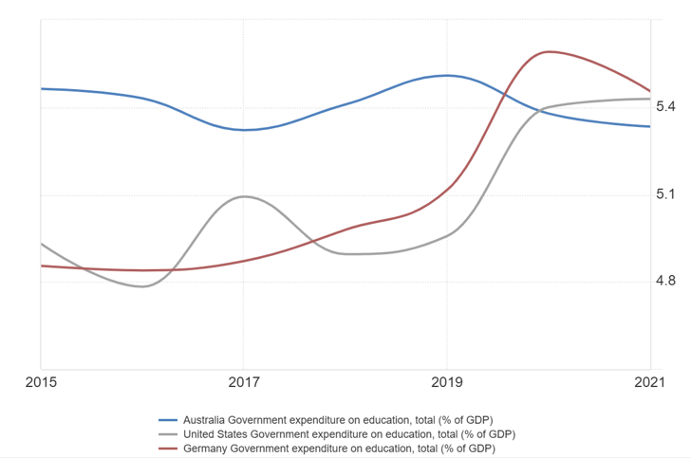 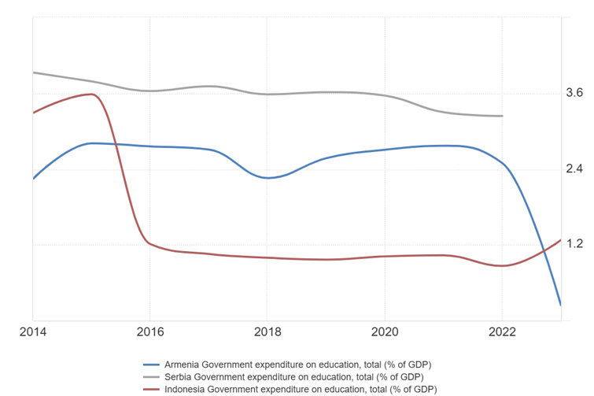

**Fig 1.** **Total education spending in Fig 2. Total education spending in upper**

**high income nations, total (%GDP) middle income nations, total (%GDP)**

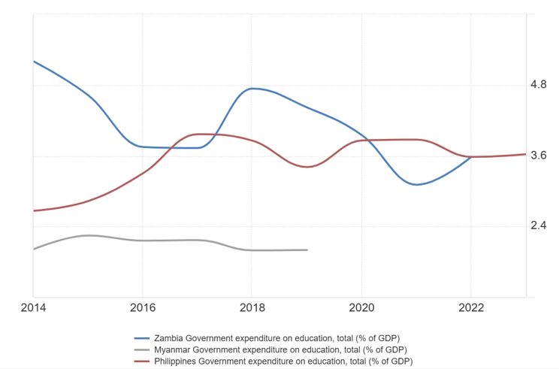 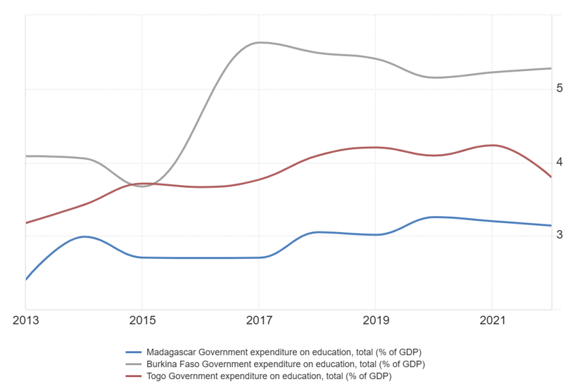

**Fig 3.** **Total education spending in lower Fig 4. Total education spending in**

**middle income nations, total (%GDP) low income nations, total (%GDP)**

According to the World Bank collection of development indicators

* Government expenditure on education, total (% of GDP) in United States was reported at 4.93% and 4.95% in 2015 and 2019 respectively (UNESCO, 2024).
* Government expenditure on education, total (% of GDP) in Germany was reported at 4.85 % and 5.11% in 2015 and 2019 respectively (UNESCO, 2024).
* Government expenditure on education, total (% of GDP) in Australia was reported at 5.46% and 5.5% in 2015 and 2019 respectively (UNESCO, 2024).
* Government expenditure on education, total (% of GDP) in Armenia was reported at 2.8 % and 2.57% in 2015 and 2019 respectively (UNESCO, 2024).
* Government expenditure on education, total (% of GDP) in Serbia was reported at 3.78 % and 3.61% in 2015 and 2019 respectively (UNESCO, 2024).
* Government expenditure on education, total (% of GDP) in Indonesia was reported at 3.58 % and 0.96% in 2015 and 2019 respectively (UNESCO, 2024).
* Government expenditure on education, total (% of GDP) in Zambia was reported at 3.47 % and 3.1% in 2016 and 2021 respectively (UNESCO, 2024).
* Government expenditure on education, total (% of GDP) in Myanmar was reported at 1.99976 % in 2019 (UNESCO, 2024).
* Government expenditure on education, total (% of GDP) in Philippines was reported at 3.4 % in 2019 (UNESCO, 2024).
* Government expenditure on education, total (% of GDP) in Madagascar was reported at 2.7% and 3.01% in 2015 and 2019 respectively (UNESCO, 2024).
* Government expenditure on education, total (% of GDP) in Burkina Faso was reported at 4.05 % and 5.4% in 2014 and 2019 respectively (UNESCO, 2024).
* Government expenditure on education, total (% of GDP) in Togo was reported at 4.2% in 2019 (UNESCO, 2024).

**The use of data analysis:**

Higher student performance can result from using data to inform instructional decisions, according to research (Wayman, 2005; Wayman, Cho, & Johnston, 2007; Wohlstetter, Datnow, & Park, 2008).

By offering insights into students' performance and engagement, data analytics can improve educational results. It enables educators and educational institutions to make wise choices that benefit both students and institutions (iLearnings, 2024).

Data analysis makes it simple for teachers to pinpoint pupils' areas of weakness and use that information to help them stay on course (Courtney, 2023).

**Findings:**

* All countries have issues in children's mathematics performance (6 to 8 years), ranging from medium to very high.
* Countries with the best performance use innovative techniques to teach mathematics, either with or without technology (challenge is medium).
* Countries with high challenges in children's mathematics performance often use conventional ways with technology as a tool.
* Countries with high challenges in children's math performance often use old or new approaches without technology.
* Education is a top priority for all nations in the sample, with the exception of Indonesia, as measured by total government education expenditure (% of GDP). As a result, solutions including government investment are not a challenge for lower middle and low income countries.
* Data analysis is crucial for continual development in education, regardless of the effectiveness of the paradigm.

**Innovativeness**

**What is the Learn & Excel model for children (ages 6-8)?**

The **Learn & Excel model** is an innovative model that was developed through the benchmarking of the best practices which proved in our analysis and the evidence based insights to provide outstanding results in combination with the use of technology as a learning tool and data analysis for teachers and schools to use for regular analysis and continuous improvements,

This model is based on 50% technology use as a learning tool, 50% innovative teaching methods and the use of data analysis (submitted by children through IPads) to ensure continuous improvement in mathematics’ education for 6-8 year olds.

The teachers’ mathematics teaching approach is based the following:

1. “Why” behind mathematical notions.
2. “How” behind solving process.
3. “Where” and “when” behind solving real world scenarios.

**The Learn & Excel math model combines the use of technology, data analysis and an innovative teachers’ approach in tandem:**

Role of teacher

|  |  |  |  |
| --- | --- | --- | --- |
| Spend 30% of overall time | Spend 40% of overall time | Spend 30% of overall time | Outside of class schedule |
| * Explain mathematical notions, solving process, and real world scenarios * Display fun educational videos * Explain 50% of the content using a computer with a projector * Explain 50% of the material using regular whiteboards | * Plan and set up different tasks in different ways (traditional dashboard, computer screen and group team) * Ask students questions to help them understand the task better * Guide students through brainstorming to identify possible answers to homework assignments | * Review student work (submitted through IPads) * Evaluate responses * Re-practice other tasks where students showed weaknesses | * Analyze the data to categorize strengths and weaknesses and develop opportunities and solutions * Analyze the data to highlight the most effective and efficient types of tasks that will produce better results * Repeat |
| * Active listening * Asking questions and clarification * Taking notes on the textbook | * Work time to practice on textbook * Use prior learning to assist * Submit answers on IPads * Partner with other peers | * Provide feedback in the form of emoji’s for each exercise and rate it as easy, medium or difficult * Ask new questions | * NA |

Role of student

**Importance**

**Why is it important for all educational institutions around the world to switch to the Learn & Excel model, especially the lower middle income and low income countries?**

Existing research demonstrated that numerical and arithmetic skills at age 7 predict socioeconomic status at age 42, after controlling for other variables (Ritchie, 2013).

Children’s mathematics low performance (6 to 8 years) has medium term impact on their primary math performance as a whole and long term impact on defining their socioeconomic status at age 42.

Mathematics also supports child development in a variety of areas (e.g. reading comprehension, oral language, etc.) (Sarama, 2012).

Most countries in the world have problems with primary school students' math performance, ranging from medium, high to very high.

The importance of the **Learn & Excel model** is to assess the mathematics performance of children (ages 6-8) around the world and to ensure that they continue their education with a strong foundation. In particular children living in lower middle income and low income countries.

**The impact**

This new innovative approach promotes interaction between teachers and children (ages 6-8), reduces children's stress and makes them see mathematics as an interesting subject rather than a difficult one. The data obtained from children's interactions on the IPads can be used by schools to analyze children's performance and gain useful insights to improve teachers' performance. The foundations that children build at age 6-8 have a significant impact on their subsequent performance in primary school (Allen et al., 2015). Only by providing a solid foundation can they develop better problem-solving and analytical skills and foster a confident generation that can contribute positively to their country in the future (House, 2024). This methodology has an impact on children by developing their brainstorming skills, increasing their self-confidence, and providing them with problem-solving and analytical skills from a young age, which will help determine their socioeconomic level (Ritchie, 2013). This model is especially important for children in lower middle-income and low-income countries because the economy of these countries cannot improve without improving the internal resources (children); to build a smart generation that will add value to their countries in all industries.

This strategy requires teachers to undergo training before becoming operational. It also gives teachers opportunity for continuous learning and growth while assessing student responses and feedback.

This approach will benefit parents who work long hours or are illiterate, and it was created with their needs in mind.

The government's role in this concept is to supply digital courses and a software for storing data in public primary schools.

The findings can inform policies aiming at increasing mathematical performance in children aged 6 to 8, and policymakers can utilize this information to develop new policies. The study's conclusions apply to all countries.

**References**

Authority, N. E. R. (2024, August 23). Strategies to support successful transitions to school. https://education.nsw.gov.au/early-childhood-education/leadership/news/strategies-to-support-successful-transitions-to-school Uis. (2024.-e). UIS Statistics. © UIS. https://data.uis.unesco.org/Index.aspx

Outhwaite, L., Anders, J., & Jo, V. H. (2022, May 1). Mathematics attainment falls behind reading in the early primary school years. https://econpapers.repec.org/paper/uclcepeow/22-06.htm

National Center for Families Learning. (2014, September 19). 60 percent of parents struggle to help with homework, survey reveals. <https://familieslearning.org/blog/60-percent-of-parents-struggle-to-help-with-homework-survey-reveals/>

Campbell, S. (2020, August 31). How is an illiterate parent supposed to homeschool? World Help. <https://worldhelp.net/how-is-an-illiterate-parent-supposed-to-homeschool/>

Allen, L., Kelly, B. B., Children, Y. B. O., & Families. (2015). Transforming the workforce for children birth through age 8. In National Academies Press eBooks. <https://doi.org/10.17226/19401>

House, S. (2024, September 2). Problem-Solving through play Method | The Schoolhouse. The Schoolhouse. <https://theschoolhouse.com.sg/blog/a-guide-to-cultivating-problem-solving-skills-through-play/>

Ritchie, S.J.; Bates, T.C. Enduring links from childhood mathematics and reading achievement to adult socioeconomic status. Psychol. Sci. 2013, 24, 1301–1308.

Sarama, J.; Lange, A.; Clements, D.H.; Wolfe, C.B. The impacts of an early mathematics curriculum on emerging literacy and language. Early Child. Res. Q. 2012, 27, 489–502.

3e International School. (2023, March 29). Navigating the transition from Kindergarten to Elementary | 3e International School. <https://3einternationalschool.org/navigating-the-transition-from-kindergarten-to-elementary/>

Pupils aged six in these countries are using computers – but are they improving their results? (2024, September 10). World Economic Forum. <https://www.weforum.org/stories/2016/05/pupils-aged-six-in-these-countries-are-using-computers-but-are-they-improving-their-results/#:~:text=Overall%2C%20the%20study%20found%20that,reading%2C%20mathematics%20or%20science%E2%80%9D>.

Nisbet, N. (2024). Why Traditional Math Education is Failing our Students: A Call for Transformation. https://blog.mindresearch.org/blog/why-traditional-math-education-is-failing-our-students-a-call-for-transformation

Ground, H. (n.d.). What’s the right age to introduce your kid to computers? Higher Ground. <https://store.hggear.com/blogs/news/whats-the-right-age-to-introduce-your-kid-to-computers?srsltid=AfmBOoplNJhTeNQKlQAamzsM03KIfn_vfkIjGnH4CzM8wSTa9R7Nh4io>

Maths: Age 7–8 (Year 3) - Oxford Owl for home. (2022, July 1). Oxford Owl for Home. <https://home.oxfordowl.co.uk/maths/primary-maths-age-7-8-year-3/>

Teaching and learning in primary education. (n.d.-b). <https://eurydice.eacea.ec.europa.eu/national-education-systems/belgium-french-community/teaching-and-learning-primary-education>

Downton, A.; MacDonald, A.; Cheeseman, J.; Russo, J.; McChesney, J. Mathematics learning and education from birth to eight years. In Research in Mathematics Education in Australasia 2016–2019; Way, J., Attard, C., Anderson, J., Bobis, J., McMaster, H., Cartwright, K., Eds.; Springer: Singapore, 2020.

Pemu, N. Connecting teacher’s activity and students’ achievement toward numeracy competency in learning mathematics. Pedagog.—Theory Prax. 2023, 8, 196–211.

Mokhtar, S. F., Yusof, Z. M., & Misiran, M. (2012). Factors affecting students’ performance in mathematics. Journal of Applied Sciences Research, 8(8), 4133-4137.

Rashidov, A. (2020). Use of differentiation technology in teaching mathematics. European Journal of Research and Reflection in Educational Sciences, 8(7), 163-167.

Study: Kids who are behind in math in first grade don’t catch up | Announce | University of Nebraska-Lincoln. (n.d.). <https://newsroom.unl.edu/announce/primarilymath/2124/11904>

Wayman, J. C. (2005). Involving teachers in data-driven decision-making: Using computer data systems to support teacher inquiry and reflection. Journal of Education for Students Placed at Risk, 10(3), 295–308.

Wayman, J. C., Cho, V., & Johnston, M. T. (2007). The data-informed district: A district-wide evaluation of data use in the Natrona County School District. Austin, TX: The University of Texas.

Wohlstetter, P., Datnow, A., & Park, V. (2008). Creating a system for data-driven decision-making: Applying the principal-agent framework. School Effectiveness and School Improvement, 19(3), 239–259.

iLearnings. (2024, August 31). The role of data analytics in enhancing educational outcomes. <https://www.linkedin.com/pulse/role-data-analytics-enhancing-educational-outcomes-ilearningscareer-3xmlc/>

Courtney, M. B., EdD. (2023, October 23). Data Analysis in Education: How Data-Driven Decision-Making Improves instruction. <https://www.linkedin.com/pulse/data-analysis-education-how-data-driven-improves-b-courtney-ed-d--5k0uc/>

PIDS study reveals serious school infrastructure gaps in PH basic educ sector. (n.d.). <https://www.pids.gov.ph/details/news/press-releases/pids-study-reveals-serious-school-infrastructure-gaps-in-ph-basic-educ-sector>

Republic of the Philippines, Department of Education. (2016). K to 12 Mathematics Curriculum Guide (pp. 2–257) [Report]. <https://depedbohol.org/v2/wp-content/uploads/2016/03/Math-CG_with-tagged-math-equipment.pdf>

Nakawa, N., Kusaka, S., Kosaka, M., Watanabe, K., & Baba, T. (2020). Primary School Children’s Counting and Number Composition Processes from Two Pilot Studies in Urban Schools in Zambia. African Journal of Research in Mathematics Science and Technology Education, 24(3), 361–374. <https://doi.org/10.1080/18117295.2020.1851889>

Case study | What we do - JICA. (n.d.). <https://www.jica.go.jp/english/activities/issues/education/study.html>

How many primary schools have electricity, clean water or accessible facilities? (2019, May 1). Theirworld. <https://theirworld.org/news/how-many-primary-schools-have-internet-electricity-clean-water-accessible-facilities/>

REPORT OF THE COMMITTEE ON EDUCATION, SCIENCE AND TECHNOLOGY FOR THE THIRD SESSION OF THE TWELFTH NATIONAL ASSEMBLY. (2018). In National Assembly of Zambia. <https://www.parliament.gov.zm/sites/default/files/documents/committee_reports/EDUCATION%2C%20SCIENCE%20AND%20TECH.pdf>

The Mathematics Curriculum in primary and lower secondary grades – TIMSS 2015 Encyclopedia. (n.d.). <https://timssandpirls.bc.edu/timss2015/encyclopedia/countries/united-states/the-mathematics-curriculum-in-primary-and-lower-secondary-grades/>

Instruction for mathematics and science in primary and lower secondary grades – TIMSS 2015 Encyclopedia. (n.d.). <https://timssandpirls.bc.edu/timss2015/encyclopedia/countries/united-states/instruction-for-mathematics-and-science-in-primary-and-lower-secondary-grades/>

The Mathematics Curriculum in primary and lower secondary grades – TIMSS 2015 Encyclopedia. (n.d.-b). <https://timssandpirls.bc.edu/timss2015/encyclopedia/countries/germany/the-mathematics-curriculum-in-primary-and-lower-secondary-grades/>

Instruction for mathematics and science in primary and lower secondary grades – TIMSS 2015 Encyclopedia. (n.d.-b). <https://timssandpirls.bc.edu/timss2015/encyclopedia/countries/germany/instruction-for-mathematics-and-science-in-primary-and-lower-secondary-grades/>

The Mathematics Curriculum in primary and lower secondary grades – TIMSS 2015 Encyclopedia. (n.d.-c). <https://timssandpirls.bc.edu/timss2015/encyclopedia/countries/australia/the-mathematics-curriculum-in-primary-and-lower-secondary-grades/>

Instruction for mathematics and science in primary and lower secondary grades – TIMSS 2015 Encyclopedia. (n.d.-c). <https://timssandpirls.bc.edu/timss2015/encyclopedia/countries/australia/instruction-for-mathematics-and-science-in-primary-and-lower-secondary-grades/>

The Mathematics Curriculum in primary and lower secondary grades – TIMSS 2015 Encyclopedia. (n.d.-d). <https://timssandpirls.bc.edu/timss2015/encyclopedia/countries/armenia/the-mathematics-curriculum-in-primary-and-lower-secondary-grades-2/>

Instruction for mathematics and science in primary and lower secondary grades – TIMSS 2015 Encyclopedia. (n.d.-d). <https://timssandpirls.bc.edu/timss2015/encyclopedia/countries/armenia/instruction-for-mathematics-and-science-in-primary-and-lower-secondary-grades-2/>

The Mathematics Curriculum in primary and lower secondary grades – TIMSS 2015 Encyclopedia. (n.d.-e). <https://timssandpirls.bc.edu/timss2015/encyclopedia/countries/serbia/the-mathematics-curriculum-in-primary-and-lower-secondary-grades/>

Instruction for mathematics and science in primary and lower secondary grades – TIMSS 2015 Encyclopedia. (n.d.-e). <https://timssandpirls.bc.edu/timss2015/encyclopedia/countries/serbia/instruction-for-mathematics-and-science-in-primary-and-lower-secondary-grades/>

The Mathematics Curriculum in primary and lower secondary grades – TIMSS 2015 Encyclopedia. (n.d.-f). <https://timssandpirls.bc.edu/timss2015/encyclopedia/countries/indonesia/the-mathematics-curriculum-in-primary-and-lower-secondary-grades/>

Instruction for mathematics and science in primary and lower secondary grades – TIMSS 2015 Encyclopedia. (n.d.-f). <https://timssandpirls.bc.edu/timss2015/encyclopedia/countries/indonesia/instruction-for-mathematics-and-science-in-primary-and-lower-secondary-grades/>

FIS G1 math Year long map for families. (n.d.). Google Docs. <https://docs.google.com/document/d/1Fd_0wR4C3Xx-fWixd6a6Lk6lSyUjQ3GVx0Nve0fW-K0/edit?tab=t.0>

Madagascar | SharEd. (2024). <https://shared.rti.org/taxonomy/term/34417>

Tiendrebeogo, E. S., & Tamura, K. (2021). Teaching Method in Mathematics Education: Neediness of the Paradigm Shift to Structured Problem-Solving Approach at Junior High School in Burkina Faso. In Naruto University of Education, NUE Journal of International Educational Cooperation (Vol. 15, pp. 51–58) [Journal-article].

UNICEF Togo. (2019). Togo Education Sectoral and OR+ SC189904 Report.

UNICEF Innocenti – Global Office of Research and Foresight, Ministry of Education of Madagascar, & UNICEF Madagascar. (2023). Data Must Speak: Unpacking Factors Influencing School Performance in Madagascar. In UNICEF Innocenti. UNICEF Innocenti.

Lakica, R., & Lakica, R. (2024, December 28). Challenges within the education system in Burkina Faso -. - Broken Chalk. <https://brokenchalk.org/challenges-within-the-education-system-in-burkina-faso/>

How many primary schools have electricity, clean water or accessible facilities? (2019b, May 1). Theirworld. https://theirworld.org/news/how-many-primary-schools-have-internet-electricity-clean-water-accessible-facilities/