# FUNDAMENTAL AND TECHNICAL ANALYSIS OF MRF TYRES LTD & APOLLO TYRES LTD

**DR V MUTHUKUMAR**

Assistant Professor, Sri Sairam Institute of Management Studies,

Sri Sairam Engineering College, Chennai

[muthukumar.mba@sairam.edu.in](mailto:muthukumar.mba@sairam.edu.in)

**S HARIHARAN**

Scholar, Sri Sairam Institute of Management Studies,

Sri Sairam Engineering College, Chennai

## ABSTRACT

This research paper explores the intricacies of the Indian tire industry, emphasizing its notable growth fueled by rising automobile demand and increasing income levels. The study centers on two key players, MRF Tyres and Apollo Tyres, employing both fundamental and technical analysis methods. The fundamental analysis, which involves examining financial ratios, indicates that Apollo Tyres demonstrates superior financial performance relative to MRF Tyres, positioning it as a more appealing investment choice. The industry analysis is contextualized through Porter’s Five Forces Model, which highlights the challenges faced by new entrants due to intense competition, significant supplier influence in specific areas, and the threat of substitutes. Nevertheless, the model also points to opportunities within the Indian market, attributed to lower production costs and the availability of affordable labor. The paper also explores technical analysis, emphasizing the significance of moving averages in detecting market trends and informing investment strategies. By smoothing out price fluctuations, moving averages provide traders with a clearer perspective on market behavior and help establish crucial support and resistance levels.

# INTRODUCTION:

India style industry is rapidly growing which is due to the increase in which is due to the increase in automobiles across the country. Rising income levels and the consistent increase in vehicle demand have both direct and indirect impacts on the growth of the tyre industry in India. The industry is projected to reach 253.9 million units by 2032, reflecting a compound annual growth rate of 3% from 2024 to 2032. Some of the most the leading players in Indian tire industries are

* MRF limited.
* CEAT Limited.
* JK tyres and Industries Ltd.
* Apollo Tyres limited.

In this research MRF tyres and Apollo tyres are considered for the fundamental and technical analysis.

## Company Overview:

* MRF TYRES

MRF tyres or Madras Rubber Factory is one of the leading largest tyre manufacturer and multinational company. It was started in 1946 and became the market leader with 50% share in 1961. MRF became a public company and 1st Indian company to export tyres to the United States. It's headquartered in Chennai and also have operations in Sri Lanka and Singapore. At present MRF holds 29% of market share in India.

* APOLLO TYRES

Apollo tyres is an international tire manufacturing and a leading tyre brands in India it was started in the year 1972 the Apollo tyre markets its product under 2 global brands Apollo and Vredestein tyres the company have manufacturing units in India and one each in Netherland and Hungary it is India's 5th and globally 17 tire manufacturing units and it is headquartered in Gurgaon, India.

# REVIEW OF LITRETURE:

**Grundy, (2006)** This review examines ways to enhance Porter’s Five Forces Model by combining it with other frameworks, such as PEST analysis, to better identify growth drivers. It also explores why some managers might be reluctant to implement Porter’s model, citing its theoretical foundation and a preference for more modern methods. Furthermore, the review highlights the ease of applying Porter’s analysis in real-world scenarios.

**Rark (2007)** This paper focuses on evaluating apparent profitability using technical analysis. It organizes the existing literature into two distinct categories: early studies and modern studies. Early research indicates that technical trending strategies yield profits in foreign exchange and futures markets but are less effective in the stock market. Conversely, modern research shows that these strategies consistently generate economic gains.

**Zun & Zhou, (2009)** This research paper examines the role of technical analysis, with a focus on moving averages, in asset allocation. It highlights that when stock prices exhibit predictability, technical analysis can substantially increase the value of the asset.

**Widyani, (2010)** In the capital market, investors and analysts generally rely on two primary methods: fundamental analysis and technical analysis. Technical analysis focuses on analyzing past trading information, including stock prices, trading volumes, and market indicators, to predict future price trends and inform investment choices.

**Graham (2015)** evaluates the company to gauge its financial health and overall value. This aspect often intimidates many traders. However, it's important to note that only a few key numbers and ratios need to be examined, and most of the necessary information can be accessed from reputable sources at no cost.

**Sakthi& C., (2016)** typically begins by forecasting the overall economy, then moves on to make predictions for specific industries, and finally assesses individual companies. Industry forecasts are informed by the broader economic predictions, while company forecasts rely on both the industry outlook and the economic projections.

## OBJECTIVE OF THE STUDY

* + Analyze the Indian tire industry using Porter’s Five Forces Model to understand competitive dynamics, including supplier and buyer power, industry rivalry, and the impact of new entrants and substitutes.
  + Compare the financial performance of MRF Tyres and Apollo Tyres through key financial ratios to identify the more promising investment.
  + Use technical analysis to assess market trends and investment potential for both companies, focusing on moving averages and price patterns.

## RESEARCH METHODOLOGY:

INDUSTRY ANALYSIS:

Poster’s Five Force Model: Evaluating the internal and external factors that impact a business is a vital process for determining the overall attractiveness of an industry. This analysis helps identify whether the market presents favorable conditions for entry. When all five forces in Porter’s Five Forces Model are strong, it suggests that the industry may pose significant challenges for new entrants. Therefore, prior to making a decision to enter a specific industry, it is essential to thoroughly assess these forces to understand the potential risks and competitive dynamics involved.

Porters five force industry analysis are:

1. Bargaining power of buyers
2. Bargaining power of suppliers
3. Threat of Substitutes
4. Threats of new entrants
5. Industry Rivalry

The analysis of Porters five force for the Tyres industry:

* 1. **Bargaining power of Suppliers:** The bargaining power of suppliers can be divided into two main categories based on industry demand.
     + **Rubber:** The bargaining power of rubber suppliers is relatively low for two key reasons. First, tire companies receive a 150-day credit period for purchasing rubber from the international market. Second, this credit is provided at LIBOR (London Interbank Offered Rate), which represents the interest rate at which banks borrow funds from one another. As a result, the bargaining power of rubber suppliers is minimal, and its impact on the business remains limited.
     + **Other Petrochemical Products**: The bargaining power of petrochemical materials suppliers are high because the petrochemical materials like carbon black and other chemicals are very costly and the price of the material are beyond control of that Tyre industries.
  2. **Bargaining power of Buyers:** The OEMs **(**Original Equipment manufacturer) have upper hand or strong position in the bargaining power of buyers the reason is the most of the OEM's are having contract with the relative tyre manufacturers under which the price of the tyres remains constant for them irrespective of market price. Bulk buying is the reason for the benefits and their relations gives the tyre firms something called brand association.
  3. **Threat of Substitutes:** The threat of substitutes is considered moderate, as the industry is encountering competition from declining sectors worldwide. These more affordable alternatives have historically reduced costs by approximately 20 to 25% compared to original products in developed countries over the past few decades, and they are also gaining traction in India.
  4. **Threats of new entrants:** In the tyre manufacturing industry, the threat of new entrants is typically moderate to low due to the significant capital investment and advanced technology required to compete effectively. But from the Indian industry point of view the threat of new entrants is high because of low production cost, cheap labourand relevant benefit so for any global bigshot companies and startups Indian market will be a good option to go for.
  5. **Industry Rivalry:** Industry rivalry is intense as international competitors increasingly expand into Indian markets, and all companies are transitioning to advanced technologies such as ERP and SCM systems. Additionally, rising input costs, particularly from the growing OEM segment, pose challenges as vehicle manufacturers are unwilling to share the financial burden with the tyre industry. Furthermore, the unorganized sector adds to the competition, creating hurdles for established brands like Apollo and MRF. **Interpretation from Industry Analysis:** The above analysis interprets that Indian tyre Industries are unfavourable. Because over three factors are high in Poster’s Five Force Model. This is not favourable position for the new business or startups to enter into the market.

## COMPANY ANALYSIS:

This approach involves a comprehensive analysis of securities to determine their intrinsic value by evaluating both quantitative and qualitative factors. By examining numerical data, such as financial statements and market trends, alongside qualitative aspects like management effectiveness and industry conditions, investors can gain deeper insights into the true worth of an asset. This method aims to provide a thorough understanding of the security’s potential for future performance.

Ratio Analysis of MRF Tyres & Apollo Tyres as on March 2023

| **PARTICULARS** | **MRF TYRES** | **APOLLO TYRES** |
| --- | --- | --- |
| Current Ratio | 1.22 | 0.96 |
| Debt Equity Ratio | 0.130 | 0.41 |
| Inventory Turnover Ratio | 3.83 | 4.51 |
| Debtors Turnover Ratio | 9.56 | 13.39 |
| Fixed Assets Turnover Ratio | 1.36 | 1.00 |
| Total Assets Turnover Ratio | 1.37 | 1.24 |
| Gross Profit Margin (%) | 4.82 | 6.92 |
| Net Profit Margin (%) | 3.61 | 3.34 |
| Return on capital employed | 8.10 | 9.15 |

## Interpretation of Company Analysis:

From the above ratio analysis of MRF tyres and Apollo tyres we can interpret that Apollo tyres takes lead on MRF tyres on all ratios except Current ratio, so we can come to a conclusion that Apollo tyres is favourable industry for investors to invest their capital.

## TECHNICAL ANALYSIS:

Technical analysis is a method used to spot trading opportunities by evaluating statistical data from market activities, such as price changes and trading volumes. This approach includes examining historical price charts and patterns to anticipate future price trends. By analyzing these indicators, traders aim to make informed decisions about trade entry and exit points, ultimately increasing their likelihood of success in the market.

## Moving Average:

A moving average is an essential instrument in technical analysis that helps to clarify price trends by filtering out the "noise" caused by random price variations. By smoothing out these fluctuations, traders can gain a clearer understanding of market trends. Some typical uses of moving averages include assessing the general direction of a trend and identifying significant support and resistance levels.

## Moving Average of MRF Tyres

| DATE | CLOSING PRICE |
| --- | --- |
| Oct 6, 2023 | 107,550.25 |
| Oct 5, 2023 | 106,583.05 |
| Oct 4, 2023 | 108,901.40 |
| Oct 3, 2023 | 107,295.60 |
| Sep 29, 2023 | 108,726.40 |
| Sep 28, 2023 | 110,284.40 |
| Sep 27, 2023 | 109,559.35 |
| Sep 26, 2023 | 108,496.35 |

107,550.25 + 106,583.05 + 108,901.40 + 107,295.60 + 108,726.40 + 110,284.40 + 110,284.40 +

108,496.3510

= 75783.4

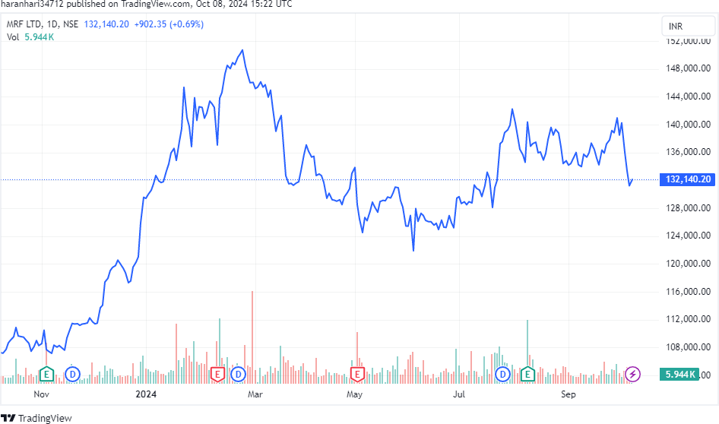

Fig.1 MRF Tyres Ltd 2023-2024 Graph

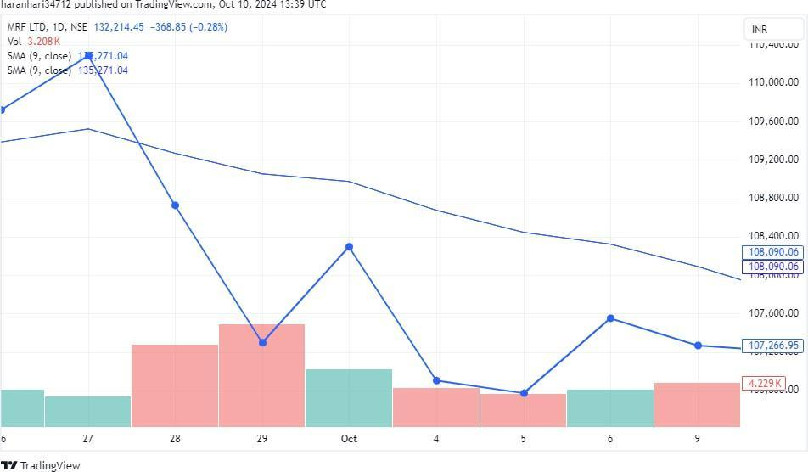

Fig.1 MRF Tyres Ltd Moving Average

## Moving Average of Apollo Tyres

| DATE | CLOSING PRICE |
| --- | --- |
| Oct 6, 2023 | 384.40 |
| Oct 5, 2023 | 373.05 |
| Oct 4, 2023 | 370.35 |
| Oct 3, 2023 | 371.85 |
| Sep 29, 2023 | 368.75 |
| Sep 28, 2023 | 367.20 |
| Sep 27, 2023 | 376.60 |
| Sep 26, 2023 | 370.55 |

384.40+ 373.05+ 370.35+ 368.75+ 367.20+ 376.60+ 370.55

10

= 261.09

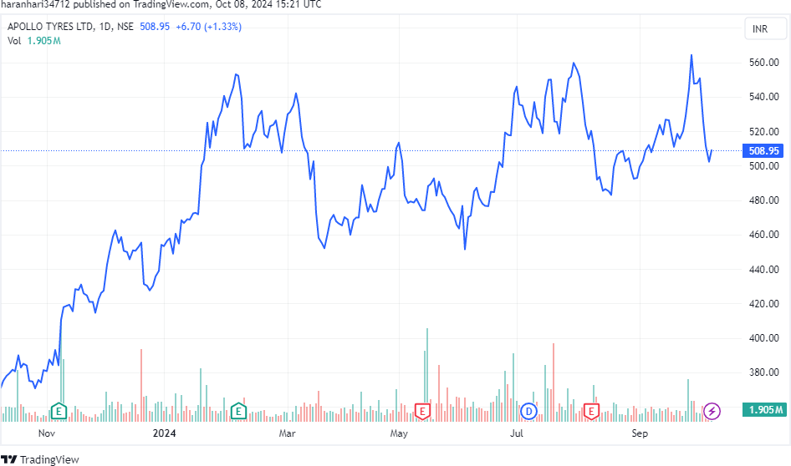

Fig.3 Apollo Tyres Ltd 2023-2024 Graph

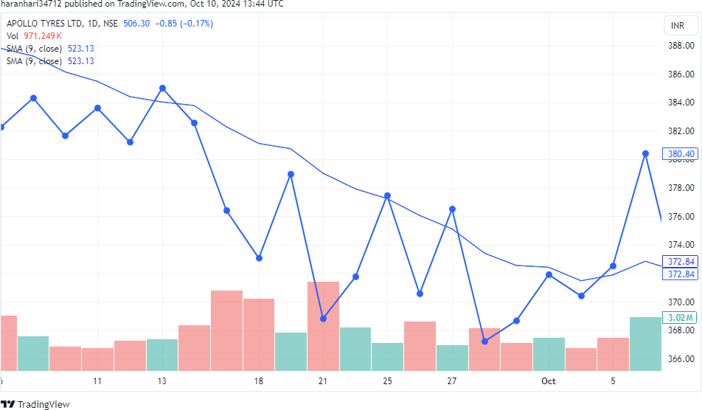

Fig.4 Apollo Tyres Ltd Moving Average

## Interpretation of Technical Analysis :

Based on the technical analysis above, it appears that Apollo Tyres Limited presents a favorable investment opportunity. When the company's share price declines, there is an expectation that it will rise again, making it a potentially good time for investors to invest in Apollo Tyres Limited.

# CONCLUSION:

In summary, the analysis of the Indian tire industry, with a particular focus on MRF Tyres and Apollo Tyres, reveals several important insights for potential investors. The sector is currently experiencing robust growth, fueled by increasing demand for automobiles and rising income levels across the country. However, despite this positive outlook, the industry also faces significant challenges, including intense competition, varying supplier power in certain areas, and the threat of substitutes.

Applying Porter’s Five Forces Model highlights that the competitive environment is challenging for new entrants, primarily due to the substantial capital investment and advanced technology required to establish a foothold. Nonetheless, the relatively low production costs and availability of skilled labor in India may still attract international firms looking to enter this burgeoning market.

From a company analysis standpoint, the financial ratio evaluation demonstrates that Apollo Tyres outperforms MRF Tyres in several crucial areas, such as return on capital employed and inventory turnover. This indicates that Apollo Tyres is currently in a more favorable financial situation, making it a more appealing choice for investors seeking reliable growth and stability. Furthermore, the technical analysis supports the notion that Apollo Tyres holds significant potential. The data suggests that any temporary declines in share prices could present strategic buying opportunities for investors. With the anticipated growth trajectory of the tire industry in the years ahead, entering Apollo Tyres could be advantageous.

Overall, while both MRF and Apollo are established entities in a thriving market, Apollo Tyres stands out as a more compelling investment option due to its superior financial performance and advantageous market positioning. Investors are encouraged to weigh these findings carefully, alongside broader market trends, to make well-informed decisions in this dynamic and evolving industry.

## REFERENCES:

1. Dr. Lakshmitha N (2018) Fundamental and Technical Analysis of Reliance Communication and Bharathi Airtel
2. Business, Z. (2017, October 23). Telecom competition heats up as Airtel targets Reliance Communication's 2G customers with new advertisement.
3. Grundy, T. (2006). Rethinking and reinventing Michael Porter's Five Forces model. Wiley Interscience, 213-229.
4. Rark, C. H. (2007). What is known about the profitability of technical analysis? Journal of Economic Surveys, 786-826.
5. Zun, Y., & Zhou, G. (2009). Technical analysis: A perspective on asset allocation using moving averages. Journal of Financial Economics, 92(3), 519-544.
6. Maran, K., and R. Anitha. "Impact of Foreign Direct Investment on Power Sector: An Empirical Study With Refrence to India." *East Asian Journal of Business Economics (EAJBE)* 3.1 (2015): 8-16.
7. Venkatesh, P., Ilakkiya, T., Ramu, M., Manikandan, M., & Senthilnathan, C. R. (2023, December). An Analysis of the Strategic Approach to Utilizing Deep Learning for the Purpose of Predicting Stock Prices. In *2023 Intelligent Computing and Control for Engineering and Business Systems (ICCEBS)* (pp. 1-4). IEEE.
8. T.Anna Prammila  V.Dhayalan  , Mr.M.Gopinath (2020)    [A STUDY ON CASH FLOW ANALYSIS WITH REFERENCE TO THE CHENNAI METRO RAIL LIMITED (CMRL)](https://scholar.google.com/citations?view_op=view_citation&hl=en&user=lfAF7eQAAAAJ&cstart=20&pagesize=80&authuser=1&citation_for_view=lfAF7eQAAAAJ:maZDTaKrznsC) , Studies in Indian Place Names (UGC Care Journal) 40 (40), 153-160
9. Venkatesh, P., et al. "An Analysis of the Strategic Approach to Utilizing Deep Learning for the Purpose of Predicting Stock Prices." *2023 Intelligent Computing and Control for Engineering and Business Systems (ICCEBS)*. IEEE, 2023.
10. Jeyalakshmi, R., Kannan, M. R., Nuskiya, M. F., & Kumar, M. N. (2021). Impact Of Interest Rate And Inflation In Stock Price Of Fmcg Companies. *Ilkogretim Online*, *20*(1), 4718-4728.
11. Sankar, S., and K. Maran. "Performance Evaluation of Select Leading Public Sector Banks in India." *EDITORIAL ADVISORY BOARD* 6 (2015): 326.
12. Prabha, P., and K. Maran. "Asian Stock Market Integration-An Empirical Approach." *International Journal of Emerging Technologies and Innovative Research* 8.4 (2021): 368-374.
13. Murugan, Mr K., et al. "A Comparison of Lumpsum and Systematic Investment Plan with Reference to Axis Mutual Fund." *Solid State Technology* (2020): 2577-2584.
14. Venkatesh, P., and D. S. Revathi. "A Study on Performance Analysis of Selected Mutual Fund Schemes in India." *Solid State Technology* 63.2S (2020).
15. Venkatesh, P., et al. "An Analysis of the Strategic Approach to Utilizing Deep Learning for the Purpose of Predicting Stock Prices." *2023 Intelligent Computing and Control for Engineering and Business Systems (ICCEBS)*. IEEE, 2023.
16. Manikandan, M., Venkatesh, P., Illakya, T., Krishnamoorthi, M., Senthilnathan, C., & Maran, K. (2024). The Significance of Big Data Analytics in the Global Healthcare Market. 2022 International Conference on Communication, Computing and Internet of Things (IC3IoT). https://doi.org/10.1109/ic3iot60841.2024.10550417
17. Ilakkiya, T., Manikandan, M., Ch, R. K., M, K., Ramu, M., & Venkatesh, P. (2024). Neuro Computing-Based Models of Digital Marketing as a Business Strategy for Bangalore’s Startup Founders. Ieee, 1–3. https://doi.org/10.1109/incos59338.2024.10527779
18. Murugan, K., Selvakumar, V., Venkatesh, P., Manikandan, M., Ramu, M., & M, K. (2023). The Big Data Analytics and its Effectiveness on Bank Financial Risk Management. Ieee, 13, 313–316. https://doi.org/10.1109/icrtac59277.2023.10480831
19. Venkatesh, P., Selvakumar, V., Ramu, M., Manikandan, M., & Senthilnathan, C. R. (2023). Measure of Well-Being of Freelancers in it Sector. Ieee. https://doi.org/10.1109/iccebs58601.2023.10448738