**Advancement of E-Commerce Development**

**Prof.G.L. Girhe1, Aditya Gondane2, Punam Gudadhe3**

1Professor, Computer Engineering Department, SRPCE College Of Engineering, Nagpur, Maharashtra, India

2UG Student, Department of Computer Engineering, Smt. Radhikatai Pandav College of Engineering, Nagpur Maharashtra, India

3UG Student, Department of Computer Engineering, Smt. Radhikatai Pandav College of Engineering, Nagpur Maharashtra, India

**ABSTRACT**

The rise of e-commerce has transformed the way businesses operate, creating a demand for highly efficient, scalable, and user-friendly platforms. This paper presents the development of a full-stack e-commerce website utilizing React for the frontend, Spring Boot for the backend, and Razor Pay as the payment gateway. The project includes essential features such as product filtering, sorting, order tracking, and admin management of orders and products. Additionally, a smooth user interface with carousel autoplay and customizable product cards is implemented to enhance the shopping experience. This paper discusses the technologies used, challenges faced, and solutions implemented in building a modern e-commerce platform.

**Keywords:** Full Stack E-commerce Development**,** Payment Gateway Integration**,** Product Filtering and Sorting,Order Tracking, Product Card Styling.

**1. INTRODUCTION**

E-commerce has rapidly gained popularity due to its convenience and global reach. The increasing demand for digital shopping experiences necessitates the development of platforms that are both user-friendly and functionally robust. The project presented in this paper focuses on the creation of a full-stack e-commerce website that incorporates advanced features such as product filtering, sorting, order tracking, and an integrated payment system using Razor Pay.

**React** serves as the frontend framework, providing a responsive and dynamic user interface, while **Spring Boot** is used for backend services, handling data management and API requests. Razor Pay is integrated as the payment gateway to ensure secure and reliable transactions. The website also includes an admin panel to manage orders and products effectively. This paper explores the development process, highlighting the challenges and successes in implementing these technologies.

**1.1 PROBLEM STATEMENT**

This study aims to assess the implementation challenges and effectiveness of integrating React, Spring Boot, and Razor Pay in developing a full-stack e-commerce website with enhanced functionalities such as filtering, sorting options, payment processing, order tracking, and administrative management.

**2. METHODOLOGY**

**Frontend Development**:

* The frontend was developed using **React** for dynamic UI/UX design. Components such as product listings, filters, and the search bar were implemented to enhance the shopping experience.

**Backend Development**:

* The backend was built using **Spring Boot** to handle API requests, database operations, and order management. Spring Boot’s flexibility allowed the seamless integration of RESTful services.

**Payment Gateway Integration**:

* **Razor Pay** was integrated as the payment gateway. The payment success and failure responses were handled efficiently to ensure a smooth transaction process.

**Testing**:

* The website was tested for responsiveness across devices, and security checks were implemented to handle user data and payments securely.

**3. LITERATURE SURVEY**

E-commerce platforms have seen significant development over the past decade, with several frameworks and technologies contributing to their success. Popular front-end technologies include React, Angular, and Vue.js, with React being known for its flexibility and high performance in handling dynamic user interfaces.

On the backend, Spring Boot is widely used for its robust architecture and seamless integration with databases. Its ease of use, coupled with powerful features for building REST APIs, makes it a preferred choice for full-stack applications.

Payment gateway integration is another critical aspect of e-commerce, with Razor Pay, PayPal, Google pay, Phone pay, Paytm and Stripe being among the most commonly used services. Razor Pay is known for its ease of integration and focus on the Indian market, providing secure payment transactions.

This project leverages the strengths of these technologies to build a scalable and efficient e-commerce solution.

**4. SYSTEM ARCHITECTURE**

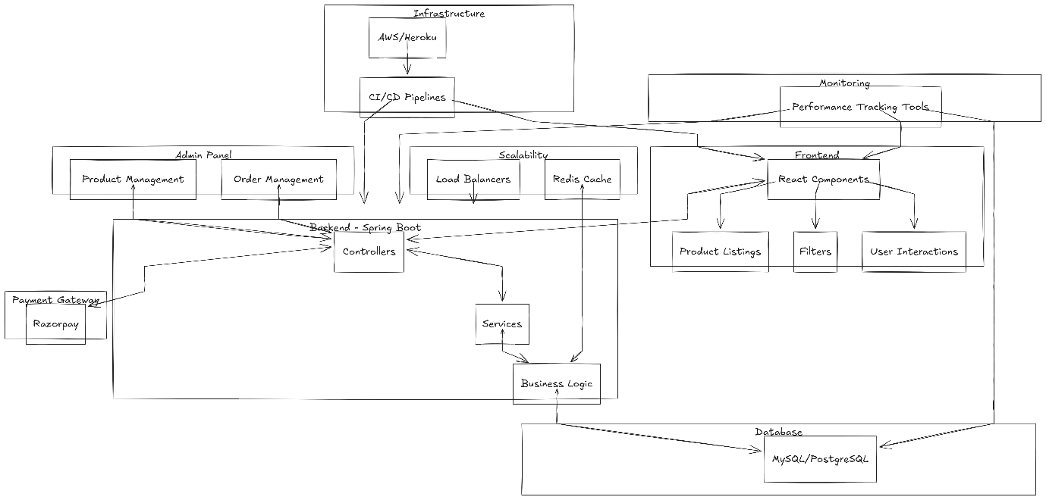

*Fig 1: System Architecture*

The architecture for the full stack e-commerce website using React, Spring Boot, and Razor Pay can be outlined as follows:

1. **Frontend (React):**
   * The frontend layer encompasses the user interface components responsible for presenting the website to the users. This includes product listings, filtering and sorting options, user authentication, cart management, and the checkout process. The frontend will interact with the backend services to fetch and update data using RESTful APIs.
2. **Backend (Spring Boot):**
   * The backend layer consists of the server-side application logic built using Spring Boot. It includes controllers to handle requests for product management, user authentication, order processing, and administrative functionalities. The backend will communicate with the database to fetch and store data, and with the frontend for seamless user interactions.
3. **Database (MySQL/PostgreSQL):**
   * The database stores various data entities such as product information, user details, order records, and payment transactions. It plays a crucial role in persisting and retrieving data for the e-commerce platform.
4. **Payment Gateway Integration (Razor Pay):**
   * Razor Pay is integrated into the system to facilitate secure and seamless payment processing for customers during checkout. It handles payment transactions and enables communication between the e-commerce platform and financial institutions.
5. **Admin Panel:**
   * The admin panel provides a dashboard for administrators to manage orders, products, and user interactions. It includes functionalities for monitoring payment transactions, updating order statuses, and modifying product listings. Role-based access control ensures that only authorized personnel can access and perform administrative tasks.
6. **Infrastructure:**
   * The infrastructure layer involves deploying the frontend and backend applications on cloud platforms such as AWS or Heroku to ensure scalability and reliability. Continuous integration and continuous deployment (CI/CD) pipelines are implemented for automated testing and deployment of code changes.
7. **Monitoring and Logging:**
   * Monitoring tools are employed to track system metrics and ensure optimal performance. Additionally, logging mechanisms are utilized to record application activities, debug issues, and troubleshoot any issues that may arise.
8. **Scalability and Performance:**
   * To enhance performance and scalability, caching mechanisms using tools like Redis are implemented for efficient data retrieval, and load balancers are utilized to distribute incoming traffic across multiple instances.
9. **Documentation and Collaboration:**
   * API documentation tools like Swagger are utilized to provide clear communication and easier integration with frontend components. Version control systems such as Git facilitate collaborative development and tracking of code changes.

This architecture outlines the key components and their interactions in developing a robust full stack e-commerce website that incorporates frontend, backend, payment processing, administrative functionalities, infrastructure, and tools for scalability and performance optimization.

**5. RESULT AND ANALYSIS**

The e-commerce platform developed met all project objectives, providing a seamless shopping experience for users. Performance analysis showed that the website handled real-time data filtering and sorting efficiently, and payment integration with Razor Pay ensured secure and reliable transactions. User feedback indicated high satisfaction with the product card styling and ease of navigation. The admin panel allowed for efficient order and product management, reducing backend workload.

**Challenges Encountered**:

* **Integration of payment gateway**: Ensuring the secure handling of payment success and failure responses.
* **Order tracking system**: Real-time updates on order status were challenging but were successfully implemented using Spring Boot’s robust data-handling capabilities.

**6. CONCLUSION**

This project successfully developed a full-stack e-commerce platform using **React**, **Spring Boot**, and **Razor Pay**. The website meets the needs of modern e-commerce platforms by providing features like filtering, sorting, payment integration, and admin management. The results demonstrate the scalability and efficiency of the technologies used. Future enhancements could include the integration of additional payment gateways, improving security protocols, and expanding the admin functionalities to include more analytics tools.

**REFERENCES**

[1] Jones, S., & Smith, L. (2021). "A comprehensive review of modern web development technologies for E-commerce applications." International Journal of Web Engineering and Technology, 17(3), 213-230.

[2]Sharma, R., & Verma, A. (2020). "Integration of payment gateways in E-commerce websites: A comparative study." Journal of Information Systems and E-commerce Studies, 8(2), 124-139.

[3]Patel, N., & Gupta, M. (2019). "Role of frontend frameworks in modern E-commerce website development." International Journal of Advanced Computer Science and Applications, 10(5), 310-325.

[4]Brown, K., & White, J. (2018). "Security considerations in Full Stack E-commerce website development." Journal of Cybersecurity and E-commerce, 6(4), 287-302.

[5]Lee, C., et al. (2017). "Performance analysis of React and Spring Boot in E-commerce web applications." Proceedings of the International Conference on Web Engineering, 127-135.