**IMPACT OF QUALITY ON MEDICAL TOURISM IN INDIA**

**\*Dr. T. Sreenivas, **Mr. N. Suresh Babu**

**ABSTRACT**

India's healthcare industry is now one of the biggest in terms of jobs and income. Hospitals, medical equipment, clinical trials, outsourcing, telemedicine, medical travel, health insurance, and medical devices are all included in the category of healthcare. The robust coverage, services, and rising spending by both public and private entities are driving the rapid growth of the Indian healthcare sector. Medical tourism is a subset of healthcare tourism in which patients go outside of their home nation to receive treatment or rehabilitation from medical facilities. While the terms medical tourism and healthcare tourism are sometimes used synonymously, healthcare tourism is a broader concept that includes, in addition to medical tourism, thermal health tourism, spa-wellness tourism, and tourism for the elderly and disabled. The present paper tries to project the Medical tourism structure, a snapshot of Indian Healthcare, Quality Health Services, reasons for increasing Medical tourism etc.

*Key Words: Medical Tourism, Health Services, Quality, Health Tourism & Tourists, Medical Value Travel (MVT), Perceived risk*

**Introduction**

Medical tourism, sometimes known as "medical travel" or "health tourism," is a quickly developing example of the worldwide commercialization of healthcare. The phrase refers to receiving medical care outside of one's home country for less money, to avoid having to wait a long period, or to get services that are unavailable there. In order to help international patients adjust to a new cultural setting and keep them occupied before and after surgery, this type of treatment is becoming more and more associated with travel-related activities. (Hopkins *etal, 2010*).

**\* Prof. T. SREENIVAS,** Professor, Department of Business Management, Yogi Vemana University, Kadapa – 516005, Andhra Pradesh,Email: [tallurus@gmail.com](mailto:tallurus@gmail.com)

**\*\* Mr.** **N.SURESH BABU**, Research Scholar (Part – Time), Department of Commerce and Business Administration, Acharya Nagarjuna University, Guntur – 522510, Andhra Pradesh, Email: [nsb.mgc@gmail.com](mailto:nsb.mgc@gmail.com)

Medical tourism is defined as organized travel beyond national borders to enhance and restore the tourists’ health (Kwan & Tavitiyaman, 2021). Travelling abroad for medical treatment has grown phenomenally in the twenty first century and is one of the healthcare has become one of India’s largest sectors, both in terms of revenue and employment. Healthcare comprises hospitals, medical devices, clinical trials, outsourcing, telemedicine, medical tourism, health insurance and medical equipment. The Indian healthcare sector is growing at a brisk pace due to its strengthening coverage, services, and increasing expenditure by public as well private player’s fastest growing exports of trade in healthcare services by the private corporate hospitals (Medhekar, 2014).

Medical tourism is a subset of healthcare tourism in which patients go outside of their home nation to receive treatment or rehabilitation from medical facilities. While the terms medical tourism and healthcare tourism are sometimes used synonymously, healthcare tourism is a broader concept that includes, in addition to medical tourism, thermal health tourism, spa-wellness tourism, and tourism for the elderly and disabled. Cardiovascular surgery, radiation therapy, organ transplantation, infertility and IVF procedures, cosmetic and plastic surgery, dialysis, dentistry, and ocular care are a few examples of medical tourism treatments. Patients who wish to combine treatment with vacation tend to favor medical tourism. (Usta & Asan, 2020).

Getting high-quality medical care at a fair price is the primary goal of medical tourists; to reduce costs, operational excellence and competitiveness must be prioritized within and externally. According to a prior study, Thailand, Singapore, and India account for 80% of the medical tourism business in Asia, making them the dominant players in the field. (Mishra & Sharma, 2021).

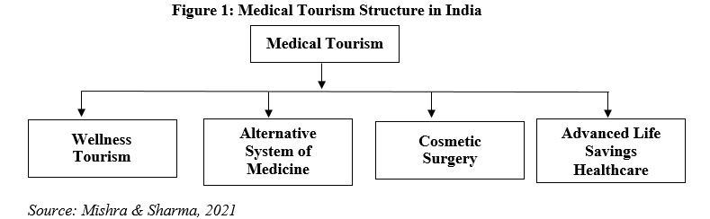

A variety of important parties with financial interests are involved in the developing worldwide market of medical tourism, including brokers, insurance companies, hospitals, media outlets, website providers, and insurance providers. These commercial interests are summarised in Figure 1. (Lunt, 2011).

**Indian Healthcare System**

Healthcare has become one of India’s largest sectors, both in terms of revenue and employment. Healthcare comprises hospitals, medical devices, clinical trials, outsourcing, telemedicine, medical tourism, health insurance and medical equipment. The Indian healthcare sector is growing at a brisk pace due to its strengthening coverage, services, and increasing expenditure by public as well private players.

India’s healthcare delivery system is categorised into two major components - public and private. The government, i.e. public healthcare system, comprises limited secondary and tertiary care institutions in key cities and focuses on providing basic healthcare facilities in the form of primary healthcare centres (PHCs) in rural areas. The private sector provides majority of secondary, tertiary, and quaternary care institutions with major concentration in metros, tier-I and tier-II cities (IBEF, 2022).

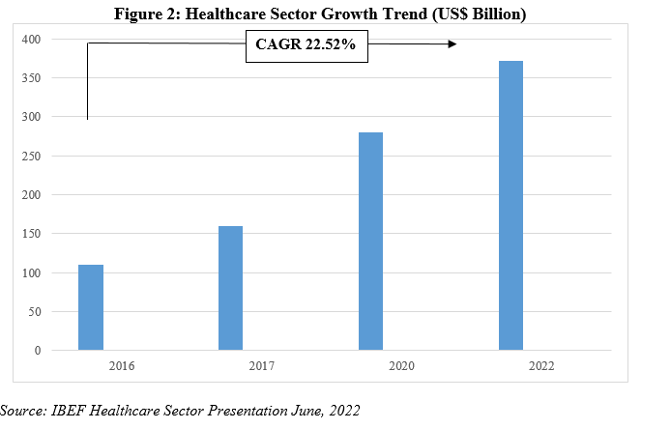

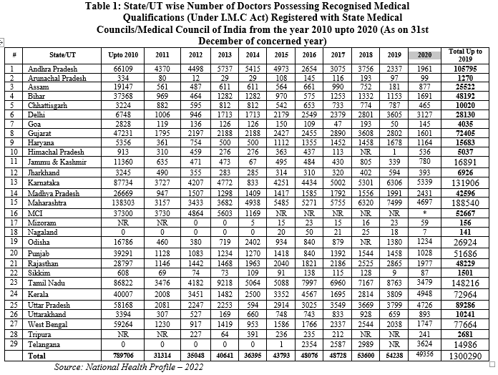

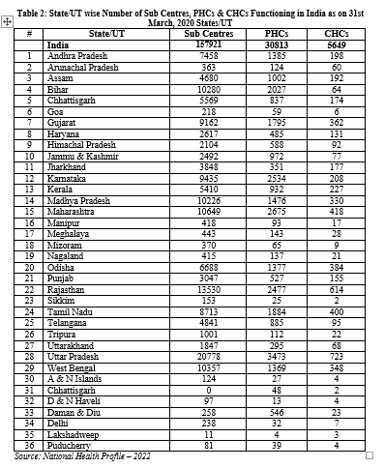

The following table depicts the some of the key programmes launched from 2014 to 2023.

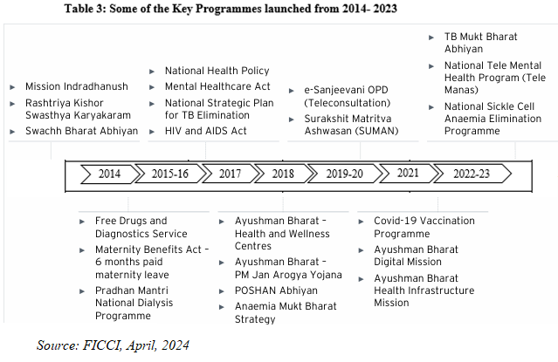

**The Meaning of Quality in Health**

The quality of healthcare is one of the most frequently mentioned concepts in health policy principles and is currently high on the agenda of policy makers at national, and international level. At the national level, addressing the issue of the quality of healthcare can be raised for several reasons, characteristically by the general commitment to provide high quality healthcare, because health is a public good

A new conceptual framework for high quality health systems with three key domains: foundations, processes of care, and quality impacts (figure 3). This framework stems from our definition of high-quality health systems and is informed by past frameworks in the fields of health systems and quality improvement, including Donabedian’s framework, WHO’s building blocksand maternal quality of care frameworks, Judith Bruce’s family planning quality framework, Getting Health Reform Right, the Juran trilogy, and the Deming quality cycle (Kruk & *etal, 2018* ).

Health services are that part of the health system, which focuses specifically on the provision of health care services in the society. A health system includes a complex set of structural relationships between populations and institutions that have an impact on health (Lambrini Kourkouta, 2021).

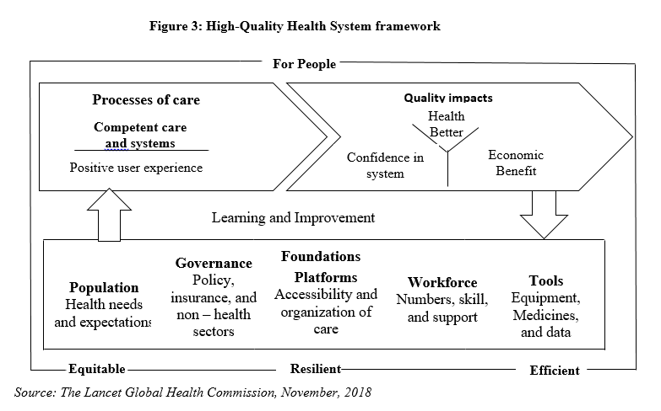

**Six Pillars of High-Quality Care**

One of the most widely accepted classifications of health care quality was developed by the US National Academy of Medicine. It defines six pillars of high-quality care: safety, effectiveness, patient-centeredness, timeliness, efficiency, and equity. Despite this apparent consensus, in practice these domains are considered unevenly. Many quality assessment programs only focus on effectiveness and safety, a few include timeliness and patient centeredness, and still fewer address the efficiency and equity of care (Annegret F. Hannawa & *etal, 2022)*.

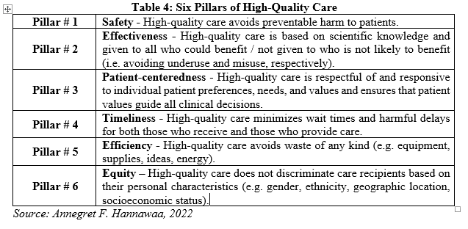

The following table depicts the Price comparison of medical producers.

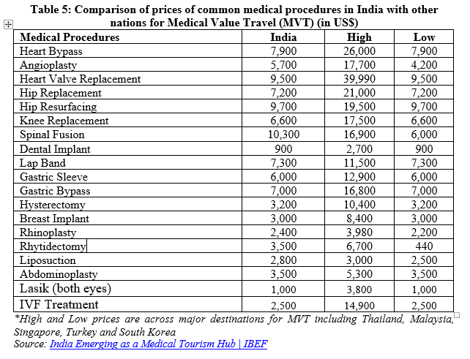

In a recent Hastings Center Report, Cohen suggested separating medical tourism into three types:

* Services that are illegal in both the patient's home country and the destination country, such as organ sales.
* Services that are illegal in the patient's home country but legal in the destination country, such as some stem cell therapies.
* Services that are legal in both the patient's home country and the destination country, such as joint replacement (Lee & Taggart, 2013).

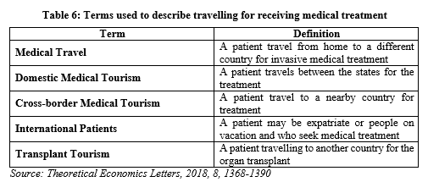

India has positioned itself as a medical centre. India's private hospitals have skilled doctors, nurses, and cooperative staff who attract medical tourists from all over the world. All of these factors are likely to increase the number of medical visitors to India (Patil, 2021).

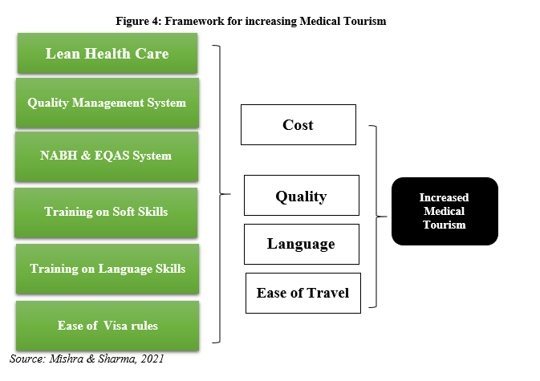

Figure 4 summarizes the framework using enablers and factors to increase the medical tourism in the region. It can be seen that ease of Travel and Language are environmental factors and external to the control of business whereas Cost and Quality are within the control of the business. Cost and Quality are interlinked and emphasis on quality can reduce the cost of operations thereby achieving operational excellence (Mishra & Sharma, 2021).

Different types of demands in medical tourism market and different laws applied in different countries create an environment of too many information, fear and uncertainty especially in relation to the aftermath, which is reasonable to expect to happen in some of the situations. Thus, the reasons why patients make the decision to use medical tourism is very important, especially for studying the possible implications related to (Alexandra Nola and Zdeslav Radovčić , 2021).

Nevertheless, medical tourism is part of a broader term, known as health tourism, which was defined by Carrera and Bridges as “the organized travel outside one’s local environment or restoration of an individual’s well-being in mind and body”. Thus, apart from the medical treatment, health tourism includes prevention, relaxation or convalescence, as well as wellness and spa industry (Klimova & Kusa , 2020) .

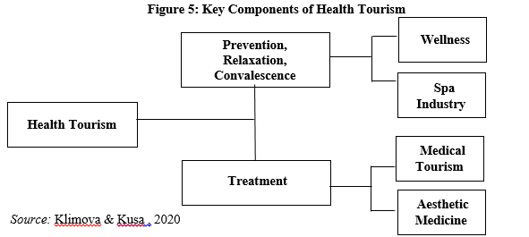

**Medical Value Travel in India**

India has been successful in establishing a reputation as a top location for top-notch clinical care for both critical and non-critical illnesses over the years. From 2020 to 2027, Medical Value Travel in India is projected to expand at a compound annual growth rate of 21.1% (EY, 2023).

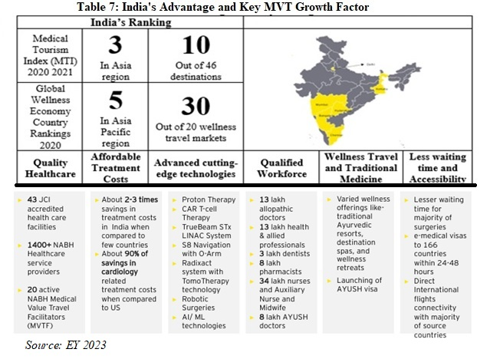

**Inbound MVT- Indian Market**

Below is a percentage distribution of foreign tourists' arrivals (FTAs) to India in 2021 for medical purposes from the top source countries.

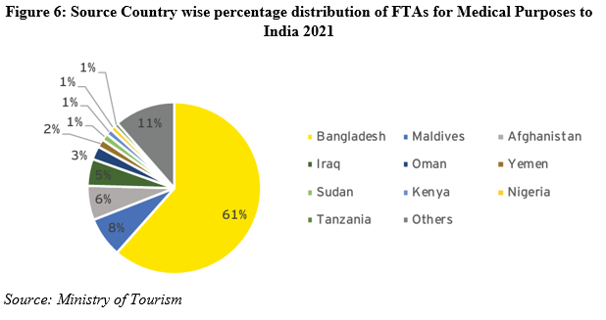

**Perceived Risk Dimension in the Medical Tourism Context**

According to the World Tourism Organization, every country should conduct a risk-benefit analysis and decide on its priorities. The WHO also believes that essential emergency travel and humanitarian assistance should be prioritized in this regard. Cargo transportation should also be a priority to provide essential medical resources. As for passengers, elderly patients and those with chronic or underlying diseases should be prioritized (Mosazadeh & etal. 2022).

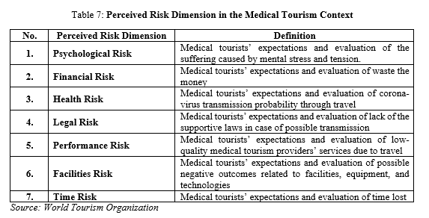

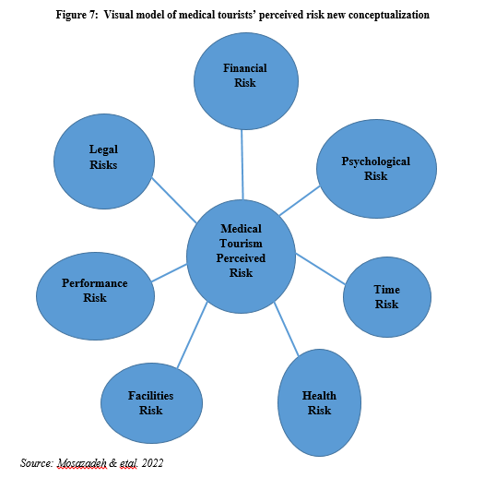

**Conclusion**

Quality of health care at the system level requires a focus on governance issues, including improving public-sector management, building institutional capacity, and promoting a culture of data-driven policies. Setting performance standards and expectations is another essential element to improving patient safety. From a sociotechnical point of view a quality system is an association, a network of humans and artefacts, formed with a view to some good purpose, e.g. improving the quality of medical practice by internal reflexivity of medical professionals in health care organisations and (a valid) external accountability to patients or society.

**References**

1. Anitha Medhekar,Public-Private Partnerships for Inclusive Development: Role of Private Corporate Sector in Provision of Healthcare Services, *Procedia - Social and Behavioral Sciences* 157 ( 2014 ) 33 – 44.
2. Annegret F. Hannawaa, Albert W. Wub , Anastasia Kolyadaa , Anastasia Potemkinaa , Liam J. Donaldsonc, The aspects of healthcare quality that are important to health professionals and patients: A qualitative study, *Patient Education and Counseling, 105 (2022) 1561–1570*
3. Blanka Klímová , Kamil Kuča , Medical Tourism: Its Research and Implications for Public Health, *Central European Journal of Public Health* 2020; 28 (3): 226–229.
4. Busse R, Panteli D, Quentin W. An introduction to healthcare quality: defining and explaining its role in health systems. Improving healthcare quality in Europe, 2019.
5. C.Virginia Lee, Linda R. Taggart, Medical Tourism, *Travel Medicine,* Third Edition, 2013.
6. Gouher Ahmed, Nabeel Al Amiri, Wajahat Khan, Outward Medical Tourism: A Case of UAE, *Theoretical Economics Letters*, 2018, 8, 1368-1390.
7. Hasan Mosazadeh, , Farshad Faezi Razi, Masoud Lajevardi, Hossein Mousazadeh, Amir Ghorbani, Farahnaz Akbarzadeh Almani and Faranak Shiran, Restarting Medical Tourism in the COVID-19 Pandemic: A Strategic-based Approach, Journal of Health Reports and Technology**,** 2022 April; 8(2)
8. *Ibid*
9. Indian Brand Equity Foundation (IBEF), 2022
10. Indrajit Hazarika, Medical tourism: its potential impact on the health workforce and health systems in India, *Oxford Health Policy and Planning* 2010;25:248–25
11. Iskra Alexandra Nola1 and Zdeslav Radovčić, Impacts of Medical Tourism on Healthcare Access, *Healthcare Access, 2021 .*
12. Laura Hopkinsa , Ronald Labonte, Vivien Runnelsb , and Corinne Packerb, Medical tourism today: What is the state of existing knowledge, *Journal of Public Health Policy* Vol. 31, 2, 185–198
13. Margaret E Kruk, Anna D Gage, Catherine Arsenault, Keely Jordan, Hannah H Leslie, Sanam Roder-DeWan, Olusoji Adeyi, Pierre Barker, Bernadette Daelmans, Svetlana V Doubova, Mike English, Ezequiel García-Elorrio, Frederico Guanais, Oye Gureje, Lisa R Hirschhorn, Lixin Jiang, Edward Kelley, Ephrem Tekle Lemango, Jerker Liljestrand, Address Malata, Tanya Marchant, Malebona Precious Matsoso, John G Meara, Manoj Mohanan, Youssoupha Ndiaye, Ole F Norheim, K Srinath Reddy, Alexander K Rowe, Joshua A Salomon, Gagan Thapa, Nana A Y Twum-Danso, Muhammad Pate, High-quality health systems in the Sustainable Development Goals era: time for a revolution, *The Lancet Global Health Commission on High Quality Health System in the SDG Era,* Vol 6 November 2018
14. Medical Tourism: Incoming and Outgoing, *the American Journal of Medicine,* Vol. 132, No 1, January 2019.
15. Neil Lunt, Richard Smith, Mark Exworthy, Stephen T. Green, Daniel Horsfall and Russell Mannion, Medical Tourism: Treatments, Markets and Health System Implications: A scoping review, 2011.
16. Sahil Patil, India – A Pivotal Centre for Medical Tourism, *Palarch’s Journal of Archaeology of Egypt/Egyptology,* 18(8) (2021).
17. Saliha Karadayi-Usta , Seyda SerdarAsan, A Conceptual Model of Medical Tourism Service Supply Chain, *Journal of Industrial Engineering and Management,* 2020 – 13(2): 246-265.
18. Siu Ching Kwan, Pimtong Tavitiyaman, Benefits and Limitations of Medical Tourism Development in Hong Kong: Local Residents’ Perspective, *Asia-Pacific Journal of Health Management,* 2021; 16(4):i1319
19. Vinaytosh Mishra, Mohita G. Sharma, Framework for Promotion of Medical Tourism: A Case of India, *International Journal of Global Business and Competitiveness* (2021) 16 (Suppl 1):103–S111.
20. Lambrini Kourkouta, Christos Iliadis, Christos Sialakis, Theodoula Adamakidou, Petros Ouzounakis and Christos Kleisiaris, Quality of Health Services*, World Journal of Advanced Research and Reviews*, 2021, 12(01), 498–502