**A REVIEW ON EXPLORING NANOCOSMECEUTICALS : INNOVATION IN NANOTECHNOLOGY**

**\*MISS:- TEJAL S. PAWAR**

**RESEARCH SCHOLAR:-B.PHARMACY**

**ASHVIN COLLEGE OF PHARMACY,MACHI HILL,ASHVI BK**

**E-MAIL ID:-** **tejal732004@gmail.com**

**CONTACT NO:- 8767070780**

**\*MISS :- SONIYA M.SHINDE**

**RESEARCH SCHOLAR:- B. PHARMACY**

**ASHVIN COLLEGE OF PHARMACY, MACHI HILL, ASHVI BK**

**E-MAIL ID:-** **Soniyashinde2408@gmail.com**

**CONTACT NO :-7058146415**

**\*MISS:- SUKANYA P. BHOKNAL**

**RESEARCH SCHOLAR:- B. PHARMACY**

**ASHVIN COLLEGE OF PHARMACY,MANCHI HILL, ASHVI BK**

**E-MAIL ID:-** **sukanyabhoknal1221@gmail.com**

**CONTACT NO:- 9404792819**

**ABSTRACT**

Cosmetics represent one of the most profitable consumer products, appealing to all age groups, from baby lotions to anti-aging creams. Products containing therapeutically beneficial active ingredients formulated with nanotechnology are known as nanocosmeceuticals, which are gaining popularity in the cosmetics sector. However, despite their high demand, nanocosmeceuticals face significant challenges related to safety—both short- and long-term—environmental concerns, and regulatory issues. The use of nanotechnology in cosmeceuticals is seeing significant success, particularly in treatments for hair damage, wrinkles, aging, and dry skin. However, there is a growing need for standardized regulations and guidelines to evaluate the efficacy, safety, and toxicity of nanotechnology-based products. This review provides an overview of the current advancements, applications, safety considerations, and regulations in nanocosmeceuticals. Cosmetic manufacturers use nanosized ingredients to enhance UV protection, improve skin penetration, boost color, control fragrance release, improve finish quality, provide anti-aging benefits, and offer various other features.

**INTRODUCTION**

In 1970s and 1980s L'Oréal scientists began using niosomes in cosmetics. Niosomes are used in shampoos, conditioners, anti-wrinkle treatments, and skin whitening creams*.[10]* The term "nanotechnology" derives from the Greek prefix "nano" in the International System of Units (SI). The origins of nanotechnology can be traced back to Erwin Schrödinger, a physicist awarded the Nobel Prize in 1933 for his work on atomic energy. The concept was later popularized in 1959 when Richard Feynman, a Nobel laureate, presented his influential lecture titled "There's Plenty of Room at the Bottom." In scientific terms, 1 nm equals 1 billionth of a meter. To put this into perspective, a single atom measures about 0.25 nm, while the diameter of a human hair is approximately 10,000 nm. Nanoscience includes both nanotechnology and nanomedicine, the latter focusing on using nanotechnology for disease prevention and treatment. Nanoparticles are seen as important to the technological advancements of the 21st century, with the potential to protect against and combat various ailments, thus enhancing overall health and immunity*.[1]*

Cosmeceuticals that use nanotechnology or nano-vehicles are referred to as nano-cosmeceuticals. These products contain active ingredients that can provide benefits where traditional medicinals may not be effective. Nano-cosmeceuticals represent the most innovative and pioneering category in topical treatments, serving as a dynamic platform for exploring botanical and natural ingredients. According to Davis Baird, "nanocosmetics" was the first segment of nanotechnology to be commercialized. Anti-aging products are the most common examples, utilizing nanoparticles that penetrate the skin to diminish the appearance of lines and wrinkles by interacting with the body. *[3]*

**CLASSIFICATION OF NANOCOSMESEUTICALS**

|  |  |  |  |  |  |  |  |  |  |  |  |  |  |  |  |  |  |  |  |  |  |  |  |  |  |  |  |  |  |  |  |  |  |  |  |  |
| --- | --- | --- | --- | --- | --- | --- | --- | --- | --- | --- | --- | --- | --- | --- | --- | --- | --- | --- | --- | --- | --- | --- | --- | --- | --- | --- | --- | --- | --- | --- | --- | --- | --- | --- | --- | --- |
| |  |  |  |  | | --- | --- | --- | --- | | Sr.no | Types | Marketed Products | Uses | | 1. | Liposome | Capture Totale  Dermosome | Antiwrinkle effect helps in removing blemish and darkspot | | 2. | Niosome | Niosome + | Whitening skin and increase facial look | | 3. | Solid lipid nanoparticles | Allure body cream | Moisturizing the skin and body | | 4. | Nanoemulsion | Vital nanoemulsions A-VC | Nourishing skin and miniaturization | | 5. | Gold nanoparticles | LR nano Gold and silk day cream | Protect and prevent skin cancer by preventing harmful radiation of sun | | 6. | Nanosphere | Nanosphere Plus | Potential anti aging agent | | 7. | Nanosuspension | Juvedical | First skin protective cosmetic, Helps to counter the signs of skin aging. | | 8. | Nanocrystals | Ceria | Limited scar | |

Table No. 1: Commercially available nanocosmeceutical formulations with their uses.*[5],[6]*

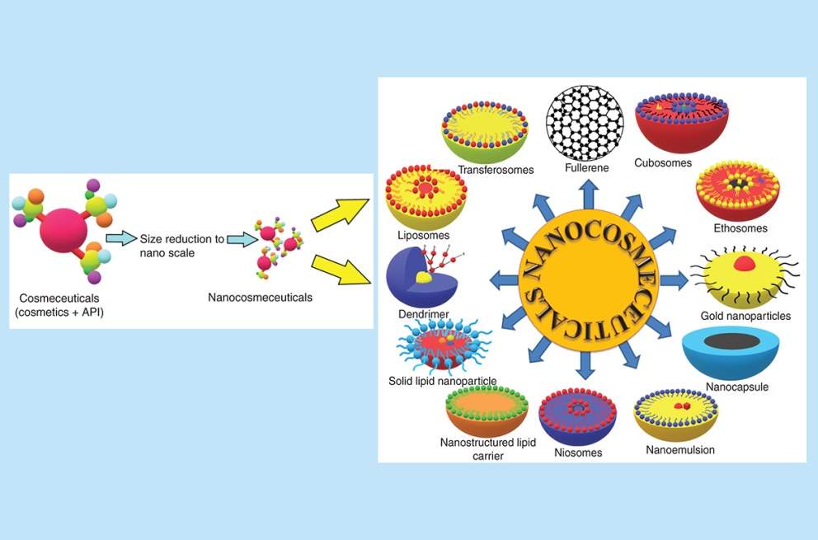Fig.1: Aspects of Nanocosmeceuticals *[12,14]*

**General Applications Of Nanocosmeceuticals** *[7]*

**Nanocosmeceuticals are used in a variety of products, including:**

1. Skin care: Nanocosmeceuticals are used to treat wrinkles, hyperpigmentation, photoaging, and other skin conditions.
2. Hair care: Nanocosmeceuticals are used to treat dandruff and hair damage.
3. Nail care: Nanocosmeceuticals are used in nail enamels.
4. Lip care: Nanocosmeceuticals are used in lip care products

**Nanocosmeceuticals have many benefits, including:**

1. Improved bioavailability: Nanotechnology can improve the bioavailability of active ingredients.
2. Prolonged effects: Nanotechnology can help active ingredients last longer.
3. Enhanced skin penetration: Nanocosmeceuticals can penetrate the skin more effectively.
4. Controlled release: Nanotechnology can help control and sustain the release of active ingredients.
5. Higher stability: Nanocosmeceuticals are more stable than traditional products.
6. Reduced dermatological hazards: Nanocosmeceuticals can help reduce some of the dermatological hazards associated with conventional cosmetics.

**Marketed examples of nanocosmeceuticals**

|  |  |  |  |  |  |
| --- | --- | --- | --- | --- | --- |
| Sr.no | **Product name** | **Origin** | **Manufacturer** | **Nanotechnology** | **Category** |
| 1. | Diorskin Extreme Fit | France | Cristian Dior | Nano-stretch networkTM | Foundation |
| 2. | Eye Tender | USA | Kara vita | Nanospheres | Eye-cream |
| 3. | Revitalift double lifting | USA | L’Oreal | Nanosomes | Anti-wrinkle cream |
| 4. | Nano in deep cleaning | China | Nano-infinity Nanotech Co.,Ltd | Nanomicelles | Lotions |
| 5. | Alusion Alumina powder | Australia | Adavanced Nanotechnology Ltd. | Nanoparticles | Powders |
| 6. | Pureology Nanowax | USA | Pureology | Nanoparticles | Hair polish |
| 7. | Nano gold 24hrs cream | Deutschland | Joyona International marketing Ltd. | Nanoparticls | Cream |

Table No: 1.2 Widely used marketed examples of Nanocosmeceuticals *[9,13]*

**CURRENT TRENDS IN COSMCEUTICALS**

The cosmeceutical industry is experiencing rapid growth, with expectations of double-digit increases over the next three years. While demand is rising, competition is also intensifying due to the entry of mass-market chains and alternative treatments. In addition to major manufacturers, physician-branded products are gaining a notable share of the market. Although cosmeceuticals can complement standard dermatological treatments, it's essential for dermatologists to be consulted before use. These products are not regulated by the FDA, and the FTC only oversees advertising claims. Therefore, dermatologists should become familiar with the available options and thoroughly evaluate their quality before recommending them to patients*.[8]* The development of this system addresses challenges faced by traditional cosmeceuticals, such as low retention of active ingredients on the skin, limited absorption, poor dispersion of insoluble components, and instability of effective ingredients. The goal is to create cosmeceuticals that effectively tackle these issues. This review highlights various nanocarriers currently used in cosmeceuticals and their applications in skin care, hair care, oral care, and beyond. The role of nanotechnology in research and development is increasingly significant, as it provides solutions to the limitations of conventional technologies and formulations, making a substantial impact on the cosmetic industry. Today, consumers seek cosmetics primarily for enhanced appearance, necessitating effective solutions for issues like wrinkles, aging, hair loss, and dandruff. Nanocarriers improve the efficacy of cosmeceutical products, offering longer-lasting effects while also enhancing their aesthetic appeal. This dual advantage not only boosts product quality and effectiveness but also enhances consumer satisfaction. Furthermore, nanocarriers offer protection against UV rays, adding to the overall benefits of cosmeceutical products.*[10]* The importance of this emerging field of research and development relies on the fact that nanoparticles exhibit unique characteristics for protecting and repairing the skin.*[15]*

**

Fig.2 :Cosmeceuticals Market growth analysis *[11]*

**CONCLUSION**

Nano cosmeceuticals represent the next generation of personal care materials, utilizing nanostructures to offer innovative beauty solutions with enhanced properties in application, aesthetics, performance, and overall consumer acceptance. Skincare products dominate this sector, making up 36.45% of the global market, driven by significant technical and economic potential. The use of nanotechnology in cosmetics is growing rapidly, yet only a few adverse effects have been reported with these nanocosmeceuticals. Therefore, it is essential to assess the safety and effectiveness of these products before they are marketed. Various countries have established different guidelines to regulate such products, which should be harmonized. Given the future growth and market potential of nanocosmeceuticals, increased attention and awareness are necessary.

**REFERENCE :**

1. Sirisha mittapally, Amtul Aziz Afnan. A Review on Nanotechnology in Cosmetics. The Pharma Innovation Journal. 2019 8 (4);668-671
2. Indu P. Kaur* and Rumjhum Agrawal. Nanotechnology: A New Paradigm in Cosmeceuticals. Recent Patents on Drug Delivery & Formulation 2007, 1, 171-182
3. Silpa Raj, Shoma Jose, U. S. Sumod, and M. Sabitha. Nanotechnology in cosmetics: Opportunities and challenges.J Pharm Bioallied Sci. 2012 Jul-Sep; 4(3): 186–193
4. Vividha Dhapte-Pawar, Shivajirao Kadam.Nanocosmeceuticals: facets and aspects.Future Sci. OA (2020) FSO613.
5. https://juvena.com/en/optimizing-day-cream-2
6. https://www.sciencedirect.com/topics/pharmacology-toxicology-and-pharmaceutical-science/nanocrystal
7. Shreya Kaul, Neha Gulati. Role of Nanotechnology in Cosmeceuticals: A Review of Recent Advances

J Pharm (Cairo). 2018; 2018: 3420204

1. Fredric S. Brandt, Alex Cazzaniga. Cosmeceuticals: Current Trends and Market Analysis.

Semin Cutan Med Surg 30:141-143

1. https://www.researchgate.net/figure/Commercial-cosmetic-formulation-containing-nanomaterials_tbl1_278162173
2. Mitali Sethi , Rafquat Rana. Nanocosmeceuticals: Trends and Recent Advancements in Self Care. AAPS PharmSciTech. 2024 Feb 29;25(3):51.
3. https://images.app.goo.gl/QbjMsAKCnw4oGEg3A
4. Vividha Dhapte-Pawar, Shivajirao Kadam. Nanocosmeceuticals: facets and aspects. Future Sci. OA (2020) FSO613
5. https://www.researchgate.net/figure/Different-nanomaterials-used-for-preparing-cosmetics-and-cosmeceuticals_tbl1_359151917
6. Mortensen LJ, Oberdorster G, Pentland AP, Delouise LA. ¨ In vivo skin penetration of quantum dot nanoparticles in the murine model:The effect of UVR. Nano Lett. 8, 2779–2787 (2008).
7. Jean Corner, Cornelia M Keck, Nanocosmetics: from ideas to products, Springer, 2019