*Review Paper*

*September 15, 2024*

Optimization of NOx Reduction Using Combination of SCR & EGR in Diesel Engine’s Exhaust System

# Darsh Patela

*aUniversity of Windsor, Researching under Prof. Ming Zheng in Clean Engine Domain*

# Abstract

The reduction of nitrogen oxides (NOx) emissions remains a critical challenge in mod- ern diesel engines, particularly in the context of increasingly stringent environmental reg- ulations. This review paper provides an in-depth examination of two prominent NOx reduction techniques: Selective Catalytic Reduction (SCR) and Exhaust Gas Recircula- tion (EGR). Both technologies are analyzed in terms of their working principles, advan- tages, and limitations. The study begins by addressing the necessity of NOx reduction in diesel engines, emphasizing the role of aftertreatment systems such as Diesel Particulate Filters (DPF), Diesel Oxidation Catalysts (DOC), and Ammonia Slip Catalyst (ASC). Subsequently, the paper presents a detailed review of an experimental investigation that evaluates the individual and combined effects of SCR and EGR systems, along with DPF and DOC, under varying EGR valve openings. The results highlight the optimal configu- ration for achieving the most effective NOx reduction. By combining these technologies, the study identifies potential pathways for improving emission control and meeting future regulatory requirements.

# *Keywords:* NOx Reduction, Diesel Engine, Selective Catalytic Reduction (SCR), Exhaust Gas Recirculation (EGR), Exhaust Aftertreatment System (ATS), SCR+EGR

1. **Introduction**

A diesel engine, similar to other internal com- bustion engines, transforms the chemical energy in fuel into mechanical power. Diesel fuel consists of hydrocarbons that, under ideal combustion condi- tions, would result solely in carbon dioxide (CO2) and water vapor (H2O) as byproducts. In real- ity, diesel exhaust gases primarily consist of CO2, H2O, and any remaining air from the engine’s in- take. The volumetric concentrations of these gases in diesel exhaust generally fall within certain typ- ical ranges. Common pollutants include unburned

Figure 1: Typical composition of diesel exhaust gases.

figure1.png

hydrocarbons (HC), carbon monoxide (CO), nitrogen oxides (NOx), and particulate mat- ter (PM). The total concentration of pollutants in diesel exhaust gases typically amounts to some tenths of one percent—this is schematically illustrated in Figure 1.

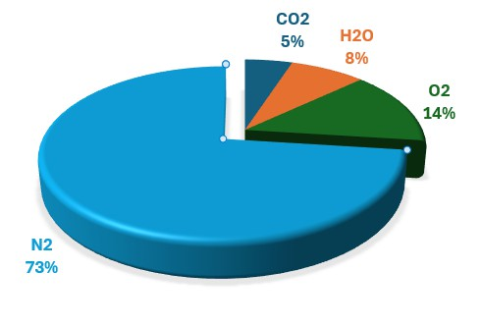

*Preprint submitted to Elsevier September 15, 2024*

# Why NOx Emissions should reduce?

figure1.png

Figure 2: Deaths from NOx Emissions.

Diesel NOx emissions con- tributed to 107,600 premature deaths globally in 2015, with 38,000 of these deaths linked to ”excess NOx emissions”—the dif- ference between emissions dur- ing real-world driving and those recorded in official lab tests. Around 80% of the deaths, both from total diesel NOx emissions and excess emissions, occurred in three major regions: the EU, China, and India shown in Figure

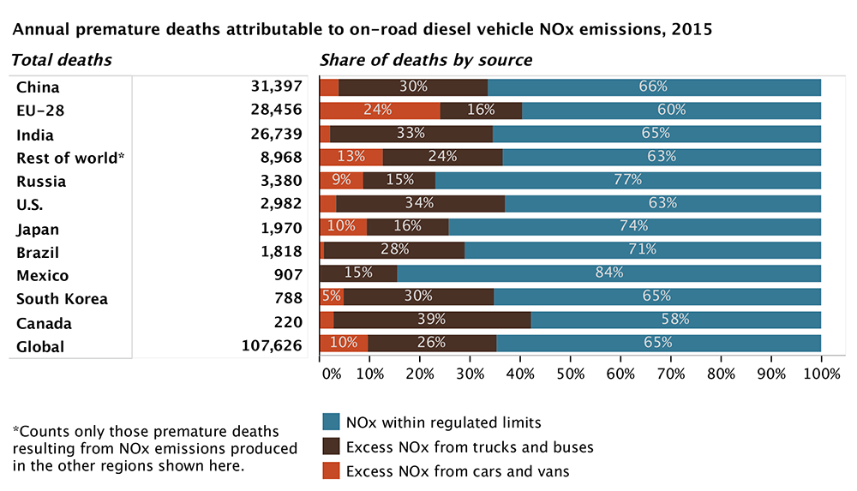2. [1]

Hence, to reduce the exhaust gas emissions, we need to do after treatment of those gases.

# What is an aftertreatment system?

An aftertreatment system is a method or device for reducing harmful exhaust emis- sions from internal-combustion engines. In other words, it is a device that cleans exhaust gases to ensure the engines meet emission regulations.

path/to/your/image.png

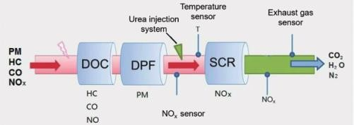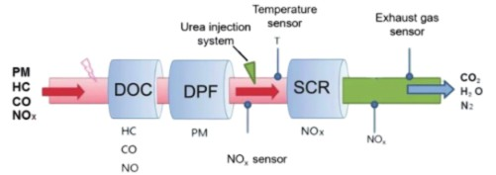

Figure 3: Schematic diagram of a typical aftertreatment system for current Diesel engines.

The typical aftertreatment system (ATS) comprises of Diesel Engine shown in fig 3: Diesel oxidation catalyst (DOC), Diesel particulate filter (DPF) and selective catalytic reduction (SCR) & Ammonia Slip Catalyst (ASC) [2]. The schematic diagram of a typical aftertreatment system for current Diesel engines is shown in Fig 3. The main function of DOC component is to convert CO to CO2 and convert hydrocarbons to H2O and CO2 [3]. The DPF component is used to capture the particulate matters while the SCR system is employed to reduce the NOx emissions [4] & An Ammonia Slip Catalyst (ASC) follows a smart catalyst design to mitigate the emission of slipped NH3 out of SCR. The catalyst combines the key NH3 oxidation function with an SCR function. [5]

# Discussing two majorly used technologies SCR & EGR for removing NOx.

SCR reduces NOx emissions by using a urea solution to convert NOx into nitrogen and water, while EGR lowers NOx by recirculating exhaust gases to reduce combustion temperatures. Both systems help meet emission regulations and improve air quality.

# Concept of Exhaust Gas Recirculation (EGR)

figure1.png

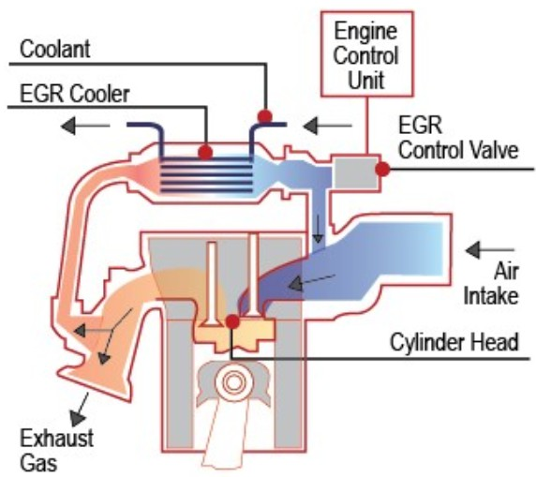Figure 4: Exhaust Gas Recirculation (EGR).

Exhaust Gas Recirculation (EGR) is an ”in combustion” emission control technique used to reduce nitrogen oxide (NOx) emissions by reintroducing a por- tion of exhaust gases into the in- take manifold [6], where it mixes with fresh air and participates in combustion inside the cylinder, as shown in Figure 4. This process lowers the combustion tempera- ture, thereby reducing NOx for- mation in fig 4. The EGR per- centage is defined as:

EGR [%] = Total Intake Air Flow Rate *×* 100 (1) Exhaust Gas Flow Rate Recirculated

A higher EGR percentage means more exhaust gases are recirculated, leading to lower combustion temperatures and reduced NOx emissions. However, excessive EGR can cause issues such as incomplete combustion and loss of engine performance. On the other hand, a lower EGR percentage recirculates less exhaust gas, resulting in higher combustion tem- peratures, which may increase NOx emissions but improve engine efficiency and power. The EGR valve controls the flow of recirculated exhaust gas, determining how much exhaust is reintroduced into the engine. The EGR cooler reduces the temperature of exhaust gases by transferring heat to the engine coolant. By limiting fresh oxygen in the combustion chamber, the system effectively lowers peak combustion temperatures, leading to reduced NOx emissions.

# Advantages:

* + - * EGR increases thermal efficiency during the engine warm-up phase, reducing cold- start emissions. It also stabilizes combustion, reducing engine knocking in certain operating conditions.
      * EGR is effective in low-load and lower-temperature conditions, where Selective Catalytic Reduction (SCR) may be less efficient, such as urban driving cycles.
      * EGR systems do not require a secondary injection system, reducing the need for refilling and lowering maintenance costs.

# Limitations:

* + - * Soot particle formation increases due to the introduction of exhaust gases, reducing engine life because of soot deposition.
      * High EGR rates necessitate the use of EGR coolers, which can add complexity and increase maintenance requirements.
      * EGR is more effective in low-power engine applications and is not recommended for heavy-duty engines due to its adverse effects on performance, fuel consumption, and oil contamination [7].

# Concept of Selective Catalytic Reaction (SCR)

path/to/your/image.png

Figure 5: Selective Catalytic Reactiion (SCR)

The Selective Catalytic Reduction (SCR) system is an advanced exhaust gas treat- ment technology designed to significantly reduce nitrogen oxides (NOx) emissions from diesel engines which takes place outside the engine. It operates by injecting a solution called AdBlue, which is a mixture of urea and deionized water, into the exhaust stream. This solution decomposes into ammonia (NH) and carbon dioxide (CO) when heated. The exhaust gases, now mixed with ammonia, pass through an SCR catalyst made from materials like titanium dioxide and vanadium oxides. Inside the catalyst, a chemical re- action occurs, where the ammonia reacts with NOx to convert it into harmless nitrogen

(N) and water (HO) as per fig 5. This process not only helps in reducing NOx emis- sions but also ensures compliance with stringent environmental regulations, improving air quality. Modern SCR systems are equipped with sensors that monitor NOx levels, AdBlue quantity, and catalyst performance to maintain optimal efficiency and regulatory compliance. [8]

# Advantages:

* + - * By allowing the engine to operate at optimal combustion conditions without com- promising performance, SCR systems contribute to improved fuel efficiency [9]; SCR systems maintain engine performance while reducing emissions
      * SCR technology is not harmful for engine life as it is not “in combustion”.
      * SCR is effective across a broad range of engine loads and temperatures, offering consistent NOx reduction.

# Limitations:

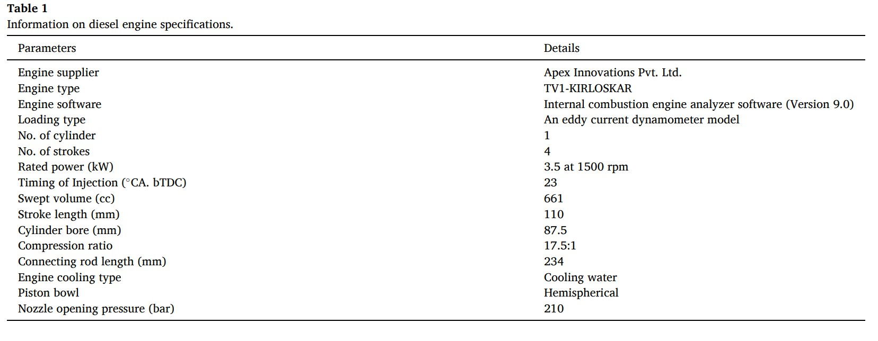

* + - * SCR systems require the injection of a urea-based solution (AdBlue/DEF), increas- ing operational complexity and costs; addition of components, such as the urea tank, dosing system, and catalyst, add to the vehicle’s weight and space requirements
      * High EGR rates necessitate the use of EGR coolers, which can add complexity and increase maintenance requirements.

# What happen when we combine them?

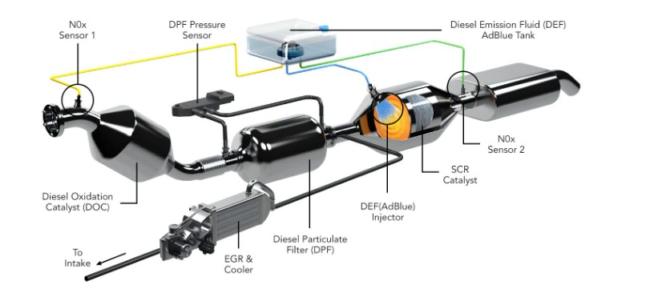

Figure 6: Exhaust Aftertreatment system.

As we know, both systems have their own pros & cons, but we can address these limitations by combining them. To understand it better an experimentation is carried out using different NOx reduction techniques (majorly SRC; EGR). It also found out the individual, combined optimum combination effects in NOx Reduction as shown in fig 6. [10]

path/to/your/image.png

# Experimentation Prerequisites

* 1. **Diesel engine setup:**

In this study, a computerized TV1-Kirloskar diesel engine with a 3.5 kW output and a constant speed of 1500 rpm was used. Engine details are shown in Table 1.

path/to/your/image.png

Figure 7: Table 1

# NOx Measuring Device:



In this study AVL Gas sensor is used to measure NOx emissions which is show in Table 2.

Figure 8: Table 2

path/to/your/image.png

# Testing conditions:

* This study monitors the NOx reduction done by SCR, EGR, and EGR + SCR at different valve openings of the EGR valve at 10%, 20%, and 30% of the exhaust gas to be circulated.
* Effect of DOC is neglected, and the effect of DPF is considered in all the combina- tions except using only EGR.
* Here Diesel base means the exhaust system has active DPF + SCR with EGR (0%); just EGR (%) means no effect of SCR is taken into consideration.
* The engine is connected to the battery. The water valves are opened to circulate water for cooling the engine.
* All the above steps are then repeated at 20%, 40%, 60%, 80%, and Full load condi- tions. Caution is taken to keep the engine speed running at a constant rate of 1500 RPM.
* The amount of fuel consumed in 1 minute will be used to carry out the required measurements.
* where *Q*wo EGR is the airflow rate without EGR, and it is equal to 26 kg/h.
* Just consider the highlighted combinations in the NOx vs Load chart in the graph.

# Results & Discussion:

Different comparisons are made in the graph (fig 9)to decide the best possible com- bination for optimum NOx Reduction. Study depicts the NOx variation for all tested systems as a function of the load on a compressed ignition engine. One of the most haz- ardous harmful exhaust pollutants from a diesel engine is NOx, which is sensitive to fuel quality, oxygen content, and combustion temperature. An increase in NOx was observed for the various systems as the load increased. Additionally, due to the buildup of carbon on the cylinder surface, burning chamber, and valve walls that serves as an insulator and raises the temperature in the engine cylinder, insufficient fuel ignition results in greater NOx outflow. In comparison to the other parameters, the NOx emission is highest at full load for 10% EGR. However, throughout all load operations, the application of EGR dramatically reduced NOx emissions. 30% EGR results in a greater reduction in NOx

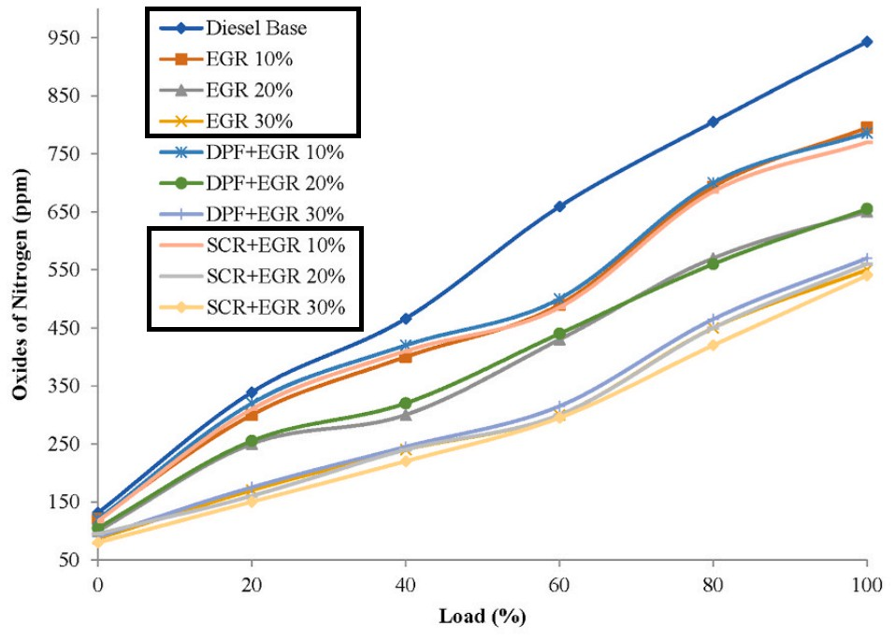emissions. The EGR or SCR alone is not so effective in reducing NOx compared to the other data. With the combination of SCR + EGR at different rates, the NOx levels are decreasing compared to all other parameters.

Figure 9: NOx Vs Load

path/to/your/image.png

# Conclusion:

While selective catalytic reduction (SCR) and exhaust gas recirculation (EGR) in- dividually offer benefits for NOx reduction, their combined application yields the most significant decrease in NOx emissions by converting it to nitrogen gas. However, this combination increases CO2 levels in the combustion chamber, which can lead to incom- plete combustion and elevated concentrations of unburned hydrocarbons (HC) and carbon monoxide (CO) in the exhaust. To balance these effects, maintaining an optimal EGR rate between 20% and 30% with SRC proves to be the most effective strategy for prior- itizing NOx reduction while minimizing adverse impacts on combustion efficiency. For further work, the combination of SCR+EGR (20-30%) may give appreciable results for controlling the Soot and NOx at a time.

# References

1. International Council on Clean Transportation (ICCT), ”New study quantifies global health, environmental impacts of excess nitrogen oxide emissions from diesel vehi- cles.” Available online: [Link](https://theicct.org/new-study-quantifies-global-health-environmental-impacts-of-excess-nitrogen-oxide-emissions-from-diesel-vehicles) .
2. Beale, A. M.; Gao, F.; Lezcano-Gonzalez, I.; et al. ”Recent advances in automotive catalysis for NOx emission control by small-pore microporous materials.” *Chem. Soc. Rev.*, 2015, 44(20), 7371–7405.
3. Wang, D.-Y.; Cao, J.-H.; Tan, P.-Q.; et al. ”Full course evolution characteristics of DPF active regeneration under different inlet HC concentrations.” *Fuel*, 2022, 310, 122452.
4. Han, F.; Yuan, M.; Chen, H. ”Selective catalytic reduction of NOx with methanol on H-ZSM-5: The effect of extraframework aluminum.” *Catal. Today*, 2020, 355, 443–449.
5. Birkhold, F.; Meingast, U.; Wassermann, P.; et al. ”Modeling and simulation of the injection of urea-water-solution for automotive SCR DeNOx-systems.” *Appl. Catal. B*, 2007, 70(1–4), 119–127.
6. Ji, C.-W. ”Experimental study of turbocharged diesel engine exhaust gas recircula- tion to reduce NOx.” *Journal of Ordnance Journal*, 2004 (3).
7. Hussain, J.; Palaniradja, K.; Alagumurthi, N.; Manimaran, R. ”Retracted: Effect of Exhaust Gas Recirculation (EGR) on Performance and Emission Characteristics of a Three Cylinder Direct Injection Compression Ignition Engine,” 2012.
8. Dietsche, K.-H.; Klingebiel, M. (editors), *Bosch Automotive Handbook*, 7th edition, 2007.
9. Zhu, Y.; Zhou, W.; Xia, C.; Hou, Q. ”Application and development of selective catalytic reduction technology for marine low-speed diesel engine: trade-off among high sulfur fuel, high thermal efficiency, and low pollution emission.” *Atmosphere*, 2022, 13(5), 731.
10. Wang, D.-Y.; et al. ”The impact of inlet HC concentration on DPF regeneration,”

*Fuel*, 2022. Available online: [Link](https://www.sciencedirect.com/science/article/pii/S2214157X22007948)