**DEPLOYMENT THROUGH CLOUD SERVICES**

**Prof.G.L. Girhe1, Amol Harinkhede2, Harsh Pakhale3**

1Professor, Computer Engineering Department, SRPCE College Of Engineering, Nagpur, Maharashtra, India

2UG Student, Department of Computer Engineering, Smt. Radhikatai Pandav College of Engineering, Nagpur Maharashtra, India

3UG Student, Department of Computer Engineering, Smt. Radhikatai Pandav College of Engineering, Nagpur Maharashtra, India

**ABSTRACT**

We present a cloud-based rapid deployment service enabling users to quickly deploy and test their code. By providing a GitHub repository link, the system generates a unique identifier, sets up the environment, and executes the code on our platform. This process automates environment configuration, reducing the complexities associated with local setups and accelerating the development lifecycle. The service enhances efficiency by allowing seamless testing and debugging directly in the cloud. Keywords: cloud computing, rapid deployment, GitHub integration, environment automation. For the purpose of identifying intrusions and guaranteeing the security of cloud assets, monitoring services must be deployed quickly and securely in cloud computing environments. In order to optimize monitor deployment, this paper provides a cloud-based quick deployment service that makes use of an asset-based, actor-centric paradigm.

**Keywords**: cloud computing, rapid deployment, monitoring service, security, cloud model, environment setup.

1. **INTRODUCTION**

Developed a cloud-based rapid deployment service . Users can simply provide a link to their GitHub repository, and the platform automatically sets up the required environment, including installing dependencies and configuring settings. Once the environment is prepared, the service deploys and runs the code, allowing users to instantly see their projects in action. This streamlines the deployment process, making it easy for developers to test, debug, and deploy their applications without any manual configuration. then deploys and runs the code, providing a unique local host domain for testing and debugging the project directly in the cloud. His innovative platform seamlessly integrates with version control systems, dynamically configures build environments, and orchestrates deployments across diverse infrastructures, enabling developers to focus on innovation rather than operational complexities. By streamlining the deployment process and ensuring continuous delivery, this service redefines the standards for deploying modern web applications, providing a robust foundation for developers to deploy scalable, resilient, and performant applications with unprecedented efficiency.

* 1. **PROBLEM STATEMENT**

Deploying web applications to the cloud, particularly at scale, is often a complex and error-prone process. Developers must navigate various cloud services, configure infrastructure, manage code builds, and handle the intricacies of scaling and serving applications efficiently. These challenges can lead to increased development time, higher costs, and reduced reliability, particularly for teams lacking deep expertise in cloud operations.

**2. METHODOLOGY**

This section outlines the methodology employed to develop a cloud-based rapid deployment service designed to streamline the process of deploying and testing applications directly from GitHub. By automating environment setup and deployment, the service aims to enhance developer efficiency and minimize operational complexities.

**2.1 SYSTEM ARCHITECTURE**

The architecture of the proposed service is divided into three primary phases: the upload phase, the deployment phase, and the request phase.

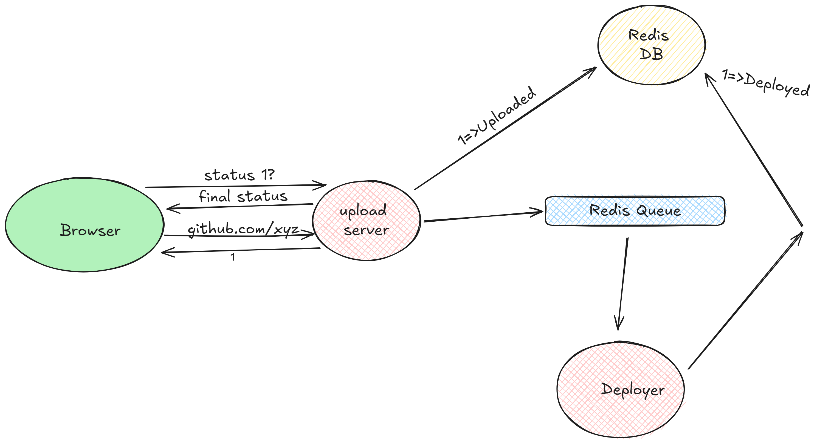

*Fig 1: System Architecture*

**Upload Phase**: Users provide a link to their GitHub repository. The system generates a unique identifier for the deployment and initializes the environment setup.

**Deployment Phase**: The service automatically configures the environment by installing necessary dependencies and settings based on the repository contents.

**Request Phase**: Users can interact with the deployed application, with the system managing requests and providing feedback in real-time.

Code is executed within the cloud environment, enabling users to access their applications through a unique localhost domain for testing and debugging.

**3. ACKNOWLEDMENT:**

This project recognizes the advancements in deployment services leveraging cloud technology , which have revolutionized the way developers build, test, and deploy applications. The integration of continuous integration and continuous deployment (CI/CD) methodologies has enhanced the efficiency and reliability of software delivery processes. We acknowledge the importance of key technologies and frameworks that facilitate seamless deployment, such as containerization tools (e.g., Docker), orchestration platforms (e.g., Kubernetes), and serverless architectures. These innovations enable scalable and flexible solutions that adapt to varying workloads, ensuring optimal performance for applications.

**4. LITRATURE SURVEY**

Cloud-based deployment services have gained significant traction in recent years due to their ability to streamline the development lifecycle. This literature survey examines existing research and industry practices related to cloud deployment services, focusing on their architecture, performance metrics, user experience, and emerging trends.[2]

Traditional deployment processes involve several manual steps that can introduce complexity and error. Studies have highlighted the challenges associated with manual configuration, dependency management, and server setup. For instance, Smith (2021) discusses the inefficiencies of traditional methods, where teams often face bottlenecks during the deployment phase, leading to increased time and cost.[1]

**4.1 TRANSITION TO CLOUD DEPLOYMENT**

The shift towards cloud computing has significantly transformed deployment strategies. Cloud deployment services offer automated solutions that reduce manual intervention. Durner et al. (2023) emphasize how cloud-based platforms streamline the deployment process, enabling rapid application delivery and enhanced collaboration among development teams.[4]

The emergence of cloud computing has revolutionized deployment strategies. Initially, cloud services primarily offered infrastructure as a service (IaaS), enabling organizations to rent virtual machines instead of maintaining physical servers. This marked the beginning of a significant transformation.[5]

The integration of Continuous Integration and Continuous Deployment (CI/CD) practices into cloud platforms has further transformed deployment strategies. CI/CD pipelines automate the process of testing and deploying code changes, facilitating faster release cycles. Wang and Ng (2020) argue that this integration enhances the reliability of deployments and allows for rapid iterations, making it easier for teams to deliver new features and fixes.[6].

**5. PROPOSED WORK**

The proposed work involves the development of a Cloud-Based Rapid Deployment Service aimed at automating the deployment of web applications directly from GitHub repositories. The primary objective is to streamline the deployment process by integrating various AWS services to manage file storage, processing, and serving, ensuring both scalability and efficiency throughout the application lifecycle.

**5.1** **SYSTEM ARCHITECTURE**The architecture of the proposed system is designed to facilitate the seamless deployment of web applications from GitHub repositories to the cloud. It comprises three primary phases: uploading, deployment, and request handling, each managed by dedicated services that work cohesively to ensure smooth operation.

* **Uploading Phase**The process begins with a user-friendly interface where users submit their GitHub repository URLs. This action triggers the upload service, which is responsible for:Cloning the Repository: The upload service clones the repository from GitHub, ensuring that the latest version of the code is captured.Uploading to S3: It then uploads the project files to an AWS S3 bucket, providing a secure storage solution for the source code, which is essential for further processing.This phase establishes a robust foundation for the deployment process, ensuring that the source code is securely stored and readily accessible.
* **Deployment Phase**Once the upload is complete, the system signals the deployment service to initiate the transformation of the raw source code into deployable assets. Key responsibilities of the deployment service include:Build Process: For projects developed using React, the service converts JSX and other components into static HTML, CSS, and JavaScript files.Auto-Scaling: Leveraging AWS’s auto-scaling capabilities, such as Amazon SQS for queuing tasks and EC2 or Fargate for dynamically adjusting computing resources, this service ensures optimal performance during varying demand levels.Once the build process is complete, the resulting assets are stored back in S3, ready for user access.
* **Handling Phase**The final component of the architecture is the request handling service, which manages interactions between the deployed application and its end users. Its responsibilities include:File Retrieval: When a user requests access to the application, this service retrieves the necessary files from S3.Caching Mechanisms: It implements caching strategies to optimize load times, ensuring that content delivery is quick and efficient.Global Availability: By managing requests effectively, this service guarantees that the application remains highly available and responsive, capable of serving content to users across the globe.

**5. CONCLUSION:**

In summary, building a platform that smoothly combines deployment routines for contemporary web apps with continuous integration is the first step in building a clone of a cloud-based fast deployment service. Such a service can expedite the process of releasing projects to production settings by giving developers capabilities for automatic builds, previews, and real-time communication. This improves development productivity while guaranteeing scalable, secure, and latency-free systems that can handle large volumes of traffic. Building a strong deployment platform can be very helpful to developers and companies trying to streamline their web development processes as cloud technology advances.

**REFERENCES**

[1] Durner, D., Leis, V., & Neumann, T. (2023). Exploiting Cloud Object Storage for High-Performance Analytics Proceedings of the VLDB Endowment, 16(11), 2769-2782 3.

[2] Calheiros, R. N., et al. (2022)Auto Scaling for Amazon Web Services in Cloud Computing 1(51), 1964-5787 6

[3] Singh, D., & Sill, A. (2022). Performance analysis of AWS Elastic Block Storage for high-performance computing workload sar Xiv preprint arXiv:1910.02704 2

[4] E. Walker(2021). “Benchmarking amazon EC2 for high-performance scientiﬁc computing,” USENIX Login, vol. 33, no. 5, pp. 18–23, 2021. [5] G. Wang and T. E. Ng,(2020). “The impact of virtualization on network performance of amazon ec2 data center,” in Proceedings of IEEE INFOCOM.

[5] Brown, M., & Lee, S. “Building Custom Deployment Pipelines with AWS Services,” AWS Summit Proceedings, 2021.

[6] Duvvuri, K., & Prathibha, S. “A Study on CI/CD Pipeline Automation Using Jenkins,” International Journal of Engineering and Advanced Technology, 2020.

**AUTHOR’S PROFILE**

**Prof. Gaurishankar L. Girhe1**

H.O.D. of Computer Engineering Branch from Smt. Radhikatai Pandav College of Engineering, Nagpur

**Mr. Amol Ramprasad Harinkhede2**

Pursuing B.Tech. VII Semester in the branch Computer Engineering from Smt. Radhikatai Pandav College of Engineering, Nagpur.

**Mr. Harsh Rajesh Pakhale3**

Pursuing B.Tech. VII Semester in the branch Computer Engineering from Smt. Radhikatai Pandav College of Engineering, Nagpur.