**“Smart Mirror Integrated with IoT”**

**Asst. Prof. P. B. Jaipurkar1, Ms. Rani R. Korde2, Ms. Sakshi M. Gongal3**

1Assistant Professor**,** Computer Engineering, SRPCE Nagpur, Maharashtra, India

2Student, Computer Engineering, SRPCE Nagpur, Maharashtra, India

3Student, Computer Engineering, SRPCE Nagpur, Maharashtra, India

**ABSTRACT**

Smart Mirror is a new addition to the smart home family that has been getting a lot of attention currently by both marketable manufacturers and academia. They describe how a raspberry Pi device can be used to enhance similar glasses with intelligence. The thing is to develop a cost-effective intelligent glass system that not only works as a regular glass, but also be suitable to display information, such as rainfall, time and location, current events, and also using voice commands for User convenience. Provide users with a personalized and interactive experience. By leveraging voice recognition technology, users can effortlessly control various features of the smart mirror, such as adjusting display settings, accessing relevant information, and interacting with connected IoT devices. This paper discusses Future IoT based on Smart Mirror which is useful in various fields of human life. Smart mirrors were developed using Arduino and Raspberry Pi for further development. In the future this technology will be useful to help humans do their jobs such as in health, sports, learning and so on. To interact with smart mirrors, users can use voice or face recognition.

**Keywords:** Raspberry Pi, Smart Mirror, Voice Recognition Technology, Home Automation, IoT

1. **INTRODUCTION**

In the realm of Internet of Things (IoT), innovative projects are transforming everyday objects into intelligent, interactive, and connected devices. Thissssss project, Smart Mirror Integration, embodies this vision by converting a conventional two-way mirror into a futuristic interface. This cutting-edge smart mirror seamlessly integrates a voice assistant, OpenCV applications, and IoT technology to create a unique user experience. The smart mirror's voice assistant enables users to access various services, such as weather updates, news, and calendar events, with mere voice commands. This feature ensures a hands-free and hassle-free experience, making it ideal for busy individuals. Moreover, the incorporation of OpenCV allows for advanced computer vision applications, including facial recognition, object detection, and augmented reality experiences. The IoT connectivity enables the smart mirror to sync with various devices and services, providing a unified and personalized experience. Users can control their smart home devices, access their social media feeds, and even monitor their health metrics, all through the smart mirror's intuitive interface. At its core, the smart mirror utilizes a two-way mirror, which allows a digital display to be hidden behind a reflective surface. This innovative setup ensures that the mirror maintains its traditional function while also serving as a display for various informational and interactive features. The integration of a voice assistant elevates the user experience by providing hands-free control over the mirror’s functions. Through voice commands, users can access real-time information such as weather updates, calendar events, and news, making the smart mirror a valuable tool for managing daily routines.

1. **LITRETURE SURVEY**
2. The integration of smart mirrors with IoT, voice assistants, and computer vision has garnered significant attention in recent years. Numerous studies and research papers have explored the potential applications and technical challenges associated with this emerging technology.
3. One area of focus has been the development of two-way mirror systems. Researchers have investigated various techniques to create transparent displays that can be integrated into mirrors, allowing for both reflective and digital functionalities. These include using transparent OLED displays, reflective LCD panels, and specialized optical coatings.
4. IoT integration has been a key aspect of smart mirror development. Studies have explored the use of different IoT platforms and protocols to connect mirrors to a wide range of devices and services. This includes smart home devices, wearable technology, and cloud-based applications. Researchers have also investigated the challenges of ensuring secure and reliable communication between the mirror and IoT components.
5. Voice assistants have played a crucial role in enhancing the user experience of smart mirrors. Studies have explored the integration of popular voice assistants like Amazon Alexa and Google Assistant into mirror systems. Researchers have focused on developing natural language interfaces that allow users to interact with the mirror using voice commands, making it more intuitive and accessible. Computer vision has been another area of interest in smart mirror research. Studies have explored the use of OpenCV and other computer vision libraries to enable tasks such as facial recognition, object detection, and gesture control. Researchers have investigated the challenges of real-time processing and accuracy in these applications, particularly in low-light conditions or with varying user profiles.
6. Several research papers have also explored the potential applications of smart mirrors in various domains. These include smart homes, retail, healthcare, education, and hospitality. Studies have highlighted the benefits of smart mirrors in providing personalized information, enhancing user experiences, and improving efficiency in these sectors.
7. **RELATED WORK**

The integration of IoT into smart mirrors has been a growing trend in recent years, driven by advancements in sensor technology, machine learning, and connectivity. A smart mirror typically incorporates a two-way mirror, which allows for the display of digital content while maintaining a reflective surface. The use of IoT enhances the mirror's functionality by enabling connectivity with other smart devices, allowing for real-time data exchange and remote control. Key related works include the development of smart mirrors that act as personal health monitors. These systems use embedded sensors and cameras to collect biometric data such as heart rate, body temperature, and facial recognition, which can be displayed on the mirror in real-time. OpenCV, an open-source computer vision library, plays a critical role in these applications by enabling facial recognition, gesture control, and emotion detection.

Research has also explored the use of augmented reality (AR) in smart mirrors, where virtual objects or information overlays can be projected onto the mirror’s surface. This opens up possibilities for virtual try-on applications, where users can see how different clothing items or accessories look on them without physically wearing them.

The development of these smart mirrors is closely linked to advancements in IoT, which provides the necessary infrastructure for seamless connectivity and data processing. However, challenges such as data privacy, security, and user acceptance remain critical issues that must be addressed as the technology continues to evolve. The convergence of IoT, AI, and AR in smart mirrors holds significant potential for transforming everyday experiences into more interactive and personalized encounters.

1. **PROPOSED WORK**

**1.Mirror Display and Surface:** At the core of the system is the two-way mirror, which serves as both a reflective surface and a display. The mirror is combined with a high-resolution LCD or LED screen placed behind it, allowing digital content to be visible while maintaining the reflective quality of the mirror.

**2**. **Microcontroller and Processing Unit:** A microcontroller, such as a Raspberry Pi or Arduino, is the central processing unit of the smart mirror. It manages data processing, communication between components, and overall system control. The microcontroller is responsible for running the operating system, executing software applications, and interfacing with other hardware components.

**3**. **Sensors and Input Devices:** Embedded sensors are crucial for gathering real-time data. These may include:

* **Camera:** For facial recognition and gesture control, utilizing computer vision technologies like OpenCV.
* **Microphone:** To enable voice commands and interaction through a voice assistant.

**4.** **Connectivity Modules:** IoT connectivity is achieved through various modules, including:

* **Wi-Fi/Bluetooth:** For wireless communication with other smart devices and the internet.
* **IoT Platform Integration:** Such as MQTT or Firebase, which facilitates data exchange and device management.

**5**. **Software and User Interface:** The software layer consists of several elements:

* **Operating System:** Running on the microcontroller to support applications and manage hardware.
* **Application Software:** Includes the smart mirror interface, which displays real-time information, health metrics, and other interactive elements.
* **Voice Assistant Integration:** Allows users to interact with the mirror via voice commands, controlling various functions and querying information.
* **Augmented Reality (AR) Engine:** If applicable, for providing virtual try-on features and other AR applications.

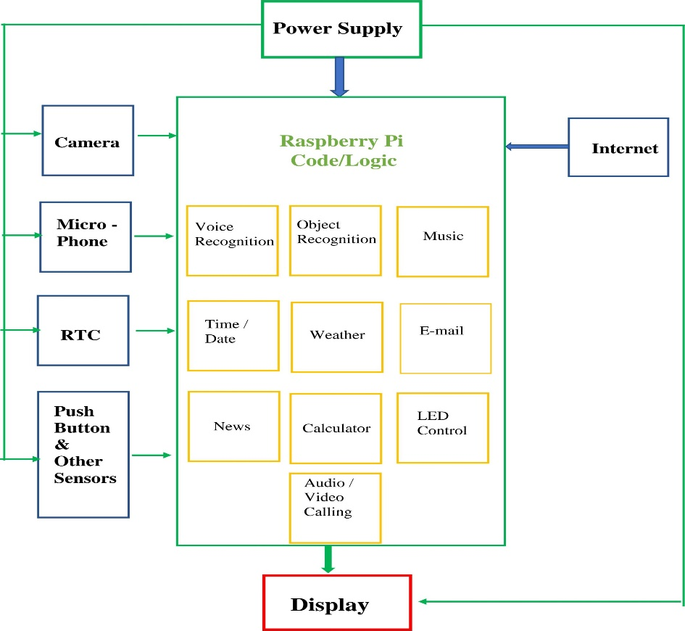**6**. **Cloud Services and Data Storage:** Data collected by the mirror, such as health metrics and user preferences, may be stored and processed in the cloud. This enables access to historical data, synchronization across devices, and more advanced data analytics.

**Mother Board**

**Mother Board**

**Figure** 4.1: System Architecture

1. **METHODOLOGY**

The raspberry pi board, which contains an ARM Cortex A53 CPU, is used as the main controlling hardware unit in the proposed system. Because the board requires an operating system, we will utilize the RASPBIAN operating system, which is based on the Windows operating system. The system must function to display notices; hence, a Monitor Screen is linked behind a 2-way mirror for display output. The whole development will be on Windows-based OS and on the python language, which is extensively supported and utilized by the researchers in the raspberry pi board. This project phases are or may be roughly classified into four categories based on the extent of work involved in each: design, raspberry pi programming, display programming, and implementation.

Mother Board

Wooden

Frame

2-way

Mirror

Display

Screen

Power Supply

Operating System

**Figure 5.1:** Block Diagram

## **5.1 TECHNIQUES**

**Hardware:**

* Mirror display
* Voice assistant module
* Computer vision camera
* IoT connectivity module
* Sensors
* Microcontroller or single-board computer
* Power supply and wiring

**Software:**

* Operating system
* Voice assistant software
* Computer vision software
* IoT connectivity software
* Mobile app for remote control and configuration
* Web interface for remote monitoring and control
* Machine learning algorithms for personalized recommendations and insights

## **MODULES**

1. **Voice Recognition:** Integrates popular voice assistants (e.g. Google Assistant) to provide hands-free control and access to information.
2. **Object Recognition:** Identifies objects in images or videos by labeling them with names or categories.
3. **Music:** Streams music and podcasts, with voice-controlled playback and playlists.
4. **Time/Date:** Displays current time and date, with optional alarm and timer functionality.
5. **Weather:** Provides real-time weather updates, forecasts, and alerts.
6. **Email:** Displays and manages email notifications, allowing users to stay connected and productive.
7. **News:** News refers to newly received or noteworthy information about recent events or developments, typically of public interest.
8. **Calendar:** Integrates with digital calendars, providing users with schedule updates and reminders.
9. **LED Control:** Regulates LED lighting, allowing users to adjust brightness, color, and ambiance.
10. **Audio/Video Calling:** It is a way to communicate using audio and video simultaneously.

These modules work together to create a comprehensive and integrated smart mirror system.

1. **CONCLUSION**

In conclusion the Smart Mirror Integration project has successfully demonstrated the potential of transforming a traditional mirror into a dynamic, interactive, and personalized interface. By integrating various modules such as IoT connectivity, voice assistant, health monitoring, and computer vision, the smart mirror provides a unique and comprehensive user experience. The project showcases the possibilities of leveraging cutting-edge technologies to create innovative solutions that enhance daily life.

The smart mirror's ability to integrate with various devices and services, provide realtime information, and offer personalized recommendations makes it an invaluable asset for users. The project's focus on health monitoring, home security, and energy efficiency highlights its potential to positively impact users' well-being and daily routines.

Moreover, the smart mirror's user-centric design and robust functionality make it an exemplary model for future IoT-based projects. The project's success demonstrates the importance of interdisciplinary collaboration, combining expertise in hardware, software, and user experience design to create a seamless and intuitive interface. As technology continues to evolve, the Smart Mirror Integration project serves as a pioneering example of the exciting possibilities that emerge when innovation meets practicality. The project's potential applications extend beyond the home, with possibilities for integration in healthcare, hospitality, and retail industries. Ultimately, the Smart Mirror Integration project has set a new standard for interactive technologies, demonstrating the transformative power of innovation and creativity.

1. **REFERENCES**
2. VOICE CONTROL IOT BASED SMART MIRROR 04/April-2024 Dr. D.D. Chaudhry*1, Avinash Hivale*2, Tushar Chavan*3, Vikas Prasad*4 Professor, Department Of Electronics And Telecommunication, Sinhgad Institute Of Technology, Lonavala, Maharashtra, India.
3. School of Computing and Mathematics Computing Individual Project BSc (Hons) Software Engineering Kathriachchi Pinnawala Integrated Smart Mirror Model 2022/2023.
4. M.A Iqbal, S Hussain, H Xing, and M Imran, “Internetof Things (IoT) Fundamentals,” in Enabling the Internet ofThings, pp. 1–28, Wiley Publishing, 2021.
5. Future IoT based on Smart Mirror: A Literature ReviewSeto Benson Handoyo1, Michael Vincentius Setiawan1, Mikhael Valensius1 and Mochammad Haldi Widianto2, Informatics Department, School of Computer Science,Bina Nusantara University, Jakarta Indonesia.(Received 01 July 2020, Revised 07 August 2020, Accepted 31 August 2020).
6. Joshi, A. et al. (2020a) IOT BASED SMART MIRROR WITH NEWS AND TEMPERATURE, International Journal of Creative Research Thoughts.
7. Mehta, D. and Jain, M. (2021) ‘Personalized Smart Mirror with User Detection’, International Research Journal of Engineering and Technology [Preprint].
8. Thejowahyono, N.F. et al. (2020) ‘Smart Mirror to Enhance Learning: A Literature Review’, International Journal on Emerging Technologies, 11(5), pp. 226–233.
9. Johri, S. Jafri, R. N. Wahi, and D. Pandey, “Smart mirror: A timesaving and affordable assistant,” in 2018 4th International Conference on Computing Communication and Automation (ICCCA), pp. 1–4, IEEE, 2018
10. R. A. Nadaf, S. Hatture, P. S. Challigidad, and V. M. Bonal, “Smart mirror using raspberry pi for human monitoring and home security,” in International Conference on Advanced Informatics for Computing Research, pp. 96–106, Springer, 2019.
11. Y. Sun, L. Geng, and K. Dan, “Design of smart mirror based on raspberry pi,” in 2018 International Conference on Intelligent Transportation, Big Data & Smart City (ICITBS), pp. 77–80, IEEE, 2018.