**PLANT DISEASE DETECTION THROUGH CONVOLUTIONAL IMAGING**

**Prof.A.A.Thakare1, Kalyani Sharnagat2, Sharvari Malve3**

1Professor, Computer Engineering Department, SRPCE College Of Engineering, Nagpur, Maharastra, India

2UG Student, Department Of Computer Engineering, Smt. Radhikatai Pandav College Of Engineering, Nagpur Maharastra, India

3UG Student, Department Of Computer Engineering, Smt. Radhikatai Pandav College Of Engineering, Nagpur Maharastra, India

**ABSTRACT**

A large portion of crops are lost to plant diseases each year worldwide. In this study, The application for detecting and classifying plant disease using deep learning object detection model was developed. The proposed the application utilizes Faster CNN object detector with Inception-v2 backbone network to achieve robust and efficient detection.This paper presents a method for detecting and classifying tomato leaf diseases using a CNN model and Learning Vector Quantization (LVQ) algorithm. The method uses color information and applies filters to three channels based on RGB components.  The proposed application can serve as an aid to farmers and crop growers who have little or no knowledge about plant diseases for early disease detection and control and therefore can reduce losses and prevent further spreading of the disease.

**Keywords:**Plant pathology,Image-based diagnosis,Plant health monitoring, Early disease detection, Deep learning model.

1. **INTRODUCTION**

plant disease detection applications are transforming agriculture by providing efficient, accurate, and scalable solutions for disease management. They represent a critical component in the move towards precision agriculture, ensuring healthier crops and more sustainable farming practices. Plant disease detection applications are pivotal in modern agriculture, leveraging advanced technologies to identify and manage plant diseases efficiently. The early detection of plant diseases is crucial for preventing significant crop losses, ensuring food security, and minimizing the use of chemical treatments. These applications integrate various tools and techniques, from traditional methods like visual inspection to cutting-edge technologies such as machine learning, image processing, and remote sensing.Plant diseases cause major production and economic losses in agriculture and forestry. For example, soybean rust (a fungal disease in soybeans) has caused a significant economic loss and just by removing 20% of the infection, the farmers may benefit with an approximately 11 million-dollar profit (Roberts et al., 2006). The bacterial, fungal, and viral infections, along with infestations by insects result in plant diseases and damage. Many such microbial diseases with time spread over a larger area in groves and plantations through accidental introduction of vectors or through infected plant materials. Another route for the spread of pathogens is through ornamental plants that act as hosts. These plants are frequently sold through mass distribution before the infections are known. An early disease detection system can aid in decreasing such losses caused by plant diseases and can further prevent the spread of diseases.In the present paper, advanced techniques of ground-based disease detection that could be possibly integrated with an automated agricultural vehicle are reviewed. In ground-based disease detection studies, both field-based and laboratory-based experiments are discussed in this paper. The field-based studies refer to studies that involve spectral data collection under field conditions, whereas laboratory-based studies refer to data collection under laboratory conditions. The laboratory-based experiments provide strong background knowledge (such as the experimental protocol and statistical algorithm for classification) for the field-based applications.

The motivation for preparing this survey stems from the fact that DL in agriculture is a recent, modern and promising technique with growing popularity, while advancements and applications of DL in other domains indicate its large potential. The fact that today there exists at least 40 research efforts employing DL to address various agricultural problems with very good results.The traditional disease diagnosis method mainly judges the health status or disease type of crops. It guides agricultural production by manually observing the color, size, and disease spot shape of crop leaves, which has problems, such as high professional requirements, long diagnosis time, and low work efficiency. Based on this, scholars are committed to identifying the characteristics of crop leaves and other characteristics through network models to achieve rapid detection and classification of diseases. At the same time, they also continue to expand the types of datasets to improve the scope of application of the method, which plays a vital reference and guiding role in the quality and output. The detection speed, accuracy, and recognition category of the model are improved by using DarkNet for feature detection after the convolutional layer.  the results of the application of the proposed models for plant disease detection and diagnosis.

1. **METHODOLOGY**

Image preprocessing objective prepare collected images for model training by enhancing quality and reducing noise.Process of Image resizing, cropping, and normalization are applied to ensure uniformity across the dataset.Augmentation techniques like rotation, flipping, and scaling are used to increase dataset diversity and robustness.Filtering techniques (e.g., contrast enhancement, denoising) help emphasize the visual features of the disease symptoms (e.g., leaf spots, discoloration). The challenges is theavoid overfitting by ensuring the augmented dataset still represents real-world conditions. The image processing is the prepare collected images for model training by enhancing quality and reducing noise. Theprocess image resizing, cropping, and normalization are applied to ensure uniformity across the dataset. augmentation techniques like rotation, flipping, and scaling are used to increase dataset diversity and robustness. Filtering techniques (e.g., contrast enhancement, denoising) help emphasize the visual features of the disease symptoms (e.g., leaf spots, discoloration). The challenges avoid overfitting by ensuring the augmented dataset still represents real-world conditions.

**2.1 Plant pathology**

Plant pathology research can use a variety of methods, including imaging techniques is the laser induced fluorescence and hyper spectral imaging are used to detect plant diseases. Hyper spectral imaging uses a wide spectrum of light to analyze each pixel of an image, and can be used with microscopy for higher resolution images. Visual estimation: Human raters can visually estimate the extent of plant disease. Microscopic evaluation: Microscopic evaluation of morphology features can help identify pathogens. Molecular, serological, and microbiological diagnostic techniques: These techniques can also be used to diagnose and detect plant diseases. Remote sensing imagery: Imagery from space agencies like NASA and ESA can be used for risk assessment systems.

**2.2 Image-based diagnosis**

Image-based diagnosis refers to the use of medical imaging technologies to identify and assess health conditions. These methodologies are essential in diagnosing, monitoring, and managing diseases, particularly when they involve structures deep within the body.

1. **MODELING AND ANALYSIS**

Efficient Plant Leaf Disease Classification By Using CNN Algorithm of Deep Learning .

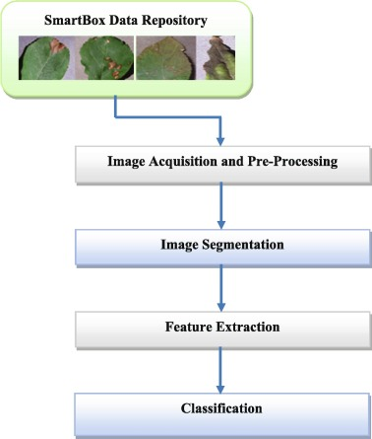

**Figure1:**Plant Disease Test Procedure.

1. **RESULTS AND DISCUSSION**

provides comprehensive information about the tools and technologies utilized for plant disease detection. It includes details about the various feature extraction methods, including those based on handcrafted and learning features, as well as the appropriate methods for processing small and large plant image datasets.

**Table 1.**Comparison of different technologies for image processing.

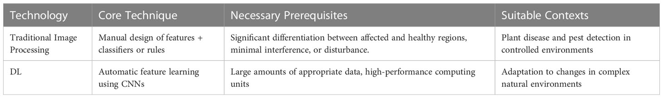

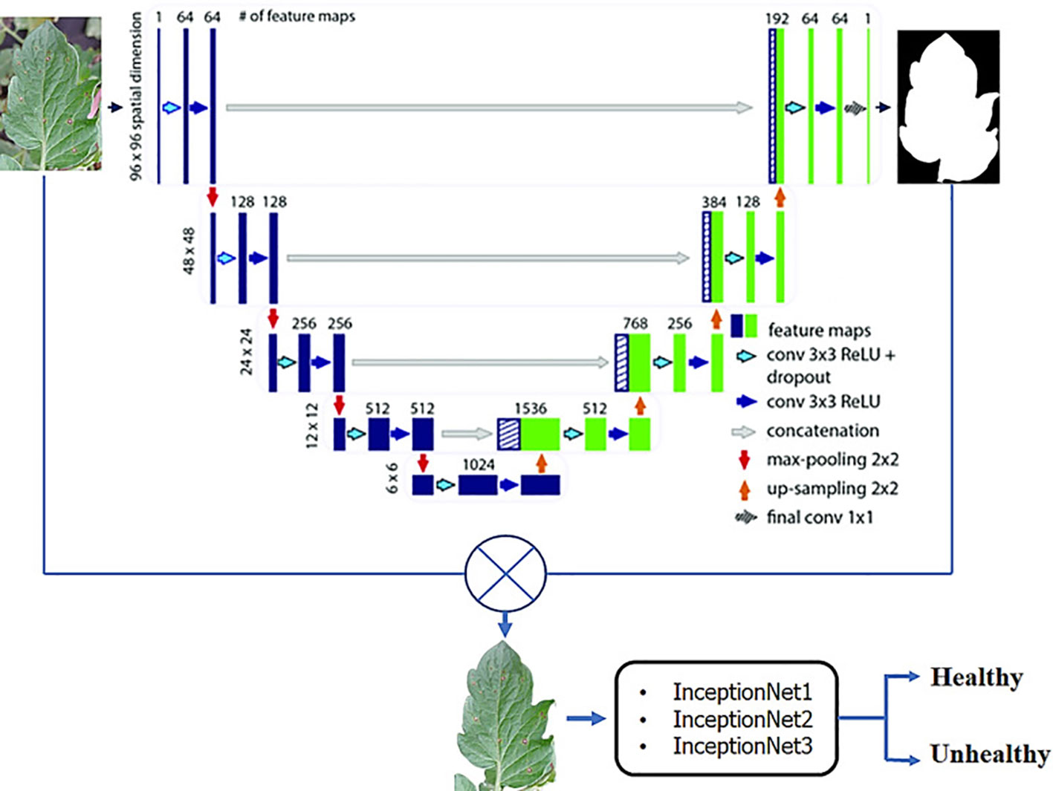

**Figure2:**A CNN framework for classifying plants into healthy and unhealthy.

The framework employs several different Inception architectures, and the final decision is made through a bagging-based approach.CNNs are a sort of DL model that are ideally suited for image classification tasks such as leaf disease detection. Multiple layers comprise the CNN’s architecture, such as fully connected layers, maxpooling, and normalization layers. The first layer in the CNN is the input layer while the second layer in most of the CNNs is convolutional layers which extract features by applying various kind of 2D filters on the image, the amount of images increase which can then dimensionally reduced pooling also known as down sampling layers, resulting in a more compact representation of the image. Fullyconnected (FC) layers in a CNN are also known as learnable features, the extracted features are processed in the FC layer forlearning and weights optimization. These layers are also responsible for making classification which can be used to recognize various plant diseases. The learning process of CNN model begins with training, the input to the CNN are images along with their labels, after the successful training of the model, the model is able to identify disease types.

1. **CONCLUSION**

The DL and ML technologies have greatly improved the detection and management of crop and plant infestations. Advances in image recognition have made it possible to identify complicated diseases and pests.  To enhance the robustness and generalization of the model, it’s important to gather images from various plant growth stages, seasons, and regions. Early identification of plant diseases and pests is crucial in preventing and controlling their spread and growth, thus incorporating meteorological and plant health data, such as temperature and humidity, is necessary for efficient identification and prediction. Unsupervised learning and integrating past knowledge of brain-like computers with human visual cognition can aid in DL model training and network learning. Achieving the full potential of this technology requires collaboration between specialists from agriculture and plant protection, combining their knowledge and experience with DL algorithms and models, and integrating the results into farming equipment.

**ACKNOWLEDGEMENTS**

Acknowledgment of plant disease detection applications refers to the recognition of the growing role that modern technologies play in identifying and diagnosing diseases in plants. With advancements in computer vision, machine learning, and image processing, significant progress has been made in developing tools and applications that assist farmers, agronomists, and researchers in early detection and management of plant diseases. The development and application of innovative technologies for plant disease detection have become vital in ensuring food security, improving crop yields, and minimizing agricultural losses. We recognize the efforts of researchers, scientists, and developers in leveraging advanced image-based methodologies, such as computer vision, machine learning to accurately detect diseases affecting various crops. We acknowledge the collaboration between academic institutions, agricultural research bodies, and the tech industry, whose joint efforts have made significant strides in plant disease detection. Their ongoing research in improving detection accuracy and creating more user-friendly, accessible tools is vital in addressing global agricultural challenges.

1. **REFERENCES**

[1] Godliver Owomugisha, John A. Quinn, Ernest Mwebaze and James Lwasa,” Automated Vision-Based Diagnosis of Banana Bacterial Wilt Disease and Black Sigatoka Disease “, Preceding of the 1’st international conference on the use of mobile ICT in Africa ,2024.

[2] P. Sachin d. Khirade, “plant disease detection using image processing,” in ieee 2022 international conference on computing communication control and automation, Pune, 2023.

[3] H. B. P. V. K. D. Jitesh p. Shah, “a survey on detection and classification of rice plant diseases,” in ieee international conference on current trends in advanced computing (icctac), Bangalore, 2022

[4] S. J. Shiv ram dubey, “detection and classification of apple fruit diseases using complete local binary patterns,” in ieee 2012 third international conference on computer and communication technology, 2021

[5] K. B. Monika jhuria, “image processing for smart farming: detection of disease and fruit grading,” in proceedings of the 2020 ieee second international conference on image information processing , 2020