**DEEP LEARNING FOR IMAGE-BASED PLANT DISEASE DETECTION**

**Prof.A.A.Thakare1, Ruchita Sharnagat2, Vishal Mirase3**

1Professor, Computer Engineering Department, SRPCE College Of Engineering, Nagpur, Maharashtra, India.

2UG Student, Department Of Computer Engineering, Smt. Radhikatai Pandav College Of Engineering, Nagpur, Maharashtra, India.

3UG Student, Department Of Computer Engineering, Smt. Radhikatai Pandav College Of Engineering, Nagpur, Maharashtra, India.

**ABSTRACT**

The user-friendly interface of the application allows farmers and agricultural professionals to easily capture and analyze leaf images using Smartphone, providing real-time feedback and actionable insights. this plant disease detection application represents a significant advancement in agricultural technology, offering a practical solution for enhancing crop health management and contributing to global food security. Future work will focus on expanding the disease database, improving model accuracy, and integrating additional features such as pest identification and weather impact analysis. The system is built on a Convolutional neural network (CNN) architecture trained on a diverse dataset comprising thousands of labeled images of healthy and diseased plants. The application can identify common diseases such as leaf spot, powdery mildew, and blight, providing users with accurate disease classifications and severity assessments. The application utilizes a combination of image processing and machine learning algorithms to accurately identify and classify various

**Keywords:** Image processing, Crop health monitoring, Agriculture technology, Machine learning, Convolutional neural networks (CNN),

1. **INTRODUCTION**

This study aims to develop a plant disease detection application utilizing machine learning algorithms, specifically Convolutional Neural Networks (CNNs), to analyze and classify plant leaf images. The application is designed to be user-friendly, allowing farmers and agricultural professionals to capture images of plant leaves using smartphones and receive instant diagnostic feedback. By leveraging technology, we can provide a more accurate, efficient, and accessible solution for farmers and agricultural workers, ultimately enhancing crop health, reducing losses, and promoting sustainable farming practices, So for identifying and preventing the spread of plant diseases we will adopt advanced technologies such as Machine Learning (ML) and Deep Learning (DL) that can help to overcome these challenges by enabling early identification of plant diseases.

In India about 70% of the populace relies on agriculture. Identification of the plant diseases is important in order to prevent the losses within the yield.  In the early ages, one cannot easily detect the disease of leaves before spreading them by using prior knowledge. Thus, the identification of leaf diseases is one of the challenging area of researches in image processing (IP), ML, as well as computer vision.In this project, we have described the technique for the detection of plant diseases with the help of their leaves pictures. Image processing is a branch of signal processing which can extract the image properties or useful information from the image. Machine learning is a sub part of artificial intelligence which works automatically or give instructions to do a particular task.The ability to analyze vast amounts of data and identify patterns that are not easily discernible to the human eye makes ML an ideal tool for this task. By utilizing image processing techniques, machine learning models can be trained to recognize disease symptoms from images of plant leaves, stems, or fruits, offering a scalable, accurate, and efficient method of detecting diseases.

1. **METHODOLOGY**
   1. **Image processing**

**Source**: The images are captured using digital cameras, Smartphone, or drones in various environmental conditions.

**Resolution:** High-quality images are crucial for accurate analysis.

**Dataset:** A dataset of healthy and diseased plant leaves, stems, or fruits is collected for training, validation, and testing.

* 1. **Convolutional Neural Networks (CNNs)**

**Convolutional Layers:** These layers apply multiple filters to input images to extract features like edges, textures, and patterns. Each filter is convolved with the input image, producing feature maps that highlight specific aspects of the image. The depth of convolution layers increases as the network goes deeper, capturing more complex patterns.

**Dataset Preparation:** Collect a large number of images of healthy and diseased plants, including leaves, stems, or fruits. Public datasets (e.g., Plant Village) or custom-collected datasets can be used.

* 1. **Agriculture technology**

Mobile Devices and Digital Cameras: Farmers or agronomists capture close-up images of plants using Smartphone or handheld devices. These images focus on specific parts of the plant, such as leaves, stems, or fruits, showing symptoms of disease.

* 1. **Machine learning**

**Image Acquisition:** Collect high-quality images of healthy and diseased plants. The dataset should cover various disease conditions across different parts of the plant (e.g., leaves, stems, fruits).

Sources of data: Field data (real-time collection), publicly available datasets (like Plant Village), and synthetic data (using augmentation techniques).

* 1. **Crop health monitoring**

**Remote Sensing Technologies:** High-resolution images are captured from satellites to monitor large-scale crop health over time.

Drones/UAVs (Unmanned Aerial Vehicles): Drones equipped with multispectral or hyper spectral cameras fly over crop fields to capture detailed images of plants.

**Field Sensors:** Ground-based IoT devices collect environmental data (e.g., soil moisture, temperature, humidity) which can be integrated into the crop health monitoring system.

1. **MODELING AND ANALYSIS**

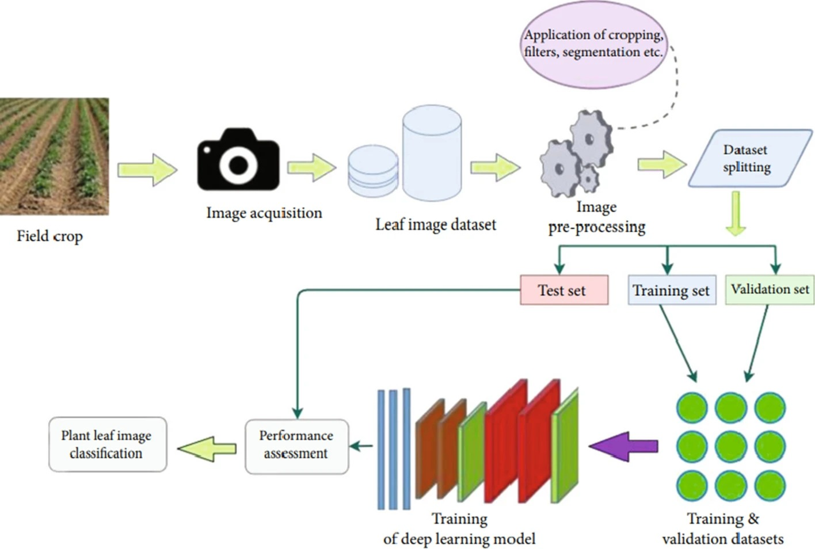

**Figure1:** Plant leaf Image Classification

1. **RESULTS AND DISCUSSION**

the performance matrices for each model developed for each of the plant. We can observe that the accuracy scores are nearly equal to f1 scores. This is because of balanced number of false negative and false positive predictions. This is considered as best case for any machine learning algorithm. The average accuracy was 93%.

**Table 1.** Performance matric for all models.

|  |  |  |  |
| --- | --- | --- | --- |
| SN. | Plant | Accuracy | F1 Score |
| 1 | Grapes | 0.95 | 0.95 |
| 2 | Corn | 0.94 | 0.94 |
| 3 | Tomato | 0.87 | 0.87 |
| 4 | Potato | 0.98 | 0.98 |
| 5 | Apple | 0.91 | 0.91 |

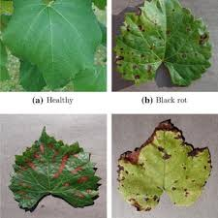

**Figure 2:** Plant Leaf Disease Recognition

1. **CONCLUSION**

The conclusion of a plant disease detection often summarizes the key findings and benefits of the application, highlights its impact, and suggests potential areas for future improvement. The plant disease detection application has demonstrated significant potential in enhancing agricultural practices by providing timely and accurate disease identification. By leveraging advanced image processing and machine learning algorithms, the application offers several key benefits, Early Detection; The application enables early identification of plant diseases, which is crucial for preventing the spread and mitigating the impact on crop yields. Accuracy and Efficiency, With high accuracy rates in disease classification, the application helps reduce the reliance on manual inspection, saving time and resources for farmers.

1. **REFERENCES**
2. Ahmed I, Yadav PK. A systematic analysis of machine learning and deep learning based approaches for identifying and

Diagnosing plant diseases. Sustain Oper Comput. 2023;4:96–104.

1. Shoaib M, et al. An advanced deep learning models-based plant disease detection: a review of recent research. Front Plant Sci. 2023;14:1–22.
2. Upadhyay SK, Kumar A. A novel approach for rice plant diseases classification with deep convolutional neural network. Int J Inf Technol. 2022;14(1):185–99.
3. S. J. Shiv ram dubey, “detection and classification of apple fruit diseases using complete local binary patterns,” in IEEE 2012 third international conference on computer and communication technology, 2021.
4. G. Shrestha, Deepsikha, M. Das and N. Dey, "Plant Disease Detection Using CNN," 2020 IEEE Applied Signal Processing Conference (ASPCON), 2020, pp. 109-113, doi: 10.1109/ASPCON49795.2020.9276722.