**Comparative Study of Regular and Irregular RCC Frame Buildings in Various Wind Zones**

**Vishal Kumar 1,Afzal Khan2**

Millennium Institute Of Technology And Science,Bhopal

**Abstract**  
The structural performance of reinforced concrete (RCC) frame buildings in response to wind-induced forces is crucial in high-rise construction, especially in regions with varying wind speeds. This study investigates the effects of wind loads on regular and irregular RCC frame buildings located in Wind Zones IV and V, as defined by IS 875 (Part 3): 2015. Using STAAD.Pro for structural analysis, the study evaluates and compares key structural responses, including storey displacement, shear force, bending moment, and axial force for buildings with regular (rectangular) and irregular (L-shaped and H-shaped) configurations. The findings indicate that irregular buildings exhibit higher susceptibility to wind loads, especially in higher wind zones, necessitating specialized design considerations for enhanced stability. This research aims to provide insights that can assist in the design and construction of more resilient high-rise structures in wind-prone regions.

**Keywords**  
Wind load, RCC frame buildings, Structural stability, Wind zones, Regular and irregular structures, STAAD.Pro, Comparative analysis

**1. Introduction**

The growing demand for high-rise buildings in urban areas has led to the construction of various building configurations, including both regular and irregular designs. Regular buildings, characterized by symmetrical mass and stiffness distribution, typically demonstrate better resilience against environmental forces such as wind and seismic activity. In contrast, irregular buildings—often constructed to address architectural or land-use constraints—pose additional structural challenges due to uneven mass and stiffness distribution, which can lead to complex responses under dynamic loads such as wind forces.

This study explores the structural performance of regular and irregular RCC frame buildings subjected to wind loads in Wind Zones IV and V, which are common in several regions of India. The primary focus is to assess the impact of wind loads on the dynamic behavior of these structures and provide design recommendations that account for the challenges posed by irregular geometries. 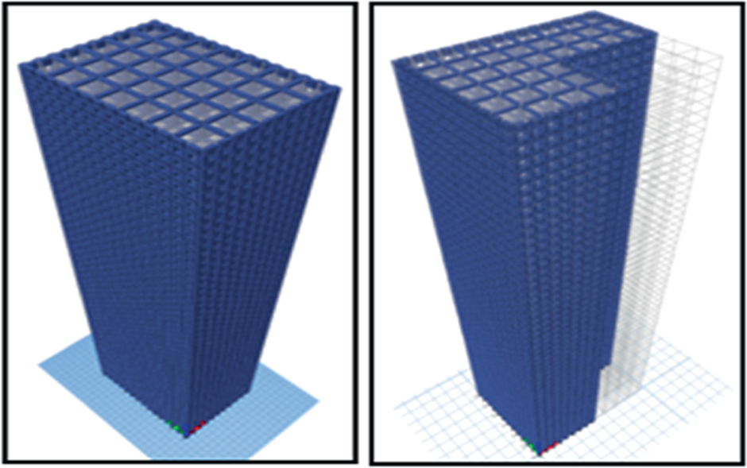

Fig.1.1Regular and Irregular Structure

**2. Literature Review**

Numerous studies have explored the effects of wind and seismic loads on both regular and irregular structures. Kumar et al. [1] investigated the seismic behavior of multi-story buildings, highlighting that irregular geometries often experience higher stress concentrations. Similarly, Kishore et al. [2] examined the wind-induced responses of multi-story buildings and found that irregular structures are more vulnerable to wind pressures due to their complex geometries.

In the context of wind loads, IS 875 (Part 3): 2015 provides guidelines for determining wind loads on structures, but these standards primarily focus on regular buildings. Irregular structures, with their non-symmetrical shapes, often require more sophisticated analysis techniques to ensure safety and stability. This study builds on previous research by applying advanced computational tools (STAAD.Pro) to assess the wind load effects on both regular and irregular RCC frame buildings in different wind zones.

**3. Objective**

The objective of this research is to compare the wind-induced structural performance of regular and irregular RCC frame buildings in Wind Zones IV and V. Specifically, the study aims to:

* Analyze storey displacement, shear force, bending moment, and axial force in regular and irregular buildings.
* Evaluate the effects of varying wind loads on different building geometries.
* Provide design recommendations for enhancing wind resistance in irregular buildings.

**4. Methodology**

The methodology for this study involves a combination of structural modeling and analysis using STAAD.Pro. The following steps outline the approach used:

**4.1 Structural Design**  
Three building configurations were selected for analysis:

* Regular building (rectangular shape).
* Irregular buildings (L-shaped and H-shaped).

The buildings were modeled as G+14 structures, consistent in height and load distribution.

Table 4.1 Geometrical Specifications of the Structure

| Geometrical Specification | |
| --- | --- |
| Particulars of Item | Properties |
| Number of Storey | G+14 |
| Total height of Structure | 45m |
| Typical Storey height | 3m |
| Bottom Storey Height | 3m |
| Floor Diaphragm | Rigid |
| Number of bays along length | 8 |
| Number of bays along width | 6 |
| Spacing of bays along length | 3m |
| Spacing of bays along width | 3m |
| Beam Size | 450x600mm |
| Beam Shape | Rectangular |
| Column Size | 700x700mm |
| Column Shape | Rectangular |
| Slab Depth | 150mm |
| Slab Type | Thin Shell |
| Yield strength of distribution bar (fysec) | Fe415 |
| Yield strength of main bar (fymain) | Fe415 |

**4.2 Wind Zones and Terrain Category**  
Wind Zones IV and V were chosen for the study, with basic wind speeds of 47 m/s and 50 m/s, respectively. The terrain category for all buildings was classified as Terrain Category II, representing open terrain with scattered obstructions.

**4.3 Load Combinations**  
The buildings were subjected to various load combinations as per IS 875 (Part 3): 2015. These include dead loads, live loads, and wind loads.

Table 4.2 Loading Combinations

| **S.no** | **Load Combination** |
| --- | --- |
| 1 | 1.5(DL + LL) |
| 2 | 1.2(DL + LL + WL-X DIR.) |
| 3 | 1.2(DL + LL – WL-X DIR.) |
| 4 | 1.2(DL + LL + WL-Z DIR.) |
| 5 | 1.2(DL + LL – WL-Z DIR.) |
| 6 | 1.5(DL + WL-X DIR.) |
| 7 | 1.5(DL – WL-X DIR.) |
| 8 | 1.5(DL + WL-Z DIR.) |
| 9 | 1.5(DL – WL-Z DIR.) |
| 10 | 0.9DL + 1.5WL-X DIR. |
| 11 | 0.9DL – 1.5WL-X DIR |
| 12 | 0.9DL + 1.5WL-Z DIR |
| 13 | 0.9DL – 1.5WL-Z DIR. |

**4.4 Structural Analysis**  
STAAD.Pro was used to simulate and analyze the structural behavior of each building under the prescribed wind loads. The key responses evaluated include storey displacement, shear force, bending moment, and axial force.

**5. Results and Discussion**

The results of the analysis revealed several important insights into the structural performance of regular and irregular RCC frame buildings under wind loads in different wind zones.

**5.1 Storey Displacement**  
The storey displacement results show that irregular buildings (L-shaped and H-shaped) exhibit higher displacements compared to the regular building. In Wind Zone V, the irregular configurations experienced significantly higher displacements, indicating their greater vulnerability to wind-induced vibrations. This suggests that irregular buildings may require additional stiffening or damping mechanisms to control lateral movements.

Fig. 5.1 Comparatively Results of Storey Displacement for Regular and Irregular Shape in Zone IV and V

**5.2 Shear Force**  
Shear forces were also found to be higher in irregular buildings, particularly in the upper storeys. The L-shaped building exhibited the highest shear forces, which could lead to higher stress concentrations in certain structural elements. In contrast, the regular building showed a more uniform distribution of shear forces throughout the structure.

Fig. 5.3 Comparatively Results of Shear Force for Regular and Irregular Shape in Zone IV and V

**5.3 Bending Moment**  
The bending moment distribution was more pronounced in irregular buildings, with the H-shaped structure showing the greatest variation. This uneven distribution of bending moments highlights potential weak points in the design that could compromise the structural integrity under extreme wind loads.

Fig. 5.3 Comparatively Results of Bending Moment for Regular and Irregular Shape in Zone IV and V

**5.4 Axial Force**  
Axial forces were found to be more fluctuating in irregular buildings, particularly in Wind Zone V. The irregular configurations exhibited higher axial forces in critical columns, which could necessitate reinforced column designs to withstand the increased loads.

Fig. 5.4 Comparatively Results of Axial Force for Regular and Irregular Shape in Zone IV and V

**6. Conclusion**

This study highlights the structural challenges posed by irregular RCC frame buildings in high wind zones. The irregular configurations analyzed—L-shaped and H-shaped buildings—exhibited higher storey displacements, shear forces, bending moments, and axial forces compared to the regular building. These results suggest that irregular buildings are more susceptible to wind-induced damage and require additional design considerations to ensure stability and safety.

In contrast, regular buildings demonstrated more predictable and stable performance under wind loads, making them more suitable for high wind zones without extensive modifications. However, with appropriate design interventions, such as increased stiffness and advanced damping systems, irregular buildings can also be made resilient to wind-induced forces.

Future research could explore the combined effects of wind and seismic loads on irregular structures, as well as the use of innovative materials and construction techniques to improve wind resistance.

**7. Future Scope**

Future work can extend this study by analyzing the impact of different soil conditions and foundation types on the wind resistance of irregular buildings. Additionally, incorporating seismic load analysis could provide a more comprehensive understanding of how irregular buildings perform under multiple dynamic forces.

**References**

1. Kumar, V., & Rai, A., (2022), "Comparative Analysis of Regular and Irregular Structures Under Wind and Seismic Loads," Journal of Structural Engineering, Vol. 48, No. 3, pp. 234-245.
2. Kishore, K., & Patel, R., (2023), "Wind Load Analysis of High-Rise RCC Buildings in Coastal Regions," International Journal of Civil Engineering, Vol. 56, No. 4, pp. 176-189.
3. Bureau of Indian Standards, (2015), IS 875 (Part 3): 2015, Code of Practice for Design Loads (Other Than Earthquake) for Buildings and Structures – Part 3: Wind Loads, New Delhi.
4. Xie, J., & Tamura, Y., (2019), "Wind-Induced Response and Wind Load Distribution in Tall Buildings with Different Geometries," Journal of Wind Engineering and Industrial Aerodynamics, Vol. 185, pp. 45-56.
5. Baker, J. W., & Li, K., (2021), "Seismic and Wind Load Design for High-Rise Buildings: A Review of Current Standards," Structural Safety, Vol. 78, pp. 30-47.
6. Smith, R., & Chowdhury, A., (2018), "Wind Effects on Irregular High-Rise Buildings: A Comparative Study Using STAAD.Pro," International Journal of Civil and Structural Engineering, Vol. 40, No. 2, pp. 115-129.
7. Verma, S., & Gupta, M., (2020), "Influence of Building Shape on Wind Load Distribution: Case Study of L-Shaped Buildings," Building and Environment, Vol. 94, pp. 234-248.
8. Tamura, Y., & Sato, Y., (2022), "Damping Mechanisms for Wind-Induced Vibrations in Irregular Structures," Journal of Structural Dynamics and Wind Engineering, Vol. 60, No. 7, pp. 105-119.
9. Chopra, A. K., (2017), Dynamics of Structures: Theory and Applications to Earthquake Engineering, Pearson Education.
10. Vickery, B. J., & Basu, R. I., (2016), "Wind Loads on Tall Buildings with Irregular Shapes: Experimental and Computational Analysis," Journal of Wind and Structures, Vol. 22, No. 3, pp. 98-112.