Lora-Enabled Green House Monitoring System

|  |  |  |
| --- | --- | --- |
| N. Rama Krishna, Assistant Professor | A.Ankitha | S.Mithila |
| *Electronics and Telematics, GNITS* | *Electronics and Telematics,GNITS* | *Electronics and Telematics,GNITS* |
| Hyderabad, India | Hyderabad ,India | Hyderabad ,India |
| [ramakrishna@gnits.aic.in](mailto:ramakrishna@gnits.aic.in) | [ammuankitha@gmail.com](mailto:ammuanitha@gmail.com) | [mithsri02@gmail.com](mailto:mithsri02@gmail.com) |

K. Syarvani L.Jhansi Aakanksha

*Electronics and Telematics,GNITS Electronics and Telematics,GNITS*

Hyderabad, India Hyderabad ,India [saisyarvaniedu26@gmail.com](mailto:saisyarvaniedu26@gmail.com) [aakankshalingam@gmail.com](mailto:aakankshalingam@gmail.com)

***Abstract*— In Green Houses, precise environmental monitoring is crucial for optimizing crop yield and quality. This project introduces a Lora-enabled greenhouse monitoring system designed to enhance agricultural efficiency through wireless technology. The systemintegrates sensors for UV light intensity, gas detection, temperature and humidity (DHT11), soil moisture, and a motor for automated plant watering. The UV light sensor ensures plants receive optimal light exposure, while the gas sensor monitors environmental conditions for plant health. The DHT11 sensor monitors temperature and humidity levels that are essential for the growth of plants. Real-time soil data is provided via soil moisture sensors conditions, enabling automated watering through a motorized system tomaintain optimal moisture levels. Using Lora technology, the system sends sensor information through the air directly to a main control center. This allows for continuous oversight and management from a distance, giving farmers the ability to make educated choices and allocate resources efficiently. The objective of this initiative is to promote sustainable agricultural practices, thereby improving both productivity and resilience in greenhouse cultivation environments. *Index Terms— LoRa, Greenhouse, RSSI, monitoring, control***

1. INTRODUCTION

A low-energy, extended-range wireless technology known as LoRa has become the go-to wireless framework for the Internet of Things (IoT). LoRa technology and its associated networks, like LoRaWAN, support smart IoT solutions that tackle major worldwide issues, such as managing energy, preserving resources, reducing pollution, improving infrastructure, and preventing natural disasters. There are many documented examples of LoRa technology being used in various fields, including smart cities, smart buildings and residences, community projects, meter systems, supply chain and logistics, farming, and more. A practical application of this technology is seen in a LoRa-powered system for monitoring greenhouses. Greenhouses offer a controlled atmosphere for plants, shielding them from pests and animals that might damage or destroy them. Moreover, the controlled environment in greenhouses lessens the impact of severe weather events, like intense rainfall. Food production by conventional means is not sufficient. Hence, farming within a greenhouse with precise environmental control is anticipated to lead to a consistent supply of farm products, no matter the weather conditions. The introduction of Internet of Things (IoT) technology has greatly improved various farming

and greenhouse activities. This includes better soil care, less water use, protection for plants, care for livestock, and the automation of agricultural tasks. Devices equipped with IoT technology in farmlands can collect information and oversee operations at every phase of production. The advancement in the miniaturization of electronic components has facilitated the integration of compact and energy-efficient IoT sensors. These sensors enable the monitoring of critical parameters such as temperature, humidity, wind direction and speed, soil quality, chemical composition, plant growth, and sunlight exposure. Among the various technologies available, LoRaWAN stands out as a prominent low-power wide-area network (LPWAN) solution, known for its extensive coverage, inherent security features, cost-effectiveness, and minimal energy consumption during operation. LoRa is particularly advantageous in regions lacking cellular connectivity. Consider a farmer managing extensive fields of crops spanning numerous hectares. In such situations, installing a wired or wireless technology infrastructure would not be economically viable. Here, LoRa wireless technology could be crucial for communication.

1. LITERATURE REVIEW

Prof. Steve A. Adeshina,Yusuf Aleshinloye Abbas,Aisha Yahaya’s research was effectively carried out, this study investigates how small-scale farmers can utilize the Internet of Things (IoT) to optimize crop cultivation year-round, even with limited resources. The results suggest that a fully implemented system can autonomously manage critical inputs necessary for healthy agricultural yields, thereby increasing crop productivity and minimizing the farmer's direct involvement. To facilitate this advancement, sensors that measure temperature, humidity, light, and gas levels were incorporated into the system to track variations within the greenhouse environment. When any of the monitored parameters exceed predetermined safety thresholds, the relevant actuator is either activated or deactivated as needed. The system operates under the control of an Arduino board, which contains the programming code and oversees the actuators, while sensor data is presented on an LCD for further analysis.. The system includes a cooling system whose function is to lower the ambient temperature and remain off when the temperature reaches the specified level. power bank functions. The implemented greenhouse monitoring and control system has a limitation in that it cannot incorporate a water system as its power source.

In this research, Hugo Sampaio and Shusaburo Motoyama

introduced a hierarchical wireless sensor network (WSN) monitoring system has been developed, tailored for greenhouses of differing dimensions. Extensive experiments were carried out to assess both the design and execution of the proposed system. The findings demonstrated that the system functions efficiently within the specified testing parameters. The initial work utilized a small-scale WSN, and future evaluations will involve field tests in actual greenhouse environments to assess the proposed hierarchical monitoring system. The Zigbee protocol facilitates the creation of an extensive wireless sensor network comprising more than 60,000 nodes. Nevertheless, the proposed system encounters a processing constraint at the serial port of the coordinator node, thereby restricting the number of sensor nodes it can effectively accommodate. [2].

Aji Hanggoro, Mahesa Adhitya Putra, Rizki Reynaldo, and Riri Fitri Sari developed a system intended for the monitoring of humidity levels in a greenhouse; however, it lacks the capability to control these levels. To overcome this shortcoming, a sophisticated Greenhouse Monitoring and Controlling system has been designed to effectively measure and manage humidity levels within a greenhouse environment. This method employs an Android smartphone that is linked to a central server through WiFi, which then communicates with a microcontroller and humidity sensor using serial communication. The results obtained from testing show that the system performs according to the specifications provided in the sensor's datasheet, demonstrating its appropriateness in real-world conditions. The successful test results confirm the proper functioning of the system, indicating its effectiveness in monitoring and controlling greenhouse humidity levels [3].

1. EXPERIMENTAL METHODS

The primary aim of this project is to develop an autonomous greenhouse monitoring system that employs LoRa technology for communication with a receiver, while also presenting sensor data through a web interface. This system will continuously observe various environmental parameters, including temperature, humidity, soil moisture, and ultraviolet light intensity. To guarantee reliable results, a systematic and methodical approach is essential. The monitoring system comprises a network of sensors, a microcontroller, and communication modules that collaborate to deliver real-time information. The sensors gather essential data regarding the greenhouse environment, which the microcontroller processes to manage automated systems, such as irrigation and climate control. such as irrigation and climate control. The data is transmitted over LoRa to ensure long-range communication with low power consumption. The system is designed using a microcontroller (such as ESP 8266 ), various environmental sensors, and a LoRa module for effective communication. By leveraging this technology, the greenhouse monitoring system can optimize resource usage, enhance crop yields, and provide valuable insights for informed decision-making in agricultural practices.

1. BLOCK DIAGRAM

Figure.1 The project is represented through a block diagram, highlighting the ESP 8266 microcontroller as the primary processing unit of the system. This microcontroller manages all associated sensors, which consist of a DHT11 sensor for monitoring humidity and temperature within greenhouses, an MQ135 sensor for evaluating air quality, and a GUVA S12SD sensor for measuring UV light levels. To facilitate the transmission of sensor data, a LoRa SX1278 communication module is integrated with the ESP8266. At the receiving end, another ESP 8266 microcontroller is connected to the LoRa module to capture the sensor data. The LoRa receiver plays a vital role in the Long Range (LoRa) communication framework, designed to receive and decode signals while maintaining minimal power consumption over extended distances. This receiver employs sophisticated modulation techniques to ensure high sensitivity, allowing it to detect weak signals even in difficult conditions.

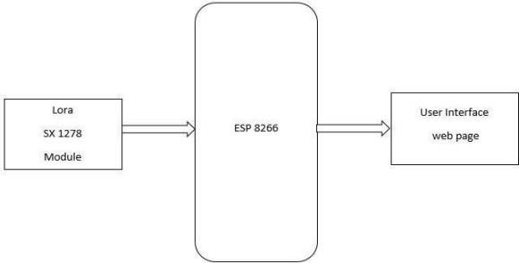

Fig.1 Transmitter Block Diagram

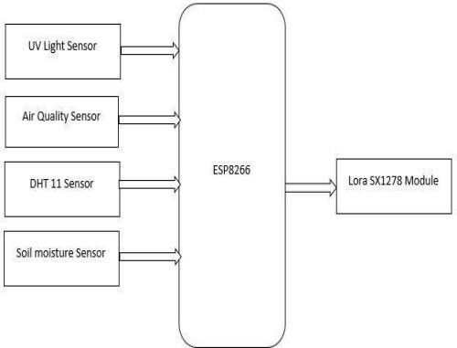

Fig.2. Receiver Block Diagram

1. HARDWARE DESCRIPTION

In this project, we utilized the ESP 8266 to enhance its functionality by incorporating various sensors and a LoRa module, which enabled us to develop a responsive and interactive system. The key components of the ESP 8266 board include the microcontroller: ESP8266, a USB port: which facilitates the connection of the ESP8266 to a computer for programming and power supply, and a USB to Serial chip: integrated within the ESP8266 module to enable communication with a computer via USB. Additionally, the board features digital pins: GPIO (General Purpose Input Output) pins that can be configured for either digital input or output, as well as analog pins: certain GPIO pins capable of reading analog values through the ADC (Analog-to-Digital Converter) with varying resolution. The 3.3V pin delivers a 3.3V output to supply power to external components. while the GND pin serves as the ground connection to complete electrical circuits.

Utilizing long-range spread spectrum modulation technology, the LoRa SX1278 is a wireless communication module. It utilizes the SX1278 chip from Semtech, which enables long- range communication with low power consumption. The module functions within the Industrial, Scientific, and Medical bands, generally at frequencies of 433MHz or 868/915MHz, contingent upon the geographical area. This enables reliable communication over extended distances, even in difficult conditions. It is commonly used in IoT applications for transmitting data wirelessly over several kilometers without requiring a complex network infrastructure, making it ideal for applications such as remote sensor monitoring, agriculture, smart cities, and more. The SX1278 module supports various modulation schemes and features like CRC error checking, which ensures reliable data transmission over extended ranges.

The DHT11 is an economical digital sensor specifically engineered to measure humidity and temperature. It can be readily connected to any microcontroller, including the

Arduino, facilitating the prompt monitoring of these environmental factors. The DHT11 is available in two forms: as a sensor and as a module. The module version is distinguished by the incorporation of a pull-up resistor and a power-on LED, features that are absent in the basic sensor. The DHT11 relative humidity sensor employs a capacitive humidity sensing element along with a thermistor to evaluate the surrounding air conditions. It features four pins: VCC, GND, Data, and one unused pin. To facilitate proper communication with the microcontroller, a pull-up resistor ranging from 5k to 10k ohms is incorporated.

The MQ-135 sensor serves as a gas sensor capable of detecting a broad spectrum of air quality levels. It is commonly employed to measure the involvement of different gases in the atmosphere. The MQ-135 operates on the principle of metal oxide semiconductors (MOS) and is responsive to multiple gases, including Ammonia (NH3), Sulfide (S), Benzene (C6H6), and Carbon monoxide (CO), among others. Its functionality relies on heating a sensitive tin dioxide (SnO2) layer, which alters its electrical resistance in response to the concentration of gases in the air. The fluctuation in resistance is subsequently measured and converted into an analog signal output, which can be understood by a microcontroller or other electronic devices. The MQ-135 sensor finds applications in monitoring air quality in indoor spaces, detecting hazardous gases in industrial environments, and being integrated into IoT devices for smart home solutions. It offers a budget-friendly approach to air pollution monitoring and plays a vital role in ensuring safety in environments where gas detection is essential.

The GUVA-S12SD sensor is a compact ultraviolet (UV) sensor module that detects UV light in the 200-400nm wavelength range. Here’s a brief overview of how the GUVA- S12SD sensor works: UV Detection: The sensor contains a photodiode that is sensitive to UV light. When UV radiation falls on the photodiode, The device produces a minor current that is directly proportional to the intensity of ultraviolet (UV) light. Amplification and Filtering: The sensor module generally comprises circuitry designed to amplify the minute current produced by the photodiode. This amplification process is essential for enhancing the signal-to-noise ratio, thereby increasing the sensor's sensitivity to UV light. Output Signal: Subsequently, the amplified signal undergoes processing and is delivered as an analog voltage signal. The output voltage is directly proportional to the UV light intensity detected by the sensor.

A soil moisture sensor quantifies the volumetric water content present in the soil. using: Two or more corrosion- resistant electrodes inserted into the soil. It evaluates the soil's electrical conductivity or dielectric permittivity, which vary with water content.C Many sensors use capacitance principles, sending a high-frequency signal between electrodes. Wet soil's higher dielectric constant changes the capacitance, indicating water content.

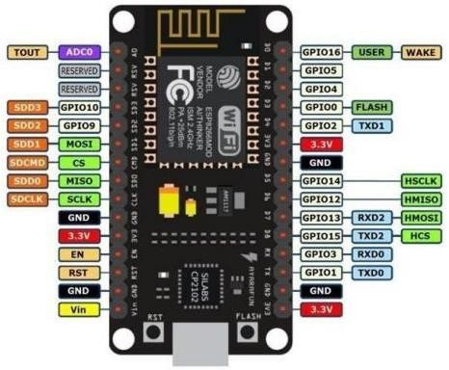

Fig. 3 ESP 8266

1. FLOW CHART DESCRIPTION

A flowchart transmitter is a pivotal component in a communication system designed to encode and transmit data efficiently through sequential steps. It employs a visual representation of processes and decision points, facilitating the clear and systematic flow of information from input to output.A critical component in a communication system designed to receive, decode, and process incoming data in a structured and systematic manner. It visually represents the sequence of steps involved in receiving and interpreting signals, ensuring efficient and reliable data retrieval from the communication channel.

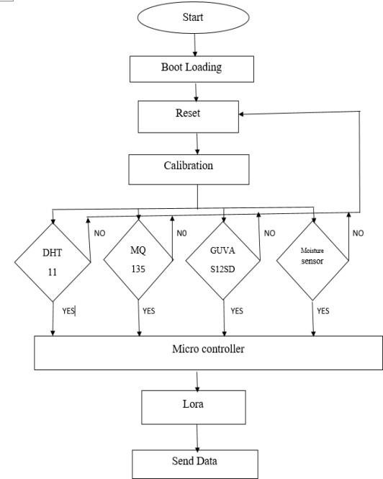

Fig.9 Transmitter Flowchart

Fig.10 Receiver Flowchart

1. 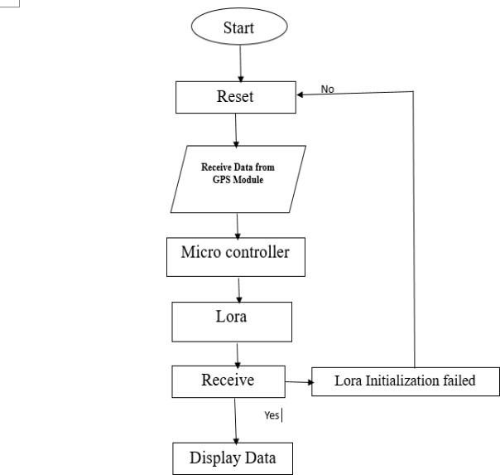RESULTS AND DISCUSSIONS

The performance of the LoRa based greenhouse monitoring system is very effective and all the necessary environmental aspects can be monitored in real time. The accurate monitoring of greenhouse conditions using sensors for UV light intensity, gas, temperature, humidity, and soil moisture content led to an enabling environment for the plants. Data transmission was achieved with the LoRa communication module over long distances and with a minimal amount of power, which was important for extensive extension projects. In the course of the prototype demonstration, the system worked reliably in delivering real time data to a control unit, to allow operation of the greenhouse environmental conditions to be performed offsite. The automated watering feature, which was connected to the soil moisture sensor, worked quite well in sustaining the favorable moisture level. As a result, the objectives of the system were met and the system presents great potential on greenhouse management since it is both stable and effective with potential to expand.

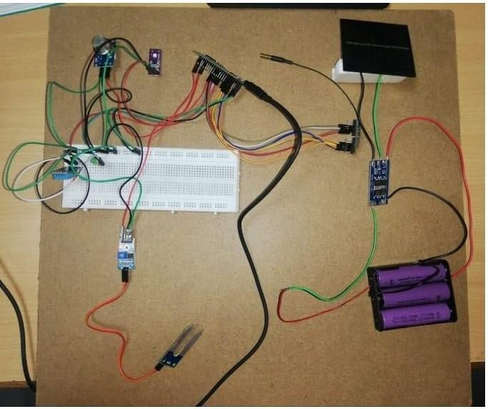Fig .10 Transmitter setup

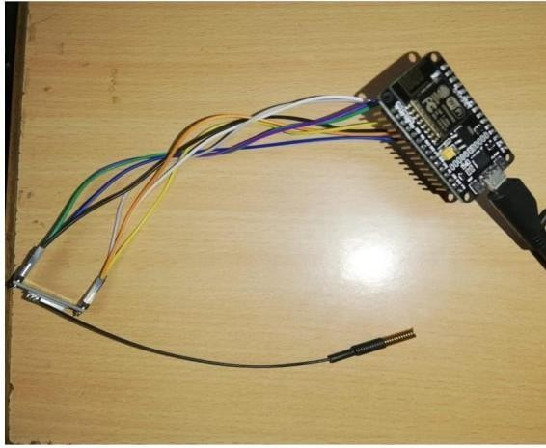

Fig .11 Receiver setup

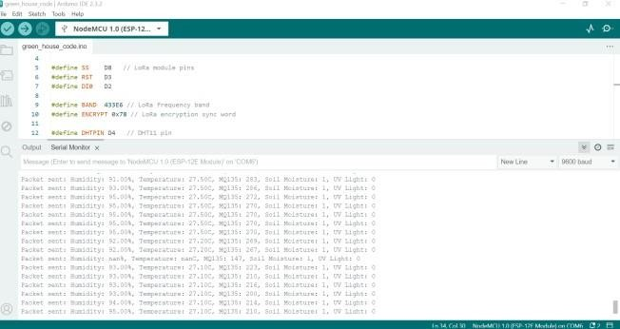

Fig.12 Transmitter data in Arduino IDE

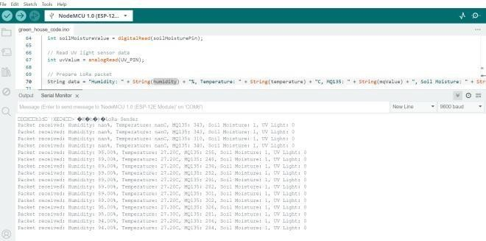

Fig.13 Receiver data in Arduino IDE

1. CONCLUSION

The creation and execution of the greenhouse monitoring system utilizing LoRa technology has been successfully completed, yielding satisfactory results in prototype demonstration. The project focused heavily on integrating advanced sensor technologies with robust communication capabilities to enable real-time monitoring and management of greenhouse environmental parameters. Significant effort was dedicated to designing a reliable and scalable system architecture. Current practices in agricultural Internet of Things and LoRa technology were referenced to guarantee the system's efficiency in data transmission over extended distances while ensuring minimal power usage. Looking forward, the prototype establishes a basis for subsequent improvements and the potential for scalability. Potential advancements include integrating artificial intelligence for predictive analytics, expanding sensor capabilities for comprehensive environmental monitoring, and leveraging cloud-based platforms for data aggregation and analysis. In conclusion, the LoRa-based greenhouse monitoring system represents a significant advancement in smart agriculture technology. It not only enhances productivity through precise environmental control but also minimizes environmental effect and maximizes resource use to support sustainable farming practices. As the system evolves, it promises to revolutionize greenhouse management by leveraging cutting-edge IoT solutions tailored to agricultural needs.

1. FUTURE SCOPE

To scale the system for larger agricultural deployments, techniques like hierarchical clustering or mesh networking can be adopted, supporting more sensors and maintaining efficient data flow across multiple greenhouses or fields. The incorporation of artificial intelligence and machine learning will allow for predictive analytics, which will support proactive adjustments to greenhouse conditions based on real-time data. This strategy will enhance the optimization of environmental factors and resource management. Additionally, enhanced security protocols, such as data encryption and multi-factor authentication, will protect the system from unauthorized access. Cloud integration can provide remote monitoring, data storage, and trend analysis, improving decision-making processes. Lastly, incorporating additional sensors for CO2, pH levels, and wind speed, alongside precision agriculture tools like automated fertilization and pesticide systems, will make the system more comprehensive, enhancing crop yield and resource efficiency. By focusing on these aspects, the system has the potential to evolve into a thorough, sustainable solution for modern agriculture.

REFERENCES

1. A. F. Rachmani and F. Y. Zulkifli, “Design of IoT Monitoring System Based on LoRa Technology for Starfruit Plantation,” IEEE Reg. 10 Annu. Int. Conf. Proceedings/TENCON, vol. 2018-Octob, no. October, pp.

1241–1245, 2019, doi: 10.1109/TENCON.2018.8650052

1. N. N. Thilakarathne, H. Yassin, M. S. A. Bakar and P. E. Abas, "Internet of Things in Smart Agriculture: Challenges, Opportunities and Future Directions," 2021 IEEE Asia-Pacific Conference on Computer Science and Data Engineering (CSDE), Brisbane, Australia, 2021, pp. 1-9, doi: 10.1109/CSDE53843.2021.9718402;
2. Shi, L., Qian, S., Wang, L., & Li, Q. (2019), "Design of Greenhouse Wireless Monitoring System Based on Genetic Algorithm," Genetic and Evolutionary Computing: Proceedings of the Twelfth International Conference on Genetic and Evolutionary Computing, pp. 153-162, 2019.
3. S. Rodríguez, T. Gualotuña and C. Grilo, "A system for the monitoring and predicting of data in precision agriculture in a rose greenhouse based on wireless sensor networks," Procedia computer science, vol.121, pp.306-313, 2017.
4. Teodoro, M. A. and Anire R., "Wireless Sensor Network with Compressive Sensing based on Bayesian Framework applied in Greenhouse Monitoring System," IEEE 11th International Conference on Humanoid, Nanotechnology, Information Technology, Communication and Control, Environment, and Management (HNICEM), pp. 1-6, Nov. 2019.
5. F. Subahi and K. E. Bouazza, “An Intelligent IoT-Based System Design for Controlling and Monitoring Greenhouse Temperature,” in IEEE Access, vol. 8, pp. 125488-125500, 2020,
6. Yin qun1, Zhang jianbo 21 Oxbridge College,.Kunming University of Science and Technology, Kunming Yunnan, China 2.Kunming University of Science and Technology,

Kunming, Yunnan, China [455601875@qq.com](mailto:455601875@qq.com)

1. T. Ahonen, R. Virrankoski, and M. Elmusrati, “Greenhouse Monitoring with Wireless Sensor Network”, Mechtronic and Embedded Systems and Applications (MESA), 2008.
2. M. E. D. Mosquera, and J. A. C. Gonzalez, “Communications System for a Soil Monitoring Network in Valle del Cauca, Colombia”, International Congress on Engineering Workshop on Applications - (WEA), doi:10.1109/WEA.2015.7370131, October 2015.

[10]N. R Mohanty, and C. Y. Patil, “Wireless Sensor Networks Design for Greenhouse Automation”, International Journal of Engineering and Innovative Technology (IJEIT), vol. 3, pp. 257-262 August 2013.

.