Suitability of conversion of pine plantation to broad leave forest in Matara and Galle Districts
Heenatigala M¹, Aluwihare WS² and Jayarathne A³.
1: Regional Deputy Conservator of Forests, Northern Regional office, Forest Department Vavunia, mohanhee@gmail.com
2: Conservator of Forests, Social Forestry and Extension division, Forest Department, Battaramulla
saalu123@yahoo.com
3: Acting Additional Conservator General of Forests (Operation), Forest Department, Battaramulla, anandamjayarathna@gmail.com

Abstract.
Approximately 16,714 hectares of pine plantations are in Sri Lanka, with 2433 and 477 hectares in Matara and Galle districts respectively. Conversion of pine lands to broadleaved forests has been ongoing, in wet zones of Sri Lanka including Matara and Galle districts., though issues such as lack of comprehensive studies, public acceptance, and species selection persist. Officers primarily focus on Dipterocarpus zeylanicus(Hora) as the species for pine conversion activities, rather than the mixed varieties. The objectives of this study are to evaluate the environmental and economic viability and social acceptance and identify and recommend suitable plant species for such conversion programs in the wet zone of Sri Lanka. Sites were selected where pine plantations were converted to broadleaved forests from 2012 to 2023, with one site in Galle and nine in Matara districts. Data like plant height, DBH (Diameter at Breast Height), No of plants and type of plant were taken. Based on the Forest Department guidelines (2014), one sample was taken in every 4 hectares of pine converted lands. Also, 3 local residences were interviewed for 10ha of land. Plant species diversity was assessed using Shannon Weiner Index, and also evaluated the enhancement of species richness and soil conditions through photo monitoring techniques. Results show a unanimous local perception that pine plantations are unsuitable for the environment in both districts. However, the conversion program has significantly increased income in nearby villages. The Shannon-Weiner Index values indicate higher biodiversity in Galle compared to Matara districts. The people have highly accepted this program. The species richness and biodiversity of the Galle district site are significantly increased than the selected sites in the Matara districts. Thus, Environmentally more viable in Galle District forests. Rather than selecting one species for the establishment, it would be better to use mixed species which are suitable for the location. Species such as Symplocos cochinchinensis, Dillenia rotusa ,Anacardium occidentale , Depterocarpus zeylanicus, are suitable for this program in the wet zone.
Key Words: Shannon -Weiner index, species richness, Income level, Social acceptance
Introduction.
In the wet forest areas of southwest Sri Lanka and the Western Ghats in India, Pinus caribaea emerged as a prevalent tree species used for reforestation on public lands. These lands were initially cleared of native forest for agricultural purposes but later transitioned to being covered by fire-tolerant grasses and ferns (Ashton et al., 2014). Despite, the establishment of over 30,000 hectares of pine plantations in Sri Lanka during the period between the 1970s and 1990s, there has been minimal adherence to silvicultural guidelines in their management since their inception (Ashton et al., 2014a). After pine establishment, these rapidly growing monocultures frequently encounter significant opposition from local communities because they fail to offer the traditional goods and services valued by these communities and provide fewer ecological benefits compared to the native vegetation they replaced (Erskine et al., 2006). Monoculture Pinus plantations can effectively transition into mixed-species tree plantations by incorporating species known for their high survival and growth rates, such as A. nobilis and M. champaca, along with species noted for their significant carbon sequestration and carbon stock potential, such as A. nobilisand T. bellirica (Chathurica et al., 2022). So, The Forest Department has launched the pine plantation conversion program in 2012, island-wide by using treasury funds. There are unsolved burning issues in this pine conversion activities such as lack of proper studies assessing the suitability of pine conservation activities in Sri Lanka's Wet Zone, the level of public acceptance and potential income increase resulting from these activities remains unclear, officers' primarily focus on Dipterocarpus zeylanicus (Hora) for pine conversion, neglecting other local species, agricultural crops near pine plantations face considerable damage from predators like monkeys and peafowl. The findings from this study will be helpful to the Forest Department offices when selecting species and areas for pine conversion activities. Therefore, the Forest Department can get optimum outcomes from these conversion activities. As a result of identifying the people's attitudes and views on pine conversion programs, the Forest Department can be used social force for forestry activities.

Objectives.
- To identify the environmental, viability and suitability.
- To Identify the social acceptance of the pine conversion activities.
- To identify suitable plant species for pine conversion programs on the wet zone of Sri Lanka.
Methodology.
Sites that are converted pine plantation into broadleaves forest from 2012 to 2023 were selected in Galle and the Matara districts where one site in Galle and 09 sites in Matara.
There are two methods for data collection.
1. The current status of broadleaf converted plantations will be taken from the random sampling collection methods. The Sample size is 12.62 radius(0.05ha) and these samples were taken randomly in each 20ha of plantations. If the plantation size is less than 10, two samples were selected randomly. Type and no of species which are presented in the plot, DBH, plant height, in each plant species, and type of seedlings have been taken as the plant data, and extrapolate these sample data to represent the whole pine conversions plantation in each Matara and Galle districts. Moreover, species richness will be calculated by the Shannon -Weiner index. The equation as fallows,

H= (N*lnN-∑(n_{i*}lnn_{i}))/N,
Where H Is the index, N is the total no of species, n_{i} is the number of individual in species i

2. In order to get the people's perceptions, acceptance, and people attitudes toward pine conversion programs will be taken from the interview with the people who are living near the pine conversion areas.

Analytical techniques.
Percentages analysis mainly used to compare the data obtained from different blocks at the different years. Simultaneously graphical represent will be used to compare the different plant species which are present in the blocks. On the other hand, Shannon Weiner index is used to identify the species richness. At the same time photo monitoring techniques will be used to identify the enhancement of the species richness and forest quality.

Results.
The table 01 has summarized the questions which are asked from the villages. Mainly 09 questions have asked to access the social acceptances. Based on the information given the table 01 is clearly indicates that 100% of the villagers are highly accepted the program on conversion of pine into the broadleaves.
Table 01: Type of questioned asked and no of reply for each questions in both districts.
Type of Questions | Galle (10) |  |  | Matara (31) |  |  | Percentage (%)
 | Yes | No | No Idea | Yes | No | No Idea | Yes | No | No Idea
1. Are pine plants suitable for the Galle and Matara Districts? |  | 10 |  |  | 31 |  |  | 100
2. Are Pine badly effect for the Surrounding Environment? | 10 |  |  | 29 |  | 2 | 95 | 5
3. Should pine plantation need to be removed? | 10 |  |  | 28 |  | 3 | 93 | 7 | 7
4. Are you aware about the conversion of pine plantation in to the broad leave forests? | 10 |  |  | 30 |  | 1 | 98 |  | 2
5. Have your income level improved from this program? | 7 |  | 3 | 27 |  | 4 | 83 |  | 17
6. Are Environmental conditions improved through this program? | 10 |  |  | 24 |  | 7 | 83 |  | 17
7. Whether the ground water condition and water sources improved or not from this pine conversion program. | 10 |  |  | 30 |  | 1 | 98 |  | 2
8. Successfulness of the program on the conversion of pine plantation in to broad leave forests | 10 |  |  | 27 |  | 4 | 90 |  | 10
9. People’s acceptability on pine conversion program. | 10 |  |  | 31 |  |  | 10

Based on the information given on the Figure 01 and table 01, this program has positive impact for the people income level. In the meantime, the Figure 02 and table 01 are figured out that the suitability of pine for the area. Figure 03 shows, no of different plant species of less than 1m height in Galle district (Ettamessakanda 2017 mixed plantation 16ha), while Figure 04, gave the information about the No of plants in different plant DBH values in Deniyaya range (Panilkandha, 2017 mixed plantation). At the same time Figure 05, indicates the type of species which have been established in the Ettamessakanda area in Galle district. Figure 06 and 07 are the pictures of the habitat improvement in the same location at the Ettamessakandha established forest. Table 02 shows the Shannon Weiner index in selected different sites in Galle and Matara Districts.

Figure 02: Percentage of suitability of pine plantation in Galle and Matara Districts.

Figure 01: Percentage of income level of individuals increased by the pine conversion program.

Figure 04: No of plants in different plant DBH values in Deniyaya range (Panilkandha, 2017 mixed plantation, 17ha).

Figure 03: No of different plant species of less than 1m height in Galle district (Ettamessakanda 2017 mixed plantation 16ha).

Figure 05: Type of species established in 2017 and 2018 at the Ettamessakanda , Galle districts.
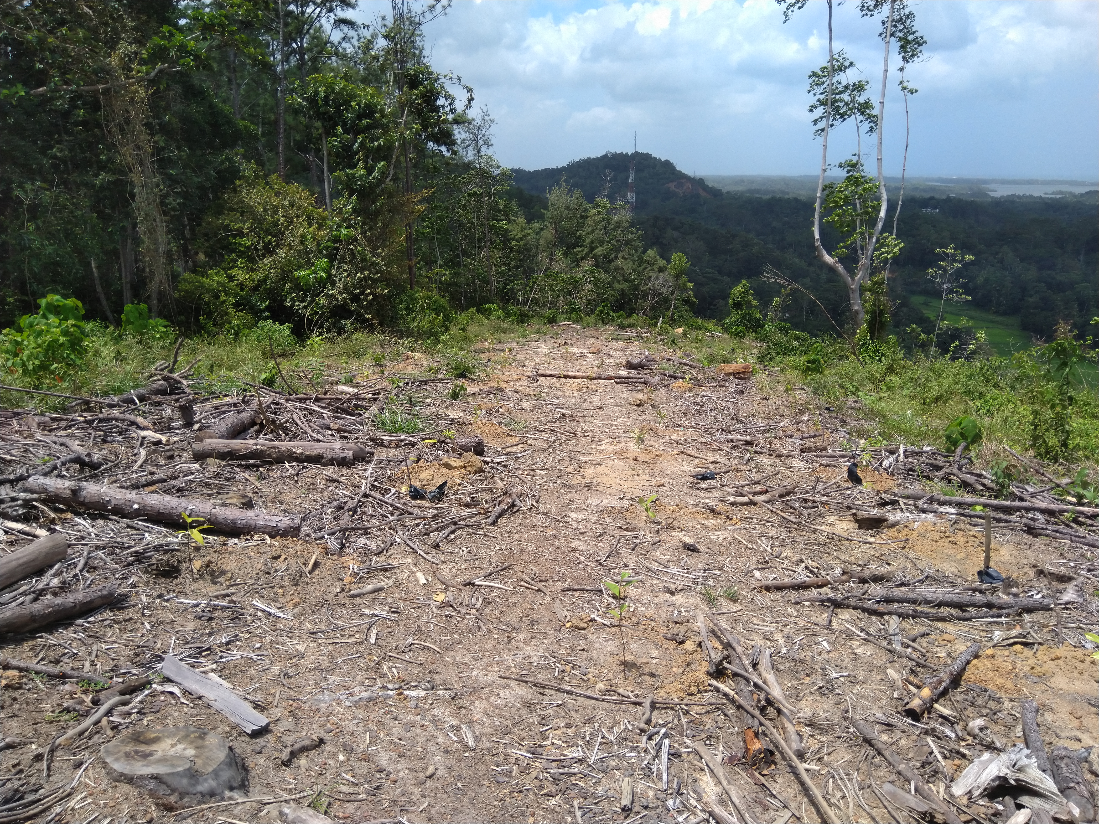
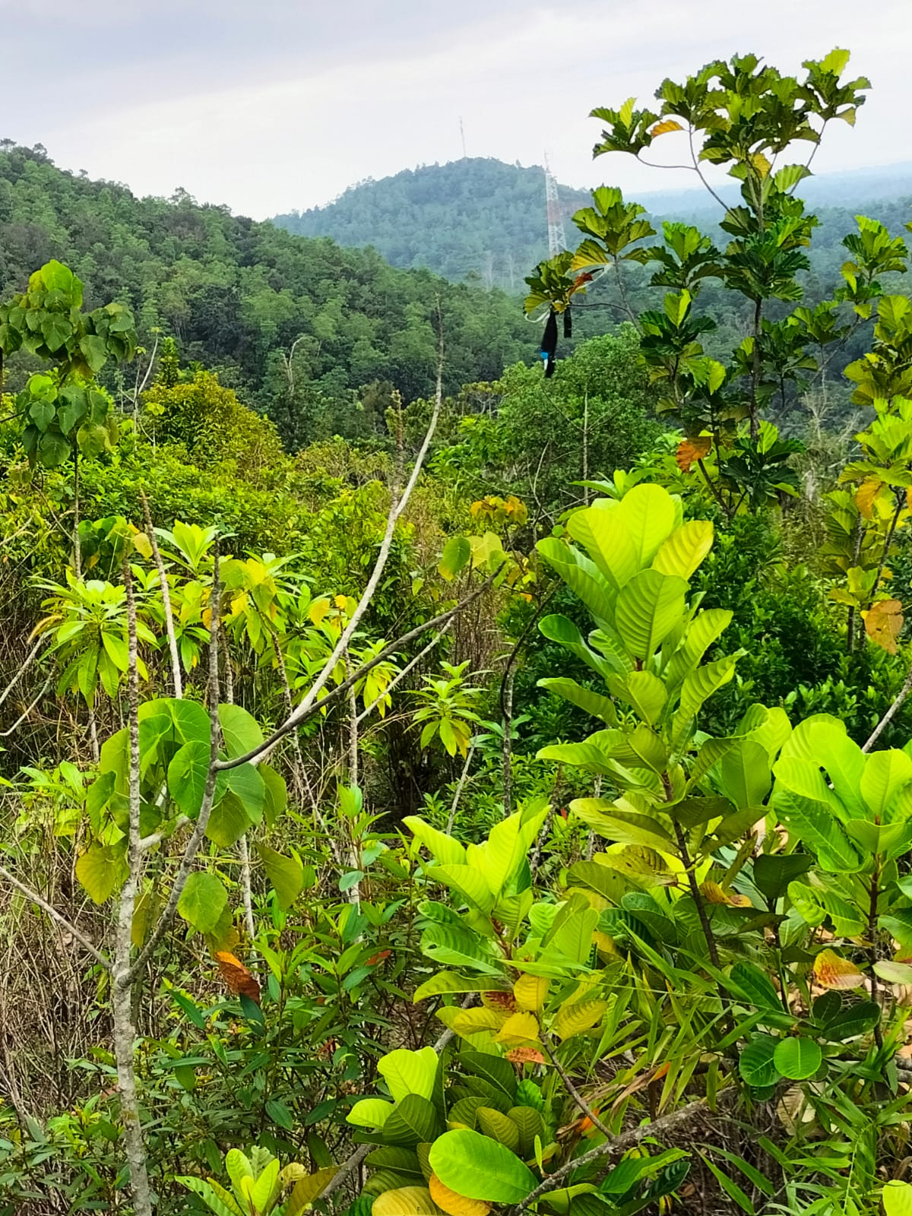

Figure 07: present status (2023 December) of the broadleaves mixed forest plantation established in 2017 at Ettamessakanda, at the same location in Galle districts, (Land mark Telephone tower and mountain).

Figure 06: After felling of pine trees mixed plants species established (just after establishment of plants in 2017 at Ettamessakanda, Galle districts, Land mark Telephone tower and mountain).

Table 01 Shannon Weiner index for different established broadleaves/ Mixed species forests.
Mixed broad leave forest name | Established year | Shannon Weiner index
Ettamessakanda, 16 ha, Galle district | 2017 | 2.9113
Panialkanda,Deniya, Matara District 17ha | 2017 | 1.2114
Kananke, Akuressa, Matara districts 02/004, 8.2ha | 2015 | 1.5113
Athuraliya, Kamburupitiya, 01/014, 16.2ha | 2016 | 1.0019

Discussion.
Both districts 100% villages accepted the suitability of this program for the areas (Table 01). Forty-one individuals were interviewed by forest field officers. As illustrated in Figure 01, interviewed people 83% agreed that the program has made a significantly positive impact on their income. The main reasons for the increment in income are, working on the plantation during the planting periods and maintenance stages which helped to increase the daily income, Tea crop yield increased from this program. And the Agricultural predator damage is reduced which increases the income. Therefore, farmers' income levels increased. The main reasons for the increment in income are, working on the plantation during the planting periods and maintenance stages which helped to increase the daily income, Tea crop yield increased from this conversion of pine plantation into the broad leaves plantation. Therefore, farmers' income levels increased due to the improvement of the crop yield. At the same time, wild predators like monkeys damage the crop yield has been reduced. So, the crop yield increased the chances for an increment of income, chances to find fuel wood are increased which can reduce the expenses for LPG gas.
Based on the results in Figure 02, 100% of the villagers agreed that 100% that pine plantations are not suitable for the environment. The main reasons for this unsuitability include depletion of water sources due to adjacent pine plantations, loss of animal habitat, creation of dry environmental conditions, and increased frequency of forest fires. In the Matara district, Depterocarpus zeylanicus(Hora) has been selected as the main plant species (more than 85%) for establishment, and the officers have given high priority to Depterocarpus zeylanicus rather than other plant species. (Figure 04). However, in Galle districts varieties of plans have been selected for the establishment, (Figure 05). Therefore, at the time of data collection (2023) more species can be found in the sites located in the Galle districts (Figure 03). There are several reasons for this suitability such as Some pine plantation are very closer to the people living areas or within the living areas which may damage for the properties. Therefore, removal of pine will create positive impact for the public properties. Improve the ground water level which will facilitate to maintain the well water level constantly. Based on the people’s views, newly established mixed species forests are Minimize the risk for forest fires may useful to manage the crop production and reduce the risk for damage of the properties. Provide food sources for wild animal which will be help to control damage for the Agricultural product and domestic products. Crop yield of the tea increased due to degraded of the plants leaves which the soil fertility been increased that rather quickly than the pine leaves. Warm condition that create difficulties on day to day life’s may minimized through this program.
When Figure 03 is compared with Figure 05, Hora (Depterocarpus zeylanicus) species has found very less amount in the Galle districts site, being this species established in 2017 and 2018. There are several reasons for that such as some wild animals like Pawn, wild bores are highly damaged the saplings, bad soil conditions, warm weather situations, and improper selection of seedlings from nurseries, which were not adequately hardened and suitable for direct planting in dry field conditions. On the other hand, Alstonia macrophylla is not selected as the plant species (Figure 03) for the establishment, the distribution of these species can be seen in the Ettamessakanda forest in Galle districts (Figure 05). Therefore, Proper and quick attention should be paid to the control of the Alstonia macrophy . However, such a distribution of Alstonia macrophylla can't be seen in the Pidurukanda, Deniyaya site (Figure 04). Galle district sites are very closer to the people's resident areas, and closer to the southern highway. Moreover, the home garden and some peripheral forest patches (near to the southern highway) are rich in Alstonia macrophylla. Therefore, seeds can easily be distributed and germinated in the Ettamessakanda site in Galle districts.
Species richness and the Shannon-Weiner Index values
Table 02 clearly indicates some selected sites in Matara and Galle districts. The Shannon-Wiener Index Values range from 0 to 5, usually ranging from 1.5 to 3.5(Karen .2009). The zero value means that only one species is presented in the area and there no species richness and biodiversity. Most of the Sites in the Matara districts have less index value, compared to the Galle districts sites. A value closer to 5 implies that there is a high species richness and biodiversity. When the species selection for the establishment, the Matara district field officers have paid more attention to the Dipterocarpus spp rather than the varieties of species. When the species selection for the establishment, the Matara district field officers have paid more attention to the Dipterocarpus spp rather than the varieties of species. Therefore, after several years the sites which are dominant with the Depterocarpus spp can be found in Matara districts which have lower index values. However, the principles are different in Galle districts, the varieties of plants have been selected for the establishment with the greater proportion of the Dipterocarpus spp. At the same time, the recommended fertilizer (N.P.K, fertilizer, 80g/ seedlings) with the ratio of 9:8:6 has been applied each year (3rd and 5th maintenance periods), which provides better and favorable conditions for better growth of the seedlings.
Figure 06 and Figure 07 compare photos from 2017 and 2023, illustrating species richness enhancement. Notably, Figure 07 highlights improved biodiversity at Ettamessakanda site, unlike Matara, as indicates in the Table 02.
Conclusion.
- The species richness and biodiversity of the Galle district site are significantly increased than the selected sites in the Matara districts. Environmentally more viable in Galle District forests.
- Based on the social survey results, the people are highly accepted and recommended this program for their areas. Peoples Income has increase which imply that the program is economically viable.
- Species like Symplocos cochinchinensis (Bombu), Dillenia rotusa ( Goda para), Anacardium occidentale ( Kadju), Salacia chinensis (Himbutu), Artocarpus heterophyllus (Jack fruit), Dillenia rotusa ( Goda para), Cariota urens (Kithul), are highly suitable for the Galle district, while Depterocarpus zeylanicus (Hora), Eucaliptus grandis, Pongonnia pinnata ( Magul Karadha), are more suitable for the Matara district selected sites.
References.
- Ashton, M., Gunathilaka, C.S.V. (2014). Restoration of rain forest beneath pine plantations: A relay floristic model with special application to tropical South Asia. Forest Ecology and Management. Vol 39. ELSEVIRE.
- Ashton, M., Goodale, U.M., Ashton, K.S & Neidel, J.D. (2014a). Restoring working forests in human dominated landscapes of tropical South Asia: an introduction. Forest Ecology and Management329: 335–339. https://doi.org/10.1016/j.foreco.2014.05.035
- Chathurica., A.G.J., Gunaratne A.M.T.A., Gunatilleke C.V.S & Gunatilleke I.A.U.N. (2022). Performance of four broad-leaved tree species in a Pinus enrichment trial in Central Highlands of Sri Lanka. Journal of Tropical Forest Science 35(1): 10–19 (2023). https://doi.org/10.26525/jtfs2023.35.1.10.
- Erskine, P. D., Lamb., A.M.B & Bristow., M. (2006). Tree species diversity and ecosystem function: can tropical multi-species plantations generate greater productivity? Forest Ecology and Management 233: 205–210. https://doi.org/10.1016/j.foreco.2006.05.013
- Karen., L. (2009). Principles of Vegetation Measurement & Assessment and Ecological Monitoring & Analysis, University of Idaho, collage of natural resources. https://www.webpages.uidaho.edu/veg_measure/modules/lessons.

