**DEVELOPING THE MODEL OF CONSTRUCTION SAFETY AT SITE**

K.B Ramesh1 Dr.M.Manikandan2

1M.Tech Construction Engineering and management, Dr. M.G.R. Educational & Research Institute, Chennai, India

2Associate Professor,Department of Civil Engg, Dr. M.G.R. Educational & Research Institute, Chennai, India

Email idroshravan@gmail.com1,manikandan2602@gmail.com2

**ABSTRACT** *The concept of safety culture is relatively new in the construction industry; however, it is gaining popularity due to its ability to embrace all perceptional, psychological, behavioral and managerial factors. To address the lack of a verifiable process to assess construction safety culture, this paper presents a conceptual model that has its roots firmly entrenched in pertinent academic and applied literature. The paper provides a critical review of the term ‘safety culture. along with distinct yet related concepts. Safety Motivation, Safety Climate, and Safety Behaviour. In particular, the model hypothesises that Safety Climate has a mediating role on the relationship between Safety Motivation and Safety Behaviour. The objective of present work is to study the various site safety measures at building construction sites and to compare the site safety measures with relevant safety codes. The study pertains to find out the provisions as laid down in the BIS codes for various aspects of safety measures at construction sites. The study included, physically visiting different construction sites, collecting the data regarding safety provisions adopted and feedback from site engineers by using questionnaire will help in implementing the safety measures at building sites more efficiently. So that that the present study will help out in ascertaining the proper safety planning in building construction.*

**1.INTRODUCTION**

Safety is a state in which hazards and conditions leading to physical, psychological or material harm are controlled in order to preserve the health and well-being of individuals and the community.Construction site safety is an aspect of construction-related activities concerned with protecting construction site workers and others from death, injury, disease or other health-related risks. Construction is an often hazardous, predominantly land-based activity where site workers may be exposed to various risks, some of which remain unrecognized.Site risks can include working at height, moving machinery (vehicles, cranes, etc.) and materials, power tools and electrical equipment, hazardous substances, plus the effects of excessive noise, dust and vibration. The leading causes of construction site fatalities are falls, electrocutions, crush injuries, and caught-between injuries.Comprehensive planning, monitoring, and control over health and safety responsibilities are essential for the success of your construction project. A safety management system prevents the worst-case scenario from happening on one of your sites, reducing accidents and driving employee morale in one go. Effectively managing safety is a daunting task, which is why we’ve put together a quick introduction to safety management in construction, giving you all the tools you need to kickstart your safety program.There are various types of construction management. Safety management includes managing all business activities that help prevent accidents and injuries and minimize risk on the job site. A safety management system includes all safety-related activity on a work site. Whether it’s hazard identification and safety policies to safety plans, objective setting, safety training schedules, and reporting procedures, you need to map out the entire management structure extensively, accounting for every last detail.Construction site safety is a very important requirement in the construction industry that is often neglected on project sites. Without proper safety regulations employees are prone to minor and major accidents on a regular basis because of the dangerous and dynamic environment of the construction industry.

**Some of the most common hazards in the construction industry are:**

• Falling objects

• Exposure to chemical substances

• Fall from heights

• Dust inhalations

• Vehicular and equipment accidents

• Working in confined spaces

• Slips on sites

• Fire and explosions

• Electrocutions

• Defective Safety Equipments

• Chemical spills

\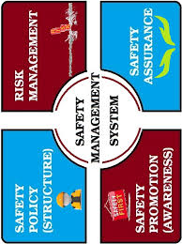 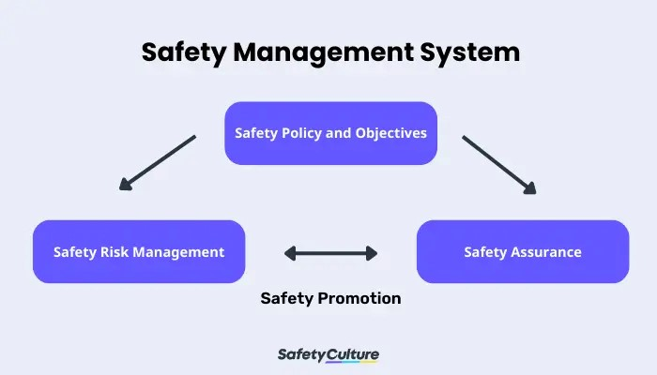

**2. IMPORTANCE OF CONSTRUCTION SAFETY**

Construction site safety is a very important requirement in the construction industry that is often neglected on project sites. Without proper safety regulations employees are prone to minor and major accidents on a regular basis because of the dangerous and dynamic environment of the construction industry. In the regulatory arena, this term applies to systems, structures, components, procedures, and controls (of a facility or process) that are relied upon to remain functional during and following design-basis events. The construction industry has taken numerous steps to avoid accidents on site and provide workers with a safe working condition and ensure safe practices but even now requisite safety in the construction industry is still a distant dream. Construction site safety is a very important requirement in the construction industry that is often neglected on project sites. Without proper safety regulations employees are prone to minor and major accidents on a regular basis because of the dangerous and dynamic environment of the construction industry.

‍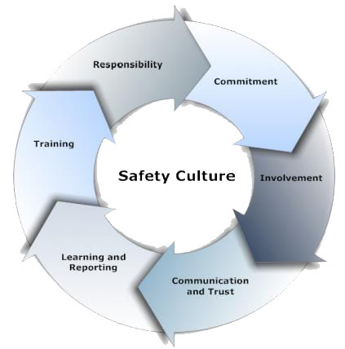

**Fig 2.Importance of AI**

**3. PROBLEM STATEMENT**

In the development process of a country, construction industry undoubtedly plays a significant role. Despite of the benefits it brings, it is known for high fatalities and accidents risk on the working place. The construction industry has always been associated with chronic problems including poor safety awareness of top management, lack of training, low safety awareness among contractor, attitudes of management and workers and also reluctance to provide allocation of budget for safety. Thus, generate serious accident at the project, affecting others. A study done by C.M. Tam et al. (2004) reveals that the behavior of contractors on safety management are of grave concern, including the lack provision of personal protection equipment, regular safety meetings and safety training. Consequently, the most significant impacts of site accidents on construction firms are high cost, cause disturbance to schedule, give bad reputation to company and burden the workers and others. Therefore, by identifying factor that affecting implementation safety control on resources such as worker, equipment and materials comprehensively and by practicing proper safety management, the construction safety risk can be reduced. This lead to better safety performance and successfulness of overall project

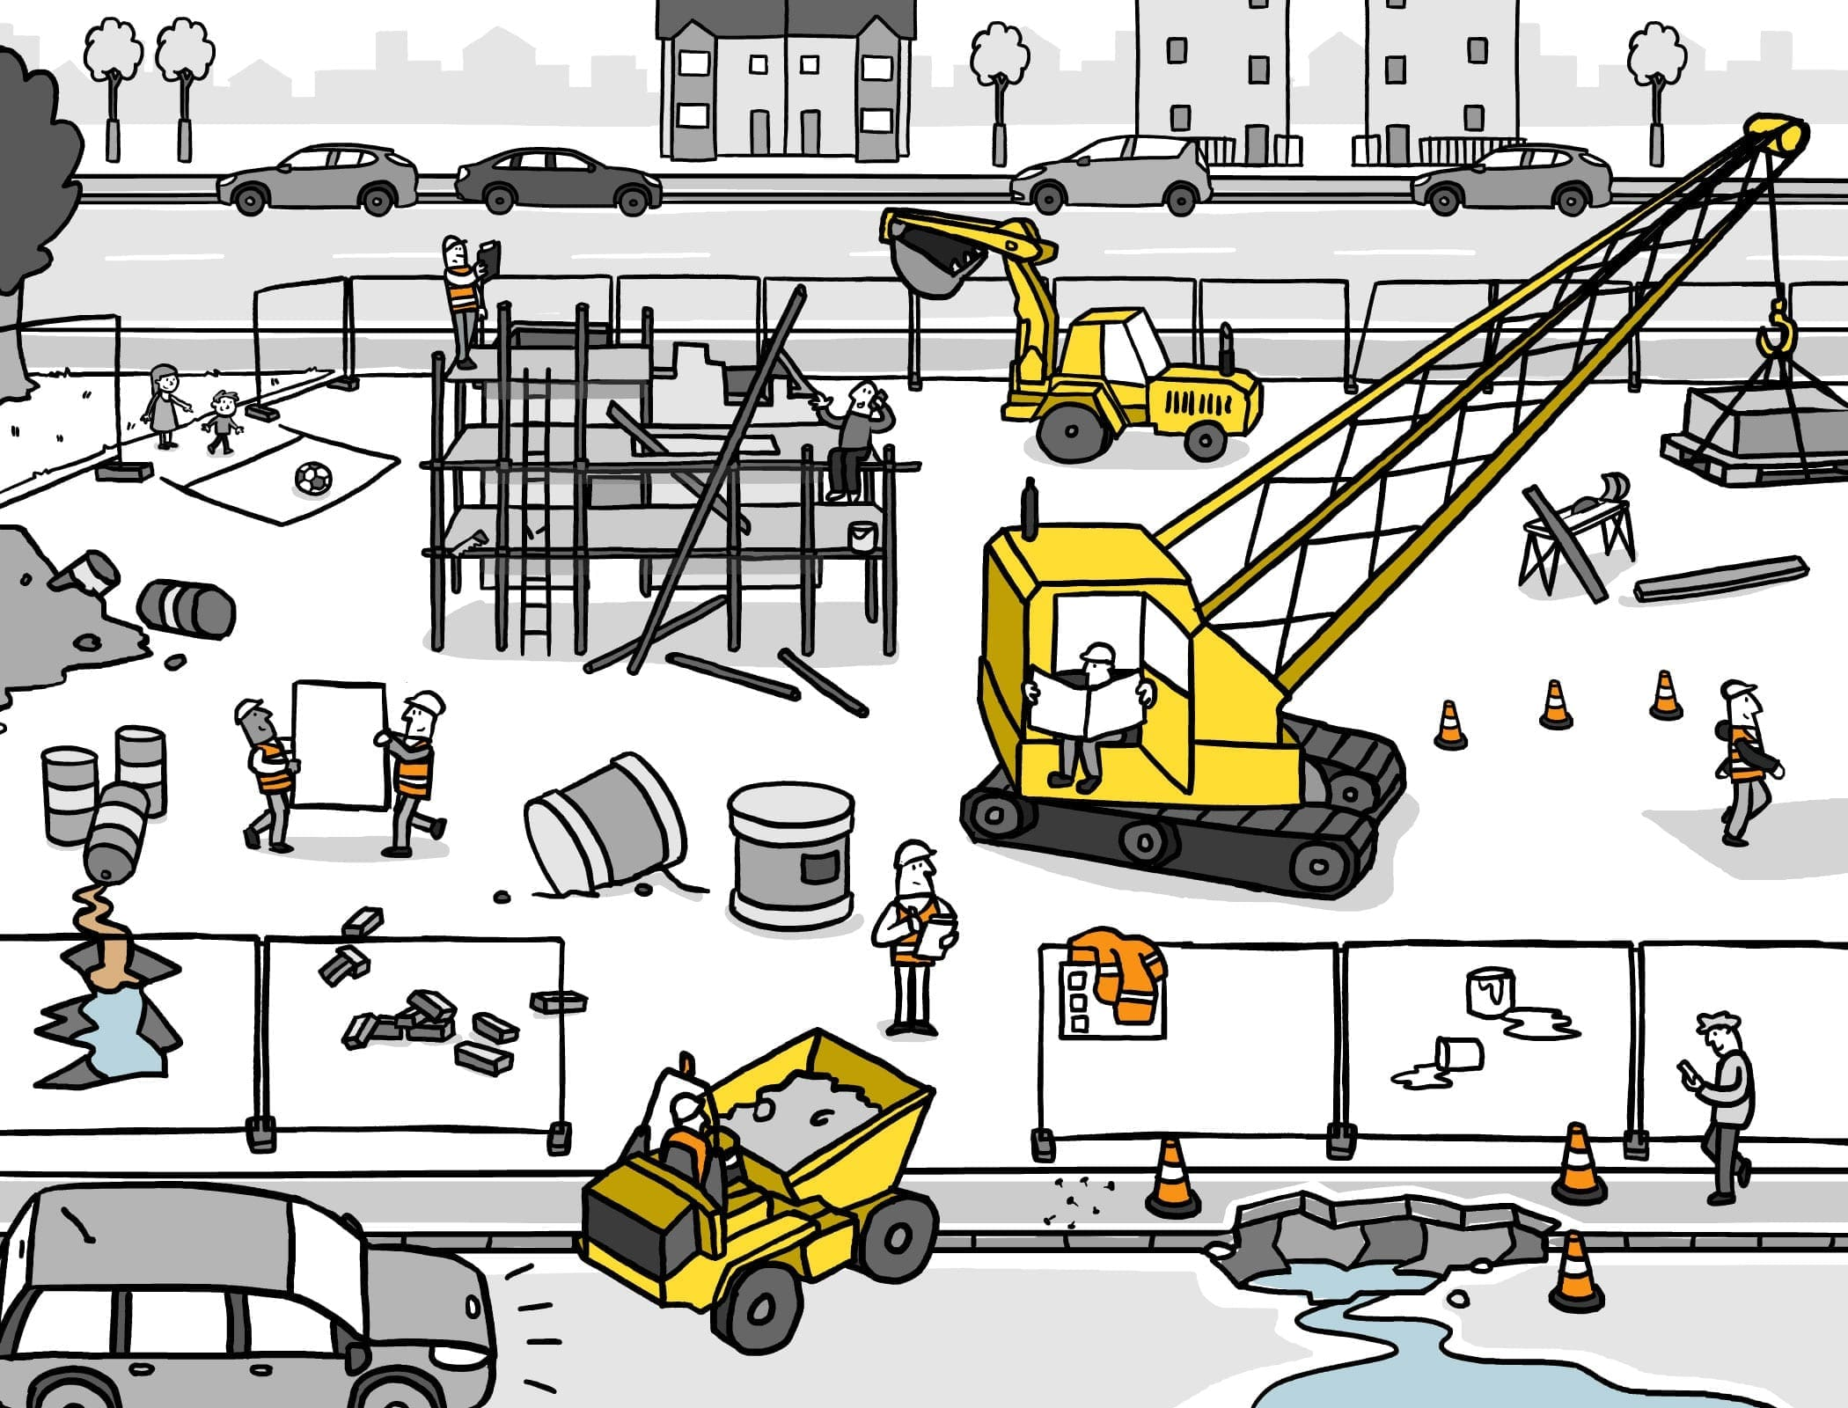

**4.RISK MANAGEMENT FOR SAFETY IN CONSTRUCTION**

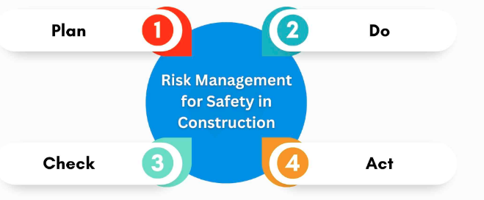

Risk management procedures for occupational site health and safety can be roughly categorised as in four simple steps, that are:

**• Plan**– The safety policies and procedures must be planned as per risk assessment report

**•Do**– Enforcements of policies and procedures.

**• Check**– In order to check for relevance, effectiveness and efficiency of implementation, the safety performance is measured.

**• Act**– Proper remedial measures must be adopted in order to prevent safety and health issues.

A risk management system for safety on construction sites can be considered more of a method rather than a product and this method has to be documented each time it is being implemented anywhere on the construction project so that the safety incharge may keep a check on its effectiveness and can also be used auditing as well as report preparation.

Safety in Construction is of paramount importance for the construction industry because accidents and mishaps are caused due to negligence and improper safety practices and workplace conditions. As a safety management system is part of the project management process, enough provisions must be made in this process to feed and document safety processes being followed on site

**5.RULES FOR CONSTRUCTION SAFETY**

**1. Always wear PPE**

All workers and visitors in the construction site should wear the appropriate PPE to reduce exposure to various hazards on the worksite. Common PPEs include goggles, helmets, gloves, ear muffs or plugs, boots, and high-visibility vests and suits.

**2. Be mindful and follow signs**

Safety signs allow management to warn and raise health and safety awareness for employees and visitors. Appropriately place them around the site where necessary. Workers should be familiar with the construction site safety tips and different signs: prohibition signs, mandatory signs, warning signs, safe condition signs, and fire fighting equipment signs.

**3. Provide clear instructions**

A site induction for general contractors should be present on site. This will enable new workers to be familiar with site operations. Toolbox talks are also an effective way of relaying health and safety instructions to the workforce. It is conducted before commencing work on either a daily or more frequent basis.

**4. Keep the construction site tidy**

Ensure that debris, dust, loose nails, and stagnant water from excavations and backfilling are not just lying around the site. The construction site must be cleaned daily and remain clutter-free to prevent slips and trips.

**5. Organize and store tools properly**

Ensure that no tools are lying around, and leave lights and power tools unplugged. Following construction site rules will help prevent tools from getting damaged or even causing injury to workers. Organizing them in their rightful place will also allow for easy navigation.

**6. Use the right equipment for each task**

Often, accidents occur due to the misuse of a tool or equipment. Avoid using makeshift tools. Instead, use the correct tool to get the job done quicker and safer.

**7. Prepare an emergency response plan**

An emergency response plan directs the workforce on what to do when emergencies like natural disasters, fire, hazardous material spills, or other types of incidents occur. Have a dedicated team responsible for managing emergency crises, answering questions, and reporting potential hazards, quality issues, or near misses.

**8. Set up safeguards**

One of the ways to ensure safety on site is by placing engineering controls such as barriers, fences, and safeguards. These will help isolate people from hazardous areas with high-voltage electricity or chemicals with toxic fumes.

**9. Inspect tools and equipment regularly**

Before commencing work, ensure that the tools and equipment to be used are free of defects or damage.

**6. LITERATURE REVIEW**

**Alexander .Laufer( 2010) deals** with the effectiveness of the various methods and the extent of their use at construction sites are examined. The study is primarily based on a sampling of medium and large construction sites. Attributes that are investigated include efficiency, reliability, and validity and diagnostic capacity of the measure in order to identify the cause for success or failure, respectively, of the safety program at a site. Data were collected through the medium of a questionnaire mailed to safety directors of the 400 largest U.S. contractors listed in the Engineering News Record. The conclusion is drawn that for the successful safety performance at construction sites, the simultaneous employment of a number of measuring methods is required. The results of this study clearly indicate that the most effective and at the same time the most widely used employed measurement methods were lost-day cases, doctor's cases, and cost of accident. No-injury cases were least effective and least in use. Process methods were found to be effective as far as their validity and diagnostic capacity extends, though their efficiency and reliability are low.

**Beny Lyachin( 2008)** presents the results of a study that identified the major factors ffecting safety in tower-crane environments and evaluated the degree to which each factor influences ongoing safety on site. This study presented a list of 21 factors with an ongoing presence that affects safety in tower-crane environments. The list was generated and consolidated based on the experience and expertise of 19 senior safety managers and equipment managers from the top ten construction companies, which among them own and employ some 300 tower cranes. With a view to quantifying risk factors, the experts also assessed the influence of each of the factors, thus making it possible to distinguish between factors that exert a strong influence and those that exert a moderate influence on site safety. Overall we get to study in this paper that ,with the limited resources available for safety improvement and accident prevention, greater attention must be paid by all parties involved e.g., construction firms, regulatory and enforcement authorities to those factors evaluated as highly affecting site safety due to tower-crane work. The study reported in this paper constitutes the first phase of a broader research

plan that aims to develop quantitative indices that objectively and realistically reflect safety levels on construction sites due to the operation of tower cranes.

**Carcano and Franco-Poot (2014)** studied the Construction Workers’ Perceptions of Safety Practices: A Case Study in Mexico. Organizational characteristics and worker perceptions were among the main factors affecting the safety climate in construction sites. Although some perceptions of workers may seem absurd to others, these components were part of their reality. Worker behavior was an extremely important factor in workplace safety as many accidents were often caused by insecure actions, in which combinations of human behavior were the consequence of such perceptions. The aim of this study was to explore workers’ perceptions of safety practices in their habitual work environment, a building site in Mexico.

**Choudhry M (2007)** determine safety climate that would enhance safety culture and positively impact perceived safety performance on construction projects. A safety climate questionnaire survey was conducted on the construction sites of a leading construction company and its subcontractors. From FA, two principal components were established, management commitment, employee involvement and inappropriate safety procedure and work practices. These factors have been regressed with the perceived safety performance scores to establish the causal relationship between safety climate and perceived safety performance.. The study concluded that management may be warned of potential safety system failures by measuring safety climate and can assess how safety is functioning in construction site environments.

**Choudhry and Fang (2008)** carried out a research on the behavior focus and found that workers are involved in unsafe behavior because of lack of safety awareness, putting on a tough image, work pressure, co-workers' attitudes, organizational, economic and psychological factors. The author suggested recommendations for improving site safety by listening to the viewpoints of the subcontractor's workers. The reason behind this was that the subcontractors deal with different situations that judge their action on how best to work safely on a construction project. The objective was broken down into three parts: workers viewpoint, unsafe behaviors and safety behavior.

**7** **METHODOLOGY**

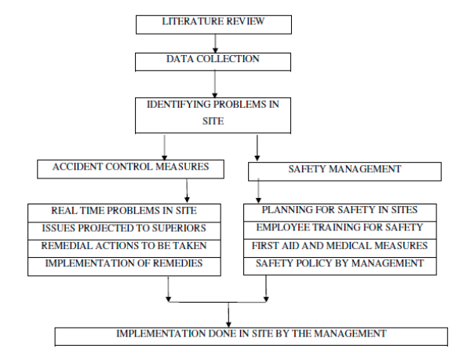

**8. CONSTRUCTION SAFETY RISKS**

**Construction Safety Risks**

[Working at heights](https://safetyculture.com/checklists/working-at-heights/) is defined as the performance of construction work at an elevated height of 2 meters or more. It is one of the biggest causes of preventable work injuries and fatalities around the world. As much as possible, working at heights should be avoided; however, this may not always be possible for most types of construction work. To help construction safety managers mitigate the risks of working at heights, here are four digital templates that are free to download and use.

[**Working at Heights Procedure Template**](https://public-library.safetyculture.io/products/working-at-heights-inspection?amp_dev=bc236895-7550-4b9d-ac7c-75eb9f44e1e9&__hstc=101368670.aa73cdee7ecaa61a72031332ed4b7754.1723988892193.1723988892193.1723991926059.2&__hssc=101368670.1.1723991926059&__hsfp=1218336316)

* Record the nature of work and the team working onsite
* Identify activities associated with working at heights
* Determine potential risks like falling, slipping, or tripping
* Evaluate controls such as training, planning, and proper use of [fall protection systems](https://safetyculture.com/checklists/fall-protection-harness/) and construction safety equipment

[**Safety Harness Working at Heights Template**](https://public-library.safetyculture.io/products/safety-harness-inspection-zgeB5?amp_dev=bc236895-7550-4b9d-ac7c-75eb9f44e1e9&__hstc=101368670.aa73cdee7ecaa61a72031332ed4b7754.1723988892193.1723988892193.1723991926059.2&__hssc=101368670.1.1723991926059&__hsfp=1218336316)

Construction safety managers can provide workers with this template for inspecting safety harnesses before use. Using this template, workers will be able to find out if the equipment is in good condition for working at heights. The following components should always be checked:

* Lanyard
* Tie-off adaptors / anchorages
* Horizontal lifelines

[**OSHA Scaffold Inspection Checklist Template**](https://public-library.safetyculture.io/products/osha-scaffold-inspection-checklist?amp_dev=bc236895-7550-4b9d-ac7c-75eb9f44e1e9&__hstc=101368670.aa73cdee7ecaa61a72031332ed4b7754.1723988892193.1723988892193.1723991926059.2&__hssc=101368670.1.1723991926059&__hsfp=1218336316)

Due to the extensive use of scaffolds in the industry, construction safety managers must ensure that scaffold inspections are performed accurately every 7 days after installation and only by a scaffold-competent person. To help guide this person in navigating OSHA [scaffolding safety](https://safetyculture.com/checklists/scaffolding-safety/)requirements, construction safety managers can provide them with the following template.

[**Ladder Inspection Checklist Template**](https://public-library.safetyculture.io/products/ladder-inspection-checklist-JrOpj?amp_dev=bc236895-7550-4b9d-ac7c-75eb9f44e1e9&__hstc=101368670.aa73cdee7ecaa61a72031332ed4b7754.1723988892193.1723988892193.1723991926059.2&__hssc=101368670.1.1723991926059&__hsfp=1218336316)

* Create a ladder profile composed of the type, construction, length, class, weight supported, photos of the ladder and its tag or label
* Identify defects in specific ladder components such as the feet of the ladder, the rung locks and spreader braces, side rails, bolts and rivets, ropes, steps and rungs

**Falls, Slips, and Trips**

Closely related with working at heights, falls, slips, and trips are often associated with ladders. As one of the top ten OSHA violations, [ladder safety](https://safetyculture.com/checklists/ladder-safety/) is vital in preventing such incidents. OSHA requires ladder inspections before initial use in each shift. Construction safety managers can satisfy this OSHA requirement by using a mobile inspection app to proactively catch issues that could lead to work-related injuries such as falls, slips, and trips.

**Moving Equipment**

Though scaffolds and ladders are considered to be of high risk, at least some are stationary, reducing their risk of endangering workers who are not using them. Unlike scaffolds and ladders, [construction machinery](https://safetyculture.com/topics/construction-machinery/), moving equipment or equipment used for lifting or lowering loads are greater threats to public safety. In 2019, [a crane collapse in Seattle](https://www.usatoday.com/story/news/nation/2019/10/17/seattle-crane-collapse-investigation-companies-fined-avoidable-accident/4018256002/) caused the deaths of four people, two of which were bystanders. To prevent similar accidents from occurring, construction safety managers should ensure that workers observe the proper safety procedures when operating moving or lifting equipment. Additionally, construction safety managers must satisfy relevant regional requirements.

**Noise**

While the idea of noise as a construction safety risk may be surprising, statistics in the UK show that an estimated [17,000 people annually](https://www.hse.gov.uk/statistics/causdis/deafness/index.htm) suffer from hearing conditions due to excessive noise at work. Performing [noise risk assessments](https://safetyculture.com/checklists/noise-risk-assessment/), especially in the construction industry, can help identify the sources of these risks and how they affect the health and safety of workers.

**Hand-arm Vibration Syndrome**

Hand-arm vibration syndrome (HAVS) is a permanent condition affecting the nerves and blood vessels of the hand. Construction workers are primarily at risk of developing HAVS due to the [prolonged use of vibrating tools and equipment](https://safetyculture.com/checklists/hand-and-power-tools/) such as concrete breakers, hammer drills, and grinders..

**Manual Handling**

Manual handling is the lifting, lowering, carrying, and moving of objects during work operations. Aside from hand-arm vibration, the characteristics of high-risk manual handling involve repetitive, sustained, high, or sudden force; repetitive movement; sustained or awkward posture; and whole-body vibration. [Assessing the risks of manual handling](https://safetyculture.com/checklists/manual-handling-risk-assessments/) is crucial to protect workers from musculoskeletal disorders such as HAVS, epicondylitis (affecting the elbow), and rotator cuff injuries (affecting the shoulder).

**9.RESULT & DISCUSSION**

**Wearable Technology**

One of the most prominent advancements in construction safety is wearable technology. Workers can don smart helmets, vests, and glasses that are equipped with sensors and communication devices. Devices such as smart helmets, vests and wristbands equipped with sensors can monitor vital signs, detect hazardous substances and provide real-time alerts in case of accidents or dangerous conditions. These devices can also track workers’ movements to prevent collisions and ensure they stay within safe zones. Detect hazardous conditions

* Provide real-time information to both the wearer and supervisors
* In case of an accident or unsafe conditions, these tools can alert authorities and even administer first aid, potentially saving lives in the process.

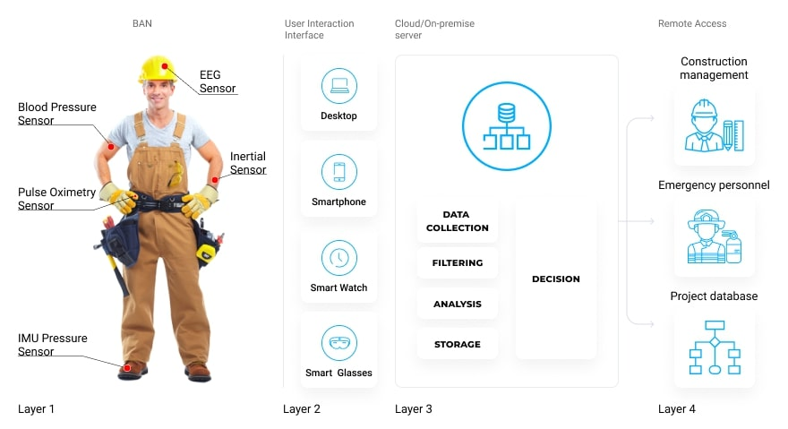

**Drones & Aerial Surveys**

Not only is drone surveying helpful for keeping workers out of harm's way, but the data can be more accurately and efficiently gathered through drone surveying and can be used to spot potential hazards on a work site before they cause problems. Drone technology has advanced at lightning speed, and these machines have quickly become an indispensable tool in construction safety. Consider some of the most common uses:

* Provide aerial surveys
* Monitor work progress
* Assess site safety from a bird’s eye view
* Help identify potential hazards
* Support jobs that require heavy lifting
* Inspect hard-to-reach areas
* Ensure compliance with safety protocols
* Overall, drone technology can help reduce the risk of accidents while simultaneously streamlining project management.

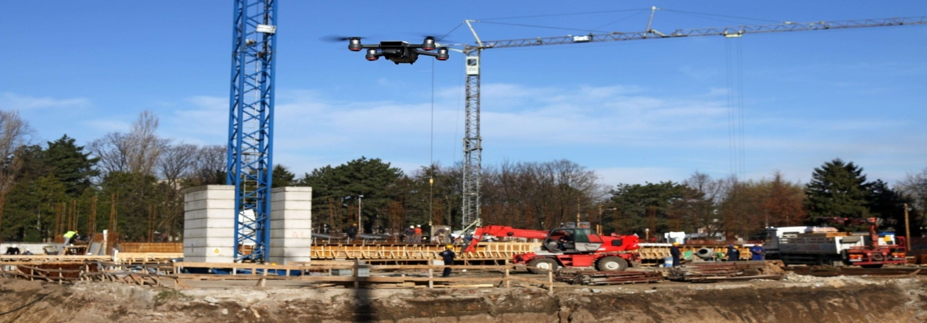

**Internet of Things (IoT)**

The Internet of Things (IoT) is transforming the construction industry. It does so by connecting various devices and equipment to a central network so that each element can function as part of a collaborative whole.IoT sensors can monitor the condition of machinery, the structural integrity of buildings, and even environmental factors in real-time. This data allows for predictive maintenance and early detection of potential safety concerns throughout the project’s lifecycle, which reduces downtime and the likelihood of accidents. IoT sensors can be used on construction sites to manage the concentration of particulate matter in the air to ensure that the site is not exposing workers and nearby residents to poor air quality levels..

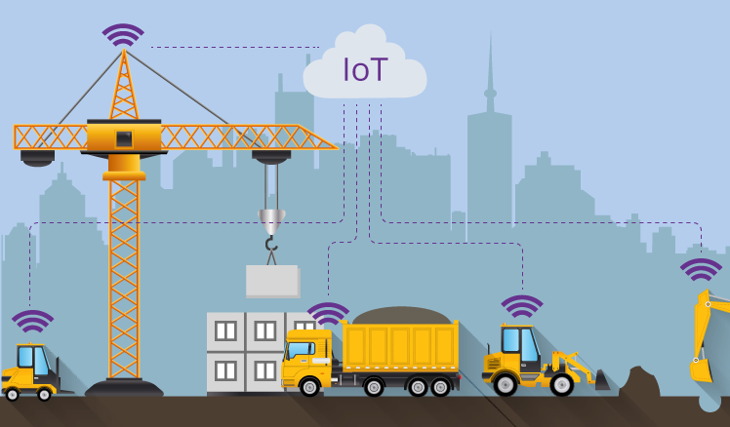

**Building Information Modeling (BIM)**

BIM technology enables the creation of digital 3D models for use on construction projects. These models provide a comprehensive view of the entire construction process, which allows for better planning and risk assessment.By simulating the construction process in a virtual environment, potential safety hazards can be identified and addressed before they become real-life incidents. Planning ahead is the key to reducing costly or dangerous situations. Building Information Modeling is a modern technique that has contributed in improvement of construction industries. Early detection of hazards during the life cycle of the project will contribute to protect the working environment from exposure to risks that will affect the time and cost.Before looking more closely at how building information modeling can improve health and safety within the construction industry and the built environment, it is worth clarifying the concept. BIM generates digital representations of the functional and physical characteristics of buildings and construction sites.

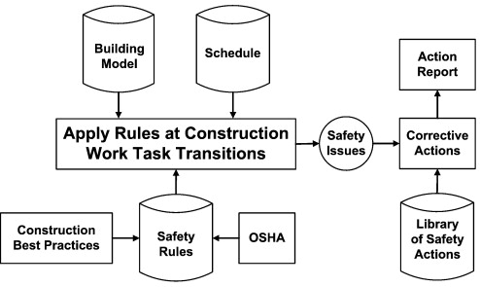

**Autonomous & Remote-Controlled Machinery**

Similar to the role drones have taken within the industry, the introduction of autonomous and remote-controlled construction machinery can greatly reduce the risk to human workers. These machines can handle tasks in hazardous environments or high-risk areas where it’s dangerous for people to work.This form of artificial intelligence (AI) technology may help decrease the likelihood of accidents associated with manual operations that were considered unavoidable in the past. Operators can control equipment from a safe distance while ensuring their safety and getting the job done efficiently and effectively. Autonomous and remote-controlled machinery can improve safety and productivity in construction by reducing the risk to human workers:

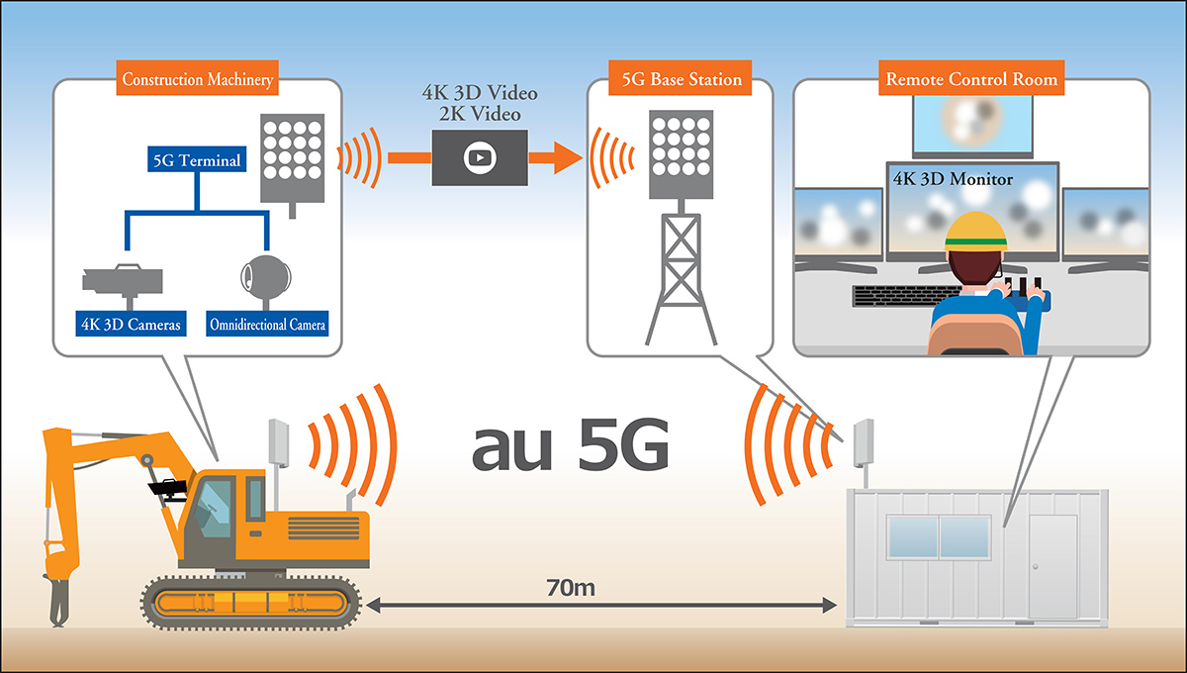

**Augmented Reality & Virtual Reality**

AR and VR technologies are being increasingly used in the construction industry for training and simulating dangerous scenarios. Workers can undergo virtual safety training before stepping into the field to practice handling emergencies without real-life risks.Beyond this capability, AR can assist workers in identifying safety hazards by overlaying digital information onto their physical surroundings.

