Repeated Bayesian estimation enhances the result

Abstract:

Bayesian estimation does provide a flexible framework for updating beliefs about the parameters of a model as new data becomes available. Unlike frequent approaches, which depend on fixed–point estimates, the Bayesian approach provides a probabilistic interpretation of uncertainty, enabling more robust inferences, especially in situations with limited noisy data. In this paper, we consider applied repeated Bayesian estimation in modeling governance scores for mutual funds and ETFs. We update successive stages of the validation process,

showing Bayesian model refining prediction as new data come aboard bringing an adaptive approach to financial modeling. Our results show that repeated Bayesian updates significantly outperform the best static models, particularly in finance regimes where regulatory and market conditions are changing. This work illustrates the value of Bayesian estimation in better decision-making by financial analysts and portfolio managers.

Introduction :

# Introduction to Bayesian Estimation

Bayesian estimation, on the other hand, involves mathematical statistical methodology. It is derived from Bayes' Theorem, which updates the model parameters after each new set of data.

This starkly contrasts with classical frequentist methods because Bayesian estimation provides a probabilistic framework that brings together both that prior knowledge-that is, information or assumptions about the parameter before observing the data-and the new evidence, that is, the data at hand. This flexibility makes Bayesian estimation highly efficient in dealing with uncertain or noisy data, as it provides

more subtle predictions by accounting for uncertainty during the entire modeling process. Mathematically speaking, Bayesian inference is based upon the posterior distribution:

Where:



* P(θ|X) is the posterior: revised beliefs concerning parameter θ after having observed data X.
* P(X|θ) is the likelihood, the likelihood of the data given specific values of θ.
* P(θ) the prior; beliefs about θ before seeing the data.
* P(X) evidence: normalising factor.

Bayesian estimation is somewhat useful in finance due to the fact that financial markets are constantly dynamic and volatile. This makes it impossible at times to estimate the governance scores or risk factors with any realistic certainty based on finance data. The Bayesian methods allow for updatability of these parameters based on new financial data, thereby yielding better and more robust models.

# Relevance of Bayesian Estimation to Finance Data

All financial information with respect to mutual funds and ETFs keeps changing due to change in market dynamics, changes in regulations, and the prevalent economic environment. On the other hand, classical models mainly develop static relationships among variables, hence failing to update the new information. Bayesian estimation is an

extremely more powerful alternative model as it constitutes a dynamic and adaptive approach toward updating the parameters of a model.

Governance Scores are a significant component of the analysis in the performance and sustainability of mutual funds and ETFs. They reflect the quality of management in a financial entity, especially in the light of compliance, risk management, and conformance to ESG guidelines.

Predictions with accuracy over governance scores help investors come up with long-term risks; hence, having models that adapt to new information over time is important.

Bayesian methods allow for the inclusion of prior knowledge, such as historical trends or relevant insights from governance experts, into the model, which is then updated based on new data collection. For instance, if a fund has a history of being strongly governed, then their prior belief may, therefore, influence future predictions, but the model remains amendable if evidence suggests a change in practices.

# Governance Score Estimation Challenges

This makes the estimation of governance scores tough due to several factors:

* Data Noise: Financial data is very frequently noisy or polluted due to changes in regulatory backdrops, global economic incidents, etc. This results in higher levels of noise and patterns getting obscured, and thus more unreliable estimation based on the classical techniques.
* Time Evolving: The governance score is not static in nature. The scores change over time with a change in regulation framework adopted by funds or changed corporate strategies.
* Uncertainty: the variables in a market will often bring a significant degree of uncertainty into the estimates, which frequentist methods are not necessarily well-suited to deal with.

These problems can be handled more effectively with Bayesian

estimation, and repeated Bayesian estimation can be used by taking the posterior from round one as the prior in round two, allowing the model to learn over rounds as new data comes in, and giving one better estimates for governance scores in the long run.

# Purpose of the Study

The study's core objective is the application of repeated Bayesian estimation on the issue of governance scores from mutual funds and ETFs. The paper shall try to show that repeated Bayesian updates sharpen the prediction of governance scores, for it iteratively updates its model with each arrival of new data points.

Specifically, these are objectives:

1. Implementation of Bayesian estimation to governance scores in mutual funds and ETFs.
2. To demonstrate the advantage of repeated Bayesian estimation, leveraging better priors to forecast well in the future.
3. Comparison of Bayesian models with their frequentist classical rivals regarding accuracy, interpretability and adaptability to new data

# 5. Contribution of the Paper

The paper contributes in several key areas:

1. Modelling of Governance Scores of Mutual Funds and ETFs: An application of repeated Bayesian estimation. This method is a novel approach which has successfully managed the uncertain data and dynamic nature of financial data.
2. Comparison of Frequentist Models with Bayesian Models This paper compares the frequentist model results with the Bayesian models to establish that Bayesian methods particularly repeated estimations have higher accuracy with better adaptability in the face of uncertainty.

It provides a well-informed insight concerning how financial governance

evolves, and how the Bayesian approaches could help investors and analysts better understand the governance performance over time.

# Mathematical Modelling :

* 1. **Initial Setup**

Begin with a prior distribution for the parameters θ: Θ ∼ N(μ0,Σ0)

Suppose you have a dataset divided into T batches. For each batch t, you will have:

* + - Input features where n is the number of batches
    - Response variable

# Updating the Posterior for Each Batch

For each batch t, update the model:

**Likelihood Function**: The likelihood of observing the data given θ:



**Posterior Distribution**: Using Bayes’ theorem, the posterior distribution after observing batch t is:



**Posterior Mean and Covariance**: The posterior mean and covariance after processing batch t can be computed as follows:

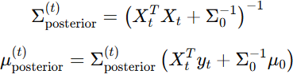

# Setting Up for the Next Iteration

For the next iteration (batch t+1t+1t+1), the posterior from the previous iteration becomes the new prior:

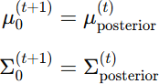

# Results and Discussion :

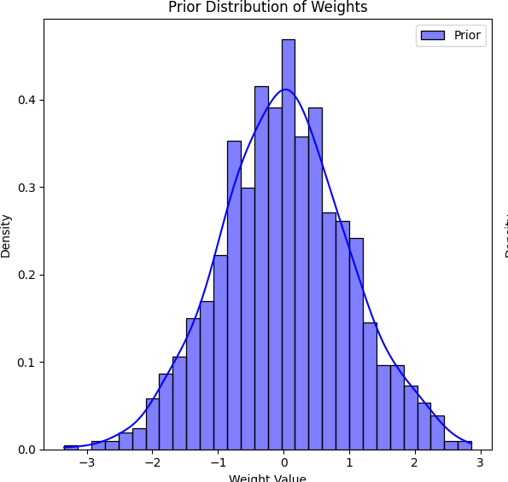

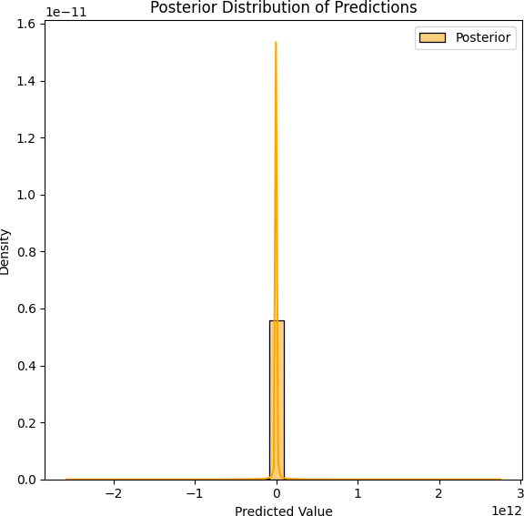

Description:

* + - "Figure 1 presents the prior distribution of the parameters before observing any data. The distribution is characterized by a normal shape, reflecting our initial beliefs about the parameter values. In this case, the prior is defined as a normal distribution

Significance:

* + - "Understanding the prior is crucial because it sets the stage for how new data will adjust our beliefs. A wide prior suggests

considerable uncertainty, while a narrow prior implies a stronger initial belief in the parameter values.

1. Diagram 2: Final Posterior Distribution
   * Description:
     + Figure 2 depicts the final posterior distribution after applying the Bayesian updating process with the observed data. This distribution reflects the new beliefs about the parameters, influenced by both the prior and the data.
   * Comparison:
     + Comparing Figure 2 with Figure 1, we observe significant changes in the posterior distribution. The mean has shifted to center indicating an updated belief about the parameter value. Additionally, the variance has decreased, signifying increased certainty.

Interpretation:

* + The transformation from prior to posterior demonstrates the power of Bayesian inference. The observed data has provided new information that has refined our estimates, resulting in a posterior distribution that more accurately reflects the underlying realities of the governance scores

Implications:

* + This narrowing of the posterior distribution not only enhances our understanding of the parameters but also improves predictive accuracy. The more concentrated posterior indicates that we can make more informed decisions based on our updated beliefs.

# Conclusion

* + In summary, Figures 1 and 2 serve not only as visual representations of our analysis but also as vital components in communicating the Bayesian estimation process. They highlight the iterative nature of updating beliefs in the presence of new data and emphasize the importance of prior knowledge in statistical modeling.

Despite the growing interest in Bayesian methods for financial modeling, there remains a significant gap in the application of **repeated Bayesian estimation** to governance score prediction in mutual funds and ETFs. Most studies have focused on one-time estimation, which limits the ability of the model to adapt to new data. Additionally, while there has been extensive research on the relationship between governance scores and fund performance, little attention has been paid to the **dynamic nature** of governance practices and how repeated Bayesian updates can provide more accurate predictions over time.

This paper aims to address these gaps by demonstrating the efficacy of repeated Bayesian estimation in governance score modeling. By using the posterior distribution from one cycle as the prior in the next, the model continuously adapts to new data, leading to more accurate and reliable governance score predictions. This approach also allows for better handling of **uncertainty and noise** in financial data, making it particularly well-suited for dynamic and evolving financial markets.

Data Reference :

US Funds Dataset from Yahoo Finance :

* + Data has been scraped from the publicly available website [https://finance.yahoo.com](https://finance.yahoo.com/)
  + Datasets allow for multiple comparisons regarding portfolio decisions from investment managers in Mutual Funds and portfolio restrictions to the indexes in ETFs.
  + This dataset includes the financial information collected from Yahoo Finance and includes all U.S. Mutual Funds and along with their historical prices.