COMPARATIVE STUDY ON ARTIFICIAL URINE SAMPLES WITH CONTROL AND TESTING EFFICANCY BY DIPSTICK AND MANUAL ANALYSIS
Vinoth Kumar.V¹, Lawanya.S²
¹Assistant Professor, Department of Hematology, MMM College of Health Sciences, Mogappair, Chennai, Tamilnadu,India
²Student, Department of Hematology, MMM College of Health Sciences, Mogappair,Chennai,Tamilnadu,India
ABSTRACT
Artificial urine has more comfortable and safety over human urine for nurse and doctors, allied health science use artificial urine for their training purposes. The study demonstrates the efficiency of artificial urine added abnormal constitutes results are interpreted by dipstick method and manual methods by using against control. Prepared two different types of artificial urine and the P^{H} was adjusted within 5 -8 ranges, the abnormal constitutes such as glucose, protein acetone, blood, glucose, bilirubin, are added to the artificial urine tested by dipstick method and manual test against control. In this study results showed, both artificial urine samples added abnormal constitutes results were very similar to the control urine.
Keywords: Artificial urine, Control urine, Dipstick method. Manual test, Abnormal constitutes
- INTRODUCTION
Urine is made of water 95% and nitrogenous 5% waste including urea, ammonia, creatinine, uric acid are normal constituents. Artificial urine refers as synthetic urine by laboratory created solution that resemble as the chemical composition of human urine. the simple artificial urine used for calibration of urine testing equipment in laboratories and used in research setting for experimental purposes. In mainly to laboratory safety practice of students to technological competence in artificial urine to eliminate the contamination. the artificial urine prepared and tested against control human sample by dipstick method and manual methods for encountering efficiency .

- MATERIALS:
Study place: MMM college of health sciences, Chennai
Duration: November -2023 (1 Month)
Selection of artificial urine: Components are recommended by authors.
Method of artificial urine preparation:
Sample I: 100ml of distilled water with Urea-25g, Sodium chloride-9g, Disodium hydrogen orthophosphate anhydrogen-2.5g, Ammonium chloride-3g, Creatinine-2g, Potassium di hydrogen orthophosphate-2.5g.Adjust the PH 5-7 range.
Sample II: 100ml of distilled water with Urea -17.3mg, Sodium chloride-1.41mg,Potassium chloride -0.280mg,Calcium chloride-0. 50mg, Ammonium chloride-0. 50mg, HCL-0.73g. Adjust the PH 5-7 range.

Adding abnormal chemical constitutes:
The abnormal constitutes such as blood 50µ𝑙, acetone 40µl, glucose250mg, protein 200mg, bilirubin30g added to the sample I and II, control urine for positive reporting. Mix until the abnormal constitutes are dissolved.

- METHODOLOGY
Figure1: Study Protocol.
- RESULTS AND DISCUSSION

Table 1.Quantitative analysis report of strip method:
Sample type | Glucose | Protein | Ketone | Bilirubin | Blood | Specific gravity
Control | 1+ | 1+ | 4+ | 1+ | 1+ | 1.010
Artificial urine sample -I | 3+ | 1+ | 4+ | 1+ | 1+ | 1.005
Artificial urine sample -II | 1+ | 4+ | 4+ | 1+ | 1+ | 1.010

Figure 2.Quantitative analysis report of strip method:
Result interpretation | Dipstick samples result
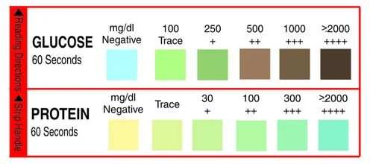 | Control | S-I | S-II
 |   1+ |   3+ | 1+
 | 1+ | 1+ | 4+
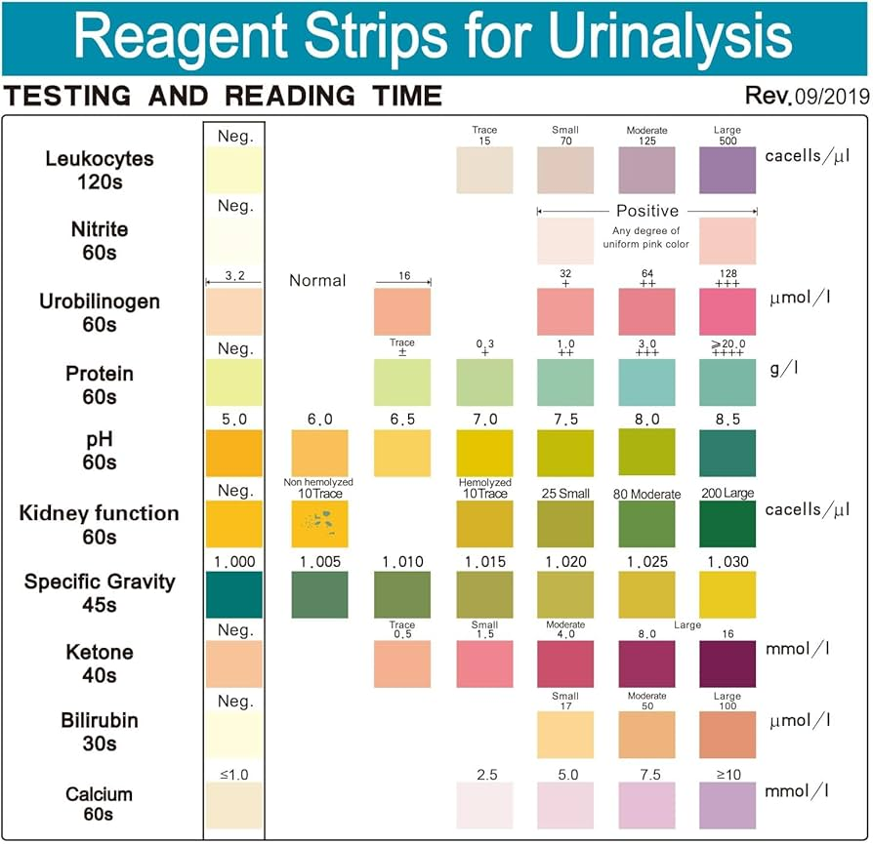 | 4+ | 4+ | 4+
 |   1+ | 1+ | 1+
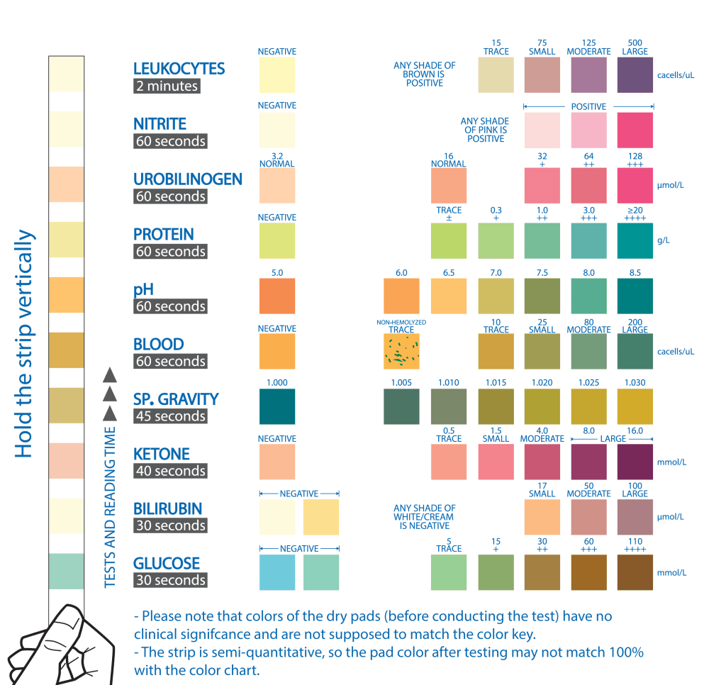 | 1+ | 1+ | 1+
 | 1.010 | 1.005 | 1.010
Table 2.Quantitative analysis report of manual method
Sample type | Glucose | Protein | Ketone | Blood | Bilirubin
Control | 1+ | 4+ | 1+ | 3+ | 1+
Artificial urine sample -I | 2+ | 1+ | 1 | 3+ | 1+
Artificial urine sample -II | 1+ | 4+ | 1+ | 2+ | 2+
Figure 3.Quantitative analysis report of manual methods:
Result interpretation | Manual methods samples results
Glucose | Control | S-I | S-II
 | 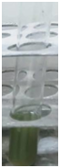 1+ | 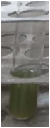 2+ | 1+
Protein | 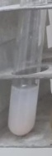  4+ | 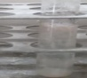  1+ | 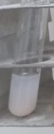  4+
Ketone | 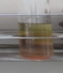  1+ | 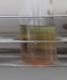  1+ | 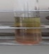  1+
Blood | 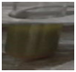  3+ | 3+ | 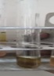  2+
Bilirubin | 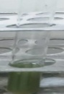  1+ | 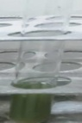  1+ | 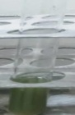  2+

- CONCLUSION
The study demonstrates the efficiency of artificial urine added abnormal constitutes results are interpreted by dipstick and manual methods by using control urine sample. In this study results based on the chemical reaction shows, both artificial urine samples abnormal constitutes added results were similar to the control sample in dipstick method and manual method.
6. ACKNOWLEDGEMENTS
My sincere thanks to Dr.Deepa C Philip, Principal, MMM College of Health Sciences, Mogappair, Chennai. 600 107, India.

7. REFERENCES
- Brain R, shmaefsky, The American Biology Teacher, kingwood college, kingwood, Texas (1989) , Journal Article ”Artificial urine for laboratory testing”, University of California Press, Vol. 57, No. 7 (Oct., 1995), pp. 428-430 .
- Purva Mathur. Indian j Med Res 2011 Hand Hygiene: back to the basics of infection control, Nov; 134(5): 611–620.
- Latifa B. khan, Hannah M. Read, Stephen .Ritchie , and Thomas proft 2017 ,”Artificial urine for teaching urinalysis concepts and diagnosis of urinary tract infection in the medical micro- biology laboratory”, J Microbiol Biol Educ ,v.18(2); 2017 .
- Kika Veljkovic, Karina Rodriguze-Capote Vipin Bhayana, robin Pickersgill, john Beattie, Lorna Clark 2012 Assessment of a four-hour delay for urine samples stored without preservatives at room temperature for urinalysis, Clin Biochem,2012 Jul;45(10-11):856-8.
- Sarigul, Neslihan ; Korkmaz, Filiz ; Kurultak, İlhan,,A New Artificial Urine Protocol to Better Imitate Human Urine,Scientific reports, 2019-12, Vol.9 (1), p.20159-11, Article 20159.
- Kanyarat Sueksakit and visith thongboonkerd 2021 ,Optimization of artificial urine formula for in vitro cellular study compared with native urine. Med Sci 2021; 18(14):3271-3279.
- T. Brooks, C.W Keevil. 1997 A simple artificial urine for the growth of urinary pathogen. Letters in Applied Microbiology, Volume 24, Issue 3, 1 March 1997, Pages 203–206.
- Jolanta prywer, Marcin Kozanecki , Ewa Mielniczek Brzoska and Agnieszka Torzewska Soild phase precipitating in artificial urine in the absence and presence of bacteria proteus mirabilis – A contribution to the understanding of infection urinary stone formation, April 2018,Crystals 8(4):164.
- Sharma Reetu, Kar A C, panda B K 2015 Study of Taila Bindu Pariksha on artificial urine. February 2015,International Journal of Research in Ayurveda and Pharmacy 6(1):15-17.
- Somachai Chutipongtanate, poitr Chomczynski , Nicoletta sacchi ,grey Hermanso 2010 Systemic comparisons of artificial urine formulas for in vitro cellular study, 2010 Jul 1;402(1):110-2.
- Carolin psotta ,E/melie j, Nilsson Thomas Sjoberg and magnus 2023 Bacteria- infected artificial urine characterization based on a combined approach using an electronic tongue complemented with H-NMR and flow cytometry, Biosensors 2023, 13(10), 916.

