**Automatic Garbage Disposal System**

**Dr. Atul H Karode1, Dr. Shekhar R Suralkar2**

1Associate Professor, Electronics and Telecommunication department, SSBT’s COET Bambhori Jalgaon, (M S) India

2Professor, 1Associate Professor, Electronics and Telecommunication department, SSBT’s COET Bambhori Jalgaon, (M S) India

**ABSTRACT**

This paper is related to human health and hygiene, as well as the cleanliness of the environment, the effectiveness of garbage disposal is very important. Although the most common ways of disposing garbage are bins and bags, both these methods are implemented manually. But it is observed that garbage disposal becomes a highly time-consuming and difficult process, and places such as schools, restaurants, hotels, offices, production plants are adversely affected. To overcome this problem, this paper proposes an automated system, implemented with the use of electronics, introduced in such places, would prove to be highly effective This job can easily achieve, with minimal labour and hazards to health, as well as time and money being saved in the process. This idea was the backbone of proposed system mentioned in this paper. The work of collecting and disposing garbage was highly tedious, because it requires human efforts and hygienic. So that is where the base of proposed project mentioned in this paper was laid. In this paper the garbage disposal system using Arduino is proposed

**Keywords:** Garbage, IR (Infra-Red) technology, Solenoids, Actuators, Arduino.

1. **INTRODUCTION**

The primary aim for this paper was to introduce a way in which garbage could be collected and disposed in an efficient and effective manner. To achieve this, the following objectives have to be completed.

* Studying the problem of garbage disposal at a school, restaurant, office, hotel,
* Production plant or any other suitable location.
* Develop a solution to that problem.
* Studying the technologies that can solve the problem.
* Designing and developing a proposed system for solving the problem.

The Users for proposed system are for the benefit of school children, can be used and implemented by various other types of individuals as well. For example, restaurant, production plant or any other public place where the disposal of garbage occurs on a daily basis, this system can be used by the people frequenting such places, to effectively dispose garbage. The Inputs for hard ware is Signals from the IR sensory, Signals from radio transmission. Inputs from the keypad of the remote controller to set the initiation times, Switch to check if the lid is open, the executed action is the garbage collector travels along the pre-defined path and receives garbage from garbage containers. Dumps the garbage at a given place Finally Sounds an alarm if the lid is open or jammed.

**2. LITERATURE SURVEY**

The survey is carried out for the purpose of proposed system. As we look to figures, it is directly proportional to increase in urbanization and industrialization. This is the main cause of generation of large amount of waste. As per the report published by World Bank, approximately 1.3 billion tons of municipal waste is generated every year and it is expected to rise to approximately 2.2 billion tons per year by 2025. Due to this waste lies littered in the surrounding, dumped on open lands and this becomes major problem for various types of disease-causing bacteria and viruses which is why waste management is of vital importance. Segregation makes it possible to reuse and recycle the waste effectively.

The authors Mazzanti & Zoboli et.al quotes that Solid waste management has become one of a major concern in environmental issues. The authors Kathiravale & Mohd Yunus, 2008 et.al highlighted that this is particularly true to urban areas where population is rapidly growing and amount of waste generated is increasing like never before. Current earth’s population is 6.8 billion and it is estimated that almost half of this population lives in urban areas. Authors Mazzanti & Zoboli, 2008 et.al mentioned that Waste generation increase proportionally to this population number and income, creating the needs of effective management. Urbanization and industrialization lead to new lifestyles and behavior which also affects waste composition from mainly organic to synthetic material that last longer such as plastics and other packaging material (Idris et al., 2004). The authors Aye & Widjaya says that the management of waste become complex and the facilities provided cannot cope with the increasing demand and needs. Therefore, best approach needs to be implemented immediately while considering environmental, social and economic aspects (Aye & Widjaya, et.al 2006). The drivers of sustainable waste management were clarified by Agamuthu et al. (2009), which include human, economic, institutional and environment aspect. The study suggests by Couth & Trois says that each driving group should be considered in local context as managing solid waste for a particular society may differ from the others. For example, waste managers in Africa need to tackle some issues including, lack of data, insignificant financial resources, vast different of amount and waste types between urban and rural area, lack of technical and human resources, low level of awareness and cultural aversion towards waste (Couth & Trois, 2010 et.al). On the other hand, shekdar concluded that the problems faced among Asian countries differ with two distinct groups; developed and developing countries. While some of the countries are having specific national policy on solid waste management, some others experience problems such as increasing urban population, scarcity of land, services coverage area, inadequate resources and technology, and so on (Shekdar, 2009 et.al).

**3. PROPOSED SYSTEM**

The figure 1 shows proposed system for Automatic Garbage Disposal System.

.

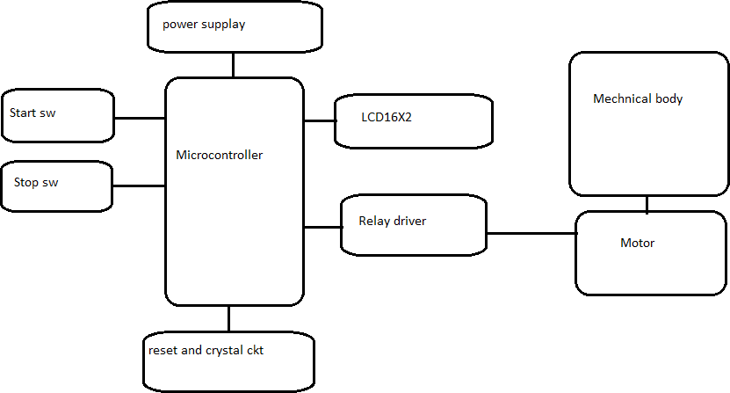

Figure 1. Proposed Ardiuno Based Garbage Disposal Machine

The operation of proposed system is monitoring the garbage level by IR Sensor and disposing it by actuators and crushing motors.

**3.1 HARDWARE REQUIREMENT**

In this section the design of system is discussed. In this system, several modules such as remote controller unit, radio transmitter, radio receiver, IR sensors, motor controller and DC motors are included. The main part, which connects all these modules, are the micro controller ICs. It acts as the brain of the system, performing all the processing between the inputs and the outputs**.**

Before using the garbage collector, you need to define the time in which the Garbage Collector should initiate. For an example, the user can set the times for the day at 7.30 a.m. after school started and 2.00 p.m. after school is finished. To input the values, in proposed system developed a Remote Controller Unit, which enhances the usability of the system. The Remote Controller Unit has an LCD display and a keypad to assist the user interface. If the user wants to start the garbage collection process at a random moment, he/she can press a specific button on the Remote Controller Unit, which initiates the garbage collection at once.

**3.1.1 Garbage Dump**

Garbage dump is located bit far from the classrooms to keep the learning environment clean. When the garbage collector reaches the garbage dump it will automatically dispose the garbage into the garbage pit. Then it will go back to the starting point or if the garbage

collection process is discontinued, because the Garbage Collector was full, then it will return and continue to collect garbage from where it has last stopped.

**3.1.2 Keypad**

Before using the garbage disposal System, you need to set the initiation times. System uses a keypad to input those values. Or else the user can press a specific button so that the Garbage Collector initiates at once. The keypad is in the Remote Controller Unit and the user can control the system through the unit from a distance.

**3.1.3 Microcontroller**

The system uses ATMEGA328 microcontrollers . This microcontroller processes the inputs from the keypad to produce outputs to the LCD display and the radio transmitter. The microcontroller reads and writes data from and to the RTC. It coordinates all the components as per given instructions to produce outputs.

**3.1.4 LCD Display**

The LCD display enhances the user friendliness of the Remote Controller Unit. User can have visual information about the status of the Remote Controller Unit. Information such as the current time, timers that are set for the initiation of the Garbage Collector, status of the radio transmitter are displayed.

**3.1.5 Garbage Collector**

The garbage collector is program in such way that each class on pre-defined times finding it way on the black path. When it reaches a garbage container, it will receive garbage from the garbage container. When the garbage bin is full it will automatically go to the waste dumping site, drop off the garbage and will continue the garbage collection from where it stopped before.

**3.1.6 IR Sensors**

In this system, IR sensors are used for several purposes. Since IR rays are absorbed by black surfaces, it can be used to choose between black and other surfaces. In the proposed system by using IR sensors that take 3 different inputs into the system.

* Detect the path of the black line, which marks the route of the garbage collector.
* Sense whether the garbage collector is full or not
* Signal the Garbage Container to drop garbage

To sense whether the Garbage Collector is full or not the phototransistor and the IR LED of an IR sensor is used.

IR LEDs are mounted on either side of the Garbage Collector on appropriate positions to signal the Garbage Container. The IR light is picked up by a phototransistor, which is connected, to the Container.

**3.1.7 Actuators Lid/Door**

Actuators are used to open and close the doors and lids of both the Garbage Container and the Garbage Collector.

**3.1.8 RF Transmitter**

This unit transmits signals from garbage collector to the garbage container to open its door making it to drop the garbage. First, we use a signal encoder, which can encode up to four bits into a single signal. Then the RF transmitter will transmit that signal to the garbage collector.

**3.1.9 Motor Left/Right**

The proposed system uses the DC motors to move the garbage collector around the selected environment. normal DC motors have very high rpm, and can only handle a little amount of torque, 120 RPM, DC geared motors are used.

**3.1.10 Motor Controller**

In the system interface, the motors cannot directly connect the motors into the micro-controller, because there are situations where we have to control the speed of the motors, such as when the garbage collector is turned. So by using the PWM (Pulse Width Modulation) method to control the voltage given to the motors.

**3.1.11 H-Bridge IC**

Motor Controller too is an H-Bridge IC. The H-Bridge IC is used an to drive the actuators, which, requires a high voltage and amperage and reversed voltage drop to drive the actuator in inverse direction. The H-Bridge IC takes the logic signals directly from the microcontroller to produce the required current for the actuators.

**3.1.12 Garbage Level Checker**

The garbage level is checked by an IR sensor and a phototransistor, which is positioned inline, and on the correct level inside the Garbage Collector. When the garbage is over a certain limit, it obstructs the IR light, which is pointed at the phototransistor. This determines the Garbage Collector to stop the current process, proceed directly to the dumpsite and to return and continue the process from where it last stopped.

**3.1.13 Garbage Container**

Purpose of garbage containers is to hold garbage temporally until the garbage collector collects them. In proposed design the garbage containers are fixed in to the outside walls of classrooms. So, students can dump garbage in to them whenever they want.

**3.2 Processor**

**3.2.1** **Microcontroller**

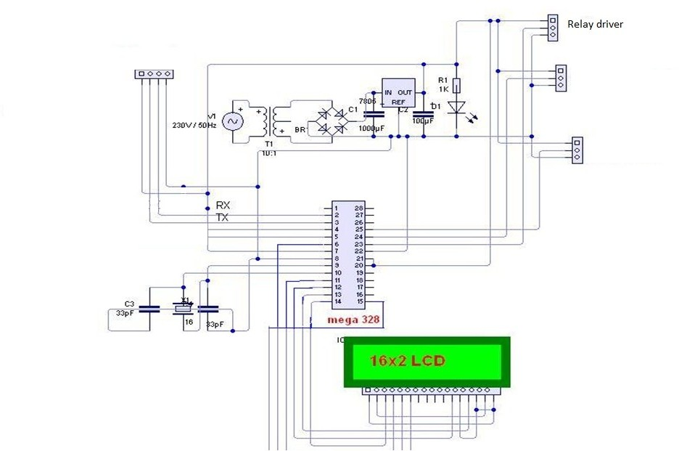Microcontroller is the main part of the whole system. In proposed system, the Arduino ATMEGA328 is used as the micro controller. It is the important part and generates control signal for the system. It takes all the inputs of the system and then performs the logic operations and arithmetic operations. Then it outputs necessary signals to the output modules. Therefore, this chip is like a smaller, simpler version of a computer CPU.

Figure 2 Circuit diagram for proposed Automatic Garbage disposable system

**4. SOFTWARE REQUIREMENT**

In proposed system programming is done by code composer studio (CCS), which is a microcontroller programming language, to program the PIC ICs. The Garbage Collector and the Remote Controller Unit has its own programs written into PICs. The functions of the two programs are described below.

Remote Controller Unit- This unit interacts with the user. The user can input the real time to the unit and set two times for which the Garbage Collector to start. The LCD displays a main menu, two timers, set time, current time screens. The keypad checks for a key press at a percentage rate of ‘buffer size’. This preload value will give an RTCC interrupt rate of 100Hz (once every 100ms) with a pre-scaler of 256. If a key press is detected, it is put in the buffer ‘k’.

Garbage Collector The second program part is of garbage collector. Even though the Collector does not interact with the user, it plays the key role of the system. To accomplish its function the microcontroller has programmed to meet up with every possibility so that the program is somewhat complex.

**5.RESULTS**

The execution result is depending on garbage collection. The Garbage Collector takes its input primarily from the sensor array. The input values from each sensor the sensor array is assigned from ‘ir1’ to ‘ir5’. By using IR sensor, it is noted that When the sensor is on and above the black surface the input is set to ‘high’(1) and when it is over a white surface the input value is set to ‘low’(0).From execution of hardware it is seen that if all the sensors are ‘high’ then the function ‘forward()’ is initiated. The function sets the duty of the pulse width modulation one and two to its maximum value thus causing the motors to drive forward at maximum speed. When the sensor ‘ir5’ is set to ‘low (0)’ then the function ‘right ()’, initiates. The function sets the duty of PWM one to half of its maximum value and PWM two to its maximum. This causes the motor to the right to rotate at half of its maximum speed and the motor to the left rotates at the maximum speed thus turning the Collector to the right. The ‘left ()’ function too occurs in the same way and the only difference is that the sides are inverted. Thus, the garbage is crushed by motors and disposed by segmenting into little and small pieces.

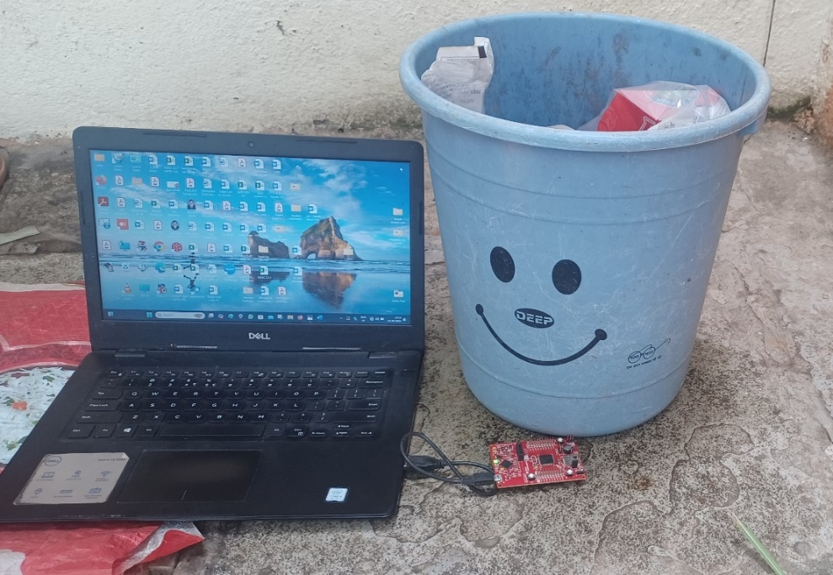

**Figure 3:** Photograph of Garbage collector with Controller unit

**6. CONCLUSION**

This paper proposes a smart garbage disposal system in which waste or garbage is monitored sensed and got disposed as it crosses threshold So it is concluded that the ‘Automatic Garbage Disposal System’ can be used effectively and efficiently in real life scenarios. It is now essential and integral part for waste disposal system.

**7. REFERENCES**

[1] Mazzanti & Zoboli “Waste generation, waste disposal and policy effectiveness:” Evidence on decoupling from the European Union August 2008.

[2] Aye, L. and Widjaya, E.R. (2006) “Environmental and economic analyses of waste disposal options for traditional markets in Indonesia. Waste Management, “26, 1180-1191. Resources Conservation and Recycling 52(10):1221-1234

http://dx.doi.org/10.1016/j.wasman.2005.09.010

[3] Agamuthu, “Drivers of sustainable waste management in Asia” June 2009 27(7):625-33,

[4] Couth, R. and Trois, C. (2012) “Cost Effective Waste Management through Composting in Africa. Waste Management”, 32, 2518-2525.

[5] Shekdar, A.V. (2009) Sustainable Solid Waste Management: An Integrated Approach for Asian Countries. Waste Management, 29, 1438-1448.