**A STUDY ON COMPETENCY MAPPING AMONG TEACHING FRATERNITY IN TUMKUR**

**Dr. Grace Hemalatha**

Associate professor , Department of MBA, Shri Devi Institute of Engineering and Technology , Tumkur, Karnataka , India ([graceprabhu2000@gamil.com](mailto:graceprabhu2000@gamil.com) )

**Mr. Sharath B R**

Associate professor , Department of MBA , Shri Devi Institute of Engineering and Technology , Tumkur , Karnataka, India ( [sharathsharu.7804@gmail.com](mailto:sharathsharu.7804@gmail.com))

**Abstract**

Educational research aimed at enhancing teaching effectiveness and educational outcomes. This study endeavours to explore the competency landscape among educators in Tumkur, focusing on identifying the key competencies essential for effective teaching in the contemporary educational landscape. The research employs a mixed-methods approach, combining qualitative interviews and quantitative surveys to gather comprehensive data.

The qualitative phase involves in-depth interviews with a diverse sample of educators in Tumkur to gain insights into their perceptions of competency requirements in teaching roles. These interviews will be analysed thematically to identify common themes and patterns related to essential competencies.

Subsequently, a quantitative survey will be conducted among a larger sample of teaching professionals in Tumkur to quantify the prevalence and importance of identified competencies. Statistical analyses will be employed to analyse the survey data and determine the significance of various competencies in the teaching fraternity.

The findings of this study aim to contribute to the existing body of knowledge on competency mapping in the field of education, particularly within the context of Tumkur. The results will have implications for teacher training programs, professional development initiatives, and educational policy formulation aimed at enhancing the quality of teaching and learning in Tumkur and similar educational settings.

**Introduction**

Competency mapping has emerged as a crucial aspect in various professions, including the field of education. In the dynamic landscape of education, the roles and responsibilities of teachers have evolved significantly. With changing educational paradigms, there is a growing need to assess and understand the competencies possessed by the teaching fraternity. Tumkur, a prominent educational hub in Karnataka, provides an intriguing context for exploring the competency mapping among teachers.

This research paper aims to investigate the competency mapping among the teaching fraternity in Tumkur. Competency mapping involves identifying, assessing, and developing the competencies required for effective job performance. In the context of education, it encompasses the knowledge, skills, attitudes, and behaviours essential for teachers to excel in their roles.

The teaching fraternity plays a pivotal role in shaping the future generation by imparting knowledge and fostering holistic development among students. Hence, understanding the competencies inherent in teachers is crucial for enhancing the quality of education and promoting professional development.

**Methodology**

Competency mapping is a crucial process in understanding the skills, knowledge, and attributes essential for effective teaching. The methodology adopted for this study involves a systematic approach to gather relevant data and analyse it to draw meaningful conclusions. Firstly, a comprehensive review of existing literature on competency mapping in education and related fields was conducted. This step provided a theoretical framework and insights into previous studies, enabling the identification of key concepts, variables, and methodologies relevant to the research topic.

Following the literature review, a mixed-methods approach was employed to collect primary data. A structured questionnaire was designed based on the identified competencies and distributed among teachers in various educational institutions across Tumkur. The questionnaire aimed to assess the perception of teachers regarding their competencies and the importance of different skills and knowledge areas in their profession.

**Statement of Problem**

In the context of Tumkur, there exists a pressing need to comprehensively understand the competency levels within the teaching fraternity. Despite the pivotal role teachers play in shaping the future generation, there is a lack of empirical data on their competencies, especially in the Tumkur region. This knowledge gap hampers efforts to enhance teaching effectiveness, curriculum development, and overall educational quality. Therefore, the primary problem addressed in this research is the absence of a detailed competency mapping of teachers in Tumkur, hindering informed decision-making processes aimed at improving educational outcomes.

**OBJECTIVES**:

1.Identify areas of strength and weakness among teaching their subject.

2.Examine the gender-based variation in teaching competencies

3.Examine the role of technology in enhancing teaching competencies.

4.Investigate the link between emotional intelligence and effective teaching.

5. Explore the roe of mentoring in developing teaching competencies.

**Data Analysis, Interpretation and suggestion**

**Opportunities**

|  |  |  |
| --- | --- | --- |
| Sl. No | No. of Respondents | Percentage |
| 1 | Confident | 52% |
| 2 | Project and Presentation | 36% |
| 3 | Interest during classes | 44% |
| 4 | communicating with students from different gender background | 44% |
| 5 | Impact on gender on teaching competencies | 62% |
| 6 | Professional growth and lifelong training | 28% |
| 7 | Skill acquisition | 32% |

1. It can be analyzed that. The 28% of people are response high confident in understanding core concepts with in subject. 52% of people are confident,
2. The 26% of people are response traditional exams typically assess the student by understanding subject. 36% of people are response project and presentation,
3. The 32% of people are response excellent in keep standards engaged and interest during subject classes. 44% of people are response very good, Because utilizing the range of teaching techniques interactive activities and real-world examples
4. The 30% of people are response highly confident in communicating the students from different gender background .44% of people are response confident, Because respect, and open communication, creating a supportive atmosphere where every student feels respected, valued, and understood, irrespective of their gender
5. The 34% of people response no impact of gender on teaching competencies, 62% of people response positive impact, . Because hereby enriching the learning atmosphere. Moreover, this diversity serves as a valuable model for students,
6. The 28% of people are response skill acquisition is the primary goal of mentoring in the context of teaching professional growth and lifelong training. Because understanding, and effective communication among students, thereby mitigating tensions and promoting harmonious interactions.
7. The 38% of people are response facilitating continuous training mentoring contribute to a teacher’s professional growth and lifelong training. 34% of people are response Encouraging participate workshops, 12% og people are response Providing opportunities for collaborative learning, 16% of people are response all of above. most of respondent are Facilitating continuous training by mentoring contribute to a teacher’s professional growth and lifelong training. Because teachers gain valuable insights, strategies, and feedback, fostering a culture of continuous learning and improvement in their practice

**Challenges**

|  |  |  |
| --- | --- | --- |
| S.No | Particulars | Percent |
| 1 | When considering gender differences | 22 % |
| 2 | Collaborate with colleagues | 32% |
| 3 | Technology contributes to personalized learning | 32% |
| 4 | Limited access to interactive content | 44% |
| 5 | social skills in creating positive and inclusive classroom environment | 35% |
| 6 | Handle stressful situation or conflicts in the class room | 40% |
| 7 | Emotional intelligence impact teachers’ | 44% |

1. It can be analyzed that 54% of respondents are Male and 48% of respondents are Female. This suggests a slight preference or higher response rate among males in the survey compared to females.
2. 36% of people are response lack of relevant data challenges might arise in assessing teaching competences when considering gender differences. Because It becomes crucial to maintain fairness in assessment by navigating diverse reasoning styles and mitigating potential cultural biases.
3. The 36% of people are always collaborate with colleagues to share teaching strategies and experience. . Because being the vital need for diverse insights and shared best practices.
4. The32% of people are response by providing standardization material technology contribute to personalized learning. 34% of people response by enabling adoptive learning platform, 20% of people response by limiting student to access to information, 14% of people are response by encouraging individual study plans. most of respondent are enabling adoptive learning platform helps technology contribute to personalized learning. Because unique needs, preferences and progress of each learner enhancing the effectiveness and customization of learning journey.
5. The 20% of people are response decreased student engagement by using educational apps in teaching. 44% of people response limited access to interactive content, 22% of people are response enhancing learning through gamification, 14% people are response reduced teacher’s flexibility. most of respondent are limited access to interactive content is the key benefit of using educational apps in teaching. Because facilitating deeper through hands on learning experiences ultimately enriching the education a significant most of respondent are extremely important are social skills in creating positive and inclusive classroom environment. Because mutual respect among students, ultimately cultivating a supportive and harmonious atmosphere conducive to learning and growth.Top of Form
6. The 35% of faculty are response extremely important of social skills in creating positive and inclusive classroom environment. Because mutual respect among students, ultimately cultivating a supportive and harmonious atmosphere conducive to learning and growth.Top of Form
7. The 40% of people are response very well in handle stressful situation or conflicts in the class room without letting it impact your teaching Because they addressing issue promptly and calmly and maintain opening communication with students.

**LITERATURE VIEW**

* The key behaviour of employees is Competency in the sample organizations that allows the organizations as a whole to function well. (Nagaraju and Sathyanarayana Gowda; 2012) [6].
* The competency term included knowledge, attributes and skills constraints in detail as well as a gap analysis between existing and desired skills and an assessment of employees' training needs. (Dr. V. K. Jain; 2013)
* Competencies are knowledge, skills, and attitudes (KSA) connected to their job position, which are generally required to fulfil work role. Competency mapping is the most appropriate tool for analysing the gap between employees' actual and expected levels of performance and addressing the identified gaps by developing tailor-made training and development programs to achieve the organization's overall vision and mission. (Bhasin and Sharma; 2018) [7].
* It’s determined that there is a gap in competency. As compare to Attitude and Knowledge Skill level was found to be comparatively lesser. This reveals the requisite for Continuous Education through training that will aid knowledge enhancement and skill improvement (Dr. Masood Ikram et.al. 2019).

**HYPOTHESIS**

**Null hypothesis (Ho) =** Social skill is not important in creating positive and inclusive classroom environment

**Alternative hypothesis (H1) =** Social skill is important in creating positive and inclusive classroom environment

|  |  |  |  |  |
| --- | --- | --- | --- | --- |
| Particular | Respondent | O-E | (O-E)2 | (O-E)2/E |
| Extremely important | 18 | 5.5 | 30.25 | 2.42 |
| Important | 17 | 4.5 | 20.25 | 1.62 |
| Neutral | 15 | 2.5 | 6.25 | 0.5 |
| Not important | 1 | -11.5 | 132.5 | 10.6 |
| Total | 50 |  |  | 15.14 |

**E =** 50/4 = 12.5

**Degree of freedom** = (n-1) = 4 - 1= 3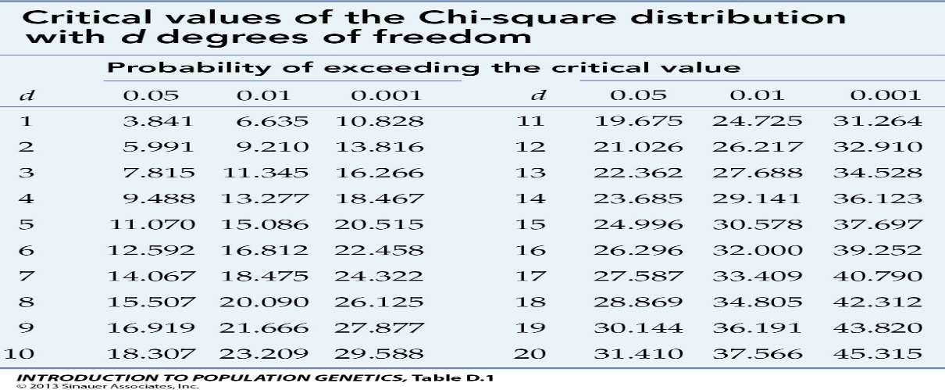

For a degree of freedom of 4 percent, the value from the previous table at freedom level 3 is 7.815 and the value computed is 15.14. In the calculated value is higher than the number from the table. Therefore, the proposed null hypothesis id disapproved

**Findings**

1. An over whelming 44% percent of the respondents are responding, with respondents acknowledge the effectiveness of this aspect.
2. An over whelming 56% percent of the respondents are responding, emotional intelligence does not significantly influence conflict management in the classroom.
3. Skill acquisition is highlighted as the primary objective of mentoring in teaching professional growth and lifelong training, according to 28% of the findings.
4. I handle stressful situations or conflicts in the classroom effectively without letting it impact my teaching, as indicated by 40% of the findings.
5. encouraging participation in workshops, and providing opportunities for collaborative learning, according to 100% of respondents.

**Suggestion**

1. Respondents overwhelmingly acknowledge the effectiveness of this aspect, suggesting a strong consensus among participants regarding its impact.
2. It suggests a prevailing perspective among participants that merits further exploration and analysis.
3. indicating a substantial emphasis on practical competencies within the mentoring process.
4. Stressful situations or conflicts in the classroom without allowing them to detrimentally affect their teaching, underscoring the importance of resilience and adaptability in pedagogical settings.
5. highlighting the critical role of active engagement and cooperative endeavors in teacher development and lifelong learning.

Top of Form

Top of Form

**Conclusion:**

In conclusion, the study on competency mapping among the teaching fraternity in Tumkur has shed light on several crucial aspects. Through the comprehensive analysis of various competencies such as subject knowledge, pedagogical skills, communication abilities, technological proficiency, and interpersonal skills, it has been revealed that there exist both strengths and areas for improvement within the teaching community

The findings indicate that while many educators in Tumkur demonstrate commendable subject expertise and dedication to their profession, there is a notable variance in the level of proficiency across different competencies. This underscores the importance of implementing targeted training and development programs to enhance the overall competency levels within the teaching fraternity.