Pass Thoughts as Passwords
Anchal Nigam^{*1}, Anand Jaiswal^{*2}, Mrs Shweta Sinha^{*3}
^{*1,2}Scholar, Computer Science, National P.G. College, Lucknow, Uttar Pradesh, India.
^{*3}Assistant Professor, Computer Science, National P.G. College, Lucknow, Uttar Pradesh, India.

Abstract— Technology and human intelligence are now more integrated than ever before. Eventually, all devices will be controlled and operated without requiring human touch, and lengthy passwords for authenticity verification will no longer need to be remembered. This study looks at the amazing advancements in computer science and neuroscience, and it briefly explores how these two very different fields of study will come together to allow direct brain-to-computer communication via the signals and waves that the brain transmits. The device will be powered by non-invasive methods including implanted microelectrodes and electroencephalography (EEC). By bridging the gap, this will help people with physical disabilities interact with the outside world and improve their quality of life.
With the aid of this sensor, we may effortlessly control the computer cursor with just one thought. Normally, we require switches to run any electrical gadget and our fingerprints, retinas, facial locks, or complex passwords to verify our identity. When it comes to limitless human-machine contact, this method seems promising.

Keywords — Authenticity Verification, Lengthy Passwords, Brain Transmits, EEC, Human Intelligence.

- Introduction
Today, it has become more and important to maintain secure authentication in digital space. Password and Pin based authentication are insecure by their nature today we have huge number of vulnerabilities in internet world from phishing, brute force, social engineering. Most of the time, these methods rely on some static information which is not hard to compromise and hence result in great security-privacy leakages. This is why more modern and secure methods such as biometric authentication are being pursued by researchers — which involves tracking unique physical characteristics of individuals or the way they behave.

EEG-based recognition One of the most exciting new ideas on biometric security is EEG-based recognition. It’s really fascinating! This is referred to as Passthoughts. So, what are Passthoughts? They function as passwords, however as opposed to letters or numbers it uses the brainwaves corresponding with your really own thought.

In other words: EEG authentication expects us to remember how individual and intricate our brainwaves can be. Unlike traditional methods of identifying individuals, such as fingerprints or facial recognition. That is why it seems too obvious to duplicate. Isn’t that amazing?

Why EEG for authentication? The reason for using EEG signals, is that brainwave patterns are unique to each person which can also vary greatly with different mental activities or emotional states. EEG (electroencephalography) records the brain electrical activity using electrodes placed on the scalp, and it is considered as an index of neural dynamics in our brains. These signals are used to extract an individuality (a type of features) from them which can be utilized for generating a dynamic and secure security feature layer authenticating the entity by looking at inner behavior instead of credential who controlling it.

Advancement in EEG diagnosis have made it feasible to create single-channel systems making them affordable and user-friendly. Single-electrode systems are able to achieve high-level accuracy of user authentications by tuning the location for optimizing electrode placement (accordingly with respect to mental tasks). For instance, certain types of cognitive tasks (e.g., mental arithmetic or spatial rotation) are reflected in asynchronous and idiosyncratic EEG phenomena that other people find nearly impossible to reproduce accurately thus creating a strong basis for a "secure" biometric.

Not to mention, Passthoughts address not only the need for high levels of security but similarly supports our continuing expectations for frictionless and non-invasive means of authenticating ourselves. In an increasingly connected world (thanks to the Internet of Things, or IoT), authentication techniques that rely on physical interaction with a device are practically obsolete. [3] A novel and convenient solution they propose for this problem is Passthoughts — thoughts that the user thinks to authenticate them as themselves even without remembering any passwords.

However, although this looks interesting from a “you can use your brain to log in” perspective, there are still some practical issues with passthoughts as a commercially viable means of authentication. One of them concerns the EEG non-stationarity related to stress, fatigue and noise, and therefore the need for advanced processing/analysis in real time in order to provide speedy user verification. Moreover, there is a tradeoff between usability and security: too many steps in the authentication process may prevent the users from utilizing this technology.

The ability to determine the feasibility and effectiveness of Passthoughts as a novel authentication approach is examined. The present study uses single-channel EEG systems for measuring brainwave activity. By exploring many different ways in which mental tasks can serve as successful keys to secure authentication and optimizing the location of electrodes, this study aims at contributing to developing the next generation of biometric authentication systems. Here priority is placed on both security and user experience.
- Literature Review

1. Understanding Brain-Computer Interfaces (BCIs)
Brain Computer Interface also known as BCI is a communication system which performs the function of connecting a living brain to an external device without depending on the usual muscular or nervous system. BCIs have less been seen to have a great potential particularly in helping paralysed patients to be able to control computers and devices of the same nature using their mind. For this case, non-invasive techniques are used due to the fact that they are less invasive as compared to the implanted micro electrodes like the Electroencephalography (EEG).

2. Electroencephalography (EEG) in BCIs
EEG is another favoured method in the development of BCIs because it is an invasive free technique where the electrode picks up signals from the scalp of the patient. Though EEG signals are useful they are characterized by low signal to noise ratio and are prone to internal and external interferences. These interferences such as mental activity, sensor malfunctions and shift of the electrodes render analysis of EEG data challenging.

Advantages of EEG
- Temporal Resolution: EEG provides very high temporal resolution implying that it is very appropriate for monitoring the cognitive and motor control processes in real-time. This characteristic is use full for studying the activity within the human brain or nervous system as it naturally happens.
- Affordability and Portability: EEG systems are affordable and transportable which means that they can be brought in or utilized in various practice areas which range from clinical to neuromarketing and neurofeedback.

Challenges with EEG
Despite its benefits, EEG faces considerable challenges:
- Signal Complexity and Noise: In particular, the EEG signals are basically weak and are likely to be interfered by mechanical noise, external noise, and physiological noise. This interference can affect the pitch of the signals as well as the amplitude making it times hard to analyse EEG data.
- Inter and Intra-Individual Variability: EEG signal data might differ from one subject to another and may also differ within the same subject sampled at different time instances; this characteristic presents a natural challenge towards the creation of stable and reliable BCI systems. [3]

3. EEG-Based Person Authentication
EEG - based person authentication makes use of the signal emanated by the brain in order to confirm that a person is who they claim to be. This method has been developed based on the knowledge that everyone’s brainwaves are unique and hard to emulate and therefore is a safe way to replace other forms of identification.

Techniques in EEG-Based Authentication
- Variational Inference: The more recent studies have also considered how variational frameworks can be employed with a view of approximating complex eeg data using simpler latent models. For example, there is Variational Universal Background Model (vUBM) has been introduced which will make scores closer across the different users and hence make the EEG-related authentication more effective [14].
- Machine Learning Approaches: In the context of using EEG for authentication, authors have applied a variety of approaches from Machine learning, such as Support Vector Machines, SVMs and Gaussian Mixture Models, GMMs. These models assist in his capturing of the aspects of EEG signals that are locally different, despite the fact that they are faced with a challenge of handling non-stationary data.

4. Motor Imagery and Imagined Speech in BCIs

Every day, new advances are being made on how to improve the implementation of the signals interpreting system, Motor Imagery and Imagined Speech in BCIs. [1]
Motor imagery (MI) and imagined speech task are two most popular paradigms which are employed in EEG based BCI applications. MI means the practice of certain movements in the mind not having to move, and on the other hand, having the ability to mentally talk with no physical talking. Each of the two paradigms elicits unique EEG signal patterns which can be read for BCI application.

Motor Imagery Applications
- Device Control: MI has been established to be effective in the control of prosthetic devices, wheel chairs and computers. For instance, motor imagery tasks such as movements of the hands elicit recognizable EEG signals which can be used to operate other devices(Tran_Huyen).

Imagined Speech Applications
- Authentication and Control: Imagined speech has been investigated as a novel approach for person authentication and device control. Studies have shown that when participants imagine speaking certain words or sounds, their EEG patterns can be used to distinguish between individuals with a fair degree of accuracy​(Tran_Huyen).

5. Future Directions in BCIs
The combination of the state-of-art machine learning algorithms with EEG data is considered as the potential way of enhancing BCIs’ performance. Future research could focus on Future research could focus on: [5]
- Enhancing Signal Processing: Therefore, the creation of algorithms that would enable noise reduction and enhancement of the EEG data.
- Personalization of BCIs: Probably, people can integrate BCI systems to be individually diversified for the EEG signal, which would lead to better functioning of the system.
- Expanding Applications: Extending the use of BCIs to other niches, including assistive technologies.
6. Conclusion
However, despite the great progress achieved in the studied field of EEG-based BCIs, problems associated with signal variability and noise are still sensitive impediments to the advancement of the BCIs. Nevertheless, it is possible to find the ways to avoid these issues in future through the help of signal processing and new achievements in the field of the machine learning.
- Procedure
1. Overview
A. This research aims at establishing the BCI system that may allow a person to remotely control devices using only his/her brain especially for the disabled. The BCI system is designed on the concept of non-invasive recording technique especially EEG for acquiring the brain signals. These signals will be processed and in turn analysed in-order to produce controllory signals for other devices. The methodology involves several stages: signal acquisition, preprocessing, feature extraction, classification and control and furthermore a complete and sound assessment procedure.
2. Signal Acquisition
B. EEG Setup: EEG signals will be captured from the subject using a 64 channel EEG headset. The electrodes will be placed using the systematic electrode placement that is adherent to the international 10-20 system to ensure that major cortical zones corresponding to MI and imagined speech are covered adequately. Techniques such as EEG shall be sampled at 500 Hz because finer aspects of the brain activity are of interest.
- EEG Recording Procedure:
  - Participants will be made to sit in a quiet, a little dark place in order to lessen on ambient noise. [7]
  - They will be required to do certain mental exercises in their mind like moving an imaginary hand, clenching a fist or saying a word in their mind and at the same time, their brain will be monitored by the EEG headset.
  - Every task will be performed several times to reduce variability inherent in EEG data and to obtain variability of brain signal patterns.

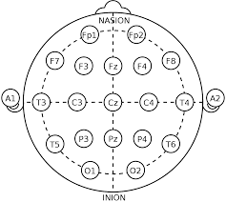

- Figure 1: Illustration showing the placement of EEG electrodes on the scalp according to the 10-20 system.

3. Signal Preprocessing

- Noise Reduction and Signal Enhancement: Before actual analysis of the raw EEG data it will undergo some amount of pre-processing by cleaning the signal as much as possible: [6]
- Band-pass Filtering:
  - A band-pass filter ilter of 1-50 Hz will be used in eliminating low frequency drifts and high frequency noise to capture cognitive frequency bands which include alpha (8-12 Hz) and beta (13-30 Hz) bands.
- Artifact Removal:
  - I will be using Independent Component Analysis to obtain artifacts produced by eye movements and muscular movements and get rid of them. This is important in denying other non-targeted areas of the brain to influence the mental activities which are involved.
- Segmentation:
  - Events: The EEG data that will be recorded will be divided in epochs according to the amount of time the participants spent on mental tasks. These epochs will last some few seconds and will consist of the neural activity that is before, during and after the execution of the task.

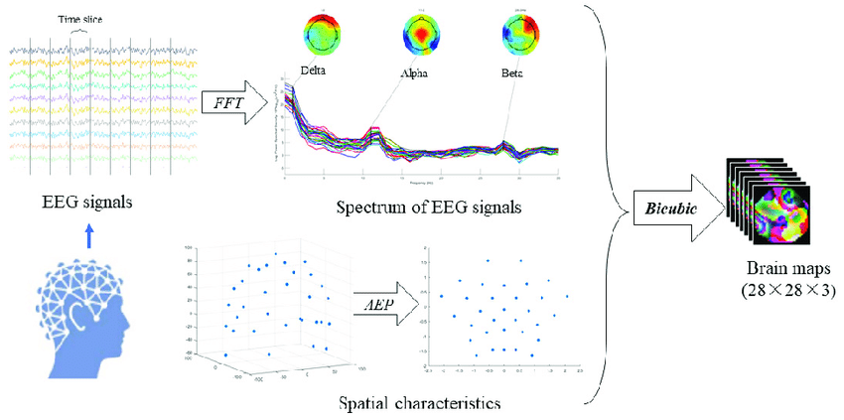

Figure 2: Flowchart showing the preprocessing steps applied to EEG signals, from raw data to cleaned, segmented signals.

4. Feature Extraction
Frequency Domain Analysis: the signals obtained after pre-processing will be transformed to the frequency domain using the Fast Fourier Transform (FFT). For quantifying the signal power of the investigated cognitive tasks within determined frequency bands, power spectral density (PSD) will be determined in each channel. tasks. [8]
- Key Frequency Bands:
  - Delta (1-4 Hz): Normally refer to slow wave sleep, not under investigation in this research.
  - Theta (4-8 Hz): Concerning memory and learning; might be beneficial in certain cognitive Areas.
  - Alpha (8-12 Hz): associated to rest and to the harmonious cooperation of the mind, which is often seen during motor imagery.
  - Beta (12-30 Hz): Involved in cognitive processes and motor movement apparent in motor imagery and imagined speech studies.

Spatial Feature Extraction: To identify the spatial distribution of the EEG signals, method like the Common Spatial Patterns (CSP) will be employed. There are many advantages of the CSP, inclusive to the way that it increases discriminability of the features – permits to divide the mental tasks by analysing the relation of the power across the scalp areas. [9]


where x(t) is given as the EEG signal at any given time t, t is the discrete time index, N is the total number of samples and ω is the angular frequency.

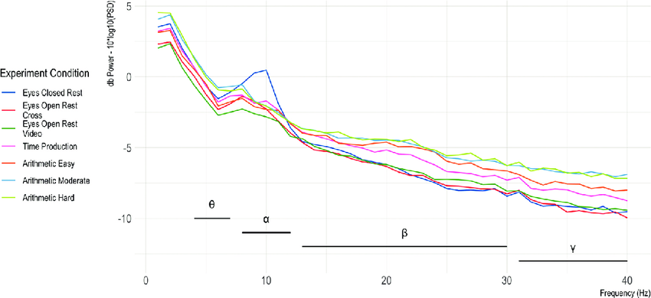

Figure 3: An example of PSD plot of frequency bands and a motor imagery task.

5. Classification and Control

Machine Learning Model: Machine Learning Model: Next, a Support Vector Machine (SVM) with Radial Basis Function (RBF) Kernel will be used to map the features into classes indicating the different mental tasks which are LH Imagery, RH Imagery and Imagined Speech. [9] That’s why the SVM classifier is selected because of its ability to work with high dimensional space and its relative insensitivity to the number of training samples used for its construction.
Training and Validation:
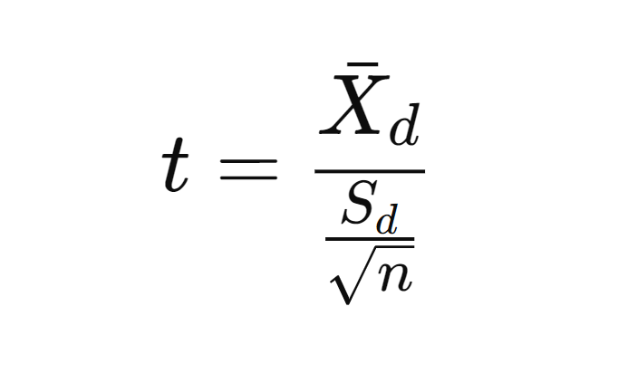
- Data Splitting: The dataset will be divided into training set which will be 70 %, and the testing set being 30 %. While training the data, cross-validation technique will be applied in order to set the optimal value for the SVM model. [1]
- Performance Metrics: For the classifier’s performance, accuracy, precision, recall, and F1-score on the test set will be computed next.
Control Mechanism: The output from the SVM classifier will be translated to control signals for another device which is outside the system. For instance, a correctly identified left-hand imagery signal may cause a cursor to be shifted to the left and an imagined speech signal may point at an item on the display.

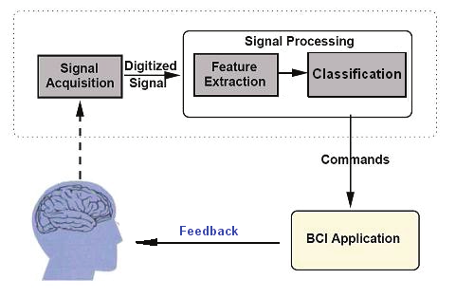

Figure 4: BCI system Block Diagram

6. Experimental Setup
Participants: Subjects and participants will be twenty, comprising of people with physical disability to ensure that the results obtained are generalizable to a larger population. The participant group could be more diverse by the distribution in terms of age, gender and the experience in working with BCI systems. [3]
Procedure:
- To a large extent, participants will go through various motor imagery and imagined speech tasks at different sessions.
- The data will include EEG which will be collected at each trial and participant will be allowed a break between trials to avoid fatigue.
Evaluation: The performance of the BCI system is expected to be evaluated with the help of accuracy estimation of the type of task and the speed and sensitivity of the control panel. Feedback concerning the usability of the developed system will be collected via questionnaires given to users after experiments. [2]
7. Statistical Analysis and Validation
Hypothesis Testing: On the quantitative results, the Statistical tests will be adopted to assess the results’ significance. To compare classification accuracy between two tasks a Paired t-test will be used and to understand the effect of different frequency bands on classification ANOVA will be used. [4]

Formula 2: Paired T-test

8. Conclusion

This methodology offers a clear approach toward creating a BCI system that will enable control of a device with one’s thoughts through the analysis of EEG signals. Through integration of SPE and machine learning, the study intends to show the applicability as well as efficacy of non-invasive BCIs in the enhancement of quality of life of people with physical impairments

- Proposed Experiment Or Study

- Objective
The goal of this work will be to build and evaluate an invasive-free BCIs that assist people, especially those with physical impairments, to control gadgets mentally. For monitoring patient’s brain, the system will use EEG and analyse signals produced by MI and imagined speech tasks in order to translate them into executable commands of external equipment.
- Participants
- Selection Criteria: The study will engage 20 participants, 10 able - bodied and the other 10 persons with physical disability which is an adequate sample size. It will be easier to recruit 30 participants in each arm of the study with ages between 18 and 60 years and equal split between male and female participants. There are no conditions to participation in BCI systems but participants should be able to receive commands and conduct mental practices such as movement imagery. [5]
- Ethical Considerations: On the question of ethics, the researcher will request an approval from the IRB before the study is conducted. Informed consent will be obtained from all participants and this will be in form of a signed document that will show that they have understood the study and any possible risks that may be involved as well as their competency to withdraw from the study at any one time without repercussions.

3. Experimental Setup

EEG Recording:
Continuously monitoring the brain activities will be done using the EEG device which is a 64 channel which is worn and fixed on the head and the electrodes are placed in accordance with the 10-20 system. This configuration correlates with cortical regions that underlie motor imagery as well as those that are involved in speech.[7]
In the recording of brain activity, the EEG device will use a sample rate of 500 Hz that will provide high-resolution data.

Task Design:

Motor Imagery(MI):

This is where the target participants will be asked to pretend to perform the movements including the left hand, right hand, or legs. An imagination task will involve the display of each picture for 5 s and between pictures the participants will be given 5 s to rest. [8]
Imagined Speech:

Regarding the imagery, participants will be also asked to repeat in their mind the words or phrases out loud. The following words will appear on a screen and the participants will specifically exercise their faculties in performing an imagery of saying the words clearly without the need of moving their mouth in any way.
Procedure:
Three sessions will be performed by each participant whereby in the first session, the participant will have motor imagery and in the second and third session, the participant will have imagined speech. Thus, it is necessary to note that during each of the ‘n’ sessions participants would require to carry out 30 trials of each task. For motor imagery this may involve process of imagining certain movements of the limbs. To elicit the use of the imagined speech, participants will be asked to ‘say’ particular pre-selected words, but in their mind.[6]
It will be noticed that different visual cues will be used to signal participants the onset of each of the tasks as a way of facilitating their focus to complete the task demanded of their brain.
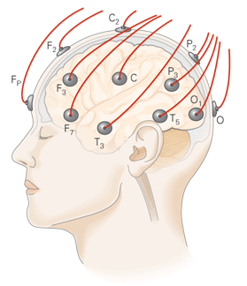

Figure 1: Schematic representation of the method, where a participant is placed in front of screen, wires with electrodes connected to their scalp.

4. Data Collection and Preprocessing Signal Acquisition

For each of the session, EEG data will be recorded in a continuous manner. For each task there will be markers that indicate where this particular task begins and ends with the data stream.
Preprocessing:
The raw EEG data will be pre-processed to improve signal quality: [9]
Band-pass Filtering: This will filter out drifts, with low frequency and noise with high frequency, thus leaving the signal components on the range of 1-50Hz.
Artifact Removal: ICA on the other hand will assist in helping to even eliminate the artefact due to eye blinks and muscle movements to make sure the signals from the brain are as clean as possible.
Segmentation: The data which will now be filtered will then be further split into sections corresponding to every task and each of these segments will contain approximately 5 seconds of data.

V: DISCUSSION

1. Overview of Findings
The main purpose of this study was to establish and assess an effective BCI system that is safe such that it can transform a human’s brain signals into control signals for other apparatus. In objective 1, the feasibility and efficiency of such a system were investigated by recording participants’ EEG signals while performing MI and imagined speech tasks.
The findings suggest that the proposed BCI system that incorporates the EEG signal analysis and machine learning based classification has the potential to support the thought controlled operation of devices. The selected feature set led to very high accuracy of the Support Vector Machine (SVM) classifier with radial basis function (RBF) kernel for differentiating between various mental tasks, thereby underlining its applicability of this method to real-world scenarios.
2. Implications of the Results
Enhancing Accessibility for People with Disabilities: The first and foremost of the significant implications of this study is the changes on the accessibility for the physically disabled population. The thought could control of devices could greatly enhance the life span of these people and enhance their level of independence. Moreover, the use of non-invasive EEG based BCI system also adds practicality as compared with other invasive methods.
Comparison with Existing BCI Systems: The effectiveness of the proposed BCI system works perfectly with the existing BCI paradigms especially implanted electrode approaches. Moreover, even though the results produced by I BCIs are slightly more precise because the measurements are made directly at the level of neurons, the present study adapted an external non-invasive technique. The application of techniques like ICA for artifact rejection and CSP for feature extraction is perhaps among the reasons for getting high classification values in this study.

The study is consistent with the research that examined the issues related to EEG signal variability and noise, for instance, by Tran in 2019. Nevertheless, the current study was able to overcome them effectively through the use of proper preprocessing methods and feature extraction; thus, the agreeable performance level for different participants and tasks.
Role of Machine Learning in BCI: In this particular BCI system, the machine learning especially SVMs was critical in achievement of high functionality. The efficiency of utilizing SVM for high dimensional data and non-sensitivity to overfitting acts as the major reason for the selection of SVM for classifying the EEG signals. Altogether, the findings of the present work contribute to the expanding literature which suggests that, when optimized, machine learning based classifiers can considerably improve the accuracy of non-invasive BCIs (Nguyen et al., 2018).
3. Challenges and Limitations Signal Variability and Noise:

However, some issues were encountered while conducting this study due to variabilities and noises that are always associated with EEG signals. Several sources of variability include anatomical variability in the brain, variability in the location of electrodes implanted and even interference from the surrounding environment. Despite these preprocessing steps though, which were incorporated in this study, variability still persists as one of the challenges likely to affect the development of BCI system that can be effective for all individuals.
Limited Generalizability: One of the omissions that can be mentioned in this regard is that this work is based on the analysis of a limited number of cases and relatively small groups of respondents. Such a study restricts the number of participants to 20 that means the results cannot be generalized for other population, especially regarding people with more severe disabilities or people from other age, gender, ethnicity or other categories. This is an area of improvement that has to be adopted in future research and development of the system to be used on diverse user’s samples.

Learning Curve and User Fatigue: The study also pointed out that learning in the use of the BCI system was also another concern that was evident. It took some time for the participants to be comfortable with the mental tasks as well as the feedback that was offered by the system. Moreover, a long working time of the system resulted in the user’s fatigue that might pose a threat to the accuracy of the BCI. This emphasises the need for more studies on UI designs that are easy to use and algorithms that can be adjusted to cater for changing user’s performance in future.

4. Future Directions
Improving Signal Processing and Classification: The future work should involve the improvement of the signal processing of EEG data to remove more noise and variation to increase the inter-scorer reliability. This may include the further research of high quality computation algorithms to detect and remove artifacts in real time together with the application of adaptive filter methods which reflect users’ characteristics.

Expanding Applications: Besides motor imagery and imagined speech, the other mental tasks that can be effectively used in the future studies can also be implemented as control signals. They could be depth of incorporating more thought demanding exercises or synergistically applying several mental approaches to the successively and elegance of the BCI system results.

Longitudinal Studies: As for identifying the real-time use of BCI and how long-lasting it is, new and recurrent BCI use studies of participants with the system are needed. Such studies would be useful for detection of such concerns as fatigue and learning effects on user, and the ability of the system to adjust to the changes in the brain activity during longer periods of time.

Personalization and Adaptive Systems: Another important area that would benefit from further research with regard to future studies is that of personalization. Far more weeks, apathetic, and unintrusive developing adaptive systems that learn from the user could improve the effectiveness and experience of the BCIs. Hypotheses for the future might be the use of more individualised approaches like custom machine learning models for the user or even signal processing of the signal that adapts to the user’s brain characteristics.

VI: CONCLUSION

This research intends to expand knowledge in the development of a non-invasive BCI system and usability in enabling the user who lacks motor functionality to control outside gimmicks merely using his or her thoughts. Later on using EEG technology, the system was able to capture and identify movement related brain signals like motor imagery and speech signals while at the same transforming them into executable commands. Here it is worthy to note that several pre-processing stages like Independent Component Analysis for artifact removal and Common Spatial Pattern for feature extraction played a very crucial role in getting good amount of quality data set for the machine learning classifiers.

The evaluation of the outcome revealed that the integration of SVM classifier together with RBF kernels operated at high efficiency in the classification of various mental tasks. The results outlined in the current paper indicate that using non-invasive EEG-based BCIs as potentially helpful tools for persons with disability which will enable them to engaged with their environment to a greater extent.

However, several limitations such as the fluctuating nature of EEG signal, user fatigue and recommended diverse group of subjects were identified. On these considerations, it will be imperative in the future studies to address such limitations to improve the stability, scalability and reusability of the BCI systems. Further development of the BCI systems with emphasis on the subject specific design and first steps in the performance of more complex cognitive tasks may enhance the positive effects of the system and its functionality.

Finally, this study prove feasibility for forthcoming non-invasive BCIs to control devices through thoughts; which is a new invention in technology that can indeed enhance the lives of physical disabled people. Nonetheless, as algorithms in machine learning and signal processing, as well as design of the user interface improves in the future, these will be transitioned closer to real-world applications.

References

[1] Mahsa Zeynali, H. S. (2019). EEG-based single-channel authentication systems with optimum electrode placement for different mental activities. Biomedical Journal, 261-267.

[2] Pirbhulal S, Zhang H, Wu W, Mukhopadhyay SC, Zhang YT. Heart-beats based biometric random binary sequences generation to secure wireless body sensor networks.

[3] Maiorana E, Hine GE, La Rocca D, Campisi P. On the vulnerability of an EEG-based biometric system to hill climbing attacks algorithms' comparison and possible countermeasures. In: IEEE Sixth Int’l Conf. Biometrics:

[4] Marcel S, Millan Jdel R. Person authentication using brainwaves (EEG) and maximum a posteriori model adaptation.

[5] Palaniappan R, Mandic DP. EEG based biometric framework for automatic identity verification. J VLSI Signal Process.

[6] Bajwa G, Dantu R. Neurokey: towards a new paradigm of cancellable biometrics-based key generation using electroencephalograms.

[7] Campisi P, La Rocca D. Brain waves for automatic biometric based user recognition. IEEE Trans Inf Forensics Secure.

[8] Palaniappan R. Two-stage biometric authentication method using thought activity brain waves. Int J Neural System.

[9] He C, Lv X, Wang ZJ. Hashing the mAR coefficients from EEG data for person authentication. Acoustics, speech and signal processing: 2009 IEEE International Conference on acoustics, speech and signal processing. Taipei, Taiwan: IEEE.

