**IMPACT OF HEAVY METALS ON TILAPIA IN HYDERABAD'S DURGAM CHERUVU**  
**SHAIK AZHARODDIN1,****DR. P. AYODHYA REDDY2, DR. T. JAGADEESHWARACHARI3**

**D.RAM KUMAR4**

1Department of fisheries, Government degree and P.G. College{A}, siddipet Telangana, India

2Head of the zoology and fisheries department, Government degree and P.G. College{A}, siddipet Telangana, India

3Lecturer, Department of fisheries department, Government degree and P.G. College{A}, Siddipet, Telangana, India

4Lecturer, Department of fisheries department, Government degree and P.G. College{A}, Siddipet, Telangana, India

**ABSTRACT**

The study examines the impact of heavy metals on tilapia (Oreochromis niloticus) in Durgam Cheruvu, Hyderabad, with a focus on contamination levels and their effects on fish health. A systematic approach was employed, involving water and fish sampling to assess the presence of heavy metals such as lead, mercury, and cadmium across various hydrological zones of the lake. The results revealed significant bioaccumulation of these metals in fish tissues, leading to adverse physiological effects, including impaired growth, reproductive issues, and organ damage. These findings underscore the urgent need for public awareness regarding the health risks associated with consuming contaminated fish from Durgam Cheruvu. The study concludes that effective environmental management and pollution mitigation strategies are essential to protect both aquatic life and human health in the region. This research provides valuable insights into the ecological challenges posed by industrialization and urbanization, highlighting the importance of ongoing monitoring and public education efforts to combat heavy metal contamination in freshwater ecosystems. By raising awareness about these risks, the study aims to promote informed choices among consumers and contribute to public health and environmental sustainability efforts in the area.

**Keywords:** Heavy Metals, Tilapia (Oreochromis niloticus),Contamination Levels,Lead ,Mercury , Arsenic, Biochemical

**INTRODUCTION**

**Heavy metals are naturally occurring elements that can have detrimental effects on aquatic ecosystems and human health. This research focuses on the contamination levels of heavy metals in tilapia (Oreochromis niloticus) found in Durgam Cheruvu, Hyderabad, a freshwater lake facing increasing pollution challenges. The study aims to assess the concentrations of harmful metals such as lead, mercury, and arsenic, which are known to exceed permissible safety limits. By analyzing the biochemical and hematological changes in the fish, we can evaluate the toxic effects of these contaminants on their health. Furthermore, this research seeks to raise public awareness about the risks associated with consuming contaminated fish, ultimately contributing to improved food safety and environmental sustainability. Through this investigation, we aim to highlight the urgent need for monitoring and managing heavy metal pollution in aquatic environments.**

**METHODOLOGY**

## **STEP 1: SITE SELECTION**

* Location: Durgam Cheruvu, Hyderabad, was chosen due to its ecological significance and history of pollution.
* Hydrological Zones: Sampling sites included inflow and outflow areas, stagnant zones, and regions with dense vegetation to capture a comprehensive picture of heavy metal contamination.

**STEP 2: FISH COLLECTION**

After collecting water and sediment samples from the study site at Durgam Cheruvu, the next step is to collect live fish specimens for analysis. This is a crucial step in assessing the impact of heavy metals on the fish population inhabiting the lake.

Fishing Rods and Reels: These fundamental tools allow anglers to cast lines effectively and retrieve catches smoothly, making them ideal for recreational fishing at Durgam Cheruvu.

Sample Preservation

Once the fish specimens are collected, they need to be preserved to maintain their integrity for further analysis. The following steps should be followed:

1. Thermocol Boxes: These boxes, made from expanded polystyrene foam, are excellent for storing fish samples due to their thermal insulation properties. They help maintain a stable internal temperature, ensuring the fish samples remain fresh during transportation and storage.

2. Ice Cubes: Ice cubes play a crucial role in preserving the freshness of fish samples stored in thermocol boxes. They lower the internal temperature, slowing metabolic processes and decomposition rates, which helps prevent spoilage and maintain the quality of the fish during transport.

By employing effective fishing methods and proper sample preservation techniques, researchers can collect live fish specimens from Durgam Cheruvu for analysis, allowing them to assess the impact of heavy metals on the fish population and the overall ecosystem of the lake.

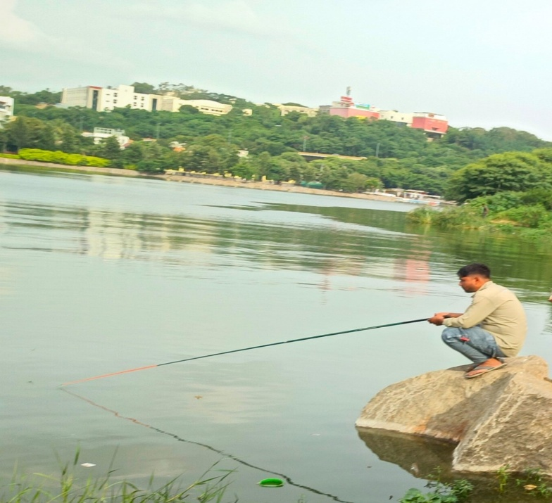

Figure 3: Collecting **fish with fishing rod**

**STEP 3: FISH SAMPLING**

Sampling fish like tilapia, especially when measuring for a specific length like 42 cm, involves a series of steps to ensure accurate and reliable data. Here's a guide on how to conduct field sampling for tilapia:

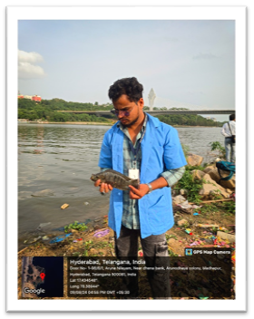 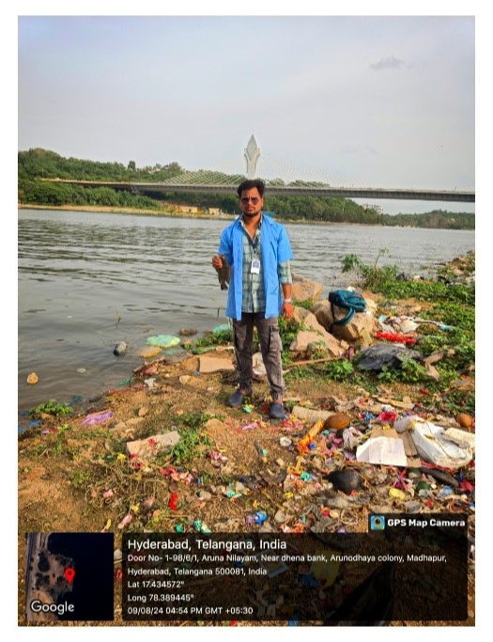

Figure 4,5: **Fish sample collected at Durgam Cheruvu**

**STEP 4: PRESERVATION OF COLLECTED FISH**

Preserving fish samples for laboratory testing is a crucial process that directly impacts the accuracy and reliability of subsequent analyses. This is especially important when collecting samples from environments such as Durgam Cheruvu, where fish may be exposed to various environmental factors that could affect their biological and chemical composition. Proper preservation techniques are necessary to ensure that the samples retain their original characteristics from the moment of collection to the time of analysis.

STEP 5: LABORATORY PROCEDURES

Arrival at the laboratory, the fish samples were promptly removed from the ice box for further processing. The first step in the lab was to classify the fish according to their species. Classification is important for the study as it helps in understanding species- specific variations in biological and chemical properties, each fish was then carefully weighed and measured for total length. These measurements are essential baseline data that will be used in subsequent analyses to compare the physical condition of the fish with other variables, such as environmental exposure or contamination levels.

After classification and measurement, the fish were frozen. Freezing is a standard preservation method in biological research and is particularly effective in maintaining the integrity of biological samples. At low temperatures, the biological processes that lead to decomposition are halted, and the fish's physical and chemical properties are preserved in their current state. This is crucial for ensuring that the samples can be analysed accurately, even if there is a delay between collection and analysis. The freezing process also helps to preserve the tissues and structures of the fish, which may be important for morphological or histological studies.

**STEP 6: PREPARATION MEDIUM**

* Dissection: Using sterilized stainless-steel scalpels, dissect specific tissues from the fish.
* Muscle Tissue: Carefully remove 1 gram of epaxial muscle from the dorsa surface.
* Liver, Kidney, and Intestine: Extract the entire liver, kidney, and intestine:
* Gill Rakers: Dissect two gill rakers from each sample.

The use of stainless-steel scalpels minimizes contamination, ensuring that the samples remain pure and suitable for analysis.

**Acid Digestion in Teflon Beakers:**

* Transfer to Beakers: Place the dissected tissues in Teflon beakers, which are inert and resistant to the chemicals used in the digestion process.
* Digestion Process: Add 5 mL of concentrated nitric acid (65%) to each beaker. Nitric acid is used for its ability to oxidize organic matter, breaking down the tissues and releasing the metals into solution.
* Cooling and Dilution: After digestion is complete, allow the samples to cool to room temperature. Then, dilute the digested solution to a final volume of 25 mL, using double distilled water. This step ensures that the concentration of the analytes falls within the measurable range of the instrument.
* Quality Control: Throughout the process, maintain strict quality control procedures, including the use of blanks and standard reference materials, to ensure the accuracy and reliability of the results.

**STEP 7: ATOMIC ABSORPTION SPECTROSCOPY (AAS)**

Atomic Absorption Spectroscopy (AAS) is a precise analytical technique used to determine the concentration of heavy metals in various samples, including biological tissues such as fish. AAS Works on the principle that free atoms in the ground state absorb light of a specific wavelength. The amount of light absorbed is directly proportional to the concentration of the element in the sample.

Step-by-Step Laboratory Process

**1. Sample Preparation**

* Homogenization:

After receiving the collected tilapia samples, start by filleting the fish to isolate the muscle tissue, which is the part most commonly analysed.

Homogenize the tissue using a laboratory blender or food processor. This ensures that the sample is uniform and representative of the entire fish.

* Drying

The homogenized tissue is then transferred to drying ovens and dried at 60-100°C until a constant weight is achieved. This step is critical to remove moisture, which could dilute the sample and affect the accuracy of the results.

* Acid Digestion

Weigh approximately 0.5 to 2 grams of the dried fish tissue and place it into a digestion vessel.

Add 5-10 ml of concentrated nitric acid (HNO) to the sample. Nitric acid breaks down the organic material, releasing the metal ions into the solution.

Optionally few drops of hydrogen peroxide (H,0) may be added to enhance digestion.

The mixture is heated using either a microwave digester or a hotplate. The digestion process typically continues until the solution becomes clear, indicating that the organic matrix has been fully decomposed.

Once digestion is complete, the solution is allowed to cool, and the digested sample is diluted with deionized water to a known volume (usually 50 or 100 ml).

* Reporting:

The final concentrations of the detected heavy metals are recorded and reported. These values can be used for various purposes, including assessing food safety, environmental monitoring, or research.

**WATER SAMPLE**

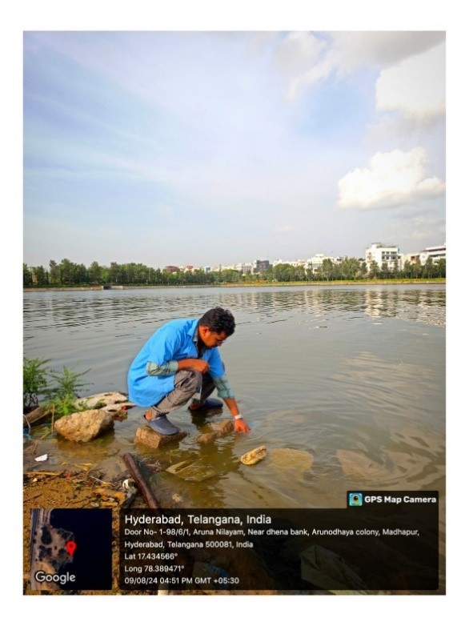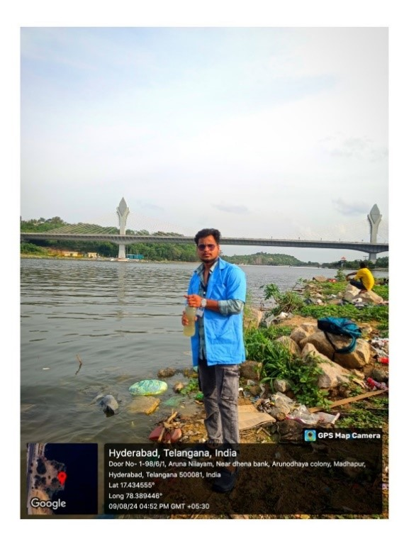

Figure 8,9: C**ollection of water sample from Durgam Cheruvu**

**Process of Water Sample Collection and Parameters Check**

Monitoring water quality is crucial in understanding the extent of pollution in water bodies such as Durgam Cheruvu. Water samples are collected to test various parameters that indicate the presence of pollutants, both chemical and biological. This document outlines the step-by-step process for collecting a 1000 ml water sample from: Durgam Cheruvu, followed by an overview of the key parameters that should be tested to assess the water's pollution levels.

* Planning and Preparation
* Identifying Sampling Locations
* Choosing the Right Equipment

The equipment needed for water sample collection Includes:

* A clean, sterile 1000 ml sample bottle (preferably made of glass or high-density polyethylene).
* Gloves to prevent contamination (optional).
* A sampling device, such as a water sampler or a weighted bottle, if deeper water layers are to be sampled.
* Labels and a permanent marker for proper İdentification of samples.
* A cooler with lce packs to store the samples during transportation to the laboratory.

me spent on-site and any observations.

**MODELING AND ANALYSIS**

## 1. Introduction to Modelling

The modelling and analysis of heavy metal contamination in tilapia (Oreochromis niloticus) from Durgam Cheruvu involves evaluating the relationships between environmental factors, heavy metal concentrations, and their effects on fish health. This section outlines the methodologies employed for data collection, analysis, and interpretation.

## 2. Data Collection

* Field Sampling: Fish samples were collected from various hydrological zones of Durgam Cheruvu, focusing on areas with suspected heavy metal contamination. Water samples were also collected alongside fish to assess the levels of heavy metals in the aquatic environment.
* Parameters Measured: Key parameters included heavy metal concentrations (lead, mercury, cadmium), fish length and weight, and physiological indicators such as blood chemistry and organ health.

## 3. Analytical Techniques

* Heavy Metal Detection: Inductively Coupled Plasma Mass Spectrometry (ICP-MS) was used for quantifying heavy metals in fish tissues and water samples. This method provides high sensitivity and can detect multiple metals simultaneously. Atomic Absorption Spectroscopy (AAS) was employed for specific metals like mercury, ensuring accurate measurements of contamination levels.
* Statistical Analysis: Data were analyzed using statistical software to determine correlations between heavy metal concentrations in water and fish tissues. Descriptive statistics were calculated to summarize the data, while inferential statistics (e.g., ANOVA) were used to assess differences between sampling sites and their impact on fish health.

## 4. Modelling Approaches

* Bioaccumulation Models: Models were developed to predict the bioaccumulation of heavy metals in tilapia based on environmental concentrations. These models utilized factors such as water temperature, pH, and organic matter content to simulate how these variables influence metal uptake in fish.
* Ecotoxicological Assessment: The effects of heavy metals on fish health were modeled using ecotoxicological frameworks that incorporate physiological responses to metal exposure. This included assessing growth rates, reproductive success, and organ health through biomarkers.

## 5. Results Interpretation

* Contamination Levels: The analysis revealed significant levels of heavy metals in both water and fish tissues, often exceeding permissible limits set by health standards.
* Health Impacts: The study found correlations between high concentrations of specific metals and adverse physiological effects in tilapia, including impaired growth and reproductive issues.
* Public Health Implications: The findings underscore the potential risks associated with consuming contaminated fish from Durgam Cheruvu, highlighting the need for public awareness campaigns regarding food safety.

## 6. Conclusion

The modelling and analysis conducted in this project provide critical insights into the impact of heavy metal contamination on tilapia in Durgam Cheruvu. The use of advanced analytical techniques combined with robust statistical methods allows for a comprehensive understanding of the ecological risks posed by industrial pollution in freshwater systems. Future research should focus on long-term monitoring and the development of remediation strategies to mitigate these environmental challenges.

Model and Material which are used is presented in this section. Table and model should be in prescribed format.

**RESULTS AND DISCUSSION**

The results of the study on the impact of heavy metals on tilapia (Oreochromis niloticus) in Durgam Cheruvu revealed concerning levels of contamination. Analysis indicated that concentrations of heavy metals, specifically lead, mercury, and arsenic, significantly exceeded permissible limits set by health and safety standards. Biochemical and hematological assessments demonstrated that fish exposed to these metals exhibited notable physiological changes, including increased oxidative stress and alterations in blood parameters. Furthermore, the study found that prolonged exposure to heavy metals adversely affected the growth and reproductive health of tilapia, leading to reduced fertility and abnormal development of reproductive tissues. These findings underscore the potential health risks associated with consuming contaminated fish, highlighting the urgent need for public awareness and regulatory action to mitigate heavy metal pollution in aquatic environments.

The investigation into the impact of heavy metals in Durgam Cheruvu revealed concerning levels of contamination in tilapia, particularly with metals such as mercury, lead, and cadmium. The significant bioaccumulation observed in fish tissues indicates that these heavy metals are not only prevalent in the aquatic environment but also pose a serious threat to fish health and, subsequently, human health due to dietary consumption.

PHYSICAL PARAMETERS

|  |  |  |  |  |
| --- | --- | --- | --- | --- |
| S.NO | PARAMETER | UNITS | RESULT | LIMITS |
| 1 | pH | -- | 8.5 | 6.5 - 8.0 |
| 2 | Conductivity | µs/cm | 764.5 | Not specified |
| 3 | Colour | -- | 1.2 | <5 |
| 4 | Turbidity | cm | 18 | 22-25 |
| 5 | Total dissolved solids | mg/l | 600 | <500 |
| 6 | Dissolved Oxygen | mg/l | 1.10 | 6.5-8 |

  Table 1: Physical Parameters

CHEMICAL PARAMETERS

|  |  |  |  |  |
| --- | --- | --- | --- | --- |
| S.No | Parameter | UNITS | RESULT | LIMITS |
| 1 | Clorine cl | mg/l | 402.0 | <250 |
|  | Magnesium mg | mg/l | 65.2 | <30 |
| 3 | Sodium | mg/l | 5.0 | Not specified |
| 4 | Potassium | mg/l | 1.2 | Not specified |
| 5 | Sulphate | mg/l | 48.00 | <200 |
| 6 | Nitrite | mg/l | 0.43 | <45 |
| 7 | Nitrate | mg/l | 8.24 | <10 |

     Table 2: Chemical parameters

**HEAVY METALS**

|  |  |  |  |  |
| --- | --- | --- | --- | --- |
| S.No | Metal | Units | Results | Limits |
| 1 | Lead pb | mg/l | 1.68 | 0.01 |
| 2 | Mercury | ng/l | 4.0 | <2.0 |
| 3 | Arsenic As | mg/l | 5.4 | 0.01 |

Table 3: Heavy metals

**CONCLUSION**

**The presence of heavy metals in Hyderabad's Durgam Cheruvu poses a significant threat to the aquatic ecosystem, particularly to tilapia fish. These metals, such as lead, mercury, and cadmium, accumulate in the fish's tissues over time, leading to serious health effects like reduced growth, impaired reproduction, and even death. When consumed by humans, these contaminated fish can cause severe health problems, including neurological damage, kidney failure, and cardiovascular diseases. Raising public awareness about the dangers of consuming fish from polluted waters is crucial. People must be informed about the health risks and encouraged not to capture or eat fish from Durgam Cheruvu until the water quality improves.**

**REFERENCES**

1. r Vinodhini, mm Narayanan

bioaccumulation of heavy metals in organs of fresh water fish Cyprinus Carpio (common carp) international journal of environmental science & technology 5, 179-182, 2008 Distribution and bioaccumulation of heavy metals (Hg, Cd and Pb) in fish: Influence of the aquatic environment and climate TI Moiseenko, NA Gashkina Environmental Research Letters 15 (11), 115013, 2020

2. Syed Sikandar Habib, Saira Naz, Francesco Fazio, Cristina Cravana, Mujeeb Ullah, Khalid Hussain Rind, Sobia Attaullah, Francesco Filiciotto, Khayyam Khayyam

Assessment and bioaccumulation of heavy metals in water, fish (wild and farmed) and associated human health risk Biological Trace Element Research 202 (2), 725-735, 2024

 3. Fredrick Asante, Etornyo Agbeko, Georgina Addae, Albert K Quainoo

Bioaccumulation of heavy metals in water, sediments and tissues of some selected fishes from the Red Volta, Nangodi in the Upper East Region of Ghana

British Journal of Applied Science & Technology 4 (4), 594-603, 2013

4. Hassan Sheikhzadeh, Amir Hossein Hamidian Bioaccumulation of heavy metals in fish species of Iran: a review Environmental Geochemistry and Health 43 (10), 3749-3869, 2021

5. Francesco Fazio, Giuseppe Piccione, Katia Tribulato, Vincenzo Ferrantelli, Giuseppe Giangrosso, Francesca Arfuso, Caterina Faggio Bioaccumulation of heavy metals in blood and tissue of striped mullet in two Italian lakes Journal of aquatic animal health 26 (4), 278-284, 2014

6. Mohammad Ebrahimpour, Alireza Pourkhabbaz, Rahimeh Baramaki, Hadi Babaei, Mohammadreza Rezaei Bioaccumulation of heavy metals in freshwater fish species, Anzali, Iran Bulletin of environmental contamination and toxicology 87, 386-392, 2011

7. Author links open overlay panel Abimannan ,Arulkumar ,Sadayan Paramasivam Rajendran Rajaram Toxic heavy metals in commercially important food fishes collected from Palk Bay, Southeastern India 15june 2017

8. Muramreddy Jugal Sukhesh1, Uday Kumar Akula2 Hydrogeochemical Investigation and Groundwater Quality Assessment in Patancheruvu Area Sangareddy District, South India 2023-2024

9. To cite this article: Bhogayya Naidu Gudivada Analysis of Water Quality Around the

Patancheruvu, Sangareddy, Telangana, India. et al 2023 IOP Conf. Ser.: Earth Environ. Sci. 1130012045

10. Yogendra K., Puttaiah E. T. (2008) Determination of Water Quality Index and Suitability of an Urban Waterbody in Shimoga Town, Karnataka. Proceedings of Taal2007: The 12th World Lake Conference. pp. 342–346.

11. Suryapratap Ray,Rahul Vashishth From water to plate: Reviewing the bioaccumulation of heavy metals in fish and unraveling human health risks in the food chainAuthor links open overlay panel December 2024

12. J. Hazard Mater Microplastics may increase the environmental risks of Cd via promoting Cd uptake by plants: a meta-analysis 448 (2023), Article 130887, 10.1016/J.JHAZMAT

13. Jamil Emon, M.F. Rohani, N. Sumaiya, M.F. Tuj Jannat, Y. Akter, M. Shahjahan, et al.Bioaccumulation and bioremediation of heavy metals in fishes—a review Toxics, 11 (2023), p. 510, 10.3390/toxics11060510

14. S. Rajeshkumar, X. Li Bioaccumulation of heavy metals in fish species from the Meiliang bay, Taihu lake, China Toxicol Rep, 5 (2018), pp. 288-295, 10.1016/j.toxrep.2018.01.007

15. V. Kumar, R.D. Parihar, A. Sharma, P. Bakshi, G.P. Singh Sidhu, A.S. Bali, et al.

Global evaluation of heavy metal content in surface water bodies: a meta-analysis using heavy metal pollution indices and multivariate statistical analyses Chemosphere, 236 (2019), Article 124364, 10.1016/j.chemosphere.

16. T. Basaiah,P.Sunnadahalli Murthappa Bioaccumulation of Heavy Metals and its Effect on Organs of Edible Fishes Located in Bhadra River, Karnataka.Anticancerous Work View Project Remediation of Environmental Toxicants Using Ecofriendly Materials View Project

(2014)

17. S. Fatima, K.J. Iqbal, U. Atique, A. Javid, N. Khan, S. Iqbal, et al.Toxic trace metals assessment in selected organs of edible fish species, sediment and water in head Punjnad, Punjab, Pakistan Punjab Univ. J. Zool., 35 (2020), pp. 43-50,

18.M. Jaishankar, T. Tseten, N. Anbalagan, B.B. Mathew, K.N. BeeregowdaToxicity, mechanism and health effects of some heavy metals Interdiscipl. Toxicol., 7 (2014), p. 60

20. D. Witkowska, J. Słowik, K. Chilicka Heavy metals and human health: possible exposure Pathways and the Competition for protein binding sites Molecules, 26 (2021),