**CULTURE OF “*Artemia salina”* USING AS A LIVE FEED FOR WILD GUPPIES (*Poecilia reticulata*)**

**MERUGU SUDHANI’1 DR.T. JAGADEESHWARACHARI 2 DR.P. AYODHYA REDDY3**

**D. RAMKUMAR4**

Government degree and P.G. College{A}, siddipet1

Lecturer in fisheries science Government degree and P.G. College{A}, Siddipet2

Head of the zoology and fisheries department Government degree and P.G. College{A}, siddipet3

Lecturer in fisheries science Government degree and P.G. College{A}, Siddipet4

**ABSTARCT**

**The culture of Artemia salina, commonly known as brine shrimp, serves as a crucial live feed in aquaculture, particularly for enhancing the growth and health of wild guppies (Poecilia reticulata). This research aims to establish a sustainable culture system by optimizing key parameters such as salinity, temperature, and aeration. The nutritional profile of Artemia is rich in proteins, essential fatty acids, and vitamins, making it an ideal feed for fish larvae. Through controlled experiments, the study evaluates the impact of Artemia on growth rates and survival of guppies, demonstrating significant benefits over traditional dry feeds. The findings indicate that Artemia culture can improve fish health and resilience against environmental stressors, supporting its broader adoption in aquaculture practices. This research contributes to sustainable aquaculture and food security by providing insights into effective feeding strategies and culture techniques for Artemia**

**KEYWORDS:**

**Artemia Salina, Brine shrimp, Live feed, Wild guppies,Aquaculture,Culture conditions, Salinity, pH, Temperature,Aeration,,Nutritional value,Protein content, Essential fatty acids, feeding regimen, Harvesting, Cysts, Nauplii, Water quality,Growth enhancement, Sustainable practices, Ornamental fishes, Zooplankton, Ecosystem health, Reproductive strategies, feeding trials, Growth rates, Survival rates, Economic benefits, Environmental impact, monitoring parameters, stocking density, Feeding schedules.**

**INTRODUCTION**

**The culture of Artemia salina, commonly known as brine shrimp, is increasingly recognized as a vital component in aquaculture particularly for providing highquality live feed for various fish species, including wild guppies (Poecilia reticulata). Artemia are small crustaceans that thrive in saline environments and are known for their exceptional nutritional profile, which includes high levels of proteins, essential fatty acids, and vitamins. This nutritional richness makes them an ideal food source for larval and juvenile fish, promoting optimal growth and health.**

**Wild guppies, characterized by their vibrant colors and adaptability, are popular in both ornamental aquaculture and ecological studies. Their dietary needs during early developmental stages are critical for their survival and growth. This research aims to establish a sustainable culture system for Artemia salina, focusing on optimizing culture conditions such as salinity, temperature, and aeration. By providing insights into effective feeding strategies, this study seeks to enhance the growth and health of wild guppies, thereby contributing to sustainable aquaculture practices and food security. The findings will not only support aquaculture efficiency but also promote the broader adoption of Artemia culture in various aquatic farming systems.**

**METHODS**

STEP 1: CYST SELECTION

Cyst selection is a crucial step in Artemia culture, as it directly impacts hatching success and the overall quality of the nauplii.

**1. Source and Quality:** Select cysts from a reputable supplier with a known hatching rate. High-quality cysts should be uniform in size, color and free from contaminants like dirt, dust, or debris.

**2. Visual Inspection:** Cysts should have a brown to reddish-brown color. Dark or black cysts often indicate poor quality or old cysts with reduced viability

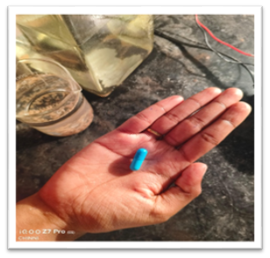 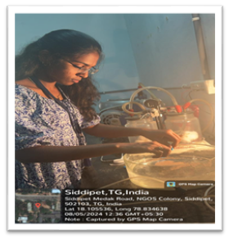Figure 9: Visual inspection of artemia capsule Figure 10: Decapsulation of artemia cyst

**3. Buoyancy Test:** A simple buoyancy test can help assess the quality. Mix the cysts in saltwater; good cysts will float while empty shells and debris will sink. Skim off the floating cysts for use.

**4.Storage Conditions:** Store cysts in a cool, dry and dark place to maintain viability. Properly stored cysts have a longer shelf life and better hatching rates.

**5. Decapsulation:** Decapsulation involves removing the hard outer shell, which can improve hatching rates, reduce the risk of bacterial contamination and make the nauplii more digestible.

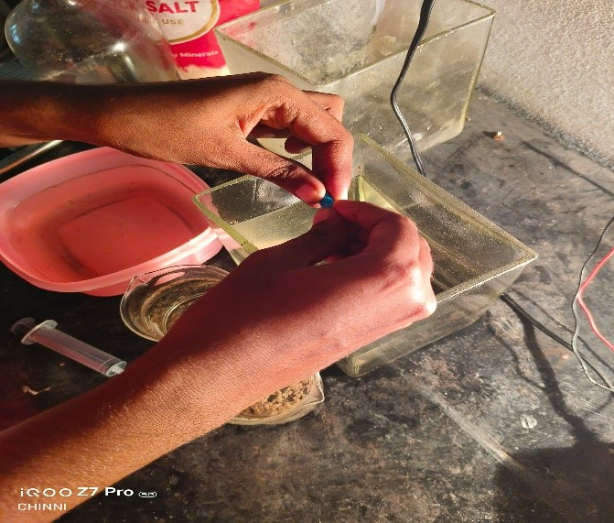 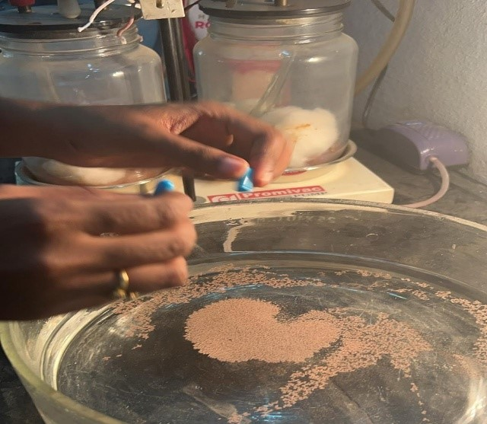

Figure 11: Buoyancy test of artemia cyst Figure 12: Eggs floating in the culture medium

**STEP 2: WATER PREPARATION**

**1. Neutralization**

It's crucial to neutralize the chlorine to prevent toxicity to the Artemia. Use Rock salt (NaCl) for this purpose. The typical procedure involves:

Amount: Add approximately 75 grams of sodium thiosulfate to the water that has been treated with chlorine.

Rinsing: Continue rinsing the water until it runs clear and no chlorine odor is detectable. This ensures that all residual chlorine has been neutralized effectively.

**2. Salinity Adjustment**

Aim for a salinity level of 28-30 parts per thousand (ppt) for optimal growth of Artemia. Here’s how to achieve this:

Adjusting Salinity: If the salinity is lower than desired, you can increase it by adding sea salt or concentrated brine. Conversely, if the salinity is too high, dilute the water with fresh water that is free from high chlorine levels.

**3. Monitoring and Maintenance**

Regular Checks: Continuously monitor the salinity, pH (optimal range is 8.0-9.0) and temperature (ideally between 26-30°C) to ensure they remain within suitable ranges for Artemia growth

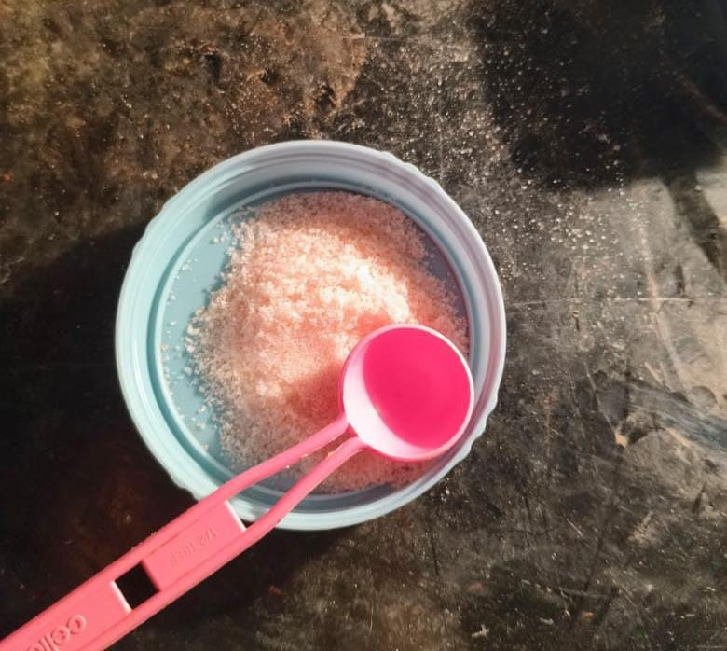 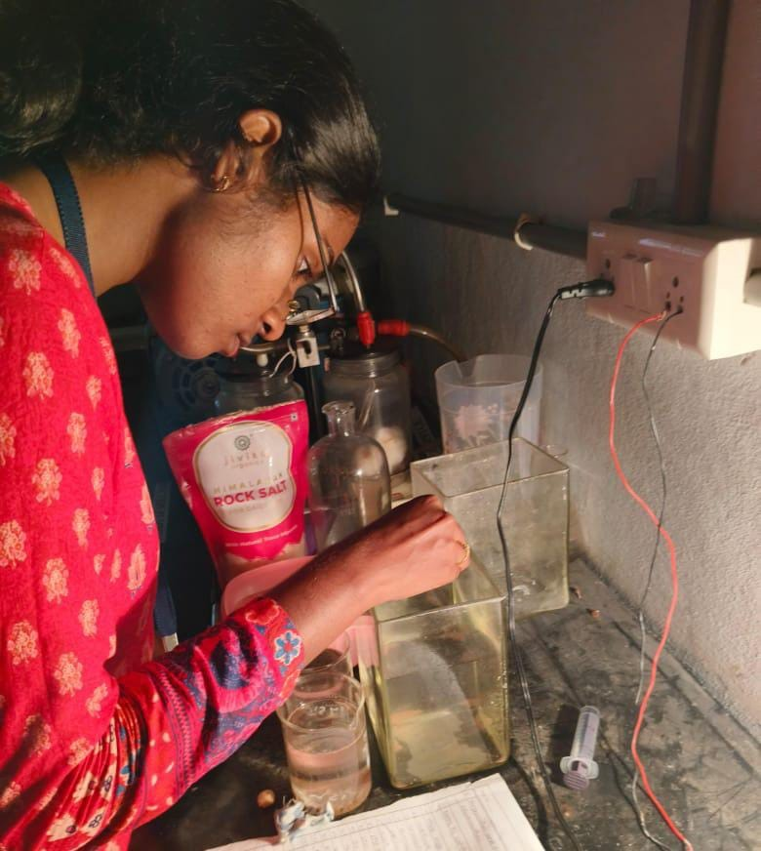

Figure 13: Rock salt Figure 14: Adding rock salt for salinity maintenance

**STEP 3: AERATION**

**Aeration Setup**

**1. Aeration Equipment**

To set up aeration, you will need:

- Tubing: Use flexible tubing to connect the air pump to the air stones or diffusers.

**2. Installation**

- Placement: Position the air stones or diffusers at the bottom of the tank to maximize the upward movement of water and ensure that bubbles rise through the entire water column.

**- Airflow Adjustment:** Start with a moderate airflow rate and adjust as necessary. Too much aeration can create excessive turbulence, which may stress the Artemia. Aim for a gentle but consistent flow that keeps the cysts and nauplii suspended without causing them to be tossed around violently.

**3. Monitoring**

- Oxygen Levels: Regularly check the dissolved oxygen levels in the water using a dissolved oxygen meter. Ideal levels for Artemia culture are typically above 5 mg/L.

- Visual Inspection: Observe the behavior of the Artemia. They should be actively swimming and suspended in the water column, indicating that the aeration is effective.

**4. Maintenance**

- Cleaning: Regularly clean the air stones and tubing to prevent clogging and ensure efficient operation.

- Pump Maintenance: Check the air pump periodically to ensure it is functioning correctly and replace it if it shows signs of wear or reduced performance.

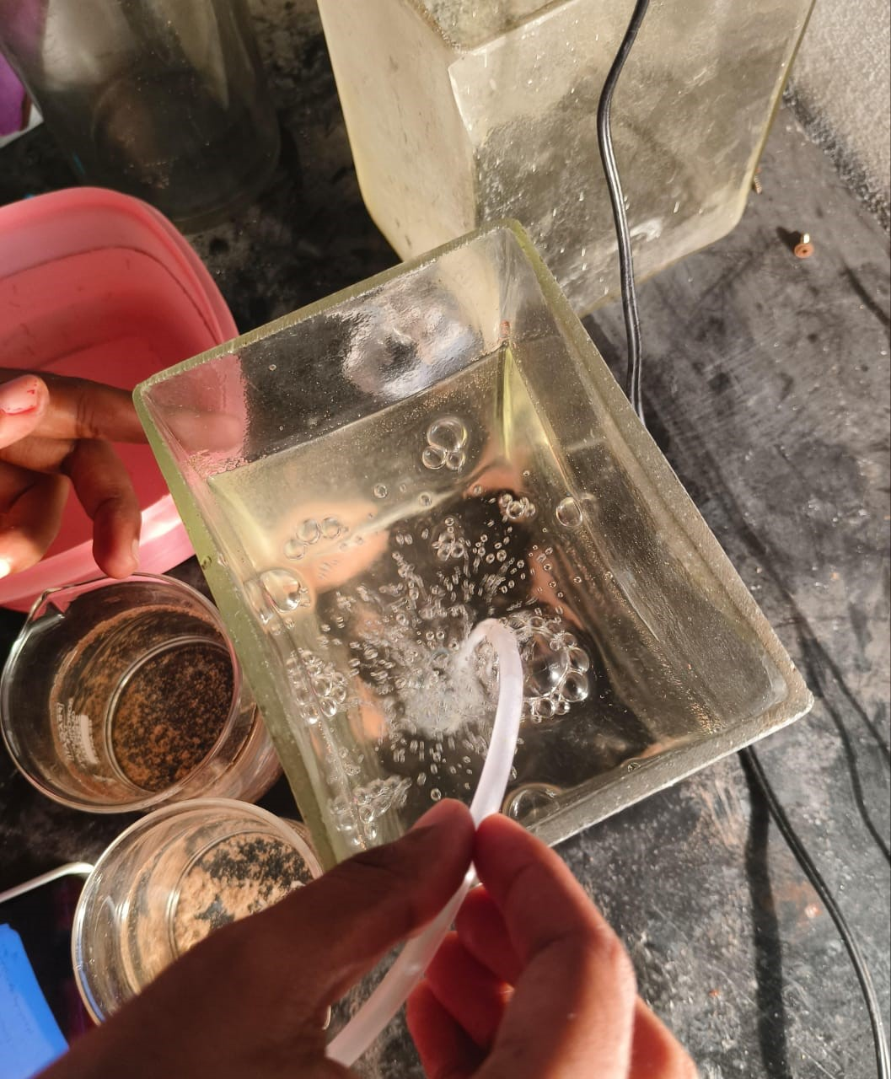 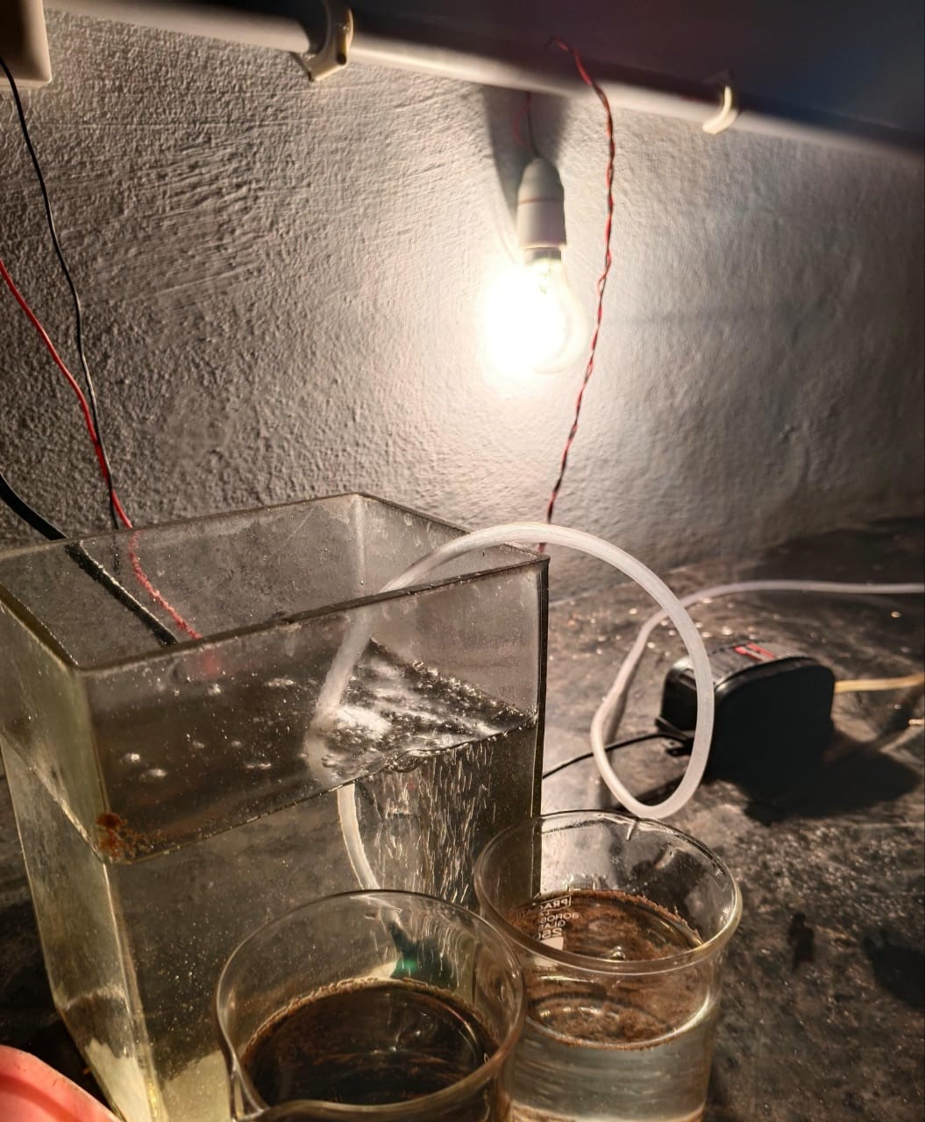

Figure 15: Installation of aerator Figure 16: Aerator setup

**STEP 4: HATCHING SETUP**

The hatching process for Artemia involves several critical steps to ensure successful development from cysts to nauplii.

**Hatching Process Steps:**

**1. Hatching Container:** Pour the prepared brine water into the hatching container, ensuring that the volume matches the number of cysts being used (2 liters per gram).

**2. Aerate the Water:** Before adding the cysts, turn on the air pump to aerate the water. This step is crucial as it helps dissolve oxygen in the water and keeps the cysts suspended, preventing them from settling at the bottom.

**3. Add Artemia Cysts:** Once the water is aerated, gently sprinkle the Artemia cysts into the water. Avoid clumping by spreading them evenly across the surface.

**4. Incubation:** Maintain the hatching environment at the specified temperature (26-30°C) and ensure continuous aeration. The cysts should remain suspended in the water column during this period.

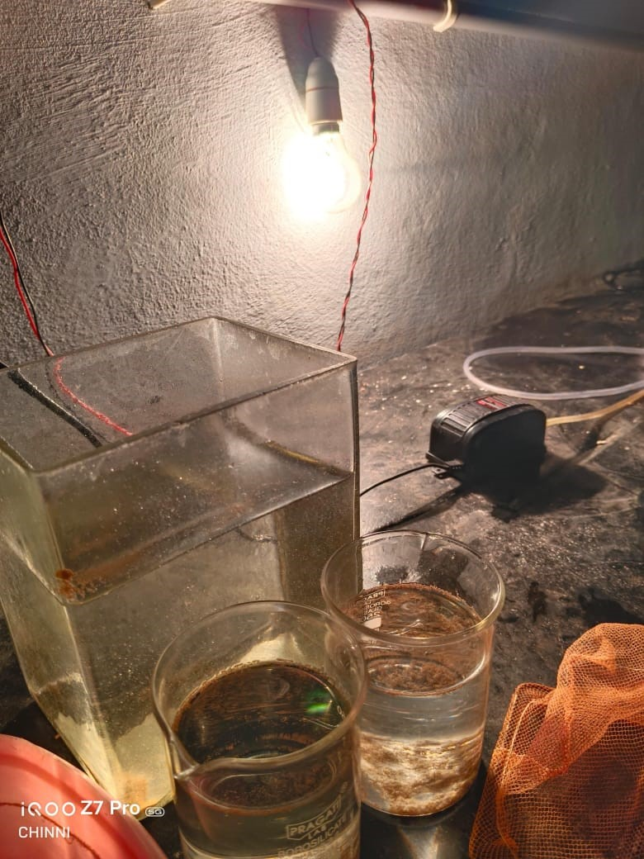 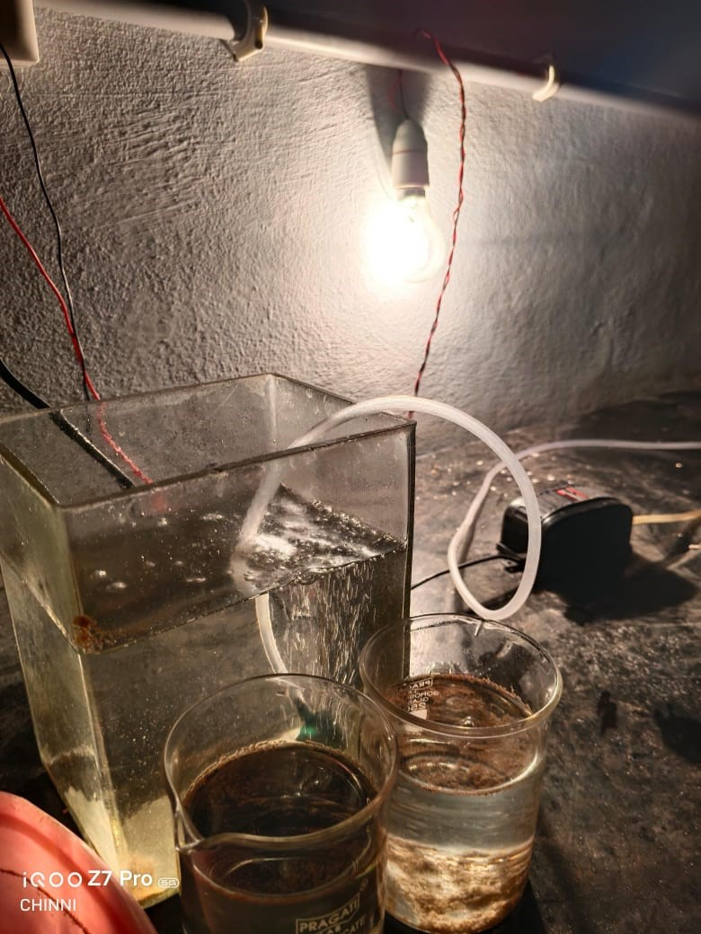

Figure 17,18: Hatching setup

**STEP 5: LIGHTING**

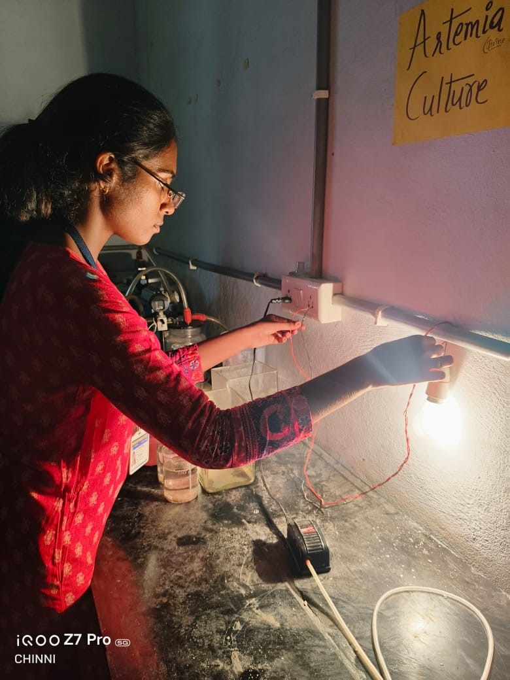

Figure 19: Lighting setup

**Lighting Setup**

**1. Choosing the Right Light Source**

For Artemia culture, an LED lamp is recommended due to its efficiency and low heat output. The light source should provide a consistent intensity of 2000 lux.

**2. Positioning the Light**

- Height and Angle: Position the LED lamp approximately 30-50 cm above the hatching container. This height ensures adequate light penetration while preventing excessive heat buildup that could affect water temperature.

- Coverage Area: Ensure that the light covers the entire surface area of the hatching container to promote uniform exposure for all cysts.

**3. Duration of Light Exposure**

- Lighting Schedule: Maintain continuous light exposure for the first 12-24 hours after adding the cysts. This duration is critical for maximizing hatching rates.

- Post-Hatching: After the initial hatching period, you can reduce the light exposure to a more moderate level, depending on the needs of the growing nauplii and the specific requirements of your aquaculture system.

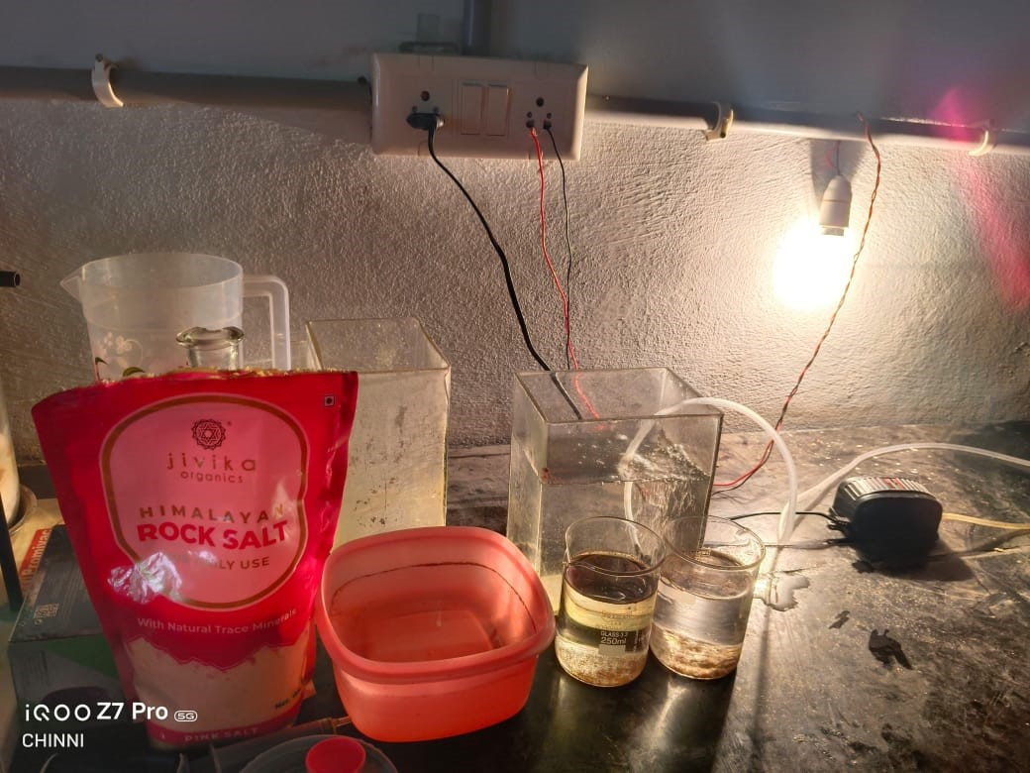

Figure 20: Lighting setup for hatching process

**STEP 6: TEMPERATURE CONTROL**

Maintaining the proper temperature is crucial for the successful hatching and growth of Artemia in culture. Here's an elaborated explanation of why temperature control is essential and how to effectively manage it throughout the hatching process.

**Importance of Temperature Control**

**1. Optimal Hatching Conditions**

Temperature plays a vital role in triggering the hatching process of Artemia cysts. Cysts require specific thermal conditions to break dormancy and initiate development. The optimal temperature range for hatching is between 28°C and 30°C.

**2. Larval Development and Growth**

After hatching, the temperature continues to influence the development and growth of Artemia nauplii:

- Metabolic Rates: Temperature directly affects the metabolic rates of Artemia. Higher temperatures (within the optimal range) accelerate growth and development, while lower temperatures slow these processes.

**3. Consistency in Culture Conditions**

Consistent temperature is essential for maintaining uniform growth and development within a culture system:

- Synchronization: By maintaining a stable temperature, all the Artemia in the culture will experience similar conditions, leading to more synchronized growth and development.

**STEP 7: STOP AERATION**

Stopping aeration is a crucial step in the harvesting process of Artemia nauplii after the hatching period. This section will explain how to stop aeration and why it is necessary for effective harvesting.

**1. Timing:** After 24 hours of hatching, it is essential to stop aeration. This timing allows sufficient time for the cysts to hatch and for the nauplii to become active swimmers.

**2. Ceasing Aeration:** To stop aeration, simply turn off the air pump or disconnect the air supply to the hatching container. Ensure that this is done gently to avoid disturbing the water too much.

**3. Allowing Cyst Shells to Float:** Once aeration is stopped, the cyst shells will begin to float to the surface of the water. This phenomenon occurs because the shells are less dense than the surrounding water. Allowing them to float is crucial for the next steps in harvesting.

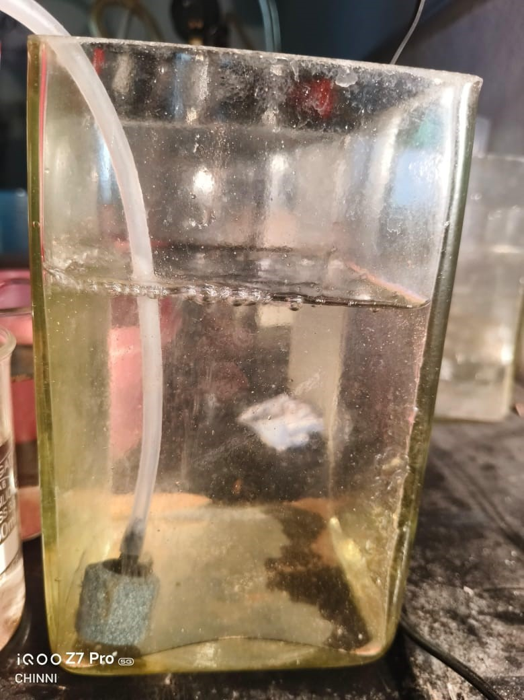

Figure 21: Stop aeration

**STEP 8: COLLECTING ARTEMIA NAUPLII**

Collecting Artemia nauplii after hatching is a critical step in the culture process, ensuring that the live feed is prepared for use in aquaculture.

Steps to collect nauplii

**1. Using a Strainer**

To collect the nauplii, use a strainer or fine mesh net with a mesh size of less than 150 micrometers. Here’s how to proceed:

- Position the Net: Gently lower the strainer into the water, ensuring that it does not disturb the settled nauplii too much.

- Strain Carefully: Slowly and carefully strain up the nauplii from the bottom of the container. The fine mesh will allow you to collect the nauplii while filtering out any remaining cyst shells and debris.

- Transfer to Collection Container: Drain the collected nauplii from the net into a clean collection container. This container should be prepared with clean, non-chlorinated water to rinse the nauplii and remove any contaminants or hatching metabolites.

**2. Rinsing the Nauplii**

After transferring the nauplii, it is essential to rinse them thoroughly:

- Rinse with Fresh Water: Gently rinse the nauplii with fresh, non-chlorinated water to remove any remaining cyst shells, debris and metabolites that may have accumulated during the hatching process.

- Avoid Overcrowding: Ensure that the density of nauplii in the collection container does not exceed 5 million per liter to maintain good water quality and oxygen levels.

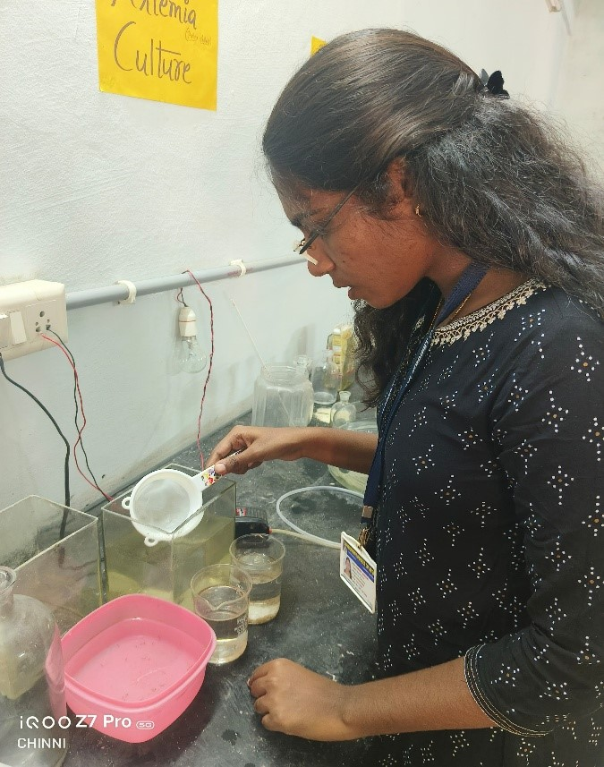 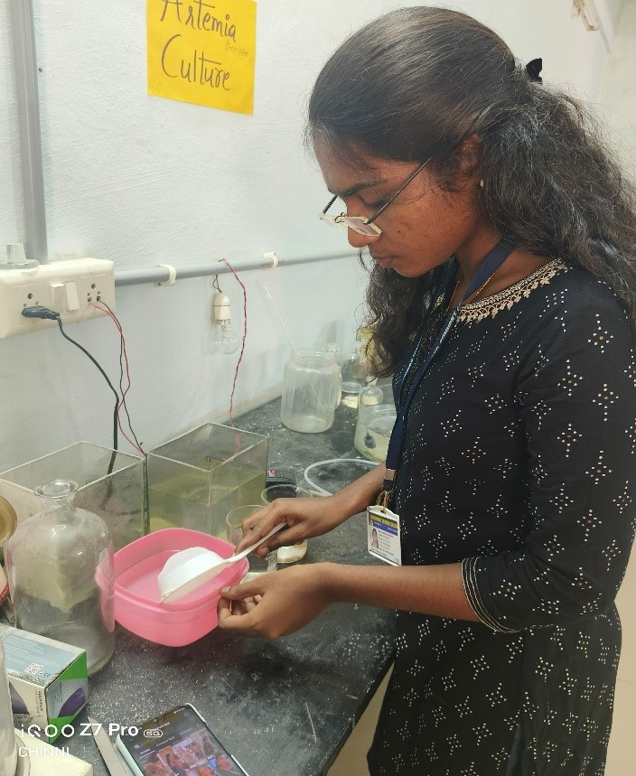

Figure 22, 23: Harvesting artemia using stainer

**STEP 9: SETTING UP A CULTURE TANK**

**1. Introducing Nauplii**

Once the culture tank is set up and the water parameters are stable, gently transfer the harvested nauplii into the tank.

- Transfer Method: Use a fine mesh net or a siphoning method to transfer the nauplii while minimizing stress and ensuring that they are not exposed to air for prolonged periods.

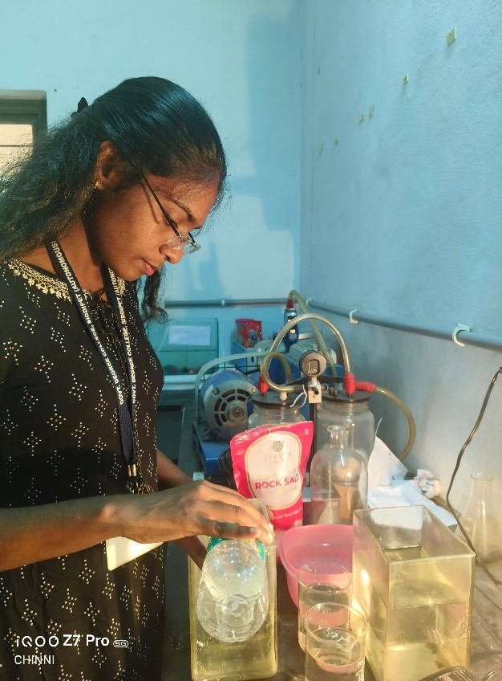 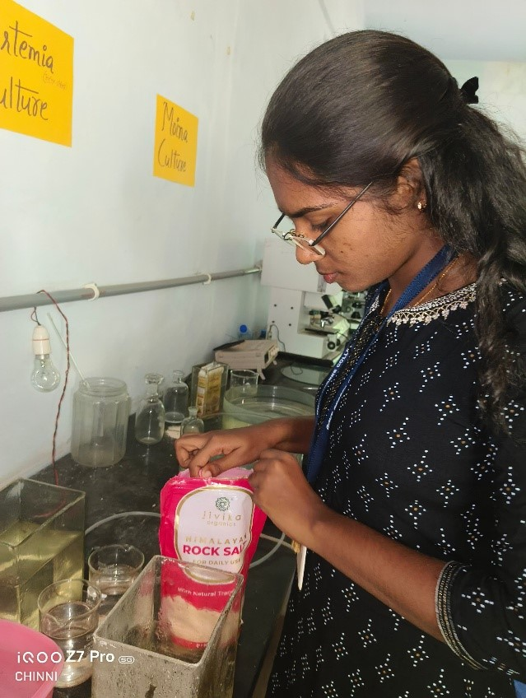

Figure 24: setting up culturing tank Figure25: Adding rock salt to the new culturing medium

**STEP 10: STOCKING DENSITY**

**Check Stocking Density**

**1. Calculating Density**

To determine the stocking density of nauplii in a culture tank, use the following formula:

For example, if you have 1,000 nauplii in 1 liter (1,000 ml) of water, the stocking density would be:

**2. Monitoring Nauplius Counts**

Regularly monitor the number of nauplii in the culture tank to ensure that the density remains within the desired range:

- Sampling: Take periodic samples of water from different areas of the tank to get an accurate count of the nauplii. This can be done using a small net or pipette.

**3. Adjusting Stocking Density**

If the nauplii density exceeds the optimal range, consider the following adjustments:

- Dilution: Transfer some nauplii to another tank to reduce the density in the original tank.

- Feeding Adjustments: If increasing density is unavoidable, ensure that feeding strategies are adjusted to meet the higher nutritional demands of the increased population.

**STEP 11: FEEDING REGIMEN**

**Feeding Regimen**

Artemia nauplii should be fed a diet of micronized soybean and pea. These plant-based feeds provide a suitable source of nutrients for the nauplii's growth and development.

**Quantity of Feed**

The daily feed ratio should be adjusted to maintain the water transparency between 15-20 cm. This is done by:

- Providing a directive feeding regime, starting with lower amounts and increasing as the

nauplii grow

- Constantly monitoring the water transparency and adjusting the feed accordingly

**Reason of feeding nauplii**

Artemia nauplii require a constant supply of feed to survive and grow. If not provided with sufficient food, the nauplii will:

- Starve and die due to lack of nutrients

- Cannibalize each other in search of food

- Fail to develop properly and reach their full growth potential

Mouth Size and Feed Particle Size

Artemia nauplii have a small mouth size, so the feed particles should be appropriately sized:

- Micronized soybean and pea are ground into a fine powder to match the nauplii's microscopic mouth

- Larger feed particles may clog the nauplii's digestive system or be too big for them to consume.

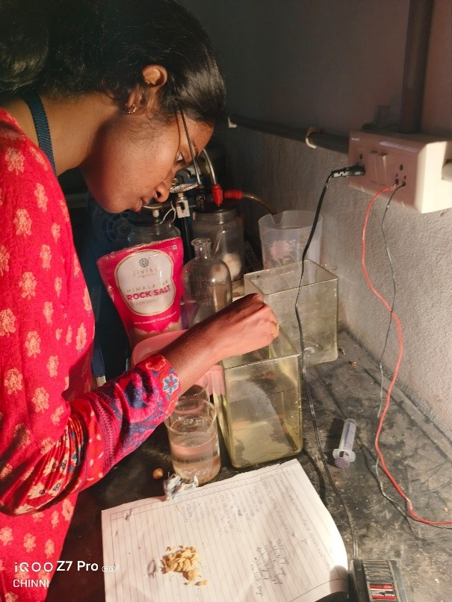

Figure 26: Feeding to artemia nauplii

**STEP 12: MONITORING AND MAINTAINING WATER QUALITY PARAMETERS**

Monitoring and maintaining water quality parameters such as salinity, pH and temperature are critical for the successful culture of Artemia nauplii.

**Importance of Water Quality Monitoring**

**1. Salinity**

Optimal Range: For Artemia culture, maintaining salinity around 35 g/L (or 35 ppt) is essential for optimal growth.

**2. pH**

Optimal Range: The pH level should be maintained around 8.4 for optimal growth.

Consequences of Neglecting pH Checks:

- Acidic Conditions: If the pH drops below the optimal range, it can lead to increased toxicity from ammonia and other metabolites, harming the nauplii.

- Alkaline Conditions: Conversely, if the pH rises too high, it can affect the solubility of nutrients and minerals, making them less available for uptake by the nauplii.

- Impaired Growth and Development: Fluctuating pH levels can disrupt enzymatic functions and metabolic processes, leading to poor growth and increased mortality.

**3. Temperature**

Optimal Range: The temperature should be maintained between 28°C and 30°C.

Consequences of Neglecting Temperature Checks:

- Metabolic Imbalance If the temperature is too low, metabolic processes slow down, leading to reduced feeding and growth rates. If too high, it can increase stress levels and lead to higher mortality rates.

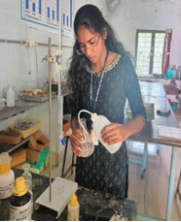 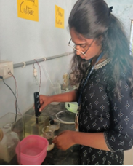

Figure 27: Salinity testFigure 28: pH test

**STEP 13: HARVESTING ARTEMIA COLLECTION**

Procedure for Feeding Harvested Artemia

**1. Preparation of Harvested Artemia**

Before feeding, ensure that the harvested Artemia are clean and free from excess salt and impurities. Follow these steps:

**2. Timing of Feeding**

- Optimal Timing: Feed the Artemia as soon as possible after harvesting, ideally within 12 hours of collection. This timing is crucial as Artemia expend energy and nutrients rapidly after hatching.

- Feeding Frequency: Depending on the needs of the fish or shrimp larvae, Artemia can be fed twice a day or more frequently if the larvae are very young and have high nutritional demands.

3. Feeding Quantity- Determining Amount: Use the following guidelines to determine the amount of Artemia to feed based on the number of fish or shrimp larvae:

- For small fish or shrimp larvae, a general guideline is to provide 2-5 nauplii per larva per feeding.

- Adjust the quantity based on the size and appetite of the larvae. Young fish have a hearty appetite, so they may require nearly as much Artemia as adult fish.

- Monitoring Water Transparency: Maintain water transparency between 15-20 cm. This can be used as an indicator of the feeding amount:

- If transparency decreases significantly, it may indicate overfeeding and you should reduce the amount of Artemia offered.

- If transparency is too high, it may suggest that the larvae are not receiving enough food, necessitating an increase in feeding.

**4. Feeding Method**

Using a Transfer Pipette or Squeeze Bottle:

- Use a transfer pipette or squeeze bottle to dispense the harvested Artemia into the feeding tank. This allows for precise control over the amount being fed.

- Gently distribute the Artemia evenly across the surface of the water to ensure that all larvae have access to the feed.

- Observation: After feeding, observe the larvae for signs of active feeding. Healthy larvae will swim towards the Artemia and consume them readily.

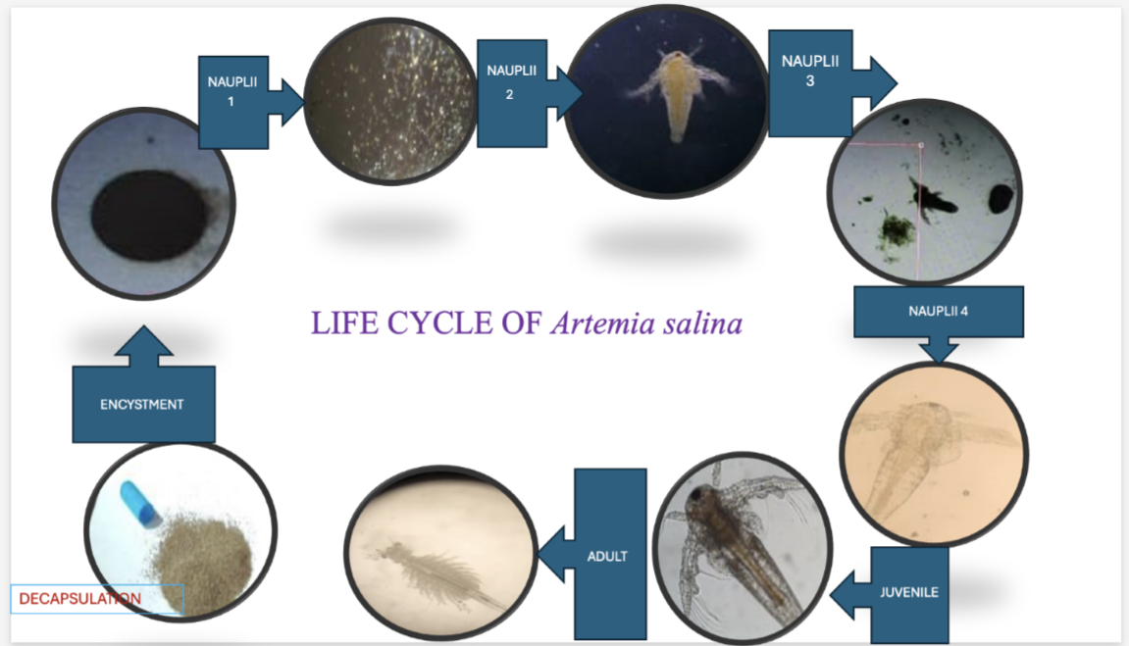

Figure 29: Life cycle of *Artemia Salina*

**RESULTS**

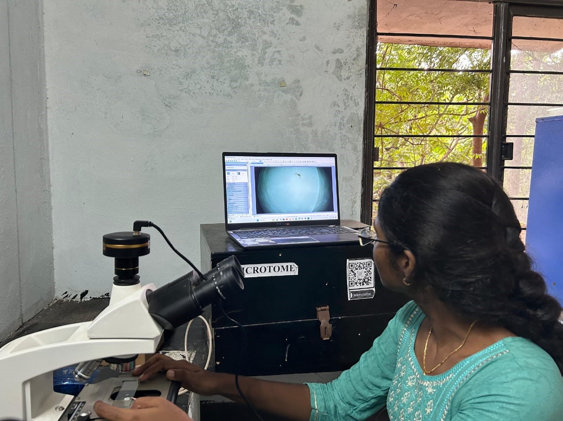

Figure 30: Microscopic view of Artemia

1. Initial Weight Measurement

Before initiating the feeding regimen, it is essential to measure the initial weight of the guppies. This provides a baseline for assessing growth over the feeding period.

Method: Use a precise scale to weigh a representative sample of guppies.

Recording: Document the weights in grams for accurate tracking.

2. Feeding Rates

Determining the appropriate feeding rates is vital for ensuring that the guppies receive adequate nutrition without overfeeding.

Daily Feeding Rate: Start with a feeding rate of approximately 10-15% of the total weight of the guppies per day. Adjust based on their response and growth.

Monitoring Consumption: Observe the guppies during feeding to ensure they are consuming the Artemia within a reasonable time frame.

3. Feeding Schedules

Establishing a consistent feeding schedule helps maintain the health of the guppies.

Frequency: Feed the guppies 2-3 times daily to provide a steady supply of nutrients.

Timing: Choose specific times each day to create a routine, which can help stimulate feeding behavior.

4. Weight Monitoring

Regular weight monitoring is crucial to assess the growth progress of the guppies.

Frequency: Weigh the guppies every 3-5 days to track changes in weight.

Recording Growth: Document the weights and calculate the average growth rate over the observation period.

5. Cumulative Feed Amount

Calculating the cumulative feed amount helps in understanding the total nutrition provided during the feeding period.

Total Feed Calculation: Multiply the daily feeding rate by the number of days fed. For example, if the daily feed is 5 grams and the feeding period is 13 days; the total feed amount would be 80 grams.

6. Stages of Artemia

Life Stages:

- Nauplius: The initial larval stage, very small and suitable for fry.

- Juvenile: Larger and more nutritious, suitable for juvenile guppies.

- Adult: Can be used for larger fish or as a supplemental feed.

7. Observations of Guppy Growth

Throughout the 13-day feeding period, careful observations should be made regarding the growth and behavior of the guppies.

Growth Indicators: Look for increased body size, improved coloration and enhanced swimming activity.

Health Assessment: Monitor for signs of stress or disease, which could indicate issues with feeding or water quality.

Feeding Schedules and Wild Guppies Growth: Day 1 to Day 13

Days 1-5:

- Feeding Amount: Average of 5 grams of Artemia per day.

- Weight Change: Average increase of 0.2 grams per guppy.

Days 6-10:

- Feeding Amount: Increased to 7 grams per day as guppies grew.

- Weight Change: Average increase of 0.3 grams per guppy.

Days 11-13:

- Feeding Amount: Adjusted to 10 grams per day to accommodate larger guppy sizes.

- Weight Change: Average increase of 0.4 grams per guppy

Cumulative Feed Calculation

Total Feed Amount:

- Days 1-5: 25 grams

- Days 6-10: 35 grams

- Days 11-13: 30 grams

Total for 13 Days: 90 grams of Artemia fed.

Growth Ratios: Average Growth Rate Calculation:

Total weight gain over 13 days divided by the initial weight gives the average growth rate.

**TABLE: 1**

|  |  |  |  |  |
| --- | --- | --- | --- | --- |
| **DAYS** | **FEED** | **10 am** | **1 pm** | **5 pm** |
| Day 1 | Artemia salina | ~2grams | ~2grams | ~2grams |
| Day 2 | Artemia salina | ~2grams | ~2grams | ~2grams |
| Day 3 | Artemia salina | ~2grams | ~2grams | ~2grams |
| Day 4 | Artemia salina | ~2grams | ~2grams | ~2grams |
| Day 5 | Artemia salina | ~2grams | ~2grams | ~2grams |
| Day 6 | Artemia salina | ~3 grams | ~2 grams | ~3 grams |
| Day 7 | Artemia salina | ~3 grams | ~2 grams | ~3 grams |
| Day 8 | Artemia salina | ~3 grams | ~2 grams | ~3 grams |
| Day 9 | Artemia salina | ~3 grams | ~2 grams | ~3 grams |
| Day 10 | Artemia salina | ~3 grams | ~2 grams | ~3 grams |
| Day 11 | Artemia salina | ~4 grams | ~3 grams | ~4 grams |
| Day 12 | Artemia salina | ~4 grams | ~3 grams | ~4 grams |
| Day 13 | Artemia salina | ~4 grams | ~3 grams | ~4 grams |

**CONCLUSION**

Artemia can be sustainably cultured under controlled conditions, optimizing key parameters such as salinity, temperature and aeration to provide a consistent and reliable source of live feed for aquaculture. With a high nutritional profile rich in proteins, essential fatty acids and vitamins, Artemia significantly benefits the growth and health of guppies, leading to improved growth rates and enhanced coloration compared to traditional dry feeds. Economically, Artemia culture is a cost-effective and accessible option for small-scale fish farmers, requiring minimal investment while yielding substantial benefits in fish farming. The study also revealed that guppies fed with Artemia exhibited notably higher survival rates, indicating that this live feed not only promotes growth but also enhances resilience against environmental stressors. These findings support the broader adoption of Artemia culture in aquaculture practices, highlighting its potential to improve fish health, production efficiency and contribute to sustainable aquaculture and food security.

REFERENCES

**•** **Alireza Asem (2023). "Phylogenetic analysis of problematic Asian species of Artemia Leach, 1819 (Crustacea, Anostraca), with the descriptions of two new species". Journal of Crustacean Biology. 83: 1–25.**

**•**  **Alireza Asem; Amin Eimanifar (2016). "Updating historical record on brine shrimp Artemia (Crustacea: Anostraca) from Urmia Lake (Iran) in the first half of the 10th century AD" (PDF). International Journal of Aquatic Science. 7: 1–5. Archived from the original (PDF) on 2016-04-01. Retrieved 2016-11-24.**

**•**  **Alireza Asem (2008). "Historical record on brine shrimp Artemia more than one thousand years ago from Urmia Lake, Iran" (PDF). Journal of Biological Research-Thessaloniki. 9: 113– 114. Archived from the original (PDF) on 2016-12-01. Retrieved 2013-05-17.**

**•**  **Jump up to: a b Martin Daintith (1996). Rotifers and Artemia for Marine Aquaculture: a Training Guide. University of Tasmania. OCLC 222006176.**

**•**  **"Introduction, biology and ecology of Artemia". Retrieved 15 October 2022.**

**•**  **F. A. Abreu-Geobios (1987). "A review of the genetics of Artemia". In P. Sorgerloo; D. A. Bengtson; W. Decleir; E. Jasper (eds.). Artemia Research and its Applications. Proceedings of the Second International Symposium on the Brine Shrimp Artemia, organized under the patronage of His Majesty the King of Belgium. Vol. 1. Western, Belgium: Universe Press. pp. 61–99. OCLC 17978639.**

**•**  **De Vos, Stephanie (2014). Genomic tools and sex determination in the extremophile brine shrimp Artemia Franciscan. Ghent: UGent. p. 3. ISBN 978-90-5989-717-5.**

**•**  **Jump up to: a b c Cleveland P. Hickman (1967). Biology of Invertebrates. St. Louis, Missouri: C. V. Mosby. OL 19205202M.**

**•** **Jump up to: a b c R. J. Criel & H. T. Macrae (2002). "Artemia morphology and structure". In T. J. Abatzopoulos; J. A. Beardmore; J. S. Clegg & P. Sorgerloos (eds.). Artemia: Basic and Applied Biology. Kluwer Academic Publishers. pp. 1–33. ISBN 978-1-4020-0746-0.**

**•**  **Jump up to: a b John K. Warren (2006). "Halotolerant life in feast or famine (a source of hydrocarbons and a fixer of metals)". Evaporites: Sediments, Resources and Hydrocarbons. Birkhäuser. pp. 617–704. ISBN 978-3-540-26011-0.**

**•** **Jump up to: a b Whitey Hitchcock. "Brine shrimp". Clinton High School Science. Archived from the original on September 3, 2010. Retrieved March 13, 2010.**

**•**  **Greta E. Tyson & Michael L. Sullivan (1980). "Scanning electron microscopy of the frontal knobs of the male brine shrimp". Transactions of the American Microscopical Society. 99 (2): 167–172. doi:10.2307/3225702. JSTOR 3225702.**

**•**  **O. Nougué; N. O. Rode; R. Jabbour-Zahab; A. Ségard; L.-M. Chevin; C. R. Haag; T. Lenormand (2015). "Automixis in Artemia: solving a century-old controversy". Journal of Evolutionary Biology. 28 (12): 2337–48. doi:10.1111/jeb.12757. PMID 26356354.**

**•**  **P. Sorgeloos; P. Dhert & P. Candreva (2001). "Use of the brine shrimp, Artemia spp., in marine fish larviculture" (PDF). Aquaculture. 200 (1–2): 147–159. doi:10.1016/s0044- 8486(01)00698-6.**

**•**  **Kai Schumann (August 10, 1997). "Artemia (Brine Shrimp) FAQ 1.1". Portland State University. Archived from the original on August 14, 2007. Retrieved March 13, 2010.**

**•** **Maniatsi, Stefania; Baxevanis, Athanasios D.; Kappas, Ilias; Deligiannidis, Panagiotis; Triantafyllidis, Alexander; Papakostas, Spiros; Bougiouklis, Dimitrios; Abatzopoulos, Theodore J. (2011-02-01). "Is polyploidy a persevering accident or an adaptive evolutionary pattern? The case of the brine shrimp Artemia". Molecular Phylogenetics and Evolution. 58 (2): 353–364. doi:10.1016/j.ympev.2010.11.029. PMID 21145977.**

**•** **Vos, Stephanie De; Bossier, Peter; Stappen, Gilbert Van; Vercauteren, Ilse; Sorgeloos, Patrick; Vuylsteke, Marnik (2013-03-04). "A first AFLP-Based Genetic Linkage Map for Brine Shrimp Artemia Franciscan and Its Application in Mapping the Sex Locus". PLOS ONE. 8 (3): e57585. Bibcode:2013PLoSO...857585D. doi:10.1371/journal.pone.0057585. ISSN 1932- 6203. PMC 3587612. PMID 23469207.**

**•**  **Han, Xuekai; Ren, Yizhuo; Ouyang, Xuemei; Zhang, Bo; Sui, Liying (2021-07- 15). "Construction of a high-density genetic linkage map and QTL mapping for sex and growth traits in Artemia Franciscan". Aquaculture. 540: 736692. doi: 10.1016/j.aquaculture.2021.736692. ISSN 0044-8486. S2CID 233663524.**

**•**  **De Vos, S.; Van Stappen, G.; Sorgeloos, P.; Vuylsteke, M.; Rombauts, S.; Bossier, P. (2019-02-01). "Identification of salt stress response genes using the Artemia transcriptome". Aquaculture. 500: 305– 314. doi: 10.1016/j.aquaculture.2018.09.067. ISSN 0044-8486. S2CID 92842322.**

**•**  **Lee, Junmo; Park, Jong Soo (2020-10-13). "Tolerance at the genetic level of the brine shrimp Artemia salina to a wide range of salinity". www.researchsquare.com. doi:10.21203/rs.3.rs-91049/v1. S2CID 234621039. Retrieved 2021-09-02.**

**•**  **Yi, Xianliang; Zhang, Keke; Liu, Renya; Giesy, John P.; Li, Zhaochuan; Li, Wentao; Zhan, Jingjing; Liu, Lifen; Gong, Yufeng (2020-01-01). "Transcriptomic responses of Artemia salina exposed to an environmentally relevant dose of Alexandrium minutum cells or Gonyautoxin2/3". Chemosphere. 238: 124661. Bibcode:2020Chmsp.238l4661Y. doi:10.1016/j.chemosphere.2019.124661. ISSN 00 45-6535. PMID 31472350. S2CID 201700530.**

**•**  **Zhang, Yulong; Wang, Di; Zhang, Zao; Wang, Zhangping; Zhang, Daochuan; Yin, Hong (2018-10-01). "Transcriptome analysis of Artemia sinica in response to Micrococcus lysodeikticus infection". Fish & Shellfish Immunology. 81: 92– 98. doi:10.1016/j.fsi.2018.06.033. ISSN 1050-4648. PMID 30006042. S2CID 51624497.**

**•**  **Chen, Bonien; Chu, Tah-Wei; Chiu, Kuohsun; Hong, Ming-Chang; Wu, Tsung-Meng; Ma, Jui-Wen; Liang, Chih-Ming; Wang, Wei-Kuang (2021-02-19). "Transcriptomic analysis elucidates the molecular processes associated with hydrogen peroxide-induced diapause termination in Artemia-encysted embryos". PLOS ONE. 16 (2): e0247160. Bibcode:2021PLoSO..1647160C. doi:10.1371/journal.pone.0247160. ISSN 1932- 6203. PMC 7894940. PMID 33606769.**

**•** **Jump up to: a b De Vos, Stephanie; Rombauts, Stephane; Coussement, Louis; Dermauw, Wannes; Vuylsteke, Marnik; Sorgeloos, Patrick; Clegg, James S.; Nambu, Ziro; Van Nieuwerburgh, Filip; Norouzitallab, Parisa; Van Leeuwen, Thomas (2021-08-31). "The genome of the extremophile Artemia provides insight into strategies to cope with extreme environments". BMC Genomics. 22 (1): 635. doi:10.1186/s12864-021-07937-z. ISSN 1471- 2164. PMC 8406910. PMID 34465293.**

**•**  **Micharl Dockey & Stephen Tonkins. "Brine shrimp ecology" (PDF). British Ecological Society. Archived from the original (PDF) on 2009-07-08.**

**•**  **L. Lewan; M. Anderson & P. Morales-Gomez (1992). "The use of Artemia salina in toxicity testing". Alternatives to Laboratory Animals. 20 (2): 297– 301. doi:10.1177/026119299202000222. S2CID 88834451.**

**•**  **Muñoz J; Gómez A; Green AJ; Figuerola J; Amat F; Rico C (2008). "Phylogeography and local endemism of the native Mediterranean brine shrimp Artemia salina (Branchiopoda: Anostraca)". Mol. Ecol. 17 (13): 3160–3177. doi:10.1111/j.1365- 294X.2008.03818.x. hdl:10261/37169. PMID 18510585. S2CID 23565318.**

**•**  **Hachem Ben Naceur; Amel Ben Rajab Jenhani; Mohamed Salah Romdhane (2009). "New distribution record of the brine shrimp Artemia (Crustacea, Branchiopoda, Anostraca) in Tunisia". Check List. 5 (2): 281–288. doi:10.15560/5.2.281. ISSN 1809-127X.**

**•**  **"Lake Urumia's Artemia Face Extinction". Financial Tribune. 28 December 2014. Retrieved 29 January 2018.**

**•**  **Eimanifar A; Asem A; Djamali M; Wink M (2016). "A note on the biogeographical origin of the brine shrimp Artemia urmiana Günther, 1899 from Urmia Lake, Iran" (PDF). Zoo taxa. 4097 (2): 294– 300. doi:10.11646/zootaxa.4097.2.12. PMID 27394547. S2CID 25998873. Archived from the original (PDF) on 2020-02-10.**

**•**  **"Endangered and Threatened Wildlife and Plants; 12-Month Finding for a Petition to List the Mono Lake Brine Shrimp as Endangered". Federal Register. 60 (173): 46571–46572. 1995.[permanent dead link]**

**•**  **H. Planel; Y. Gaubin; R. Kaiser; B. Pianezzi (1980). "The effects of cosmic rays on Artemia egg cysts". Laboratoire Médicale. Report for National Aeronautics and Space Administration.**

**•**  **H. Bücker & G. Horneck (1975). "The biological effectiveness of HZE-particles of cosmic radiation studied in the Apollo 16 and 17 Biostack experiments". Acta Astronautica. 2 (3–4): 247–264. Bibcode:1975AcAau...2.247B. doi:10.1016/0094-5765(75)90095- 8. PMID 11887916**