**Traditional Uses of *Argemone mexicana* in Indian Folk medicine.**

**Dr. Sanjay Kumar Acharya**

**Department of Botany, Govt. Dungar College, Bikaner**

**Abstract**

*Argemone mexicana*, commonly known as Mexican poppy, is a widely recognized medicinal plant in Indian folk medicine. Indigenous communities across various regions of India have long utilized this plant for its therapeutic properties. Traditionally, *Argemone mexicana* has been employed to treat a wide array of ailments, including skin disorders, respiratory issues, digestive disturbances, and inflammatory conditions. The plant’s seeds, leaves, and latex are particularly valued for their medicinal benefits. For instance, the latex is applied topically to heal wounds and sores, while decoctions of the leaves are consumed to alleviate symptoms of jaundice and malaria. Additionally, the seeds are known to possess purgative properties and are used in treating digestive problems.

This review seeks to consolidate ethnobotanical knowledge regarding the traditional uses of *Argemone mexicana* across different Indian regions. It also aims to highlight the plant's significance in the cultural practices of various ethnic groups. Moreover, the study discusses the potential risks associated with the use of *Argemone mexicana*, given its known toxic properties, particularly due to the presence of alkaloids like sanguinarine and dihydrosanguinarine. By exploring both the benefits and dangers of this plant, the study emphasizes the need for careful application and further scientific research to validate traditional claims and ensure safe usage.

**Keywords:** Argemone mexicana, Indian folk medicine, medicinal plants, ethnobotany, toxicology, herbal remedies, indigenous knowledge.

**Introduction**

Argemone mexicana commonly referred to as Mexican poppy or prickly poppy is a plant of considerable significance in Indian folk medicine. Native to the Americas, Argemone mexicana has become naturalized in various tropical and subtropical regions, including India, where it is widely found in waste lands, roadsides, and agricultural fields. Despite its classification as a weed, the plant holds a prominent place in traditional medicine systems across India, particularly among rural and indigenous communities.

The widespread use of Argemone mexicana in folk medicine is attributed to its diverse pharmacological properties, which are harnessed for treating a variety of ailments. The plant's different parts—seeds, leaves, roots, and latex—are utilized in various formulations. For instance, the bright yellow latex is applied directly to the skin to treat conditions such as warts, skin infections, and wounds. The seeds are known for their purgative and emetic properties and are used in small doses to treat digestive disorders, though caution is advised due to their toxic potential. Infusions and decoctions of the leaves are traditionally consumed to alleviate symptoms of respiratory issues like asthma and bronchitis, as well as liver disorders like jaundice.

In many regions of India, Argemone mexicana also holds cultural significance, often being employed in religious rituals and traditional healing practices. However, the plant's toxic nature, primarily due to the presence of alkaloids such as sanguinarine and dihydrosanguinarine, poses a significant risk when not used appropriately. Cases of poisoning, especially due to adulteration of edible oils with Argemone oil, highlight the need for caution and proper knowledge in its application.

This introduction aims to provide a comprehensive overview of the traditional uses of Argemone mexicana in Indian folk medicine, exploring the plant’s role in ethnomedicine, its therapeutic potential, and the associated risks. Understanding these aspects is crucial for preserving traditional knowledge while ensuring safe and effective use of this potent medicinal plant.

**Aim of the Study**

The aim of this study is to investigate and document the traditional uses of Argemone mexicana in Indian folk medicine, focusing on its ethnobotanical applications among various indigenous and rural communities. The study seeks to elucidate the specific ailments treated with Argemone mexicana, the methods of preparation and administration, and the cultural significance of the plant in traditional healing practices. Additionally, this research aims to assess the potential risks associated with the plant’s use, particularly its toxicological aspects, to provide a balanced understanding of its medicinal value and safety. Through this study, we intend to contribute to the preservation of traditional knowledge and support the informed and safe use of Argemone mexicana in contemporary herbal medicine.

Here are some points to Aim of Study

|  |  |
| --- | --- |
| **Ethnobotanical Documentation** | To systematically document the traditional knowledge related to Argemone mexicana from various regions of India, capturing the diverse ways in which different communities utilize the plant for medicinal purposes. |
| **Phytochemical Analysis** | To identify and analyze the active phytochemical constituents in Argemone mexicana those are responsible for its medicinal properties, thereby linking traditional uses with scientific evidence. |
| **Comparative Analysis** | To compare the traditional medicinal uses of Argemone mexicana across different ethnic groups and geographic regions within India, highlighting variations and commonalities in its application. |
| **Risk Assessment** | To evaluate the toxicological risks associated with the use of Argemone mexicana, particularly focusing on cases of misuse or overdose, and to recommend safe usage guidelines based on traditional and scientific knowledge. |
| **Cultural Significance** | To explore the cultural and ritualistic significance of Argemone mexicana in Indian traditional practices, understanding how its use extends beyond medicine into spiritual and social domains. |
| **Conservation of Knowledge** | To contribute to the conservation and transmission of traditional knowledge regarding Argemone mexicana, ensuring that this indigenous wisdom is preserved for future generations and integrated into modern medicinal practices where appropriate. |
| **Public Health Implications** | To investigate the public health implications of the widespread use of Argemone mexicana, particularly in rural areas, and to propose strategies for educating communities about the safe and effective use of this plant. |

These aims of study will provide a comprehensive framework for studying Argemone mexicana within the context of Indian folk medicine, balancing the preservation of traditional knowledge with the need for safety and scientific validation.

**Review of Literature**

The medicinal properties of *Argemone mexicana* have been widely recognized in Indian folk medicine and extensively studied in recent years. This plant, native to tropical America but widely naturalized in India, plays a significant role in the Ethnomedicinal practices of various rural and nomadic communities.

Agarwal and Bansal (2017) (1) highlight the extensive role of *Argemone mexicana* in indigenous medicine, emphasizing its use in treating skin conditions, respiratory issues, and gastrointestinal disorders. They note that despite its toxic nature, the plant has been used with caution in traditional remedies for centuries. In particular, the latex of the plant is used to treat wounds, infections, and other skin ailments. Kumar and Kumar (2018) (3) further expand on these uses, documenting the Ethnomedicinal importance of *Argemone mexicana* in treating conditions like jaundice, fever, and parasitic infections, particularly among rural populations in northern India. Their review reflects the adaptability of traditional medicine in using local resources for managing common health conditions.

The pharmacological and toxicological profile of *Argemone mexicana* is thoroughly explored by Jaiswal and Gupta (2020) (2) who analyze its bioactive compounds, such as sanguinarine and dihydrosanguinarine. While the plant's therapeutic potential is well-documented, they emphasize the risks associated with its toxic properties, particularly in cases of adulteration in edible oils, which has led to outbreaks of epidemic dropsy in India. They argue for a balanced view of the plant, recognizing its medicinal potential while underscoring the need for regulated use.

Sharma and Singh (2019) (5) focus on the use of *Argemone mexicana* by the nomadic tribes of the Indian desert, particularly in Rajasthan. In their study, they document how the plant is used for treating fevers, skin infections, and digestive issues, aligning with the broader Ethnomedicinal uses identified by earlier studies. Similarly, Sharma (2002) (6) discusses the use of *Argemone mexicana* by nomadic tribes in the Thar Desert, describing it as a crucial medicinal resource in an arid environment where access to formal healthcare is limited.

Patel and Patel (2022) (4) delve into the phytochemical constituents of *Argemone mexicana*, linking its medicinal uses to its alkaloids and other bioactive compounds. Their review suggests that while these compounds offer therapeutic benefits, such as antimicrobial and anti-inflammatory properties, they also pose significant health risks if not used properly. They echo earlier studies in calling for more research to develop safe medicinal applications of the plant.

The ethnobotanical survey by Singh and Sharma (2021) (7) further corroborates these findings, with an emphasis on the use of *Argemone mexicana* in Rajasthan. Their study presents detailed accounts of how rural and tribal communities incorporate the plant into daily healthcare practices, particularly for treating skin ailments, digestive disorders, and respiratory problems. These findings are supported by the broader ethnopharmacological work of Srivastava, Gupta, and Sharma (2009) (8) who highlight the plant’s role in traditional medicine across different regions of India.

Subramanian and Kannan (2010) (9) provide a comparative analysis of traditional and modern healthcare approaches, discussing the integration of plants like *Argemone mexicana* into contemporary medicine. They advocate for a more formalized understanding of traditional knowledge to develop safe, effective treatments. Yoganarasimhan (2000) (10) also emphasizes the need for further research into medicinal plants like *Argemone mexicana* to validate traditional uses and explore their potential for broader medical applications.

In conclusion, the literature on *Argemone mexicana* underscores its significant role in Indian folk medicine, particularly among rural and nomadic communities. While its medicinal properties have been extensively documented, the plant’s toxic nature calls for careful, regulated use. Further research is necessary to harness its therapeutic potential while mitigating the risks associated with its toxic compounds.

**Classification and Morphology of Argemone mexicana**

Kingdom: Plantae

Phylum: Angiosperms

Order: Papaverales

Family: Papaveraceae

Genus: Argemone

Species: Argemone mexicana

The morphology of this is characterized by several distinctive features that make the plant easily recognizable:

|  |  |
| --- | --- |
| **Habit** | *Argemone mexicana* is an annual herbaceous plant that typically grows to a height of 30 to 100 cm. The plant has a coarse, prickly appearance and often forms a bushy or branched structure. |
| **Root** | The plant has a well-developed taproot system, which helps it anchor firmly in the soil. The roots are capable of penetrating deep into the ground, aiding in water absorption, especially in arid environments. |
| **Stem** | The stem of *Argemone mexicana* is erect, branched, and covered with sharp prickles. The stem is hollow, cylindrical, and exudes yellowish latex when cut or damaged. The stem surface is often greenish-blue or glaucous, giving the plant a slightly waxy appearance. |
| **Leaves** | The leaves of *Argemone mexicana* are alternate, sessile (without a petiole), and deeply lobed, with each lobe ending in a sharp spine. The leaves are typically 10 to 20 cm long and have a blue-green color with prominent white veins. The surface of the leaves is also covered with prickles, adding to the plant's defensive mechanisms. |
| **Flowers** | The flowers of *Argemone mexicana* are large, showy, and yellow, measuring about 4 to 6 cm in diameter. They are solitary and arise from the axils of the upper leaves. Each flower has six petals that are crinkled and delicate, surrounding a cluster of numerous stamens with bright yellow anthers. The ovary is superior, and the flowers are hermaphroditic, containing both male and female reproductive organs. |
| **Fruit** | The fruit is a capsule, typically oblong or ovoid, and measures 2 to 4 cm in length. The capsule is densely covered with prickles and splits open when mature to release numerous small, black seeds. The seeds are round, smooth, and have a reticulated surface. |
| **Seeds** | The seeds of *Argemone mexicana* are small, about 1 to 2 mm in diameter, and black or dark brown in color. They have a characteristic warty or reticulated surface and contain a significant amount of oil, which is toxic if ingested. |
| **Latex** | One of the notable features of *Argemone mexicana* is its yellow latex, which exudes from any damaged part of the plant. This latex is known for its medicinal properties as well as its toxic effects. |

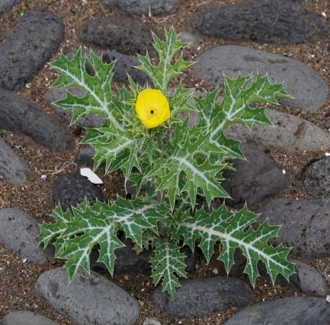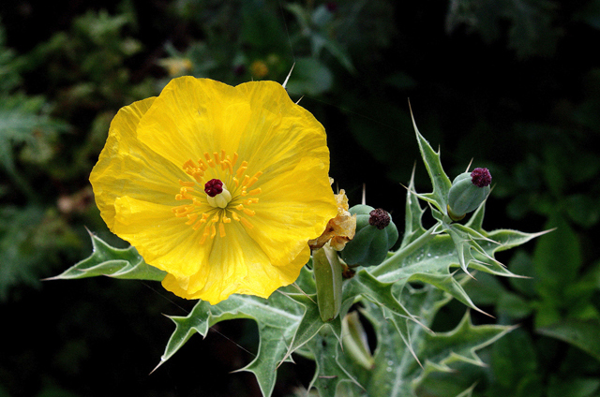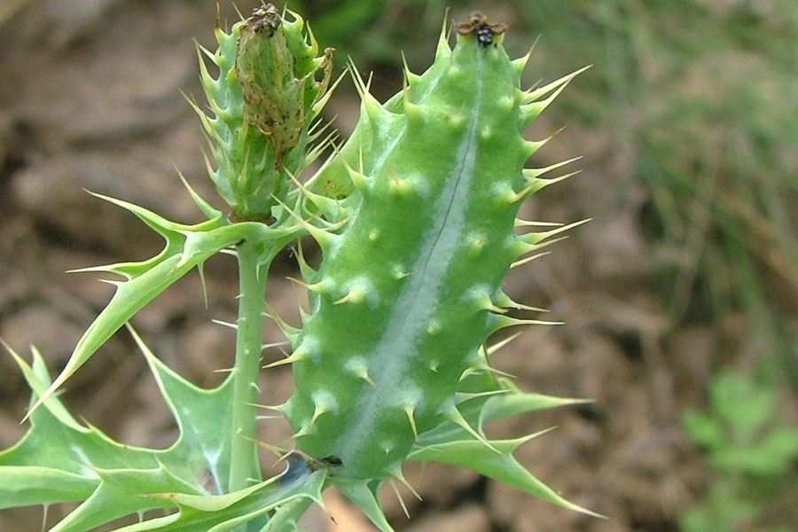

(Plant) (Flower) (Fruit)

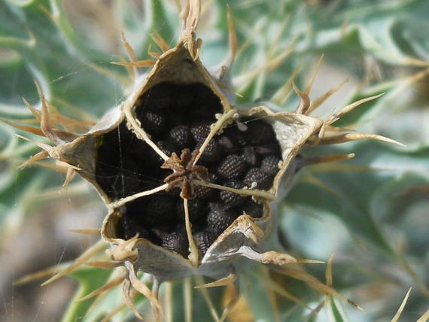 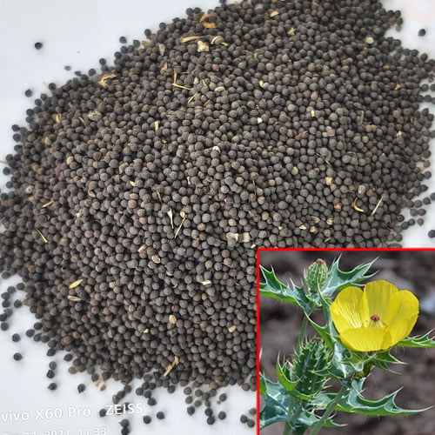 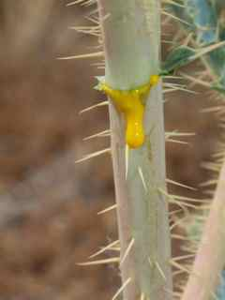

(Seed in Fruit) (Seed) (Latex)

*Argemone mexicana* has a distinctive, spiny appearance with its prickly stems, leaves, and fruits, along with its bright yellow flowers. The plant is well adapted to dry and arid conditions and is often found growing in wastelands, roadsides, and other disturbed areas.

**Bioactive compound found in Argemone mexicana**

*Argemone mexicana* contains a variety of bioactive compounds, primarily alkaloids that contribute to its medicinal properties as well as its toxicity. Here are the bioactive compounds found in *Argemone mexicana*:

|  |  |
| --- | --- |
| **Alkaloids** | **Sanguinarine:** A benzophenanthridine alkaloid, sanguinarine is one of the most prominent compounds in *Argemone mexicana*. It has antimicrobial, anti-inflammatory, and anticancer properties but is also toxic if ingested in large quantities.  **Dihydrosanguinarine:** Similar to sanguinarine, this alkaloid also exhibits antimicrobial properties and contributes to the plant's overall toxicity.  **Berberine:** This alkaloid is known for its antimicrobial, antidiabetic, and anti-inflammatory effects. It is also present in various other medicinal plants.  **Protopine:** Another significant alkaloid, protopine has sedative, analgesic, and antispasmodic properties.  **Chelerythrine:** Known for its antimicrobial, anti-inflammatory, and anticancer activities, chelerythrine is another benzophenanthridine alkaloid present in *Argemone mexicana*. |
| **Flavonoids** | **Quercetin:** A common flavonoid with antioxidant, anti-inflammatory, and Cardioprotective properties.  **Kaempferol:** This flavonoid has antioxidant, anti-inflammatory, and anticancer activities. |
| **Fatty Acids** | **Palmitic Acid:** A saturated fatty acid that contributes to the lipid content of the seeds.  **Oleic Acid:** A monounsaturated fatty acid with potential cardiovascular benefits.  **Linoleic Acid:** An essential polyunsaturated fatty acid, important for maintaining cell membrane integrity. |
| **Sterols** | **β-Sitosterol:** A phytosterol that has been shown to have anti-inflammatory and cholesterol-lowering effects. |
| **Other Compounds** | **Proteins and Amino Acids:** Present in the seeds, these contribute to the nutritional profile but are also linked to the plant’s toxicity.  **Phenolic Compounds:** These contribute to the antioxidant properties of the plant. |

These bioactive compounds in *Argemone mexicana* are responsible for its wide range of pharmacological activities, including antimicrobial, anti-inflammatory, and anticancer effects. However, the presence of toxic alkaloids like sanguinarine and dihydrosanguinarine also poses significant health risks, particularly if the plant is consumed improperly.

**Medicinal uses of Argemone mexicana Found in Ayurveda**

In Ayurveda, *Argemone mexicana*, known as "Shailkanta" or "Swarna Kshiri," is recognized for its various medicinal properties. Although the plant is toxic and requires careful handling, it has been traditionally used in small, controlled doses to treat several ailments. Here are some of the key medicinal uses of *Argemone mexicana* in Ayurveda:

|  |  |
| --- | --- |
| **Skin Disorders** | *Argemone mexicana* is used in Ayurvedic medicine to treat various skin conditions, including eczema, scabies, ringworm, and other parasitic skin infections. The plant's latex is applied topically to affected areas due to its antimicrobial and anti-inflammatory properties, which help reduce inflammation and infection. |
| **Wound Healing** | The yellow latex of *Argemone mexicana* is traditionally applied to cuts, wounds, and sores to promote healing. Its antiseptic and anti-inflammatory properties help prevent infection and speed up the healing process. |
| **Respiratory Disorders** | The plant is used to treat respiratory ailments such as asthma, bronchitis, and coughs. Decoctions made from the leaves are consumed to alleviate symptoms of these conditions, as *Argemone mexicana* is believed to have expectorant properties that help clear mucus and ease breathing. |
| **Digestive Issues** | In Ayurveda, *Argemone mexicana* seeds are used in very small, controlled doses as a purgative to treat constipation and other digestive disturbances. The seeds are known for their strong laxative properties, which help stimulate bowel movements. |
| **Eye Conditions** | The plant's latex is sometimes used in Ayurvedic practices to treat eye infections such as conjunctivitis. However, this application is highly controversial and dangerous due to the plant's toxicity, and it is not commonly recommended. |
| **Liver Disorders** | *Argemone mexicana* is used in the treatment of jaundice and other liver-related ailments. The leaf decoction is consumed to help detoxify the liver and support its function. The plant's bitter principles are believed to stimulate bile production, aiding in the treatment of liver conditions. |
| **Malaria and Fevers** | Traditional Ayurvedic practices include the use of *Argemone mexicana* for treating fevers, particularly those associated with malaria. The plant's antipyretic properties help reduce fever and combat the symptoms of malaria. |
| **Pain Relief** | The analgesic properties of *Argemone mexicana* make it useful in treating pain and inflammation. The latex or leaf extracts are applied to painful areas or consumed to relieve headaches, joint pain, and other inflammatory conditions. |
| **Dental Issues** | The latex is sometimes used to treat dental problems such as toothaches and gum diseases. Its antimicrobial properties help in reducing oral infections and inflammation. |
| **Antiseptic Use** | *Argemone mexicana* latex is used as an antiseptic for cleaning wounds and ulcers, preventing them from getting infected. Its strong antimicrobial action is beneficial in traditional Ayurvedic wound care. |
| **Antiparasitic Treatment** | The plant is traditionally used to treat intestinal worms and other parasitic infections. Its anthelmintic properties are utilized in small doses to expel parasites from the body. |
| **Reproductive Health** | In some Ayurvedic practices, *Argemone mexicana* is used to address certain reproductive health issues, though its use in this area is less common and requires careful management due to its toxic nature. |

*Argemone mexicana* has a long history of medicinal use in Ayurveda, its application is highly specific and typically involves very small, controlled doses due to the presence of toxic alkaloids.

**Harmful effect of Argemone mexicana**

*Argemone mexicana* is known for its toxic properties, which can lead to severe health issues if not used properly. The plant contains several potent alkaloids, such as sanguinarine and dihydrosanguinarine, which are primarily responsible for its harmful effects. Here are some harmful effects of *Argemone mexicana*:

|  |  |
| --- | --- |
| **Epidemic Dropsy** | One of the most serious consequences of consuming *Argemone mexicana* oil is epidemic dropsy, a condition caused by the adulteration of edible oils with *Argemone* oil. Symptoms include swelling of the legs, severe pain, shortness of breath, and heart failure. Epidemic dropsy has historically led to numerous fatalities in India. |
| **Toxicity** | The plant's alkaloids, particularly sanguinarine, are toxic and can cause significant damage to the body. Ingesting even small amounts of the plant or its oil can lead to poisoning, with symptoms such as nausea, vomiting, diarrhea, abdominal pain, and headaches. In severe cases, it can cause respiratory distress, convulsions, and death. |
| **Skin Irritation** | Contact with *Argemone mexicana* latex can cause skin irritation, including redness, itching, and blistering. Sensitive individuals may experience more severe reactions, such as dermatitis. |
| **Eye Damage** | The plant’s latex is particularly dangerous if it comes into contact with the eyes. It can cause severe irritation, inflammation, and even lead to temporary or permanent blindness if not treated promptly. |
| **Hepatotoxicity** | *Argemone mexicana* can cause liver damage if ingested in large amounts. The toxic alkaloids can lead to liver inflammation, jaundice, and in severe cases, liver failure. |
| **Respiratory Issues** | Inhalation of *Argemone mexicana* fumes or ingestion of its extracts can lead to respiratory problems, including difficulty breathing, coughing, and exacerbation of asthma symptoms. |
| **Neurotoxicity** | The toxic compounds in *Argemone mexicana* can affect the nervous system, leading to symptoms such as dizziness, confusion, convulsions, and in extreme cases, neurological damage. |
| **Cardiovascular Problems** | *Argemone mexicana* has been associated with cardiovascular issues, particularly in cases of epidemic dropsy. The toxic alkaloids can lead to heart failure, arrhythmias, and other serious cardiac conditions. |
| **Gastrointestinal Disturbances** | Consumption of *Argemone mexicana* can cause gastrointestinal issues such as severe abdominal pain, vomiting, and diarrhea, leading to dehydration and electrolyte imbalance. |
| **Reproductive Toxicity** | *Argemone mexicana* may have adverse effects on reproductive health, potentially causing fetal toxicity and teratogenic effects when ingested during pregnancy. |
| **Immunotoxicity** | The plant's alkaloids may suppress the immune system, making the body more susceptible to infections and reducing its ability to heal. |
| **Potential for Adulteration** | *Argemone mexicana* oil is sometimes adulterated with mustard oil, a common cooking oil in India. This adulteration can lead to widespread poisoning and outbreaks of epidemic dropsy, with significant public health implications. |
| **Cumulative Toxicity** | Repeated or prolonged exposure to *Argemone mexicana* can lead to cumulative toxicity, where small amounts of the toxic compounds build up in the body over time, eventually leading to serious health issues. |

Given these harmful effects, the use of *Argemone mexicana* in traditional medicine or any other form should be approached with extreme caution. It is crucial to avoid consuming the plant or its oil unless under strict guidance from a qualified healthcare professional, and only in very controlled, small doses. Public awareness and regulatory measures are essential to prevent accidental poisoning and ensure the safety of populations potentially exposed to this toxic plant.

**Conclusion**

The traditional uses of *Argemone mexicana* in Indian folk medicine reflect a deep-seated knowledge of its medicinal properties and the resourcefulness of indigenous and rural communities. This plant has been utilized for a range of ailments, from skin disorders and wound healing to digestive issues and respiratory problems. Its various parts—seeds, leaves, and latex—are harnessed for their therapeutic potential, demonstrating the plant's significant role in traditional healing practices.

However, the medicinal benefits of *Argemone mexicana* are accompanied by notable risks, primarily due to its toxic alkaloids, such as sanguinarine and dihydrosanguinarine. These compounds can cause serious health issues if not used carefully, underscoring the importance of proper dosage and preparation. Cases of epidemic dropsy and other toxic reactions highlight the need for caution in its application.

The integration of *Argemone mexicana* into traditional medicine systems showcases the intricate balance between utilizing natural resources and managing their potential hazards. While traditional knowledge provides valuable insights into the plant's uses, ongoing scientific research is essential to validate these practices and ensure safety. By combining traditional wisdom with modern scientific approaches, there is an opportunity to enhance the therapeutic use of *Argemone mexicana* while mitigating its risks.

Overall, *Argemone mexicana* remains a significant part of India's medicinal plant repertoire, reflecting both the depth of traditional knowledge and the need for careful management to harness its benefits responsibly.

**References**

|  |  |
| --- | --- |
| 1 | Agarwal, R., & Bansal, P. (2017). "Role of *Argemone mexicana* in Indigenous Medicine: A Review." *Pharmacognosy Reviews*, 11(22), 110-117. |
| 2 | Jaiswal, S., & Gupta, S. (2020). "Pharmacological and Toxicological Profile of *Argemone mexicana* L.: A Review." *Toxicology Reports*, 7, 357-367. |
| 3 | Kumar, A., & Kumar, V. (2018). "Exploring the Ethnomedicinal Importance of *Argemone mexicana* in Indian Folk Medicine." *Journal of Medicinal Plants Research*, 12(34), 672-680. |
| 4 | **Patel, S., & Patel, P.** (2022). "Traditional Uses and Phytochemical Constituents of Argemone mexicana: A Review." Journal of Ethnopharmacology, 284, 114776. |
| 5 | Sharma, R., & Singh, S. (2019). "Traditional Medicinal Plants of the Indian Desert: Focus on *Argemone mexicana*." *Desert Plants*, 39(1), 47-55. |
| 6 | Sharma, B. K. (2002). *Ethnobotany of the Thar Desert: The Use of Plants by the Nomadic Tribes*. Scientific Publishers. |
| 7 | Singh, A., & Sharma, S. (2021). "Ethnobotanical Survey of Medicinal Plants in Rajasthan, India: A Comprehensive Study." *Journal of Ethno biology and Ethnomedicine*, 17(1), 12. |
| 8 | Srivastava, J. K., Gupta, S., & Sharma, A. (2009). *Herbal Medicine for Human Health*. Springer. |
| 9 | Subramanian, S. S., & Kannan, S. (2010). *Traditional Medicine and Modern Health Care: An Overview*. Elsevier. |
| 10 | Yoganarasimhan, S. N. (2000). *Medicinal Plants of India*. Vol. 1. Interline Publishing. |