**Harnessing the Power of Graph Theory for Machine Learning Applications in Complex Data Analysis**

**1Dokku Sankara Rao, Assoc. professor & HoD, Dept. of BS & H, Chalapathi Institute of Technology, Guntur-522016, A.P, India.**

**2Thati Raghavaiah, Asst. professor, Dept. of BS & H, Chalapathi Institute of Technology, Guntur-522016, A.P, India.**

***Abstract***

***Graph Theory, a fundamental area of mathematics, explores the relationships between vertices, which can represent various types of objects, connected by edges. This field has become integral to understanding and analyzing complex relationships in diverse applications, including social networks, molecular networks, disease networks, and network modeling. With the advent of artificial intelligence (AI) and its burgeoning role in everyday life, Graph Theory's applications have extended into machine learning. By leveraging graph-theoretic concepts, we can reduce the dimensionality of datasets and streamline analysis processes, thereby enhancing machine learning models. This paper explores how graph theory can be effectively applied to machine learning, demonstrating its potential to improve model performance and data interpretation.***

***KEYWORDS***

***Graph THEORY, Machine learning, Graph-based Representations.***

1. **INTRODUCTION:**

Machine learning (ML) has become an indispensable tool across diverse fields, leveraging methodologies from mathematics, statistics, computer science, and cognitive science. Among these, graph theory has emerged as a powerful ally, providing essential frameworks and techniques for efficiently managing and analyzing complex relational data.

Graph theory, with its focus on the study of graphs — structures made up of nodes (vertices) and edges — offers robust tools for representing intricate data relationships. This is particularly relevant in machine learning, where understanding and processing complex data structures is crucial. The intersection of graph theory and machine learning spans various domains, including information retrieval, recommendation systems, question-answering systems, community detection, disease analysis, and document classification.

In information retrieval, graphs can represent the semantic relationships between documents and queries, facilitating more effective search and retrieval processes. Recommendation systems often use graph-based models to capture user preferences and item similarities, enhancing the accuracy of suggestions. In question-answering systems, graph-based approaches help in understanding and reasoning over vast amounts of unstructured information to generate accurate answers.

Community detection in social networks or biological networks benefits from graph theory's ability to identify clusters or communities within data. Disease analysis leverages graph structures to model interactions between genes, proteins, and diseases, uncovering insights into disease mechanisms and potential treatments. Document classification uses graph representations to model the relationships between different documents, improving the accuracy and relevance of categorization.

Machine learning techniques, in turn, utilize these graph-based representations to solve a wide array of problems. Algorithms that operate on graphs, such as graph convolutional networks and spectral methods, are employed to enhance the learning process by leveraging the structural information inherent in graph data.

This paper explores the synergistic relationship between graph theory and machine learning, highlighting how graph-based approaches contribute to various stages of the machine learning workflow. By examining the applications and methodologies in this intersection, we aim to shed light on the powerful capabilities that arise from combining these two fields.

**II. Machine Learning Process:**

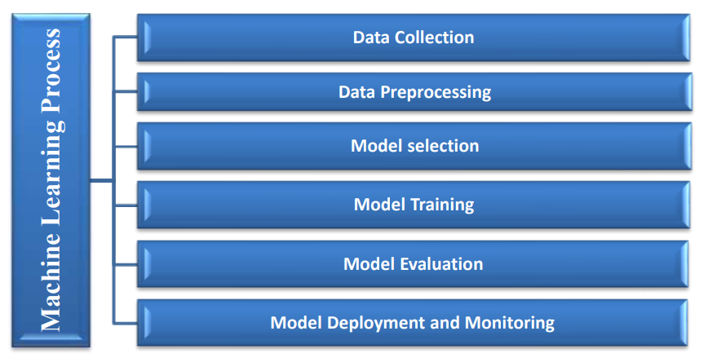

**Figure 1:** Machine Learning Process

The integration of graph theory into machine learning has significantly advanced the field, leveraging graph-based methods to tackle complex tasks and enhance performance. A substantial body of literature highlights the pivotal role of graph theory in improving various machine learning applications.

1. **Graph Attention Networks (GATs)**: According to [3], Graph Attention Networks (GATs) introduce attention mechanisms to learn node representations by focusing on their neighbors. This approach allows GATs to weigh the importance of different neighbors dynamically, improving the representation of nodes and their relationships within the graph. GATs are particularly effective in handling graphs where the importance of connections varies, such as social networks or citation networks.
2. **Graph Convolutional Networks (GCNs)**: The study in [2] extends Graph Convolutional Networks (GCNs) to semi-supervised learning settings, where only a small fraction of nodes are labeled. By incorporating both labeled and unlabeled data, GCNs propagate information across the graph, enhancing node classification tasks. This semi-supervised learning approach helps in leveraging the underlying graph structure to make more informed predictions.
3. **Comprehensive Review of Graph Neural Networks (GNNs)**: [4] provides a thorough overview of various Graph Neural Network (GNN) models and their applications in machine learning. This review encompasses techniques such as graph convolutional networks, graph attention networks, and others. It examines their applications in diverse areas like social network analysis, recommendation systems, and bioinformatics, showcasing the versatility and effectiveness of graph-based methods in machine learning tasks.

The literature collectively demonstrates the adaptability and efficacy of graph theory in machine learning. From node classification and link prediction to recommendation systems and ranking, graph-based approaches enable significant advancements across these tasks.

**Graphical Representations in Machine Learning**

To illustrate how graph theory is applied in machine learning, the following graphical representations are commonly used:

1. **Graph Convolutional Network (GCN) Architecture**:
   * **Nodes and Edges**: Represent data points and their relationships.
   * **Convolution Layers**: Apply filters to aggregate information from neighboring nodes.
   * **Activation Functions**: Introduce non-linearity to capture complex patterns.
2. **Graph Attention Network (GAT) Architecture**:
   * **Attention Mechanisms**: Assign weights to neighbors based on their importance.
   * **Node Aggregation**: Combine information from weighted neighbors.
   * **Output Layer**: Produces node representations considering attention weights.
3. **Graph-Based Recommendation System**:
   * **User-Item Graph**: Represents users and items as nodes, with edges indicating interactions.
   * **Graph-based Filtering**: Uses the graph structure to recommend items based on user preferences and item similarities.
4. **Community Detection in Social Networks**:
   * **Community Detection Algorithms**: Identify clusters or communities within the network.
   * **Visualization**: Shows clusters of nodes with dense intra-community connections.

These graphical representations and models exemplify how graph theory enhances machine learning by providing a structured way to analyze and interpret complex data relationships. They highlight the diverse applications of graph-based methods, from improving classification accuracy to recommending products and detecting communities.

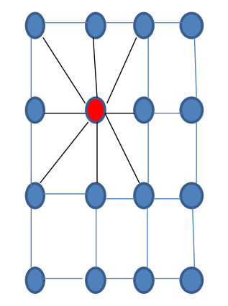

**Figure 2:** 2D Convolution Neural Network

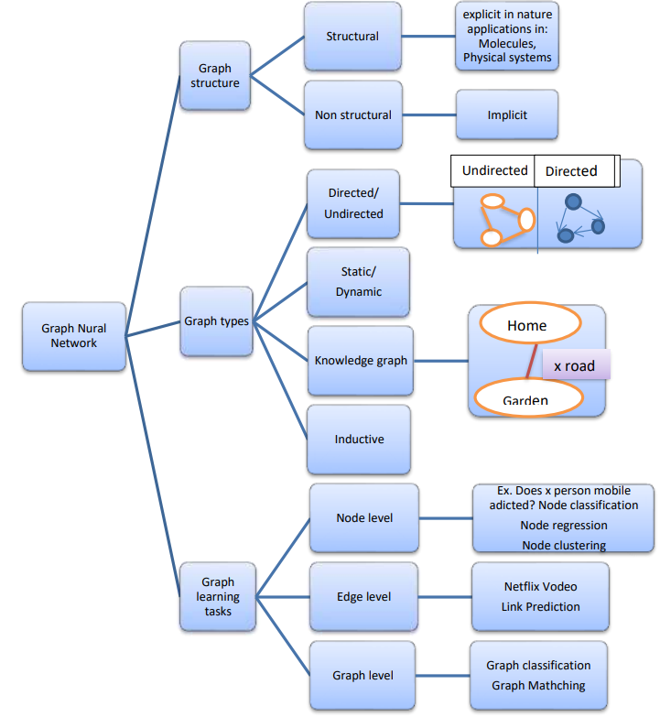

**Figure 3:** Graph Neural Network Taxonomy:

**III. Role of Graph Theory in Machine Learning:**

Graph theory plays a crucial role in machine learning by providing robust methods for representing, analyzing, and learning from complex data structures. Below, we delve into the specific contributions of graph theory to machine learning, highlighting its impact on representation learning, clustering, and various other applications.

**1. Learning via Representation**

**Graph Neural Networks (GNNs)** utilize graph theory concepts to learn node representations within a network. This approach captures both the structural and feature information of nodes, making it invaluable for several machine learning tasks:

* **Node Classification**: By learning embeddings for each node that encapsulate its features and its relationships with neighboring nodes, GNNs can classify nodes into different categories based on their learned representations.
* **Link Prediction**: GNNs predict the likelihood of the existence of an edge between two nodes, leveraging the learned representations of the nodes and their connections.
* **Graph Classification**: For tasks requiring classification of entire graphs, such as in bioinformatics or social network analysis, GNNs aggregate information from all nodes and edges to derive a graph-level representation.

**Data Graphs**: These graphs organize information where entities are represented as vertices and their relationships as edges. They are widely used in:

* **Information Retrieval**: Graphs represent documents and their relationships, improving search and retrieval by leveraging semantic connections.
* **Recommendation Systems**: User-item interactions are modeled as graphs to make personalized recommendations based on user preferences and item similarities.
* **Question-Answering Systems**: Graphs model relationships between concepts and entities to enhance the accuracy of answers derived from large datasets.

**2. Cluster Graphs**

Clustering is a significant task in machine learning that groups similar data points based on certain features or characteristics. Cluster graphs visually represent the relationships among data points within clusters:

* **Graph-Based Clustering**: This involves grouping nodes based on their connectivity or similarity. For example:
  + **Spectral Clustering**: Utilizes the eigenvalues and eigenvectors of the graph Laplacian matrix to partition the graph into clusters. This method captures global structure by analyzing the graph's spectrum.
  + **Community Detection**: Identifies groups of nodes with dense interconnections, revealing the underlying community structure in the graph.
* **K-Means Clustering**: An unsupervised learning technique that partitions data into KKK clusters. Unlike graph-based clustering, K-Means does not use graph theory but can be combined with graph-based methods for improved performance in certain contexts.
  + **K-Means Algorithm**: Groups data points into KKK clusters by minimizing the variance within each cluster. It operates iteratively, adjusting cluster centers and reassigning data points until convergence.

**Graphical Representations and Applications**

**1. Graph Neural Networks (GNNs) Architecture**:

* **Nodes and Edges**: Represent data points and their relationships.
* **Message Passing**: Aggregates information from neighboring nodes.
* **Learned Embeddings**: Captures node features and structural information.

**2. Data Graphs in Recommendation Systems**:

* **User-Item Interaction Graph**: Users and items are nodes, with edges representing interactions.
* **Recommendation Generation**: Utilizes graph-based techniques to suggest items based on user behavior and item similarity.

**3. Spectral Clustering**:

* **Graph Laplacian Matrix**: Represents the graph's structure.
* **Eigenvectors**: Used to determine cluster membership based on spectral properties.

**4. K-Means Clustering**:

* **Cluster Centers**: Represent the mean position of data points in each cluster.
* **Assignment**: Data points are assigned to the nearest cluster center.

In summary, graph theory enhances machine learning by providing sophisticated methods for data representation, clustering, and analysis. By leveraging graph-based approaches, machine learning models can effectively capture and utilize complex relationships within data, leading to improved performance in various applications.

**IV. Conclusion:**

This paper underscores the significant potential of graph theory in advancing machine learning techniques and addressing complex real-world problems. The synergy between graph theory and machine learning is evident in their combined ability to tackle challenges associated with interconnected and multifaceted data structures. By harnessing the principles of graph theory, we can develop sophisticated models that offer deeper insights and more accurate predictions across a range of applications.

**Key Contributions:**

1. **Enhanced Model Development**: Graph theory provides a robust framework for representing and analyzing interconnected data. This capability is crucial for developing machine learning models that can efficiently process and interpret complex relationships, leading to more precise and actionable insights.
2. **Interdisciplinary Synergy**: The integration of graph theory with machine learning illustrates the interdisciplinary nature of these fields. This collaboration enriches both domains, as graph theory contributes structural insights while machine learning leverages these insights for improved data analysis and prediction.
3. **Complex Problem Solving**: Graph-based approaches address real-world problems such as social network analysis, recommendation systems, and disease modeling. These applications benefit from the ability to model and analyze relationships between entities, ultimately enhancing the accuracy and effectiveness of solutions.
4. **Framework for Complex Structures**: Graph theory's contribution to data science lies in its powerful framework for managing and interpreting complex structures. This framework is instrumental in analyzing data with intricate dependencies and connections, thereby advancing our understanding of complex phenomena.

**V. Future Directions:**

Despite the substantial progress made, there remains a need for further research to fully exploit the potential of graph theory in machine learning. Key areas for exploration include:

* **Scalability and Efficiency**: Developing algorithms and models that can handle larger and more complex graphs efficiently remains a critical challenge. Research into scalable solutions can significantly impact real-world applications.
* **Integration with Emerging Technologies**: Combining graph-based methods with other advanced technologies, such as quantum computing and edge computing, could open new avenues for solving complex problems.
* **Applications to New Domains**: Expanding the use of graph theory to emerging fields and problems, such as personalized medicine and smart cities, could reveal untapped opportunities and innovative solutions.

In conclusion, the intersection of graph theory and machine learning offers a promising avenue for research and application. By continuing to explore and leverage the strengths of both disciplines, we can address existing challenges and unlock new opportunities, driving forward the development of more effective and insightful machine learning techniques.

**VI. References:**

1. Vellela, S. S., & Balamanigandan, R. (2022, December). Design of Hybrid Authentication Protocol for High Secure Applications in Cloud Environments. In 2022 International Conference on Automation, Computing and Renewable Systems (ICACRS) (pp. 408-414). IEEE.
2. Priya, S. S., Vellela, S. S., Reddy, V., Javvadi, S., Sk, K. B., & Roja, D. (2023, June). Design And Implementation of An Integrated IOT Blockchain Framework for Drone Communication. In 2023 3rd International Conference on Intelligent Technologies (CONIT) (pp. 1-5). IEEE.
3. Vellela, S. S., & Balamanigandan, R. (2023). An intelligent sleep-awake energy management system for wireless sensor network. Peer-to-Peer Networking and Applications, 16(6), 2714-2731.
4. Vellela, S.S., Balamanigandan, R. Optimized clustering routing framework to maintain the optimal energy status in the wsn mobile cloud environment. Multimed Tools Appl (2023). [https://doi.org/10.1007/s11042-023- 15926-5](https://doi.org/10.1007/s11042-023-%2015926-5)
5. Vullam, N., Yakubreddy, K., Vellela, S. S., Sk, K. B., Reddy, V., & Priya, S. S. (2023, June). Prediction And Analysis Using A Hybrid Model For Stock Market. In 2023 3rd International Conference on Intelligent Technologies (CONIT) (pp. 1-5). IEEE.
6. Vellela, S. S., Reddy, V. L., Roja, D., Rao, G. R., Sk, K. B., & Kumar, K. K. (2023, August). A Cloud-Based Smart IoT Platform for Personalized Healthcare Data Gathering and Monitoring System. In 2023 3rd Asian Conference on Innovation in Technology (ASIANCON) (pp. 1-5). IEEE.
7. Davuluri, S., Kilaru, S., Boppana, V., Rao, M. V., Rao, K. N., & Vellela, S. S. (2023, September). A Novel Approach to Human Iris Recognition And Verification Framework Using Machine Learning Algorithm. In 2023 6th International Conference on Contemporary Computing and Informatics (IC3I) (Vol. 6, pp. 2447-2453). IEEE.
8. Vellela, S. S., Vuyyuru, L. R., MalleswaraRaoPurimetla, N., Dalavai, L., & Rao, M. V. (2023, September). A Novel Approach to Optimize Prediction Method for Chronic Kidney Disease with the Help of Machine Learning Algorithm. In 2023 6th International Conference on Contemporary Computing and Informatics (IC3I) (Vol. 6, pp. 1677-1681). IEEE.
9. Vellela, S. S., Roja, D., Sowjanya, C., SK, K. B., Dalavai, L., & Kumar, K. K. (2023, September). Multi-Class Skin Diseases Classification with Color and Texture Features Using Convolution Neural Network. In 2023 6th International Conference on Contemporary Computing and Informatics (IC3I) (Vol. 6, pp. 1682-1687). IEEE.
10. Vullam, N., Vellela, S. S., Reddy, V., Rao, M. V., SK, K. B., & Roja, D. (2023, May). Multi-Agent Personalized Recommendation System in E-Commerce based on User. In 2023 2nd International Conference on Applied Artificial Intelligence and Computing (ICAAIC) (pp. 1194-1199). IEEE.
11. VenkateswaraRao, M., Vellela, S., Reddy, V., Vullam, N., Sk, K. B., & Roja, D. (2023, March). Credit Investigation and Comprehensive Risk Management System based Big Data Analytics in Commercial Banking. In 2023 9th International Conference on Advanced Computing and Communication Systems (ICACCS) (Vol. 1, pp. 2387-2391). IEEE
12. Vellela, S. S., Reddy, B. V., Chaitanya, K. K., & Rao, M. V. (2023, January). An Integrated Approach to Improve E-Healthcare System using Dynamic Cloud Computing Platform. In 2023 5th International Conference on Smart Systems and Inventive Technology (ICSSIT) (pp. 776-782). IEEE.
13. K. N. Rao, B. R. Gandhi, M. V. Rao, S. Javvadi, S. S. Vellela and S. Khader Basha, "Prediction and Classification of Alzheimer’s Disease using Machine Learning Techniques in 3D MR Images," 2023 International Conference on Sustainable Computing and Smart Systems (ICSCSS), Coimbatore, India, 2023, pp. 85-90, doi: 10.1109/ICSCSS57650.2023.10169550.
14. S Phani Praveen, RajeswariNakka, AnuradhaChokka, VenkataNagarajuThatha, SaiSrinivasVellela and UddagiriSirisha, “A Novel Classification Approach for Grape Leaf Disease Detection Based on Different Attention Deep Learning Techniques” International Journal of Advanced Computer Science and Applications(IJACSA), 14(6), 2023. <http://dx.doi.org/10.14569/IJACSA.2023.01406128>
15. Madhuri, A., Jyothi, V. E., Praveen, S. P., Sindhura, S., Srinivas, V. S., & Kumar, D. L. S. (2022). A New Multi-Level Semi-Supervised Learning Approach for Network Intrusion Detection System Based on the ‘GOA’. Journal of Interconnection Networks, 2143047.
16. Praveen, S. P., Sarala, P., Kumar, T. K. M., Manuri, S. G., Srinivas, V. S., &Swapna, D. (2022, November). An Adaptive Load Balancing Technique for Multi SDN Controllers.In 2022 International Conference on Augmented Intelligence and Sustainable Systems (ICAISS) (pp. 1403-1409).IEEE.
17. Reddy, V., Sk, K. B., Roja, D., Purimetla, N. R., Vellela, S. S., & Kumar, K. K. (2023, November). Detection of DDoS Attack in IoT Networks Using Sample elected RNN-ELM. In 2023 International Conference on Recent Advances in Science and Engineering Technology (ICRASET) (pp. 1-7). IEEE.
18. Vullam, N., Roja, D., Rao, N., Vellela, S. S., Vuyyuru, L. R., & Kumar, K. K. (2023, November). Enhancing Intrusion Detection Systems for Secure E-Commerce Communication Networks. In 2023 International Conference on the Confluence of Advancements in Robotics, Vision and Interdisciplinary Technology Management (IC-RVITM) (pp. 1-7). IEEE.
19. Biyyapu, N., Veerapaneni, E. J., Surapaneni, P. P., Vellela, S. S., & Vatambeti, R. (2024). Designing a modified feature aggregation model with hybrid sampling techniques for network intrusion detection. Cluster Computing, 1-19.
20. Praveen, S. P., Vellela, S. S., & Balamanigandan, R. (2024). SmartIris ML: Harnessing Machine Learning for Enhanced Multi-Biometric Authentication. Journal of Next Generation Technology (ISSN: 2583-021X), 4(1).
21. S. SrinivasVellela *et al*., "Fusion-Infused Hypnocare: Unveiling Real-Time Instantaneous Heart Rates for Remote Diagnosis of Sleep Apnea," *2024 International Conference on Knowledge Engineering and Communication Systems (ICKECS)*, Chikkaballapur, India, 2024, pp. 1-5, doi: 10.1109/ICKECS61492.2024.10617211.]
22. Vuyyuru, L.R., Purimetla, N.R., Reddy, K.Y. et al. Advancing automated street crime detection: a drone-based system integrating CNN models and enhanced feature selection techniques. Int. J. Mach. Learn. & Cyber. (2024). <https://doi.org/10.1007/s13042-024-02315-z>
23. Kumar, K. K., Rao, T. S., Vullam, N., Vellela, S. S., Jyosthna, B., Farjana, S., & Javvadi, S. (2024, March). An Exploration of Federated Learning for Privacy-Preserving Machine Learning. In 2024 5th International Conference on Innovative Trends in Information Technology (ICITIIT) (pp. 1-6). IEEE.
24. Vellela, S. S., Sowjanya, C., Vullam, N., Srinivas, B. R., Durga, M. L., Jyosthna, B., & Kumar, K. K. (2024, March). An Examination of Machine Learning Applications in the Field of Cybersecurity Approaches for Detecting and Mitigating Threats. In 2024 Third International Conference on Intelligent Techniques in Control, Optimization and Signal Processing (INCOS) (pp. 1-6). IEEE.
25. Polasi, P.K., Vellela, S.S., Narayana, J.L. et al. Data rates transmission, operation performance speed and figure of merit signature for various quadurature light sources under spectral and thermal effects. J Opt (2024). <https://doi.org/10.1007/s12596-024-02032-4>
26. Vellela, S.S., Balamanigandan, R. An efficient attack detection and prevention approach for secure WSN mobile cloud environment. Soft Comput (2024). <https://doi.org/10.1007/s00500-024-09891-w>
27. Krishna, C. V. M., Krishna, G. G., Vellela, S. S., Rao, M. V., Sivannarayana, G., & Javvadi, S. (2023, December). A Computational Data Science Based Detection of Road Traffic Anomalies. In 2023 Global Conference on Information Technologies and Communications (GCITC) (pp. 1-6). IEEE.
28. Vullam, N., Roja, D., Rao, N., Vellela, S. S., Vuyyuru, L. R., & Kumar, K. K. (2023, December). An Enhancing Network Security: A Stacked Ensemble Intrusion Detection System for Effective Threat Mitigation. In 2023 3rd International Conference on Innovative Mechanisms for Industry Applications (ICIMIA) (pp. 1314-1321). IEEE.
29. Basha, S. K., Purimetla, N. R., Roja, D., Vullam, N., Dalavai, L., & Vellela, S. S. (2023, December). A Cloud-based Auto-Scaling System for Virtual Resources to Back Ubiquitous, Mobile, Real-Time Healthcare Applications. In 2023 3rd International Conference on Innovative Mechanisms for Industry Applications (ICIMIA) (pp. 1223-1230). IEEE.
30. Vellela, S. S., Vullum, N. R., Thommandru, R., Rao, T. S., Sowjanya, C., Roja, D., & Kumar, K. K. (2024, May). Improving Network Security Using Intelligent Ensemble Techniques: An Integrated System for Detecting and Managing Intrusions in Computer Networks. In 2024 International Conference on Advances in Modern Age Technologies for Health and Engineering Science (AMATHE) (pp. 1-7). IEEE.
31. Reddy, B. V., Sk, K. B., Polanki, K., Vellela, S. S., Dalavai, L., Vuyyuru, L. R., & Kumar, K. K. (2024, February). Smarter Way to Monitor and Detect Intrusions in Cloud Infrastructure using Sensor-Driven Edge Computing. In 2024 IEEE International Conference on Computing, Power and Communication Technologies (IC2PCT) (Vol. 5, pp. 918-922). IEEE.
32. Vellela, S. S., Rao, M. V., Mantena, S. V., Reddy, M. J., Vatambeti, R., & Rahman, S. Z. (2024). Evaluation of Tennis Teaching Effect Using Optimized DL Model with Cloud Computing System. International Journal of Modern Education and Computer Science (IJMECS), 16(2), 16-28.
33. Rao, A. S., Dalavai, L., Tata, V., Vellela, S. S., Polanki, K., Kumar, K. K., & Andra, R. (2024, February). A Secured Cloud Architecture for Storing Image Data using Steganography. In 2024 2nd International Conference on Computer, Communication and Control (IC4) (pp. 1-6). IEEE.
34. Reddy, N. V. R. S., Chitteti, C., Yesupadam, S., Desanamukula, V. S., Vellela, S. S., & Bommagani, N. J. (2023). Enhanced speckle noise reduction in breast cancer ultrasound imagery using a hybrid deep learning model. Ingénierie des Systèmes d’Information, Vol. 28, No. 4.
35. Kumar, E. R., Chandolu, S. B., Kumar, K. P. V., Rao, M. V., Muralidhar, V., Nagarjuna, K., & Vellela, S. S. (2023, November). UAVC: Unmanned Aerial Vehicle Communication Using a Coot Optimization-Based Energy Efficient Routing Protocol. In 2023 International Conference on Recent Advances in Science and Engineering Technology (ICRASET) (pp. 1-5). IEEE.
36. Kommineni, K. K., & Prasad, A. (2023). A Review on Privacy and Security Improvement Mechanisms in MANETs. International Journal of Intelligent Systems and Applications in Engineering, 12(2), 90-99.
37. Vellela, S. S., Balamanigandan, R., & Praveen, S. P. (2022). Strategic Survey on Security and Privacy Methods of Cloud Computing Environment. *Journal of Next Generation Technology*, *2*(1).
38. Vellela, S. S., & Krishna, A. M. (2020). On Board Artificial Intelligence With Service Aggregation for Edge Computing in Industrial Applications. *Journal of Critical Reviews*, *7*(07).
39. Vellela, S. S., Pushpalatha, D., Sarathkumar, G., Kavitha, C. H., & Harshithkumar, D. (2023). Advanced Intelligence Health Insurance Cost Prediction Using Random Forest. *ZKG International*, *8*.
40. Vellela, S. S., Narapasetty, S., Somepalli, M., Merikapudi, V., & Pathuri, S. (2022). Fake News Articles Classifying Using Natural Language Processing to Identify in-article Attribution as a Supervised Learning Estimator. *Mukt Shabd Journal*, *11*.
41. Vellela, S. S., Chaganti, A., Gadde, S., Bachina, P., & Karre, R. (2022). A Novel Approach for Detecting Automated Spammers in Twitter. *Mukt Shabd*, *11*, 49-53.
42. Praveen, S. P., Vellela, S. S., & Balamanigandan, R. (2024). SmartIris ML: Harnessing Machine Learning for Enhanced Multi-Biometric Authentication. *Journal of Next Generation Technology (ISSN: 2583-021X)*, *4*(1).
43. Vellela, S. S., Babu, B. V., & Mahendra, Y. B. (2024). IoT-Based Tank Water Monitoring Systems: Enhancing Efficiency and Sustainability. *International Journal for Modern Trends in Science and Technology*, *10*(02), 291-298.
44. Burra, R. S., APCV, G. R., & Vellela, S. S. (2024). Infinite Learning, Infinite Possibilities: E-Assessment with Image Processing Technologies. *International Research Journal of Modernization in Engineering Technology and Science*, *6*.
45. Vellela, S. S., KOMMINENI, K. K., Rao, D. M. V., & Sk, K. B. (2024). An Identification of Plant Leaf Disease Detection Using Hybrid Ann and Knn. *Sai Srinivas Vellela, Dr K Kiran Kumar, Dr. M Venkateswara Rao, Venkateswara Reddy B, Khader Basha Sk, Roja D, AN IDENTIFICATION OF PLANT LEAF DISEASE DETECTION USING HYBRID ANN AND KNN, Futuristic Trends in Artificial Intelligence, e*.
46. Vellela, S. S. (2024). IoT Based Smart Irrigation and Controlling System. *IoT Based Smart Irrigation and Controlling System, International Journal for Modern Trends in Science and Technology*, *10*(02), 77-85.