Overview of a Modified Genetic Algorithm on Single Allocation Hub Location Problem Optimisation

Suraju A. Fadare 1 and Babajide A. Ojo2

1,2 Department of Electrical and Electronic Engineering, Federal Polytechnic, Ilaro

1 [suraju.fadare@federalpolyilaro.edu.ng](mailto:suraju.fadare@federalpolyilaro.edu.ng) (Correspondent author)

2 [babajide.ojo@federalpolyilaro.edu.ng](mailto:babajide.ojo@federalpolyilaro.edu.ng)

Abstract

The logical connections between multiple service receivers and a servicing hub equate to a single allocation hub location problem (SAHLP) of hub-spoke networks. Many relevant research works affirmed SAHLP optimisation as a non-deterministic polynomial (NP) problem. Hence, genetic algorithm (GA) was utilised in solving such NP optimisation problems. In this work, genetic algorithm (GA) was modified to optimise the number of hubs to be activated to provide demanded services for spokes in their proximity. The chromosome for the modified GA (MGA) model have a length equal to number of hubs in a sample space. Furthermore, the fitness function utilised for the evaluation of the solution of the MGA was the objective function for the SAHLP optimisation. The fitness function of the MGA-SAHLP model have two parts – the spoke’s demand and hub setup cost functions – with their respective weights. The developed MGA-SAHLP model was implemented using Matlab® 2023. The Simulations were carried out using randomly generated demands from spokes, setup cost of hubs, locations of hubs and spokes, and other required parameters by the model. The overview of the results obtained were presented. It was observed that the weight of the demand function has greater effect in determining the convergent time and the number of activated hubs. The MGA-SAHLP model is applicable in economical setting up of customer support service systems that considers magnitude of customer’s demands, proximity of customers to service centers and cost of establishing the service centers as obtained in electronic telecommunication networks and customer support services.

# Introduction

A hub is a general term in this paper for a facility that provide a specific demanded service or services (DS) to a customer or customers from another customer (Farahani et al., 2013; Kemmar et al., 2021; Mohammad, 2009; Rakhmawati et al., 2020; Ratli et al., 2022; Zhang et al., 2023). Hence, airport for connecting flights, centralised warehouse, shipment centre, customer service centres (CSC) or electronic communication switches and routers, and central train stations are hub for provision of communication linkage or support services to spokes as demanded (Amine et al., 2021; Campbell et al., 2005; Hekmatfar and Pishvaee, 2009; Kemmar et al., 2021; Tanash et al., 2017; W. Y. Wang and Li, 2020; Zhang et al., 2023). There must be demands from the spokes to the hub and the hub must have the capacity to provide the demanded services (Hekmatfar and Pishvaee, 2009; Mohammad, 2009; Serper and Alumur, 2016; S. Wang et al., 2020; Zheng et al., 2022). The spokes are the customers or devices that depend on hub to achieve their demands.

Furthermore, the location or positioning of the hubs within the purview of the sampled area that contains the customers is an optimization problem (Amine et al., 2021; Habibzadeh Boukani et al., 2016; Hillebrandt, 2015; Karatas and Onggo, 2019; Ratli et al., 2022; Simon et al., 2019). Hub location problem (HLP) optimisation involves the trading off parameters like Euclidean norm distance between spokes and their connected hub, cost of establishing hubs, demands from hubs and capacity of the hubs to respond to the demand from the connected spokes (Kemmar et al., 2021; Rakhmawati et al., 2020; Ratli et al., 2022; Ruela et al., 2009; Tanash et al., 2017). The minimization of the total objective cost function in accordance with a specific formulated model for the consider HLP will determine the number of hubs that will be sited or enabled.

Multiple allocation HLP (MAHLP) and single allocation HLP (SAHLP) are the basic types of HLP considering interconnection of hubs and spokes together (Ratli et al., 2022; Zhang et al., 2023). MAHLP involves possibility of having a spoke directly connected to more than one hubs simultaneously. But in SAHLP, a spoke can only be connected directly to a hub. Both MAHLP and SAHLP optimisation arenon-polynomial (NP) hard time. This paper was focussed on the SAHLP because it is applicable to computer, sensor and telecommunication networks that a device is connected to just an access point (AP) or a base station (BS) or switch. Hence, the objectives of the paper is to present an overview of the result of utilising SAHLP solution using genetic algorithm (GA) to assign certain number of spoke nodes to a specific number of hubs.

# Literature Review

Most relevant research works reported and discussed different HLP and their models (Alumur et al., 2012, 2021; Bollapragada et al., 2006; Campbell, 1994; Campbell and O’Kelly, 2012; Farahani et al., 2013; Jost and Clausen, 2023; Serper and Alumur, 2016; Tefek and Beşkirli, 2019). Furthermore, their applications in Telecommunications Engineering for wireless networks was of great interests to some researchers (Alumur et al., 2021; Campbell et al., 2002; Contreras, 2015; Contreras et al., 2010; Hillebrandt, 2015; Labbé et al., 2005; Umar et al., 2021; Wandelt et al., 2022). The assignment of spoke nodes to a hub is similar to the assignments of network terminals to a switch or routers at the centre of a star topology in telecommunication network (Carello et al., 2004; Contreras et al., 2010; Erişkin, 2021; Karatas and Onggo, 2019; Labbé et al., 2005).

The application of HLP in assigning spokes or terminal nodes to a hub node involves consideration of metrics for routes between spoke nodes and the hub node, and metrics for the capacity of the hub to cater for the total demands from the connected spokes. Equation (1) consider the summation of the performance metrics of the direct route between each spoke node and the central hub nodes with regards the amount of respective demand ($d_{i}$) for resources or services from the servicing hub and their minimum distance of separation ($D_{i}^{Min}$). Equation (2) is a model of the cost function

|  |  |  |  |
| --- | --- | --- | --- |
|  | $$D{= \sum_{i=1}^{N}{d_{i}×D_{i}^{Min}}}$$ |  | (1) |

Equation (2) defines the cost function for the cost of establishing the service centre *j*. The notation $f_{j}$ is a decision variable to indicate the active or inactive states of the selected hub. If a hub at hub node *j* is activated to provide services for a spoke node *i* at a minimum distance ($D_{i}^{Min}$), $f_{j}=1;$ otherwise, $f_{j}=0$. The notation $c_{j}$ is the cost or capacity requires by the hub node *j* to provide to offer the demanded services from the spoke nodes.

|  |  |  |  |
| --- | --- | --- | --- |
|  | $$C= \sum_{j=1}^{M}{α_{j}×c_{j}}=$$ |  | (2) |

Equation (3) is a model of the HLP solution as an optimization solution that minimize the summation of both distance and cost functions of equation (1) and equation (2). However, the minimization of the HLP optimization problem was classified as a non-polynomial time (NP) hard problem. Hence, it can be solved using by genetic algorithms (GA).

|  |  |  |  |
| --- | --- | --- | --- |
|  | $$\min_{ }{(C+D)= \sum_{i=1}^{N}{d_{i}×D_{i}^{Min}}}+ \sum_{j=1}^{M}{α_{j}×c_{j}}$$ | $∀_{i , j}$; *i=*1,2,…,N*; j=*1,2,…,M | (3) |

# Research Methodology

A HLP solution as an NP solution could be quickly proffered using heuristic approach like bio-evolution based optimisation algorithms like Genetic Algorithm (GA), Particle Swarm Optimisation (PSO) algorithm and Anti Bee Colony algorithm (Bhattacharjee and Mukhopadhyay, 2022; Karatas and Onggo, 2019; Okwu and Tartibu, 2021; Tefek and Beşkirli, 2019; W. Y. Wang and Li, 2020). Hence, this research work harnessed GA to allocate optimally activate a random number of hub nodes and distribute spoke nodes for them to service. This GA based HLP optimisation utilised the demands of the various spokes nodes, the distance of spokes to their servicing hubs and cost or capacity of hubs to service their connected nodes. The model of equation (3) was remodified to give a weighted HLP model solution as shown in equation (4).

|  |  |  |  |
| --- | --- | --- | --- |
|  | $$\min_{ }{(C+D)=w_{d} \sum_{i=1}^{N}{d_{i}×D_{i}^{Min}}}+ w_{c}\sum_{j=1}^{M}{α_{j}×c_{j}}$$ |  | (4) |

The weight for the capacity portion of the model ($w_{c}$) and the weight for the demand portion of the model ($w_{d}$) assist in using the GA to overview the effects of the cost of establishing a hub, and separation distance between the active hub and its connected spoke on the HLP solution. The HLP optimisation solution is utilised for activation of optimal number of hub nodes, allocate spoke nodes to the activated hub nodes with the constraint that no spoke node is served by two or more hubs. Figure 1 displays the flowchart of the modified GA (MGA) based model HLP solutions for activation of optimal number hub nodes among the given *m* number of hub nodes and distribution of *n* number of spoke nodes among the activated nodes based. The resulted optimal hub-spoke networks is decided by the GA based on minimum separation distance, service demands, cost or capacity of the activated hubs, weights of the demand and cost portions of the solution models.

To ease general applicability of the modified GA to simulate solutions for the proposed hub-spokes network, four different functions were created – Create_Model, HLP_Cost_Function, HLP_MGA and HLP_Solution_Plot. Create_Model function served as input data provider for the CHLP. It provides a set of m number of spokes nodes that might represents sensors or telecommunication end terminals or customers that demand or/and receive service(s) from the servicing hub. Furthermore, the input data contains another set of n number of hub nodes or service centres that provides the demanded services to the nodes assigned to them. Other input data that the Create_Model provides are the Cartesian or GPS locations of all the hubs (xs,ys) and spokes (xc,yc), the relative values of the demands (D), the set of relative distance between a particular spoke and its active servicing hub (d), the set of cost or capacity of active servicing hubs (c), the weight of the demand portion (w1), and weight of the capacity portion (w2) of the model utilized for the cost function. The HLP_Cost_Function was used to implement the model that serves as the fitness function for the GA. The HLP_Solution_Plot serves as the function that the produce the simulated output of the HLP Solutions using the instantaneous input parameters.

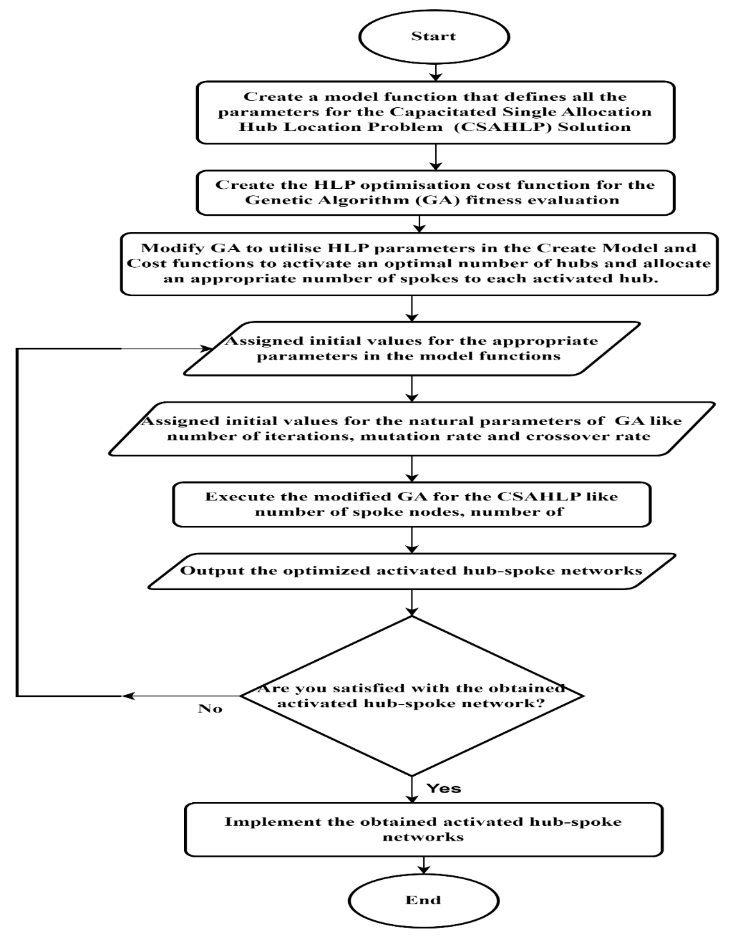

**Figure 1: Flowchart for Modified Genetic Algorithm for Single Allocation Hub Location Problem (MGA-SAHLP)**

# Results and Discussion

The overview of the simulation results obtained after running the aforementioned Matlab functions in associations with the modified GA Matlab function using the data attached in prior tables are display below. Table 1 shows the first set of input data used to run the MGA-SAHLP for the simulation of the MGA-SAHLP solution. Figure 2 is a typical illustration of the random generation of the locations of the spokes and inactive hubs using the Creative_Model function portion of the MGA-SAHLP using the input data set 1 in Table 1. Finally, Figure 3 is the graphical simulation result for running the MGA-SAHLP simulation model using the input data set 1.

Table 1: Input Data Set 1 for the Create_Model Function Part of the MGA SAHLP Simulation

|  |  |  |  |  |  |  |  |
| --- | --- | --- | --- | --- | --- | --- | --- |
| Input Parameter | Number of Spoke | Number of hubs | Dimension of the Sampled along x axis | Dimension of the Sampled along x axis | Weight of Demand Function | Weight of Cost of Hub Function | Maximum Number of Iteration |
| M | n | xmin - xmax | ymin - ymax | w1 | w2 | MaxIt |
| Data | 100 | 20 | 0 – 100 | 0 – 100 | 1 | 1 | 50 |

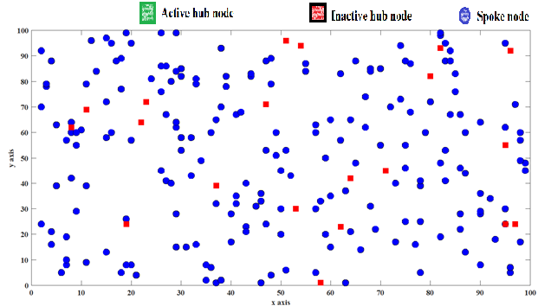

**Figure 2: Simulation of the Spoke Nodes and Inactive Hub Nodes usimg Create_Model Function Portion of the MGA-SAHLP**

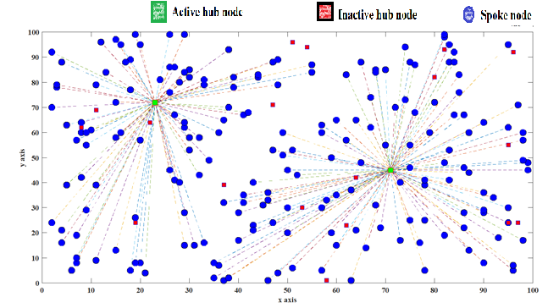

**Figure 3: The Spoke – Node Networks using MGA-SAHLP Solution with Equal Weights Using Input Data Set 1**

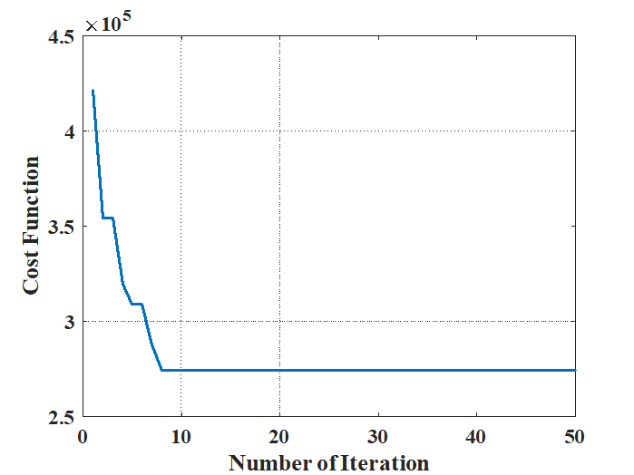

**Figure 4: MGA-SAHLP Performance for the Simulation Using Input Data Set 1**

The MGA performed the optimisation task by activating just two servicing hubs out of the twenty provided hubs using the equal weights for the demand and capacity functions as shown in the Figure 2. Hence, the MGA-SAHLP solution algorithms allocates the spokes nodes to the two activated hubs to give us two hub-spoke networks in the sampled space. Figure 4 depicts that that the algorithm converged to the minimum total optimisation cost function (MTOCF) before the ten (10) iterations.

Furthermore, the weight of the demands function was increased to five (5) to observe the effects on MTOCF. Table 2 shows the value of the input parameters for the MGA-SAHLP. The obtained results shows that six (6) out of the twenty (20) randomly generated hubs were activated to serve the 100 hubs spokes as shown in Figure 5. The optimisation consider proximity to an activated hub to allocate a spoke to hub. However, Figure 6 shows that about twenty-eight (28) number of iterations is required which is relative higher than using equal weights.

**Table 2: Input Data Set 2 for the Create_Model Function Part of the MGA**

|  |  |  |  |  |  |  |  |
| --- | --- | --- | --- | --- | --- | --- | --- |
| Input Parameter | Number of Spoke | Number of hubs | Dimension of the Sampled along x axis | Dimension of the Sampled along x axis | Weight of Demand Function | Weight of Cost of Hub Function | Maximum Number of Iteration |
| M | n | xmin - xmax | ymin - ymax | w1 | w2 | MaxIt |
| Data | 100 | 20 | 0 – 100 | 0 - 100 | 5 | 1 | 50 |

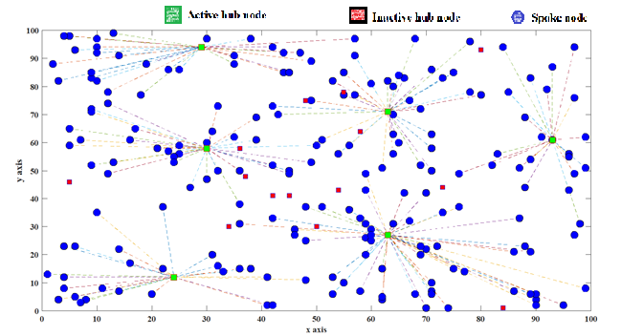***Figure 5: The Spoke – Node Networks using MGA-SAHLP Solution with Unequal Weights Using Input Data Set 2***

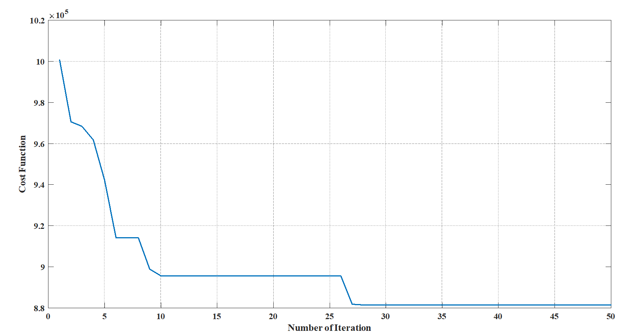

**Figure 6: MGA-SAHLP Performance for the Simulation Using Input Data Set 2**

Moreover, the weight of the demand function was reduced to one (1) and the weight of the setup cost function was increased to five (5) to observed the effect of the set up cost function on the MTOCF. Table 3 contains the input data that was utilised to run the MGA-SAHLP optimisation simulation for this scenario. Figure 7 shows that one (1) hub out of the twenty (20) randomly placed hubs was activated. Also, the MGA-SAHLP consider the demand function parts of the MTOCF by ensuring that one of the central located hubs was activated for each complete re run of the MGA-SAHLP optimization Matlab function. Hence, the simulation proffered one hub-spoke network solution in Figure 7, which required less than twelve 12 iterations to converge as depicted by Figure 8.

**Table 3: Input Data Set 3 for the Create_Model Function Part of the MGA**

|  |  |  |  |  |  |  |  |
| --- | --- | --- | --- | --- | --- | --- | --- |
| Input Parameter | Number of Spoke | Number of hubs | Dimension of the Sampled along x axis | Dimension of the Sampled along x axis | Weight of Demand Function | Weight of Cost of Hub Function | Maximum Number of Iteration |
| M | n | xmin - xmax | ymin - ymax | w1 | w2 | MaxIt |
| Data | 100 | 20 | 0 – 100 | 0 - 100 | 1 | 5 | 50 |

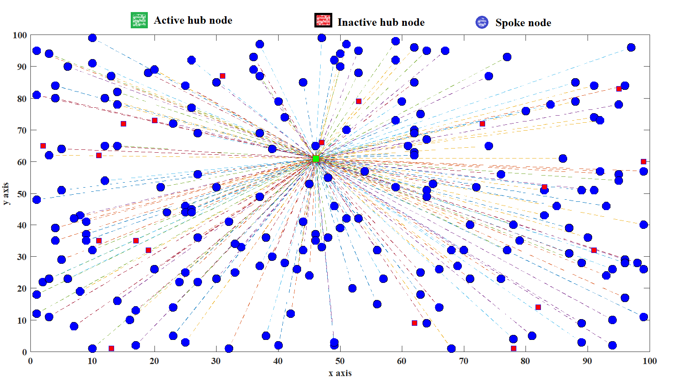

**Figure 7: The Spoke – Node Networks using MGA-SAHLP Solution with Unequal Weights Using Input Data Set 3**

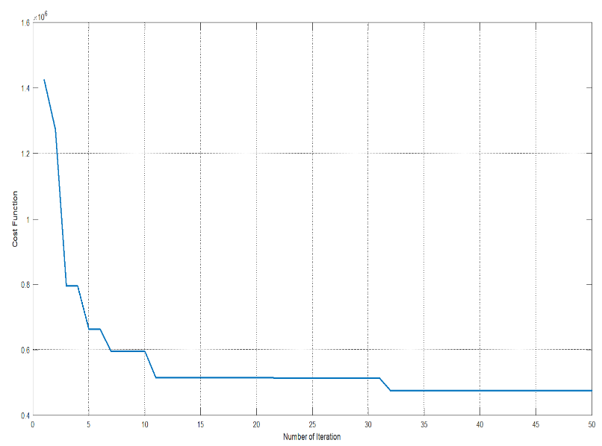

**Figure 8: MGA-SAHLP Performance for the Simulation Using Input Data Set 3**

Furthermore, the population of the spoke hubs was increased as shown in Table 4 with other parameters. Despite both weights having a unit amount, two hub-spoke networks were proffered as the simulations solutions as shown in Figure 9. In addition, despite increased in the population, the MGA-SAHLP optimisation Matlab function converged before the 10 iteration as shown in Figure 10.

**Table 4: Input Data Set 4 for the Create_Model Function Part of the MGA**

|  |  |  |  |  |  |  |  |
| --- | --- | --- | --- | --- | --- | --- | --- |
| Input Parameter | Number of Spoke | Number of hubs | Dimension of the Sampled along x axis | Dimension of the Sampled along x axis | Weight of Demand Function | Weight of Cost of Hub Function | Maximum Number of Iteration |
| M | n | xmin - xmax | ymin - ymax | w1 | w2 | MaxIt |
| Data | 100 | 20 | 0 – 1000 | 0 - 1000 | 1 | 1 | 50 |

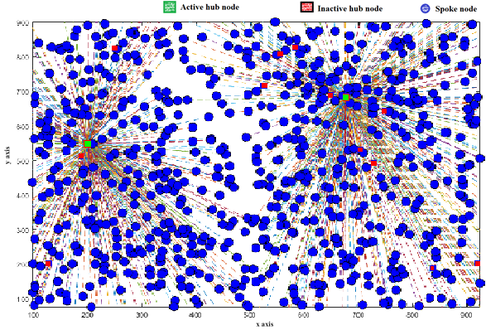

***Figure 9: The Spoke – Node Networks using MGA-SAHLP Solution with Equal Weights Using Input Data Set 4***



**Figure 10: MGA-SAHLP Performance for the Simulation Using Input Data Set 4**

Although, two hub-spoke network was achieved, but proximity is highly demanded for a better quality of service (QoS). Hence, the weight of the demand function needs to be increased for a better QoS for higher population and larger sampled space. Table 5 contains the parameter used for the simulation of this scenario with the demand function increased to 10. Eight (8) hub-spoke networks was proffered as the MGA-SAHLP optimisation solution as shown in Figure 11.

Table 5: Input Data Set 5 for the Create_Model Function Part of the MGA

|  |  |  |  |  |  |  |  |
| --- | --- | --- | --- | --- | --- | --- | --- |
| Input Parameter | Number of Spoke | Number of hubs | Dimension of the Sampled along x axis | Dimension of the Sampled along x axis | Weight of Demand Function | Weight of Cost of Hub Function | Maximum Number of Iteration |
| M | n | xmin - xmax | ymin - ymax | w1 | w2 | MaxIt |
| Data | 100 | 20 | 0 – 1000 | 0 - 1000 | 10 | 1 | 50 |

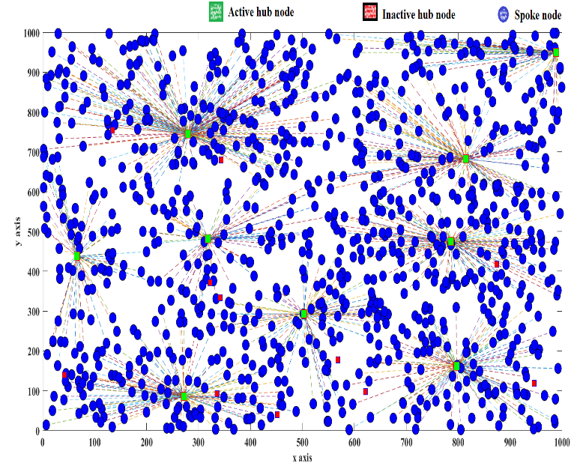

Figure 11: The Spoke – Node Networks using MGA-SAHLP Solution with Unequal Weights Using Input Data Set 5



**Figure 12: MGA-SAHLP Performance for the Simulation Using Input Data Set 5**

Fantastically, the algorithm for the latest scenario converged at about 50 iterative units as shown in Figure 12. Considering Figure 4, 6, 8,10 and 12, the weights of the demand function, w1, increases the number of units of iteration requires for the MGA to converged. Consequentially, the inference is that w1 has a greater effect on the performance of the MGA-SAHLP in relative to weight of the setup cost function, w2. Furthermore, Figure 3, 5, 7, 9 and 11 show that the obtained optimised hub-spoke networks are determines by the contributions of both functions. Hence, the amount of the demands and separation distance between the potential active hubs determine the possible number of hub-spoke networks to be generated by the MGA-SAHLP optimisation solution.

# Conclusion

This research work focused on examining MGA-SAHLP in providing optimisation solutions in telecommunication services and related distant customer oriented services. The optimisation formulation resulted for the SAHLP spoke-hub networks resulted to minimum total optimisation cost function (MTOCF). The parameters of the spokes and hubs used for the overviewed MTOCF are applicable to the aforementioned services. The initial or setup cost function is relative to the cost of establishing or capacity of the servicing customer centre or hub. Furthermore, the demand function parameters were limited to the values of the demands and minimum separation distance between a spoke and hub. Both demand and setup cost functions are weighted using w1 and w2 respectively. It was observed that the convergent time of the MGA for the SAHLP is proportional to the w1. Furthermore, another observation is that w1 is proportional to the number of activated hubs because the developed MGA-SAHLP prioritizes the proximity to the servicing hubs despite considering the setup cost in determining the number of activated hubs. The MGA-SAHLP is applicable in optimal allocation of customer’s communication equipment nodes to optimally selected access points (AP) or base stations in telecommunications. Also, it is applicable in economical setting up customer support service systems that considers magnitude of customer’s demands, proximity of customers to service centers and cost of establishing the service centers.

# References

Alumur, S. A., Campbell, J. F., Contreras, I., Kara, B. Y., Marianov, V., and O’Kelly, M. E. (2021). Perspectives on modeling hub location problems. In *European Journal of Operational Research* (Vol. 291, Issue 1). https://doi.org/10.1016/j.ejor.2020.09.039

Alumur, S. A., Kara, B. Y., and Karasan, O. E. (2012). Multimodal hub location and hub network design. *Omega*, *40*(6), 927–939. https://doi.org/10.1016/j.omega.2012.02.005

Amine, G. M., Nadia, H., Nassim, M., and Lyes, K. (2021). Optimization of the collaborative hub location problem with metaheuristics. *Mathematics*, *9*(21). https://doi.org/10.3390/math9212759

Bhattacharjee, A. K., and Mukhopadhyay, A. (2022). *Solving Hierarchical Hub Facility Location Problem Using Refined Genetic Algorithm*. https://doi.org/10.1007/978-981-16-5207-3_41

Bollapragada, R., Yanjun, L., and Rao, U. S. (2006). Budget-constrained, capacitated hub location to maximize expected demand coverage in fixed-wireless telecommunication networks. *INFORMS Journal on Computing*, *18*(4), 422–432. https://doi.org/10.1287/ijoc.1050.0143

Campbell, J. F. (1994). Integer programming formulations of discrete hub location problems. *European Journal of Operational Research*, *72*(2), 387–405. https://doi.org/10.1016/0377-2217(94)90318-2

Campbell, J. F., Ernst, A. T., and Krishnamoorthy, M. (2002). Hub Location Problems. In *Facility Location*. https://doi.org/10.1007/978-3-642-56082-8_12

Campbell, J. F., Ernst, A. T., and Krishnamoorthy, M. (2005). Hub arc location problems: Part I - Introduction and results. *Management Science*, *51*(10), 1540–1555. https://doi.org/10.1287/MNSC.1050.0406

Campbell, J. F., and O’Kelly, M. E. (2012). Twenty-five years of hub location research. *Transportation Science*, *46*(2), 153–169. https://doi.org/10.1287/TRSC.1120.0410

Carello, G., Croce, F. Della, Ghirardi, M., and Tadei, R. (2004). *Solving the Hub Location Problem in Telecommunication Network Design : A Local Search Approach*. https://doi.org/10.1002/net.20020

Contreras, I. (2015). Hub Location Problems. *Location Science*, 311–344. https://doi.org/10.1007/978-3-319-13111-5_12

Contreras, I., Fernández, E., and Marín, A. (2010). The Tree of Hubs Location Problem. *European Journal of Operational Research*, *202*(2), 390–400. https://doi.org/10.1016/j.ejor.2009.05.044

Erişkin, L. (2021). Point coverage with heterogeneous sensor networks: A robust optimization approach under target location uncertainty. *Computer Networks*, *198*. https://doi.org/10.1016/j.comnet.2021.108416

Farahani, R. Z., Hekmatfar, M., Arabani, A. B., and Nikbakhsh, E. (2013). Hub location problems: A review of models, classification, solution techniques, and applications. *Computers and Industrial Engineering*, *64*(4), 1096–1109. https://doi.org/10.1016/j.cie.2013.01.012

Habibzadeh Boukani, F., Farhang Moghaddam, B., and Pishvaee, M. S. (2016). Robust optimization approach to capacitated single and multiple allocation hub location problems. *Computational and Applied Mathematics*, *35*(1). https://doi.org/10.1007/s40314-014-0179-y

Hekmatfar, M., and Pishvaee, M. (2009). Hub location problem. *Contributions to Management Science*, *May 2009*, 243–270. https://doi.org/10.1007/978-3-7908-2151-2_11

Hillebrandt, J. (2015). New Approaches of Realizing an Optimized Network. In *Lecture Notes in Logistics*. https://doi.org/10.1007/978-3-319-12856-6_7

Jost, N., and Clausen, U. (2023). Approximation Algorithms for p-Hub Center Problems. In *Lecture Notes in Logistics*. https://doi.org/10.1007/978-3-031-28236-2_15

Karatas, M., and Onggo, B. S. (2019). Optimising the barrier coverage of a wireless sensor network with hub-and-spoke topology using mathematical and simulation models. *Computers & Operations Research*, *106*, 36–48. https://doi.org/10.1016/J.COR.2019.02.007

Kemmar, O., Bouamrane, K., and Gelareh, S. (2021). Hub location problem in round-trip service applications. *RAIRO - Operations Research*, *55*, S2831–S2858. https://doi.org/10.1051/ro/2020125

Labbé, M., Yaman, H., and Gourdin, E. (2005). A branch and cut algorithm for hub location problems with single assignment. In *Mathematical Programming* (Vol. 102, Issue 2). https://doi.org/10.1007/s10107-004-0531-x

Mohammad, N. (2009). Using Genetic Algorithms for the Single Allocation Hub Location Problem. In *Computer*.

Okwu, M. O., and Tartibu, L. K. (2021). Genetic Algorithm. *Studies in Computational Intelligence*, *927*, 125–132. https://doi.org/10.1007/978-3-030-61111-8_13

Rakhmawati, F., Suwilo, S., Sutarman, and Zarlis, M. (2020). A model to determine optimally hub location for a communication network. *International Journal of Advanced Science and Technology*, *29*(4), 1974–1979.

Ratli, M., Urošević, D., El Cadi, A. A., Brimberg, J., Mladenović, N., and Todosijević, R. (2022). An efficient heuristic for a hub location routing problem. *Optimization Letters*, *16*(1), 281–300. https://doi.org/10.1007/s11590-020-01675-z

Ruela, A. S., Cabral, R. S., Aquino, A. L. L., and Guimaraes, F. G. (2009). Evolutionary design of wireless sensor networks based on complex networks. *ISSNIP 2009 - Proceedings of 2009 5th International Conference on Intelligent Sensors, Sensor Networks and Information Processing*. https://doi.org/10.1109/ISSNIP.2009.5416785

Serper, E. Z., and Alumur, S. A. (2016). The design of capacitated intermodal hub networks with different vehicle types. *Transportation Research Part B: Methodological*, *86*, 51–65. https://doi.org/10.1016/j.trb.2016.01.011

Simon, M., Iveta, D. L., Huraj, L., and Pospichal, J. (2019). Multi-Hub Location Heuristic for Alert Routing. *IEEE Access*, *7*. https://doi.org/10.1109/ACCESS.2019.2907161

Tanash, M., Contreras, I., and Vidyarthi, N. (2017). An exact algorithm for the modular hub location problem with single assignments. *Computers and Operations Research*, *85*, 32–44. https://doi.org/10.1016/j.cor.2017.03.006

Tefek, M. F., and Beşkirli, M. (2019). Solving the Facility Placement (p-Hub) Problem Using Artificial Bee Colony. *European Journal of Science and Technology (EJOSAT)*, *(Special Issue)*, 193–200. https://doi.org/10.31590/ejosat.637825

Umar, S., Abetu, M. T., Efa, B. T., Dinsa, E. F., and Prabhat, P. (2021). Wireless Sensor Networks Source Location Privacy Preservation Mechanism. *Communications in Computer and Information Science*, *1394 CCIS*. https://doi.org/10.1007/978-981-16-3653-0_13

Wandelt, S., Dai, W., Zhang, J., and Sun, X. (2022). Toward a Reference Experimental Benchmark for Solving Hub Location Problems. *Transportation Science*, *56*(2). https://doi.org/10.1287/trsc.2021.1094

Wang, S., Chen, Z., and Liu, T. (2020). Distributionally robust hub location. *Transportation Science*, *54*(5), 1189–1210. https://doi.org/10.1287/TRSC.2019.0948

Wang, W. Y., and Li, Z. F. (2020). Hub-and-spoke network construction of China’s domestic coal transportation. *Dalian Haishi Daxue Xuebao/Journal of Dalian Maritime University*, *46*(1). https://doi.org/10.16411/j.cnki.issn1006-7736.2020.01.009

Zhang, C., Sun, X., Dai, W., and Wandelt, S. (2023). Solving Hub Location Problems With Profits Using Variable Neighborhood Search. *Transportation Research Record*, *2677*(1), 1675–1695. https://doi.org/10.1177/03611981221105501

Zheng, Y., Ji, Y., Shen, Y., Liu, B., and Du, Y. (2022). Hub location problem considering spoke links with incentive-dependent capacities. *Computers and Operations Research*, *148*. https://doi.org/10.1016/j.cor.2022.105959