**A Detailed Review on power management systems in Electric Vehicles: Efficiency, battery life and Regenerative Braking**

**Ponnamaneni Rampranay1, vepur shireesha2, Salivoju Laharika3, Nenavath Tharun4,kommu kavya kusuma5**

1,2Assistant professor ,Department of EEE, Scient institute of technology ,Hyderabad,India.([rampranay123@gmail.com](mailto:rampranay123@gmail.com), [vepur.shireesha@gmail.com](mailto:vepur.shireesha@gmail.com))

3,4,5Student,department of ECE , Scient institute of technology ,Hyderabad,India. ([laharikasalivoju@gmail.com](mailto:laharikasalivoju@gmail.com), [nenavaththarunayak@gmail.com](mailto:nenavaththarunayak@gmail.com), kommukavyakusuma@gmail.com )

**Abstract :**

The growing demand for electric vehicles(EV’s) has very much need for efficient power management systems to minimize the usage and extend vehicle range.in these paper, the study begins by the categorized the different types of EV’s, including battery electric vehicles(BEVs),Hybrid Electric vehicles(HBVs),Plug-in Hybrid Electric vehicles(PHEVs) and examine the unique power management challenges faced by each. The significant part of the electric vehicle is regenerative breaking system which is very important to enhance the energy efficiency and also analyzing the factors such as battery life, rate, energy recovery and overall system efficiency the study identifies the most effective system for modern electric vehicles.

**Keywords:** Electric Vehicles (EVs), Power Management, Regenerative Braking, Battery Electric Vehicles (BEVs), Hybrid Electric Vehicles (HEVs), Plug-in Hybrid Electric Vehicles (PHEVs), Energy Efficiency.

**Introduction:**

Electric vehicles are very crucial solution for reducing the pollution or emissions and they can reduce the rate of the fuels etc.. Effective power management ensures optimal energy flow between the battery, motor, regenerative braking system, and auxiliary systems, minimizing energy loss and improving overall efficiency. Key technologies, such as regenerative braking, help recover and store kinetic energy during braking, enhancing the vehicle's energy use. Additionally, smart power management strategies optimize energy distribution across various systems, improving efficiency. This paper focuses on different types of EVs—Battery Electric Vehicles (BEVs), Hybrid Electric Vehicles (HEVs), and Plug-in Hybrid Electric Vehicles (PHEVs)—and examines the role of regenerative braking in achieving efficient energy use. By analyzing these systems, we identify the best approaches for maximizing EV performance and sustainability.

**Literature survey:**

Fayez Alanazi. In these paper presents electric vehicles, benefits, challenges and potential solutions for widespread adaption. This paper is about how the world is affected by the rising of oil costs and increasing of carbon emissions. So there by it came electric vehicles.it also explores the challenges and difficulties faced in their adoption.

T.Ravichandran, P.Laxman, K.Srisailam. These paper presents an efficient power management system for battery management system in electric vehicles. A novel power management strategy (PMS) for a small urban electric vehicle presented in this study. By developing a PMS that is more effective for battery electric vehicles, it is possible to extended their driving range and extended the lifespan of the batteries.

**Electric vehicles:**

An EV is defined as a vehicle that can be powered by an electric motor that draws electricity from a battery and is capable of being charged from an external source.

 The vehicle can be powered by a [collector system](https://en.wikipedia.org/wiki/Current_collector), with electricity from external sources, or can be powered autonomously by a [battery](https://en.wikipedia.org/wiki/Electric_vehicle_battery) or by converting [fuel](https://en.wikipedia.org/wiki/Fuel) to electricity using a [generator](https://en.wikipedia.org/wiki/Electric_generator) or [fuel cells](https://en.wikipedia.org/wiki/Fuel_cell)[1].

Electric vehicle works on the simple principle which takes an electric energy and converted it into mechanical energy. when the presses the accelerator the controller sends the electrical energy from battery to motor. These motor converts the energy from one to another and there by it starts the wheels of the vehicle[5]. As the vehicle decelerates or brakes, the regenerative braking system captures some of the energy, converting it back to electricity and recharging the battery.

During the late 20th and early 21st century, the [environmental impact](https://en.wikipedia.org/wiki/Environmental_issues_with_petroleum) of the petroleum-based transportation infrastructure, along with the fear of [peak oil](https://en.wikipedia.org/wiki/Peak_oil), led to renewed interest in electric transportation infrastructure. EVs differ from [fossil fuel](https://en.wikipedia.org/wiki/Fossil_fuel)-powered vehicles in that the electricity they consume can be generated from a wide range of sources, including [fossil fuels](https://en.wikipedia.org/wiki/Fossil_fuels), [nuclear power](https://en.wikipedia.org/wiki/Nuclear_power), and renewables such [as solar power](https://en.wikipedia.org/wiki/Solar_power) and [wind power](https://en.wikipedia.org/wiki/Wind_power), or any combination of those. Recent advancements in battery technology and charging infrastructure have addressed many of the earlier barriers to EV adoption, making electric vehicles a more viable option for a wider range of consumers.

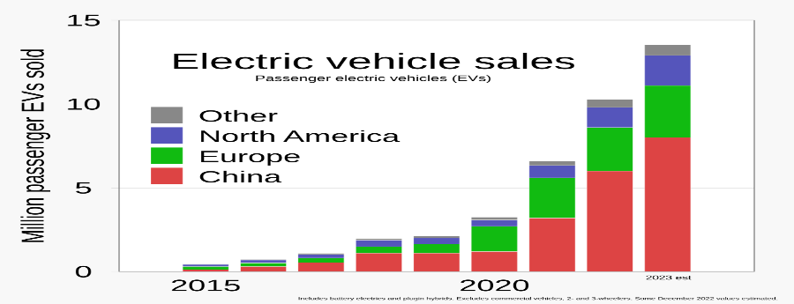

**Figure 1:** selling of electric vehicles from 2015 to 2020

Electric motors are more efficient than internal combustion engines in converting stored energy into driving a vehicle. However, they are not equally efficient at all speeds. To allow for this, some cars with dual electric motors have one electric motor with a gear optimized for city speeds and the second electric motor with a gear optimized for highway speeds. The electronics select the motor that has the best efficiency for the current speed and acceleration. [Regenerative braking](https://en.wikipedia.org/wiki/Regenerative_braking), which is most common in electric vehicles, can recover as much as one fifth of the energy normally lost during braking.

**Lithium ion battery:**

Lithium-ion batteries are currently used in most portable consumer electronics such as cell phones and laptops because of their high energy per unit mass and volume relative to other electrical energy storage systems. They also have a high power-to-weight ratio, high energy efficiency, good high-temperature performance, long life, and low self-discharge. Most components of lithium-ion batteries can be recycled, but the cost of material recovery remains a challenge for the industry. Most of today's all-electric vehicles and PHEVs use lithium-ion batteries, though the exact chemistry often varies from that of consumer electronics batteries.

**Battery Electric vehicle(BEV**):

These vehicles are also known as All-Electric Vehicles (AEV). The working of these vehicles are revolves around the seamless conversion of electrical energy stored in rechargeable batteries and convert it into an mechanical energy and power up the wheels of the vehicles. The work of the EV is starts from the battery which uses the lithium ion battery which stores an energy from an external charging sources

When the driver presses the accelerator, the electrical energy from the battery to the motor where the this motor converts the AC to DC motor after that it converts it into mechanical energy and generates the torque and that drives the wheels of the vehicle . As the vehicle moves, it consumes energy from the battery, but BEVs also feature regenerative braking systems to enhance efficiency. now the driver declares the brakes, and the motor switches its into a generator capturing the vehicle’s kinetic energy and converting it back into electrical energy. Whatever the recovered energy is again goes into the battery, and it starts recharging it and reducing overall energy consumption. This regenerative braking system not only increases efficiency but also helps extend the vehicle’s range by utilizing energy that would otherwise be lost in conventional braking systems.

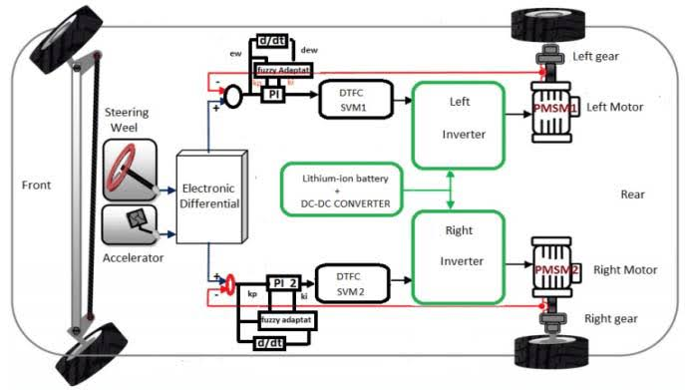

**Figure 2**: battery electric vehicle(BEV)

**Hybrid Electric Vehicle (HEV)**

These are also known as parallel hybrid . These hybrid electric vehicle, it is a combination of both engine with electric motor and battery. The engine gets energy from fuel, and the motor gets electricity from batteries. The transmission is rotated simultaneously by both engine and electric motor.

**Full Hybrids**

Full hybrids have a large enough battery and powerful enough electric motor to allow the vehicle to run on electric power alone, gas power alone, or a combination of both. They can switch between these modes automatically depending on driving conditions.

In these full hybrid electric vehicle (HEV) we have the internal combustion engine (ICE) with an electric motor and battery to enhance fuel efficiency and reduce emissions. The vehicle's control system intelligently manages power distribution between these two sources based on driving conditions. In electric-only mode, the vehicle relies solely on the electric motor for propulsion at low speeds or during light acceleration, resulting in quieter and cleaner operation. During higher speeds or more demanding driving conditions, the ICE provides additional power. The system also utilizes regenerative braking to convert kinetic energy into electrical energy, which recharges the battery for future use. This hybrid powertrain optimizes fuel economy by using the electric motor and ICE in combination or independently as needed, balancing performance and efficiency while reducing overall emissions

* **Examples**: Toyota Prius

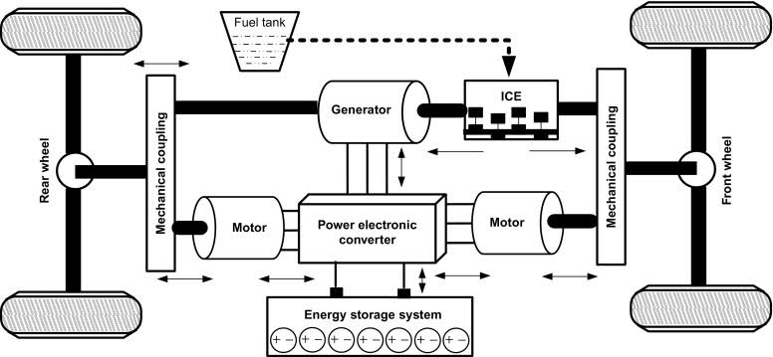

**Figure3:** Full Hybrid EVs

**Mild Hybrids**:

Mild hybrids cannot operate only on electric power. The electric motor assists the internal combustion engine to improve efficiency and performance, especially during acceleration and idling.

A mild hybrid vehicle operates by integrating an electric motor with an internal combustion engine (ICE) to assist rather than replace the engine’s power. Unlike full hybrids, mild hybrids cannot drive only on electric power; instead, the electric motor supports the ICE to enhance overall efficiency and performance. The electric motor in a mild hybrid assists during acceleration, provides power to the vehicle’s accessories, and helps with functions like engine start-stop systems, which improve fuel efficiency by shutting off the engine when the vehicle is idling and quickly restarting it when needed. Regenerative braking is also employed to capture and store energy in the battery when slowing down, which is then used to assist the ICE or power the vehicle’s electrical systems[6]. This integration helps reduce fuel consumption and emissions by optimizing the operation of the ICE and providing additional power when necessary, but it does not offer the electric-only driving mode available in full hybrids.

* **Examples**: Honda Insight



**Figure4**: Mild Hybrid EVs

**Plug-in hybrid Electric vehicles(PHEV)**

These are also known as series hybrids.A Plug-in Hybrid Electric Vehicle (PHEV) is a type of hybrid vehicle that combines the features of traditional hybrid vehicles with the capability to be charged from an external power source. This design allows PHEVs to operate on electric power alone for a certain distance before switching to gasoline power

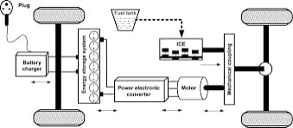A Plug-in Hybrid Electric Vehicle (PHEV) operates by combining an internal combustion engine (ICE) with an electric motor and a high-capacity battery that can be recharged from an external power source. The PHEV can run on electric power alone when the battery is fully charged, providing zero-emission driving for short trips and urban commutes. When the battery is depleted or additional power is needed, the vehicle switches to hybrid mode, utilizing both the electric motor and the ICE to optimize performance and fuel efficiency. Regenerative braking helps to recharge the battery by converting kinetic energy into electrical energy during braking or coasting. The vehicle’s control system automatically manages power distribution and transitions between electric and gasoline power based on driving conditions and battery charge. This hybrid approach allows PHEVs to offer extended electric-only range, reduced fuel consumption, and flexibility for longer journeys, making them a versatile and efficient option for various driving needs.

**Figure 5:** plug-in hybrid EVs

**Fuel cell Electric vehicles:**

In these fuel cell it uses the lithium-ion battery. In Fuel Cell Electric Vehicles (FCEVs),the hydrogen gas (H₂) is introduced into the anode side of the fuel cell. At the anode, the hydrogen molecules are splitted by platinum catalyst the splitted hydrogen molecules are protons (H⁺) and electrons (e⁻). The protons are passed through the electrolyte membrane to the cathode, while the electrons travel through an external circuit, generating electricity that powers the vehicle’s electric motor. On the cathode side, oxygen is from air these two are combines and form H2O molecule and heat as by-products. This method is very easy and efficient and generates the electricity and produce zero emissions. The only emission from FCEVs is water vapour. These are differ from battery vehicles because they generation of electricity on demand rather than depends on stored energy.

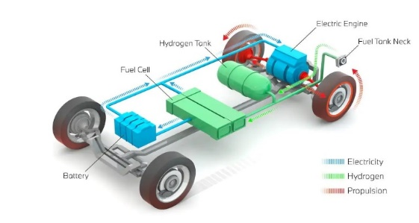

**Figure 6:** fuel cell electric vehicle

**Extended range electric vehicles:**

In these also we are using the lithium ion batteries. Extended-Range Electric Vehicles (EREVs) use a combination of electric power and a small gasoline engine to extend their driving range. These vehicles run on a electricity[3]. If the vehicle battery is low then the small amount of gasoline engine is kicks into more electricity. Whatever these extra is either recharges the battery otherwise it drives the motor depends on vehicle driving.The vehicle automatically switches between using the battery and the engine to make sure you can keep driving longer distances. This setup lets EREVs offer the benefits of electric driving while also providing extra range when needed, reducing reliance on charging stations and emissions compared to traditional cars.

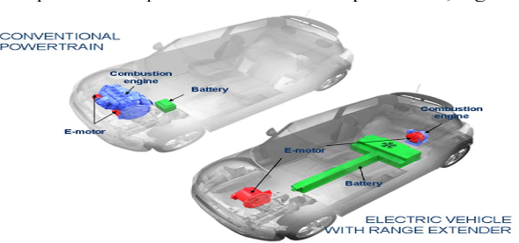

**Figure 7:** Extended range EVs

**Solar Electric Vehicles(SEVs):**

Solar Electric Vehicles (SEVs) use solar panels to capture sunlight and convert it into electricity. These panels, mounted on the vehicle's roof or body, generate power to either run the electric motor or charge the battery. The sunlight is directly goes to panels and produce electricity these electricity is stored for later usage , when there is no sunlight like cloudy days [4].

These solar electric vehicles can be charged externally if it is needed but by using the solar panels the driving range increases and reduce the realiance on charging stations. The efficiency of solar power depends on factors like sunlight availability and panel size, but SEVs aim to make transportation more eco-friendly by using renewable energy.

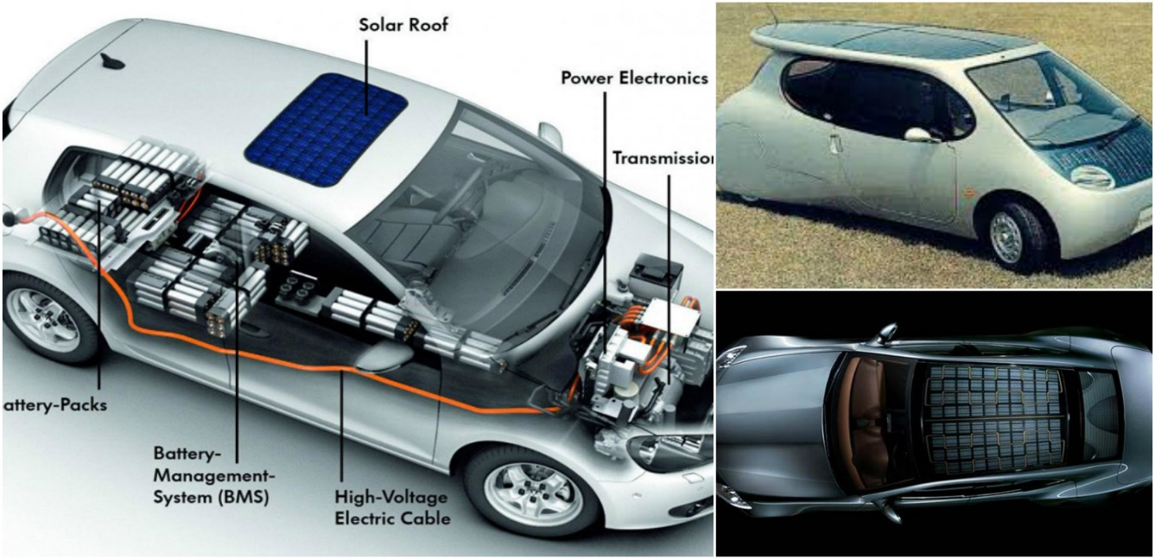

**Figure 8:**solar EVs

**How the electric vehicles are charged:**

They are several methods to charge the electric vehicles , how they are charging with an external sources some of the charging techniques are given below:

**1.Home charging**: Home charging for electric vehicles (EVs) allows owners to recharge at home using two main methods. Level 1 charging uses a standard 120-volt outlet, adding about 3-5 miles of range per hour, ideal for overnight charging. For faster charging, Level 2 chargers use a 240-volt outlet, providing 10-30 miles of range per hour[2]. These chargers are more efficient and usually require professional installation. Home charging offers the convenience of charging your EV overnight or when needed, reducing reliance on public charging stations.

2. **Public Charging Stations:**

Public charging stations provide electric vehicle (EV) owners with access to recharge their vehicles away from home[7]. They typically offer Level 2 chargers for moderate-speed charging and DC Fast Chargers for rapid charging.

These stations are strategically located in public areas like parking lots, shopping centers, and along highways to ensure convenience for long-distance travel. Users typically pay for charging through a credit card, mobile app, or membership card. The availability and speed of charging can vary by location, with some stations offering additional amenities like real-time availability updates.

**3. Solar Charging:**

**Solar Panels**:

Solar panel technology converts sunlight into electricity using photovoltaic (PV) cells. These cells are made from semiconductor materials, such as silicon, that generate an electric current when exposed to sunlight. Solar panels are typically installed on rooftops or open areas to maximize exposure to sunlight. The electricity produced can be used directly or stored in batteries for later use. This technology is a key component in renewable energy systems, providing a clean and sustainable power source.

**Solar Charging Stations:**

Some public places have solar-powered charging stations where the energy collected from the sun is used to charge the EV. These are eco-friendly, but not as widely available.

**4. Workplace Charging**:

Workplace charging involves installing EV charging stations at businesses for providing faster charging compared to home outlets[8]. These chargers are typically located in parking areas and may require access through a company card or app. Workplace charging supports sustainability goals and makes it convenient for employees to charge their EVs during work hours.

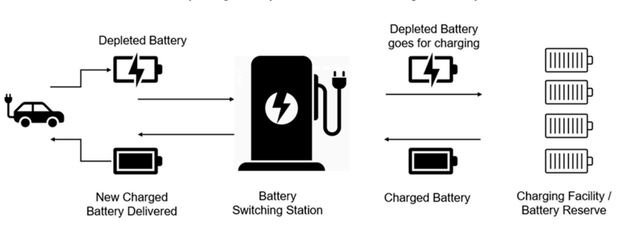l

**Figure 9:** charging sources of EVs

|  |  |  |
| --- | --- | --- |
| **Vehicle type** | **Power source** | **efficiency** |
| Battery EVs | Electricity rechargeable batteries | 80-90% |
| Hybrid EVs | Gasoline and electric motor | 30-40% |
| Plug in hybrid EVs | Plug in and gasoline engine | 50-60%(electric) |
| Fuel cell EVs | Hydrogen fuel cells | 50-60% |
| Extended range EVs | Electric motor and gasoline backup | 80%(electric) |
| Solar EVs | Solar panels and battery | 15-20%(solar) |

**Table1:** power and efficiency in EVs

**Conclusion:**

These electric vehicles are very ecofriendly and they reduces noises, pollution when compare to the normal vehicles by storing the electrical energy and converted it has into mechanical energy. These electric vehicles are simpler and easy to maintain it. The Battery Electric Vehicle (BEV) is often considered the best for overall efficiency and sustainability. It runs entirely on electricity, producing zero emissions, and offers the highest energy conversion rates, making it ideal for eco-conscious drivers.

**Future scope:**

The future of this electric vehicles is highly promising with advancements in battery technologies they are like in high speed, longer range of discharging time and low in cost. Integration with renewable energy sources and smart grids will further enhance sustainability. Autonomous driving, vehicle-to-grid (V2G) technology, and improved energy management systems will make BEVs even more efficient. As charging infrastructure expands and government policies favor eco-friendly transport, BEVs are expected to play a pivotal role in the global shift towards cleaner and smarter transportation systems.

**References:**

[1]. Ravichandra, Laxman and Srisailam (2022) “An efficient power management for battery management system in electric vehicles”.

[2].Jing liu , xiangjun li, and Hongwen (2020) “Electric vehicle charging infrastructure”.

[3].K. Srinivasa Rao, P.Srinivas ,G. Ramesh (2020) “ Electric Vehicle policy and incentitives in India”.

[4].Jonath wellings, David greenwood , stuart R.coles “understanding the future of electric vehicles -an analysis of multiple factors that influence the market”.

[5].D.Barapture, C.Kanfade, A.bari, R.Nimbalkar, R.Wagh, R.Nile “Electric vehicles”

[6]. Xuesong Zhou, Youjie ma, Zhiqiang Gao ,Yanjauan WU, jinliang “The current research on Electric vehicles”.

[7].Muhammad Salman, Apostolos pesyrids, pano sphicas, amin,ayat gharehghani and bianca maria vagliceo “electric vehicle modelling for future technology and market penetration analysis”.

[8]. Ana luiza de,Luiz Fillipe M.viera, Macros A vieria ,hervaldo S.carvalho “Efficient power management in real -time Embedded systems”

Top of Form

Bottom of Form