Effective Warm-Up Protocols for improving Badminton Players Footwork Performance

Lam Cho Wai

Rachellam0205@gmail.com

ABSTRACT ……….……………………………………………………………P.3

CHAPTER 1: INTRODUCTION

1.1 Introduction …………………………………………………….....P.3-5

1.2 Study Background ………………………………………………...P.5

1.2.1 The RAMP System………………………………………………...P.5

1.3 Problem Statement………………………………………………...P..6

1.4 Research Questions………………………………………………..P.6

1.5 Research Goals and Objectives…………………………. ………..P.6

1.6 Research Hypotheses………………………………………………P.6

1.7 Research Significance and Benefits………………………………..P.6-7

CHAPTER 2: LITERATURE REVIEW

2.1 Introduction of Literature Review…………………………………P.8

2.2 Effect of warm-up protocols on badminton footwork performance (table of

review. …………………………………………………………….P.9-17

2.3 Elements needed in warm-up ……………………………………..P.17-18

2.4 Summary of Literature Findings (gap of knowledge) …………….P.19

CHAPTER 3: METHODS

3.1 Research Design……………………………………………………P.20

3.2 Participants…………………………………………………………P.20

3.3 Materials ……………………………………………………………P.20

3.4 Protocols/Measurements ……………………………………………P.20-22

3.4 Statistical Analysis………………………………………………….P.22

CHAPTER 4: RESULTS & DISCUSSION

4.1 Results………………………………………………………………P.23-25

4.2 Discussion…………………………………………………………..P.26-27

4.3 Limitations …………………………………………………………..P.27

CHAPTER 5: CONCLUSION……………………………………………………..P.27

APPENDIX I CONSENT FORM

APPENDIX II INFORMACTION SHEET

APPENDIX III SCORE SHEET

APPENDIX IV PICTURES OF EXPERIMENT

**ABSTRACT**

The purpose of this study is to summarize the different studies on how warming up affects badminton footwork performance, (including reaction time and change of direction speed) then develop and investigate the effectiveness of a structured RAMP warm-up targeting badminton footwork performance. Thus, providing guidelines regarding structural and sequenced warm-up routine customized for badminton players who aimed at improving footwork performance. A proposed warm-up protocol is designed after literature review and

IM-specific warm-up, loaded warm-up, box drop jump and unilateral squat should be included in the warm-up protocol according to the research. Data collection was done with 20 asymptomatic regularly trained badminton players. The players were divided into control and experimental group, only the experimental group will follow the proposed warm-up protocol. Footwork performance measurements were done by counting the maximum number of rallies with reaction lights called BlazePod™ . Data collected were then analyzed using one-way ANOVA. In the experimental group (n=10), the mean of the maximum number of rallies increased from pre- to post-test by 3, from 30.80 ±3.259 to 33.80 ±3.155. while in the control group, the mean increased by 0.1, from 31.00 ±3.266 to 31.10 ±2.85. There was a significant improvement in the experimental group (p<0.001). The proposed warm-up protocol is effective in activating lower body muscle groups to improve badminton footwork performance and may provide guidance to coaches and athletes to develop warm-up programs.

Keywords: badminton footwork, warm-up, RAMP warm-up, change of direction speed, reaction time.

**INTRODUCTION**

1.1 Introduction

Badminton is a tactical sport that requires a high level of coordination ability in the lower body (such as change of direction speed (CODS)) to sustain a rally (Seth,2016). Players need to execute one shot every two seconds while accelerating, decelerating, and changing direction toward the center of the court and to the opponents' return shot due to the game's dynamic nature (Loturco, et al., 2022). For an athlete to achieve optimal footwork performance with more spontaneous movement, these essential motor characteristics require specific preparation and warm-up (Bishop,2003). In the traditional warm-up routine, stretching and sport-specific activities are typically performed after a brief period of low-intensity exercise (Safran, et al.,1989).

Due to the high-speed nature of badminton, fine-tuning of their physical components is required for maximum performance. CODS is considered one of the essential performance predictors (Tiwari, et al.,2011). Badminton players must perform a wide range of footwork movements, including repetitive forward and backward braking, push-offs, gliding, lunging, and jumping at various speeds (Lin, et at., 2007). CODS is further classified into four phases: initial acceleration, deceleration, turn, and re-acceleration (Dos' Santos et al., 2019). A qualitative coaching panel determined that COD performance was the best physical indicator of badminton skill (r=0.74), according to Jeyaraman and Kalidasan (Hughes & Cosgrove,2006). Tiwari et al. (2011) discovered a link between CODS and winning percentage in Indian state-level players (r =.83; P<.05). As a result, researching the best method for acute CODS augmentation is likely to improve performance.

Any specific warm-up for badminton should aim to improve change of direction speed (CODS) to effectively prepare the athlete for competition/training (Maloney, 2014). A warm-up is a period of preparation designed to improve future competition or training performance (Hedrick, 1992). Warm-up has been shown to improve neurological function by increasing muscle heat, blood flow, coordination, and proprioceptive susceptibility (Cilli, et al., 2014). After dynamic warm up, athletes' muscle elasticity and joint mobility improve, which directly affects CODS and thus influences how they make decisions and react spontaneously (Kraner, Et al., 2017).

Warm-up activities have been shown in studies to increase muscle temperature, encourage muscle contraction, reduce the time required to reach peak tension and relaxation, and reduce the viscous resistance of the muscles and joints (Neiva, et al.,2014). Furthermore, warm-up hyperthermia causes vasodilation and increased muscular blood flow, which most likely results in improved aerobic function due to higher oxygen consumption in subsequent tasks (Gray & Nimmo,2001; Pearson, et al.,2011). It has also been demonstrated that an increase in heart rate after active warm-up and a higher baseline oxygen consumption at the start of subsequent activity, in theory, improve oxygen supply to active muscles and stimulate the aerobic energy system (Burnley, et al.,2011).

Therefore, it is important to develop an effective and practical warm-up protocol for badminton players that helps improve badminton footwork performance. A literature review is conducted to compare different warm-up methods to improve badminton athletes' court performance, and it is discovered that warm-ups such as IM-specific warm-up, loaded warm-up, box drop jump, foam rolling, and unilateral squat could be effective for improving badminton players' footwork performance and the purpose of this study is to summarize previous research on how warming up affects badminton footwork performance (including reaction time and change of direction speed), and then develop and test the effectiveness of a structured RAMP warm-up targeting badminton footwork performance. Thus, providing guidelines for a structural and sequenced warm-up routine customized to badminton players seeking to enhance their footwork performance.

1.2 Study Background

Three types of warm-up exercises are available: passive warm-up, which involves raising body temperature through external means; general warm-up, which involves making general movements; and specific warm-up, which involves activating the muscles that will be used in the next, more demanding exercise (Shellock & Prentice, 1985). Dynamic warm-up has been demonstrated to offer instant benefits in speed/power performance, whereas general warm-up techniques like static stretching are not effective. However, supplementing a warm-up with particular "preconditioning" exercises may improve performance even more (Yeung, et al., 2021). The performance of jumping, sprinting, and CODS is significantly and acutely reduced by static stretching (Beckett, et al., 2009).

Recently, the use of integrated warm-up protocols such as specific warm-up coupling with inspiratory muscle (IM) warm-up, loaded warm-up, etc has grown in popularity (Chen, et al., 2022). Furthermore, in recent years, the concept of post-activation performance enhancement (PAPE) has been incorporated into warm-up routines to maximise motor unit and brain recruitment prior to criterion performance (Tillin & Bishop, 2009). Seitz and Haff (2016) propose that resistance exercise be performed in several sets at intensities ranging from 60 to 84% of one repetition maximum (1-RM) or simply one set at > 85% of 1-RM to induce PAPE. Maloney et al. (2014) discovered that a ballistic warm-up with added weight improves badminton performance via a potential post activation performance enhancement response. Yeung et al. (2021) also suggest that, while dynamic warming up has numerous examples of producing immediate improvements in speed/power performance, adding specific "preconditioning" exercises to a warm-up may further boost performance gains.

1.2.1 the RAMP system

By building the skills and movement capabilities required to succeed in sport, the RAMP (Raise, Activate, Mobilize, and Potentiate) system of warm-up offers a method to enhance performance. Stronger athletes can be built logically, methodically, and effectively with the help of this tool (Jeffreys, 2019).

the RAMP is a system that can be used to maximize the sequenced contribution of focused warm-up exercises, hence optimizing athletic performance for each session. Additionally, by fostering the foundational athletic competencies, RAMP enables the implementation of exercises that not only maximise performance in the following activity but also make a significant contribution to an athlete's long-term improvement (Jeffreys, 2019).

1.3 Problem Statement

According to research, static stretching is still the most used method in warm-up routines among athletes. It was preferred because it appears to be simpler and safer to implement than the other methods (Woolstenhulme, et al., 2006). There might also be due to lack of education to coaches and athletes on the awareness and how to carry out a structured warm up. It is known that structural warm-up is actually more beneficial to sports performance. However, based on current research, there is lack of specific and effective warm-up protocol for badminton athletes’ footwork performance. As a result, coaches must create their own customized warm-up routines based on individual experiences. The interaction of many variables, the complexity of their relationship (such as volume, intensity, and recovery period), and the lack of a standardized warm-up approach make summarizing warm-up approaches difficult (Fradkin, et al., 2010).

1.4 Research Questions

* What should be included in a structured warm-up protocol for acute improvement in badminton footwork?​
* how can a structured warm-up affect badminton athlete footwork performance?​
* Is there any significance different within the pre-test and post-test of the same group? ​
* Is there any significance different between control and experimental group?​

1.5 Research Objectives

Objectives:

1. compare the difference between non-structured warm-up and structured RAMP

warm-up

2. Investigate the effectiveness of a structured RAMP warm-up targeting badminton

footwork performance

provide guidelines regarding structural and sequenced warm-up routine customized

for badminton players

1. develop an effective warm up protocol to improve court performance of badminton athletes.

1.6 Research Hypotheses

H0: there is no significant differences between the control group and experimental group

H1: there is significant differences between the control and experimental group

1.7 Research Significance and Benefits

Even though different stretching and warming-up exercises are frequently advised before to physical activity, little study has been done to ascertain the effects of these exercises on badminton athletic performance. The variety of research designs makes data comparison difficult (e.g., protocols, outcomes targeted, number of participants, and athlete skill level, etc.). Despite research demonstrating the effectiveness of various warm-up activities on badminton footwork performance, no research has suggested a comprehensive protocol and warm-up sequence to guide coaches and players throughout their entire warm-up session.

Therefore, this research can provide scientific evidence and guidelines for coaches and athletes to set a structured warm-up routine, especially for those who are emphasizing on the importance of footwork performance.

CHAPTER 2: LITERATURE REVIEW

2.1 Introduction of Literature Review

Warm-up has been playing an important role in improving sports performance but there is no conclusive suggestion on warm-up protocol specifically for badminton athletes for footwork improvement. Literature review is done to compare different warm up methods to improve court performance of badminton athletes

2.2 Effect of warm-up protocols on badminton footwork performance

|  |  |  |  |  |  |  |  |
| --- | --- | --- | --- | --- | --- | --- | --- |
| Table 1. Effect of warm-up protocols on badminton footwork performance | | | | | |  |  |
| No. | Authors and year | Study target/target population | Test method/warm-up protocol | Outcome measures | Main finding | Degree of improvement | comment |
| 1 | Lin, et al., 2007. Specific inspiratory muscle warm-up enhances badminton footwork performance. | 10 male badminton players were chosen at random to undergo identical tests in three different trials; IM-specific warm-up vs Placebo | The placebo and experimental trials each included an Inspiratory Muscle (IM) warm-up consisting of two sets of 30-breath manoeuvres with an inspiratory pressure-threshold load comparable to 15% (PLA) and 40% (IMW) maximum inspiratory mouth pressure, respectively. | IM function in maximal inspiratory pressure at zero flow (P0)  IM function in  maximal rate of P0 development (MRPD)  Footwork (FW)max  Rating of perceived breathlessness for every minute (RPB/min)  Blood lactate ([La– ]b) | IM-specific warm-up increased footwork performance in the subsequent maximal incremental badminton-footwork test.  The influence of the accompanying reduction in [La-]b buildup was minimal. | FWmax was enhanced 6.8% ± 3.7% | The integrated warm-up protocol in IMW but not in PLA improved P0 and MRPD.  The improved footwork was due in part to the reduced breathlessness caused by the increased IM function |
| 2 | Yeung, et al., 2021. Does a Loaded Warm-Up Influence Jump Asymmetry and Badminton-Specific Change of Direction Performance? | Two trials were completed by a total of 21 amateur badminton players (age 29.5 years, playing experience 8.4 years); Effect of three exercises loaded with a weight vest on CODS | The first group performed a control warm-up. In the second, they repeated the warm-up but added three exercises loaded with a weight vest (LWU) of 10% body mass. Players conducted single-leg countermovement jump and badminton-specific Change of direction speed (CODS) tests after both warm-ups. | CODS  single-leg improvement in countermovement jump  Improvement in single-leg countermovement jump asymmetry | There were no significant differences in CODS, single-leg countermovement leap, or single-leg countermovement jump asymmetry between the control warm-up and the LWU.  Five players had CODS improvements greater than the minimal detectable change.  Two players had negative responses. Asymmetry was not correlated to CODS after control warm-up but was correlated to CODS after LWU. | / | LWU had no significant influence on performance or asymmetry. |
| 3 | Maloney, Turner, & Miller., 2014. Acute effects of a loaded warm-up protocol on change of direction speed in professional badminton players. | 8 elite badminton players took part in 3 sessions, which include vertical counter-movement jump and CODS testing before and after the dynamic warm-up; Effect of loaded warm up on COD | The three warm-up conditions included wearing a weighted vest with an equivalent weight to (a) 5% of one's body mass, (b) 10% of one's body mass, and (c) no weighted vest at all. Performances in the vertical jump and CODS were then assessed at 15 seconds, 2, 4, and 6 minutes after the warm-up. | Pre- and post-warm-up Vertical jump and CODS performance  in 3 different conditions | After warming up, there was no major effect of condition, time, or interaction effect on mean vertical jump performance.    CODS Peak performances were substantially faster in the 10% loaded condition compared to the control condition, but not in the 5% loaded condition. | significantly faster peak performance in the 10% loaded condition (5%; ES = 0.83; P = .012) | Following a loaded warm-up, elite badminton players performed noticeably higher in the CODS test. compared to an unloaded warm-up, the loaded warm-up did not significantly affect vertical jump performance. |
| 4 | Lin, Lee, & Chang., 2020. Acute Effects of Dynamic Stretching Followed by Vibration Foam Rolling on Sports Performance of Badminton Athletes. | 40 badminton players (25 male,15 female college students), no incidence of musculoskeletal disorder in the preceding 6 months; Dynamic stretching (DS) vs vibration foam rolling (VFR) | Two protocols: (1) Dynamic stretching (DS); (2) DS followed by vibration foam rolling (VFR)  Each subject carried out the two protocols separately, in a randomized order, separated by a 48-hour period. | Knee range of motion (ROM) Muscle stiffness Lower limb power (countermovement jump [CMJ])  Agility. | DS increased knee flexion ROM, CMJ height and agility but increased quadriceps muscle stiffness and increased gastrocnemius muscle stiffness.  DS and VFR increased knee extension ROM, reduced quadriceps muscle stiffness, CMJ height, and agility | Agility 4.74% faster,  CMJ height 2.41% higher | Both protocols also improves performance.  DS can be considered as the first line of warm-up exercise to increase ROM, CMJ height, and agility. Adding VFR to DS results in a greater reduction of muscle stiffness, which potentially reduces the risk of injury. |
| 5 | Kwon, et al., 2022. The Effect of Warm up type on Physical Fitness factor related to Badminton Players Performance. | Ten female badminton players from S-gu high schools and colleges in Seoul took part in the event. The same patients were randomly assigned to dynamic warm-up (DSW), elastic band warm-up (EBW), and non-warm-up exercise (CON) at a 2-week interval. | Crossover research was carried out to investigate the impact of the warm-up program. | Range of motion (flexion, abduction, external rotation, internal rotation) agility (Agility-t test) muscle power (CMJ) | Results of abduction, external rotation, internal rotation, agility, and muscle power were not statistically significant. | / | Further investigation on program for agility improvement is needed. The insignificance might be due to the small sample size. |
| 6 | Chua, et al., 2021. Effectiveness of On-Court Resistive Warm-Ups on Change of Direction Speed and Smash Velocity during a Simulated Badminton Match Play in Well-Trained Players. | Fourteen national training squad badminton players (11 males, 3 females, age 17-19 y) completed the experimental sessions in random order; Effect of control (CON), weighted wearable resistance (WWR), and resistance band variable resistance (BVR) on CODS and smash velocity | A repeated-measures approach was used in this investigation, with three warm-up conditions: CON, WWR and BVR. | Change of direction speed (CODS)  Smash velocity (SV) at 5 timepoints | CODS was substantially faster under the two resistance warm-up conditions (WWR and BVR) at baseline compared to the CON condition.  No differences were found at the subsequent timepoints.  Under all three warm-up conditions, SV was considerably quicker than at baseline for all four workout blocks but there were no changes in SV across the three warm-up conditions across all five assessed timepoints. | Improvement of 1.38% in CODS with WWR, Improvement in 0.41% with BVR | When compared to the same warm-up exercises using bodyweight, adding resistance (10% body weight) in sport-specific plyometric activities employing WWR or BVR during warm-up routines may elicit PAPE effects on change of direction speed but not smash velocity in well-trained badminton players. |
| 7 | Sole, et al., 2013. Mechanical analysis of the acute effects of a heavy resistance exercise warm-up on agility performance in court-sport athletes | Five men and five women decided to take part in the current study. All of the subjects were National Collegiate Athletic Association Division II athletes; evaluate the acute effects of a heavy resistance exercise warm-up on agility performance | A counterbalanced design was used to examine agility performance during a 10 m shuttle test after either a dynamic warm-up (DW) or a high resistance warm-up (HRW) protocol. The HRW protocol included three sets of squats at 50, 60, and 90% of 1RM. | Agility performance  Stride length  Stride frequency Stance time  Flight time  Average ground reaction force  Agility time | There were no significant differences in any of the mechanical characteristics between the HRW and DW procedures (p>0.05), while there was a trend toward the HRW protocol yielding faster agility times than the control protocol (p = 0.074). | / | The insignificance results could be due to the small sample size |
| 8 | THAPA, et al., 2020. A combination of ballistic exercises with slow and fast stretch-shortening cycle induces post-activation performance enhancement. | 12 male athletes were recruited to do box jump and immediate drop jump (BDJ) or walking control; Analyze the impact of a mix of ballistic exercises (BE) with slow and fast stretch-shortening cycle (SSC) on the capacity for sprinting and COD. | Participants did 3-5 repetitions of either a combination of box jump and immediate drop jump (BDJ) or walking control; measurements taken before and after the jump or walk | CODS performance before and after intervention | When compared to the baseline and controlled settings, there was a significant improvement in COD performance following BDJ. While there was no improvement in 15 m sprint performance with baseline or controlled conditions. | 5.13% improvement in modified agility test | A BDJ procedure followed by a warm-up induces the Post-activation performance enhancement effect and enhances COD performance. |
| 9 | Adigüzel, et al., 2018. The Acute Effects of Different Warm-Up Protocols on Change of Direction and Reactive Speed Performance | 113 high school students take part in the study. The students were placed into three groups: general warming (GW), open skill warming (OSW), and closed skill warming (CSW); compare the effects of different warm-up protocols | COD test and Reactive speed test were conducted after GW, OSW, and CSW  protocols were applied. In this study, general warming protocol was designed as control application and other warming protocols were designed as experimental application. | Reactive speed  Change of direction speed | In terms of CODS,  The difference between OSW and GW was statistically significant.  The difference between CSW and GW was statistically significant.  However, the difference between closed and open skill warming was not statistically significant.  In terms of reactive speed, the difference between GW and OSW was significant. However, the difference between CSW and OSW was not statistically significant. | CODS: Improvement in14.3% for OSW and 15.4% for CSW    Reactive speed: 4.50% for OSW and 7.57% for CSW | Warming that includes open and closed skills could enhance COD and reactive speed performance. CSW might be more preferable. |

2.3 elements needed in warm-up

From the 6 studies that showed positive effects on footwork performance (Lin, et al., 2007; Maloney, et al., 2014; Chua, et la., 2021; Lin, et al., 2020; THAPA, et al., 2020; Adigüzel, et al., 2018), we can conclude that IM-specific warm-up, loaded warm-up, box drop jump and unilateral squat should be included in the warm-up protocol

2.4 proposed warm-up protocol

Table 2. preliminary design of warm-up protocol

|  |  |  |  |  |
| --- | --- | --- | --- | --- |
| Order | Exercise | Targeted Muscles/joints | Movement [distance/reps x set] | Rest time (s) |
| Raise | Locomotor exercise  (linear) | Whole body | Jog [25m x 2sets] | 60 |
| Whole body | back pedal [25m x 2] | 60 |
| Locomotor exercise  (lateral) | Whole body | Carioca [25m x 2] | 60 |
| Lower body | Lateral shuffle [25mx2] | 60 |
| IM-specific warm-up | Inspiratory muscles | 30-breaths x 2 sets | / |
| Foam rolling | bilateral shoulder, anterior thigh, posterior thigh, posterior calf, and lower back. | 20s for each muscle group | / |
| Activate | Loaded warm-up drills | Gluteus maximus, quadriceps femoris, Gastrocnemius | Bilateral countermovement jumps [5 reps x1] | 60 |
| Gluteus maximus, quadriceps femoris, Gastrocnemius, hamstrings, hip flexors, spinae erectors | Alternating split squat jumps  [5 reps x 1 each leg] | 60 |
| gluteus maximus, biceps femoris, semitendinosus, rectus femoris, vastus lateralis, vastus medialis, tibialis anterior, and medial gastrocnemius | Unilateral squat | 60 |
| Ballistic exercise | All lower body muscles | Box drop jump [5 reps x 3] | 60 |
| Mobilize | Dynamic stretch | Neck, should, back mobilization | Thread the needle [2s x 3 each side] | / |
| Dynamic stretch | Shoulder, back, hip mobilization | Forward lunge with rotation [2s x 3 each side] | / |
| Dynamic stretch | Knees and ankles mobilization | Knees to wall [2s x 3] | / |
| Potentiate | Footwork | Whole body | Shadowing drills [15 reps × 2 circuits] | 90 |

2.4 Summary of Literature Findings (gap of knowledge)

This research discovered that 6 studies had shown beneficial effects in bettering badminton footwork performance and, in the end, recommended a warm-up programme. The effectiveness of warm-up exercises such as IM-specific warm-up, loaded warm-up, box drop jump, foam rolling, and unilateral and bilateral squats is also improved.

This literature review elucidates the findings of published research that focus on the effects of warm up on badminton lower body performance and to recommend the most effective warm-up protocols

CHAPTER 3: METHODS

3.1 Research Design

In between-subject experimental design, each badminton player conducts 2 footwork test on 2 consecutive training days, to prevent effects of training affecting the results. Each test was conducted before training and after assigned warm-up protocol. There are only two mode of warm-up to be used, regular warm-up and proposed warm-up protocol. After warm-up, footwork performance test is performed, and the maximum number of rallies was recorded.

3.2 Participants (consent form in appendix)

20 asymptomatic badminton players (age=20.5±2.56) will be divided into 2 groups, control (n=10) and experimental group (n=10). Participants should be at least state level and are actively participating in regular training for 3-4days a week. Each subject read and signed an informed consent form, and they were verbally informed about the procedures they would undergo.

3.3 Materials

In the proposed warm up protocol, 10 foam rollers, 2 plyo boxes, 10 yoga mats and 10 weighted vest were used. While for the footwork performance test, BlazePod™ reactive agility assessment device and the mobile app connected to it were used

3.4 Protocols/Measurements

All subjects perform the same regular warm-up protocol (1km jog followed by stretching) during the first test. During the second test, subjects perform their assigned warm-up, control group doing regular warm-up while the experimental group doing the proposed warm-up protocol. Following each warm-up session, players perform once six-point footwork. Each set last for 1 minute and the max number of rallies will be counted and recorded with BlazePod™ (Figure 1&2).

One half of a badminton court used as the site for the footowrk test. The layout of the test suggested by Chin, et al. (1995) is illustrated in Figure 3. The first pair of reaction light(L1 and R1) will be near the forecourt, the second pair (L2 and R2) will be near the midcourt, and the third pair (L3 and R3) will be at the backcourt.

Figure 1&2. BlazePod™ features

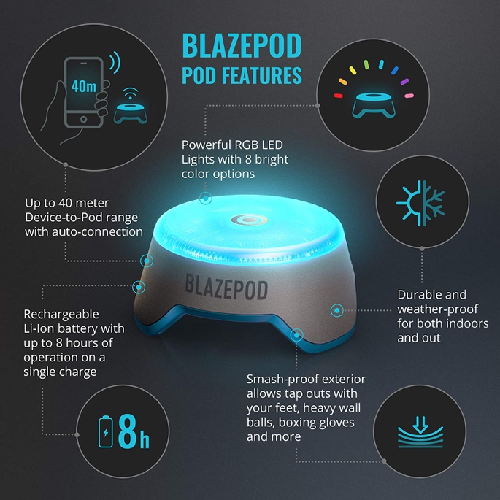

Figure 3. Experimental set-up

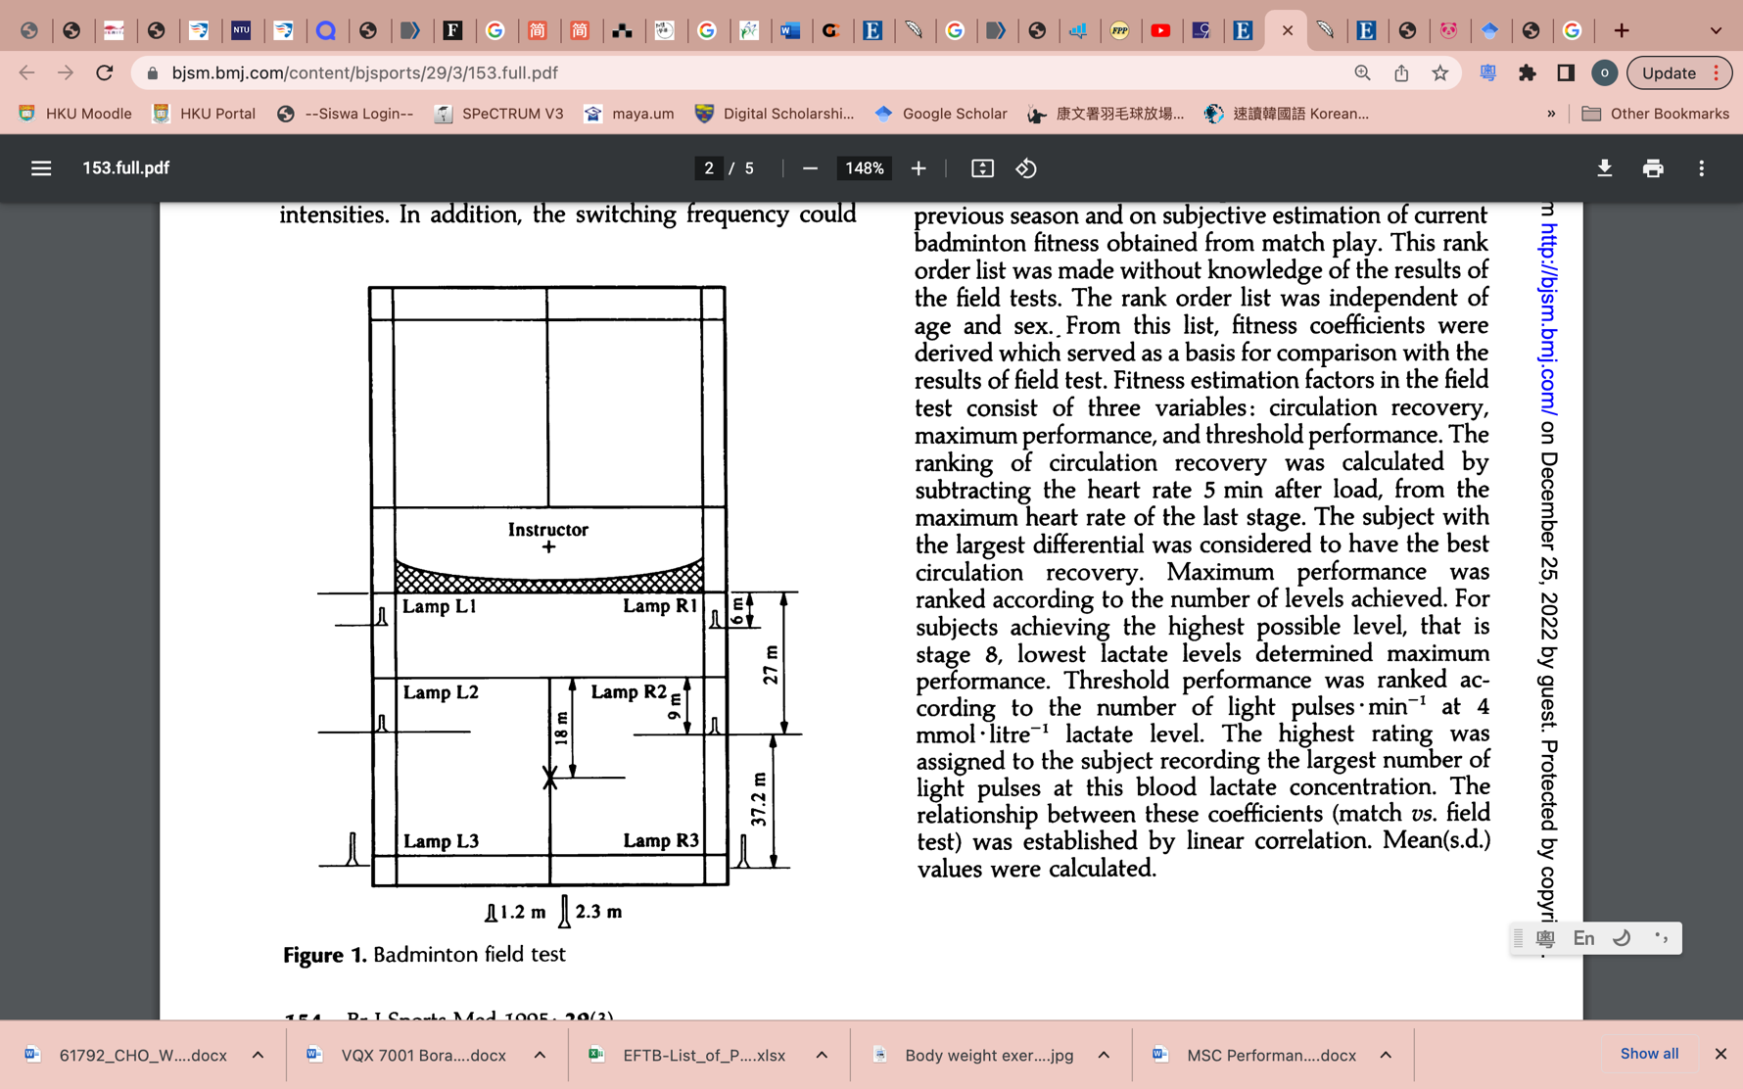

However in this research, instead of lamp, reaction light is used as a modification of the test (Figure 3). The original test involves lamp connecting to programing device located outside the court (Chin, et al., 1995) which makes the set up more hectic and complicated. With technology, footwork performance can be tested directly with the set of reaction lights (BlazePod™) and measurements can be seen directly through the mobile app connected with it. It was suggested in research that the BlazePod™ technology provides reliable information (de-Oliveira, et al., 2021).

With the Blazepod app, Lights were lit with the control of the app (Figure 1). As soon as the corresponding light was lit, the subjects were directed to run towards the light from a central location (point X), when the subject returns to point X from the light, it is considered as one rally. The subjects executed a front and side lunge in response to the forecourt and midcourt light flashes. For the rear court flashes, subjects need to turn towards the rear corner than perform front lunge like receiving a passive lobe shot. Since subjects are always facing forward, instructor is needed to help giving verbal instructions to subjects if they needed to move to the rear court. The maximum number of rallies were then recorded for statistical analysis.

3.4 Statistical Analysis

To compare mean values and statistical significance between groups, SPANOVA (Split-plot ANOVA) was used. The difference between pre-test and post-test of control group and experimental group max no. of rallies is calculated respectively and SPSS version 26 was used to analyze the data. For continuous variables, mean and standard deviations were determined. A significance level of p < 0.05 was considered statistically significant for this analysis.

CHAPTER 4 RESULTS AND DISCUSSION

4.1 Results

The results obtained from experiments are shown in table 4.1. the maximum number of rallies completed

Table 4.1 Results from experiment

|  |  |  |  |  |  |
| --- | --- | --- | --- | --- | --- |
| Control Group | | | Experimental Group​ | | |
| ​ | Pre-test​ | Post-test​ |  | Pre-test​ | Post-test​ |
| No. of rallies​ | 27​ | 28​ | **No. of rallies​** | 27​ | 30 |
| ​ | 35​ | 35​ |  | 29​ | 32​ |
| ​ | 30​ | 31​ |  | 27​ | 30​ |
| ​ | 32​ | 32​ |  | 34​ | 37​ |
| ​ | 33​ | 33​ |  | 34​ | 37​ |
| ​ | 37​ | 36​ |  | 33​ | 37​ |
| ​ | 31​ | 30​ |  | 29​ | 33​ |
| ​ | 29​ | 28​ |  | 28​ | 31​ |
| ​ | 28​ | 29​ |  | 31​ | 33​ |
| ​ | 28​ | 29​ |  | 36​ | 38​ |

Graph 4.1Experimental results for control and experimental group

The assumptions required for the analyses (normality, homogeneity of variances and sphericity) were met. the Kolmogorov-Smirnov/Shapiro-Wilk tests, Box's M test and Levene’s test was used to examine the conformity of the variables to normal Distribution (>0.05).

Table 4.2 Test of normality

|  |  |  |  |  |  |  |  |
| --- | --- | --- | --- | --- | --- | --- | --- |
|  |  | Kolmogorov-Smirnova | |  | Shapiro-Wilk | |  |
|  | group | Statistic | df | Sig. | Statistic | df | Sig. |
| pretest | control | 0.13 | 10 | .200* | 0.944 | 10 | 0.599 |
|  | experimental | 0.21 | 10 | .200* | 0.909 | 10 | 0.276 |
| posttest | control | 0.17 | 10 | .200* | 0.913 | 10 | 0.302 |
|  | experimental | 0.245 | 10 | 0.091 | 0.863 | 10 | 0.082 |
| * This is a lower bound of the true significance. | | | |  |  |  |  |

Table 4.3 Test of Homogeneity of Variances (Levene’s Test)

|  |  |  |  |  |  |
| --- | --- | --- | --- | --- | --- |
|  |  | **Levene Statistic** | **df1** | **df2** | **Sig.** |
| pretest | Based on Mean | 0.079 | 1 | 18 | 0.782 |
|  | Based on Median | 0.066 | 1 | 18 | 0.8 |
|  | Based on Median and with adjusted df | 0.066 | 1 | 17.683 | 0.8 |
|  | Based on trimmed mean | 0.079 | 1 | 18 | 0.782 |
| posttest | Based on Mean | 0.536 | 1 | 18 | 0.473 |
|  | Based on Median | 0.156 | 1 | 18 | 0.698 |
|  | Based on Median and with adjusted df | 0.156 | 1 | 17.848 | 0.698 |
|  | Based on trimmed mean | 0.553 | 1 | 18 | 0.467 |
| Tests the null hypothesis that the error variance of the dependent variable is equal across groups. | | | | | | |

Table 4.4 Box's M Test of Equality of Covariance Matricesa

|  |  |
| --- | --- |
| Box's M | 1.177 |
| F | 0.345 |
| df1 | 3 |
| df2 | 58320 |
| Sig. | 0.793 |

All tests are significant (p>0.05) which indicates that the assumptions for one-way ANOVA are not violated, can proceed to one way ANOVA.

Table 4.5 footwork performance test results within and between groups

|  |  |  |  |  |  |  |  |  |  |  |  |
| --- | --- | --- | --- | --- | --- | --- | --- | --- | --- | --- | --- |
| Test | Control group (n=10) | | Experimental group  (n=10) | | | Group effect | Time effect | | | Interaction Effect | |
| Mean | SD | mean | SD |  | | |  |  | |
| Pre-test | 31.00 | 3.266 | 30.80 | 3.259 | F= 0.807,  P= 0.381  ηp2= 0.043 | | | F= 79.349, P<0.001*  ηp2=0.815 | F=69.44,  p<0.001*  ηp2=0.794 | |
| Post-test | 31.10 | 2.850 | 33.80 | 3.155 |

* p<0.05. F: Split Plot ANOVA (SPANOVA) test.

Experimental group shows a more significant improvement in post-test results (M=33.80 ±3.155) than pre-test results (M=30.800 ±3.259), with a change of +3.0 . Control group shows slight increase from M=31.00 ±3.266 in pre-test to M=31.10 ± 2.850 in post-test, with a change of +0.1. (Graph 4.2)

The data collected were analyzed with a split-plot ANOVA with Group as the between participants factor and Time as the within participants factor. The test indicated a main effect of Time (F(1, 18) = 79.349, p < 0.001), with an effect size of 0.815 and the interaction between Group and Time was significant as well (F(1,18) = 69.44, p < 0.001), with an effect size of 0.794; the effect of Group was not significant (F(1,18) = 0.381 p = 0.043) and the effect size was 0.04 (table 4.5).

Graph 4.2 Estimated marginal means of pre-test and post-test in both groups



4.2 DISCUSSION

One of the purposes of this study is to compare the difference between non-structured warm-up and structured RAMP warm-up in improving badminton footwork performance. The findings of this study showed that there is significant increase in footwork performance after completing the proposed warm-up protocol, which suggested that the warm-up protocol is effective to activate lower body muscle groups. Since The two trials are done in consecutive sessions (1 day after previous training) so it is less likely to be an improvement due to training effect.

This was the first study to evaluate the effect of a structured RAMP warm-up on CODS.

The RAMP system offers a framework for creating efficient warm-up routines for both competition and training (Jefferys, 2006). Furthermore, effective warm-up planning throughout the training can result in ergonomically effective workouts. Effective movement/skill-based elevation sections allow for a significant amount of skill or movement development activity while requiring no additional time from the athlete (Jefferys, 2006).

By combining all the effective warm-ups from current studies, the research protocol is comprehensive in a way that all the benefits of different warm-up activities are included. IM warm-up impact on increasing the muscle force output capacity may be facilitated by neural facilitation. By minimizing reflex inhibition in IM and reducing the degree of co-contraction between the muscles that contract on inspiration and expiration, the contribution includes improvements in intra- and intermuscular coordination (Volianitis et al., 2001).

Foam rolling is beneficial in a way that it helps to reduce passive muscle stiffness and increasing ROM, could be brought on by the release of the cross-bridge brought  by the active or passive mobilization of the lower leg. (Morales‐Artacho, et al., 2017)

Loaded warm-up (10% of body weight) is the best amount of load to improve peak performance (Maloney, et al., 2014). It is believed that a higher loading causes superior muscular activation and, as a result, provides a bigger potential for potentiation. Therefore, the role of loading in the modulation of potentiation following heavy resistance training is crucial (Rahimi, 2007).

Like any other ballistic warm-up, box drop jumps induces PAP.  The PAP was attributed to two mechanisms: increased reflex electrical activity in the spinal cord and increased phosphorylation of the myosin light chain, which increases the sensitivity of the actin-myosin interaction to calcium (Chen, et al., 2013). Increased motor-unit recruitment, muscle spindle firing, and a synergistic relationship between the musculature and PAP were all recognized mechanisms for improving performance (Hilfiker, et al., 2007). Additionally, it is suggested that drop jump training may make it easier to achieve PAP and that properly designed plyometric training may cause the PAP effect (Hilfiker, et al., 2007).

With all the combined benefits, which are mentioned above, the proposed protocol successfully produced a positive effect on badminton footwork performance. Nonetheless, every player is different, fine tune of program for each athlete is still needed under the principle of individualization. For example, in deciding loading for loaded warm-up, every athlete experienced different enhancement under a different loading scenario. Although this might be a result of population variability that occurs naturally, potentiation-based research has frequently noted this phenomenon. For instance, Till and Cooke (2009) reported that different people responded differently to their potentiation treatments, with responses ranging from -7.1% to + 8.2%.

4.3 Limitations and improvements

In this research, only small number of participants are recruited, increasing the number of participants can improve the power of the research. Also, due to time limitation, the footwork test was done once only for each subject, to improve accuracy, can be done 5-6 times and take the average in future research. In addition, other factors such as gender might have effect on the improvement are not considered, they can be included in the future when the number of subjects increase.

CHAPTER 5: CONCLUSION

Warm-up programs are important for badminton payers to improve their performance and the proposed warm-up protocol is effective to activate lower body muscle groups. Coaches and athletes may use this warm-up protocol to improve training/competition performance. Further research can be done for investigating effective warm-up for upper body performance to provide more all-round whole body warm and muscle activation for badminton athletes.

APPENDIX I CONSENT FORM

**FORM 3: CONSENT FORM** **(ENGLISH)**

**Research on Effective Warm-Up Protocols for Improving Badminton Players Footwork Performance**

To become a participant in the research, you or your parent/legal guardian are advised to sign this Consent Form.

I herewith confirm that I have met the requirement of age and am capable of acting on behalf of myself /* as a parent/legal guardian as follows*:*

1. I understand the nature and scope of the research being undertaken.

2. All my questions relating to this research and my participation therein have been answered to my

satisfaction.

3. I voluntarily agree to take part in this research, to follow the study procedures and to provide all

necessary information to the investigators as requested.

4. I may at any time choose to withdraw from this research without giving reasons.

5. I have received a copy of the Subjects Information Sheet and Consent Form.

6. Except for damages resulting from negligent or malicious conduct of the researcher(s), I hereby

release and discharge University of Malaya and all participating researchers from all liability

associated with, arising out of, or related to my participation and agree to hold them harmless from

any harm or loss that may be incurred by me due to my participation in the research.

7. I have read and understood all the terms and conditions of my participation in the research.

I have read the statements above, understand the same, and voluntarily sign this form.

Dated :_____ day _____ month ______ year

Name of participants (18 years & above): ________________________________________________

IC/Passport number: ___________________________________

Signature: _______________________ Date:______________________

***To be filled by parents/legal guardians for participants aged below 18 years***

Name of parent/legal guardian: ________________________________________________________

IC/Passport number Parent/legal guardian: __________________________________

Signature of parent/legal guardian: _______________ Date:____________________

Ralationship of the guardian to the participant:_______________________________________

Name of researcher: __________________________ IC/Passport number: __________________

Signature of researcher: ________________________

APPENDIX II INFORMATION SHEET

[*Date*]

**Research on Effective Warm-Up Protocols for Improving Badminton Players Footwork Performance**

**INFORMATION SHEET FOR PARTICIPANTS**

Thank you for showing an interest in this project. Please read this information sheet carefully before deciding whether or not to participate. If you decide to participate we thank you. If you decide not to take part there will be no disadvantage to you of any kind and we thank you for considering our request.

**What is the Aim of the Project?**

the objective is to invsetigate and develop an effective warm up protocol to improve court performance of badminton athletes.

**What Type of Participants are Needed?**

20 asymptomatic badminton players

Participants should be at least state level and are participating in regular training for 3-4days a week.

Without undergoiong any strength and conditioning program to imrpove on-court performance

**What will Participants be Asked to Do?**

Each athlete will be assigned to each group randomly. On the first day, all athletes will perform their regular warm-up routine before a footwork test to established baseline measurement. On the second day, athletes will be performing their assigned warm-up routine, athletes in the control group will continue to perform regular warm-up routine before footwork test and atheletes in the experimental group will perform the proposed warm-up routine. Following each warm-up session, players will three random six-point runs to measure their performance and record their reaction and overall movement speeds. Please be aware that you may decide not to take part in the project without any disadvantage to yourself of any kind.

**Can Participants Change their Mind and Withdraw from the Project?**

You may withdraw from participation in the project at any time if injury takes place and without any disadvantage to yourself of any kind.

**What Data or Information will be Collected and What Use will be Made of it?**

Results of this project may be published but any data included will in no way be linked to any specific participant.

You are most welcome to request a copy of the results of the project should you wish. The data collected will be securely stored in such a way that only those mentioned above will be able to gain access to it. At the end of the project any personal information will be destroyed immediately except that, as required by the University's research policy, any raw data on which the results of the project depend will be retained in secure storage for five years, after which it will be destroyed.

**What if Participants have any Questions?**

If you have any questions about our project, either now or in the future, please feel free to contact either:-

Lam Cho Wai or ASSOCIATE PROF. DR. ASHRIL BIN YUSOF

Faculty of Sports and Exercise Science Faculty of Sports and Exercise Science

S2103054@siswa.um.edu.my ashril@um.edu.my

**APPENDIX III SCORE SHEET**

|  |  |  |  |  |  |  |  |  |  |  |  |  |  |  |  |  |  |
| --- | --- | --- | --- | --- | --- | --- | --- | --- | --- | --- | --- | --- | --- | --- | --- | --- | --- |
| Control group |  |  |  | | |  | | Experimental group | | | |  | |  | |  | |
| Name | Age | Gender | Max number of rallies | |  | | Name | | Age | | Gender | | Max number of rallies | | | |
| pre | post | pre | | post | |
| Jeremy Chai | 19 | M | 27​ | 28​ | |  | | Chang Yi | | 19 | | F | | 27​ | | 30 | |
| Cheng Zhang yao | 17 | M | 35​ | 35​ | |  | | Danial Nasrul | | 24 | | M | | 29​ | | 32​ | |
| Wong Zi yi | 17 | F | 30​ | 31​ | |  | | Fan Khim Hou | | 24 | | M | | 27​ | | 30​ | |
| Cheng Chang Jun | 20 | M | 32​ | 32​ | |  | | Johnathan Chai | | 20 | | M | | 34​ | | 37​ | |
| Amirul Lee | 23 | M | 33​ | 33​ | |  | | Chan Yong Ming | | 19 | | M | | 34​ | | 37​ | |
| Guan Yu Vern | 24 | M | 37​ | 36​ | |  | | Chan Pei Xin | | 17 | | F | | 33​ | | 37​ | |
| Soh Aik Yong | 24 | M | 31​ | 30​ | |  | | Chan Yuen Kiu | | 24 | | F | | 29​ | | 33​ | |
| Ku Jia Hom | 18 | M | 29​ | 28​ | |  | | Chi Yang | | 21 | | M | | 28​ | | 31​ | |
| Aahley Wong | 18 | M | 28​ | 29​ | |  | | Lum Chee Ming | | 24 | | M | | 31​ | | 33​ | |
| Lum Chee yew | 23 | F | 28​ | 29​ | |  | | Lam Cho Wai | | 24 | | F | | 36​ | | 38​ | |

**APPENDIX IV EXPERIMENTAL SETUP**

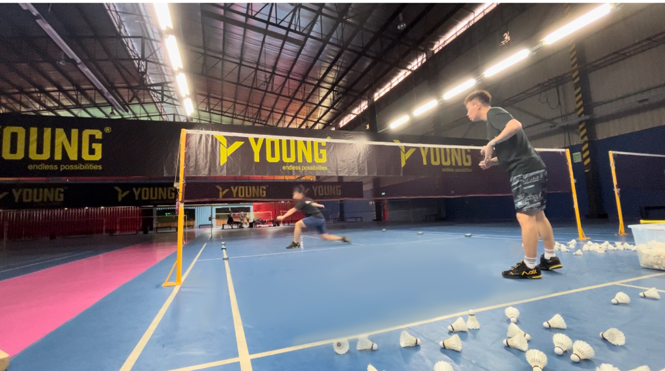

**Reference**

Bishop, D. (2003). Warm-up II: Performance changes following active warm up on exercise performance. Sports Med, 33(1), 483-498.

Chen, C. (2016). Research on badminton footwork training and teaching effect based on computer aided information processing. Revista Ibérica de Sistemas e Tecnologias de Informação, (E5), 115.

Chen, Z. R., Wang, Y. H., Peng, H. T., Yu, C. F., & Wang, M. H. (2013). The acute effect of drop jump protocols with different volumes and recovery time on countermovement jump performance. The Journal of Strength & Conditioning Research, 27(1), 154-158.

Chua, M. T., Chow, K. M., Lum, D., Tay, A., Goh, W. X., Ihsan, M., & Aziz, A. R. (2021). Effectiveness of On-Court Resistive Warm-Ups on Change of Direction Speed and Smash Velocity during a Simulated Badminton Match Play in Well-Trained Players. Journal of functional morphology and kinesiology, 6(4), 81. https://doi.org/10.3390/jfmk6040081

de-Oliveira, L. A., Matos, M. V., Fernandes, I. G., Nascimento, D. A., & da Silva-Grigoletto, M. E. (2021). Test-retest reliability of a visual-cognitive technology (BlazePod™) to measure response time. Journal of Sports Science & Medicine, 20(1), 179.

Escobar Hincapié, A., Agudelo Velásquez, C. A., Ortiz Uribe, M., García Torres, C. A., & Rojas Jaramillo, A. (2021). Unilateral and Bilateral Post-Activation Performance Enhancement on Jump Performance and Agility. International journal of environmental research and public health, 18(19), 10154. https://doi.org/10.3390/ijerph181910154

Hilfiker, R., Hübner, K., Lorenz, T., & Marti, B. (2007). Effects of drop jumps added to the warm-up of elite sport athletes with a high capacity for explosive force development. The Journal of Strength & Conditioning Research, 21(2), 550-555.

Hughes, M. G. (2008). Field-based assessment of speed and power in junior badminton players. In Science and Racket Sports IV (pp. 92-98). Routledge.

Jeffreys, I. (2019). The warm-up: Maximize performance and improve long-term athletic development. Human Kinetics.

Jeffreys, I. J. U. J. (2006). Warm up revisited–the ‘ramp’method of optimising performance preparation. UKSCA Journal, 6, 15-19.

Kwon, I. S., H. S., Kim, D. H., & Park, D. S.. (2022). The Effect of Warm up type on Physical Fitness factor related to Badminton Players Performance. Sport science, 40(1), 29-35

Lin, H., Tong, T. K., Huang, C., Nie, J., Lu, K., & Quach, B. (2007). Specific inspiratory muscle warm-up enhances badminton footwork performance. Applied Physiology, Nutrition, and Metabolism, 32(6), 1082-1088.

Lin, W. C., Lee, C. L., & Chang, N. J. (2020). Acute Effects of Dynamic Stretching Followed by Vibration Foam Rolling on Sports Performance of Badminton Athletes. Journal of sports science & medicine, 19(2), 420–428.

Maloney, S. J., Turner, A. N., & Miller, S. (2014). Acute effects of a loaded warm-up protocol on change of direction speed in professional badminton players. Journal of applied biomechanics, 30(5), 637–642. https://doi.org/10.1123/jab.2014-0048

Morales‐Artacho, A. J., Lacourpaille, L., & Guilhem, G. (2017). Effects of warm‐up on hamstring muscles stiffness: Cycling vs foam rolling. Scandinavian journal of medicine & science in sports, 27(12), 1959-1969.

Rahimi, R. (2007). The acute effects of heavy versus light-load squats on sprint performance. Facta Universitatis-Series: Physical Education and Sport, 5(2), 163-169.

Seth, B. (2016). Determination factors of badminton game performance. International Journal of Physical Education, Sports and Health, 3(1), 20-22.

THAPA, R. K., KUMAR, A., KUMAR, G., & NARVARIYA, P. (2020). A combination of ballistic exercises with slow and fast stretch-shortening cycle induces post-activation performance enhancement. Age (years), 21(1.2), 19-23.

Volianitis, S., McConnell, A. K., & Jones, D. A. (2001). Assessment of maximum inspiratory pressure. Respiration, 68(1), 22-27.

Woolstenhulme, M. T., Griffiths, C. M., Woolstenhulme, E. M., & Parcell, A. C. (2006). Ballistic stretching increases flexibility and acute vertical jump height when combined with basketball activity. The Journal of Strength & Conditioning Research, 20(4), 799-803.